**Online Delivery Restaurants Project**

**Problem Statement**:

The team is looking for expansion andopening more restaurants. Strategies/suggestions about opening newer restaurants.

**Objective Question**

* The data consists of some inconsistent and missing values so ensure that the data used for further analysis is cleaned.

For cleaning the whole data, we check first there are not null and duplicate values available in data, for that we apply filter on each column and check.

We found in Cuisines Column there are some BLANKS values, so we change blanks into FOOD value. Also, we are extracting the year from Date-Key-Opening Column.

With the **=LEFT (U2,4)** function.

* Using the LookUp functions, fill up the countries in the original data using the country code.

**=XLOOKUP (C2, 'country description'! $A:$A, 'country description'!$B:$B)**

* Create a table to represent the number of restaurants opened in each country.
* According to our analysis we find that India has highest number of restaurants **8652.**
* And the Canada have least number of restaurants that is **4.**
* And the total number of restaurants in the given data set that is **9551.**

Select all Raw data and create a pivot table, and in row we add the country column and in value we add the Restaurant Name column and summaries by count function.

|  |  |
| --- | --- |
| *Country* | COUNT of Restaurant |
| Australia | 24 |
| Brazil | 60 |
| Canada | 4 |
| India | 8652 |
| Indonesia | 21 |
| New Zealand | 40 |
| Philippines | 22 |
| Qatar | 20 |
| Singapore | 20 |
| South Africa | 60 |
| Sri Lanka | 20 |
| Turkey | 34 |
| United Arab Emirates | 60 |
| United Kingdom | 80 |
| United States of America | 434 |

* Also, the management wants to look at the number of restaurants opened in each year.
* According to our data, every year more than 1000 restaurants are open all over the country from 2010 to 2018.
* As per our analysis the maximum number of restaurants open in 2018 and the minimum number of restaurants open in 2012.

Create the pivot table add Year column in row and Restaurant Name column in value and summaries by count function.

|  |  |
| --- | --- |
| *Opening Year* | COUNTA of Restaurant |
| 2010 | 1080 |
| 2011 | 1098 |
| 2012 | 1022 |
| 2013 | 1061 |
| 2014 | 1051 |
| 2015 | 1024 |
| 2016 | 1027 |
| 2017 | 1086 |
| 2018 | 1102 |
| **Grand Total** | **9551** |

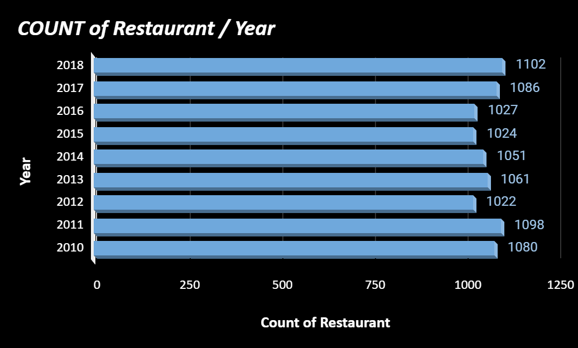

* What is the total number of restaurants in India which are in the price range of 4?

**=COUNTIFS ('Raw Data’! D2:D,"INDIA",'Raw Data’! Q2: Q,"4")**

Using the COUNTIFS function on the Raw data, we get the number of restaurants in India which are in the (Price range of 4) **388.**

* According to the data, what is the average number of voters for the restaurants in each country?

Create the pivot table and add country column in row and votes column in value and summaries by Average function.

With the help of pivot table, we can easily define the Average votes of country. According to our analysis **Brazil** got minimum average of votes and **United Arab Emirates** maximum average of votes.

|  |  |
| --- | --- |
| *Country* | AVERAGE of Votes |
| Australia | 111.4 |
| Brazil | 19.6 |
| Canada | 103.0 |
| India | 137.2 |
| Indonesia | 772.1 |
| New Zealand | 243.0 |
| Philippines | 407.4 |
| Qatar | 163.8 |
| Singapore | 31.9 |
| South Africa | 315.2 |
| Sri Lanka | 146.5 |
| Turkey | 431.5 |
| United Arab Emirates | 493.5 |
| United Kingdom | 205.5 |
| United States of America | 428.2 |

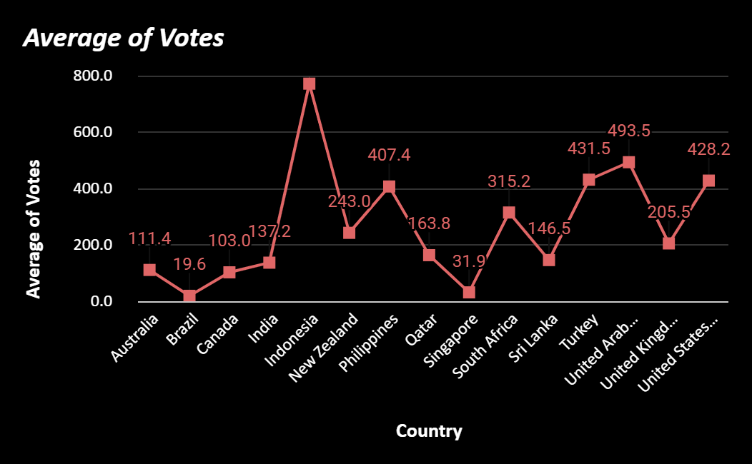

**Subjective Questions**

* Suggest a few countries where the team can open newer restaurants with lesser competition. Which visualization/technique will you use here to justify the suggestions?

We are suggesting few countries for opening new restaurants in Data Analysis sheet in excel project. That are **Australia, Canada, Indonesia, New Zealand, Qatar, Singapore, Sri Lanka, Turkey.** Number of restaurants in this country is very less and **rating is below than 4.5.**

On my visualization and technique create pivot table and add country column in row and restaurants name in value summaries by count function. We fetch the list of number of restaurants in each county after that we add filter on count of restaurants column and select only up to 40 restaurants and we get result of few countries where we open new restaurants in lesser competition.

|  |  |  |
| --- | --- | --- |
| ***Country*** | **Count of Restaurant** | **AVERAGE of Rating** |
| Australia | 24 | 3.7 |
| Canada | 4 | 3.6 |
| Indonesia | 21 | 4.3 |
| New Zealand | 40 | 4.3 |
| Qatar | 20 | 4.1 |
| Singapore | 20 | 3.6 |
| Sri Lanka | 20 | 3.9 |
| Turkey | 34 | 4.3 |

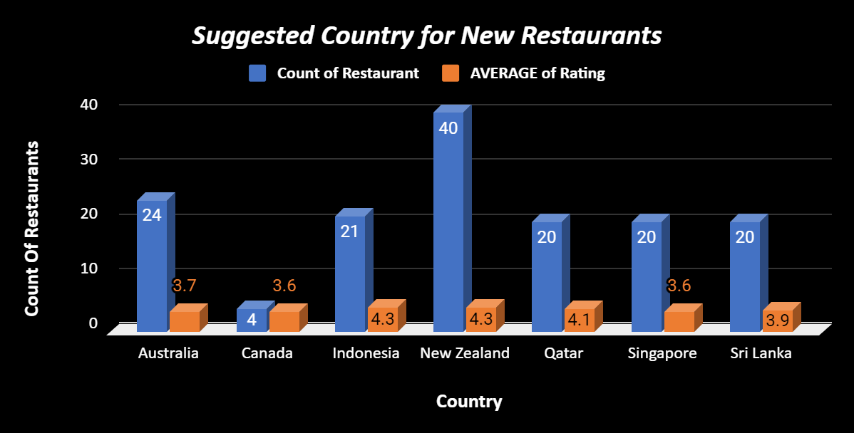

* According to the countries you suggested, what is the current quality in terms of ratings for restaurants that are open there?

According to my analysis the average rating of suggested country is minimum **3.6** and country are **Canada, Singapore**. The maximum average rating is 4.3 and country are **Indonesia, New Zealand, and Turkey.**

To fetching the quality in term off Rating we add the rate column in value and summaries by Average function on same pivot table of Data analysis sheet.

|  |  |  |
| --- | --- | --- |
| ***Country*** | **Count of Restaurant** | **AVERAGE of Rating** |
| Australia | 24 | 3.7 |
| Canada | 4 | 3.6 |
| Indonesia | 21 | 4.3 |
| New Zealand | 40 | 4.3 |
| Qatar | 20 | 4.1 |
| Singapore | 20 | 3.6 |
| Sri Lanka | 20 | 3.9 |
| Turkey | 34 | 4.3 |

* What is the current expenditure on food in the suggested countries, so that we can keep our financial expenditure in control?

The average money we spend on food is called as Expenditure on food. For opening the new restaurant, we know the average money we spend on food to control the financial expenditure.

As per my analysis we find the average cost of two person as per given data and change the Country currency in US Doller $ for convenience.

And we find the in Tukey we spend average amount like 2.80$ and in Singapore we need to spend 116.34 $ to control the financial expenditure.

For fetching the current expenditure on food in the suggested countries we add the average cost of two column in value and summaries by Average function to get the average cost in that country. And for new restaurants we can keep our financial expenditure in control.

|  |  |  |
| --- | --- | --- |
| *Country* | Average Cost for two | In US dollar |
| Australia | 24.1 | $15.87 |
| Canada | 36.3 | $27.03 |
| Indonesia | 281190.5 | $17.85 |
| New Zealand | 69.8 | $42.79 |
| Qatar | 223.8 | $61.47 |
| Singapore | 155.8 | $116.34 |
| Sri Lanka | 2375.0 | $7.52 |
| Turkey | 84.9 | $2.80 |

|  |  |
| --- | --- |
| **Country** | **Currency** |
| Australia | Dollar ($) |
| Canada | Dollar ($) |
| Indonesia | Indonesian Rupiah (IDR) |
| New Zealand | Dollar ($) |
| Qatar | Qatari Rial (QR) |
| Singapore | Dollar ($) |
| Sri Lanka | Sri Lankan Rupee (LKR) |
| Turkey | Turkish lira |

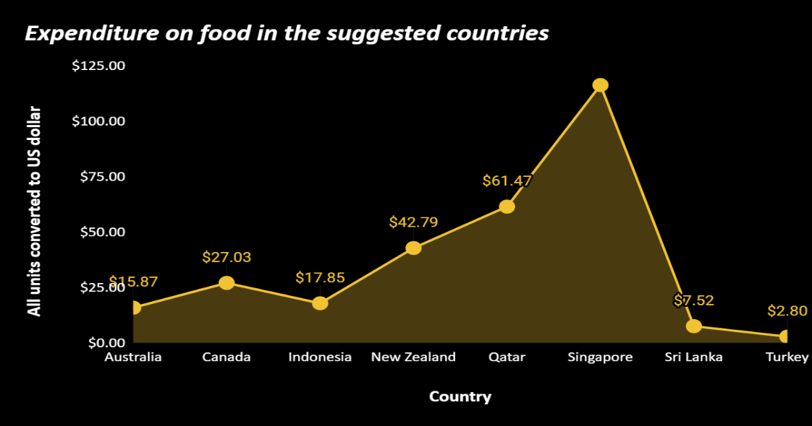

* Come up with the names of restaurants from the recommended states that are our biggest competitors and those that are rated in the lower brackets, i.e., 1-2 or 2-3.

There is total **8 country (Australia, Brazil, Canada, India, New Zealand, Singapore, Sri Lanka, United Arab Emirates, United Kingdom, United State of America) those** have less than 3 rating. And the biggest competitor is **India with 1.8** rating**.**

Create Pivot table and add country and Restaurants name in row and put Restaurants name in value and summarise by count for calculate the number of restaurants. And in filter add rating, select less than 3.

|  |  |  |
| --- | --- | --- |
| *Country* | Count of Restaurant | AVERAGE of Rating |
| Australia Total | 3 | 2.6 |
| Brazil Total | 6 | 1.3 |
| Canada Total | 1 | 3.0 |
| India Total | 4027 | 1.8 |
| New Zealand Total | 1 | 2.3 |
| Singapore Total | 1 | 3.0 |
| Sri Lanka Total | 2 | 2.5 |
| United Arab Emirates Total | 1 | 2.4 |
| United Kingdom Total | 2 | 1.9 |
| United States of America Total | 5 | 1.5 |

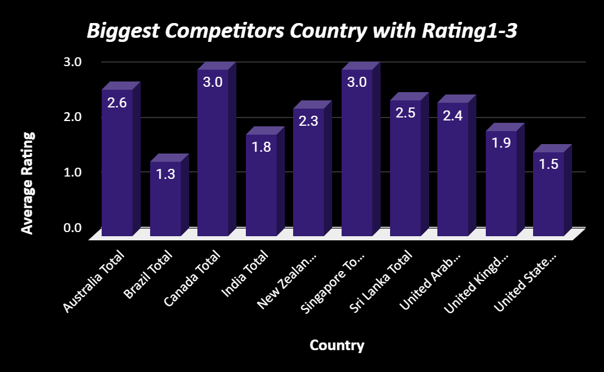

* Which cuisines should we focus on in the newer restaurants to get better feedback? Does the choice of cuisines affect the restaurant ratings?

We focus on High rating cuisines for newer restaurants because different country has different cuisines and only some cuisines have high rating. And other cuisines have low rating and it also affect the rating of the cuisines.

As per my analysis we select **139** different cuisines to serve in our newer restaurants.

Create pivot table and add country and cuisine in row and add rating in value and summaries by average.

|  |  |
| --- | --- |
| **Country** | **Number of Cuisines** |
| **Australia Total** | **6** |
| **Canada Total** | **1** |
| **Indonesia Total** | **17** |
| **New Zealand Total** | **37** |
| **Philippines Total** | **21** |
| **Qatar Total** | **11** |
| **Singapore Total** | **3** |
| **Sri Lanka Total** | **13** |
| **Turkey Total** | **30** |

* According to our current data, should we go for online delivery and table booking? Does that affect the customer’s ratings?

Yes, we can go for online delivery and table booking because the average of rating is higher in those restaurants having both online delivery and table booking. And it also affects the rating.

* Formula for finding average rating have been table booking and online delivery.

**=AVERAGEIFS ('Raw Data’! T2: T, 'Raw Data’! M2:M,"Yes",'Raw**

**Data’! N2: N, "Yes")**

* Formula for finding average rating have not been table booking and online delivery.

**=AVERAGEIFS ('Raw Data’! T2: T, 'Raw Data'! M2:M,"No",'Raw**

**Data'!N2:N,"No")**

|  |  |  |  |
| --- | --- | --- | --- |
| *Table booking* | AVERAGE of Rating | *Online delivery* | AVERAGE of Rating |
| No | 2.809686644 | No | 2.754309859 |
| Yes | 3.482556131 | Yes | 3.288004896 |

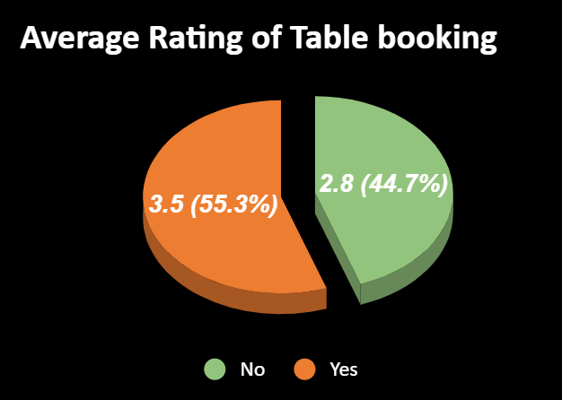

* Should the team keep the rate of cuisines higher? Will that affect the feedback? According to our data are the rates of cuisines and ratings, correlated?

As per my analysis you can increase the number of cuisines but the rate of cuisines put it as average not more then that. Then you capture the market and control your finencial expenditure.

Yes, the price range and rate are correleted that is **0.46** this not Good strength but it comes in moderate section.

**Formula is – CORREL(A:A,B:B)**

We are create the pivot table and add country and cuisines in row, after that we add rating in value and summerzise by average and add average of two in value and summerise by average.

|  |  |
| --- | --- |
| **Strength** |  |
| **0 to 0.19** | **Very weak** |
| **0.2 to 0.39** | **Weak** |
| **0.40 to 0.59** | **Moderate** |
| **0.6 to 0.79** | **Strong** |
| **0.8 to 1** | **Very Strong** |

* What is the distribution of several restaurants of different price ranges in all the countries?

According to given data **9551** restaurants available in all country and with different price range like in Price Range 1 there are **4444** restaurants, and Price Range 2 there are **3113** restaurants, Price Range 3 there are **1408** restaurants, and Price Range 4 there are **586** restaurants presents.

Once again, we create pivot table and add Prize range in row and Restaurants Name in value and summaries by Count function. So, we easily fetch the different prize range of restaurants of all the countries.

|  |  |
| --- | --- |
| *Price range* | COUNT of Restaurant |
| 1 | 4444 |
| 2 | 3113 |
| 3 | 1408 |
| 4 | 586 |

