PROJECT DELIVERY METHODOLOGY
SYSTEM DESIGN

National College of Ireland
CRYPTO SCANNER
VERSION: 1.0 | REVISION DATE: 02.08.2018
Approval of the System Design indicates an understanding of the purpose and content described in this deliverable. By signing below, each individual agrees with the content contained in this deliverable.
Approver Name | Title | Signature | Date

Contents
Section 1 Introduction 1
1.1 Purpose 1
Section 2 Data Model Design 1
Section 3 Process Model Design 1
Section 4 Create/Read/Update/Create (CRUD) Matrix (Interaction Analysis) 1
Section 5 Detailed Design 2
5.1 User/Batch/Report Interface Design Overview 2
5.2 User Interface Navigation Hierarchy 2
5.3 User Interface Functional Screen/Report and/or Batch process 2
5.4 Other Interfaces 3
Section 6 Technical Architecture 4
6.1 System Architecture 4
6.2 Technical Architecture Design 4
6.3 System Development/Testing Environment 5
Section 7 Requirements Traceability Matrix 5
Section 8 References 6
Section 9 Glossary 6
Section 10 Document Revision History 6
Section 11 Appendices 6

Section 1 Introduction

1.1 Purpose
The purpose of System Design document is to translate the business requirements and business processes into a technical design that will be used to develop the application.

Section 2 Data Model Design
Data Model Location | Transaction  Market  Currency

Section 3 Process Model Design

Process Model Design location | 1.  Name: Select markets  Purpose: User selects markets that he/she wishes to query for prices  Inputs: User selects with mouse available checkboxes  Output: User selection is sent to back end and recorded in form of state variables  2.  Name: Query markets  Purpose: To obtain data from markets  Inputs: Starts by clicking the button, no other input required.  Output: Data in JSON format, pre-formatted by individual market module.  3.  Name: Format the market data  Purpose: To format the data so that it conforms to algorithm requirements.  Inputs: Raw data from markets, pre-formatted by individual market modules.  Output: Single variable that holds data from all markets in JSON format.  4.  Name: Run arbitrage algorithm.  Purpose: Run arbitrage algorithm against the formatted data.  Inputs: Formatted JSON object  Output: JSON object. Each object key relates to a transaction.

Section 4 Create/Read/Update/Delete (CRUD) Matrix (Interaction Analysis)

Get a market data  Save results  Delete results  Update results | Creates an instance of market data object  Creates an instance of results objects and saves it to database  Deletes instance of results object  Updates the displayed results as per specific filters

Section 5 Detailed Design

5.1 User/Batch/Report Interface Design Overview
UI/UX does not serve primary role for this application. Text based output within console would be sufficient, but for the clarity, and project presentation purposes, an extremely simple, and hopefully clean design has been adopted.
User interface is build within Electron application. Electron desktop application provides ‘out of the box’ user interface platform in form of a Chromium browser. Front end will be referred as ‘renderer process’ henceforth. Because UI is browser based, design is created using web technologies, such as, HTML , CSS, and JavaScript.

5.2 User Interface Navigation Hierarchy
⇒ Main page – user has access to navigation bar and, filters, and scan button
⇒ Markets page – list of all available markets that can be queried for data
⇒ Scheduler page – provides options to schedule scan

5.3 User Interface Functional Screen/Report and/or Batch process

7.3. Main page
Contains Scan button, filters, and once scan is completed, displays the results.

7.3.1 Scan button
Initiates main feature, scan of market data

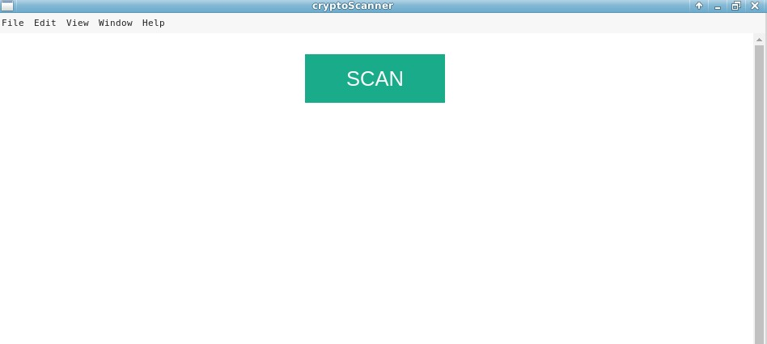

7.3.2 Results
Displays results of the scan
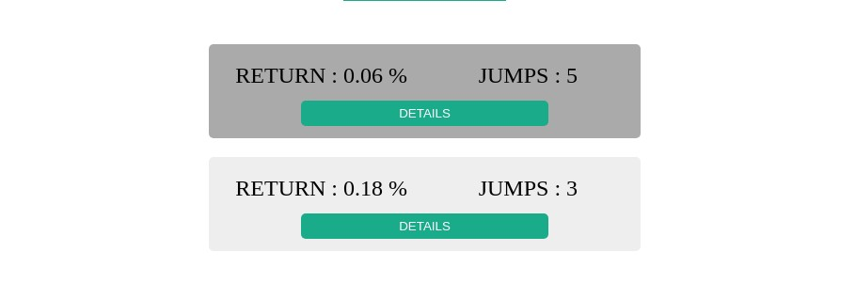

7.3.3 Detailed results
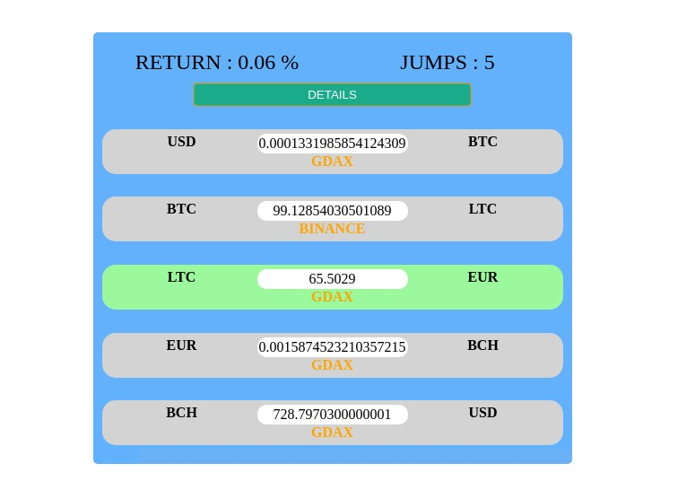
Displays details related to each potential arbitrage opportunity

7.4. Markets page
Contains a list of all market API’s that are integrated with the application

7.5. Scheduler page
Contains a options that allow user to schedule a scan to run in the future

Section 6 Technical Architecture

6.1 System Architecture
Operating System: Linux Mint v.16
Database: MongoDB
Language: JavaScript running within Node.js runtime environment.
Framework: Electron
Packages-dependencies: Axios, Async, Graph-data-structure
Packages-development: Mocha, Chai, Eslint, Prettier

6.2 Technical Architecture Design

6.2.1 Class Diagram

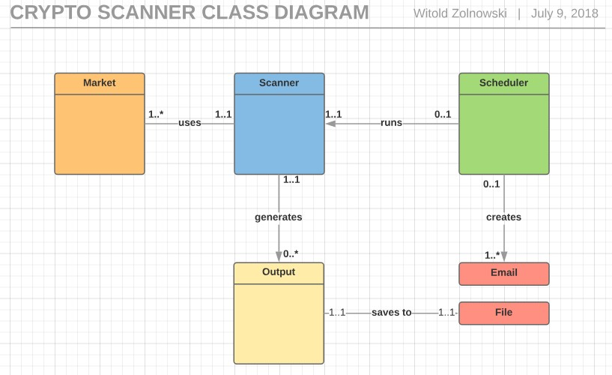

6.3 System Development/Testing Environment

6.3.1 Development Environment
- Developer Workstation Configuration
Application developed in Linux Mint operating system, application is optimized for Chrome browser. Application server is built in and managed by Electron.
- Supporting Development Infrastructure Configuration
NPM is used for package management. Code is running within Node.js. Primary text editor: Emacs v24.

6.3.2 QA Testing Environment
- QA Workstation Configuration
Unit testing performed with help of Mocha, and Chai packages.

Section 7 Requirements Traceability Matrix
Provide reference to the location of the Requirements Traceability Matrix that indicates traceability from the requirements documented in the Software Requirements Specifications to the design elements documented in the System Design Description.
Requirements Traceability Matrix Location

Section 8 References
Provide a list of all documents and other sources of information referenced in the System Design document and utilized in developing the System Design document. Include for each the document number, title, date, and author.
Document No. | Document Title | Date | Author

Section 9 Glossary
Define of all terms and acronyms required to interpret the System Design document properly.
⇒

Section 10 Document Revision History
Identify changes to this document
Version | Date | Name | Description

Section 11 Appendices
Include any relevant appendices.
⇒

