Tutorial 10: Tree

Balanced/ Non-Balanced Binary Tree
- Insert the following elements in an ordered binary tree:
Ali, Bill, CJ, Dan, Ella, Flo, Gill
- Represent graphically the tree after all the elements were inserted.
Ali
Bill
CJ
Dan
Ella
Flo
Gill
- Is the resulting tree balanced? Why?
NO

- How many steps are required to find Gill?
7

- For the tree given below answer the following:

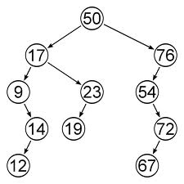

- Give height and depth for the following nodes: 17, 19, 50 and 67
17: H=3; D=1 19: H=0; D=3 50: H=4; D=0 67: H=0; D=4

- List the elements from the tree using the post-order traversal.
12, 14, 9, 19, 23, 17, 67, 72, 54, 76, 50

List the elements from the tree using the pre-order traversal.
50, 17, 9 14, 12, 23, 19, 76, 54, 72, 67

Q3: What are the heights of the trees in the following figures?
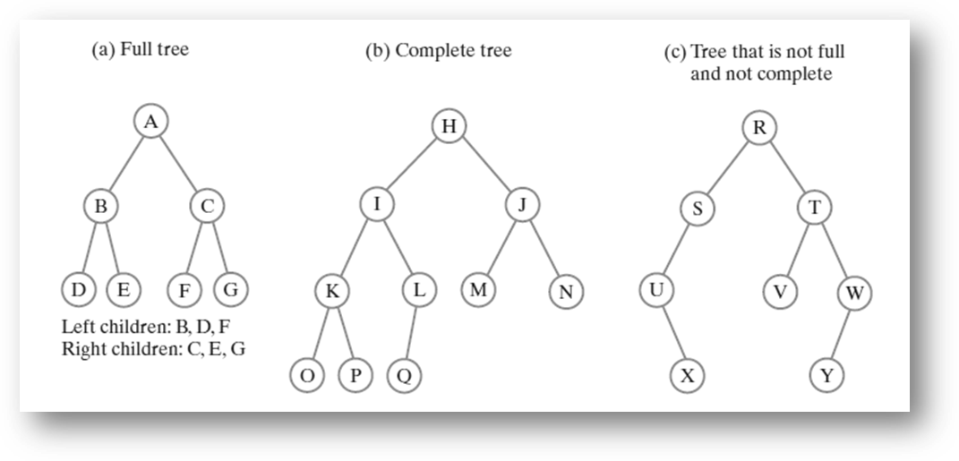
3, 3, and 4, respectively.

