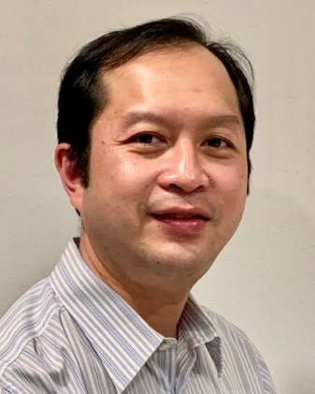WIttawat Na RANONG

# Contact:

Sriracha, Chonburi

 : +66 85 083 6080

 : wittawat.naranong@gmail.com

 : linkedin.com/in/wittawat-naranong

 : github.com/wittawatTon

: resume-theta-gray-89.vercel.app

### Profile Summary

A results-driven IT Director with over 15 years of leadership experience specializing in IT infrastructure, cybersecurity, and application development. Recognized for driving innovation, operational efficiency, and delivering large-scale projects from conception to completion. Proficient in aligning IT strategies with business objectives, managing cross-functional teams, and enhancing performance through cutting-edge technological solutions.

### Key Achievements

* Nationwide Project Leadership: Spearheaded the implementation of a mobile phone number registration system across Thailand for a leading telecommunications company.
* Security Innovation: Developed a robust brand protection by security labeling for a global security networking company.
* Manufacturing Efficiency: Developed and deployed a security and time attendance management system for a large-scale manufacturing plant, significantly improving operational efficiency.
* Payment Systems Expertise: Led the creation of a contactless e-purse system, integrating stored value cards with electronic data capture (EDC) terminals.
* Financial Security: Delivered a complex credit/debit card personalization project, meeting stringent financial security standards.

### Professional Experience

#### **Thai British Security Printing PCL**

#### **Plus Tech Innovation PCL.**

IT Director

Jun 2019 - Jan 2021

* Led a team of 40+ IT professionals, overseeing IT operations across multiple sites in ASIAN, including infrastructure, applications, and cybersecurity.
* Ensured compliance with ISO 27001 and VISA/MasterCard security standards, leading audits and driving remediation efforts.
* Developed a cloud-based subscription authentication and tracking service on AWS, integrating advanced security labeling.
* Managed the migration of ERP systems (SAP, Microsoft Dynamics AX) and HR systems, achieving improved operational efficiency with minimal downtime.
* Collaborated with C-level executives to develop IT budgets, forecasts, and resource allocation strategies, aligning IT initiatives with corporate goals.
* Pioneered new business opportunities in smart factoring and IT solution.
* Enhanced server infrastructure with VMware virtualization.

IT System Development Manager  
Jun 2014 - May 2019

* Led a team of 15 engineers to develop and implement critical software solutions, including financial smart card personalization, efficient mailing systems, advanced security printing, and automated manufacturing processes.
* Designed and deployed a mobile/web e-registration system using ID card authentication, streamlining user registration processes.
* Enhanced brand protection by developing a robust web-based platform for security label manufacturing. This integrated system streamlined label ordering, production, and inventory management, serving global contract manufacturers and significantly reducing the risk of counterfeit products.
* Implemented IoT solutions in manufacturing using MQTT protocol and developed inspection and product matching systems with engineers.
* Deployed a warehouse management system using UHF RFID technology.
* Streamlined production efficiency by integrating manufacturing time sheets with time and attendance data.

R&D Team Lead (Software Development)Oct 2006 - May 2014

* Directed the development of a contactless e-purse system integrated with a loyalty program, improving customer retention and transaction efficiency.
* Developed an RFID-based warehouse solution, optimizing inventory management and operational efficiency.

#### **Thai CRT Co. Ltd**

R&D Engineer  
Apr 1996 - Sep 2006

* Designed and developed Cathode Ray Tubes (CRT) using finite element methods.
* Created a photolithography mathematical model for CRTs using MATLAB/MATHCAD.
* Served as the R&D server administrator, ensuring the reliability and security of critical IT infrastructure.

### Training and Certifications

* Management Development Program, Wharton University
* Risk Management
* Java Card Training, NXP
* Leader as Coach

### Skills

* IT Strategy & Planning
* Project Management
* Team Leadership & Development
* Object-Oriented Programming: C, Java, Node.js, JavaScript
* SQL
* Cryptography & Key Management
* Hardware Security Module

### Education

* Bachelor's Degree in Electrical Engineering, Chiangmai University (1992-1996)
* Bachelor's Degree in Economics, Sukhothai Thammathirat University (1997-2000)

### Language Proficiency

* English: TOEIC Score: 910 (Listening: 490, Reading: 420)