Graphs and Tables for STRIPS 2020
witte
12/23/2020
This is the rain and runoff table for 2016:
 |  | Runoff (in.)
Site | Rain (in.) | Control | Treatment
Armstrong | 27.4 | 1.12 | 0.05
E. IA Airport | 31.5 | 3.86 | 2.98
Rhodes | 19.1 | 0.29 | 0.06
Spirit Lake | 7.7 | 0.14 | 0.00
Whiterock | 15.0 | 0.25 | 0.37
Worle | 24.5 | 0.50 | 0.62
This is the rain and runoff table for 2017:
 |  | Runoff (in.)
Site | Rain (in.) | Control | Treatment
Armstrong | 24 | 0.67 | 0.06
E. IA Airport | 11 | 0.00 | 0.00
Marshalltown | 18 | 0.08 | 2.49
McNay | 13 | 1.18 | 1.77
Rhodes | 19 | 0.59 | 0.12
Spirit Lake | 10 | 0.74 | 0.00
Whiterock | 19 | 1.37 | 0.38
Worle | 15 | 0.15 | 0.06
This is the rain and runoff table for 2018:
 |  | Runoff (in.)
Site | Rain (in.) | Control | Treatment
Armstrong | 26 | 0.25 | 0.07
E. IA Airport | 31 | 3.43 | 1.85
Marshalltown | 14 | 0.04 | 1.36
McNay | 23 | 2.60 | 4.63
Rhodes | 32 | 5.01 | 2.08
Spirit Lake | 17 | 1.45 | 1.84
Whiterock | 24 | 3.83 | 1.90
Worle | 16 | 1.43 | 1.14
This is the rain and runoff table for 2018 with site codes:
 |  | Runoff (in.)
Site | Rain (in.) | Control | Treatment
ARM | 26 | 0.14 | 0.05
EIA | 31 | 3.10 | 1.79
MAR | 14 | 0.04 | 0.46
MCN | 20 | 0.57 | 4.93
RHO | 32 | 4.60 | 1.76
SPL | 57 | 0.87 | 0.78
WHI | 24 | 2.54 | 1.62
WOR | 43 | 3.42 | 2.49
This is the rain and runoff table for 2019 with site codes:
 |  | Runoff (in.)
Site | Rain (in.) | Control | Treatment
ARM | 29 | 0.20 | 0.09
MAR | 22 | 0.15 | 0.41
MCN | 22 | 0.14 | 4.08
RHO | 22 | 2.15 | 0.65
SPL | 26 | 3.31 | 0.09
WHI | 24 | 0.20 | 0.80
WOR | 25 | 0.46 | 0.75
This is the rain and runoff table for 2019 with site names:
 |  | Runoff (in.)
Site | Rain (in.) | Control | Treatment
Armstrong | 29 | 0.34 | 0.13
Marshalltown | 22 | 0.13 | 1.20
McNay | 22 | 0.66 | 3.86
Rhodes | 22 | 2.34 | 0.77
Spirit Lake | 26 | 6.20 | 0.11
Whiterock | 24 | 0.31 | 0.93
Worle | 25 | 0.70 | 0.82
This is the rain and runoff table for 2020 with site codes:
 |  | Runoff (in.)
Site | Rain (in.) | Control | Treatment
ARM | 9.9 | 0.17 | 0.06
MAR | 12.5 | 0.04 | 1.45
MCN | 12.7 | 0.02 | 2.05
RHO | 13.9 | 0.34 | 0.17
SPL | 11.0 | 0.10 | 0.00
WHI | 9.1 | 0.00 | 0.21
WOR | 11.4 | 0.01 | 0.02
This is the rain and runoff table for 2020 with site names:
 |  | Runoff (in.)
Site | Rain (in.) | Control | Treatment
Armstrong | 9.9 | 0.17 | 0.06
Marshalltown | 12.5 | 0.04 | 1.45
McNay | 12.7 | 0.02 | 2.05
Rhodes | 13.9 | 0.34 | 0.17
Spirit Lake | 11.0 | 0.10 | 0.00
Whiterock | 9.1 | 0.00 | 0.21
Worle | 11.4 | 0.01 | 0.02
Here is the table summing the rain and runoff over the years 2016-present:
 |  | Runoff (in.)
Site | Rain (in.) | Control | Treatment
ARM | 117 | 2.55 | 0.37
EIA | 74 | 7.29 | 4.83
MAR | 67 | 0.29 | 6.50
MCN | 71 | 4.46 | 12.31
RHO | 106 | 8.57 | 3.20
SPL | 72 | 8.63 | 1.95
WHI | 91 | 5.76 | 3.79
WOR | 92 | 2.79 | 2.66
Here is the nutrient table from 2016:
 | Nitrate (lbs/ac) |  | Orthophosphate (lbs/ac) |  | Total Suspended Solids (lbs/ac)
Site | Control | Treatment | Control | Treatment | Control | Treatment
Armstrong | 0.12 | 0.01 | 0.03 | 0.00 | 82.2 | 0.26
E. IA Airport | 0.50 | 0.67 | 0.09 | 0.06 | 22.6 | 7.25
Rhodes | 0.14 | 0.00 | 0.01 | 0.00 | 11.1 | 0.21
Spirit Lake | 0.00 |  |  |  | 12.2
Whiterock | 0.00 |  | 0.00 |  | 4.7
Worle | 0.00 |  | 0.00 |  | 5.2
Here is the nutrient table from 2017:
 | Nitrate (lbs/ac) |  | Orthophosphate (lbs/ac) |  | Total Suspended Solids (lbs/ac)
Site | Control | Treatment | Control | Treatment | Control | Treatment
Armstrong | 0.21 | 0.00 | 0.02 | 0.00 | 52.5 | 0.24
Marshalltown | 0.00 | 0.00 | 0.00 | 0.00 | 4.1 | 1.22
McNay | 2.20 | 5.31 | 0.14 | 0.05 | 192.3 | 66.26
Rhodes | 0.09 | 0.01 | 0.02 | 0.00 | 166.8 | 2.88
Spirit Lake | 0.02 |  |  |  | 52.5
This is the nutrient loss table for 2018:
 | Nitrate (lbs/ac) |  | Orthophosphate (lbs/ac) |  | Total Suspended Solids (lbs/ac)
Site | Control | Treatment | Control | Treatment | Control | Treatment
Armstrong | 0.00 |  | 0.00 |  | 0.43
E. IA Airport | 0.36 | 0.06 | 0.05 | 0.03 | 22.77 | 69
Marshalltown | 0.00 |  | 0.00 |  | 0.06
McNay | 0.02 | 0.27 | 0.03 | 0.13 | 8.99 | 108
Rhodes | 0.17 | 0.64 | 0.24 | 0.07 | 106.95 | 34
Spirit Lake | 0.52 | 0.11 |  |  | 53.12 | 15
Whiterock | 0.00 | 0.19 | 0.02 | 0.03 | 113.54 | 48
Worle | 0.17 | 0.16 | 0.06 | 0.05 | 74.70 | 110
This is the nutrient loss table for 2018 with site codes instead of full names:
 | Nitrate-N (lbs/ac) |  | Orthophosphate (lbs/ac) |  | Total Suspended Solids (lbs/ac)
Site | Control | Treatment | Control | Treatment | Control | Treatment
ARM | 0.00 |  | 0.01 |  | 0.74
EIA | 0.39 | 0.06 | 0.05 | 0.03 | 25.18 | 72
MAR | 0.00 |  | 0.00 |  | 0.06
MCN | 0.07 | 0.26 | 0.13 | 0.13 | 41.60 | 103
RHO | 0.18 | 0.76 | 0.27 | 0.08 | 116.43 | 40
SPL | 0.98 | 0.25 |  |  | 98.39 | 36
WHI | 0.00 | 0.22 | 0.03 | 0.03 | 171.37 | 56
WOR | 0.27 | 0.18 | 0.09 | 0.06 | 114.56 | 122
This is the nutrient loss table for 2019 with site full names:
 | Nitrate-N (lbs/ac) |  | Orthophosphate (lbs/ac) |  | Total Suspended Solids (lbs/ac)
Site | Control | Treatment | Control | Treatment | Control | Treatment
Armstrong | 0.02 | 0.01 | 0.02 | 0.00 | 38.1 | 0.58
Marshalltown | 0.00 | 0.13 | 0.00 | 0.02 | 10.2 | 125.76
McNay | 0.80 | 3.03 | 0.10 | 0.27 | 122.9 | 304.78
Rhodes | 0.33 | 0.13 | 0.09 | 0.06 | 1,029.2 | 534.35
Spirit Lake | 0.00 | 0.01 |  |  | 7.3 | 3.35
Whiterock | 0.01 | 0.02 | 0.00 | 0.02 | 6.0 | 26.90
Worle | 0.09 | 0.08 | 0.01 | 0.01 | 66.4 | 76.64
This is the nutrient loss table for 2019 with site codes instead of full names:
 | Nitrate-N (lbs/ac) |  | Orthophosphate (lbs/ac) |  | Total Suspended Solids (lbs/ac)
Site | Control | Treatment | Control | Treatment | Control | Treatment
ARM | 0.02 | 0.01 | 0.02 | 0.00 | 38.1 | 0.58
MAR | 0.00 | 0.13 | 0.00 | 0.02 | 10.2 | 125.76
MCN | 0.80 | 3.03 | 0.10 | 0.27 | 122.9 | 304.78
RHO | 0.33 | 0.13 | 0.09 | 0.06 | 1,029.2 | 534.35
SPL | 0.00 | 0.01 |  |  | 7.3 | 3.35
WHI | 0.01 | 0.02 | 0.00 | 0.02 | 6.0 | 26.90
WOR | 0.09 | 0.08 | 0.01 | 0.01 | 66.4 | 76.64
 | Nitrate-N (lbs/ac) |  | Orthophosphate (lbs/ac) |  | Total Suspended Solids (lbs/ac)
Site | Control | Treatment | Control | Treatment | Control | Treatment
Marshalltown | 0.00 | 0.12 | 0.00 | 0.04 | 0.70 | 75.0
McNay | 0.00 | 0.15 | 0.00 | 0.05 | 0.38 | 109.1
Rhodes | 1.30 | 0.03 | 0.02 | 0.00 | 14.15 | 4.4
Spirit Lake | 0.34 |  | 0.02 |  | 30.73
Worle |  | 0.00 |  | 0.00 |  | 0.2
This is the nutrient loss table for 2020 with site codes instead of full names:
 | Nitrate-N (lbs/ac) |  | Orthophosphate (lbs/ac) |  | Total Suspended Solids (lbs/ac)
Site | Control | Treatment | Control | Treatment | Control | Treatment
MAR | 0.00 | 0.12 | 0.00 | 0.04 | 0.70 | 75.0
MCN | 0.00 | 0.15 | 0.00 | 0.05 | 0.38 | 109.1
RHO | 1.30 | 0.03 | 0.02 | 0.00 | 14.15 | 4.4
SPL | 0.34 |  | 0.02 |  | 30.73
WOR |  | 0.00 |  | 0.00 |  | 0.2
This is a table of the cumulative nutrient losses for 2016-present:
 | Nitrate-N (lbs/ac) |  | Orthophosphate (lbs/ac) |  | Total Suspended Solids (lbs/ac)
Site | Control | Treatment | Control | Treatment | Control | Treatment
ARM | 0.35 | 0.02 | 0.08 | 0.00 | 174 | 1
EIA | 0.89 | 0.73 | 0.14 | 0.09 | 48 | 79
MAR | 0.00 | 0.25 | 0.00 | 0.06 | 15 | 202
MCN | 3.07 | 8.75 | 0.37 | 0.50 | 357 | 584
RHO | 2.04 | 0.93 | 0.41 | 0.14 | 1,338 | 582
SPL | 1.34 | 0.26 | 0.02 | 0.00 | 201 | 39
WHI | 0.01 | 0.24 | 0.03 | 0.05 | 182 | 83
WOR | 0.36 | 0.26 | 0.10 | 0.07 | 186 | 198
This is the site specific table for rain, runoff, and nutrients for all years with site full names (check runofftablesandgraphs.R for what site this is):
 |  | Runoff (in.) |  | Nitrate-N (lbs/ac) |  | Orthophosphate (lbs/ac) |  | Total Suspended Solids (lbs/ac)
Year | Rain (in.) | Control | Treatment | Control | Treatment | Control | Treatment | Control | Treatment
2016 | 27 | 0.65 | 0.03 | 0.07 | 0.00 | 0.02 | 0 | 48.02 | 0.17
2017 | 24 | 0.39 | 0.04 | 0.12 | 0.00 | 0.01 | 0 | 30.69 | 0.16
2018 | 26 | 0.14 | 0.05 | 0.00 |  | 0.00 |  | 0.43
2019 | 29 | 0.20 | 0.09 | 0.01 | 0.01 | 0.01 | 0 | 22.26 | 0.39
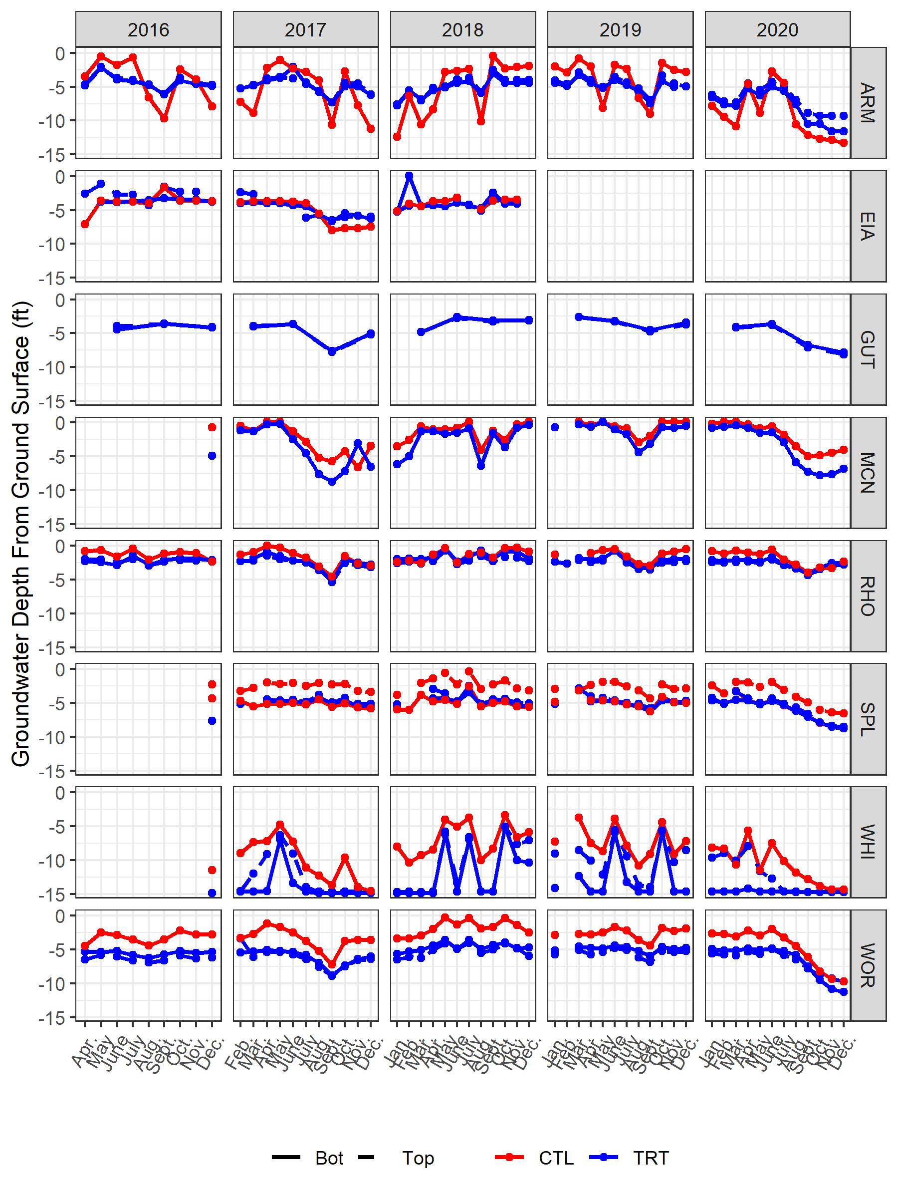
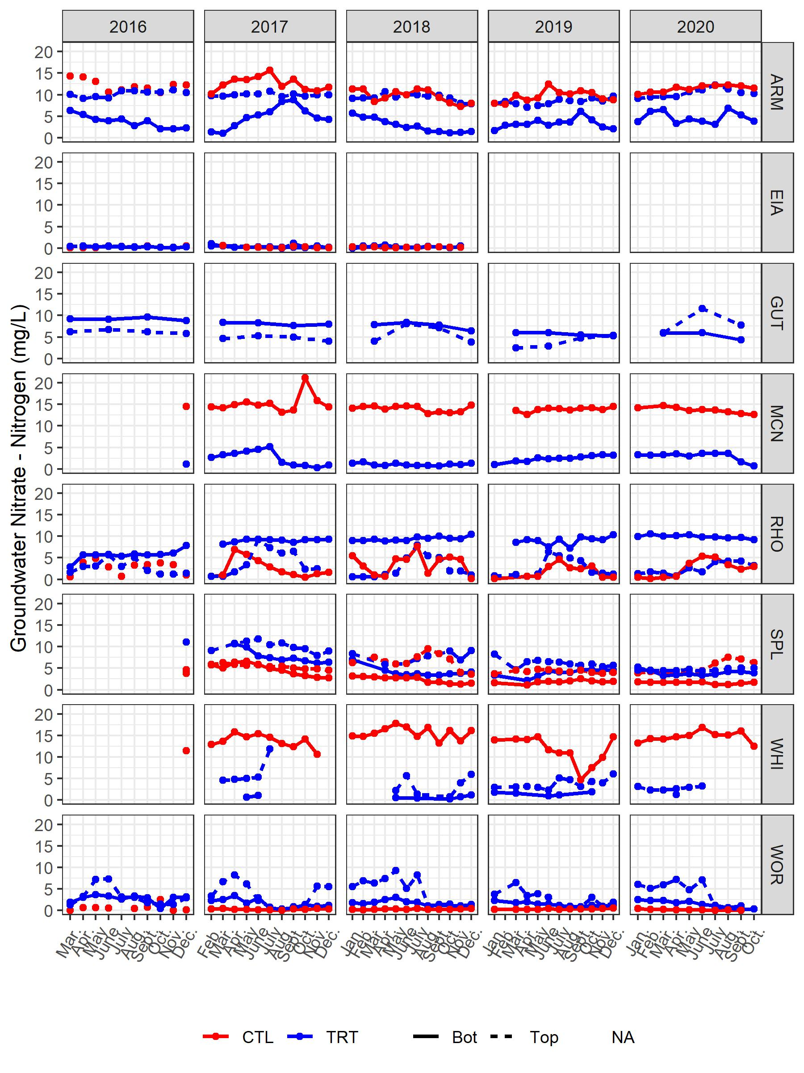
Runoff table for the Armstrong report:
 |  | Runoff (in.)
Year | Rain (in.) | Control | Treatment
2016 | 27 | 1.12 | 0.05
2017 | 24 | 0.67 | 0.06
2018 | 26 | 0.25 | 0.07
Nutrient export table for Armstrong 2018:
 | Nitrate (lbs/ac) |  | Orthophosphate (lbs/ac) |  | Total Suspended Solids (lbs/ac)
Year | Control | Treatment | Control | Treatment | Control | Treatment
2016 | 0.12 | 0.01 | 0.03 | 0 | 82.20 | 0.26
2017 | 0.21 | 0.00 | 0.02 | 0 | 52.53 | 0.24
2018 | 0.00 |  | 0.00 |  | 0.43
Runoff table for the Spirit Lake:
 |  | Runoff (in.)
Year | Rain (in.) | Control | Treatment
2016 | 7.7 | 0.14 | 0.0
2017 | 10.2 | 0.74 | 0.0
2018 | 17.4 | 1.45 | 1.8
Nutrient export table for Spirit Lake:
 | Nitrate (lbs/ac) |  | Total Suspended Solids (lbs/ac)
Year | Control | Treatment | Control | Treatment
2016 | 0.00 |  | 12
2017 | 0.02 |  | 52
2018 | 0.52 | 0.11 | 53 | 15

