Graphs and Tables for strips 2018
witte
January 7, 2019
This is the rain and runoff table for 2016:
 |  | Runoff (in.)
Site | Rain (in.) | Control | Treatment
Armstrong | 27.44 | 0.65 | 0.03
E. IA Airport | 31.54 | 3.49 | 2.88
Rhodes | 19.09 | 0.27 | 0.05
Spirit Lake | 7.66 | 0.07 | 0.00
Whiterock | 15.04 | 0.17 | 0.31
Worle | 24.49 | 0.33 | 0.57
This is the rain and runoff table for 2017:
 |  | Runoff (in.)
Site | Rain (in.) | Control | Treatment
Armstrong | 24.41 | 0.39 | 0.04
E. IA Airport | 11.14 | 0.00 | 0.00
Marshalltown | 17.80 | 0.09 | 0.84
McNay | 13.31 | 0.26 | 1.87
Rhodes | 19.13 | 0.54 | 0.10
Spirit Lake | 10.15 | 0.39 | 0.00
Whiterock | 19.49 | 0.90 | 0.33
Worle | 15.28 | 0.10 | 0.05
This is the rain and runoff table for 2018:
 |  | Runoff (in.)
Site | Rain (in.) | Control | Treatment
Armstrong | 26.50 | 0.14 | 0.05
E. IA Airport | 31.26 | 3.10 | 1.79
Marshalltown | 14.21 | 0.04 | 0.46
McNay | 23.06 | 0.57 | 4.89
Rhodes | 31.54 | 4.60 | 1.76
Spirit Lake | 17.44 | 0.77 | 0.78
Whiterock | 23.86 | 2.54 | 1.62
Worle | 15.63 | 0.93 | 1.04
This is the rain and runoff table for 2018 with site codes:
 |  | Runoff (in.)
Site | Rain (in.) | Control | Treatment
ARM | 26.50 | 0.14 | 0.05
EIA | 31.26 | 3.10 | 1.79
MAR | 14.21 | 0.04 | 0.46
MCN | 20.07 | 0.57 | 4.93
RHO | 31.54 | 4.60 | 1.76
SPL | 57.22 | 0.87 | 0.78
WHI | 23.86 | 2.54 | 1.62
WOR | 42.62 | 3.42 | 2.49
This is the rain and runoff table for 2019 with site codes:
 |  | Runoff (in.)
Site | Rain (in.) | Control | Treatment
ARM | 28.82 | 0.20 | 0.09
MAR | 22.38 | 0.15 | 0.41
MCN | 22.01 | 0.14 | 4.08
RHO | 22.48 | 2.15 | 0.65
WHI | 23.66 | 0.20 | 0.80
WOR | 25.16 | 0.46 | 0.75
This is the rain and runoff table for 2019 with site names:
 |  | Runoff (in.)
Site | Rain (in.) | Control | Treatment
Armstrong | 28.82 | 0.20 | 0.09
Marshalltown | 22.38 | 0.15 | 0.41
McNay | 22.01 | 0.14 | 4.08
Rhodes | 22.48 | 2.15 | 0.65
Whiterock | 23.66 | 0.20 | 0.80
Worle | 25.16 | 0.46 | 0.75
Here is the table summing the rain and runoff over the years 2016-present:
 |  | Runoff (in.)
Site | Rain (in.) | Control | Treatment
ARM | 107.17 | 1.38 | 0.21
EIA | 73.94 | 6.59 | 4.67
MAR | 54.39 | 0.28 | 1.71
MCN | 58.38 | 0.97 | 10.84
RHO | 92.24 | 7.56 | 2.56
SPL | 35.25 | 1.23 | 0.78
WHI | 82.05 | 3.81 | 3.06
WOR | 80.56 | 1.82 | 2.41
Here is the nutrient table from 2016:
 | Nitrate (lbs/ac) |  | Orthophosphate (lbs/ac) |  | Total Suspended Solids (lbs/ac)
Site | Control | Treatment | Control | Treatment | Control | Treatment
Armstrong | 0.07 | 0.00 | 0.02 | 0.00 | 48.02 | 0.17
E. IA Airport | 0.45 | 0.65 | 0.08 | 0.05 | 20.40 | 7.01
Rhodes | 0.13 | 0.00 | 0.00 | 0.00 | 10.15 | 0.18
Spirit Lake | 0.00 | NA | NA | NA | 6.49 | NA
Whiterock | 0.00 | NA | 0.00 | NA | 3.14 | NA
Worle | 0.00 | NA | 0.00 | NA | 3.40 | NA
Here is the nutrient table from 2017:
 | Nitrate (lbs/ac) |  | Orthophosphate (lbs/ac) |  | Total Suspended Solids (lbs/ac)
Site | Control | Treatment | Control | Treatment | Control | Treatment
Armstrong | 0.12 | 0.00 | 0.01 | 0.00 | 30.69 | 0.16
Marshalltown | 0.00 | 0.00 | 0.00 | 0.00 | 4.59 | 0.41
McNay | 0.48 | 5.60 | 0.03 | 0.05 | 41.74 | 69.96
Rhodes | 0.08 | 0.01 | 0.02 | 0.00 | 153.25 | 2.44
Spirit Lake | 0.01 | NA | NA | NA | 28.03 | NA
This is the nutrient loss table for 2018:
 | Nitrate (lbs/ac) |  | Orthophosphate (lbs/ac) |  | Total Suspended Solids (lbs/ac)
Site | Control | Treatment | Control | Treatment | Control | Treatment
Armstrong | 0.00 | NA | 0.00 | NA | 0.43 | NA
E. IA Airport | 0.36 | 0.06 | 0.05 | 0.03 | 22.77 | 69.47
Marshalltown | 0.00 | NA | 0.00 | NA | 0.06 | NA
McNay | 0.02 | 0.27 | 0.03 | 0.13 | 8.99 | 107.82
Rhodes | 0.17 | 0.64 | 0.24 | 0.07 | 106.95 | 33.88
Spirit Lake | 0.52 | 0.11 | NA | NA | 53.12 | 15.20
Whiterock | 0.00 | 0.19 | 0.02 | 0.03 | 113.54 | 48.04
Worle | 0.17 | 0.16 | 0.06 | 0.05 | 74.70 | 110.40
This is the nutrient loss table for 2018 with site codes instead of full names:
 | Nitrate-N (lbs/ac) |  | Orthophosphate (lbs/ac) |  | Total Suspended Solids (lbs/ac)
Site | Control | Treatment | Control | Treatment | Control | Treatment
ARM | 0.00 | NA | 0.00 | NA | 0.43 | NA
EIA | 0.36 | 0.06 | 0.05 | 0.03 | 22.77 | 69.47
MAR | 0.00 | NA | 0.00 | NA | 0.06 | NA
MCN | 0.02 | 0.28 | 0.03 | 0.14 | 8.99 | 107.85
RHO | 0.17 | 0.64 | 0.24 | 0.07 | 106.95 | 33.88
SPL | 0.52 | 0.11 | NA | NA | 52.67 | 15.20
WHI | 0.00 | 0.19 | 0.02 | 0.03 | 113.54 | 48.04
WOR | 0.17 | 0.17 | 0.06 | 0.05 | 74.73 | 111.16
This is the nutrient loss table for 2019 with site full names:
 | Nitrate-N (lbs/ac) |  | Orthophosphate (lbs/ac) |  | Total Suspended Solids (lbs/ac)
Site | Control | Treatment | Control | Treatment | Control | Treatment
Armstrong | 0.01 | 0.01 | 0.01 | 0.00 | 22.26 | 0.39
Marshalltown | 0.00 | 0.04 | 0.00 | 0.01 | 11.32 | 42.51
McNay | 0.17 | 3.20 | 0.02 | 0.29 | 26.67 | 321.77
Rhodes | 0.30 | 0.11 | 0.08 | 0.05 | 945.30 | 452.29
Whiterock | 0.00 | 0.02 | 0.00 | 0.02 | 3.97 | 23.00
Worle | 0.06 | 0.08 | 0.01 | 0.01 | 43.33 | 70.06
This is the nutrient loss table for 2019 with site codes instead of full names:
 | Nitrate-N (lbs/ac) |  | Orthophosphate (lbs/ac) |  | Total Suspended Solids (lbs/ac)
Site | Control | Treatment | Control | Treatment | Control | Treatment
ARM | 0.01 | 0.01 | 0.01 | 0.00 | 22.26 | 0.39
MAR | 0.00 | 0.04 | 0.00 | 0.01 | 11.32 | 42.51
MCN | 0.17 | 3.20 | 0.02 | 0.29 | 26.67 | 321.77
RHO | 0.30 | 0.11 | 0.08 | 0.05 | 945.30 | 452.29
WHI | 0.00 | 0.02 | 0.00 | 0.02 | 3.97 | 23.00
WOR | 0.06 | 0.08 | 0.01 | 0.01 | 43.33 | 70.06
This is a table of the cumulative nutrient losses for 2016-present:
 | Nitrate-N (lbs/ac) |  | Orthophosphate (lbs/ac) |  | Total Suspended Solids (lbs/ac)
Site | Control | Treatment | Control | Treatment | Control | Treatment
ARM | 0.20 | 0.01 | 0.04 | 0.00 | 101.00 | 1.00
EIA | 0.81 | 0.71 | 0.13 | 0.08 | 43.00 | 76.00
MAR | 0.00 | 0.04 | 0.00 | 0.01 | 16.00 | 43.00
MCN | 0.67 | 9.08 | 0.08 | 0.48 | 77.00 | 500.00
RHO | 0.68 | 0.76 | 0.34 | 0.12 | 1,216.00 | 489.00
SPL | 0.53 | 0.11 | 0.00 | 0.00 | 87.00 | 15.00
WHI | 0.00 | 0.21 | 0.02 | 0.05 | 121.00 | 71.00
WOR | 0.23 | 0.25 | 0.07 | 0.06 | 121.00 | 181.00
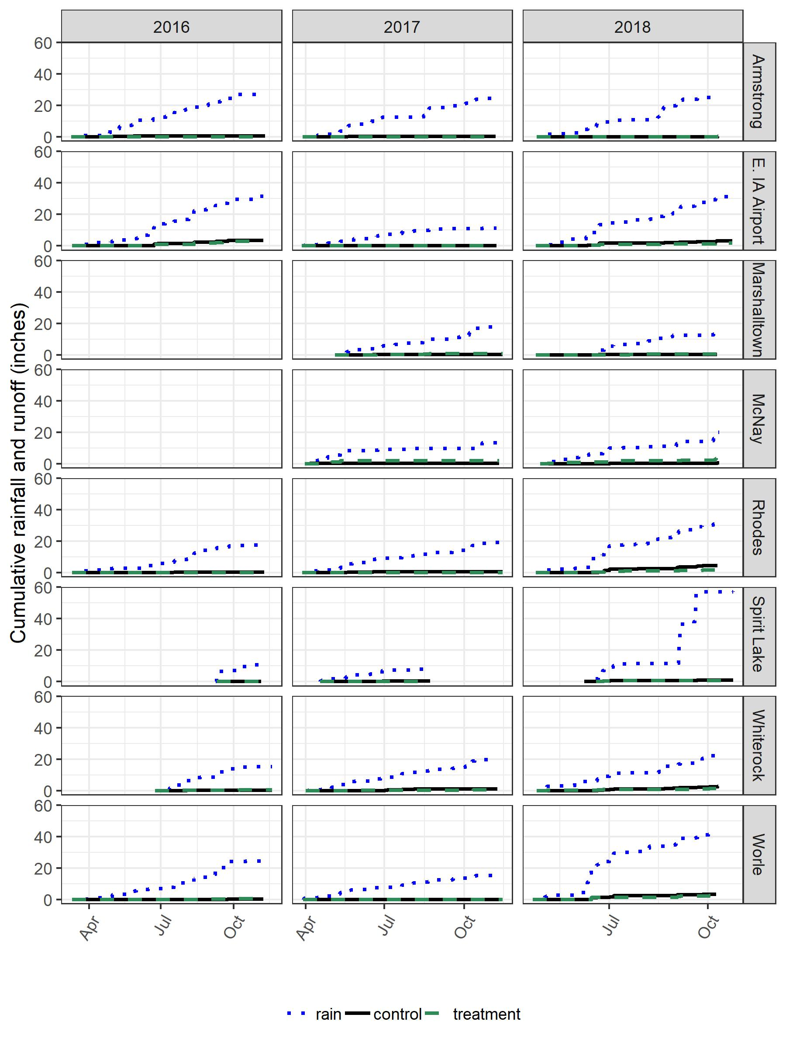
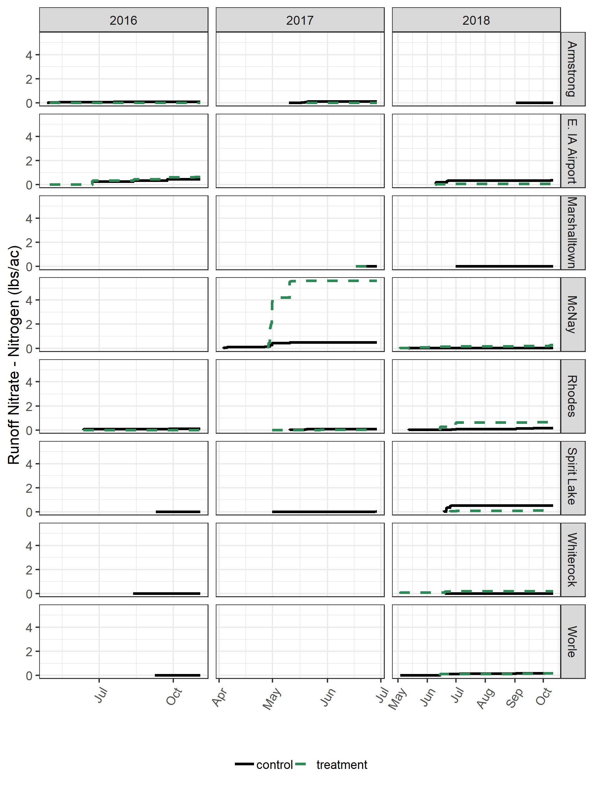
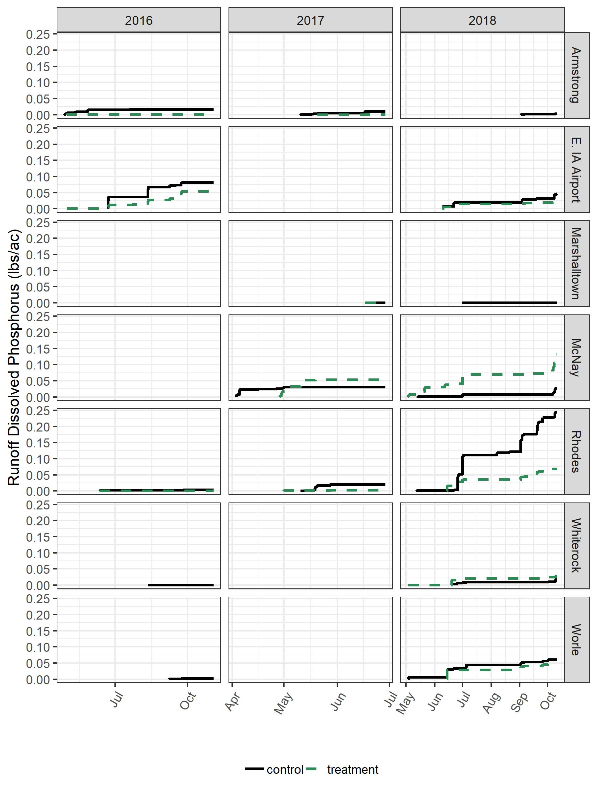
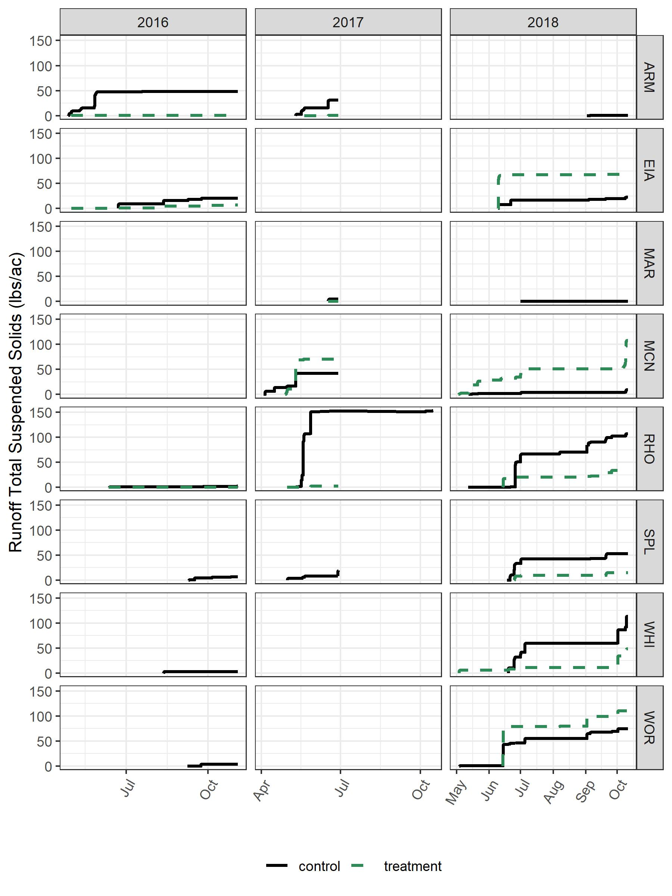
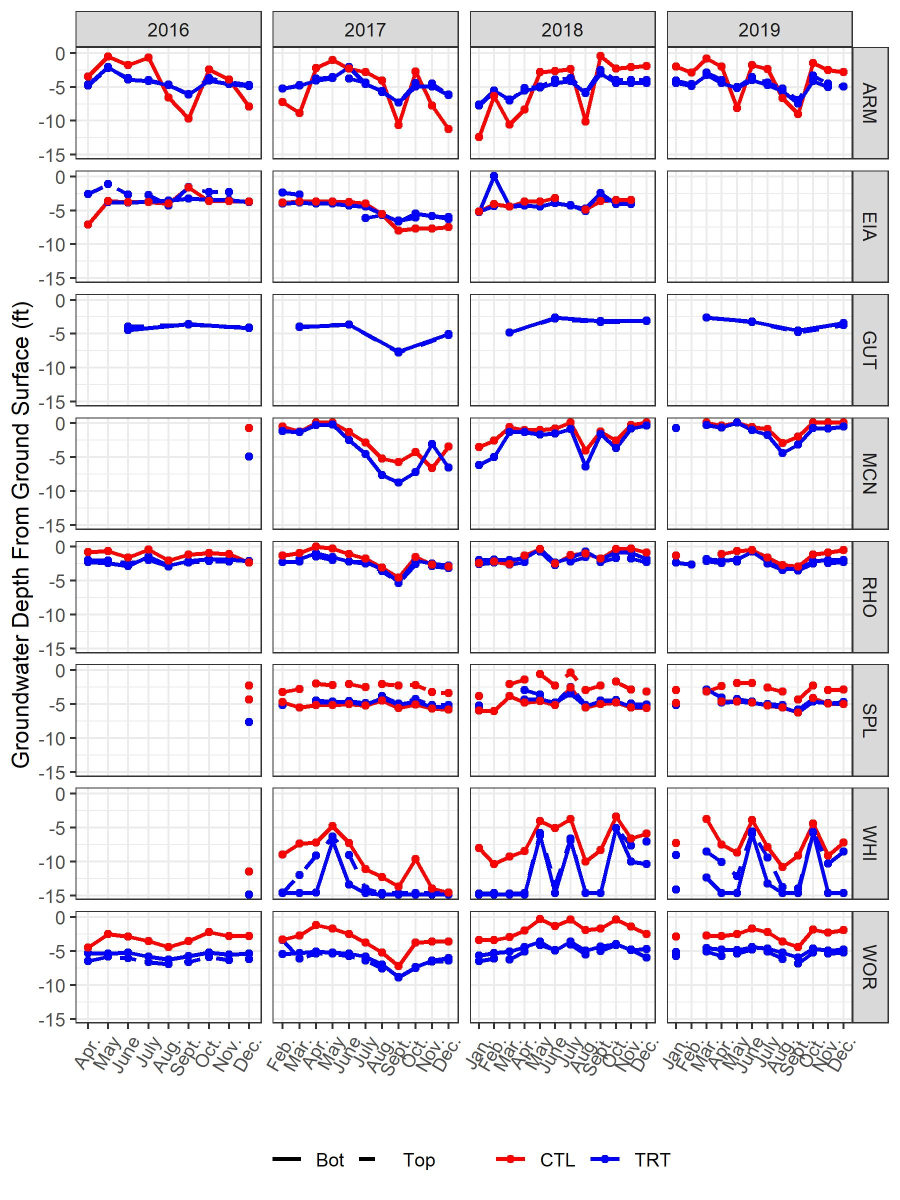
Runoff table for the Armstrong report:
 |  | Runoff (in.)
Year | Rain (in.) | Control | Treatment
2016 | 27.44 | 0.65 | 0.03
2017 | 24.41 | 0.39 | 0.04
2018 | 26.50 | 0.14 | 0.05
Nutrient export table for Armstrong 2018:
 | Nitrate (lbs/ac) |  | Orthophosphate (lbs/ac) |  | Total Suspended Solids (lbs/ac)
Year | Control | Treatment | Control | Treatment | Control | Treatment
2016 | 0.07 | 0.00 | 0.02 | 0.00 | 48.02 | 0.17
2017 | 0.12 | 0.00 | 0.01 | 0.00 | 30.69 | 0.16
2018 | 0.00 | NA | 0.00 | NA | 0.43 | NA
Runoff table for the Spirit Lake:
 |  | Runoff (in.)
Year | Rain (in.) | Control | Treatment
2016 | 7.66 | 0.07 | 0.00
2017 | 10.15 | 0.39 | 0.00
2018 | 17.44 | 0.77 | 0.78
Nutrient export table for Spirit Lake:
 | Nitrate (lbs/ac) |  | Total Suspended Solids (lbs/ac)
Year | Control | Treatment | Control | Treatment
2016 | 0.00 | NA | 6.49 | NA
2017 | 0.01 | NA | 28.03 | NA
2018 | 0.52 | 0.11 | 53.12 | 15.20

