tablesforstrips2018
witte
January 4, 2019
## Loading required package: knitr
## Warning: package 'knitr' was built under R version 3.4.4
## Loading required package: kableExtra
## Warning: package 'kableExtra' was built under R version 3.4.4
## Loading required package: dplyr
## Warning: package 'dplyr' was built under R version 3.4.4
##
## Attaching package: 'dplyr'
## The following objects are masked from 'package:stats':
##
## filter, lag
## The following objects are masked from 'package:base':
##
## intersect, setdiff, setequal, union
Runoff
Site
Rain
Control
Treatment
Armstrong
27.44
0.65
0.05
E. IA Airport
31.54
3.49
2.88
Marshalltown
17.80
0.09
0.84
McNay
16.89
0.56
4.87
Rhodes
31.54
4.60
1.76
Spirit Lake
11.85
0.58
0.55
Whiterock
23.86
2.54
1.62
Worle
28.58
3.41
2.49

Including Plots
You can also embed plots, for example:
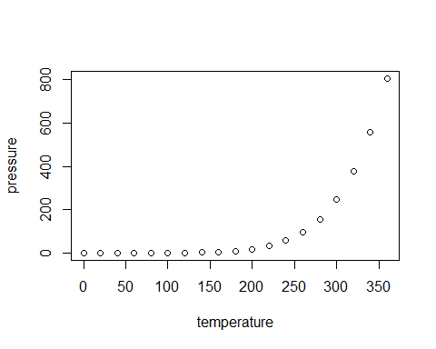
Note that the echo = FALSE parameter was added to the code chunk to prevent printing of the R code that generated the plot.

