Graphs and Tables for strips 2018
witte
January 7, 2019
This is the rain and runoff table for 2016:
 |  | Runoff (in.)
Site | Rain (in.) | Control | Treatment
Armstrong | 27.44 | 0.65 | 0.03
E. IA Airport | 31.54 | 3.49 | 2.88
Rhodes | 17.95 | 0.19 | 0.05
Spirit Lake | 10.56 | 0.07 | 0.00
Whiterock | 15.04 | 0.17 | 0.31
Worle | 24.49 | 0.33 | 0.57
This is the rain and runoff table for 2017:
 |  | Runoff (in.)
Site | Rain (in.) | Control | Treatment
Armstrong | 24.41 | 0.39 | 0.04
E. IA Airport | 11.14 | 0.00 | 0.00
Marshalltown | 17.80 | 0.09 | 0.84
McNay | 13.31 | 0.26 | 1.87
Rhodes | 19.13 | 0.54 | 0.10
Spirit Lake | 7.83 | 0.38 | 0.00
Whiterock | 19.49 | 0.90 | 0.33
Worle | 15.28 | 0.10 | 0.05
This is the rain and runoff table for 2018:
 |  | Runoff (in.)
Site | Rain (in.) | Control | Treatment
Armstrong | 26.50 | 0.14 | 0.05
E. IA Airport | 31.26 | 3.10 | 1.79
Marshalltown | 14.21 | 0.04 | 0.46
McNay | 20.07 | 0.57 | 4.93
Rhodes | 31.54 | 4.60 | 1.76
Spirit Lake | 57.22 | 0.87 | 0.78
Whiterock | 23.86 | 2.54 | 1.62
Worle | 42.62 | 3.42 | 2.49
This is the rain and runoff table for 2018 with site codes:
 |  | Runoff (in.)
Site | Rain (in.) | Control | Treatment
ARM | 26.50 | 0.14 | 0.05
EIA | 31.26 | 3.10 | 1.79
MAR | 14.21 | 0.04 | 0.46
MCN | 20.07 | 0.57 | 4.93
RHO | 31.54 | 4.60 | 1.76
SPL | 57.22 | 0.87 | 0.78
WHI | 23.86 | 2.54 | 1.62
WOR | 42.62 | 3.42 | 2.49
This is the rain and runoff table for 2019 with site codes:
 |  | Runoff (in.)
Site | Rain (in.) | Control | Treatment
ARM | 13.23 | 0.05 | 0.06
MAR | 10.79 | 0.15 | 0.34
MCN | 12.60 | 0.13 | 3.14
RHO | 12.91 | 1.65 | 0.50
WHI | 5.12 | 0.00 | 0.01
WOR | 13.39 | 0.45 | 0.72
Here is the nutrient table from 2016:
 | Nitrate (lbs/ac) |  | Orthophosphate (lbs/ac) |  | Total Suspended Solids (lbs/ac)
Site | Control | Treatment | Control | Treatment | Control | Treatment
Armstrong | 0.07 | 0.00 | 0.02 | 0.00 | 48.02 | 0.17
E. IA Airport | 0.45 | 0.65 | 0.08 | 0.05 | 20.40 | 7.01
Rhodes | 0.11 | 0.00 | 0.00 | 0.00 | 2.01 | 0.18
Spirit Lake | 0.00 | NA | NA | NA | 6.49 | NA
Whiterock | 0.00 | NA | 0.00 | NA | 3.14 | NA
Worle | 0.00 | NA | 0.00 | NA | 3.40 | NA
Here is the nutrient table from 2017:
 | Nitrate (lbs/ac) |  | Orthophosphate (lbs/ac) |  | Total Suspended Solids (lbs/ac)
Site | Control | Treatment | Control | Treatment | Control | Treatment
Armstrong | 0.12 | 0.00 | 0.01 | 0.00 | 30.69 | 0.16
Marshalltown | 0.00 | 0.00 | 0.00 | 0.00 | 4.59 | 0.41
McNay | 0.48 | 5.60 | 0.03 | 0.05 | 41.74 | 69.96
Rhodes | 0.08 | 0.01 | 0.02 | 0.00 | 153.25 | 2.44
Spirit Lake | 0.01 | NA | NA | NA | 19.00 | NA
This is the nutrient loss table for 2018:
 | Nitrate (lbs/ac) |  | Orthophosphate (lbs/ac) |  | Total Suspended Solids (lbs/ac)
Site | Control | Treatment | Control | Treatment | Control | Treatment
Armstrong | 0.00 | NA | 0.00 | NA | 0.43 | NA
E. IA Airport | 0.36 | 0.06 | 0.05 | 0.03 | 22.77 | 69.47
Marshalltown | 0.00 | NA | 0.00 | NA | 0.06 | NA
McNay | 0.02 | 0.27 | 0.03 | 0.13 | 8.99 | 107.82
Rhodes | 0.17 | 0.64 | 0.24 | 0.07 | 106.95 | 33.88
Spirit Lake | 0.52 | 0.11 | NA | NA | 53.12 | 15.20
Whiterock | 0.00 | 0.19 | 0.02 | 0.03 | 113.54 | 48.04
Worle | 0.17 | 0.16 | 0.06 | 0.05 | 74.70 | 110.40
This is the nutrient loss table for 2018 with site codes instead of full names:
 | Nitrate-N (lbs/ac) |  | Orthophosphate (lbs/ac) |  | Total Suspended Solids (lbs/ac)
Site | Control | Treatment | Control | Treatment | Control | Treatment
ARM | 0.00 | NA | 0.00 | NA | 0.43 | NA
EIA | 0.36 | 0.06 | 0.05 | 0.03 | 22.77 | 69.47
MAR | 0.00 | NA | 0.00 | NA | 0.06 | NA
MCN | 0.02 | 0.27 | 0.03 | 0.13 | 8.99 | 107.82
RHO | 0.17 | 0.64 | 0.24 | 0.07 | 106.95 | 33.88
SPL | 0.52 | 0.11 | NA | NA | 53.12 | 15.20
WHI | 0.00 | 0.19 | 0.02 | 0.03 | 113.54 | 48.04
WOR | 0.17 | 0.16 | 0.06 | 0.05 | 74.70 | 110.40
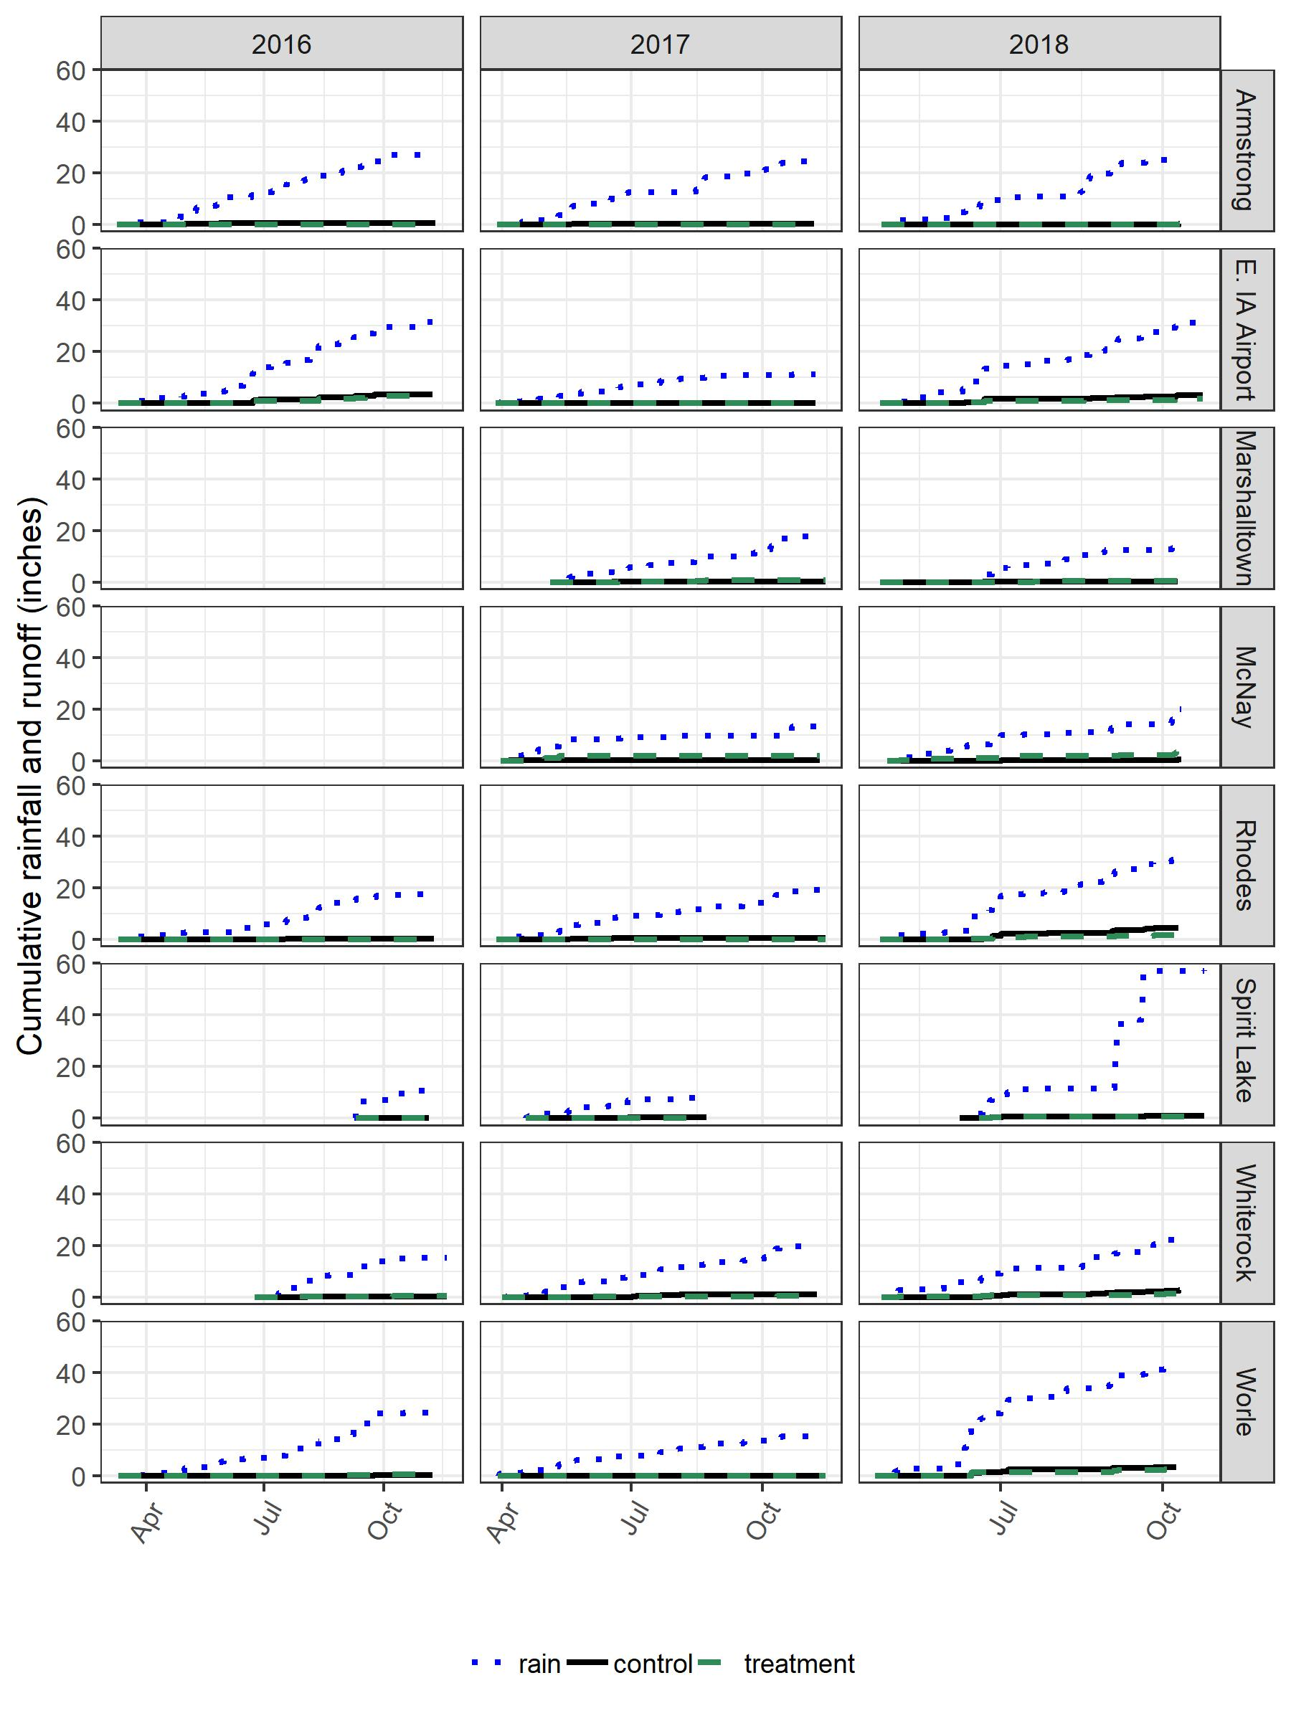
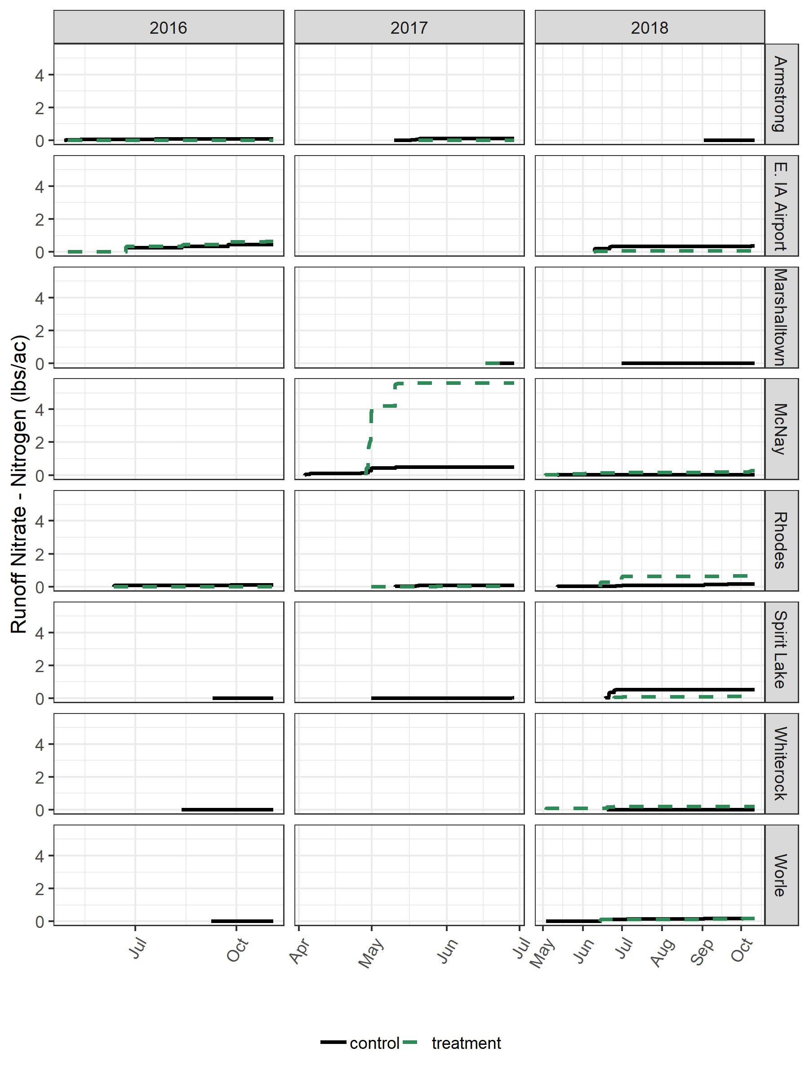
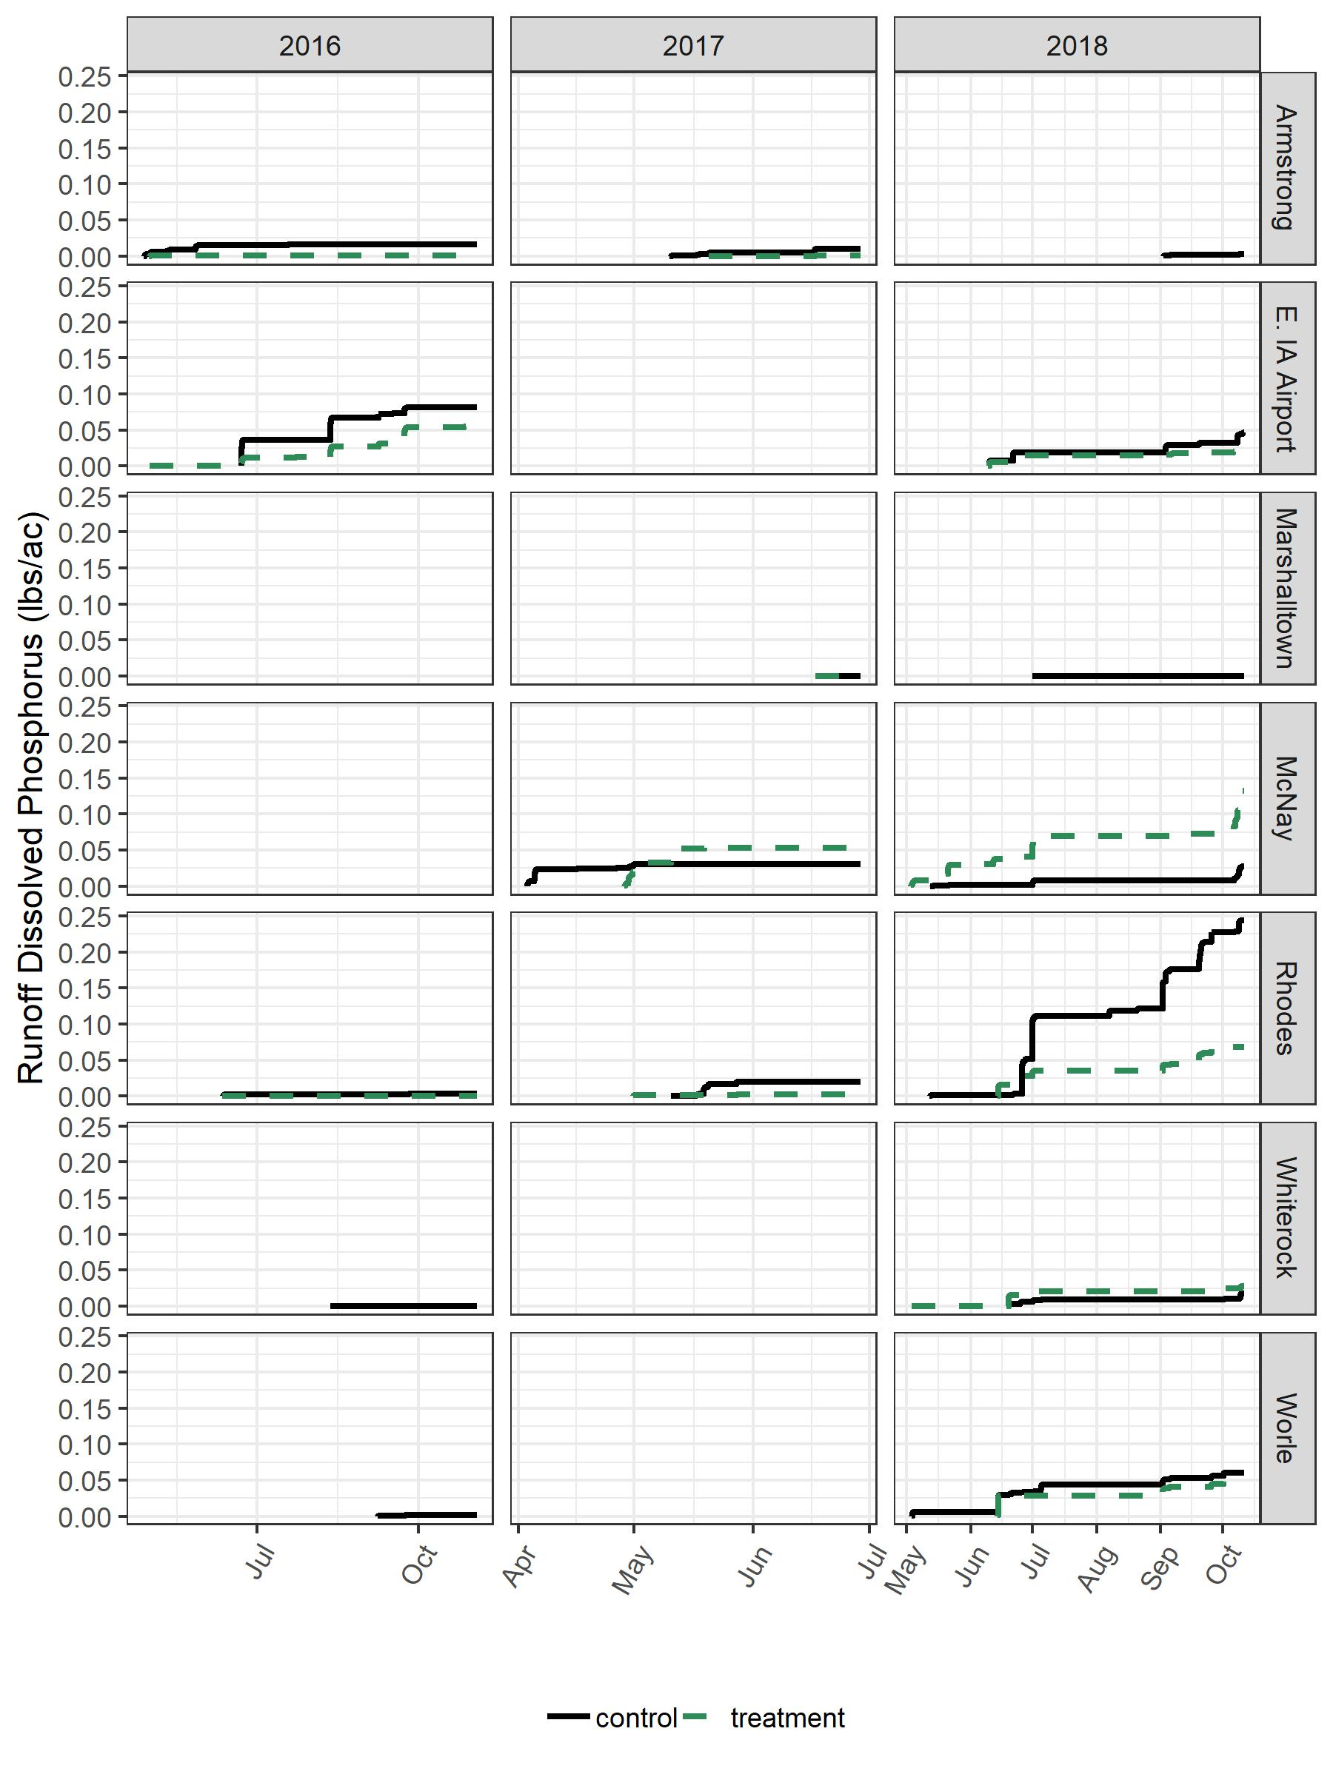
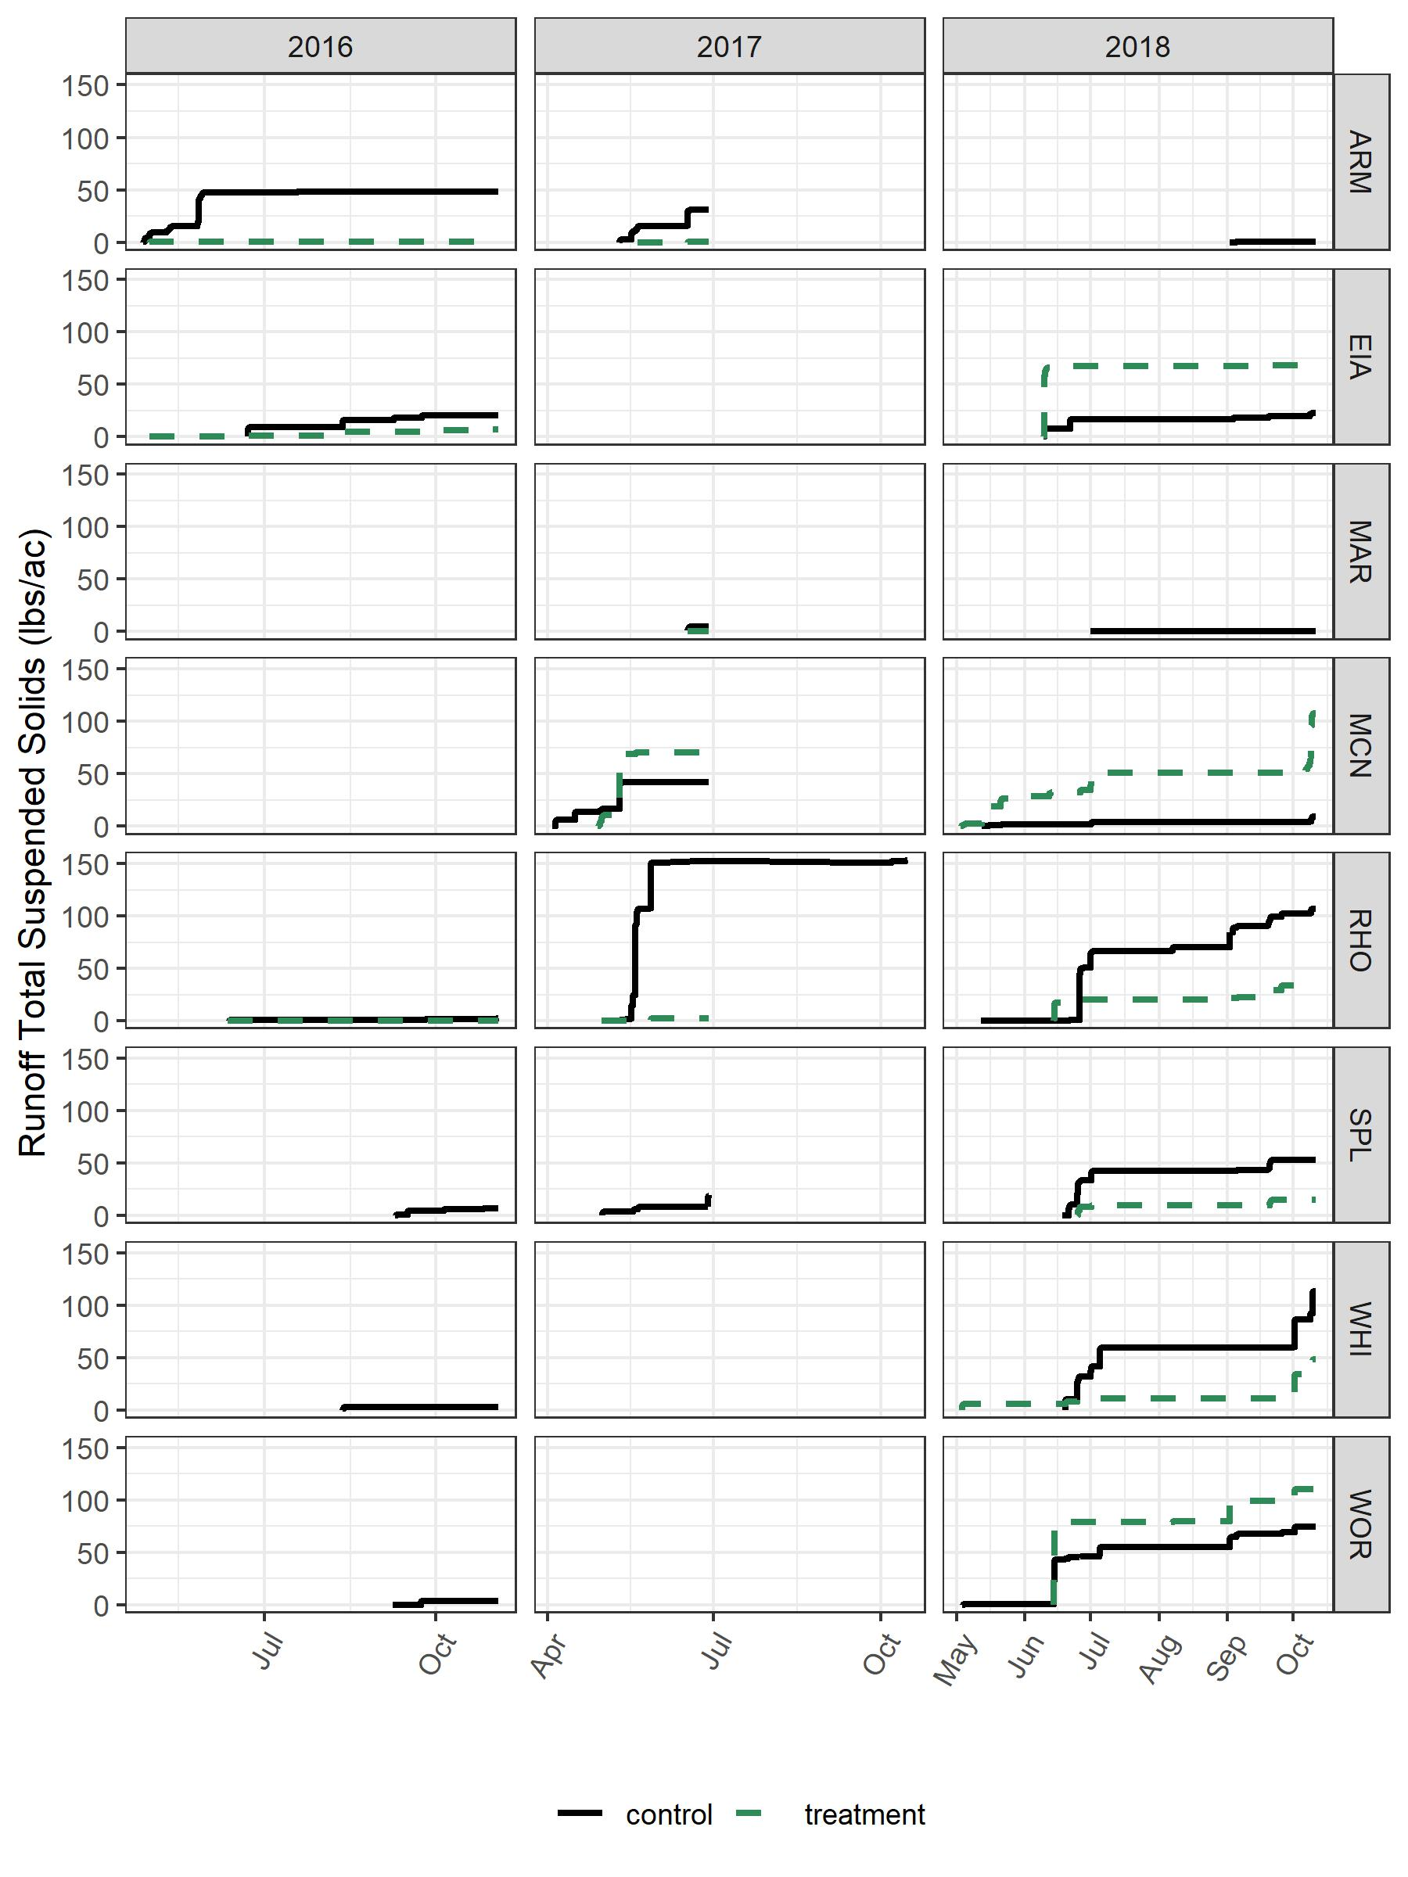
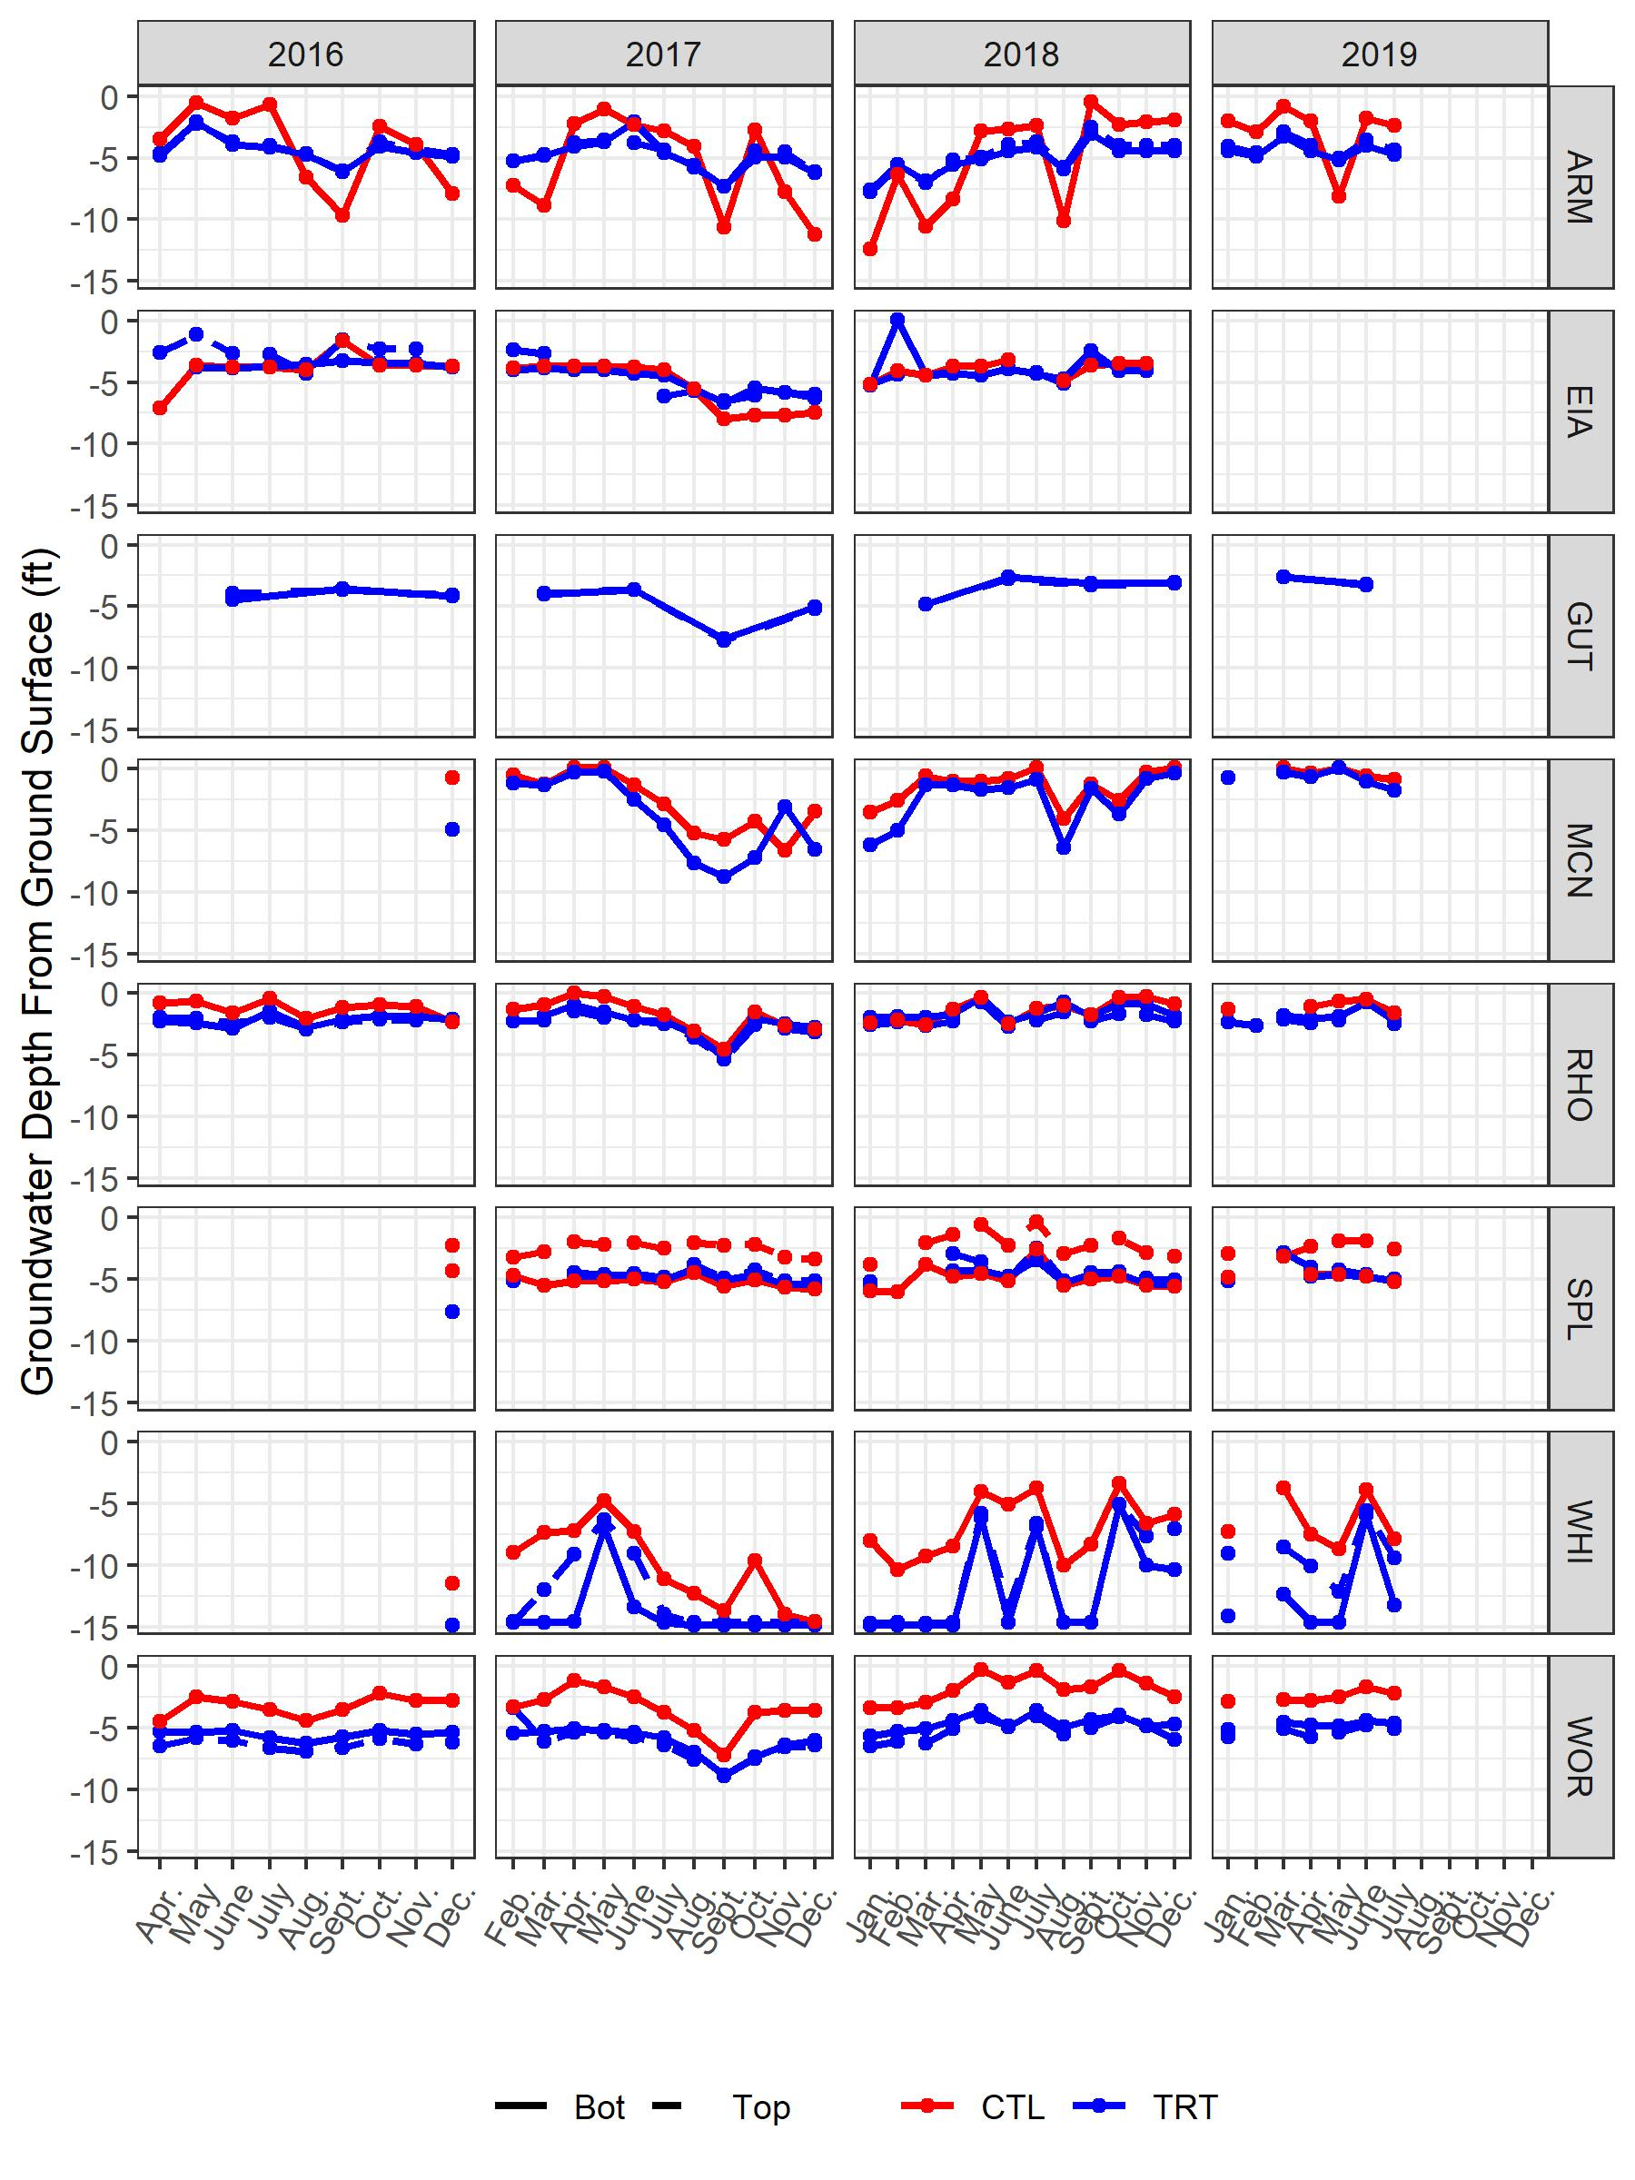
Runoff table for the Armstrong report:
 |  | Runoff (in.)
Year | Rain (in.) | Control | Treatment
2016 | 27.44 | 0.65 | 0.03
2017 | 24.41 | 0.39 | 0.04
2018 | 26.50 | 0.14 | 0.05
Nutrient export table for Armstrong 2018:
 | Nitrate (lbs/ac) |  | Orthophosphate (lbs/ac) |  | Total Suspended Solids (lbs/ac)
Year | Control | Treatment | Control | Treatment | Control | Treatment
2016 | 0.07 | 0.00 | 0.02 | 0.00 | 48.02 | 0.17
2017 | 0.12 | 0.00 | 0.01 | 0.00 | 30.69 | 0.16
2018 | 0.00 | NA | 0.00 | NA | 0.43 | NA
Runoff table for the Spirit Lake:
 |  | Runoff (in.)
Year | Rain (in.) | Control | Treatment
2016 | 10.56 | 0.07 | 0.00
2017 | 7.83 | 0.38 | 0.00
2018 | 57.22 | 0.87 | 0.78
Nutrient export table for Spirit Lake:
 | Nitrate (lbs/ac) |  | Total Suspended Solids (lbs/ac)
Year | Control | Treatment | Control | Treatment
2016 | 0.00 | NA | 6.49 | NA
2017 | 0.01 | NA | 19.00 | NA
2018 | 0.52 | 0.11 | 53.12 | 15.20

