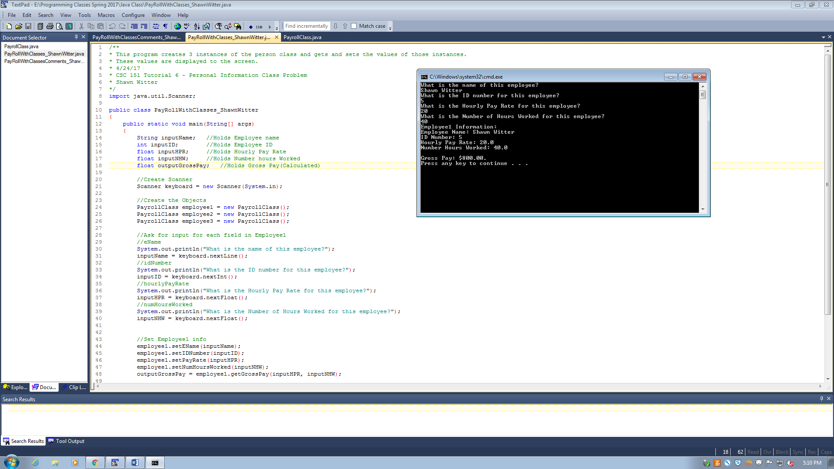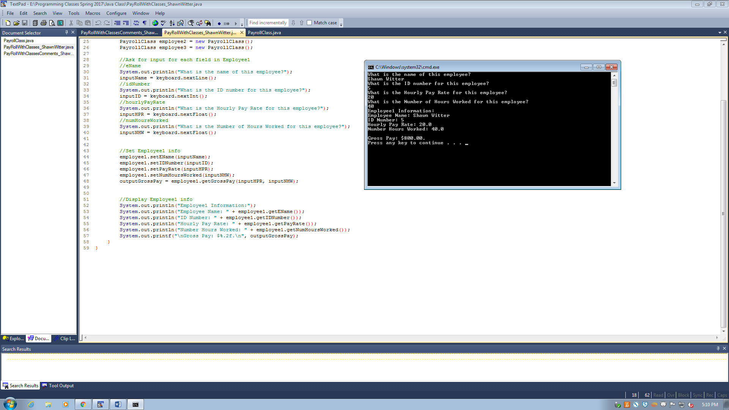

PayrollClass

|  |
| --- |
| PayrollClass |
| * eName: String * idNumber: int * hourlyPayRate : float * numHoursWorked : float |
| + PayrollClass(String: employeeName, int : IDNumber)  + setEName(String employeeName) : void  + setIDNumber(int IDNumber): void  +setPayRate(float PayRate): void  +setNumHoursWorked(float numberHoursWorked): String  +getEName(): String  +getIDNumber(): int  + getPayRate(): float  + getNumHoursWorked(): float |

