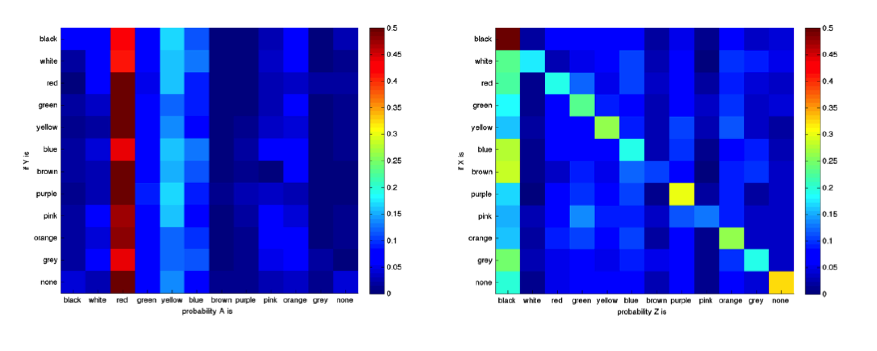

Figure x: Color category of letter matches shows a large amount of independence between letters. Right panel shows the probability of A being each color category given the color category assigned to Y (maybe the axes should be flipped?). In this case the probability A is a given color does not depend very much on Y. Right panel shows an example where there is a bias for Z to be black regardless of the color for X, however there is an additional tendency for X and Z to be the same color.