Supplement for Witthoft et al, Regularities in Grapheme-Color Synesthesia

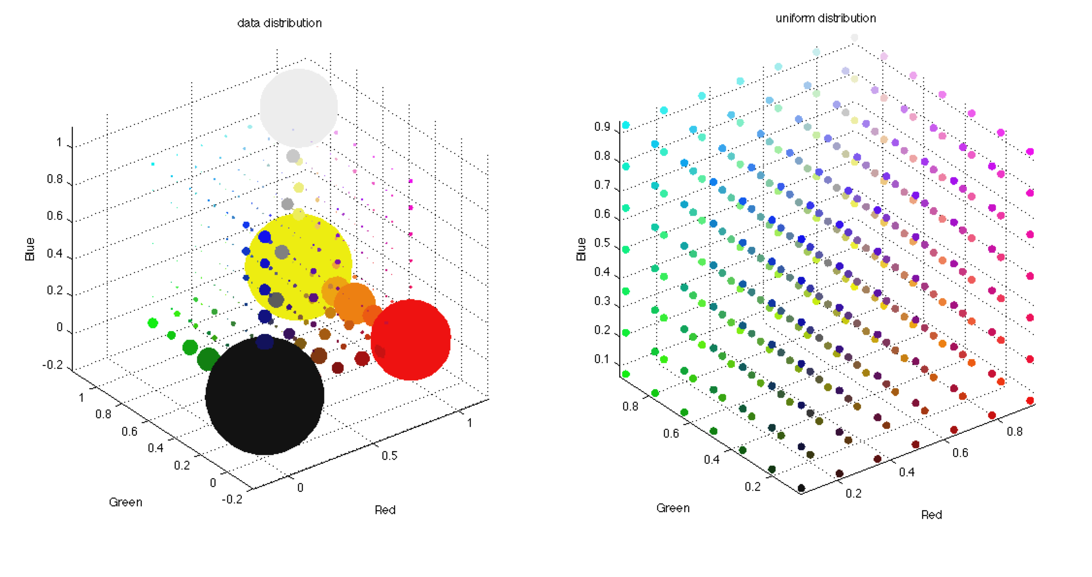

**Figure 1.** **Synesthetes letter-color matches do not sample RGB space uniformly.** Left panel shows data from 160,000+ matches. Circumference of bubbles are scaled to the proportion of matches in each equally sized region of the space. Right panel shows what data would look like if sampled in a random uniform fashion with same scaling for bubbles. Note that scaling by circumference exaggerates the volumes.

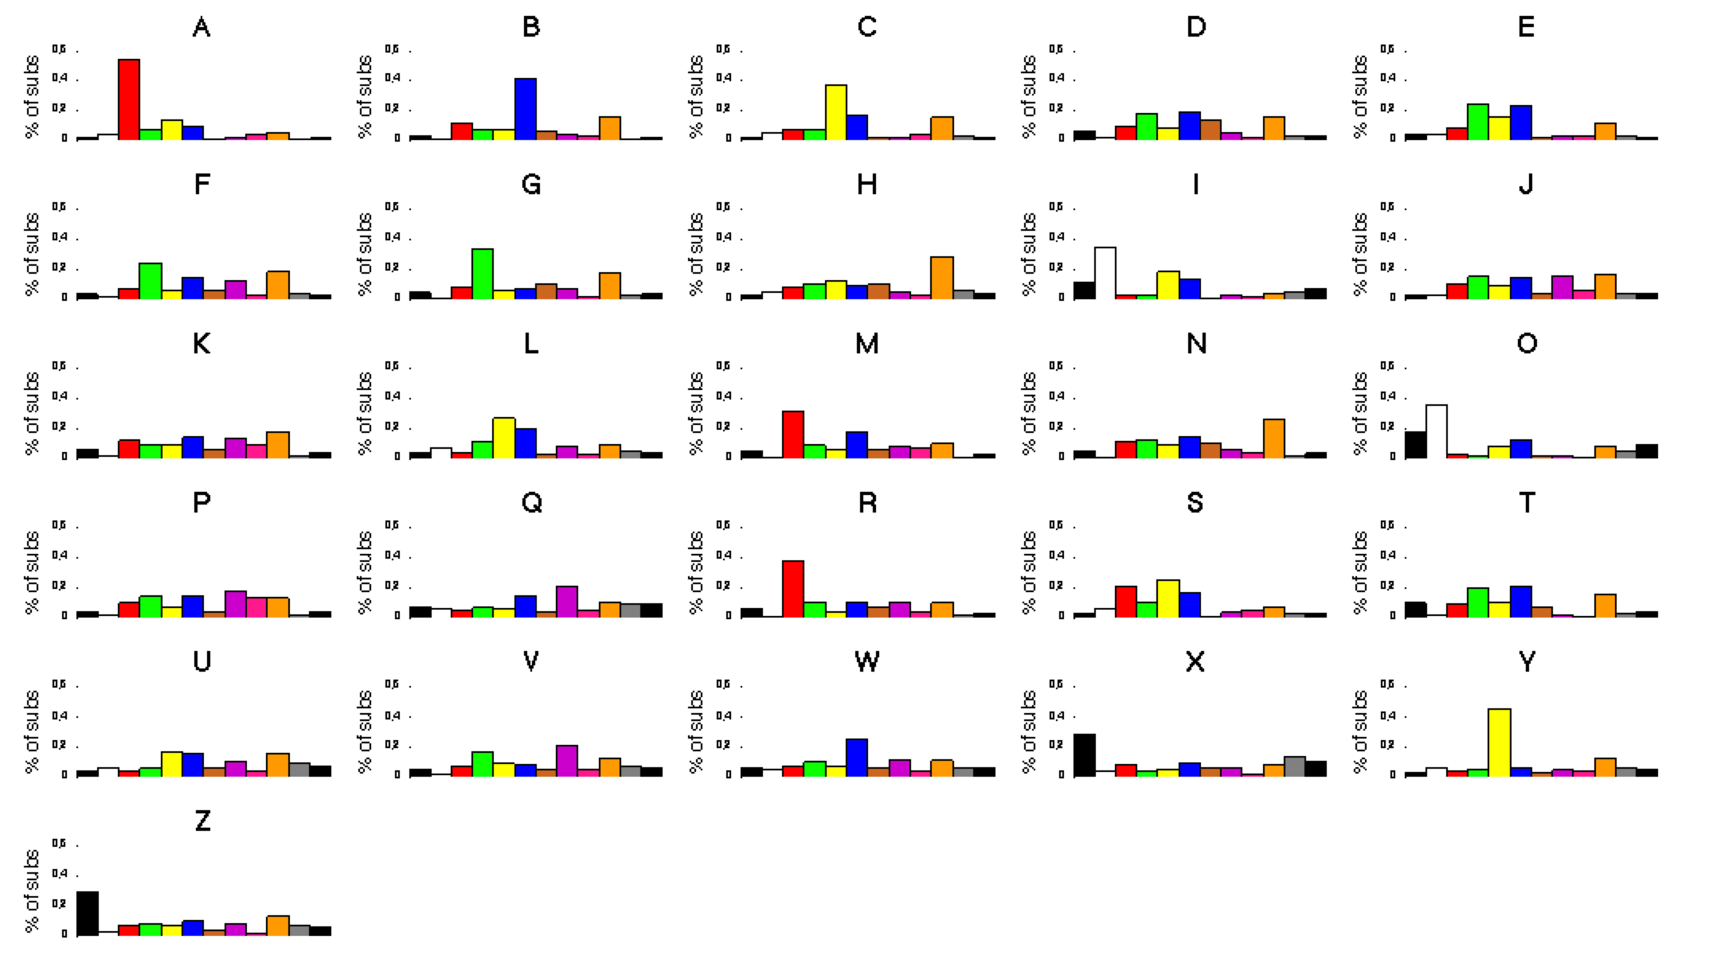

**Figure 2: Distributions of color choices for each letter are not random uniform.** Plot shows % of times a particular color category is chosen for each letter from entire data set. In many cases there is an obvious environmental source for the choice (eg Y is always yellow).

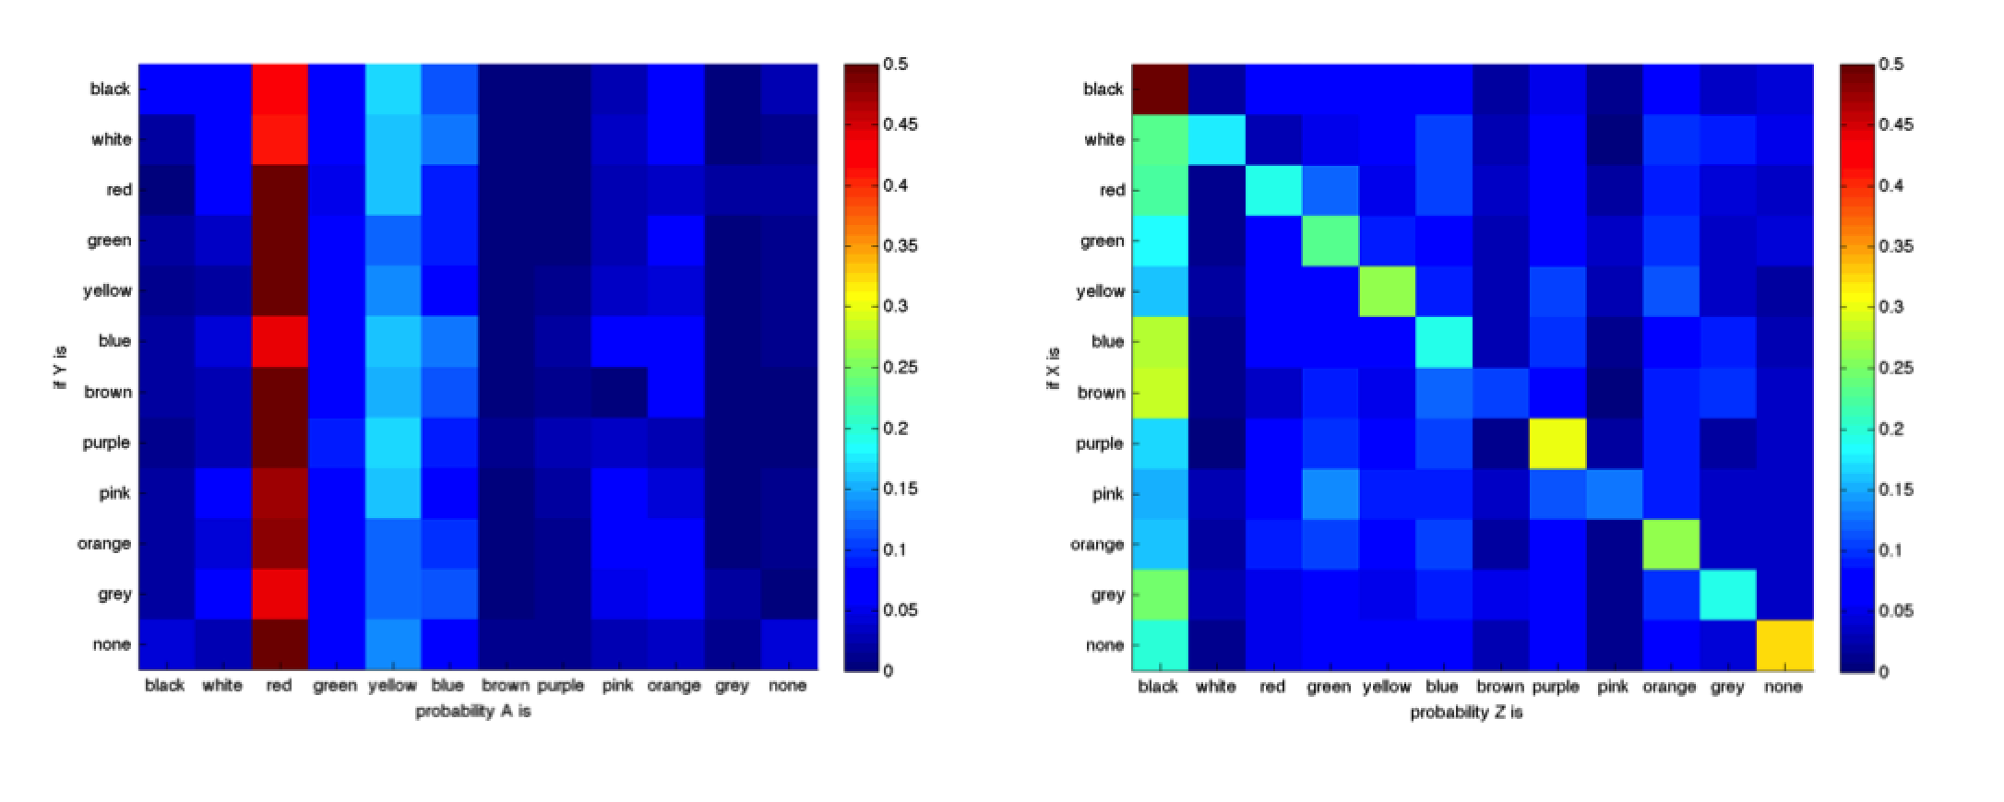

**Figure 3: Color category of letter matches shows a large amount of independence between letters.** Right panel shows the probability of A being each color category given the color category assigned to Y. In this case the probability A is a given color does not depend very much on color choice for Y. Right panel shows an example where there is a bias for Z to be black regardless of the color for X, however there is an additional tendency for X and Z to be the same color.

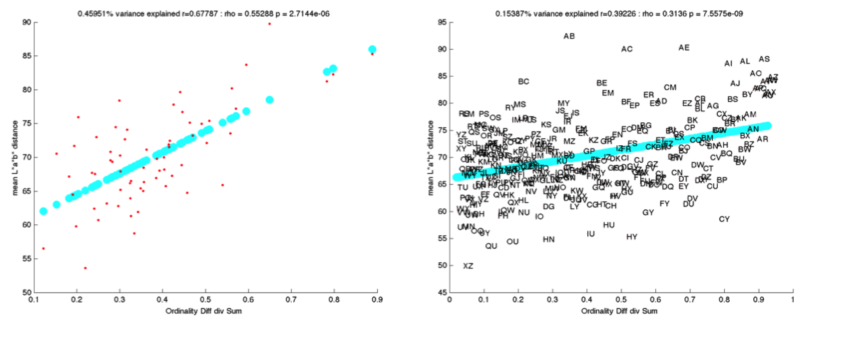

**Figure 4: Distance between average color matches can be predicted from environmental features.** MedianCIEL*a*b* distance between letter pairs averaged across subjects is predicted by how far apart the letter pairs are in the alphabet. This is consistent with previous observations by Watson et al (2012), but with much reduced amount of variance explained, as letter pairs are not avveraged together. Environmental influences are only very weakly apparent at the individual subject level (analyis not shown).