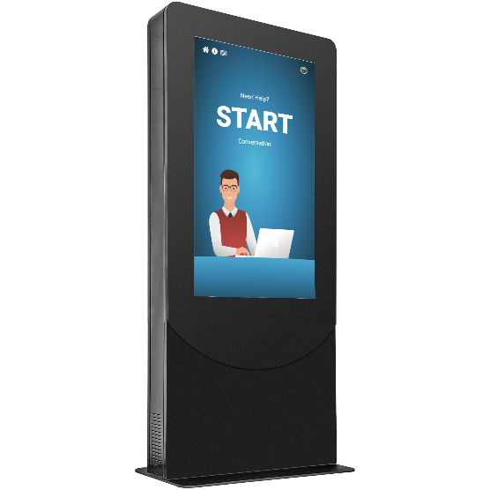Smart Receptionist

The smart and cost-effective solution to guide visitors on premises.

Wittykiosk provides a customized kiosk solution with advanced software that interacts with your visitors using **conversational voice interfac**e. It's easy to ask a question, get directions, or get connected with companies.

How does it work?

It is an kiosk-like device with voice control, touch screen, camera, speakers and ticket printer, that has been tailored for the use of big **office centres**.

Visitors can contact desired companies via full **HD video calls** and representatives can allow or deny access to the offices.

People also can **ask information** about toilets, lifts on premises/nearby cafes and restaurants, parking, etc.

And all of that is achieved using conversational voice interface - it is just like a real person. Also, there is a backup option to just use a **touch-based menu** to navigate the system.

|  |  |
| --- | --- |
| Product Features   * Voice recognition * Face detection * Touch screen * Video calls * Visitor control * Ticket printer * Multi-language * Text-to-speech | Cost  One kiosk hardware: 4000 EUR  Set up fee: from 2000 EUR  Monthly subscription: from 300 EUR |