

Practical Lab Book MCA 2025-2026 SEM I
Subject – Internet Of Things

Submitted by- Guided By-
SRN:31242488
Tushar Betala Dr. Bharati Pandurang Kawade

INDEX -1

Sr.  No. | Problem Statement | Signature
01 | To interface Light Emitting Djode(LED)- Blinking LED.
02 | To interface Button and LED – LED blinking when button is pressed.
03 | To interface a PIR Sensor with Arduino to Drive an LED Indicator.
04 | To use the DHT11 temperature & humidity sensor with Arduino.
05 | To interface the LM35 temperature sensor with Arduino.  .
06 | To interface the Traffic Signal Simulation with Arduino.
07 | To interface the Ultrasonic Sensor with Arduino.
08 | To interface 7 segments step by step in Arduino.
09 | To interface a 4×4 matrix keypad with Arduino and develop a program to detect and display the pressed key using the serial monitor.
10 | To interface an LCD display with Arduino.

Practical 1
- To interface Light Emitting Diode(LED)- Blinking LED.
Code:
const int ledPin = 13; // Pin connected to the LED
void setup() {
pinMode(ledPin, OUTPUT); // Set the LED pin as an output
}
void loop() {
digitalWrite(ledPin, HIGH); // Turn on the LED
delay(1000); // Wait for 1 second
digitalWrite(ledPin, LOW); // Turn off the LED
delay(1000); // Wait for 1 second
}

Output :
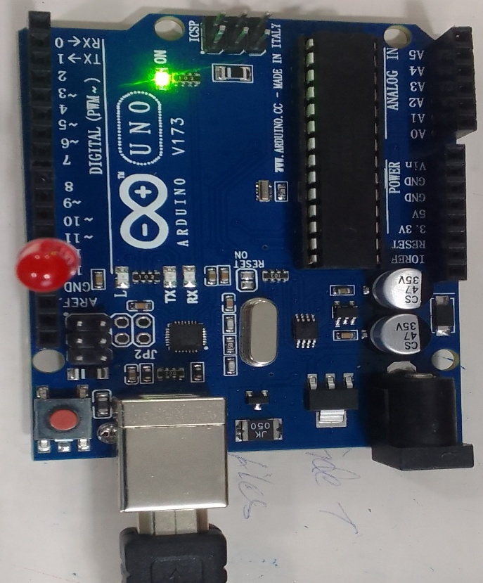  Turn Off the LED | 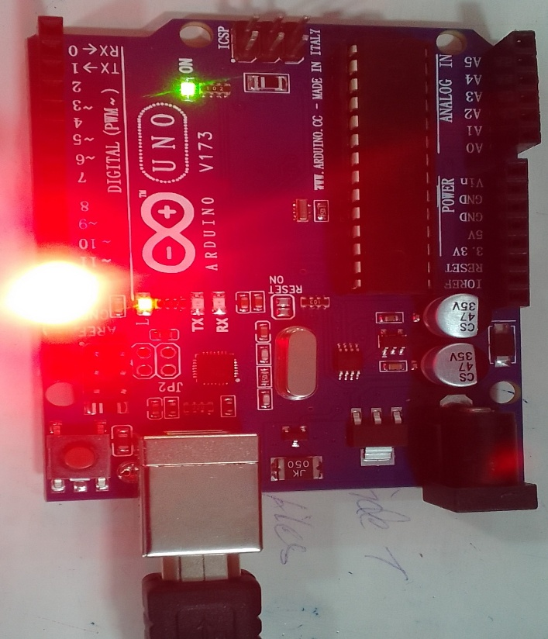  Turn On the LED

- To interface Button and LED – LED blinking when button is pressed.
Code:
const int buttonPin = 2; // Pin connected to the button
const int ledPin = 13; // Pin connected to the LED
int buttonState = 0; // Variable to store the button state
void setup() {
pinMode(ledPin, OUTPUT); // Set the LED pin as an output
pinMode(buttonPin, INPUT); // Set the button pin as an input
}
void loop() {
buttonState = digitalRead(buttonPin); // Read the state of the button (HIGH or LOW)
// Check if the button is pressed (buttonState is LOW)
if (buttonState == LOW) {
digitalWrite(ledPin, HIGH); // Turn on the LED
delay(500); // Wait for 500 milliseconds (0.5 seconds)
digitalWrite(ledPin, LOW); // Turn off the LED
delay(500); // Wait for another 500 milliseconds
}
}

Output :
Turn Off the LED Turn On the LED

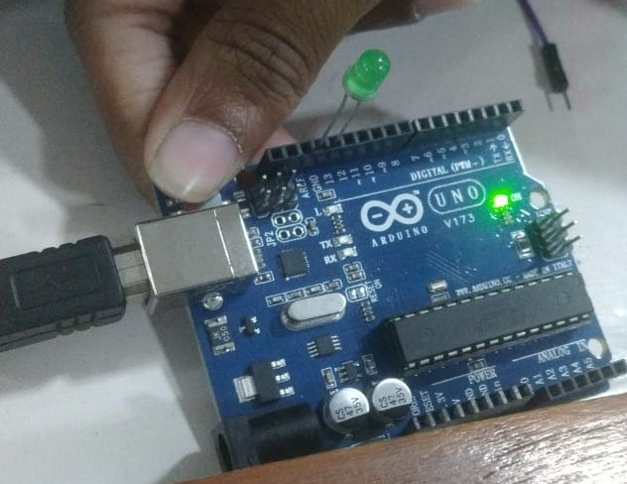 | 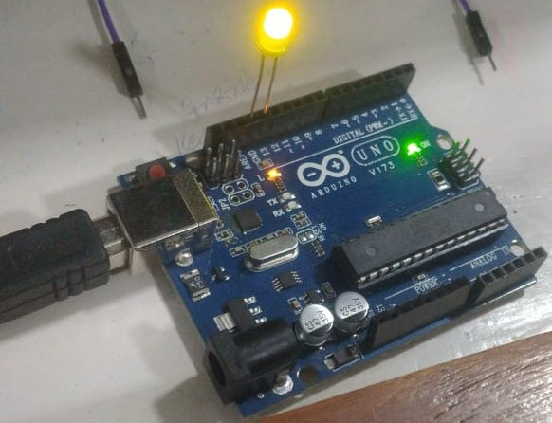

- To interface a PIR Sensor with Arduino to Drive an LED Indicator.
Code:
int pirPin = 2; // PIR sensor OUT pin
int ledPin = 4; // LED pin
int pirState=0;
void setup() {
pinMode(pirPin, INPUT); // Set PIR pin as input
pinMode(ledPin, OUTPUT); // Set LED pin as output
Serial.begin(9600); // Start serial communication
}

void loop() {
int pirState = digitalRead(pirPin); // Read PIR state

if (pirState == HIGH) {
digitalWrite(ledPin, HIGH); // Turn LED on
Serial.println("Motion Detected!");
} else {
digitalWrite(ledPin, LOW); // Turn LED off
}

delay(1000); // Small delay to stabilize reading
}

Output :

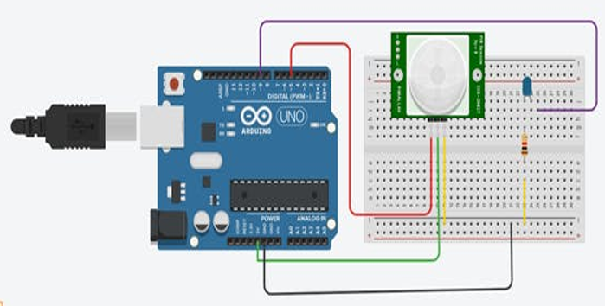

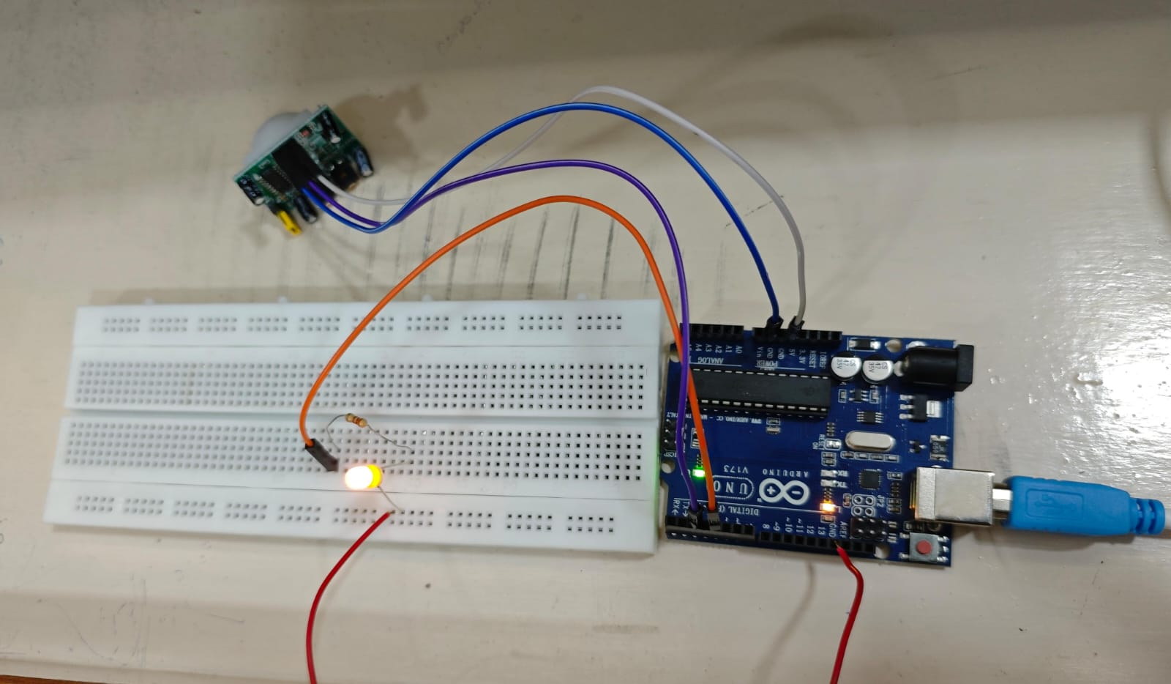

- To use the DHT11 temperature & humidity sensor with Arduino.

Code:
#include "DHT.h" // Include DHT library
#define DHTPIN 2 // Pin connected to DATA
#define DHTTYPE DHT11 // Define sensor type (DHT11 or DHT22)
DHT dht(DHTPIN, DHTTYPE);
void setup() {
Serial.begin(9600);
dht.begin();
Serial.println("DHT11 Sensor Test");
}
void loop() {
// Wait a few seconds between measurements
delay(2000);
float h = dht.readHumidity();
float t = dht.readTemperature(); // Celsius
// Check if reading failed
if (isnan(h) || isnan(t)) {
Serial.println("Failed to read from DHT sensor!");
return;
}
Serial.print("Humidity: ");
Serial.print(h);
Serial.print(" %\t");
Serial.print("Temperature: ");
Serial.print(t);
Serial.println(" °C");
}
Output :

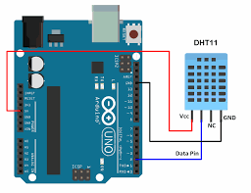
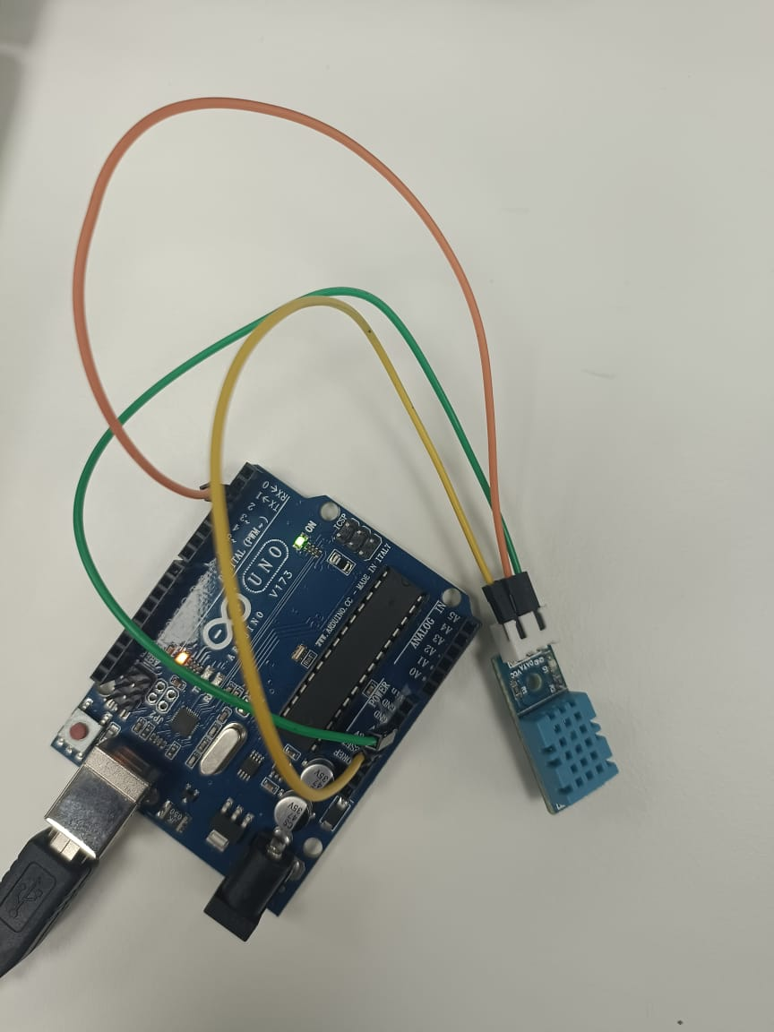

- To interface the LM35 temperature sensor with Arduino.
Code:
int sensorPin = A0; // LM35 output connected to A0
float sensorValue; // to store ADC value
float temperature; // calculated temperature
void setup() {
Serial.begin(9600);
}
void loop() {
sensorValue = analogRead(sensorPin); // read analog value (0-1023)
// Convert to voltage (Arduino is 5V with 10-bit ADC)
float voltage = sensorValue * (5.0 / 1023.0);
// LM35 gives 10mV per °C → 0.01V = 1°C
temperature = voltage * 100;
Serial.print("Temperature: ");
Serial.print(temperature);
Serial.println(" °C");
delay(1000); // read once per second
}

Output :

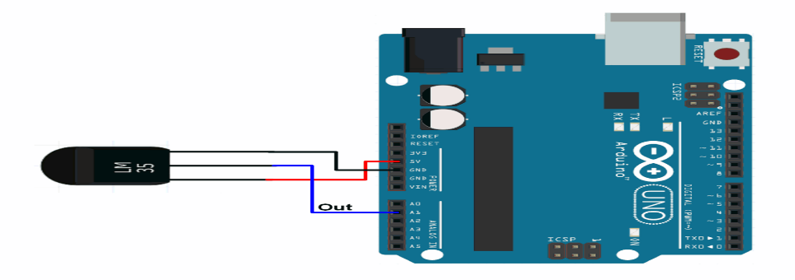
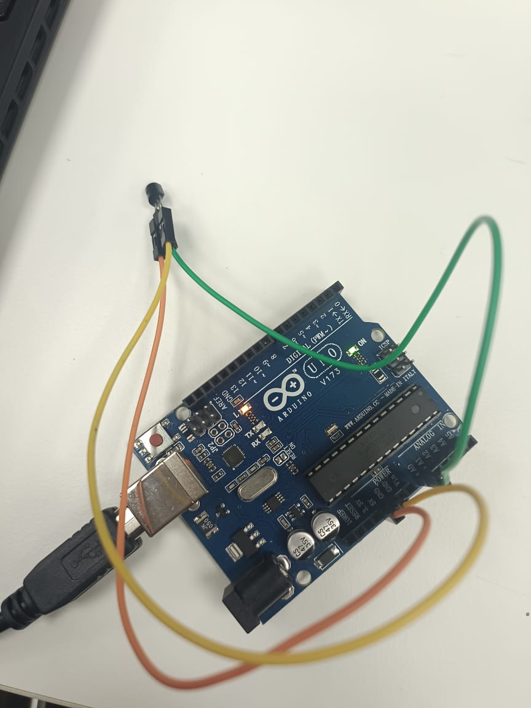
- To interface the Traffic Signal Simulation with Arduino.
Code:

int redLed = 8;
int yellowLed = 9;
int greenLed = 10;

void setup() {
pinMode(redLed, OUTPUT);
pinMode(yellowLed, OUTPUT);
pinMode(greenLed, OUTPUT);
}

void loop() {
// Red ON (Stop)
digitalWrite(redLed, HIGH);
digitalWrite(yellowLed, LOW);
digitalWrite(greenLed, LOW);
delay(5000); // 5 seconds

// Green ON (Go)
digitalWrite(redLed, LOW);
digitalWrite(yellowLed, LOW);
digitalWrite(greenLed, HIGH);
delay(5000); // 5 seconds

// Yellow ON (Caution)
digitalWrite(redLed, LOW);
digitalWrite(yellowLed, HIGH);
digitalWrite(greenLed, LOW);
delay(2000); // 2 seconds
}

Output :
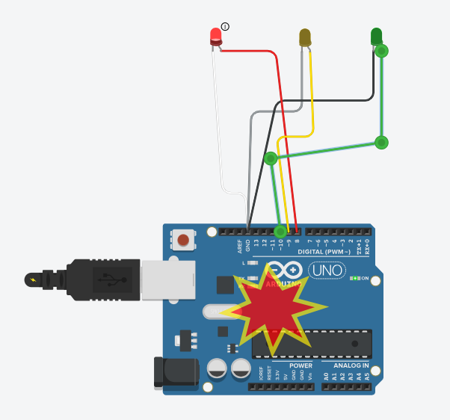  RED  GREEN  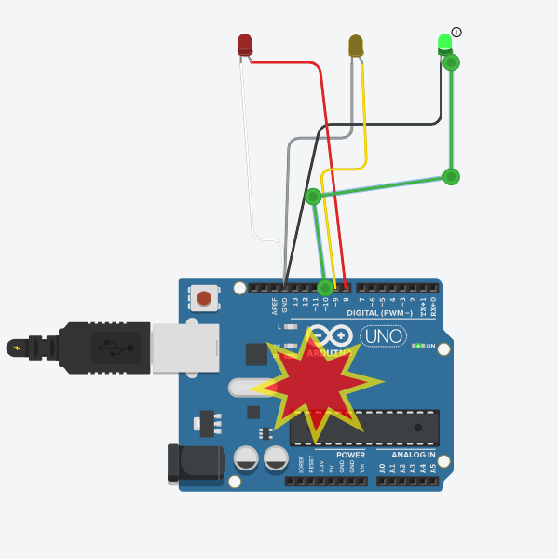 | 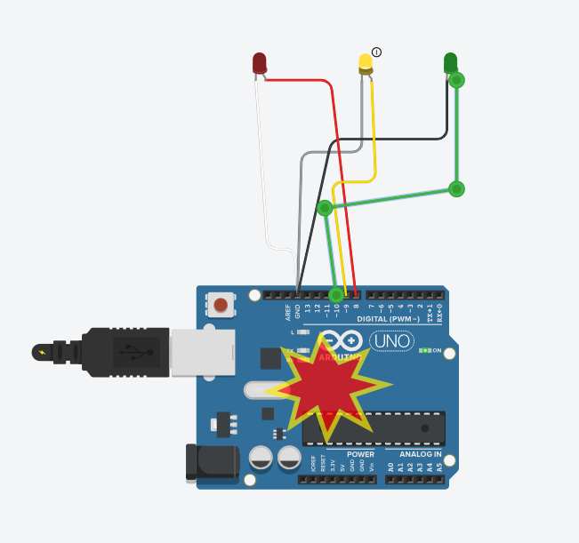  YELLOW

- To interface the Ultrasonic Sensor with Arduino.
Code:
// HC-SR04 simple example (Trig=9, Echo=10)
const int trigPin = 9;
const int echoPin = 10;
unsigned long duration;
float distanceCm;

void setup() {
Serial.begin(9600);
pinMode(trigPin, OUTPUT);
pinMode(echoPin, INPUT);
}

void loop() {
// Make sure Trig is LOW
digitalWrite(trigPin, LOW);
delayMicroseconds(2);

// Send 10 microsecond pulse to trigger
digitalWrite(trigPin, HIGH);
delayMicroseconds(10);
digitalWrite(trigPin, LOW);

// Read the time for echo (timeout 30000 us ~ 5 m)
duration = pulseIn(echoPin, HIGH, 30000);

if (duration == 0) {
Serial.println("Out of range");
} else {
// distance in cm: duration (us) * 0.01715
distanceCm = duration * 0.01715;
Serial.print("Distance: ");
Serial.print(distanceCm);
Serial.println(" cm");
}

delay(200); // 5 readings/second
}

Output :
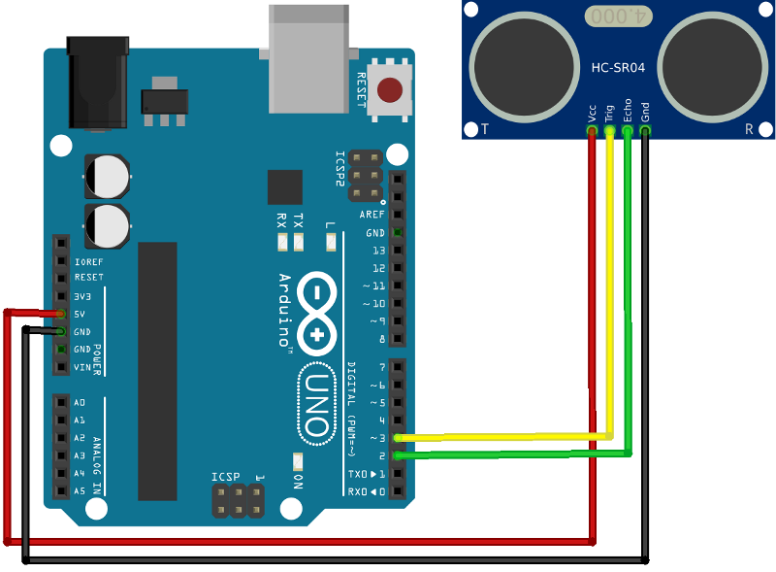

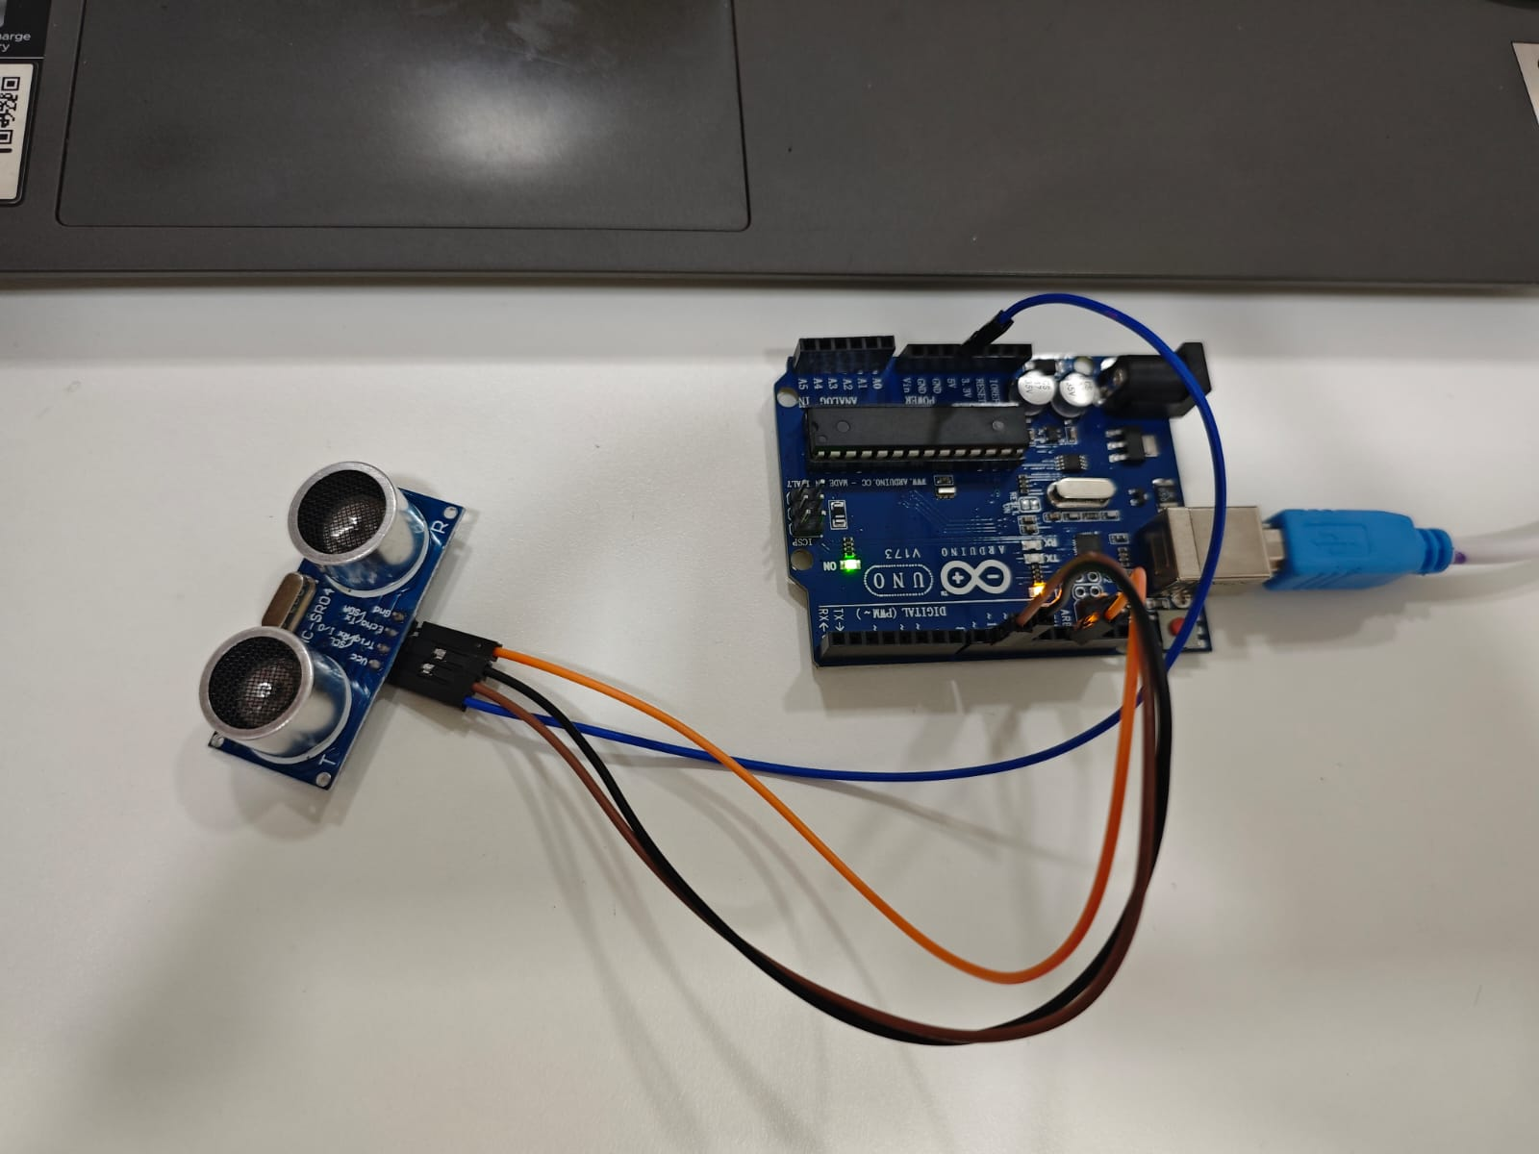

- To interface 7 segments step by step in Arduino.

Code:
// Pin mapping for segments a-g
int segPins[7] = {2, 3, 4, 5, 6, 7, 8};

// Digit patterns for 0-9 (1 = ON, 0 = OFF)
byte digits[10][7] = {
{1,1,1,1,1,1,0}, // 0
{0,1,1,0,0,0,0}, // 1
{1,1,0,1,1,0,1}, // 2
{1,1,1,1,0,0,1}, // 3
{0,1,1,0,0,1,1}, // 4
{1,0,1,1,0,1,1}, // 5
{1,0,1,1,1,1,1}, // 6
{1,1,1,0,0,0,0}, // 7
{1,1,1,1,1,1,1}, // 8
{1,1,1,1,0,1,1} // 9
};

void setup() {
for (int i = 0; i < 7; i++) {
pinMode(segPins[i], OUTPUT);
}
}

void loop() {
for (int num = 0; num < 10; num++) {
showDigit(num);
delay(1000); // 1 second delay
}
}

void showDigit(int num) {
for (int i = 0; i < 7; i++) {
digitalWrite(segPins[i], digits[num][i]);
}
}

Output :
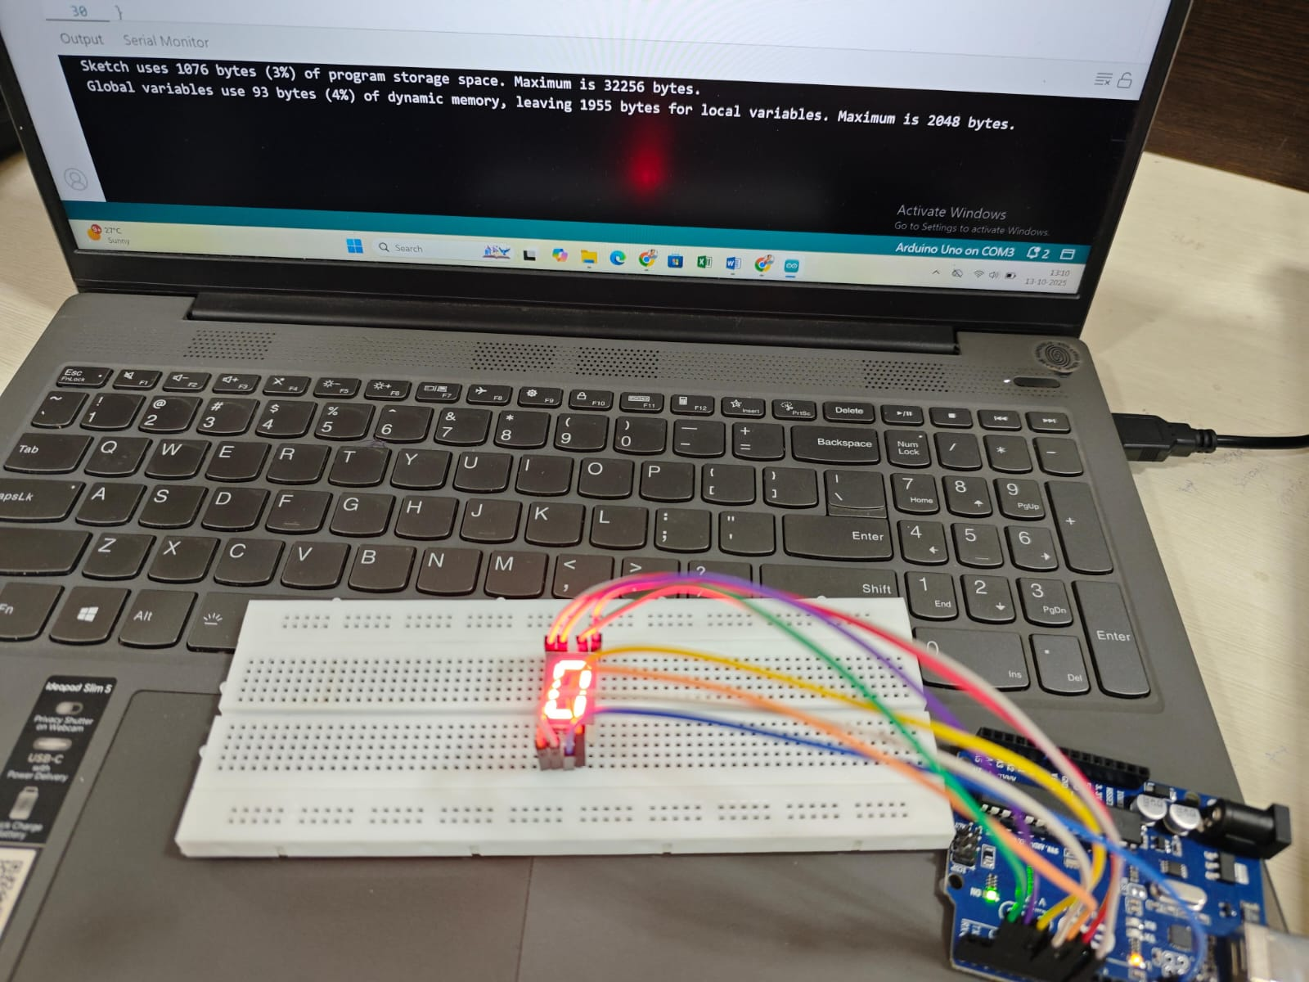

- To interface a 4×4 matrix keypad with Arduino and develop a program to detect and display the pressed key using the serial monitor.

Code:
#include <Keypad.h>

const byte ROWS = 4;
const byte COLS = 4;

char keys[ROWS][COLS] = {
{'1','2','3','A'},
{'4','5','6','B'},
{'7','8','9','C'},
{'*','0','#','D'}
};

// change these pin numbers to match your wiring
byte rowPins[ROWS] = {9, 8, 7, 6}; // R0, R1, R2, R3
byte colPins[COLS] = {5, 4, 3, 2}; // C0, C1, C2, C3

Keypad keypad = Keypad( makeKeymap(keys), rowPins, colPins, ROWS, COLS );

void setup() {
Serial.begin(9600);
}

void loop() {
char k = keypad.getKey();
if (k) {
Serial.print("Key: ");
Serial.println(k);
}
}

Output :
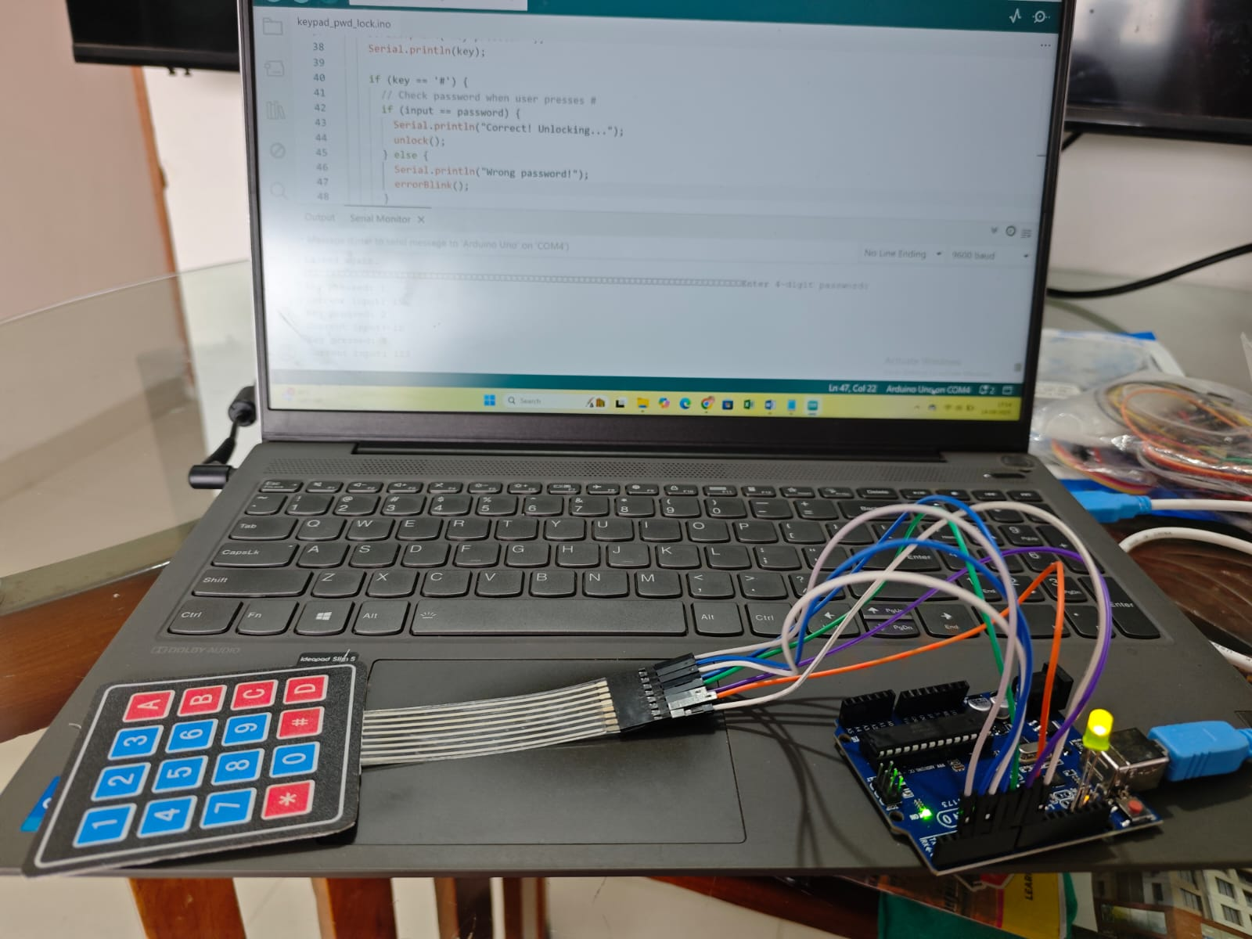

- To interface an LCD display with Arduino.

Code:
#include <LiquidCrystal.h>;

const int rs = 12, en = 11, d4 = 5, d5 = 4, d6 = 3, d7 = 2, ct=9;
LiquidCrystal mylcd(rs, en, d4, d5, d6, d7);

void setup() {
analogWrite(ct,50);
//ct- this sets the brightness level. Sets PWM brightness for the LCD backlight (50/255 ≈ 20% brightness).
mylcd.begin(16, 2); // Initializes the LCD with 16 columns and 2 rows.
mylcd.print("Hello, Arduino!"); // Displays the text “Welcome” on the first line of the LCD.

}

void loop()
{
}

Output :

