Newman (1974) Crack-Closure Finite-Element Program FINAL
Fortran 77 conversion, verification and comparison with the published results
Source: J. C. Newman, Jr., “Finite-Element Analysis of Fatigue Crack Propagation — Including the Effects of Crack Closure”, Ph.D. thesis, Virginia Polytechnic Institute and State University, 1974. Appendix E (computer program listing, thesis pp. 102–121), Appendix D (input description) and Figures 4 and 7–10.
Date: 10 October 2026
1. Summary 2
2. Transcription of the published listing 2
2.1 Misprints corrected 3
2.2 Lines reconstructed in SYMBAN 3
3. Conversion to Fortran 77 3
3.1 Dialect changes 3
3.2 Precision 3
3.3 Error in the published coupling stiffness terms 3
3.4 Enlarged array dimensions 4
4. Centre-cracked panel after Newman’s Figure 4 5
4.1 Geometry and mesh 5
4.2 Analysis conditions 6
5. Comparison with Newman’s published results 7
5.1 Closure and opening stresses 7
5.2 Crack-surface displacements 7
6. Plastic zones on the Figure 4 mesh 9
7. Files 10
Compiling and running 10

1. Summary
The CDC FORTRAN listing of program FINAL in Appendix E of Newman’s thesis was transcribed from page images and converted to standard Fortran 77. The program performs a plane-stress, elastic–perfectly-plastic finite-element analysis of a cracked panel under cyclic loading, using constant-strain triangles, the initial-stress method, and spring elements to model crack-surface contact, crack growth and closure.
- The conversion follows the published code statement for statement. Every departure is marked in the source with a comment beginning C***.
- Five evident misprints in the stiffness assembly were corrected, and seven lines of subroutine SYMBAN hidden by paste-up strips in the thesis copy were reconstructed.
- Two genuine issues were found and characterised: the published u–v coupling stiffness terms have BETA2 and BETA3 interchanged (exact only for Poisson’s ratio 1/3), and 32-bit REAL arithmetic is inadequate for the program’s rigid-spring technique (the CDC used 60-bit words), so double precision is now used.
- Array dimensions were raised from 400 elements / 250 nodes to 4000 elements / 2500 nodes through PARAMETER statements, with run-time dimension checks.
- A new input deck reproduces the centre-cracked panel and mesh of Newman’s Figure 4. Closure and opening stresses for Smax = 15 and 20 ksi agree with Newman’s Figures 7 and 8 to within about 0.2 ksi, and crack-surface displacements reproduce Figures 9 and 10.
- On that mesh, the forward plastic zone at the first peak covers 14 elements at 15 ksi and 52 elements at 20 ksi, and reverse yielding on unloading is confined to one to three elements at the crack tip.

2. Transcription of the published listing
Appendix E occupies PDF pages 111–130 of the scanned thesis. OCR text of program listings is unreliable, so each page was rendered at 500 dpi and read from the image. The listing consists of the main program and five subroutines:
Program unit | Function
PROGRAM FINAL | Input, mesh subdivision, node numbering, boundary-node and element–node identification, bandwidths, stiffness and load assembly, elastic unit-load solution
SUBROUTINE PLAS | Incremental elastic–plastic analysis (initial-stress method), load reversal, convergence control
SUBROUTINE CONTACT | Changes crack-line spring stiffness when crack surfaces close or open
SUBROUTINE BREAK | Releases the crack-tip node at maximum load (crack growth by one element)
SUBROUTINE PLOUT | Prints applied stress, crack-opening displacements, nodal displacements, element stresses and strains
SUBROUTINE SYMBAN | Variable-bandwidth symmetric LDLᵀ solver with rank-one modification of the factors

A faithful transcription in the original CDC dialect (Hollerith strings delimited by asterisks, multiple replacement, PROGRAM card file list) is kept as NEWMAN_FINAL_CDC_transcription.f for checking against the thesis.

2.1 Misprints corrected
The stiffness terms below contain subscripts that cannot be correct: YR(2) and XR(1) refer to fixed nodes 2 and 1 rather than to the element’s nodes. Taken literally, the program would assemble an incorrect stiffness matrix. The corrected forms follow from the constant-strain-triangle stiffness, and the published text is retained in comments.
Statement | Published | Corrected
AA(NUJU), AA(NUKU), AA(NVIU) | (YR(J)-YR(2)) | (YR(J)-YR(K))
AA(NUIV), AA(NUKV) | (XR(K)-XR(1)) | (XR(K)-XR(J))

2.2 Lines reconstructed in SYMBAN
Paste-up strips in the thesis copy overlay parts of SYMBAN on thesis pp. 119–121. The hidden lines were reconstructed from the surrounding code and the algorithm of Appendix C (Cholesky LDLᵀ factorisation with rank-one update of the factors):
- RETURN and 20 IF (IFAC .GE. 2) GO TO 300 — only “…TO 300” is visible; the character position fixes the length of the statement.
- DO 180 J=1,NRHS, X = B(I,J), DO 170 K=MN,IM1 — start of the forward substitution, partly overprinted.
- DO 310 I=J+1,N — row loop of the rank-one update, hidden under a strip.

3. Conversion to Fortran 77

3.1 Dialect changes
- PROGRAM card file list removed; units 5 and 6 are the preconnected input and output units.
- CDC *…* string delimiters in FORMAT statements changed to apostrophes.
- CDC multiple replacement Q(I)=Z(I)=0.0 split into two statements.
- Hollerith data 4HHALT / 4HGROW held in REAL variables replaced by CHARACTER*4 HALT, GROW, WORD.
- A scalar Q used in the node-merging loop renamed QQ, because Q is an array in COMMON /MAIN/.
- The element-reading loop uses a separate counter, because the READ redefines the DO variable I, which Fortran 77 does not permit.
- MP initialised to zero in PLAS (the CDC loader zero-filled memory).

3.2 Precision
The program fixes nodes with “rigid” springs of stiffness SK2 = 10⁷ × E (about 10¹¹), and subroutine SYMBAN later removes that stiffness from the factored matrix by a rank-one downdate when a node is released (crack growth) or a crack face opens. The CDC 6000-series machines carried about 14 significant digits in single precision; 32-bit REAL carries about 7, so the downdate leaves meaningless factors. In 32-bit arithmetic, cyclic runs failed to converge and then diverged to NaN after the first node release. IMPLICIT DOUBLE PRECISION (A-H,O-Z) is therefore declared in every program unit.

3.3 Error in the published coupling stiffness terms
In the four off-diagonal u–v coupling terms AA(NVJU), AA(NVKU), AA(NUJV) and AA(NUKV), the coefficients BETA2 and BETA3 are interchanged relative to the constant-strain-triangle stiffness. The interchange is exact only when BETA2 = BETA3, which for plane stress means Poisson’s ratio ν = 1/3. A uniform-stress patch test (σ = 1 applied to an uncracked panel) confirms this:
Case | σy (expected 1) | σx (expected 0)
Published terms, ν = 0.3 | 1.0199 | −0.057
Published terms, ν = 0.3333 | 1.00002 | −0.00005
BETA2/BETA3 interchanged back, ν = 0.3 | 0.99999 | −0.000001

The published form was changed in the converted program. All analyses in this report use ν = 0.3333, for which the published terms are exact.

3.4 Enlarged array dimensions
All array sizes are now set by one PARAMETER statement repeated in each routine that contains COMMON /MAIN/. A new subroutine DIMERR stops the run with a message if a problem exceeds any limit, and integer output fields that print node and element numbers were widened.
Quantity | Parameter | Published | Now
Elements (after subdivision) | MAXEL | 400 | 4000
Nodes | MAXNOD | 250 | 2500
Degrees of freedom | MAXDOF | 500 | 5000
Stiffness storage (words) | MAXA | 12 000 | 2 000 000
Boundaries | MAXBND | 6 | 10
Nodes on one boundary | MAXBN | 50 | 500
Elements meeting at a node | MAXEPN | 8 | 12

Results for an existing deck are unchanged by the enlargement. A 3960-element model and a 1968-element model (the Figure 4 mesh with NDIV = 1) ran without difficulty, and a 4048-element model was correctly rejected by the dimension check.

4. Centre-cracked panel after Newman’s Figure 4

4.1 Geometry and mesh
Newman’s thesis gives an initial crack half-length of 1.075 in. and a total panel width of 18 in.; the panel height of 10 in. (quarter model) was scaled from Figure 4. The quarter-panel mesh was built to follow the figure:
- Crack-tip region (Figure 4, lower view): 0.80 × 0.40 in., built on a 32 × 16 grid with h = 0.025 in. Uniform h × h squares split by diagonals cover 10 × 3 elements, with node A (the initial crack tip) at x = 1.075 in. and nodes B–F at 0.025 in. spacing. Element size doubles in stages (h, 2h, 4h, 8h) to 0.2 in. at the edge of the region, through centre-node transition cells as in the figure.
- Remainder of the panel (Figure 4, upper view): boundary nodes placed at the positions measured from the figure, with the interior filled automatically by graded triangles from 0.2 in. at the crack-tip region to about 3 in. at the top edge. The density matches Newman’s; the layout is not his exact row pattern.
- Size: 492 elements, 273 nodes, 23 003 words of stiffness storage — beyond the published limits, so the enlarged program is required. Elements are ordered by reverse Cuthill–McKee numbering to keep the bandwidth small.
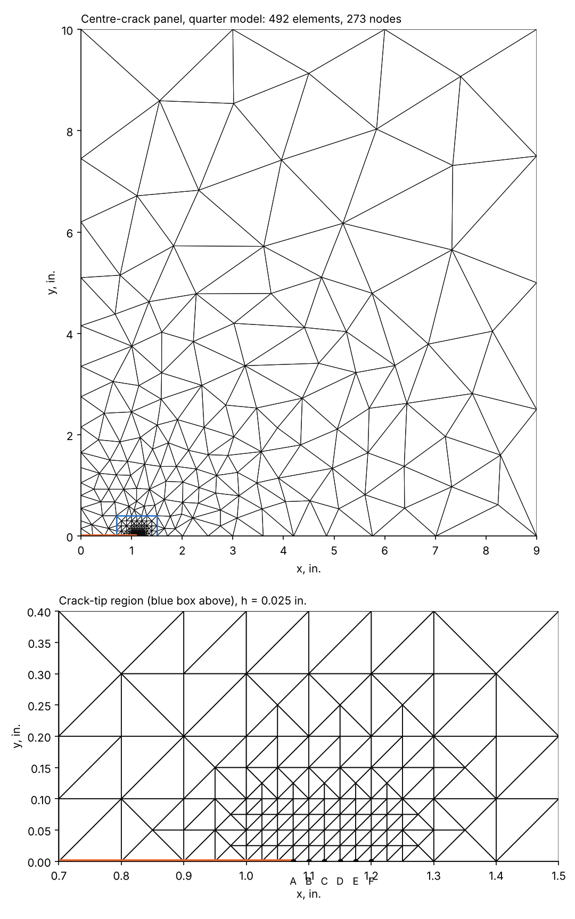
Figure 1. Quarter-panel mesh (top) and crack-tip region with nodes A–F (bottom).

4.2 Analysis conditions
Item | Value
Material | E = 10 000 ksi, ν = 0.3333, σys = 50 ksi (Newman’s values)
Boundary conditions | x = 0: u = 0 (symmetry); y = 0: v = 0 on the ligament, crack faces free; y = 10 in.: uniform stress S
Loading | Constant amplitude, R = 0, Smax = 15 ksi and 20 ksi; nodes A–D released at successive peaks; final reload to Smax
Solution controls | PCT = 0.05, G = 1.5, ERIT = 0.001; at most 26 (15 ksi) and 46 (20 ksi) iterations per load step
Minimum stress card | 0.001 ksi rather than 0.0: with 0.0 the published stop test overshoots by one load increment into compression

5. Comparison with Newman’s published results
Newman’s values were digitised from page images of his Figures 7–10, so they carry reading errors of about ±0.1 ksi and ±0.05 × 10⁻³ in. To obtain displacement profiles at intermediate loads during unloading, both decks were re-run with output at every load increment; this changes only printing, and the closure and opening events are identical.

5.1 Closure and opening stresses
Event | Newman 15 ksi | This run 15 ksi | Newman 20 ksi | This run 20 ksi
First yield | 5.73 | 5.86 | — | 5.86
A closure | 3.97 | 4.15 | 7.84 | 8.00
A opening | 3.70 | 3.91 | 6.10 | 6.14
B closure | 4.24 | 4.24 | 8.35 | 8.23
B opening | 4.24 | 4.39 | 7.79 | 7.85
C closure | 4.17 | 4.30 | 8.33 | 8.24
C opening | 4.27 | 4.44 | 8.50 | 8.53
D closure | 4.19 | 4.35 | 8.33 | 8.36
All values in ksi.
All values agree within about 0.2 ksi, and the same behaviour appears in both:
- At Smax = 15 ksi the crack closes and reopens at almost the same stress, settling at about 28–30% of Smax (Newman: “approximately 30 percent”).
- At Smax = 20 ksi, compressive yielding behind the tip on the first cycle makes node A reopen well below its closure stress (about 6.1 against 8 ksi). The opening stress then rises cycle by cycle towards the closure level of about 8.3 ksi, roughly 40% of Smax (Newman: “approximately 40 percent”).

5.2 Crack-surface displacements
- At maximum load (Figure 9): the sharp knee just behind node A, and the near-uniform spacing of the curves for crack tips A to E, are reproduced. Behind the knee the computed displacements are about 5–10% larger than Newman’s (for example 2.54 against about 2.37 × 10⁻³ in. at x = 1.05 in. with the tip at E); ahead of A the agreement is close.
- During unloading with the tip at E (Figure 10): the profiles at 20, 13, 8.5, 5 and 0 ksi match closely, including closure of nodes A–D before zero load and the crack surface behind A remaining open at zero load.
The displacement offset is attributed to model details rather than to the program: the outer mesh is not Newman’s exact layout, the panel height was scaled from the figure, and Newman’s Poisson’s ratio is not stated. Because of the BETA2/BETA3 interchange (Section 3.3), his results would shift if he had used a value other than 1/3.
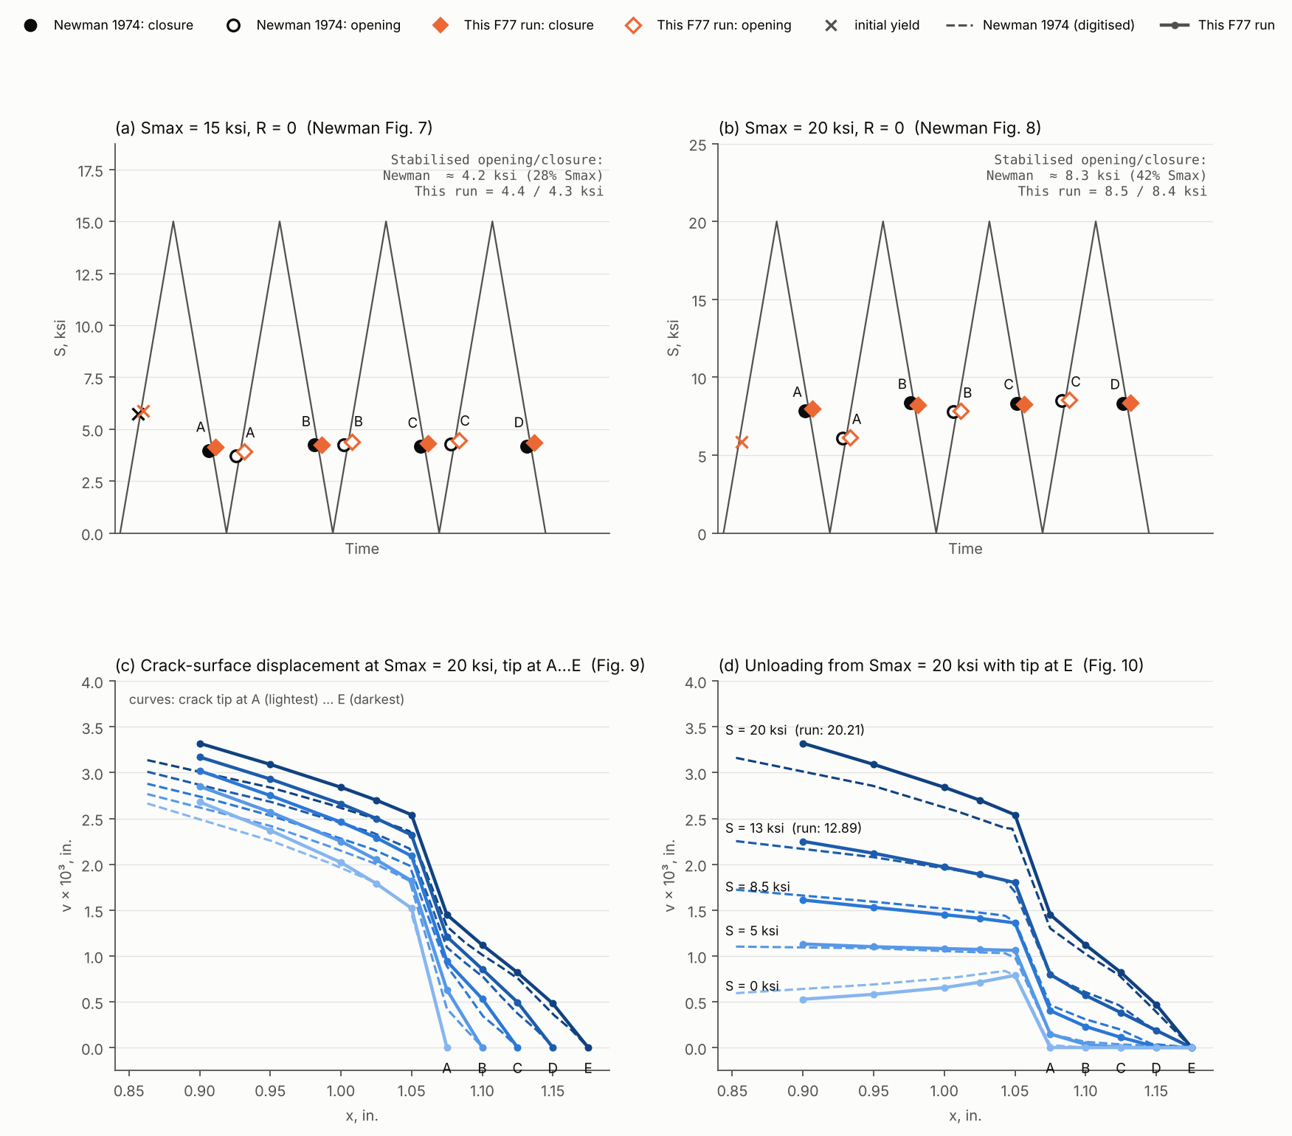
Figure 2. This Fortran 77 run against Newman (1974): closure and opening stresses for Smax = 15 ksi (a, Fig. 7) and 20 ksi (b, Fig. 8); crack-surface displacements at Smax = 20 ksi with the tip at A–E (c, Fig. 9); and during unloading with the tip at E (d, Fig. 10).

6. Plastic zones on the Figure 4 mesh
Element stresses for every element were printed at each target load, and an element is counted as plastic when its von Mises effective stress is at the yield stress (σe ≥ 49.5 ksi). Elements at yield are classed as forward (tensile σy) or reverse (compressive σy). Figure 3 shows the crack-tip region at three stages for each load level: the first peak with the tip at node A, the fourth peak just after node D was released (tip at E), and zero load after that cycle.
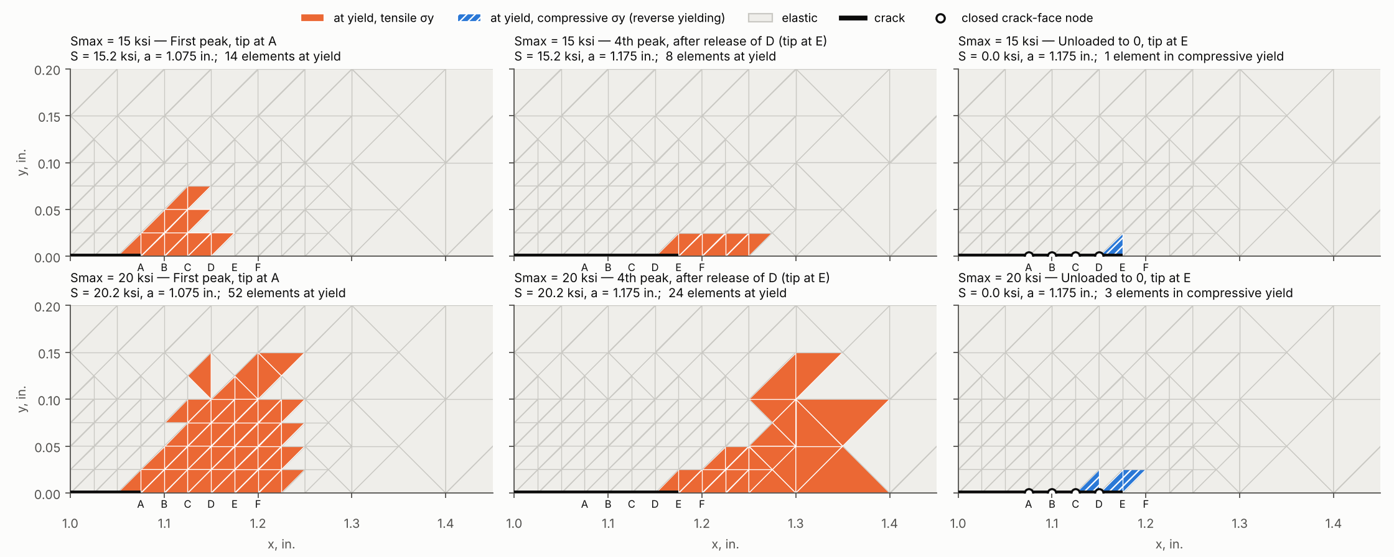
Figure 3. Elements at yield in the crack-tip region of the Figure 4 mesh for Smax = 15 ksi (top) and 20 ksi (bottom), R = 0. Closed crack-face nodes at zero load are shown as open circles.
Quantity | Smax = 15 ksi | Smax = 20 ksi
Elements at yield, first peak (tip at A) | 14 | 52
Forward zone ahead of A along the crack line | 0.100 in. (4 elements) | 0.175 in. (7 elements)
Height of forward zone | 0.075 in. | 0.15 in.
Dugdale strip-yield estimate | 0.13 in. | 0.26 in.
Elements at yield, 4th peak (tip at E) | 8 | 24
Elements in compressive yield at zero load (tip at E) | 1 | 3
Reverse zone at zero load | one element just behind E | from behind D to 0.025 in. ahead of E
Dugdale reverse-zone estimate (ΔS = Smax) | 0.03 in. | 0.06 in.
Crack-face nodes closed at zero load | A, B, C, D | A, B, C, D

- At the first peak the plastic zone is a compact lobe ahead of node A, inclined forward as expected for plane stress; at 20 ksi it reaches the edge of the 0.025 in. elements and continues into the 0.05 in. transition elements.
- After four increments of growth the zone at peak load is smaller (8 and 24 elements). The material behind the tip has been stretched plastically and the closed wake carries load at low stress, so less of the cycle is effective at the new tip. At 20 ksi most of the zone now lies in the coarser elements beyond x = 1.25 in., so its shape there is resolved only coarsely.
- On unloading, reverse yielding is confined to the elements at the crack tip, about one fifth to one quarter of the forward zone, as simple strip-yield theory suggests. At 20 ksi the compressive yield extends behind the tip into the wake, where the closed crack faces press together — the effect Newman describes as lowering the opening stress at node A in Figure 8.
- Because the program releases one node per cycle and the elements are 0.025 in., the reverse zone at 15 ksi is only about one element; a finer crack-tip grid would be needed to resolve its shape.

7. Files
All files are in D:\Temp\NewmanCrackFEA.
File | Contents
NEWMAN_FINAL_F77.f | Fortran 77 program (double precision, 4000-element dimensions)
NEWMAN_FINAL_CDC_transcription.f | Transcription of the listing as printed (CDC dialect)
make_newman_fig4_mesh.py | Generates the Figure 4 mesh and input deck (arguments: Smax, cycles, output file)
ccp_fig4_S15.dat / .out | Figure 4 panel, Smax = 15 ksi
ccp_fig4_S20.dat / .out | Figure 4 panel, Smax = 20 ksi
trace_S15.dat / .out, trace_S20.dat / .out | As above, with output at every load increment
ccp_fig4_mesh.png | Picture of the Figure 4 mesh
compare_newman.py | Comparison plot script, with the digitised values from Figures 7–10
newman_comparison.png | Comparison with Newman’s Figures 7–10
fig4_mesh_plastic_zones.png | Plastic zones on the Figure 4 mesh (Section 6)
pz.py, plot_pz.py | Scripts that extract element stresses and plot the plastic zones

Compiling and running
gfortran -std=legacy -O2 -o final NEWMAN_FINAL_F77.f
final < ccp_fig4_S15.dat > ccp_fig4_S15.out
The input deck format is that of Newman’s Appendix D; the mesh generator requires the Python packages numpy, scipy, triangle and matplotlib.

