Biostatistics Assignment
Jolene Wium
2026-03-26
Table of contents

1. Introduction
Provide a brief overview of the study question, population, and why the analysis matters.
Example:
This assignment evaluates the relationship between an exposure and a health outcome in a defined study population. The report presents descriptive statistics, measures of association, selected statistical tests, and an interpretation of the findings in epidemiological terms.

2. Research question and objective
State the primary research question clearly.
Example:
Is exposure X associated with outcome Y in the study population?
State the objective in one sentence.
Example:
The objective of this analysis is to estimate the association between exposure status and outcome status, and to interpret the findings with reference to chance, bias, and confounding.

3. Study design and variables
Briefly describe the design and key variables.
- Study design: cohort / case-control / cross-sectional / trial
- Exposure variable:
- Outcome variable:
- Covariates of interest:
- Unit of analysis:

4. Data setup

4.1 Load data
Replace the example file path with your own dataset.
 | exposure | outcome | age | bmi | sex
0 | 1 | 1 | 45 | 24.20 | F
1 | 1 | 0 | 33 | 27.80 | F
2 | 1 | 1 | 51 | 30.10 | M
3 | 0 | 0 | 29 | 22.40 | F
4 | 0 | 0 | 62 | 28.90 | M

4.2 Data structure and missingness
 | variable | dtype | missing_n | missing_pct
0 | exposure | int64 | 0 | 0.00
1 | outcome | int64 | 0 | 0.00
2 | age | int64 | 0 | 0.00
3 | bmi | float64 | 0 | 0.00
4 | sex | str | 0 | 0.00
Briefly comment on missingness, coding, exclusions, and any recoding performed.

5. Methods
Describe the analysis plan in paragraph form. Mention:
- descriptive statistics used
- measure(s) of association
- statistical tests
- significance level
- handling of missing data
- any stratified or adjusted analysis
Example:
Continuous variables were summarised using means and standard deviations or medians and interquartile ranges, as appropriate. Categorical variables were summarised using frequencies and percentages. The association between exposure and outcome was assessed using the risk ratio and odds ratio. Group differences in continuous variables were explored using an independent-samples t-test. A two-sided alpha of 0.05 was used.

6. Descriptive statistics

6.1 Sample size
Analytic sample size: 12

6.2 Summary statistics for continuous variables
 | variable | count | mean | std | median | min | max
0 | age | 12.00 | 42.67 | 10.03 | 42.50 | 29.00 | 62.00
1 | bmi | 12.00 | 26.71 | 2.84 | 26.80 | 22.40 | 31.20

6.3 Frequency tables for categorical variables
 | exposure | n | percent
0 | 1 | 6 | 50.00
1 | 0 | 6 | 50.00

 | outcome | n | percent
0 | 0 | 7 | 58.33
1 | 1 | 5 | 41.67

6.4 Table 1: descriptive characteristics by exposure group
 | exposure | n | mean_age | sd_age | median_bmi
0 | 0 | 6 | 41.00 | 12.21 | 24.80
1 | 1 | 6 | 44.33 | 8.09 | 27.45
Interpret the main descriptive patterns in 2 to 4 sentences.

7. Visualisations

7.1 Distribution of age
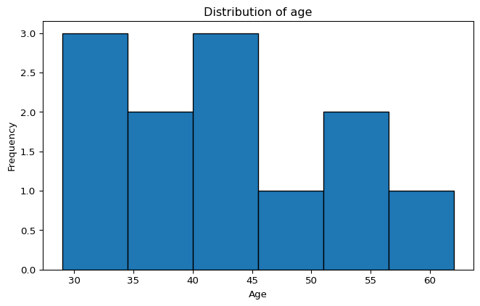

7.2 BMI by exposure group
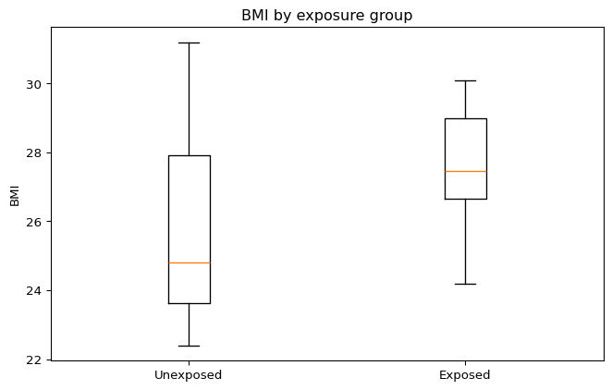
Write one short sentence describing what each figure shows.

8. Measures of association

8.1 2 × 2 table
Let:
- $a$ = exposed and diseased
- $b$ = exposed and not diseased
- $c$ = unexposed and diseased
- $d$ = unexposed and not diseased
 | Outcome present | Outcome absent
Exposed | 4 | 2
Unexposed | 1 | 5

8.2 Risk in each group
The risk among the exposed is:
$$Risk_{exposed}=\frac{a}{a+b}$$
The risk among the unexposed is:
$$Risk_{unexposed}=\frac{c}{c+d}$$
 | measure | estimate
0 | Risk in exposed | 0.67
1 | Risk in unexposed | 0.17

8.3 Risk ratio
$$RR=\frac{a/(a+b)}{c/(c+d)}$$
Risk ratio: 4.000

8.4 Odds ratio
$$OR=\frac{a×d}{b×c}$$
Odds ratio: 10.000

8.5 Optional: approximate 95% confidence interval for the odds ratio
$$SE\left[ln(OR)\right]=\sqrt{\frac{1}{a}+\frac{1}{b}+\frac{1}{c}+\frac{1}{d}}$$
$$95\% CI=exp\left(ln(OR)±1.96×SE\left[ln(OR)\right]\right)$$

9. Statistical testing

9.1 Example: independent-samples t-test for BMI by exposure
State the null and alternative hypotheses in words.
Example:
- Null hypothesis: mean BMI is the same in the exposed and unexposed groups.
- Alternative hypothesis: mean BMI differs between the exposed and unexposed groups.
 | test | statistic | p_value
0 | Welch t-test | 0.98 | 0.35
Interpret the p-value in one sentence, using your chosen significance level.

10. Bias, confounding, and effect modification

10.1 Bias
Discuss possible sources of bias, for example:
- selection bias
- information bias
- recall bias
- measurement error
- loss to follow-up

10.2 Confounding
State whether there may be confounding and why.
Example:
Age may confound the association between exposure and outcome because it could plausibly be associated with both the exposure and the outcome.

10.3 Effect modification
State whether stratified analysis might be useful.
Example:
Sex may be assessed as a possible effect modifier by estimating the association separately in males and females and comparing stratum-specific estimates.

11. Stratified analysis (optional section)

11.1 Example: descriptive summary by sex
 | sex | exposure | n | outcome_risk
0 | F | 0 | 3 | 0.33
1 | F | 1 | 4 | 0.75
2 | M | 0 | 3 | 0.00
3 | M | 1 | 2 | 0.50
Comment on whether the association appears similar across strata.

12. Interpretation
Provide a concise interpretation of the main result.
Example:
The estimated risk ratio was greater than 1, suggesting that exposure may be associated with a higher risk of the outcome in this sample. The odds ratio was in the same direction. However, the findings should be interpreted cautiously because the sample is small and potential confounding has not yet been addressed.

13. Limitations
Typical limitations to consider:
- small sample size
- missing data
- residual confounding
- measurement error
- limited generalisability
- temporality issues in cross-sectional data

14. Conclusion
Answer the research question directly in 2 to 4 sentences.
Example:
In this analysis, exposure was positively associated with the outcome. The direction of effect was consistent across the risk ratio and odds ratio. Although the findings suggest a possible association, stronger causal inference would require a larger sample and careful assessment of bias and confounding.

15. Appendix

15.1 Reproducibility information
3.13.1 (tags/v3.13.1:0671451, Dec 3 2024, 19:06:28) [MSC v.1942 64 bit (AMD64)]

