* **Development plan:**

Task list:

Report that consists of:

Development plan

System architecture:

* + - SRP
* DRY

Software design patterns

Reflection

Web application

MoSCoW:

Mo (Reflection, System architecture, Software design patterns, database with minimum 2 tables linked to each other with foreign key, CRUD, Entity Framework Core)

S (Development plan)

Co (MVC)

W ()

Gantt Chart:

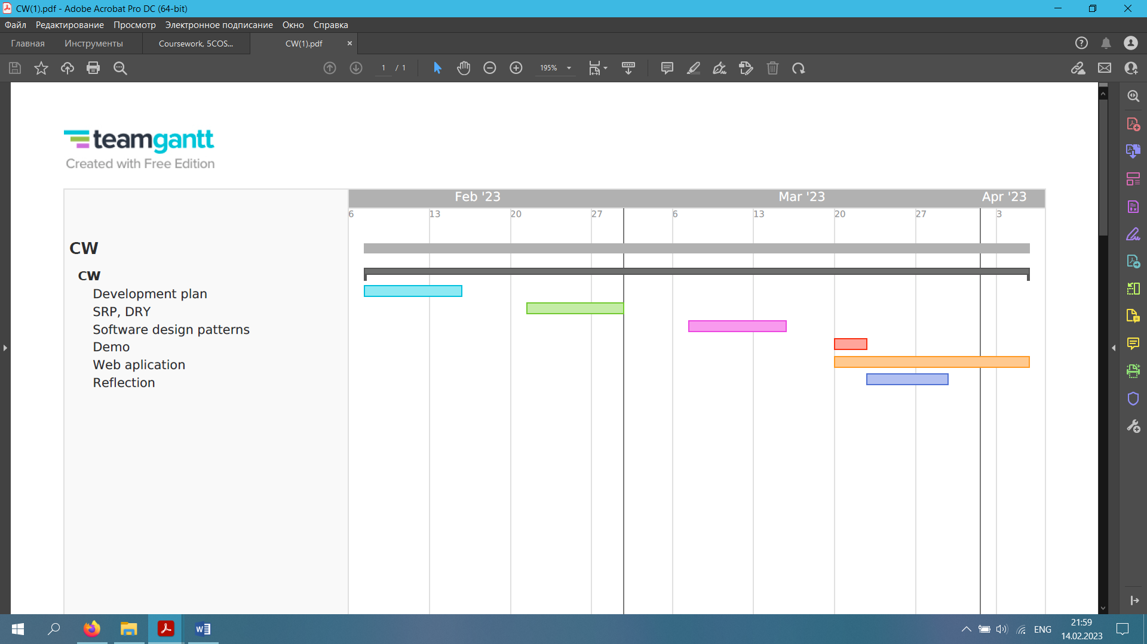

* **SRP, DRY:**

SRP: A class should have only one reason to change. In other words, a class should only have one job. For example, if you have a class that changes frequently for various reasons, you should split that class into multiple classes, each addressing a single problem.

Code example:

public class Student {

public void registerStudent() {

}

public void calculate_Student_Results() {

}

public void sendEmail() {

}

}

**We divided it into different classes**

public class StudentRegister {

public void registerStudent() {

}

}

public class StudentResult {

public void calculate_Student_Result() {

}

}

public class StudentEmails {

public void sendEmail() {

}

}

DRY: If you need to repeat your code multiple times, refactor your code to abstract it.

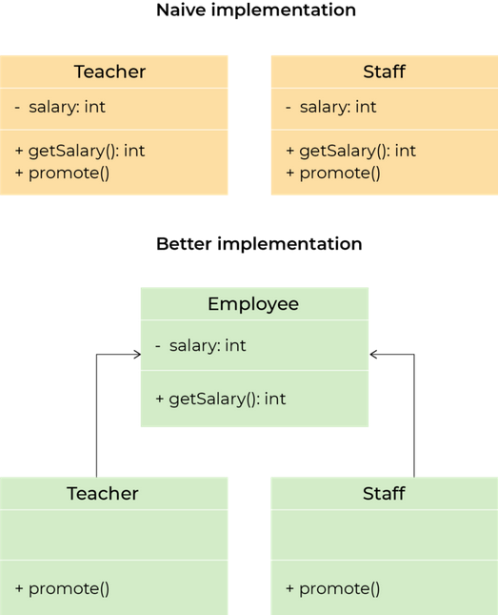

* **Software design patterns:**

I will apply Liskov Substitution Principle cause it helps to model good inheritance hierarchies. It helps to prevent model hierarchies that don't conform to the Open/Closed principle.

For instance:

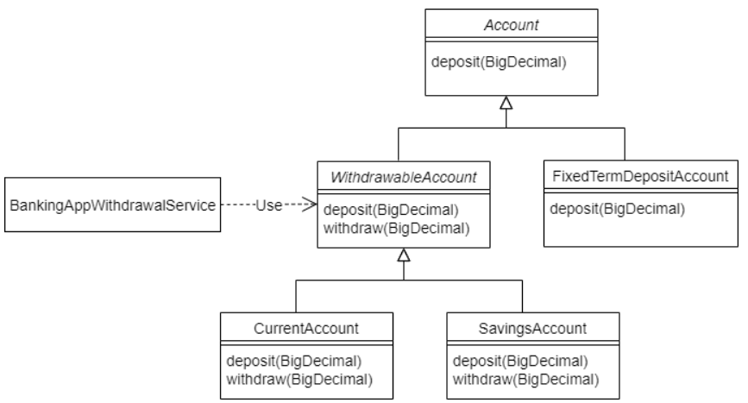

* **Reflection**

The development of a web application came with its own difficulties, although I stuck to my development plan, various pitfalls constantly appeared. While writing the development plan, I thought about everything well and therefore this is my easiest application development, since before that I sat down to write something without a plan. Of course, the hardest part of all is developing a web application. I had a few problems with CRUD and in order to link two tables with a foreign key. I ended up learning a lot about how to plan and develop really big projects.

<https://github.com/wiut00012803/Web-Applications-Development>