|  |  |
| --- | --- |
| Module code and name: | Web Application Development |
| Assessment: | CW 1 |
| Student ID: | 00012938 |
| Submission deadline: | 20.03.2024 |
| Wordcount |  |
| Results date and type of feedback |  |
| Result (Pass or Fail) |  |
| **Feedback** | |
|  | |

**Table of Content**

Introduction 2

Development Plan 2

***MoSCoW Task List: 2***

***Gannt Chart 2***

***Database Schema 3***

*ERM Diagram: 3*

*Relational Diagram: 4*

Github 4

System Architecture 4

API Explained 4

SPA Explained 4

Conclusion 4

Reference 4

# Introduction

This project is about student grading application

# Development Plan

## MoSCoW Task List:

Must-Have:

1. User Authentication
2. User Registration
3. Minimal Profile Information Input (Name, Picture, Surname, etc.)
4. Roles restriction (Teacher/Student accounts with specific limitations on account type)
5. Module Creation
6. Enrollment of students for a module
7. Assignment Creation
8. Grading Specific Students for specific assignments
9. Grades View Functionality

Should-Have:

1. Dashboard for Students
2. Average Grade Calculator
3. Number of Enrolled Students View Functionality

Could-Have:

1. Module Ownership by multiple Teachers
2. File Upload Functionality

Won’t-Have:

1. Report Generation
2. Average module grade calculator
3. Visual charts for grades
4. Image upload (only link insertion)

## Gannt Chart

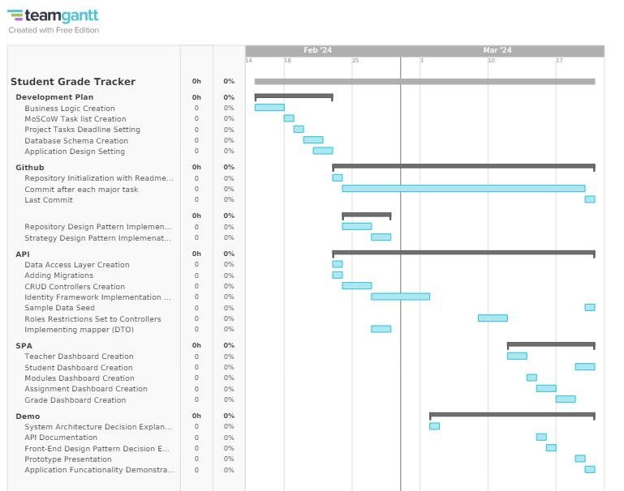

## Database Schema

### ERM Diagram:

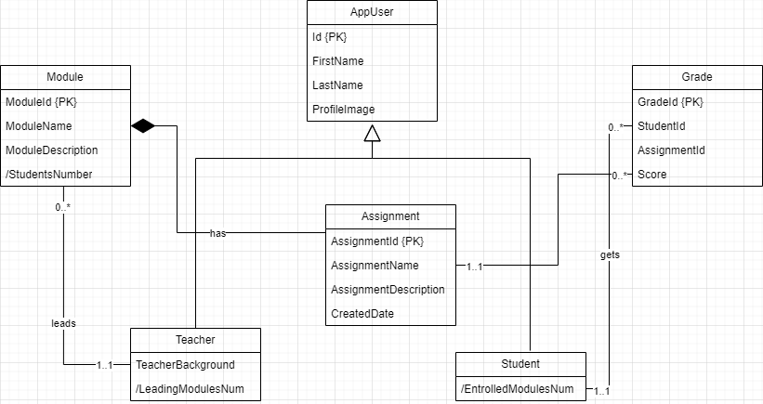

### Relational Diagram:

Before Applying IdentityFramework for Roles Creation:



ModuleStudent Table was added by Framework a we have many-to-many relation.

After implementing IdentityFramework:



# Github

## Link

<https://github.com/wiut00012938/WAD.CW.12938>

## Repository Initialization

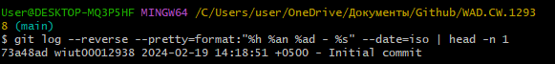

## Main commit details

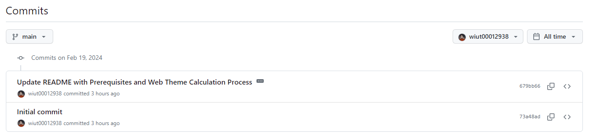

## Last Commit

# System Architecture

# API Explained

# SPA Explained

# Conclusion

# Reference