Westminster International University in Tashkent
BSc (Hons) Business Information Systems
6COSC017C Machine Learning and Data Analytics
Coursework 1 (50% of the module mark)
Predicting lost-time mine injuries from MSHA open data
An end-to-end machine learning study with a deployed decision-support application
Student ID: 13130
Marker: Ruslan Isaev
Submission date: December 2026
Word count (executive summary and sections 1 to 5 with headings; tables, captions, references and appendices excluded): 7,357
Repository: https://github.com/alim29042004-max/mlda-cw1
Deployed application: to be added after deployment

Table of contents
Right-click and choose Update Field (or press F9) to fill the table of contents.

List of figures
Figure 1. Counts and shares of non-lost-time and lost-time cases for all 101,609 in-scope rows before the split, drawn as a bar chart because two class sizes are compared. Source: author's analysis of MSHA open data.
Figure 2. Normal Q-Q plots of six numeric features on the training split, with 5,000 seeded points per panel and skewness computed on all training rows; Q-Q plots are used because departures from the dashed reference line show where each distribution differs from a normal one. Source: author's analysis of MSHA open data.
Figure 3. Pearson (left) and Spearman (right) correlation matrices of the 20 numeric features on the training split, drawn as heatmaps on one diverging scale centred at zero so that the two coefficients can be compared cell by cell. Source: author's analysis of MSHA open data.
Figure 4. Density histograms (30 bins) with kernel density estimates of the 20 numeric features by outcome class on all 81,289 training rows, drawn as densities so that classes of unequal size share one scale. Source: author's analysis of MSHA open data.
Figure 5. Box plots of the 20 numeric features by outcome class on all 81,289 training rows, with whiskers at 1.5 times the IQR and outlier points omitted, chosen because medians and quartiles are the comparison that skewed features need. Source: author's analysis of MSHA open data.
Figure 6. Corner pair plot of the five numeric features with the largest absolute point-biserial correlation, for 5,000 seeded training rows without missing values, coloured by outcome to show pairwise structure and class overlap. Source: author's analysis of MSHA open data.
Figure 7. Lost-time rate per level for the eight categorical features with the highest Cramer's V on the training split, showing the twelve largest levels and a pooled bar for levels under 100 rows, with the overall rate dashed; proportion bars are used because the question is the rate per level. Source: author's analysis of MSHA open data.
Figure 8. Percentage of missing values in the 30 most incomplete columns of the joined base table on the training rows, ranked as bars so that structural and sporadic gaps can be told apart. Source: author's analysis of MSHA open data.
Figure 9. Histograms (60 bins) of total mining experience and previous-year employee-hours on the training split before (left) and after (right) the log1p transform, with the right-hand axes in log1p units, IQR fences (k = 1.5) and Z-score fences (|z| > 3) and the number of rows each flags, used to compare the two outlier rules on skewed data. Source: author's analysis of MSHA open data.
Figure 10. First two principal components of the 20 median-imputed and standardised numeric features, fitted on the training split with 5,000 seeded points shown and coloured by outcome, used to check for linear class separation in two dimensions. Source: author's analysis of MSHA open data.
Figure 11. Preparation flow from the three MSHA files to the fitted model, in which stateless rules run on all 101,609 rows before the mine-year grouped split and every learned step is fitted inside one scikit-learn Pipeline on the 81,289 training rows; a flow diagram is used because the order of the steps carries the leakage argument. Source: author's analysis of MSHA open data.
Figure 12. Learning curve of HGB with its selected settings, giving mean training-fold and validation-fold PR-AUC (average precision) with one standard deviation bands over five grouped folds of a 10,000-row subsample of the training split, drawn against training size because the gap between the two curves separates variance from bias. Source: author's analysis of MSHA open data.
Figure 13. Validation curves of the eight tuned models, giving mean training-fold and validation-fold PR-AUC (average precision) with one standard deviation bands over the five grouped folds of the training split against the hyperparameter with most searched values, the other hyperparameters held at their selected values (for the random forest, the best sampled candidate per value), with the selected value dashed; curves are drawn because the train-validation gap and its shape show over- and underfitting. Source: author's analysis of MSHA open data.
Figure 14. Recall, specificity, precision, F1 and flag rate (top) and expected cost per 1,000 cases at six cost ratios on a log scale (bottom) against the decision threshold of HGB on the 20,320 test reports, with the three out-of-fold thresholds dashed and the cost of reviewing everything dotted; one threshold axis lets each rate and cost be read at the same cut-off. Source: author's analysis of MSHA open data.
Figure 15. Calibration curves of the eight tuned models and the lookup baseline on the 20,320 test reports, plotting the observed lost-time rate against the mean predicted probability in ten equal-width bins with marker size proportional to the cases in each bin and Brier scores in the legend; a reliability diagram is used because the application displays these probabilities. Source: author's analysis of MSHA open data.
Figure 16. ROC curves of the eight tuned models and the lookup baseline on the 20,320 test reports, with test ROC-AUC in the legend and the chance diagonal dotted; ROC space is shown because it does not depend on prevalence. Source: author's analysis of MSHA open data.
Figure 17. Precision-recall curves of the eight tuned models and the lookup baseline on the 20,320 test reports, with average precision (PR-AUC) in the legend and the prevalence of 0.486 dotted as the no-skill level; precision-recall space is shown because precision along the curve is the review cost of each lost-time case found. Source: author's analysis of MSHA open data.
Figure 18. Permutation importance of the 20 most important input features of HGB, measured as the mean drop in test PR-AUC (average precision) over five shuffles on 5,000 test reports with one standard deviation whiskers; importance is computed on input features rather than one-hot columns so that each nominal code counts once. Source: author's analysis of MSHA open data.
Figure 19. The 20 largest coefficients of the tuned logistic regression fitted on the training split, with numeric inputs standardised and one-hot columns coded 0 or 1 and labelled by their codebook meaning, where positive values (blue) raise and negative values (orange) lower the odds of a lost-time case; signed bars are used because each coefficient converts to an odds ratio. Source: author's analysis of MSHA open data.
Figure 20. Confusion matrices on the 20,320 test reports for HGB (top) and the lookup baseline (bottom) at the default threshold of 0.5 (left) and at each one's out-of-fold capacity threshold (right), with counts and row percentages; matrices are shown because each cell is a distinct outcome for the adjuster. Source: author's analysis of MSHA open data.

List of tables
Table 1. Error costs assumed for the claim-flagging decision and the evidence behind each value; the false-negative cost and the cost ratio are assumptions varied in the threshold analysis, and the review-everything floor is computed on all 101,609 in-scope reports. Source: author's assumptions from the cited cost sources and analysis of MSHA open data.
Table 2. Mapping of MSHA degree-of-injury codes to the lost_time target, with row counts and prevalence on all in-scope reports of 2010-2025 before the train/test split, and the two alternative labels that were assessed. Source: author's analysis of MSHA open data.
Table 3. Success criteria S1 to S7, fixed before modelling and evaluated on the 20% mine-year-grouped held-out test set (S6 also by sector on the temporal split), with the reference value each must beat and the four baselines; reference values come from the pre-modelling data profile, with lookup baseline values on the 2020-2025 temporal split and rule values on all in-scope reports. Source: author's analysis of MSHA open data.
Table 4. The three MSHA source tables with their size, grain, key and licence, and how each was joined to the accident rows; the files were published on 9 October 2026 and pulled on 14 October 2026 at 12:06 UTC from the MSHA Open Government Data page (https://arlweb.msha.gov/OpenGovernmentData/OGIMSHA.asp), each zip file at https://arlweb.msha.gov/OpenGovernmentData/DataSets/ followed by its name, and the full SHA-256 digests are in data/raw/SNAPSHOT.json. Source: author's analysis of MSHA open data.
Table 5. Data dictionary of the 55 model features (23 categorical, 20 numeric and 12 binary) grouped by type, with meaning and source table; the definitions apply to every row of the training and test splits, every feature is known when Form 7000-1 is filed, and outcome fields such as DAYS_LOST are excluded as leakage. Source: author's analysis of MSHA open data and codebooks.
Table 6. Sample statistics of 12 of the 20 numeric features on the 81,289 training rows; the trimmed mean cuts 10% from each tail, variance and SD (sample standard deviation) use the n - 1 denominator, prev_hours is in thousands of employee-hours, and skewness is read against the bands below 0.5 symmetric, 0.5 to 1 moderate and above 1 high. Source: author's analysis of MSHA open data.
Table 7. Association of the numeric features (point-biserial r, top 10 by absolute value) and the categorical features (bias-corrected Cramer's V, top 10, number of levels in brackets) with the lost-time target, and the numeric features whose variance inflation factor exceeds 5 with their most correlated partner, all on the 81,289 training rows; every listed r and V has p < 0.001. Source: author's analysis of MSHA open data.
Table 8. Preprocessing decision log in execution order, giving for each step the problem found, the options considered, the choice and the data shape afterwards; counts in steps 1 to 9 refer to all 101,609 in-scope rows and counts in steps 10 to 14 to the 81,289 training rows of the grouped split unless a cell says otherwise, E codes name the error rules logged in reports/metrics/error_rules.csv, and a table is used so that every step is judged on the same six attributes. Source: author's analysis of MSHA open data.
Table 9. The eight candidate algorithms with their paradigm, key assumption, the violation found in the training split and the bias it introduces, scaling need, interpretability and the module week in which each was taught; violations refer to the exploratory analysis of the training split in Section 2. Source: author's analysis of MSHA open data.
Table 10. Hyperparameter search per model on the 81,289 training rows with five grouped folds; the first row of each model gives the search, the number of candidates, the selected candidate's validation PR-AUC (mean ± SD) and its training-fold PR-AUC, the last column the best validation PR-AUC with another value (in brackets), and the rows marked as follow-up give wider grids searched after the test scoring, which changed no choice. Source: author's analysis of MSHA open data.
Table 11. Cross-validated scores (mean ± SD over five grouped folds of the 81,289-row training split) of each model's selected candidate at the default threshold of 0.5, ordered by PR-AUC, the refit metric; KNN and the SVM were cross-validated on their 39,999-row and 9,913-row subsamples, and TNR is pooled over the out-of-fold predictions of all training rows, so it has no SD. Source: author's analysis of MSHA open data.
Table 12. Test-set scores of the eight tuned models and four baselines on the 20,320 held-out reports at the default threshold of 0.5, in the brief's column order with F1, PR-AUC and accuracy added and ordered by PR-AUC; TPR equals recall, TP / (TP + FN), and both columns are kept because the brief lists both, while TNR is specificity, TN / (TN + FP). Source: author's analysis of MSHA open data.
Table 13. Test-set scores on the 20,320 held-out reports at each model's capacity threshold, the lowest threshold whose out-of-fold specificity reached 0.40 on the training split, with the resulting flag rate, balanced accuracy, MCC and Brier score; the threshold-free AUC and PR-AUC are in Table 12, and the two constant baselines are omitted because no threshold changes a constant score. Source: author's analysis of MSHA open data.
Table 14. Statistical comparisons of HGB, namely McNemar tests against the lookup baseline on the 20,320 test reports at the default and capacity thresholds, row-wise and clustered by the 6,724 test mine-years, paired tests against the MLP on the five cross-validation folds of PR-AUC, and 95% percentile bootstrap intervals (1,000 resamples) of test metrics by rows and by mine-years. Source: author's analysis of MSHA open data.
Table 15. Multi-criteria comparison of the four strongest tuned models and the SVM, compiled after HGB was selected by cross-validated PR-AUC: test-set cost at the out-of-fold cost-optimal thresholds, transfer of out-of-fold threshold targets to the test set, recall at one equal workload, the temporal split (top two only), explanations, run times on eight workers and the size of the saved pipeline. Source: author's analysis of MSHA open data.
Table 16. Confusion counts on the 20,320 test reports for HGB at its capacity threshold and at 0.5, and for the lookup baseline at its capacity threshold, where a true positive is a lost-time case flagged for early review and a false negative a lost-time case left in routine handling. Source: author's analysis of MSHA open data.
Table 17. Success criteria S1 to S7, fixed before modelling, with S7 a reporting criterion, evaluated on the 20,320 test reports for HGB, the MLP and the lookup baseline with thresholds fixed on out-of-fold probabilities, with S5 repeated on the temporal and mine-grouped splits. Source: author's analysis of MSHA open data.
Table 18. Errors of HGB at its capacity threshold of 0.210 on the 20,320 test reports, giving missed lost-time cases by sector, by degree-of-injury code and for the six nature x body part cells with most misses, and flagged non-lost-time cases by degree code. Source: author's analysis of MSHA open data.
Table 19. Model card of the HGB pipeline, after Mitchell et al. (2019), with metrics on the 20,320 test reports at the capacity threshold unless stated otherwise. Source: author's analysis of MSHA open data.
Table 20. Outcomes per 1,000 filed cases on the 20,320-row held-out test set for HGB at three thresholds fixed on out-of-fold probabilities and at two other review capacities, for the lookup baseline at its capacity threshold, for the one-field hand rule built for this study and for reviewing everything, with the expected cost at the 2:1 and 5:1 cost ratios at USD 200 per review; counts are test confusion counts scaled to 1,000 cases, the two capacity rows take their cut-off from the test scores (labels only count the hits), and reviewing everything costs USD 102,825 per 1,000 on the test set against USD 102,829 on all in-scope reports. Source: author's analysis of MSHA open data.
Table 21. Uncertainty, generalisability and mechanism checks of HGB, covering cross-validation on the training split, 95% percentile bootstrap intervals and paired tests on the held-out test set, results by sector, a temporal split, a mine-grouped split, the reports still open at filing and logistic regression given the lookup baseline's joint cell; the capacity threshold is the out-of-fold threshold for specificity 0.40, and the last two checks were run after the test scoring and changed no choice. Source: author's analysis of MSHA open data.
Table 22. Sample statistics of the remaining eight of the 20 numeric features on the 81,289 training rows, with the same definitions as the main descriptive table of Section 2.3; the trimmed mean cuts 10% from each tail, variance and SD (sample standard deviation) use the n - 1 denominator, and skewness is read against the bands below 0.5 symmetric, 0.5 to 1 moderate and above 1 high. Source: author's analysis of MSHA open data.
Table 23. Mean absolute SHAP value of the 15 encoded columns with the largest values for HGB, computed by TreeExplainer on 500 seeded test reports in log-odds units, beside the coefficient of the same column in the tuned logistic regression fitted on the training split (numeric inputs standardised); one-hot columns are labelled with their MSHA codebook meaning. Source: author's analysis of MSHA open data.

Abbreviations
ARIMA | Autoregressive integrated moving average (a time-series model)
AUC | Area under the receiver operating characteristic curve
CART | Classification and regression trees (the decision-tree algorithm of scikit-learn)
CV | Cross-validation
DART | Days away, restricted or transferred (an injury-severity grouping used by US regulators)
EDA | Exploratory data analysis
FN / FP | False negative / false positive
HGB | Histogram-based gradient boosting (scikit-learn HistGradientBoostingClassifier), the selected model
IQR | Interquartile range
KNN | K-nearest neighbours
MAR | Missing at random
MCAR | Missing completely at random
MCC | Matthews correlation coefficient
MLP | Multilayer perceptron
MSHA | Mine Safety and Health Administration (US Department of Labor)
NCCI | National Council on Compensation Insurance
PR-AUC | Area under the precision-recall curve (average precision)
RBF | Radial basis function (the SVM kernel)
ReLU | Rectified linear unit (the MLP activation)
ROC | Receiver operating characteristic
ROC-AUC | Area under the receiver operating characteristic curve
SD | Sample standard deviation
SHAP | Shapley additive explanations (per-feature contributions to a prediction)
SMOTE | Synthetic minority over-sampling technique
SVM | Support vector machine
TNR | True negative rate (specificity)
TP / TN | True positive / true negative
TPR | True positive rate (recall)
VIF | Variance inflation factor

Executive summary
The business question is whether a mine injury report can be classified at filing as a lost-time case, one needing an indemnity reserve and a return-to-work plan. The study used 101,609 injury reports filed with the US Mine Safety and Health Administration in 2010-2025, joined to mine attributes and previous-year hours and case history. Eight algorithms were tuned with mine-year-grouped cross-validation, and histogram-based gradient boosting was selected.
It reaches a held-out test recall of 0.943 and a precision of 0.599 at the capacity threshold, which flags about three cases in four, with a PR-AUC of 0.841. I recommend that workers'-compensation insurers and self-insured operators rank new claims by this score for early review, with an adjuster confirming each flag. Because the label also records whether the operator offered restricted duty, results are reported by sector, and the score should not rank mines for inspection.

1 Introduction

1.1 Business case
The operator's safety officer files every reportable US mine injury on Mine Safety and Health Administration (MSHA) Form 7000-1 within ten working days (Legal Information Institute, no date a). The workers'-compensation insurer or self-insured operator then decides whether to open an indemnity reserve, a return-to-work plan and medical case management. Federal surveillance counted 3,604 non-fatal lost-time injuries at US mines in 2024 (National Institute for Occupational Safety and Health, no date); in-scope reports here averaged about 5,000 a year from 2020. The form also records the degree of injury, filed for 45.0% of in-scope reports once the worker was back (Table 21); the score serves the earlier decision at first notice and uses only circumstance, worker and mine fields.
Table 1 prices the two errors. A false negative delays the reserve, return-to-work plan and medical management, and late-reported claims cost more (Business Insurance, 2015); a false positive costs a needless review. Their ratio is assumed and varied. With almost half the reports positive, reviewing everything is cheapest from about 10:1, so review capacity sets the threshold and the model is judged on ranking. Capacity, about three cases in four, is an assumption without a public source, so Table 20 also flags half and five in six of the filings.
Table 1. Error costs assumed for the claim-flagging decision and the evidence behind each value; the false-negative cost and the cost ratio are assumptions varied in the threshold analysis, and the review-everything floor is computed on all 101,609 in-scope reports. Source: author's assumptions from the cited cost sources and analysis of MSHA open data.
Item | Meaning at filing | Value used | Evidence and status
False positive (C_FP) | a case flagged for early review that ends as restricted duty or medical treatment only | USD 200 (range 105 to 260) | 2 to 4 claims-adjuster hours at the median wage of USD 37.51 per hour, loaded by 1.4, plus about 1 hour of safety-officer time (Bureau of Labor Statistics, 2025)
False negative (C_FN) | a lost-time case left unflagged, so reserve, return-to-work plan and medical management start late | USD 4,000 (range 3,100 to 6,200), an assumption | 5% to 10% of the National Council on Compensation Insurance (NCCI) accident-year 2025 average lost-time claim of USD 61,900 (indemnity 31,300 plus medical 30,600) (Gen Re, 2026); the share is a judgement, and the NCCI report-lag study, where claims reported in week 3 cost 35% more (Business Insurance, 2015), is an analogy only
Cost ratio C_FN : C_FP | weight of one miss against one unnecessary review | 20:1 base; sensitivity set 2:1, 3:1, 5:1, 10:1, 20:1, 30:1 | implied threshold on a calibrated probability p* = 1 / (1 + ratio), 0.333 at 2:1 and 0.048 at 20:1
Review-everything floor | error cost of flagging every case: each of the 514 non-lost-time cases per 1,000 becomes a USD 200 false positive, and correct decisions cost nothing because C_FN is the loss net of a review | USD 102,829 per 1,000 cases at any ratio | cost-optimal from about 10:1 upwards at 48.6% prevalence, so review capacity sets the threshold (the capacity threshold: specificity 0.40, about 75% of cases flagged, an assumption without a public source)

A one-field hand rule built for this study, flagging all but cuts, dust in the eye and scratches, catches most cases of both classes but cannot trade recall for specificity as capacity changes (Table 3). In Mitchell's (1997) terms, task T is labelling each new report lost-time or not, experience E is the labelled training reports, and performance P is the held-out area under the precision-recall curve (PR-AUC). Following Provost and Fawcett (2013), this is supervised binary classification with probability estimates, scored in batch on daily filings and interactively in the application.

1.2 Problem framing
One row is one injured person on one Form 7000-1 (Mine Safety and Health Administration, no date). The target lost_time, derived from DEGREE_INJURY_CD (Table 2), is positive for fatalities, permanent disabilities and days-away cases, which trigger wage replacement, and negative for restricted-duty-only and no-lost-time cases. A "serious" label (fatal, permanent or 30 or more days lost; 24.8% positive) assumes days lost are final at filing, yet open cases are right-censored. The days away, restricted or transferred (DART) label (69.0% positive) assumes restricted duty matters to the payer, which owes no indemnity for it. I kept the days-away label because it matches the reserve decision and the federal injury-survey definition (Bureau of Labor Statistics, no date).
Table 2. Mapping of MSHA degree-of-injury codes to the lost_time target, with row counts and prevalence on all in-scope reports of 2010-2025 before the train/test split, and the two alternative labels that were assessed. Source: author's analysis of MSHA open data.
DEGREE_INJURY_CD | Codebook meaning | Rows | Class
01 | Fatality | 567 | positive
02 | Permanent total or partial disability | 1,124 | positive
03 | Days away from work only | 36,948 | positive
04 | Days away from work and restricted activity | 10,728 | positive
05 | Days of restricted activity only | 20,788 | negative
06 | No days away from work, no restrictions | 31,454 | negative
00, 07, 08, 09, 10 | Accident only, occupational illness, natural causes, non-employee, all other cases including first aid | 19,932 | excluded
All in-scope reports | 49,367 positive and 52,242 negative | 101,609 | prevalence 48.6%
Coal mines | sector from COAL_METAL_IND | 41,461 | prevalence 63.0%
Metal and non-metal mines | sector from COAL_METAL_IND | 60,148 | prevalence 38.6%
Alternative "serious" | 01 or 02, or DAYS_LOST of 30 or more; DAYS_LOST is right-censored for open cases | 25,233 positive | prevalence 24.8%; sensitivity analysis only
Alternative DART | 01 to 05 against 06; invariant to restricted-duty practice | 70,155 positive | prevalence 69.0% (coal 69.9%, metal and non-metal 68.5%); Cramer's V with sector 0.015 against 0.240 for lost_time

Coal reports are lost-time far more often than metal and non-metal ones (63.0% against 38.6%), so metrics are reported by sector. At 48.6% prevalence the classes are near balance, and the cost asymmetry enters through the threshold. I fixed seven success criteria before fitting any model (Table 3). PR-AUC is primary (S2), ahead of the area under the receiver operating characteristic curve (ROC-AUC, S1), because precision along the ranked queue is the yield of each review (Section 4.4). Recall is tested where adjusters review about three cases in four (S3), cost only where a threshold can beat reviewing everything (S4), and calibration because the application shows probabilities (S6). The model must also beat the four baselines of Table 3.
Table 3. Success criteria S1 to S7, fixed before modelling and evaluated on the 20% mine-year-grouped held-out test set (S6 also by sector on the temporal split), with the reference value each must beat and the four baselines; reference values come from the pre-modelling data profile, with lookup baseline values on the 2020-2025 temporal split and rule values on all in-scope reports. Source: author's analysis of MSHA open data.
# | Criterion | Target | Reference value
S1 | ROC-AUC (area under the receiver operating characteristic curve) | 0.80 or more | lookup baseline 0.794
S2 | PR-AUC (average precision), the primary metric | 0.75 or more | prevalence 0.486 (random ranking)
S3 | Recall at the capacity threshold (set on out-of-fold probabilities so that specificity is 0.40, about 75% of cases flagged) | 0.92 or more (implied precision about 0.59) | lookup baseline 0.910; best one-field rules from the data profile 0.928 at specificity 0.293 and 0.896 at 0.429
S4 | Expected cost per 1,000 cases at the cost-optimal out-of-fold threshold, ratios 2:1, 3:1 and 5:1 | below the review-everything floor and below the lookup at each ratio | floor USD 102,829; lookup baseline USD 76,860, 87,677 and 97,437
S5 | Recall at the out-of-fold threshold for a 50% flag rate (planned as recall among the 50% of cases with the highest scores; both are reported) | 0.78 or more | lookup baseline 0.750; random 0.486
S6 | Brier score on the test set, and by sector on the temporal split | 0.20 or less | constant prediction at the prevalence 0.250
S7 | Statistical comparison: McNemar test against the lookup baseline and a paired test across cross-validation folds between the two best models | reported | not applicable
Baseline | Majority class (predict "not lost-time" for every case) |  | accuracy 0.514, recall 0.000
Baseline | Review everything (predict "lost-time" for every case) |  | recall 1.000, specificity 0.000, precision 0.486, USD 102,829 per 1,000 cases
Baseline | Hand rule built for this study from the data profile: nature of injury is not a cut, dust in the eye or a scratch |  | recall 0.896, specificity 0.429, precision 0.597
Baseline | Lookup baseline: lost-time rate of each nature of injury x body part x sector cell, fitted on training rows |  | ROC-AUC 0.810 in-sample and 0.794 on the temporal split

1.3 Dataset origin, provenance, licensing and integration
The data are three open MSHA files (US Department of Labor, Mine Safety and Health Administration, 2026a, 2026b). Under Title 30, Part 50 of the Code of Federal Regulations, operators file Form 7000-1 for each accident, injury and illness and Form 7000-2 for quarterly hours (Legal Information Institute, no date b). Because MSHA refreshes the files weekly, I pinned the version of 9 October 2026 by SHA-256 digest (Table 4). As federal government works they are public domain under 17 U.S.C. 105, free to copy, modify and redistribute (Office of the Law Revision Counsel, 2020).
MSHA collects the forms for enforcement and for incidence rates per 200,000 employee-hours (Mine Safety and Health Administration, 2026); scoring single reports is a reuse with four collection biases. Operators self-report and may omit first-aid cases, which limits the results to reported injuries. The label also records employer practice, since a back sprain becomes days away or restricted duty depending on whether restricted work is offered. Because the Mines table is a snapshot, attributes that may post-date the accident were dropped or re-dated. Contractor hours are absent from the production file, which understates exposure at mines that use contractors. I kept 2010-2025, as older rows have more blank experience fields and 2026 cases are still open.
I combined the tables with left joins validated as many-to-one and asserted the row count after each (Table 4). Production was summed to mine-years and joined on the previous year, since current-year hours are not yet due for first-quarter accidents; unmatched rows kept a missing-value flag. Table 5 lists the resulting features. The repository's data card follows Gebru et al. (2021), and the dataset was reserved in the module Discussions forum ({{DISCUSSIONS_POST}}).
Table 4. The three MSHA source tables with their size, grain, key and licence, and how each was joined to the accident rows; the files were published on 9 October 2026 and pulled on 14 October 2026 at 12:06 UTC from the MSHA Open Government Data page (https://arlweb.msha.gov/OpenGovernmentData/OGIMSHA.asp), each zip file at https://arlweb.msha.gov/OpenGovernmentData/DataSets/ followed by its name, and the full SHA-256 digests are in data/raw/SNAPSHOT.json. Source: author's analysis of MSHA open data.
Source file (SHA-256, first 12 hex digits) | Rows x columns | Grain (one row is) | Key | Licence | Join and rows before -> after | Matched rows
Accidents.txt in Accidents.zip (62d0c861a5c3) | 275,220 x 57 | one injured person on one Form 7000-1, or one accident without injury | DOCUMENT_NO | US public domain (17 U.S.C. 105); attribution to the US Department of Labor requested (US Department of Labor, no date) | base table; CAL_YR from 2010 (275,220 -> 125,718), to 2025 (-> 121,541), degree codes 01 to 06 (-> 101,609) | not applicable
Mines.txt in Mines.zip (1a0957ff0049) | 92,060 x 59 | one mine, with attributes as at the snapshot date | MINE_ID (7-digit string) | US public domain (17 U.S.C. 105) | left join on MINE_ID, many-to-one; 101,609 -> 101,609 | 101,609 (100.0%), no orphans
MinesProdYearly.txt in MinesProdYearly.zip (c0fdca86d175) | 658,922 x 11 | employee-hours and average employees for one mine, calendar year and subunit (Form 7000-2) | MINE_ID, CALENDAR_YR, SUBUNIT_CD | US public domain (17 U.S.C. 105) | summed to 370,794 mine-years; left join on MINE_ID and CALENDAR_YR = CAL_YR - 1, many-to-one; 101,609 -> 101,609 | 100,403 (98.8%); 1,206 kept with missing exposure and prev_year_matched = 0

Table 5. Data dictionary of the 55 model features (23 categorical, 20 numeric and 12 binary) grouped by type, with meaning and source table; the definitions apply to every row of the training and test splits, every feature is known when Form 7000-1 is filed, and outcome fields such as DAYS_LOST are excluded as leakage. Source: author's analysis of MSHA open data and codebooks.
Type | Feature(s) | Meaning | Source table
Categorical | SUBUNIT_CD | part of the mine where the accident happened (underground, surface at an underground mine, strip or open pit, mill or preparation plant, office and others) | Accidents
Categorical | FIPS_STATE_CD | state of the mine | Accidents
Categorical | UG_LOCATION_CD, UG_MINING_METHOD_CD | underground location and mining method; level "none" when the accident was not underground | Accidents
Categorical | MINING_EQUIP_CD, EQUIP_MFR_NAME | equipment involved and its manufacturer; level "none" when no equipment was involved | Accidents
Categorical | CLASSIFICATION_CD, ACCIDENT_TYPE_CD | circumstance class (for example handling materials, slip or fall) and accident type (for example struck by a falling object, over-exertion) | Accidents
Categorical | OCCUPATION, ACTIVITY_CD | job title of the injured worker and the activity at the time | Accidents
Categorical | INJURY_SOURCE_CD, NATURE_INJURY_CD, INJ_BODY_PART_CD | object or substance that caused the injury, nature of the injury (for example sprain, fracture, cut) and body part | Accidents
Categorical | COAL_METAL_IND | sector, coal or metal and non-metal | Accidents
Categorical | PRIMARY_CANVASS | commodity group of the mine (coal, metal, non-metal, stone, sand and gravel) | Mines
Categorical | SAFETY_COMMITTEE_IND, PART48_TRAINING, PORTABLE_OPERATION | yes/no flags for a safety committee, a restriction on MSHA enforcing Part 48 training, and a portable operation, as recorded at the snapshot | Mines
Categorical | status_103i_at_accident | section 103(i) spot-inspection status in force at the accident date (never, in force, formerly, unknown) | Mines, with the accident date
Categorical | type_at_time | mine type (underground, surface or facility) from the previous year's production subunits | MinesProdYearly (fallback: Accidents SUBUNIT_CD)
Categorical | mine_size_band | previous-year average employees in five bands, from 1-4 to 200+ | MinesProdYearly
Categorical | accident_weekday, accident_month | day of the week and month of the accident | Accidents (ACCIDENT_DT)
Numeric | TOT_EXPER, MINE_EXPER, JOB_EXPER | years of total mining, current-mine and current-job experience after the consistency rules | Accidents
Numeric | log1p_tot_exper | log(1 + TOT_EXPER), which reduces right skew | derived from Accidents
Numeric | exper_ratio_mine, exper_ratio_job | mine and job experience as a share of total experience, between 0 and 1 | derived from Accidents
Numeric | no_injuries_capped | number of people injured in the occurrence, capped at 10 | Accidents
Numeric | accident_hour, shift_begin_hour | clock hour of the accident and of the start of the shift | Accidents
Numeric | hours_into_shift | hours from the start of the shift to the accident, missing above 16 | Accidents
Numeric | latitude, longitude | mine coordinates, with invalid pairs set to missing | Mines
Numeric | prev_hours, log1p_prev_hours | employee-hours worked at the mine in the previous year, raw and log-transformed | MinesProdYearly
Numeric | prev_employees, prev_hours_per_employee | previous-year average employees and hours per employee | MinesProdYearly
Numeric | prev_incidents | reports at the mine in the previous year that were filed before the accident date | Accidents (full file)
Numeric | prev_incident_rate_200k, prev_lost_time_rate_200k | previous-year reports and lost-time cases per 200,000 employee-hours, capped at 50 and log-transformed | Accidents (full file) and MinesProdYearly
Numeric | prev_lost_time_share | share of the previous year's valid-code cases (degree 01 to 06) filed before the accident date that were lost-time | Accidents (full file)
Binary | is_night, is_weekend | accident between 18:00 and 05:59; accident on a Saturday or Sunday | Accidents
Binary | new_to_mine | less than one year of experience at the current mine | Accidents
Binary | is_contractor | the report carries a contractor identifier | Accidents
Binary | immed_reportable | the accident was one of the types MSHA must be told of within 15 minutes | Accidents
Binary | exper_inconsistent | job or mine experience exceeded total experience before correction | Accidents
Binary | prev_year_matched | previous-year production was found for the mine | MinesProdYearly
Binary | tot_exper_missing, accident_hour_missing, hours_into_shift_missing, prev_share_missing, coords_missing | missing-value indicators for total experience, accident hour, hours into shift, previous-year lost-time share and coordinates | derived

1.4 Aims and objectives
The aim is a calibrated lost-time score at filing that ranks cases better than the hand rule and the lookup baseline, pursued through four objectives. Section 2 describes every model feature on the training rows and ties each skewed, redundant or incomplete feature to a preparation step. Section 3 fits every learned step on training rows only and asserts that no mine-year crosses the split. Section 4 tunes eight algorithms with grouped cross-validation and tests the final model against S1 to S7. Section 5 states the expected cost per 1,000 cases at the cost ratios of Table 1, recall by sector and the limits of both.

2 Exploratory Data Analysis

2.1 Summary
Medians, quartiles and box plots were read before any model was fitted (Tukey, 1977), on training rows only except for the target count. The joined table holds 101,609 rows and the 55 features of Table 5, and 48.6% of rows are lost-time cases (Figure 1). Raw experience and exposure measures are right-skewed (Table 6; Figure 2), and previous-year hours and employees measure mine size twice (Figure 3), a problem for logistic regression and naive Bayes. The mine's previous-year lost-time share and the nature of the injury are most associated with the target (Table 7; Figure 4; Figure 5), yet the classes overlap in every two-dimensional view (Figure 6). Lost-time rates differ most across injury natures (Figure 7), and missing values sit mainly in structural placeholders (Figure 8). The skew led to median imputation, log1p features and retained outliers in Section 3 (Figure 9), and two principal components show no linear class separation (Figure 10).

2.2 Structure, variable types and target
Each row is one injured worker on one Form 7000-1; the statistics describe the 81,289 training rows. I classified every feature by measurement scale, because scale decides the summary statistic, the plot and the encoder (Han et al., 2022); Table 5 gives each type. Categorical features are nominal codes, summarised by mode and level count, except mine_size_band, whose five employee bands are ordinal. The modal nature of injury, sprain or strain, covers 32.4% of rows, and OCCUPATION has 193 levels, which motivated rare-level pooling. Integer-coded weekday and month were also treated as categorical, since their code values carry no magnitude. Type corrections converted numeric text, kept zero-padded codes such as MINE_ID as strings and parsed HHMM clock fields as integers (Section 3.2).
The target lost_time (Section 1.2) is close to balanced, with negatives outnumbering positives by 1.06 to one (Figure 1). The majority-class baseline, predicting no lost time for every case, is correct for 51.4% of cases yet finds none, so accuracy is reported but not used for selection. Resampling methods such as SMOTE target minority classes too rare to learn (He and Garcia, 2009), and this target is not one. The cost gap between a missed lost-time case and an unnecessary review is handled by the decision threshold instead (Section 3.6).
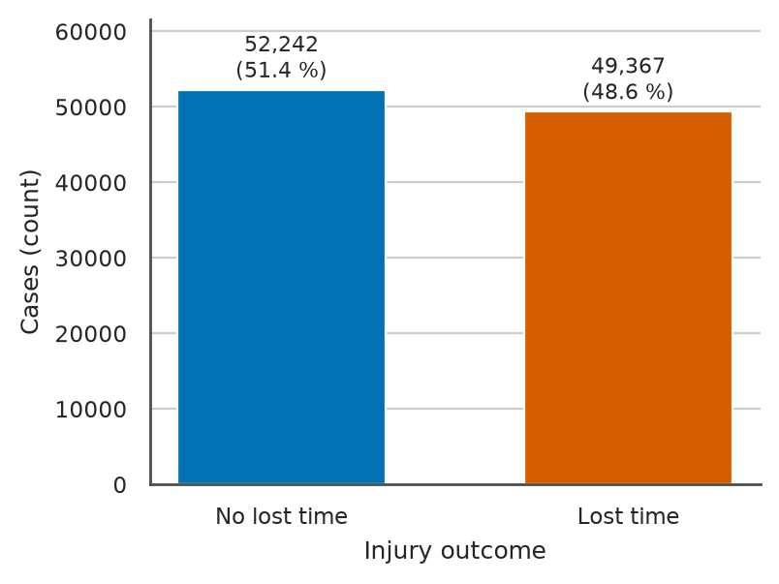
Figure 1. Counts and shares of non-lost-time and lost-time cases for all 101,609 in-scope rows before the split, drawn as a bar chart because two class sizes are compared. Source: author's analysis of MSHA open data.

2.3 Descriptive statistics and distributions
Table 6 covers the numeric features with the strongest target association or most extreme shape, and Table 22 in Appendix A covers the rest. Measures of centrality diverge under right skew, and total experience has a mean of 9.8 years, a median of 6.0 and a trimmed mean between them. The mean assumes symmetry and is pulled up by long careers, the median ignores how far the tail reaches, and the trimmed mean discards a fifth of the rows to resist both (Bruce et al., 2020). I chose the median as the imputation centre for skewed features. A mean fill would inflate the tenure of unrecorded rows, which are lost-time more often (Section 3.4), so the bias would fall on the costliest misses.
Table 6. Sample statistics of 12 of the 20 numeric features on the 81,289 training rows; the trimmed mean cuts 10% from each tail, variance and SD (sample standard deviation) use the n - 1 denominator, prev_hours is in thousands of employee-hours, and skewness is read against the bands below 0.5 symmetric, 0.5 to 1 moderate and above 1 high. Source: author's analysis of MSHA open data.
Feature (unit) | Missing % | Mean | Median | Trimmed mean | Variance | SD | Min | Q1 | Q3 | Max | IQR | Skewness
TOT_EXPER (years) | 1.2 | 9.8 | 6.0 | 8.0 | 108.6 | 10.4 | 0.02 | 1.9 | 14.4 | 60.0 | 12.5 | 1.37
log1p_tot_exper | 1.2 | 1.89 | 1.95 | 1.90 | 1.09 | 1.04 | 0.02 | 1.07 | 2.74 | 4.11 | 1.66 | -0.07
MINE_EXPER (years) | 1.4 | 5.8 | 2.6 | 4.0 | 64.6 | 8.0 | 0.02 | 0.7 | 7.5 | 58.0 | 6.8 | 2.25
JOB_EXPER (years) | 4.5 | 6.2 | 3.0 | 4.5 | 65.0 | 8.1 | 0.02 | 0.9 | 8.1 | 60.0 | 7.1 | 2.09
exper_ratio_mine (ratio) | 1.7 | 0.72 | 1.00 | 0.77 | 0.15 | 0.38 | 0.00 | 0.33 | 1.00 | 1.00 | 0.67 | -0.83
hours_into_shift (hours) | 3.8 | 4.8 | 4.5 | 4.7 | 8.4 | 2.9 | 0.0 | 2.5 | 7.0 | 16.0 | 4.5 | 0.42
longitude (degrees) | 0.2 | -92.6 | -87.5 | -90.9 | 217.9 | 14.8 | -166.6 | -104.0 | -81.5 | -64.9 | 22.5 | -1.20
prev_hours (thousand hours) | 1.2 | 612.7 | 247.0 | 413.6 | 1,044,971 | 1,022.2 | 0.001 | 69.6 | 829.6 | 7,735.3 | 760.0 | 4.27
prev_employees (persons) | 1.2 | 281.6 | 113.0 | 186.4 | 239,644 | 489.5 | 1 | 33 | 367 | 3,837 | 334 | 4.59
prev_incidents (count) | 1.2 | 15.8 | 6.0 | 9.9 | 667.0 | 25.8 | 0 | 1 | 19 | 190 | 18 | 3.11
prev_lost_time_rate_200k (log1p) | 1.2 | 0.86 | 0.79 | 0.78 | 0.65 | 0.81 | 0.00 | 0.00 | 1.46 | 3.93 | 1.46 | 0.60
prev_lost_time_share (ratio) | 19.8 | 0.48 | 0.50 | 0.48 | 0.11 | 0.33 | 0.00 | 0.22 | 0.75 | 1.00 | 0.53 | 0.01

Variance, a measure of variability, is in squared units, so the table adds the sample standard deviation in original units. For prev_hours it exceeds the mean, so a few very large mines dominate the spread. The standard deviation assumes symmetric spread, whereas the interquartile range (IQR) covers the middle half of the rows and assumes no shape (Han et al., 2022). I used the IQR for skewed features and outlier fences. Mines with 200 or more employees supply 36.7% of training rows, and treating their exposure as error would discard the insurer's largest group of cases.
The skewness columns of Table 6 and Table 22 put nine of the 20 numeric features in the high band above 1 in absolute value, with prev_employees the most skewed continuous measure. A log1p transform assumes positive values with multiplicative spread. A Yeo-Johnson transform fits its exponent but is harder to interpret, and raw values suit only trees, which split on rank order (Kuhn and Johnson, 2019). I added log1p versions of total experience and previous-year hours beside the raw columns.
Normality was checked with Q-Q plots of six features (Figure 2). Total experience bends away from the reference line at both ends, its log1p version follows the line except at its bounds, and prev_lost_time_share has point masses at both extremes. A Shapiro-Wilk test would reject normality for trivial departures at about 80,000 rows; a Q-Q plot shows where a distribution departs (Bruce et al., 2020). Pearson's r is pulled by tail points, so Spearman's rank correlation is reported beside it. Gaussian naive Bayes probabilities are likely to be miscalibrated, which would move a cost-based threshold and the review workload.
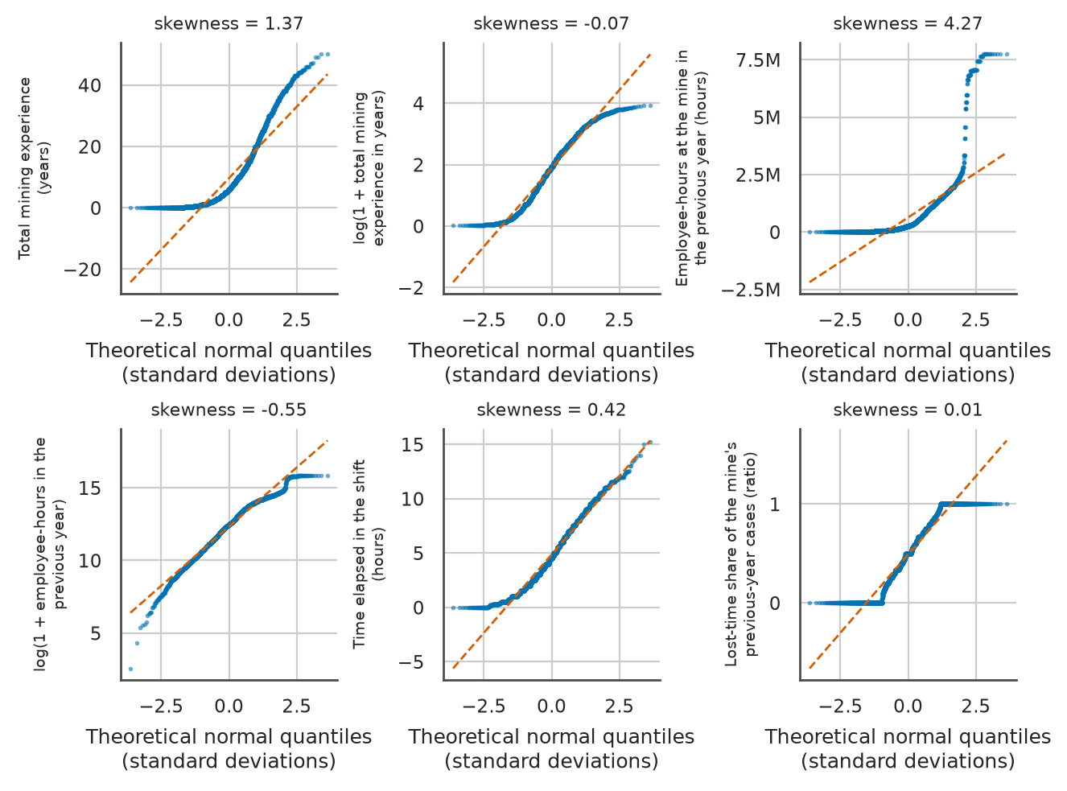
Figure 2. Normal Q-Q plots of six numeric features on the training split, with 5,000 seeded points per panel and skewness computed on all training rows; Q-Q plots are used because departures from the dashed reference line show where each distribution differs from a normal one. Source: author's analysis of MSHA open data.

2.4 Correlation and association
The correlation matrix of the 20 numeric features was computed with Pearson's r for linear and Spearman's rank correlation for monotone association (Figure 3). The two disagree most for log1p_prev_hours against prev_employees, 0.645 against 0.994, because the relation is monotone but curved. Pearson assumes linearity and reacts to extreme points, whereas Spearman assumes only monotonicity (Han et al., 2022). I therefore read redundancy from Spearman, since a Pearson-only reading would understate it. Redundant size measures let logistic-regression coefficients trade weight from one refit to the next, which would make the reasons the application shows beside each flagged claim unstable.
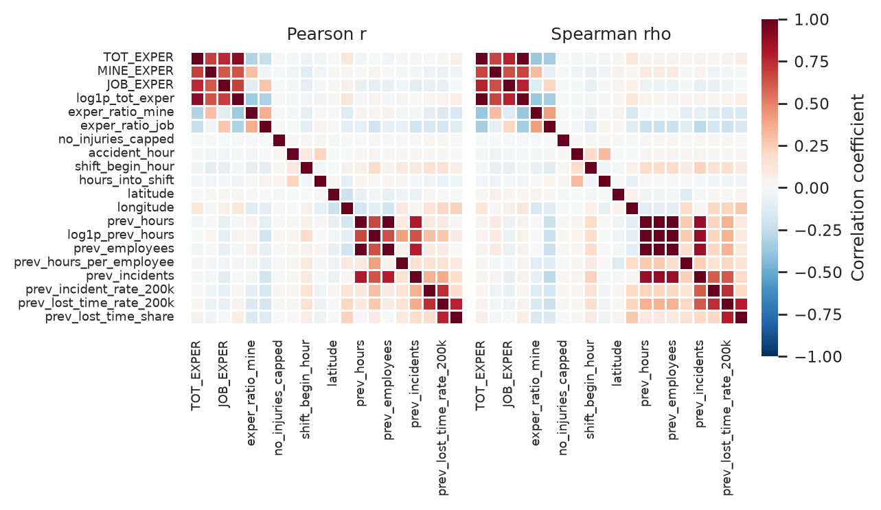
Figure 3. Pearson (left) and Spearman (right) correlation matrices of the 20 numeric features on the training split, drawn as heatmaps on one diverging scale centred at zero so that the two coefficients can be compared cell by cell. Source: author's analysis of MSHA open data.
Point-biserial r, Pearson's r with one dichotomous variable, ranked the numeric features against the target, and bias-corrected Cramer's V, which corresponds to the Phi coefficient for two levels, ranked the categorical features (Table 7). The leaders are prev_lost_time_share at r = 0.292 and NATURE_INJURY_CD at V = 0.391, far below the 0.95 level at which I would suspect leakage. Mutual information would capture non-monotone effects but carries no sign, and chi-square p-values cannot rank features when trivial effects are significant at this sample size (Tan et al., 2019). Total experience and shift start hour also enter the top ten, consistent with Yedla et al. (2020).
Table 7. Association of the numeric features (point-biserial r, top 10 by absolute value) and the categorical features (bias-corrected Cramer's V, top 10, number of levels in brackets) with the lost-time target, and the numeric features whose variance inflation factor exceeds 5 with their most correlated partner, all on the 81,289 training rows; every listed r and V has p < 0.001. Source: author's analysis of MSHA open data.
Rank | Numeric feature | r | Categorical feature (levels) | V | Feature with VIF > 5 | VIF | Partner (Pearson r)
1 | prev_lost_time_share | 0.292 | NATURE_INJURY_CD (27) | 0.391 | prev_hours | 176.4 | prev_employees (0.996)
2 | prev_lost_time_rate_200k | 0.205 | INJ_BODY_PART_CD (46) | 0.364 | prev_employees | 164.8 | prev_hours (0.996)
3 | longitude | 0.135 | INJURY_SOURCE_CD (124) | 0.311 | prev_lost_time_rate_200k | 8.3 | prev_lost_time_share (0.772)
4 | prev_incidents | 0.099 | ACCIDENT_TYPE_CD (41) | 0.282 | TOT_EXPER | 7.5 | log1p_tot_exper (0.895)
5 | exper_ratio_mine | -0.096 | FIPS_STATE_CD (54) | 0.243 | log1p_tot_exper | 6.0 | TOT_EXPER (0.895)
6 | exper_ratio_job | -0.083 | PRIMARY_CANVASS (5) | 0.239
7 | prev_incident_rate_200k | 0.073 | COAL_METAL_IND (2) | 0.237
8 | log1p_tot_exper | 0.068 | ACTIVITY_CD (96) | 0.225
9 | TOT_EXPER | 0.060 | CLASSIFICATION_CD (21) | 0.217
10 | shift_begin_hour | 0.058 | OCCUPATION (193) | 0.215

Multicollinearity is worst for mine size. Previous-year hours and employees correlate at r = 0.996, both with a variance inflation factor (VIF) above 160, and Table 7 lists three more features with a high VIF. In logistic regression this inflates coefficient variance and destabilises signs (Hosmer et al., 2013). In naive Bayes it breaks conditional independence, so size evidence is counted twice and posteriors become overconfident, although the ranking can survive (Domingos and Pazzani, 1997). Dropping one column assumes it adds nothing, and principal components give up interpretable features. I kept both, under the L2 penalty in logistic regression, and did not interpret the pair's coefficients. Overconfident probabilities would misplace the threshold, so calibration is checked in Section 4.

2.5 Visual analysis and plot justification
Figures were drawn with Matplotlib (Hunter, 2007) and seaborn (Waskom, 2021). Bars in Figure 1 compare two counts by length, which reads more accurately than pie angles. The heatmaps in Figure 3 share one diverging scale but miss interactions and categorical features, covered by Figure 7. I did not plot a full scatter matrix of the 20 numeric features, because 190 panels would be unreadable.
Figure 4 overlays class-wise density histograms and kernel density curves, because density puts unequal classes on one scale. All panels share 30 bins, since the Freedman-Diaconis rule would set between one bin for the capped victim count and 274 for hours per employee. Experience is often recorded in whole years, which gives the log-experience histogram regular spikes, a comb that the 60-bin panel in Figure 9 repeats. The classes overlap except on the previous-year lost-time share, where non-lost-time cases pile up at zero. Box plots (Figure 5) give the medians and quartiles that skewed features need; lost-time cases have the higher median lost-time share and lie further east, near the Appalachian coal fields.
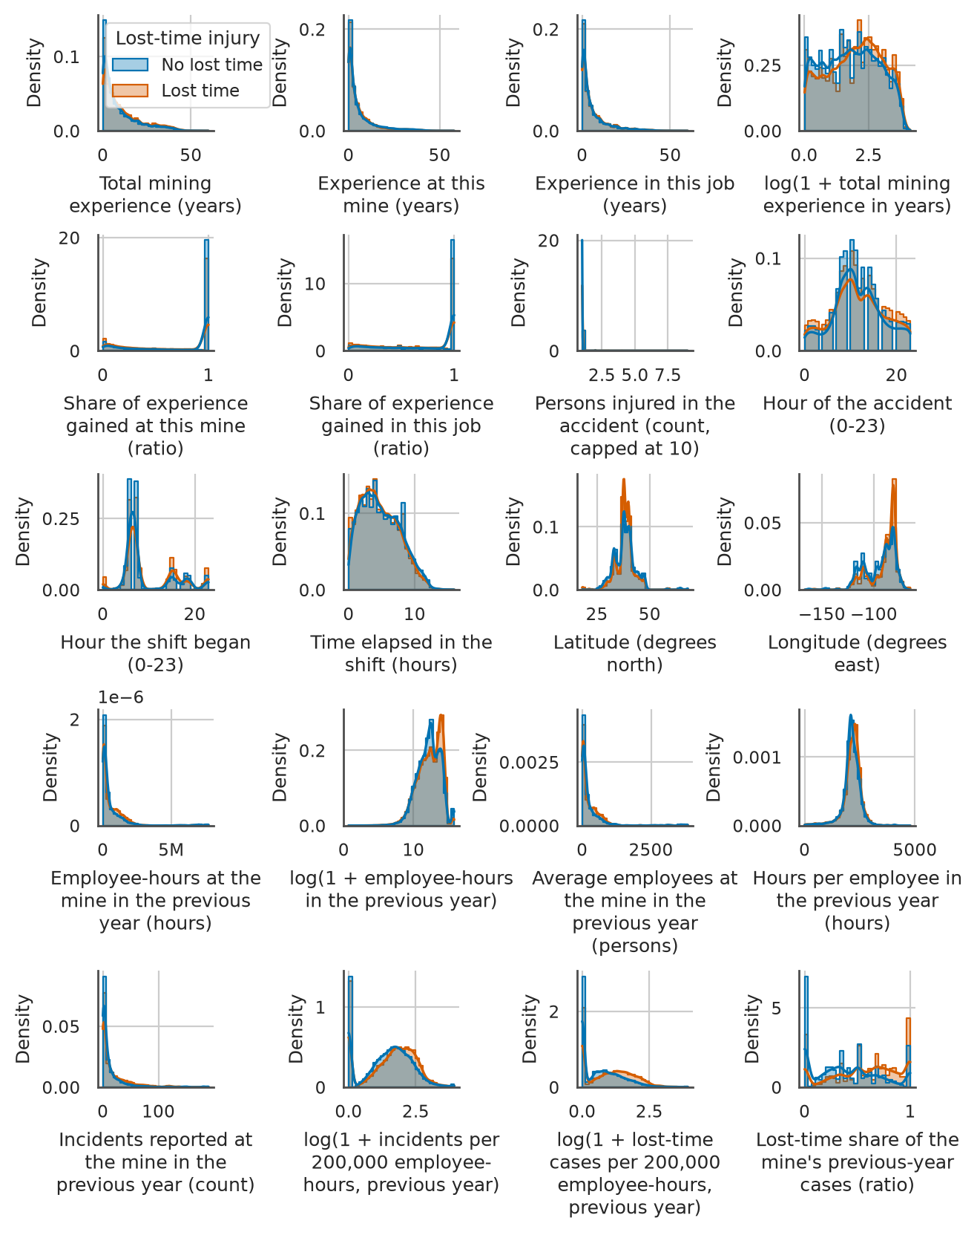
Figure 4. Density histograms (30 bins) with kernel density estimates of the 20 numeric features by outcome class on all 81,289 training rows, drawn as densities so that classes of unequal size share one scale. Source: author's analysis of MSHA open data.
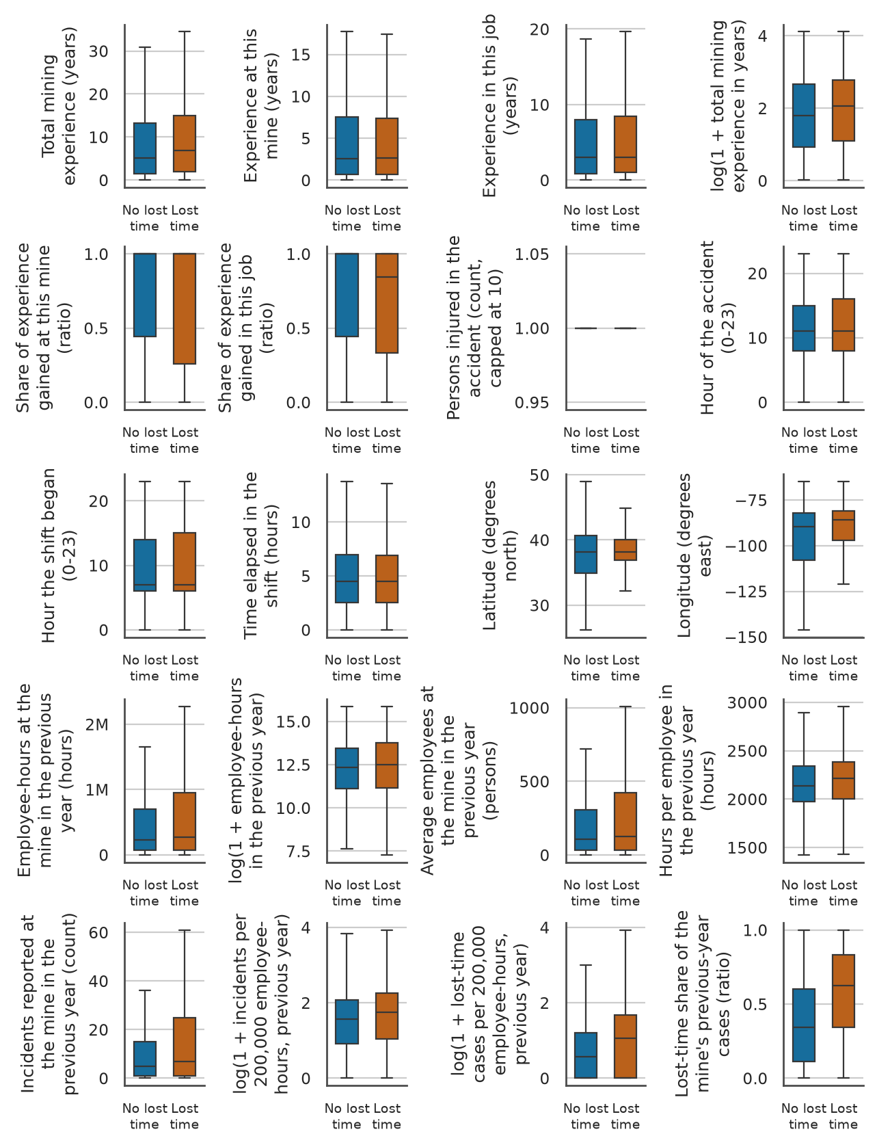
Figure 5. Box plots of the 20 numeric features by outcome class on all 81,289 training rows, with whiskers at 1.5 times the IQR and outlier points omitted, chosen because medians and quartiles are the comparison that skewed features need. Source: author's analysis of MSHA open data.
The corner pair plot (Figure 6) draws the five features most correlated with the target on 5,000 seeded rows to avoid overplotting; the lost-time history measures fan out together and the classes mix in every panel. Figure 7 plots lost-time rates per level for the eight categorical features with the highest V, since a rate shows how far a level moves the probability. Cuts and lacerations sit near 18% against 48.6% overall, coal mines above it, and printed sizes flag thin data.
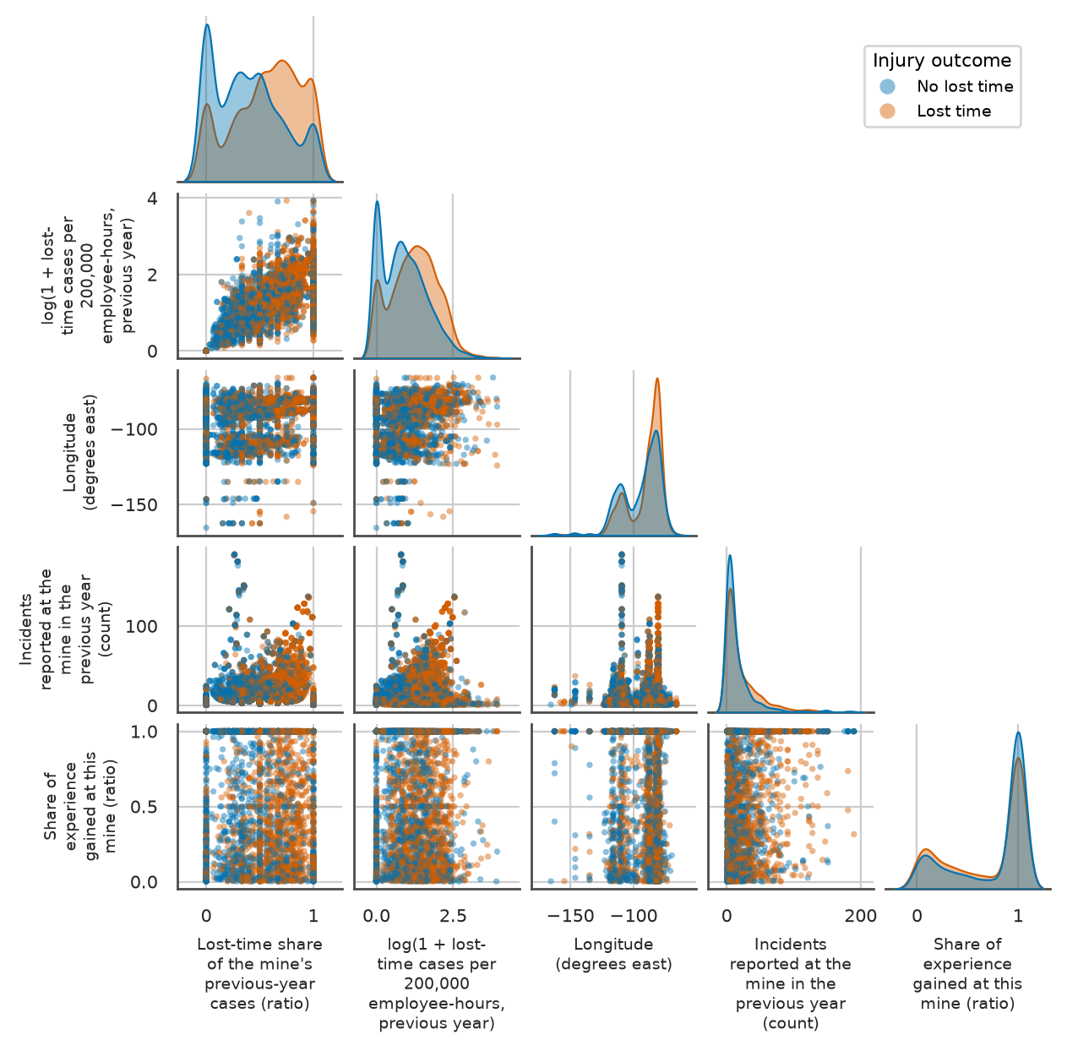
Figure 6. Corner pair plot of the five numeric features with the largest absolute point-biserial correlation, for 5,000 seeded training rows without missing values, coloured by outcome to show pairwise structure and class overlap. Source: author's analysis of MSHA open data.
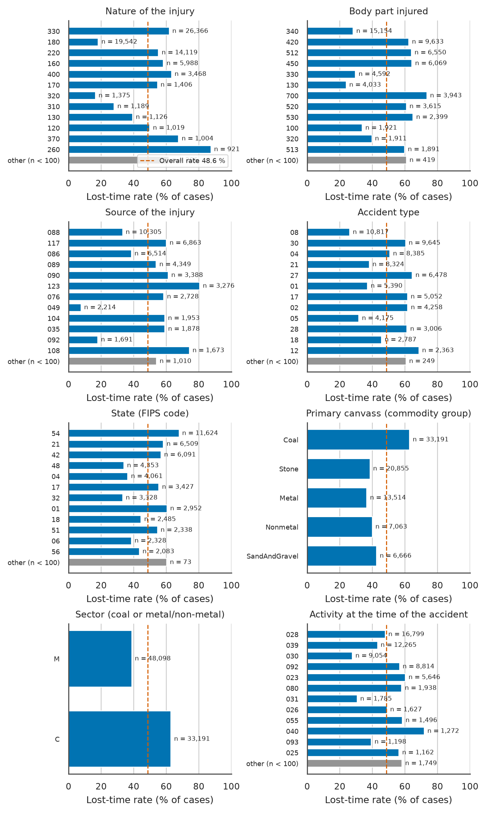
Figure 7. Lost-time rate per level for the eight categorical features with the highest Cramer's V on the training split, showing the twelve largest levels and a pooled bar for levels under 100 rows, with the overall rate dashed; proportion bars are used because the question is the rate per level. Source: author's analysis of MSHA open data.
Because imputation is decided per column, Figure 8 ranks the most incomplete columns as bars; underground, equipment and contractor gaps are structural, and one indicator covers the 985 rows missing all exposure columns (Section 3.4). In Figure 9, IQR fences flag 4,020 raw experience values and Z-score fences 714, because the tail inflates the standard deviation. After log1p neither rule flags any experience value, and Section 3.5 kept these long careers.
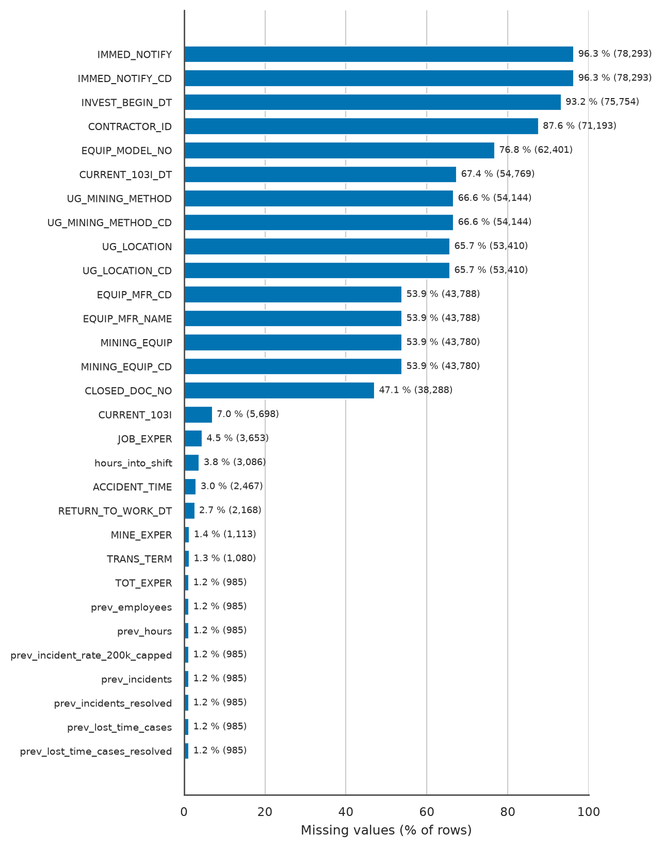
Figure 8. Percentage of missing values in the 30 most incomplete columns of the joined base table on the training rows, ranked as bars so that structural and sporadic gaps can be told apart. Source: author's analysis of MSHA open data.
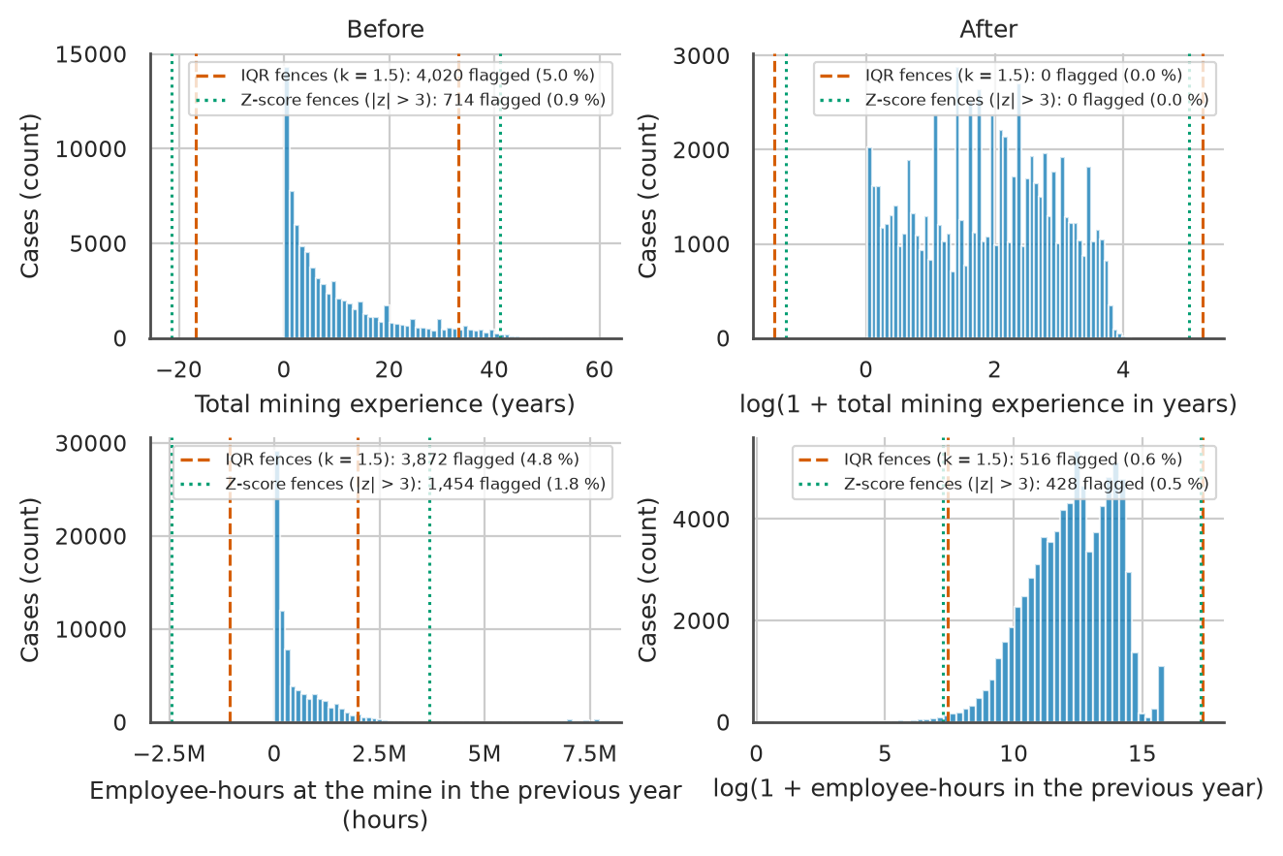
Figure 9. Histograms (60 bins) of total mining experience and previous-year employee-hours on the training split before (left) and after (right) the log1p transform, with the right-hand axes in log1p units, IQR fences (k = 1.5) and Z-score fences (|z| > 3) and the number of rows each flags, used to compare the two outlier rules on skewed data. Source: author's analysis of MSHA open data.
Two principal components of the standardised numeric features, explaining 18.5% and 16.1% of the variance, show whether the classes separate linearly (Figure 10). The classes overlap throughout, although a plane holding a third of the variance cannot rule out separation in more dimensions.
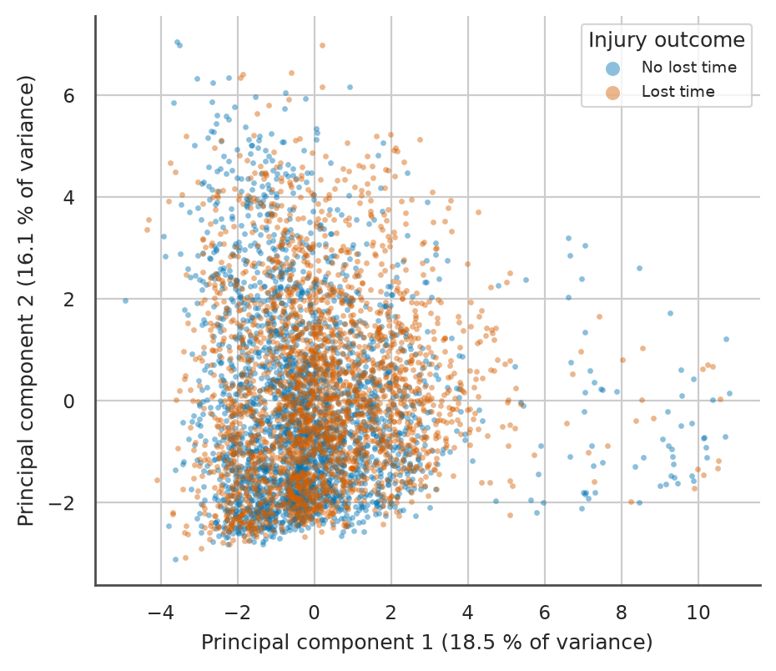
Figure 10. First two principal components of the 20 median-imputed and standardised numeric features, fitted on the training split with 5,000 seeded points shown and coloured by outcome, used to check for linear class separation in two dimensions. Source: author's analysis of MSHA open data.

3 Dataset preparation

3.1 Summary
Preparation followed the order of Table 8, whose last column gives the shape after each step, and Figure 11 draws the same flow. Type-safe loading read every Accidents row as text, and scope filtering kept 101,609 in-scope reports. Integration added the Mines and previous-year production tables with asserted row counts, the error rules blanked or recoded impossible values, and the duplicate audit removed nothing. Feature engineering and the leakage audit left the features of Table 5, and the mine-year grouped split held out a fifth of the rows for testing, without resampling. Imputation, outlier handling, encoding and scaling then turned the training split into an 81,289 x 552 matrix. All learned transformations are fitted on the training split only inside a scikit-learn Pipeline with ColumnTransformer (Pedregosa et al., 2011).
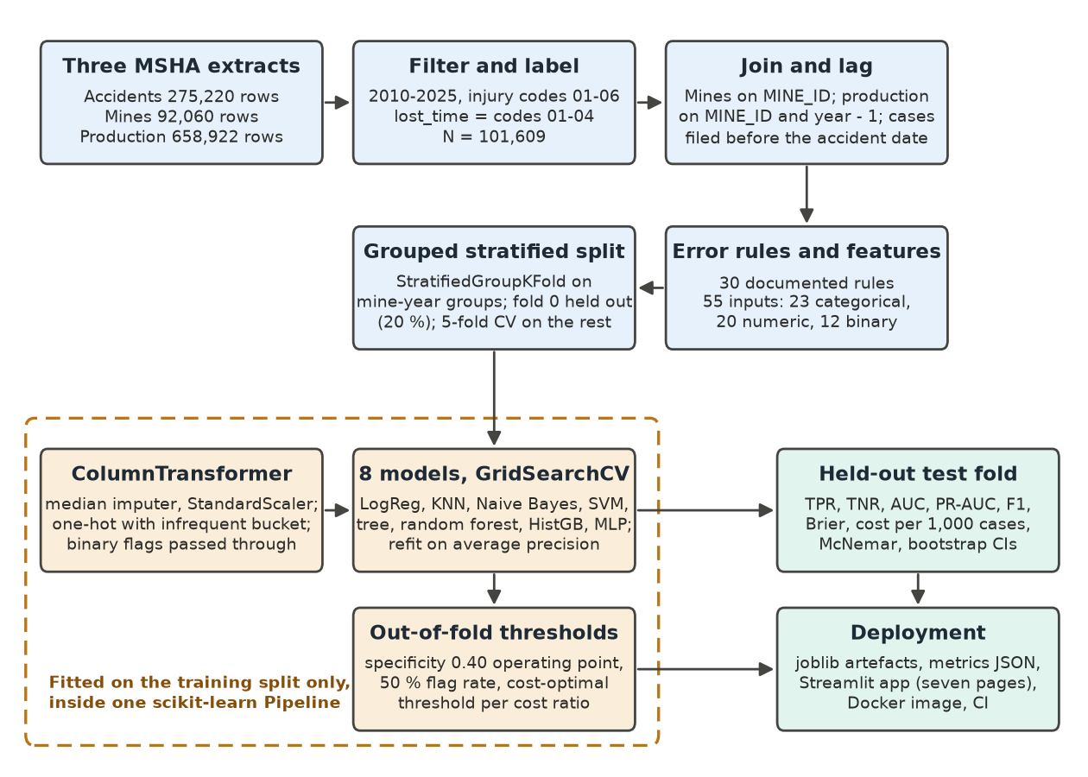
Figure 11. Preparation flow from the three MSHA files to the fitted model, in which stateless rules run on all 101,609 rows before the mine-year grouped split and every learned step is fitted inside one scikit-learn Pipeline on the 81,289 training rows; a flow diagram is used because the order of the steps carries the leakage argument. Source: author's analysis of MSHA open data.

3.2 Integration and error correction
I read every column as text, because type inference would strip the leading zeros from MINE_ID, and asserted every join's row count (Table 4). The error rules learn nothing, so they ran on all rows before the split. Job experience exceeded total experience on 3,731 rows by a median of six years, too much for rounding (Table 8). Clipping assumes the job field is overstated and a swap assumes a data-entry exchange; I set the value to missing with a flag, because neither assumption can be checked (Han et al., 2022). A blank stops invented tenure from moving a case across the review threshold.

3.3 Duplicates and multi-victim accidents
No row is an exact duplicate, and five rows match only when the document number, closing document and narrative are ignored (Table 8). Dropping them assumes double filing; keeping them assumes distinct victims, as MSHA requires one Form 7000-1 per injured person (Mine Safety and Health Administration, no date). Collapsing the 2,614 same-day multi-victim groups would make the accident the unit, although insurers reserve per claimant. I kept every row, one per claimant to reserve, and the grouped split keeps each same-day group on one side.

3.4 Missing values
Numeric gaps are small except for the previous-year lost-time share, absent on 19.8% of training rows (Figure 8). Blank-experience reports are lost-time in 59.3% of training cases against 48.5% of recorded ones, so the gaps are not missing completely at random (MCAR). Blank experience clusters in early years (Table 8), consistent with missing at random (MAR) given year and mine (Rubin, 1976). The lost-time share is structurally undefined (zero over zero) at mines without a previous-year case.
Listwise deletion needs MCAR, mean imputation presumes symmetry, and KNNImputer or IterativeImputer, which predict gaps from other features, would invent histories for quiet mines (van Buuren, 2018). I chose SimpleImputer with the median for skewed numerics plus seven explicit indicators, since add_indicator would repeat one flag across six co-missing exposure columns. Structural placeholders became their own level and other categorical gaps a constant "missing" level, since most_frequent would place surface accidents underground. Columns over 60% blank, other than structural placeholders, were dropped. The indicators carry the higher lost-time rate of unrecorded reports into the score, so fewer such cases go unreviewed.

3.5 Outliers
Total experience has a skewness of 1.37 and previous-year hours 4.27 (Table 6). Right skew inflates the standard deviation behind the Z-score rule and puts its lower fence below zero. Tukey's IQR fences rest on quartiles (Tukey, 1977) but assume symmetric tails, so at this skew they flag over five times as many experience rows as the Z-score rule (Figure 9), all plausible veteran careers. I kept the values, added log1p versions and left clipping as an application option. Lagged rates were winsorised, since at the smallest mines a single case gives an extreme rate. Linear, distance-based and Gaussian models react to such extremes, while tree splits use only rank.

3.6 Instance selection and class balance
Scope filtering was the only instance selection and left a training prevalence of 48.6% (Table 8). SMOTE inside the folds assumes interpolated neighbours are plausible cases, which fails for one-hot codes (Chawla et al., 2002; Lemaitre et al., 2017), and under- or over-sampling discards or repeats rows. I applied no resampling, searched class_weight for logistic regression and left the cost asymmetry to an out-of-fold threshold tuned in Section 4. The test set was never resampled. Resampling would also bias the probabilities that adjusters see and that set the cost-optimal threshold.

3.7 Feature engineering
Every engineered feature uses fields known at filing (Table 5). Clock and calendar features give accident and shift-start hours, a night flag, hours into shift, weekday, weekend and month. Experience features add log1p of total experience, mine and job shares of the total and a new-to-mine flag. Exposure features give hours per employee and size bands, and history features turn previous-year cases filed before the accident date into rates per 200,000 hours and a lost-time share. Same-year hours were rejected because quarterly hours reports arrive after the quarter (Legal Information Institute, no date b), and accident-date counting because 1.9% of prior cases were filed after the accident (Table 8; Kaufman et al., 2012; Kuhn and Johnson, 2019). Leakage would overstate the test recall on which review capacity is planned.

3.8 Encoding and scaling
Most categorical features are nominal codes with up to 193 levels (Table 8). Ordinal encoding assumes an order that linear models read as magnitude and target encoding needs fold-safe estimates, so I chose OneHotEncoder with handle_unknown="infrequent_if_exist" and a min_frequency of 0.1%, which pools rare and unseen levels. The ordered size band stayed one-hot, as its lost-time rate is not monotonic, and only the target was label-encoded. Under MinMaxScaler a few very large mines would squeeze most previous-year hours into the bottom tenth of the range, and Normalizer mixes units within a row. I applied StandardScaler to logistic regression, K-nearest neighbours (KNN), support vector machine (SVM), multilayer perceptron (MLP) and Gaussian naive Bayes and no scaler to the tree models, whose splits ignore monotone rescaling (Pedregosa et al., 2011). Unscaled hours would dominate distances, so KNN flags would follow mine size.

3.9 Train, validation and test split
A stratified random split would treat rows as independent. Yet the mean label of later accidents in the same mine-year ranks a row with a ROC-AUC of 0.667, near the best planned feature (Table 8). Four numeric features, the coordinates and previous-year hours and employees, identify the mine-year for 99.9% of rows, so KNN and tree ensembles could memorise outcomes. Grouping by mine alone would test only unseen mines, yet 91.9% of reports from 2020 came from mines that had filed before.
I held out one StratifiedGroupKFold fold of mine-year groups (random_state 42) as the test set, with five-fold StratifiedGroupKFold on the training rows for validation (Kohavi, 1995). Assertions confirm disjoint groups and prevalence within one percentage point of the whole. The insurer therefore sees recall on unseen mine-years, with temporal and mine-grouped splits as secondary checks.

Table 8. Preprocessing decision log in execution order, giving for each step the problem found, the options considered, the choice and the data shape afterwards; counts in steps 1 to 9 refer to all 101,609 in-scope rows and counts in steps 10 to 14 to the 81,289 training rows of the grouped split unless a cell says otherwise, E codes name the error rules logged in reports/metrics/error_rules.csv, and a table is used so that every step is judged on the same six attributes. Source: author's analysis of MSHA open data.
Step | Problem found (evidence, count) | Options considered | Chosen | Why | Rows x cols after
1 Load and type coercion | Pipe-delimited latin-1 files fail strict UTF-8; codes such as MINE_ID are zero-padded text; placeholders ?, ? , NO VALUE FOUND; trailing spaces (E26, E27) | pandas type inference; all columns as text, then explicit conversion | Text read, str.strip(), placeholders to NaN, to_numeric for numeric fields only | Inference turns 0200024 into an integer and breaks the join | 275,220 x 57 (Accidents)
2 Scope filter | 2026 partial and provisional (47.0% of its code 03/04 rows lack DAYS_LOST); experience blank on 20.1% of pre-2010 rows; codes 00 and 07-10 are not accident injuries to employees (19,932 rows in 2010-2025) | All years and codes; years only; years and codes | CAL_YR 2010-2025 and degree codes 01-06 | Complete label; one row is one injured worker | 101,609 x 57
3 Integration (Mines, previous-year production, lagged cases) | Production unique on MINE_ID, year and subunit (658,922 of 658,922); 1,206 rows without previous-year production (lost-time 53.7% vs 48.5%) | Inner join; same-year left join; previous-year left join | Left joins, validate="many_to_one", indicator columns, asserted row counts; Mines matched 100.0%, previous-year production 98.8%; commodity flags agree on 100.0% | Inner join drops new or idle mines; same-year hours are unreported at filing | 101,609 x 88
4 Error rules for experience and victim count (E1-E4, E21) | Job experience above total on 3,731 rows (median excess 6.0 years); mine experience above total on 83; any value above 60 years on 3; negative values 0; victim count above 10 on 33 | Clip to total; swap fields; drop rows; NaN with flag | NaN plus exper_inconsistent flag; assertion for negatives; victim count capped at 10 | A swap is plausible but unprovable, so clipping invents tenure; dropping loses 3.7% of rows | 101,609 rows, values only
5 Error rules for times, places, dates and mine attributes (E5-E12, E22-E25) | Accident time 9999 on 3,091 rows and 2400 on 326; shift start 9999 or blank on 519, 2400 on 1,833, three characters on 48; shift wraps midnight on 11,538; more than 16 h into shift on 662; invalid coordinates 3; 103(i) status dated after the accident or blank 22,368; previous-year hours below 2,000 on 764 | String slicing; drop rows; NaN or recode | Integer HHMM parsing, 2400 to 00:00, 9999 to NaN, minute difference modulo 1,440, more than 16 h to NaN; coordinates outside the valid box to NaN; later-dated 103(i) status to "Unknown"; lagged rates winsorised at 50 per 200,000 h; dates asserted valid (0 failures) | Each rule decodes a convention or blanks an impossible value without inventing data; counts logged in error_rules.csv | 101,609 x 96
6 Duplicates and multi-victim accidents | Exact duplicates 0; DOCUMENT_NO unique; 5 rows identical without DOCUMENT_NO, CLOSED_DOC_NO and NARRATIVE; 2,614 same-day mine groups hold 5,530 rows (883 with mixed labels) | Drop near duplicates; one row per accident; keep | Keep every row; same-day groups kept on one side of the split | One Form 7000-1 per injured person, so the rows are distinct claimants | 101,609 x 96
7 Leakage and sparse-column removal | DAYS_LOST Cramer's V 0.955 with the target; CLOSED_DOC_NO present for 72.2% of positives vs 33.5% of negatives; Mines status date after the accident for 40.4% of rows; EQUIP_MODEL_NO 76.7% blank | Keep with caveat; keep for EDA only; drop | Drop outcome fields, snapshot attributes, identifiers and columns more than 60% missing | Not known, or not reliable, when the form is filed | 101,609 rows
8 Feature engineering | Raw HHMM times, dates, counts and hours; 1.9% of previous-year cases filed after the row's accident date | Raw fields; same-year exposure; previous-year counts cut at accident date; cut at filing date | Clock, calendar, experience, report-flag, exposure, lagged-history, 103(i)-status, coordinate and missing-indicator features with the filing-date cut | Every feature passes the known-at-filing check | 101,609 x 55 (23 categorical, 20 numeric, 12 binary)
9 Train, validation and test split | 82.3% of rows share a mine-year with another date; later siblings' mean label gives ROC-AUC 0.667; unstratified group folds give prevalence 46.5-50.9% | Stratified random 80/20; group by MINE_ID (8,303 groups); temporal 2010-2019 vs 2020-2025 | StratifiedGroupKFold (5 folds, shuffle, random_state = 42) on 32,732 mine-years, fold 0 as test; 5-fold StratifiedGroupKFold on the training rows as validation | No mine-year or same-day group crosses the split; prevalence 48.6% in both train and test | Train 81,289 x 55; test 20,320 x 55 (6,724 mine-years)
10 Class balance | Training prevalence 48.6%; negative to positive 1.058 on all rows | None; class_weight; random under- or over-sampling; SMOTE inside folds; threshold tuning | No resampling; class_weight in the logistic-regression grid; threshold tuned on out-of-fold probabilities; test set untouched | Near balance; resampling distorts the probabilities used by the cost threshold | 81,289 x 55
11 Missing values | Missing on training rows: TOT_EXPER 1.2%, JOB_EXPER 4.5% (after E1), hours_into_shift 3.8%, previous-year exposure 1.2%, prev_lost_time_share 19.8%, coordinates 0.2%; structural placeholders 53.9-66.6%; lost-time 59.3% when TOT_EXPER is blank vs 48.5% when recorded; TOT_EXPER blank on 2.2% of 2010 rows and under 1% from 2017 onwards | Listwise deletion; mean; median; most_frequent; KNNImputer; IterativeImputer; add_indicator | SimpleImputer(median) for numerics; seven explicit indicator flags; level "none" for structural placeholders; constant level "missing" for other categorical gaps | Skewed columns; not MCAR; built-in indicators would repeat one flag six times | 81,289 x 55, no NaN
12 Outliers and skew | Skewness TOT_EXPER 1.37, prev_hours 4.27; TOT_EXPER flagged by IQR fences 4,020 (5.0%) vs Z-score 714 (0.9%); prev_hours 3,872 (4.8%) vs 1,454 (1.8%) | IQR clip; Z-score clip; log1p; keep | Keep values; add log1p of both (log1p TOT_EXPER flags 0 under both rules); clipping as an application option | Flagged values are real veterans and large mines; impossible values handled by E3 and E25 | 81,289 x 55
13 Encoding | 23 nominal features; OCCUPATION 193 titles, EQUIP_MFR_NAME 132, INJURY_SOURCE_CD 124 on training rows; unseen levels possible at inference | One-hot; ordinal; target encoding; label encoding | OneHotEncoder(handle_unknown="infrequent_if_exist", min_frequency=0.001); OrdinalEncoder as application option; label encoding for the target only | No false order; levels below about 81 training rows and unseen levels pooled | 81,289 x 552
14 Scaling | prev_hours from 1 to 7,735,308 h (median 246,979); experience 0.02 to 60 years | StandardScaler; MinMaxScaler; RobustScaler; Normalizer; none | StandardScaler for logistic regression, KNN, SVM, MLP and Gaussian naive Bayes; none for decision tree, random forest and histogram-based gradient boosting | Distance, gradient and variance-based models need comparable scales; tree splits are invariant to monotone rescaling | 81,289 x 552

4 Modelling

4.1 Summary
The task is supervised binary classification of each Form 7000-1 report as lost-time or not, with a probability that ranks the adjuster's review queue. Eight algorithms were compared on the same split and fold scheme (Table 9): logistic regression, KNN, Gaussian naive Bayes, a decision tree, a random forest, histogram-based gradient boosting (HGB), an SVM with a radial basis function (RBF) kernel and an MLP. Each was tuned by GridSearchCV, or RandomizedSearchCV for the forest, over five StratifiedGroupKFold folds of mine-year groups inside the training split. PR-AUC, computed as average precision, was the primary metric and the refit criterion (Table 10). Decision thresholds were then fixed on out-of-fold probabilities, so the test set was scored once. HGB ranked first in cross-validation (Table 11) and on the test set (Table 12), with a test PR-AUC of 0.841. At its capacity threshold it flags about three reports in four and finds 0.943 of lost-time cases with a precision of 0.599 (Table 13; Table 16). It passes five of the six performance criteria and misses recall at half capacity by a small margin (Table 17).

4.2 Algorithm selection
Encoding yields 552 columns, mostly zero-valued one-hot indicators beside skewed numeric and binary features (Table 8). Size relations are monotone but curved and collinear (Table 7). Nominal codes lead the associations, and the classes are near balance. An adjuster needs a reason for every flag and the application scores forms on demand, so interpretability and speed also counted (Table 9).
Table 9. The eight candidate algorithms with their paradigm, key assumption, the violation found in the training split and the bias it introduces, scaling need, interpretability and the module week in which each was taught; violations refer to the exploratory analysis of the training split in Section 2. Source: author's analysis of MSHA open data.
Algorithm | Paradigm | Key assumption | Violation in this data and resulting bias | Scaling | Interpretability | Taught week
Logistic regression | parametric; discriminative; eager | log-odds linear and additive in the encoded columns | curved size effects (Pearson r 0.645 against Spearman 0.994) and nature x body part interactions; underfits (high bias) | StandardScaler | high: coefficients convert to odds ratios | 4
KNN | non-parametric; discriminative; lazy (instance-based) | rows close in scaled Euclidean space share outcomes | 552 mostly binary dimensions flatten distances, so votes drift towards the local base rate | StandardScaler | low: a flag is explained only by similar past reports | 5
Gaussian naive Bayes | parametric; generative; eager | features independent given the class, each Gaussian within a class | collinear size measures (VIF above 160) and nine highly skewed numeric features; evidence counted twice, overconfident posteriors | StandardScaler (var_smoothing is relative to the largest variance) | medium: class-conditional means | 5
Decision tree (CART) | non-parametric; discriminative; eager | classes separate in axis-aligned boxes | curved effects need many steps; greedy splits give high variance | none | high when shallow: if-then rules | 6
Random forest | non-parametric bagging ensemble; discriminative; eager | averaging decorrelated deep trees cancels their variance | few violations; averaged leaf frequencies pull probabilities towards the middle | none | medium: permutation importance | 6
Histogram-based gradient boosting (HGB) | non-parametric boosting ensemble; discriminative; eager | log-odds is a sum of small trees on binned features | rare levels pooled into one column; greedy binned splits; tied to the training-period mix of codes | none | medium: permutation importance and SHAP values | 6
SVM, RBF kernel | non-parametric (kernel); discriminative; eager | a smooth wide-margin boundary in kernel space | training cost at least quadratic in rows, so fitted on 10,000 rows; scores need Platt scaling | StandardScaler | low: margin scores only | 5
MLP | parametric; discriminative; eager | a smooth mapping learnable by gradient descent | tens of thousands of weights on sparse one-hot inputs; overfits without alpha and early stopping | StandardScaler | low: needs post-hoc explanation | 10

Logistic regression passes a weighted sum of the inputs through the sigmoid and minimises binary cross-entropy by lbfgs, a quasi-Newton relative of gradient descent, under an L2 penalty that weakens as C rises (Hosmer et al., 2013). Linear log-odds miss curved size effects and code interactions, so it underfits. Its readable odds ratios made it the transparency benchmark. Gaussian naive Bayes applies Bayes' theorem, combining the class prior with per-feature Gaussian likelihoods into a posterior. Conditional independence fails for the duplicated size measures and normality for the skewed and binary features (Figure 2), so evidence is counted twice and posteriors become overconfident. Ranking can survive this (Domingos and Pazzani, 1997), and it stayed as a fast generative baseline and calibration test.
KNN, a lazy instance-based learner, labels a report by the vote of its K nearest training rows under Euclidean distance, with K odd to avoid ties (Cover and Hart, 1967). Distances need standardised inputs and lose contrast across 552 mostly binary dimensions, the curse of dimensionality. It tests whether similarity to past claims adds signal; since scoring compares each report with every stored row, I fitted it on whole mine-years capped at 40,000 rows. An SVM maximises the margin between the classes, with C penalising rows inside the margin and the RBF width gamma setting how local the boundary is (Cortes and Vapnik, 1995). Training time grows at least quadratically with rows, so I fitted it on whole mine-years capped at 10,000 rows and obtained probabilities by Platt scaling. It stayed to check whether a smooth boundary ranks lost-time cases better than tree splits.
A decision tree splits greedily on the axis-aligned threshold that most reduces Gini impurity or entropy. It needs no scaling and nests interactions, yet a small change in the rows can alter every split below the root. A random forest averages deep trees grown on bootstrap samples with a random feature subset per split, which decorrelates them and cuts that variance (Breiman, 2001). The tree stayed as the single-tree reference for the ensembles, the forest as the bagging rival to HGB.
HGB adds shallow trees in stages, fitting each to the gradient of the log loss and shrinking it by the learning rate, with capped leaf nodes and early stopping. It follows the second-order boosting of XGBoost (Chen and Guestrin, 2016). As a sum of small trees, its log-odds can follow curved effects and code interactions. Tree ensembles lead on medium-sized tabular data (Grinsztajn et al., 2022), so it was expected to rank the review queue best.
The MLP trains one or two hidden layers of rectified linear units by Adam, a gradient-descent variant, with alpha as an L2 penalty and early stopping (Bishop, 2006). Tens of thousands of weights on mostly zero inputs invite overfitting, so the network stayed small. It tests whether learned code combinations add recall at the capacity threshold.
Three families were rejected. Time-series models such as ARIMA assume one quantity observed at regular intervals, but each row is a separate claim and time enters through lagged mine history. Clustering would discard the label, so unsupervised methods stayed in the exploratory analysis (Figure 10). Deep tabular networks trail tree ensembles at this scale and need more tuning than the MLP (Grinsztajn et al., 2022). Because no algorithm wins on every problem (Wolpert, 1996), the eight were compared under one protocol.
The learning curve places that comparison in bias-variance terms (Hastie et al., 2009). On a 10,000-row subsample HGB's training score falls and validation score rises as rows are added (Figure 12), so its gap is variance that more data removes. Naive Bayes shows almost no gap at a low score, so its error is bias (Table 10). A flexible, regularised learner therefore suits this volume of data.
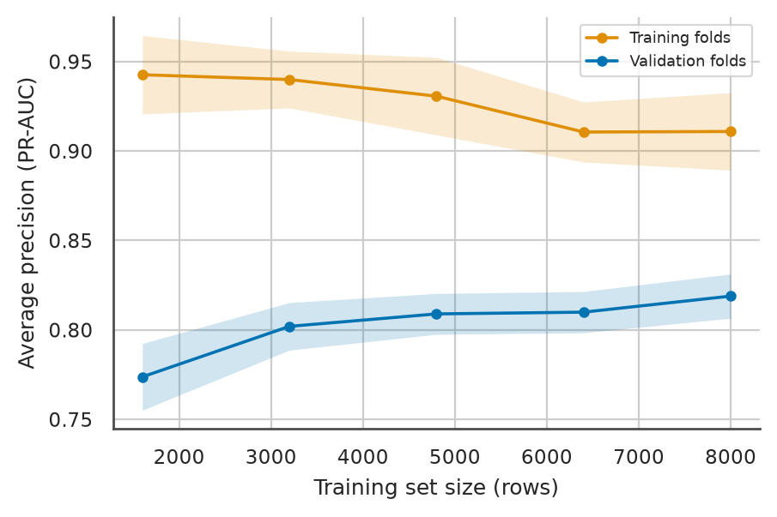
Figure 12. Learning curve of HGB with its selected settings, giving mean training-fold and validation-fold PR-AUC (average precision) with one standard deviation bands over five grouped folds of a 10,000-row subsample of the training split, drawn against training size because the gap between the two curves separates variance from bias. Source: author's analysis of MSHA open data.

4.3 Model selection per algorithm
Every search tuned the whole pipeline, which refitted imputers, encoder, scaler and classifier on the training rows of each fold (Figure 11). I used five StratifiedGroupKFold folds over mine-year groups inside the training split, which keep each mine-year on one side and the lost-time share near that of the whole. Kohavi (1995) favoured ten stratified folds; five halved the fits and left about 16,000 rows per validation fold. Grouping mirrors deployment, where the insurer scores mine-years the model has not seen, so no setting is rewarded for memorising a mine's other claims. PR-AUC was the refit metric, with the other metrics recorded alongside. Seed 42 fixed the folds, subsamples and estimators.
Table 10 lists every searched hyperparameter with its meaning, bounds, selected value and the best score reached with any other value. Most grids contain the scikit-learn default and step towards stronger and weaker regularisation, and settings outside them kept defaults for the reasons listed. The random forest is the exception, since RandomizedSearchCV sampled only part of its grid; the full grid, searched after testing, added 0.001 with 200 trees. For HGB, both caps on boosting rounds scored identically at the faster learning rate, because early stopping ended training before either cap.
Table 10. Hyperparameter search per model on the 81,289 training rows with five grouped folds; the first row of each model gives the search, the number of candidates, the selected candidate's validation PR-AUC (mean ± SD) and its training-fold PR-AUC, the last column the best validation PR-AUC with another value (in brackets), and the rows marked as follow-up give wider grids searched after the test scoring, which changed no choice. Source: author's analysis of MSHA open data.
Model (search; validation PR-AUC; training PR-AUC) | Hyperparameter: meaning | Values searched | Why these bounds | Selected | Best other value
Logistic regression (grid, 8 candidates; 0.820 ± 0.003; 0.828) | C: inverse strength of the L2 penalty | 0.01, 0.1, 1, 10 | four decades around the default of 1 | 1 | 0.820 (10); 0.815 (0.01)
 | class_weight: reweights the classes in the loss | None, balanced | tests reweighting as the alternative to resampling at near balance | None | 0.820 (balanced)
 | Fixed settings | L2 penalty, lbfgs solver, max_iter 2,000 | L2 suits collinear columns; no convergence warning was logged
KNN (grid, 6; 0.764 ± 0.009; 1.000) | n_neighbors (K): number of voters | 11, 25, 51 | odd values from a local to a smooth vote | 51 | 0.758 (25)
 | weights: equal or inverse-distance votes | uniform, distance | lets close neighbours count more | distance | 0.757 (uniform)
 | p: Minkowski power | 2 | Euclidean distance only, to keep six candidates | 2 | none
 | Fixed settings | brute-force search; 39,999-row subsample of whole mine-years | tree indexes do not help in 552 dimensions; scoring cost grows with stored rows
 | Follow-up grid (6 candidates, 265 s) | n_neighbors 51, 101, 151 with both weightings | the original optimum sat at the grid edge | 51, distance (0.764) | 0.763 (101); 0.761 (151)
Gaussian naive Bayes (grid, 5; 0.734 ± 0.006; 0.735) | var_smoothing: share of the largest variance added to every variance | 1e-9, 1e-6, 1e-3, 0.1, 1 | log-spaced from the default upwards, since near-constant one-hot columns have tiny variances | 0.1 | 0.702 (1)
 | Fixed settings | class priors from training frequencies | the priors then equal the 48.6% prevalence
Decision tree (grid, 24; 0.803 ± 0.004; 0.827) | max_depth: longest root-to-leaf path | 4, 8, 12, None | from a readable tree to unlimited growth | 12 | 0.793 (None)
 | min_samples_leaf: smallest leaf | 5, 20, 50 | larger leaves give steadier lost-time rates | 50 | 0.794 (20)
 | criterion: impurity measure | gini, entropy | the two impurity measures taught | gini | 0.802 (entropy)
 | Fixed settings | best split over all features; no cost-complexity pruning | depth and leaf size already prune the tree
Random forest (random search, 4 of 24 grid points; 0.821 ± 0.003; 0.946) | n_estimators: number of trees | 100, 200 | the default and double | 100 | not sampled
 | max_depth: longest path in each tree | 8, 12, None | as for the single tree | None | 0.808 (12)
 | min_samples_leaf: smallest leaf | 5, 20 | small leaves suit averaged deep trees | 5 | 0.815 (20)
 | max_features: features tried per split | sqrt, log2 | the two usual subset sizes for decorrelation | sqrt | not sampled
 | Fixed settings | bootstrap samples, Gini impurity | the design of Breiman (2001)
 | Follow-up grid (all 24 points, 559 s) | every combination of the values above | the random search sampled four points | 200 trees, otherwise as selected (0.822 ± 0.003) | 0.821 (100 trees); 0.810 (log2)
HGB (grid, 16; 0.838 ± 0.003; 0.873) | learning_rate: shrinkage applied to each tree | 0.05, 0.1 | the default and half of it | 0.05 | 0.837 (0.1)
 | max_iter: cap on boosting rounds | 200, 400 | caps only, since early stopping ends training | 400 | 0.837 (200)
 | max_leaf_nodes: leaves per tree | 15, 31 | the default and about half | 31 | 0.836 (15)
 | l2_regularization: penalty on leaf values | 0, 1 | no penalty or a unit penalty | 0 | 0.838 (1)
 | early_stopping | True | stops after 10 rounds without loss improvement on a 10% validation split | True | none
 | Fixed settings | min_samples_leaf 20, 255 bins, no depth limit | the leaf count already limits tree size
 | Follow-up grid (24 candidates, 1,104 s) | max_leaf_nodes 15, 31, 63; min_samples_leaf 20, 100 in place of the inert max_iter (fixed at 400); learning_rate and l2_regularization as above | 31 leaves sat at the grid edge, and leaf size was not searched | 63 leaves, min_samples_leaf 100, l2 1 (0.840 ± 0.003; training 0.886) | 0.838 (selected settings)
SVM, RBF kernel (grid, 4; 0.795 ± 0.014; 0.858) | C: penalty on margin violations | 1, 10 | the default and a weaker penalty; each fit took about three minutes | 1 | 0.786 (10)
 | gamma: RBF kernel width | scale, 0.01 | the default heuristic and one fixed value | 0.01 | 0.791 (scale)
 | Fixed settings | Platt scaling over five inner folds; 9,913-row subsample of whole mine-years | probabilities are needed for thresholds; training time is quadratic in rows
MLP (grid, 9; 0.833 ± 0.004; 0.870) | hidden_layer_sizes: units per hidden layer | (64), (128), (128, 64) | one or two small layers for about 65,000 rows per fold | (128) | 0.832 (64)
 | alpha: L2 weight penalty | 1e-4, 1e-2, 1e-1 | log-spaced from the default upwards | 0.01 | 0.832 (0.1)
 | Fixed settings | ReLU units; Adam with initial learning rate 0.001; batches of 200; early stopping on a 10% split; at most 200 epochs | standard settings, with early stopping against overfitting

Figure 13 plots training and validation PR-AUC against each search's most varied hyperparameter. The decision tree underfits at depth 4 with equal scores, overfits at unlimited depth with a wide gap and peaks at depth 12 with large leaves. The random forest's deep trees open a wider gap still, yet its validation score rises with depth, because averaging cancels much of each tree's variance. The SVM overfits as C grows and has the largest fold-to-fold spread, a cost of its small subsample.
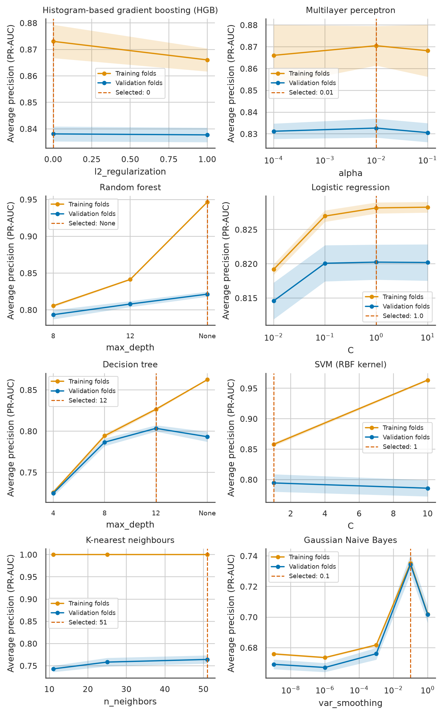
Figure 13. Validation curves of the eight tuned models, giving mean training-fold and validation-fold PR-AUC (average precision) with one standard deviation bands over the five grouped folds of the training split against the hyperparameter with most searched values, the other hyperparameters held at their selected values (for the random forest, the best sampled candidate per value), with the selected value dashed; curves are drawn because the train-validation gap and its shape show over- and underfitting. Source: author's analysis of MSHA open data.
Logistic regression is flat from C = 0.1 upwards, with training and validation scores close together, which marks a high-bias model. KNN scores 1.000 on its training folds under distance weighting, because each training row is its own nearest neighbour. Its validation score was still rising at the grid edge of K = 51, yet K = 101 and 151, tried after testing, scored lower. Gaussian naive Bayes peaks sharply in var_smoothing without a gap; one smoothing constant decides its score. HGB and the MLP have flat curves and moderate gaps, so their model class matters more than the selected values.
The threshold was tuned as a further hyperparameter on out-of-fold probabilities, never on test rows, whose labels would then make the reported recall optimistic. The capacity rule takes the lowest threshold whose out-of-fold specificity reaches the target, a second rule flags half the cases, and a cost rule minimises out-of-fold expected cost at each cost ratio (Figure 14). For HGB the capacity threshold of 0.210 gave a test specificity of 0.403 against the 0.40 target, so the review workload planned on training rows held on unseen mine-years.
The grids stayed narrow for compute reasons (Table 15). Searches took from about a minute for logistic regression to twenty minutes for four SVM candidates, and the temporal split repeated all of them. Wider grids for KNN, the forest and HGB, searched after the test scoring and not used for selection, raised no validation PR-AUC by more than 0.002 (Table 10), within one fold standard deviation. Under the one-standard-error rule, which picks the simplest candidate within one standard error of the best mean (Hastie et al., 2009), logistic regression would take a tenfold stronger penalty, the MLP its smaller layer and HGB the faster learning rate with fewer rounds. I kept the highest mean, since each alternative lies within fold noise and none changes the ranking of algorithms.

4.4 Evaluation metrics
A true positive (TP) is a lost-time case flagged at filing, whose reserve and return-to-work plan then start early. A false negative (FN) is a lost-time case left in routine handling, the miss priced at USD 4,000 in Table 1. A false positive (FP) sends a restricted-duty or no-lost-time case to an unnecessary review costing about USD 200, and a true negative (TN) is such a case left alone. Accuracy, the share of correct cells, was reported but not used, because it prices both errors alike and the majority class reaches 0.514 while flagging nothing (Table 12).
Recall, the true positive rate (TPR), is TP / (TP + FN), the share of lost-time cases flagged and the quantity the insurer most needs. Precision, TP / (TP + FP), is the share of flags that are lost-time and sets the review effort per catch. Specificity, the true negative rate (TNR), is TN / (TN + FP), the share of other cases left alone, which fixes the workload. F1, the harmonic mean of precision and recall, weights both errors equally, so it was reported but not optimised; the expected cost states the asymmetry that an F-beta score would only approximate. Balanced accuracy averages TPR and TNR, and the Matthews correlation coefficient (MCC) is zero for any constant prediction, so both expose a model that flags everything.
ROC-AUC is the probability that a random lost-time case scores above a random other case and does not depend on prevalence (Fawcett, 2006). PR-AUC averages precision over all recall levels, and its no-skill level equals the prevalence of 0.486. A model dominates in precision-recall space exactly when it dominates in ROC space (Davis and Goadrich, 2006). At this prevalence the imbalance argument of Saito and Rehmsmeier (2015) does not apply, and the two measures rank the models alike. PR-AUC is primary because precision is the review yield along the adjuster's queue, while S3 measures recall at the planned capacity.
Because the application shows each probability and the cost rule takes it at face value, calibration was checked. The Brier score, the mean squared gap between probability and outcome, is 0.250 for a constant prediction at the prevalence, and Figure 15 compares predicted with observed rates. Gaussian naive Bayes places many lost-time cases in its lowest bin, the overconfidence expected in Section 2.4. HGB follows the diagonal. Expected cost per 1,000 cases is 1,000 x (FN x C_FN + FP x C_FP) / N, with C_FP from Table 1 and C_FN set by the cost ratio (Figure 14). Reviewing everything costs the same at any ratio, and at high ratios the cheapest threshold flags nearly every case at about that cost, so cost separates models only at the low ratios that S4 tests.
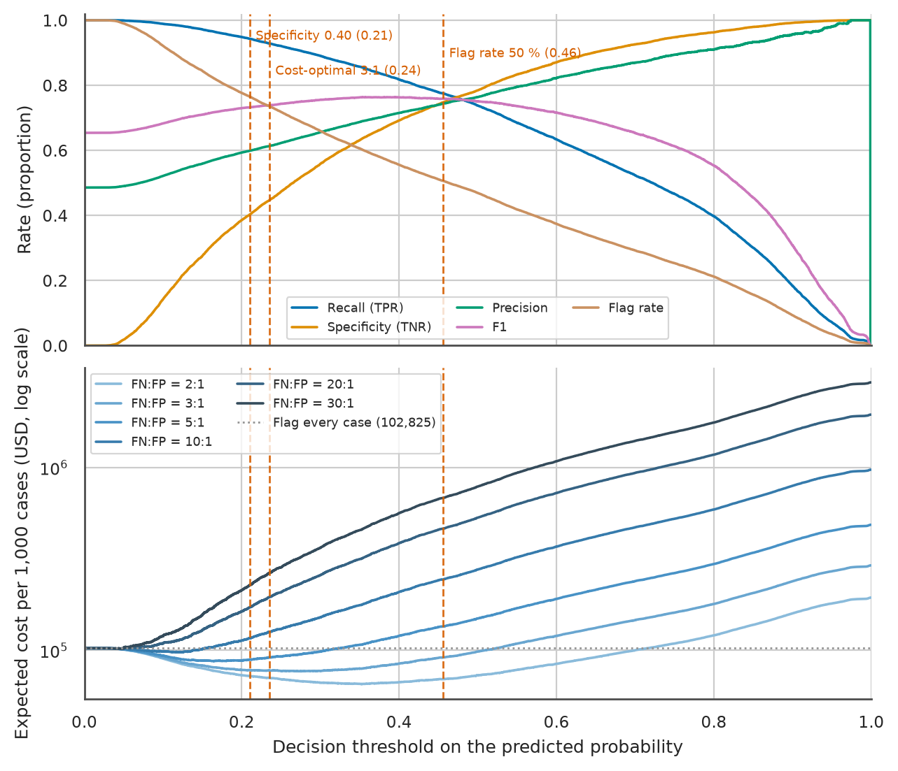
Figure 14. Recall, specificity, precision, F1 and flag rate (top) and expected cost per 1,000 cases at six cost ratios on a log scale (bottom) against the decision threshold of HGB on the 20,320 test reports, with the three out-of-fold thresholds dashed and the cost of reviewing everything dotted; one threshold axis lets each rate and cost be read at the same cut-off. Source: author's analysis of MSHA open data.
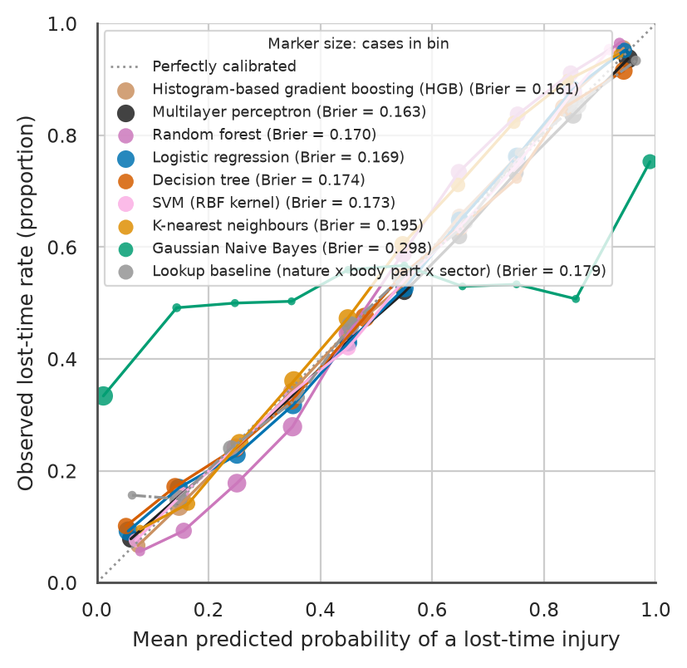
Figure 15. Calibration curves of the eight tuned models and the lookup baseline on the 20,320 test reports, plotting the observed lost-time rate against the mean predicted probability in ten equal-width bins with marker size proportional to the cases in each bin and Brier scores in the legend; a reliability diagram is used because the application displays these probabilities. Source: author's analysis of MSHA open data.
Cross-validated scores are fold means and standard deviations on training rows and served selection only; the test set was scored once with every choice fixed, and the two sit in separate tables. No metric here captures fairness between sectors, whose label partly records employer practice, or drift after the training years, so results are also reported by sector and on a temporal split (Table 21).

4.5 Comparison and final model
Table 11 gives the cross-validated scores and Table 12 the test scores at the default threshold of 0.5. HGB leads both, the MLP is second, and logistic regression nearly ties the random forest. The curves of the top six models lie close together, while KNN and naive Bayes fall below the lookup baseline (Figure 16; Figure 17). At each capacity threshold, recall is close among the top six, and the MLP's highest recall comes with the lowest specificity (Table 13).
Table 11. Cross-validated scores (mean ± SD over five grouped folds of the 81,289-row training split) of each model's selected candidate at the default threshold of 0.5, ordered by PR-AUC, the refit metric; KNN and the SVM were cross-validated on their 39,999-row and 9,913-row subsamples, and TNR is pooled over the out-of-fold predictions of all training rows, so it has no SD. Source: author's analysis of MSHA open data.
Model | PR-AUC | ROC-AUC | F1 | Recall (TPR) | TNR (pooled) | Precision | Accuracy | Brier
HGB | 0.838 ± 0.003 | 0.839 ± 0.002 | 0.743 ± 0.002 | 0.723 ± 0.007 | 0.789 | 0.764 ± 0.005 | 0.757 ± 0.002 | 0.163 ± 0.001
MLP | 0.833 ± 0.004 | 0.835 ± 0.004 | 0.740 ± 0.007 | 0.719 ± 0.019 | 0.788 | 0.763 ± 0.007 | 0.755 ± 0.002 | 0.166 ± 0.002
Random forest | 0.821 ± 0.003 | 0.828 ± 0.003 | 0.732 ± 0.004 | 0.704 ± 0.009 | 0.793 | 0.762 ± 0.003 | 0.750 ± 0.002 | 0.173 ± 0.001
Logistic regression | 0.820 ± 0.003 | 0.825 ± 0.002 | 0.739 ± 0.002 | 0.740 ± 0.007 | 0.751 | 0.738 ± 0.005 | 0.746 ± 0.002 | 0.171 ± 0.001
Decision tree | 0.803 ± 0.004 | 0.812 ± 0.004 | 0.724 ± 0.015 | 0.715 ± 0.046 | 0.753 | 0.735 ± 0.021 | 0.735 ± 0.004 | 0.176 ± 0.002
SVM, RBF kernel | 0.795 ± 0.014 | 0.807 ± 0.011 | 0.722 ± 0.017 | 0.722 ± 0.020 | 0.752 | 0.723 ± 0.016 | 0.731 ± 0.015 | 0.179 ± 0.005
KNN | 0.764 ± 0.009 | 0.766 ± 0.008 | 0.648 ± 0.013 | 0.585 ± 0.017 | 0.793 | 0.725 ± 0.014 | 0.691 ± 0.010 | 0.197 ± 0.003
Gaussian naive Bayes | 0.734 ± 0.006 | 0.735 ± 0.002 | 0.601 ± 0.003 | 0.529 ± 0.006 | 0.781 | 0.696 ± 0.006 | 0.659 ± 0.003 | 0.305 ± 0.003

Table 12. Test-set scores of the eight tuned models and four baselines on the 20,320 held-out reports at the default threshold of 0.5, in the brief's column order with F1, PR-AUC and accuracy added and ordered by PR-AUC; TPR equals recall, TP / (TP + FN), and both columns are kept because the brief lists both, while TNR is specificity, TN / (TN + FP). Source: author's analysis of MSHA open data.
Model | TPR | TNR | AUC | Recall | Precision | F1 | PR-AUC | Accuracy
HGB | 0.738 | 0.785 | 0.843 | 0.738 | 0.764 | 0.751 | 0.841 | 0.762
MLP | 0.749 | 0.769 | 0.839 | 0.749 | 0.754 | 0.752 | 0.837 | 0.759
Random forest | 0.707 | 0.799 | 0.833 | 0.707 | 0.769 | 0.737 | 0.827 | 0.755
Logistic regression | 0.744 | 0.758 | 0.829 | 0.744 | 0.744 | 0.744 | 0.825 | 0.751
SVM, RBF kernel | 0.731 | 0.763 | 0.820 | 0.731 | 0.744 | 0.737 | 0.811 | 0.747
Decision tree | 0.676 | 0.799 | 0.817 | 0.676 | 0.761 | 0.716 | 0.805 | 0.739
Lookup baseline (nature x body part x sector) | 0.655 | 0.801 | 0.804 | 0.655 | 0.756 | 0.702 | 0.790 | 0.730
KNN | 0.589 | 0.807 | 0.773 | 0.589 | 0.743 | 0.657 | 0.770 | 0.701
Gaussian naive Bayes | 0.524 | 0.802 | 0.741 | 0.524 | 0.715 | 0.605 | 0.741 | 0.667
Baseline: hand rule (not a cut, dust in the eye or a scratch) | 0.898 | 0.423 | 0.660 | 0.898 | 0.595 | 0.716 | 0.584 | 0.654
Baseline: majority class | 0.000 | 1.000 | 0.500 | 0.000 | 0.000 | 0.000 | 0.486 | 0.514
Baseline: review everything | 1.000 | 0.000 | 0.500 | 1.000 | 0.486 | 0.654 | 0.486 | 0.486

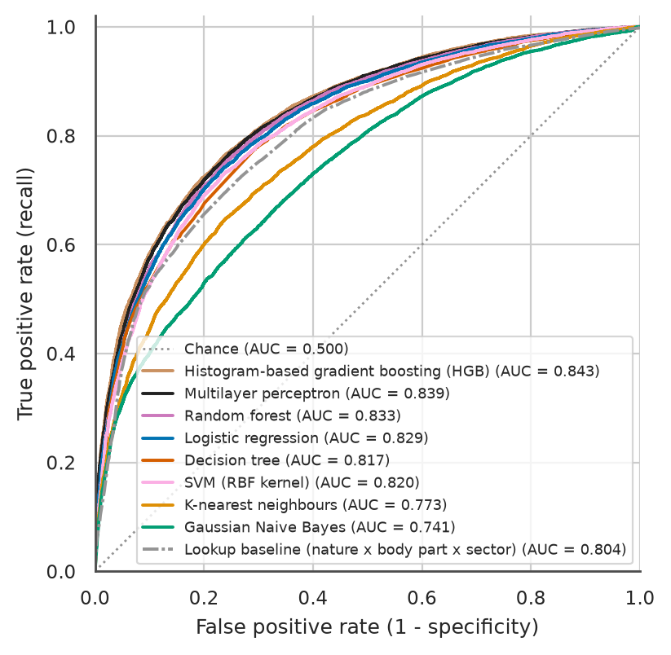
Figure 16. ROC curves of the eight tuned models and the lookup baseline on the 20,320 test reports, with test ROC-AUC in the legend and the chance diagonal dotted; ROC space is shown because it does not depend on prevalence. Source: author's analysis of MSHA open data.
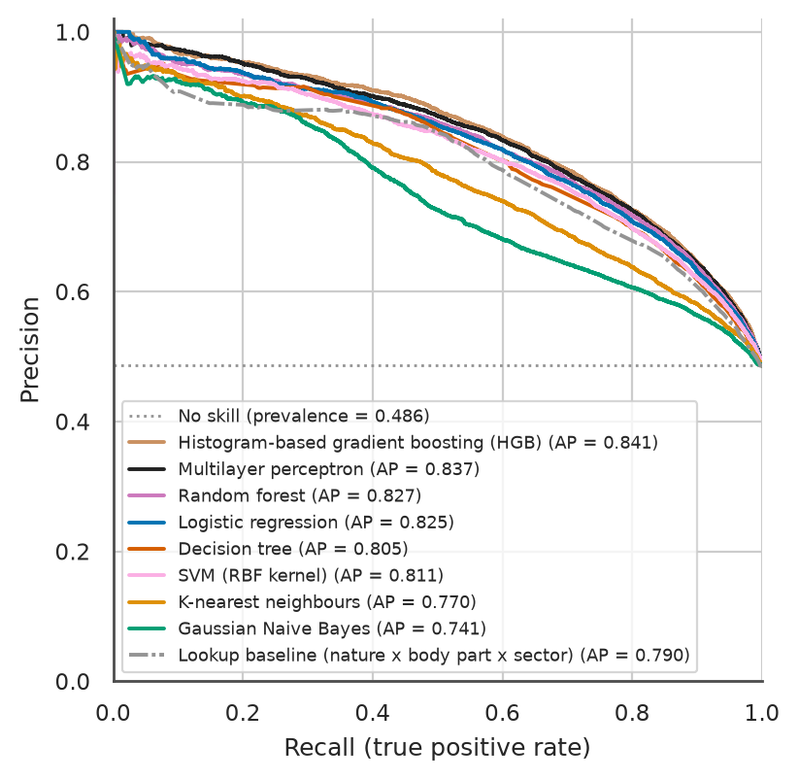
Figure 17. Precision-recall curves of the eight tuned models and the lookup baseline on the 20,320 test reports, with average precision (PR-AUC) in the legend and the prevalence of 0.486 dotted as the no-skill level; precision-recall space is shown because precision along the curve is the review cost of each lost-time case found. Source: author's analysis of MSHA open data.
Table 13. Test-set scores on the 20,320 held-out reports at each model's capacity threshold, the lowest threshold whose out-of-fold specificity reached 0.40 on the training split, with the resulting flag rate, balanced accuracy, MCC and Brier score; the threshold-free AUC and PR-AUC are in Table 12, and the two constant baselines are omitted because no threshold changes a constant score. Source: author's analysis of MSHA open data.
Model | Threshold | Flag rate | TPR (recall) | TNR | Precision | F1 | Balanced accuracy | MCC | Brier
HGB | 0.210 | 0.765 | 0.943 | 0.403 | 0.599 | 0.733 | 0.673 | 0.409 | 0.161
MLP | 0.187 | 0.783 | 0.948 | 0.373 | 0.588 | 0.726 | 0.660 | 0.389 | 0.163
Random forest | 0.290 | 0.759 | 0.935 | 0.408 | 0.599 | 0.730 | 0.672 | 0.401 | 0.170
Logistic regression | 0.222 | 0.760 | 0.934 | 0.405 | 0.597 | 0.728 | 0.669 | 0.396 | 0.169
SVM, RBF kernel | 0.237 | 0.753 | 0.927 | 0.411 | 0.598 | 0.727 | 0.669 | 0.391 | 0.173
Decision tree | 0.239 | 0.774 | 0.932 | 0.376 | 0.585 | 0.719 | 0.654 | 0.368 | 0.174
Lookup baseline (nature x body part x sector) | 0.225 | 0.753 | 0.916 | 0.402 | 0.591 | 0.719 | 0.659 | 0.368 | 0.179
KNN | 0.308 | 0.733 | 0.886 | 0.412 | 0.588 | 0.707 | 0.649 | 0.337 | 0.195
Gaussian naive Bayes | 0.001 | 0.727 | 0.868 | 0.407 | 0.580 | 0.696 | 0.637 | 0.308 | 0.298
Baseline: hand rule (not a cut, dust in the eye or a scratch) | not applicable (fixed rule) | 0.733 | 0.898 | 0.423 | 0.595 | 0.716 | 0.660 | 0.363 | 0.346

Table 14 tests whether these differences exceed noise (Dietterich, 1998; Demšar, 2006). McNemar's test rejects equal error rates between HGB and the lookup baseline at both thresholds, also when clustered by mine-year (Durkalski et al., 2003). Between the top two, the paired fold test gives p = 0.044 after the Nadeau and Bengio (2003) correction for overlapping training folds, while the Wilcoxon test cannot fall below 0.0625 with five folds. The MLP's test PR-AUC lies inside HGB's mine-year bootstrap interval, so the gap between the top two sits at the edge of noise and the gap to the lookup baseline does not.
Table 14. Statistical comparisons of HGB, namely McNemar tests against the lookup baseline on the 20,320 test reports at the default and capacity thresholds, row-wise and clustered by the 6,724 test mine-years, paired tests against the MLP on the five cross-validation folds of PR-AUC, and 95% percentile bootstrap intervals (1,000 resamples) of test metrics by rows and by mine-years. Source: author's analysis of MSHA open data.
Comparison | Test | Result | p-value
HGB against lookup baseline, threshold 0.5 | McNemar, rows treated as independent | chi-square 131.7; HGB alone correct on 1,929 reports, lookup baseline alone on 1,278 | below 0.001
HGB against lookup baseline, threshold 0.5 | McNemar clustered by mine-year (Durkalski et al., 2003) | chi-square 78.5 | below 0.001
HGB against lookup baseline, capacity thresholds (0.210 and 0.225) | McNemar, rows treated as independent | chi-square 35.2; 1,289 against 1,004 reports | below 0.001
HGB against lookup baseline, capacity thresholds | McNemar clustered by mine-year (Durkalski et al., 2003) | chi-square 24.4 | below 0.001
HGB against MLP, cross-validated PR-AUC | paired t-test | mean difference 0.0054 (SD 0.0028); HGB higher in all five folds; t = 4.36 | 0.012
HGB against MLP, cross-validated PR-AUC | corrected resampled t-test (Nadeau and Bengio, 2003) | t = 2.90 | 0.044
HGB against MLP, cross-validated PR-AUC | Wilcoxon signed-rank | W = 0 | 0.0625, the smallest value possible with five folds
HGB, test PR-AUC 0.841 | bootstrap of rows; bootstrap of mine-years | 0.835 to 0.848; 0.825 to 0.856
HGB, test ROC-AUC 0.843 | bootstrap of rows; bootstrap of mine-years | 0.838 to 0.848; 0.835 to 0.851
HGB, recall 0.943 at the capacity threshold | bootstrap of rows; bootstrap of mine-years | 0.939 to 0.947; 0.938 to 0.949

I selected HGB by the rule fixed before any test score was computed, the highest cross-validated PR-AUC, where its lead over the MLP exceeds one fold standard deviation (Table 11). Table 15 reports test-set evidence that checks this choice but did not make it. HGB has the lowest expected cost at the three low cost ratios, and its thresholds landed nearer their targets, where the MLP over-flagged. At an equal workload both catch the same share of lost-time cases. On the temporal split HGB kept the higher PR-AUC, and its specificity barely moved when the 103(i) status or the immediate-reporting flag was removed, unlike the MLP's.
Its permutation importance puts nature of injury and body part first (Figure 18), as do most of the largest logistic coefficients, and two of its four largest mean SHAP values (Table 23; Lundberg and Lee, 2017), for cuts and finger injuries, match negative coefficients (Figure 19). The final pipeline uses the settings of Table 10, refitted on all training rows, at its out-of-fold capacity threshold (Table 16; Figure 20). There it flags about three test reports in four and misses 561 of 9,873 lost-time cases, against 830 misses for the lookup baseline at about the same specificity.
Table 15. Multi-criteria comparison of the four strongest tuned models and the SVM, compiled after HGB was selected by cross-validated PR-AUC: test-set cost at the out-of-fold cost-optimal thresholds, transfer of out-of-fold threshold targets to the test set, recall at one equal workload, the temporal split (top two only), explanations, run times on eight workers and the size of the saved pipeline. Source: author's analysis of MSHA open data.
Criterion | HGB | MLP | Random forest | Logistic regression | SVM, RBF kernel
Cross-validated PR-AUC (rank of eight) | 0.838 (1) | 0.833 (2) | 0.821 (3) | 0.820 (4) | 0.795 (6)
Test PR-AUC | 0.841 | 0.837 | 0.827 | 0.825 | 0.811
Test cost per 1,000 cases at 2:1 / 3:1 / 5:1 (USD) | 65,896 / 77,697 / 87,638 | 67,274 / 78,031 / 89,085 | 67,648 / 78,839 / 90,463 | 68,760 / 80,079 / 90,945 | 70,955 / 82,234 / 93,317
Test specificity at the out-of-fold threshold for specificity 0.40 | 0.403 | 0.373 | 0.408 | 0.405 | 0.411
Test flag rate at the out-of-fold threshold for a 50% flag rate | 0.506 | 0.525 | 0.497 | 0.498 | 0.498
Test recall at one equal workload, the top 75.9% of test scores (the median flag rate of the eight capacity thresholds) | 0.940 | 0.940 | 0.935 | 0.933 | 0.930
Temporal split: PR-AUC on 2020-2025 | 0.843 | 0.834 | not run | not run | not run
Temporal split: specificity at the capacity threshold across three feature variants | 0.376 to 0.378 | 0.313 to 0.425 | not run | not run | not run
Explanation available | permutation importance; SHAP values | permutation importance | permutation importance | coefficients as odds ratios | permutation importance
Scaler needed | no | yes | no | yes | yes
Tuning time (s) | 580 | 188 | 140 | 71 | 1,193
Prediction time for 20,320 reports (s) | 0.27 | 0.12 | 0.64 | 0.09 | 45.36
Saved pipeline (MB) | 0.45 | 0.81 | 20.37 | 0.01 | 1.25

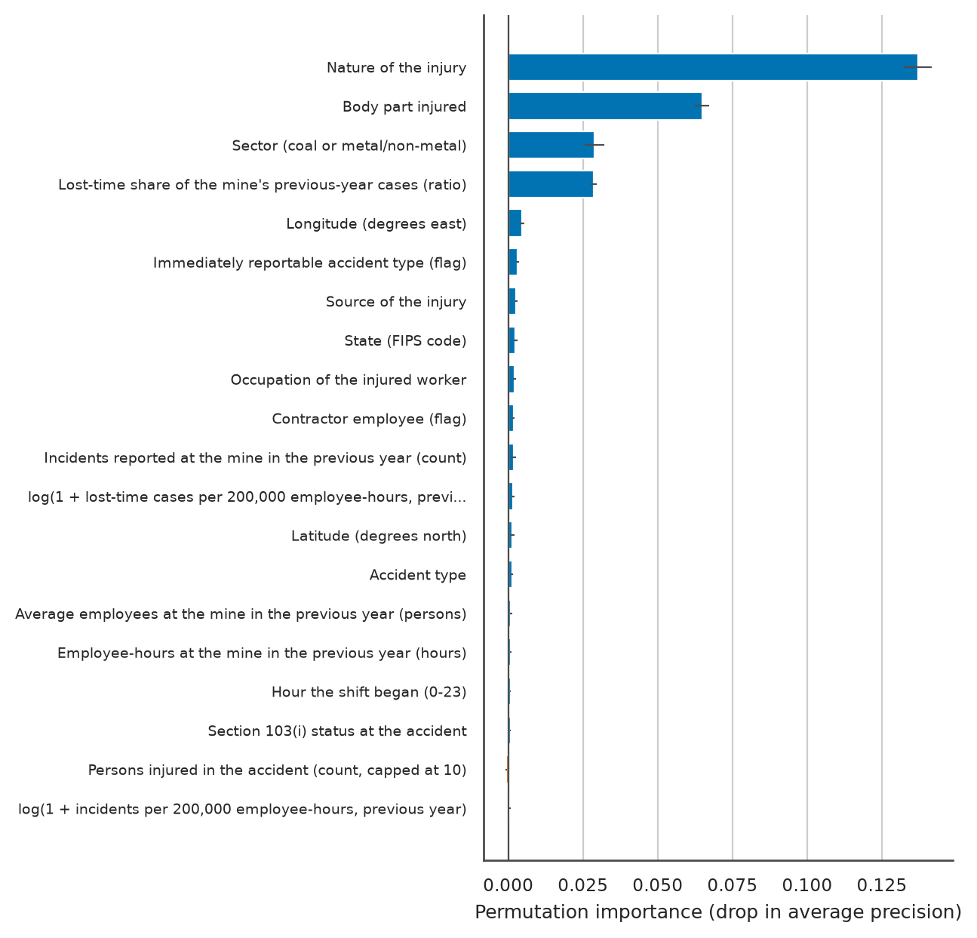
Figure 18. Permutation importance of the 20 most important input features of HGB, measured as the mean drop in test PR-AUC (average precision) over five shuffles on 5,000 test reports with one standard deviation whiskers; importance is computed on input features rather than one-hot columns so that each nominal code counts once. Source: author's analysis of MSHA open data.
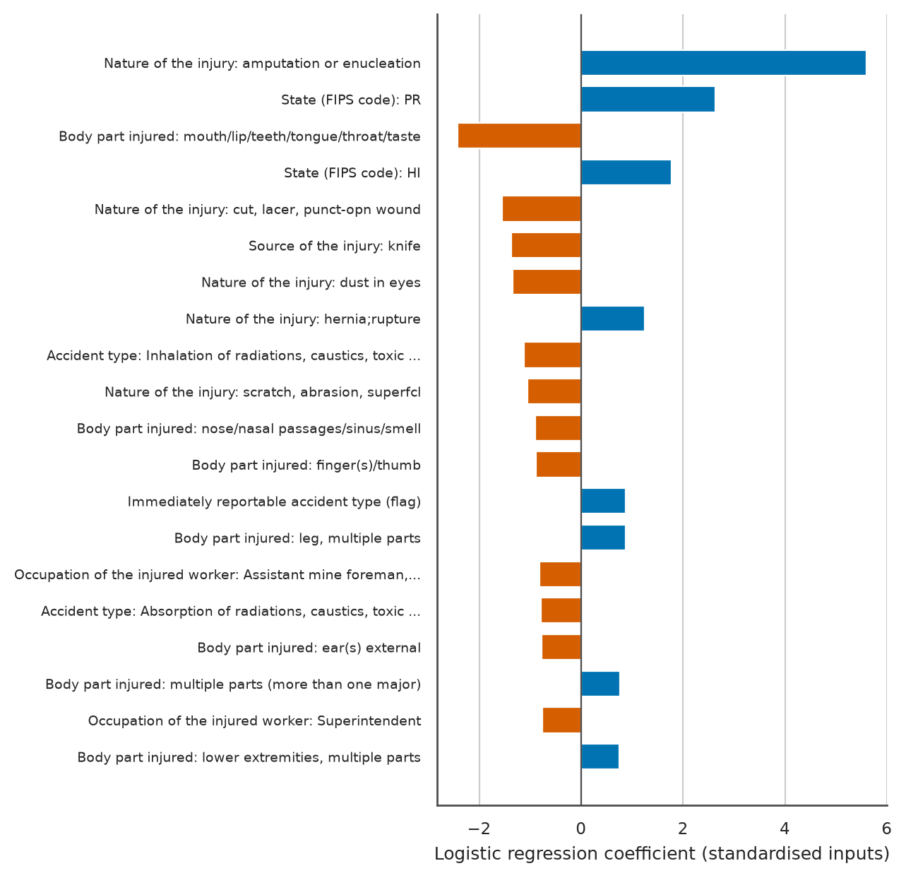
Figure 19. The 20 largest coefficients of the tuned logistic regression fitted on the training split, with numeric inputs standardised and one-hot columns coded 0 or 1 and labelled by their codebook meaning, where positive values (blue) raise and negative values (orange) lower the odds of a lost-time case; signed bars are used because each coefficient converts to an odds ratio. Source: author's analysis of MSHA open data.
Table 16. Confusion counts on the 20,320 test reports for HGB at its capacity threshold and at 0.5, and for the lookup baseline at its capacity threshold, where a true positive is a lost-time case flagged for early review and a false negative a lost-time case left in routine handling. Source: author's analysis of MSHA open data.
Model and threshold | TP: lost-time, flagged | FN: lost-time, not flagged | FP: other, flagged | TN: other, not flagged | Recall | Precision | Flag rate
HGB, capacity threshold 0.210 | 9,312 | 561 | 6,232 | 4,215 | 0.943 | 0.599 | 0.765
HGB, threshold 0.5 | 7,284 | 2,589 | 2,249 | 8,198 | 0.738 | 0.764 | 0.469
Lookup baseline, capacity threshold 0.225 | 9,043 | 830 | 6,248 | 4,199 | 0.916 | 0.591 | 0.753

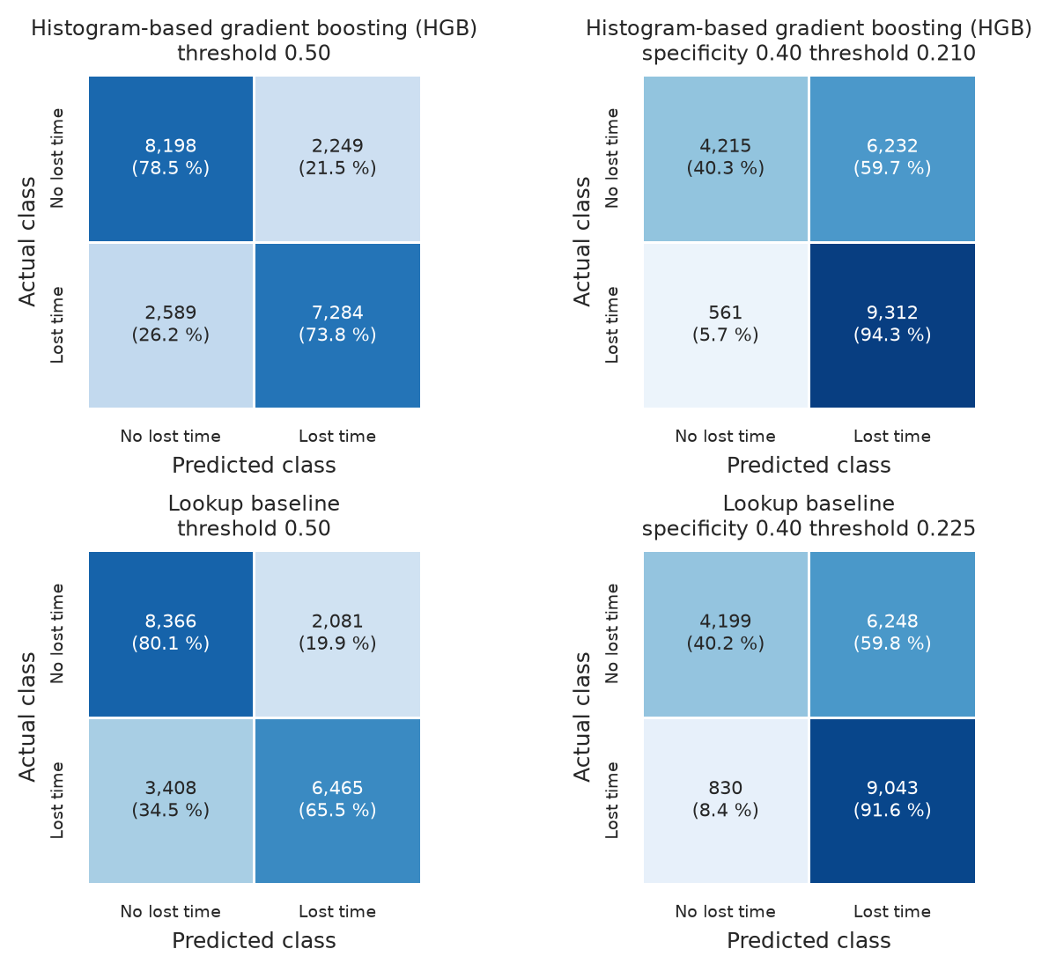
Figure 20. Confusion matrices on the 20,320 test reports for HGB (top) and the lookup baseline (bottom) at the default threshold of 0.5 (left) and at each one's out-of-fold capacity threshold (right), with counts and row percentages; matrices are shown because each cell is a distinct outcome for the adjuster. Source: author's analysis of MSHA open data.
Table 17 sets the result against the success criteria. HGB passes S1 to S4 and S6, and Table 14 holds the comparisons that S7 requires. It misses S5 at the out-of-fold threshold for a 50% flag rate (0.775 against 0.78), and the miss recurs on the temporal and mine-grouped splits. The MLP passes S1 to S6 only by flagging more than half the reports; among the top half of test scores, the planned form of S5, neither model reaches the target. I kept the pre-fixed rule, since switching after the test results would turn the test score into a selection score. The lookup baseline also passes S1, S2 and S6, so S3 to S5 separate the learned models from it. At half capacity more lost-time cases would go unflagged than planned, so I recommend the capacity threshold, where S3 passes.
Table 17. Success criteria S1 to S7, fixed before modelling, with S7 a reporting criterion, evaluated on the 20,320 test reports for HGB, the MLP and the lookup baseline with thresholds fixed on out-of-fold probabilities, with S5 repeated on the temporal and mine-grouped splits. Source: author's analysis of MSHA open data.
Criterion | Target | HGB | Result | MLP | Lookup baseline
S1 ROC-AUC | 0.80 or more | 0.843 | pass | 0.839 | 0.804
S2 PR-AUC | 0.75 or more | 0.841 | pass | 0.837 | 0.790
S3 recall at the out-of-fold threshold for specificity 0.40 | 0.92 or more | 0.943 (specificity 0.403) | pass | 0.948 (0.373) | 0.916 (0.402)
S4 cost per 1,000 cases at the out-of-fold cost-optimal threshold, 2:1 / 3:1 / 5:1 (USD) | below the review-everything floor (102,825 on the test set) and below the lookup baseline | 65,896 / 77,697 / 87,638 | pass | 67,274 / 78,031 / 89,085 | 73,553 / 85,472 / 98,061
S5 recall at the out-of-fold threshold for a 50% flag rate | 0.78 or more | 0.775 (flag rate 0.506) | fail | 0.790 (0.525) | 0.753 (0.520)
S5 as planned: recall among the 50% of test reports with the highest scores (cut-off from the test scores, labels only count hits) | 0.78 or more | 0.769 (flag rate 0.500) | fail | 0.768 (0.500) | 0.725 (0.490, tied scores)
S5 on the temporal split (2020-2025) and the mine-grouped split | 0.78 or more | 0.749 and 0.762 | fail | 0.724 (temporal) | 0.710 (mine-grouped)
S6 Brier score on the test set, and by sector on the temporal split | 0.20 or less | test 0.161 (coal 0.135, metal and non-metal 0.179); temporal split: coal 0.125, metal and non-metal 0.187 | pass | test 0.163 (0.135 and 0.182); temporal split: 0.131 and 0.193 | test 0.179 (0.150 and 0.199)
S7 statistical comparison | McNemar test against the lookup baseline and a paired fold test between the top two | clustered McNemar p below 0.001; corrected paired t p = 0.044 (Table 14) | reported

Table 18 shows that no fatality or permanent disability was missed. Most misses are cuts and lacerations, above all to fingers, thumbs and hands, where half or more of the lost-time cases score below the threshold; such injuries are usually minor, so the few that keep a worker away resemble the many that do not. Metal and non-metal mines hold most misses and have the lower precision (Table 19), consistent with their lower lost-time rate. Most false positives are restricted-duty cases, which differ from lost-time ones mainly in whether restricted work was offered.
Table 18. Errors of HGB at its capacity threshold of 0.210 on the 20,320 test reports, giving missed lost-time cases by sector, by degree-of-injury code and for the six nature x body part cells with most misses, and flagged non-lost-time cases by degree code. Source: author's analysis of MSHA open data.
Group | Cases | Misclassified | Share
All lost-time cases | 9,873 | 561 missed | 0.057
Lost-time cases, coal | 5,280 | 152 missed | 0.029
Lost-time cases, metal and non-metal | 4,593 | 409 missed | 0.089
Fatality (code 01) | 142 | 0 missed | 0.000
Permanent disability (02) | 224 | 0 missed | 0.000
Days away only (03) | 7,380 | 376 missed | 0.051
Days away and restricted activity (04) | 2,127 | 185 missed | 0.087
Cut, laceration or puncture x finger or thumb | 324 | 170 missed | 0.525
Cut, laceration or puncture x hand | 104 | 65 missed | 0.625
Fracture x finger or thumb | 392 | 51 missed | 0.130
Fracture x mouth, lips, teeth or throat | 19 | 17 missed | 0.895
Dust in the eyes x eye | 36 | 16 missed | 0.444
Burn or chemical injury x eye | 46 | 16 missed | 0.348
Non-lost-time: restricted activity only (05) | 4,212 | 3,297 flagged | 0.783
Non-lost-time: no days away and no restriction (06) | 6,235 | 2,935 flagged | 0.471

Table 19 is the model card of HGB (Mitchell et al., 2019). Its monitoring entries follow Sculley et al. (2015), who show that deployed models accrue hidden debt through shifting inputs and feedback loops. A feedback loop is plausible here, since return-to-work plans prompted by flags could turn lost-time cases into restricted-duty ones and change the label the model learns from.
Table 19. Model card of the HGB pipeline, after Mitchell et al. (2019), with metrics on the 20,320 test reports at the capacity threshold unless stated otherwise. Source: author's analysis of MSHA open data.
Field | Content
Model | HistGradientBoostingClassifier from scikit-learn 1.9.1 inside the preprocessing pipeline of Figure 11; learning rate 0.05, at most 400 rounds with early stopping, 31 leaf nodes, no L2 penalty; refitted on the 81,289 training rows on 14 October 2026; saved pipeline 0.45 MB
Intended use | ranking new Form 7000-1 reports at filing for early review by workers'-compensation adjusters at insurers and self-insured operators, flagging reports that score 0.210 or more (about three in four); an adjuster confirms every flag
Out-of-scope uses | ranking mines for inspection, which the DART label suits better; setting benefit levels or denying claims; judging individual workers; reports outside 2010-2025 or outside degree codes 01 to 06
Data | 101,609 MSHA reports of 2010-2025 (Section 1.3), split by 32,732 mine-years with 6,724 of them in the test set; secondary temporal split (2010-2019 against 2020-2025) and mine-grouped split
Metrics | PR-AUC (primary), ROC-AUC, recall, specificity, precision, Brier score and expected cost per 1,000 cases, with thresholds from out-of-fold probabilities
Overall performance | PR-AUC 0.841 (mine-year bootstrap 95% interval 0.825 to 0.856), ROC-AUC 0.843 and Brier score 0.161; recall 0.943, specificity 0.403 and precision 0.599 at threshold 0.210
Subgroup performance | coal (8,270 reports, prevalence 0.638): recall 0.971, specificity 0.397, precision 0.740, PR-AUC 0.912, Brier 0.135; metal and non-metal (12,050 reports, prevalence 0.381): recall 0.911, specificity 0.406, precision 0.486, PR-AUC 0.708, Brier 0.179
Stability checks | temporal split: PR-AUC 0.843 and recall 0.944 at a realised specificity of 0.377; mine-grouped split: PR-AUC 0.836 and recall 0.936; removing immed_reportable or the 103(i) status, counting only resolved earlier cases or blanking early-January exposure changed test PR-AUC by at most 0.001; without the 175 amputation reports, all lost-time, test PR-AUC is 0.834
Limitations | misses S5 (recall 0.775 at a 50% flag rate); the label records whether restricted duty was offered; precision below 0.5 in metal and non-metal mines; self-reported data omit unreported injuries; scores describe association, not cause
Ethical considerations | no names or narratives are used, but occupation, experience and state can stand in for groups of workers; a flag must never reduce benefits; the sector gap is disclosed; the application states the intended use and leaves the decision to a person
Monitoring | track the flag rate against the planned three in four, and PR-AUC and Brier score by sector on newly closed cases; retrain or recalibrate when PR-AUC falls below the S2 target of 0.75, the Brier score exceeds the S6 limit of 0.20 or the share of pooled infrequent levels grows (Sculley et al., 2015)

5 Conclusion

5.1 Key data analysis findings
- Lost-time cases are 48.6% of the 101,609 in-scope reports (Figure 1), so a rule that finds none is right about half the time and the insurer needs a ranked review queue.
- Nature of injury and body part lead the association with lost time (Cramer's V of 0.391 and 0.364, Table 7), with cuts near 18% lost-time (Figure 7), so the fields the safety officer completes on the form carry most of the signal at filing.
- The mine's previous-year lost-time share is the strongest numeric signal (point-biserial r = 0.292, Table 7; Figure 5), so mine history known before the accident shifts each score, though it partly reflects the restricted-duty practice behind the label.
- Coal reports are lost-time in 63.0% of cases against 38.6% in metal and non-metal mines, while the DART label hardly varies by sector (Table 2), so the label records employers' restricted-duty practice as well as severity, and scores must be read within sector.
- Gaps are mostly structural, but reports without total experience are lost-time in 59.3% of training cases against 48.5% of recorded ones (Figure 8; Table 8), so missing-value indicators keep that higher risk visible to the reserve decision.
- The classes overlap in every two-dimensional view (Figure 6; Figure 10), and the one-field hand rule reaches a specificity of 0.429 (Table 3), so sparing needless reviews without losing lost-time cases needs a model that combines many fields.

5.2 Interpretation of results
Per 1,000 filed cases at the capacity threshold, HGB misses 27.6 lost-time cases against 49.5 for the one-field hand rule, for a slightly larger review load (Table 20). Its cost-optimal thresholds undercut reviewing everything at low cost ratios. At the base ratio of Table 1 the cheapest threshold flags almost every case (Figure 14), leaving the score to order the queue when capacity binds.
Table 20. Outcomes per 1,000 filed cases on the 20,320-row held-out test set for HGB at three thresholds fixed on out-of-fold probabilities and at two other review capacities, for the lookup baseline at its capacity threshold, for the one-field hand rule built for this study and for reviewing everything, with the expected cost at the 2:1 and 5:1 cost ratios at USD 200 per review; counts are test confusion counts scaled to 1,000 cases, the two capacity rows take their cut-off from the test scores (labels only count the hits), and reviewing everything costs USD 102,825 per 1,000 on the test set against USD 102,829 on all in-scope reports. Source: author's analysis of MSHA open data.
Policy | Threshold | Flagged | Lost-time cases caught | Lost-time cases missed | False alarms | Expected cost at 2:1 (USD) | Expected cost at 5:1 (USD)
HGB, capacity threshold (out-of-fold specificity 0.40) | 0.210 | 765.0 | 458.3 | 27.6 | 306.7 | 72,382 | 88,947
HGB, cost-optimal at 2:1 | 0.335 | 621.9 | 421.4 | 64.5 | 200.5 | 65,896 | 104,577
HGB, cost-optimal at 5:1 | 0.165 | 821.0 | 468.7 | 17.2 | 352.3 | 77,333 | 87,638
HGB, half of the filings flagged (top 50% of test scores) | 0.463 | 500.0 | 373.7 | 112.2 | 126.3 | 70,148 | 137,470
HGB, five in six filings flagged (top 83.3% of test scores) | 0.157 | 833.3 | 470.4 | 15.5 | 362.9 | 78,760 | 88,031
Lookup baseline, capacity threshold | 0.225 | 752.5 | 445.0 | 40.8 | 307.5 | 77,835 | 102,343
Hand rule built for this study: nature is not a cut, dust in the eye or a scratch | not applicable | 733.2 | 436.4 | 49.5 | 296.8 | 79,144 | 108,819
Review everything | not applicable | 1,000.0 | 485.9 | 0.0 | 514.1 | 102,825 | 102,825

Nature, body part and sector lead the permutation importance (Figure 18), and their joint cells explain about half of HGB's lead over logistic regression. A one-hot block for the joint cell raises the cross-validated PR-AUC of logistic regression from 0.820 to 0.829, against 0.838 for HGB (Table 21). Logistic regression assumes additive log-odds, so it forms those cells only when they are supplied. Trees also rank skewed inputs, follow curved size effects and isolate each structural "none" level, which fits the rest of the gap and the lead of tree ensembles on tabular benchmarks (Grinsztajn et al., 2022).
The estimates hold under resampling and harder splits (Table 21). The fold standard deviation of PR-AUC is 0.003, and the clustered bootstrap interval of test PR-AUC clears the S2 target. The Wilcoxon test does not confirm the corrected fold test against the MLP, so that lead is thin. Unseen mines and 2020-2025 reports move PR-AUC by under 0.01, and in 2020-2025 recall holds in both sectors while specificity falls below plan. S5 is missed by 0.005, so a team reviewing half the filings catches fewer cases than planned.
Table 21. Uncertainty, generalisability and mechanism checks of HGB, covering cross-validation on the training split, 95% percentile bootstrap intervals and paired tests on the held-out test set, results by sector, a temporal split, a mine-grouped split, the reports still open at filing and logistic regression given the lookup baseline's joint cell; the capacity threshold is the out-of-fold threshold for specificity 0.40, and the last two checks were run after the test scoring and changed no choice. Source: author's analysis of MSHA open data.
Check | Data and protocol | Result for HGB
Cross-validation | 5-fold mine-year-grouped CV on the 81,289 training rows | PR-AUC 0.838 (SD 0.003, folds 0.834 to 0.841); ROC-AUC 0.839 (SD 0.002)
Bootstrap intervals | 1,000 resamples of the 20,320 test rows and of their 6,724 mine-years | PR-AUC 0.841 (rows 0.835 to 0.848; mine-years 0.825 to 0.856); ROC-AUC 0.843 (mine-years 0.835 to 0.851); recall at the capacity threshold 0.943 (mine-years 0.938 to 0.949)
Paired fold test against the MLP | PR-AUC on the same five CV folds | mean difference 0.005; corrected t-test p = 0.044; Wilcoxon signed-rank p = 0.0625
McNemar test against the lookup baseline | test set at the capacity threshold, row-wise and clustered by mine-year | p < 0.001 in both forms (clustered chi-square 24.4, 1 df)
By sector | test set at the capacity threshold 0.210 | coal (n = 8,270) recall 0.971, specificity 0.397, precision 0.740; metal and non-metal (n = 12,050) recall 0.911, specificity 0.406, precision 0.486
Temporal split | re-tuned on 2010-2019 (71,877 rows) with thresholds from its out-of-fold probabilities, scored on 2020-2025 (29,732 rows) | ROC-AUC 0.834, PR-AUC 0.843; recall 0.944 and specificity 0.377 at the capacity threshold; coal recall 0.973 and Brier 0.125; metal and non-metal recall 0.918 and Brier 0.187
Mine-grouped split | no mine on both sides (8,303 mines; 20,289 test rows), primary hyperparameters | ROC-AUC 0.838, PR-AUC 0.836, recall 0.936 at the capacity threshold, recall 0.762 at a 50% flag rate
Feature variants | primary split with fixed hyperparameters: immed_reportable set to 0; status_103i_at_accident constant; 175 amputation test rows (nature code 100) removed | PR-AUC 0.840, 0.841 and 0.834 against 0.841
S5, recall at a 50% flag rate | out-of-fold threshold 0.456, test flag rate 50.6%; and the top 50% of test scores, the planned form | 0.775 against the 0.78 target (missed); MLP 0.790 at a 52.5% flag rate; top half of test scores: HGB 0.769, MLP 0.768
Reports still open at filing | 45,679 in-scope reports (45.0%) were filed once the worker was back at work, lost-time in 20.4% against 71.6% of the rest; test reports with a return-to-work date after the filing date or none (11,290, prevalence 0.712), thresholds unchanged | ROC-AUC 0.812, PR-AUC 0.920; recall 0.950 and specificity 0.212 at the capacity threshold; reports filed after the return (9,030, prevalence 0.203): ROC-AUC 0.828, recall 0.914
Logistic regression with the joint cell | the selected logistic regression refitted with a one-hot block for the nature x body part x sector cell (724 columns), same five folds and test rows | CV PR-AUC 0.829 (SD 0.004) against 0.820 without the block and 0.838 for HGB; test PR-AUC 0.833 against 0.825

The question of Section 1.1 is answered yes for an insurer that reviews about three cases in four, the load at which the score outranks both hand-built references. I recommend that insurers and self-insured operators score daily filings and review them in score order down to capacity, from the 0.210 threshold. An adjuster should decide every flagged claim, and the score should not rank mines for inspection.

5.3 Limitations
The data are operator self-reports under Part 50, so the findings cover reported injuries and inherit under-reporting that varies by mine and year. The label also records each employer's restricted-duty practice, which the model learns with severity. Contractor hours are absent from the production file, so exposure is understated at contractor-heavy mines, and Mines attributes are a snapshot that can post-date the accident. About one in twenty late-2025 reports may still be re-coded. Test metrics also pool reports filed after the worker's return, and ranking is weaker on the open ones (Table 21).
Grids were small, though wider ones tried after testing gained at most 0.002; the test set was one fold, and the SVM and KNN used subsamples. No external data set was scored, and the cost comparison rests on an assumed USD 4,000 per missed case (Table 1). SHAP values cover 500 rows, and the application retrains on reduced grids, so its live numbers differ from the full run.

5.4 Future work
External validation on closed 2026 reports, with the thresholds fixed here, comes first. Sector-level monitoring of the Brier score and review rate should trigger a refit at the S6 limit. An insurer's closed claims could then price a missed case and replace the assumed ratio. Narrative text with post-filing leakage controls, and a DART model, come last. Uzbekistan publishes only aggregate accident statistics (Kun.uz, 2026), so transfer there would first need case-level reports with a degree-of-injury code.

5.5 Ethical considerations
The MSHA files are public-domain US government works (Office of the Law Revision Counsel, 2020), credited to the US Department of Labor as requested (US Department of Labor, no date). No names or narratives enter the model, but occupation, experience, mine and date could identify a worker at a small mine, so scored lists should stay with claims staff. Self-reporting adds representational bias and the label measurement bias (Mehrabi et al., 2021), as the same injury scores lower where restricted duty is offered. Recall at the capacity threshold is 0.971 in coal and 0.911 in metal and non-metal mines (Table 21), so misses fall more often on metal and non-metal workers. The model card (Table 19) and the application's decision-support notice rule out using a score to contest or delay a claim. I recommend that an adjuster confirm every flag and that the insurer compare recall by sector each quarter, recalibrating when the gap widens.

References
Bishop, C.M. (2006) Pattern Recognition and Machine Learning. New York: Springer.
Breiman, L. (2001) 'Random forests', Machine Learning, 45(1), pp. 5-32. doi:10.1023/A:1010933404324.
Bruce, P., Bruce, A. and Gedeck, P. (2020) Practical Statistics for Data Scientists. 2nd edn. Sebastopol, CA: O'Reilly Media.
Bureau of Labor Statistics (2025) Occupational Outlook Handbook: Claims adjusters, appraisers, examiners, and investigators. Washington, DC: US Department of Labor. Available at: https://www.bls.gov/ooh/business-and-financial/claims-adjusters-appraisers-examiners-and-investigators.htm (Accessed: 14 October 2026).
Bureau of Labor Statistics (no date) Handbook of Methods: Survey of Occupational Injuries and Illnesses - Concepts. Available at: https://www.bls.gov/opub/hom/soii/concepts.htm (Accessed: 14 October 2026).
Business Insurance (2015) 'Delayed reporting of workplace injuries can raise comp claim costs up to 51%', 7 June. Available at: https://www.businessinsurance.com/delayed-reporting-of-workplace-injuries-can-raise-comp-claim-costs-up-to-51/ (Accessed: 14 October 2026).
Chawla, N.V., Bowyer, K.W., Hall, L.O. and Kegelmeyer, W.P. (2002) 'SMOTE: Synthetic minority over-sampling technique', Journal of Artificial Intelligence Research, 16, pp. 321-357. doi:10.1613/jair.953.
Chen, T. and Guestrin, C. (2016) 'XGBoost: A scalable tree boosting system', in Proceedings of the 22nd ACM SIGKDD International Conference on Knowledge Discovery and Data Mining. San Francisco, CA, 13-17 August. New York: ACM, pp. 785-794. doi:10.1145/2939672.2939785.
Cortes, C. and Vapnik, V. (1995) 'Support-vector networks', Machine Learning, 20(3), pp. 273-297. doi:10.1007/BF00994018.
Cover, T. and Hart, P. (1967) 'Nearest neighbor pattern classification', IEEE Transactions on Information Theory, 13(1), pp. 21-27. doi:10.1109/TIT.1967.1053964.
Davis, J. and Goadrich, M. (2006) 'The relationship between Precision-Recall and ROC curves', in Proceedings of the 23rd International Conference on Machine Learning. Pittsburgh, PA, 25-29 June. New York: ACM, pp. 233-240. doi:10.1145/1143844.1143874.
Demšar, J. (2006) 'Statistical comparisons of classifiers over multiple data sets', Journal of Machine Learning Research, 7, pp. 1-30.
Dietterich, T.G. (1998) 'Approximate statistical tests for comparing supervised classification learning algorithms', Neural Computation, 10(7), pp. 1895-1923. doi:10.1162/089976698300017197.
Domingos, P. and Pazzani, M. (1997) 'On the optimality of the simple Bayesian classifier under zero-one loss', Machine Learning, 29(2-3), pp. 103-130. doi:10.1023/A:1007413511361.
Durkalski, V.L., Palesch, Y.Y., Lipsitz, S.R. and Rust, P.F. (2003) 'Analysis of clustered matched-pair data', Statistics in Medicine, 22(15), pp. 2417-2428. doi:10.1002/sim.1438.
Fawcett, T. (2006) 'An introduction to ROC analysis', Pattern Recognition Letters, 27(8), pp. 861-874. doi:10.1016/j.patrec.2005.10.010.
Gebru, T., Morgenstern, J., Vecchione, B., Vaughan, J.W., Wallach, H., Daume III, H. and Crawford, K. (2021) 'Datasheets for datasets', Communications of the ACM, 64(12), pp. 86-92. doi:10.1145/3458723.
Gen Re (2026) Workers' comp healthy amid change. 26 May. Available at: https://www.genre.com/us/knowledge/publications/2026/may/workers-comp-healthy-amid-change-en (Accessed: 14 October 2026).
Grinsztajn, L., Oyallon, E. and Varoquaux, G. (2022) 'Why do tree-based models still outperform deep learning on typical tabular data?', in Advances in Neural Information Processing Systems 35, Datasets and Benchmarks Track.
Han, J., Pei, J. and Tong, H. (2022) Data Mining: Concepts and Techniques. 4th edn. Cambridge, MA: Morgan Kaufmann.
Hastie, T., Tibshirani, R. and Friedman, J. (2009) The Elements of Statistical Learning: Data Mining, Inference, and Prediction. 2nd edn. New York: Springer.
He, H. and Garcia, E.A. (2009) 'Learning from imbalanced data', IEEE Transactions on Knowledge and Data Engineering, 21(9), pp. 1263-1284. doi:10.1109/TKDE.2008.239.
Hosmer, D.W., Lemeshow, S. and Sturdivant, R.X. (2013) Applied Logistic Regression. 3rd edn. Hoboken, NJ: Wiley.
Hunter, J.D. (2007) 'Matplotlib: A 2D graphics environment', Computing in Science and Engineering, 9(3), pp. 90-95. doi:10.1109/MCSE.2007.55.
Kaufman, S., Rosset, S., Perlich, C. and Stitelman, O. (2012) 'Leakage in data mining: Formulation, detection, and avoidance', ACM Transactions on Knowledge Discovery from Data, 6(4), Article 15. doi:10.1145/2382577.2382579.
Kohavi, R. (1995) 'A study of cross-validation and bootstrap for accuracy estimation and model selection', in Proceedings of the 14th International Joint Conference on Artificial Intelligence. Montreal, 20-25 August. San Francisco, CA: Morgan Kaufmann, vol. 2, pp. 1137-1145.
Kuhn, M. and Johnson, K. (2019) Feature Engineering and Selection: A Practical Approach for Predictive Models. Boca Raton, FL: CRC Press.
Kun.uz (2026) 'Workplace accidents kill 248 people in Uzbekistan in 2025', 13 January. Available at: https://kun.uz/en/news/2026/01/13/workplace-accidents-kill-248-people-in-uzbekistan-in-2025over-240-people (Accessed: 14 October 2026).
Legal Information Institute (no date a) 30 CFR 50.20 - Preparation and submission of MSHA Report Form 7000-1. Available at: https://www.law.cornell.edu/cfr/text/30/50.20 (Accessed: 14 October 2026).
Legal Information Institute (no date b) 30 CFR 50.30 - Preparation and submission of MSHA Form 7000-2. Available at: https://www.law.cornell.edu/cfr/text/30/50.30 (Accessed: 14 October 2026).
Lemaitre, G., Nogueira, F. and Aridas, C.K. (2017) 'Imbalanced-learn: A Python toolbox to tackle the curse of imbalanced datasets in machine learning', Journal of Machine Learning Research, 18(17), pp. 1-5.
Lundberg, S.M. and Lee, S.-I. (2017) 'A unified approach to interpreting model predictions', in Advances in Neural Information Processing Systems 30, pp. 4765-4774.
Mehrabi, N., Morstatter, F., Saxena, N., Lerman, K. and Galstyan, A. (2021) 'A survey on bias and fairness in machine learning', ACM Computing Surveys, 54(6), Article 115. doi:10.1145/3457607.
Mine Safety and Health Administration (2026) Mine Injury and Worktime, Quarterly: January-December 2025, preliminary. Available at: https://arlweb.msha.gov/Stats/Part50/WQ/2025/MIWQ%20-%20CY2025Q4.pdf (Accessed: 14 October 2026).
Mine Safety and Health Administration (no date) Mine Accident, Injury and Illness Report, MSHA Form 7000-1 (OMB No. 1219-0007), with instructions. Available at: https://www.msha.gov/sites/default/files/Support_Resources/Forms/7000-1.pdf (Accessed: 14 October 2026).
Mitchell, M., Wu, S., Zaldivar, A., Barnes, P., Vasserman, L., Hutchinson, B., Spitzer, E., Raji, I.D. and Gebru, T. (2019) 'Model cards for model reporting', in Proceedings of the Conference on Fairness, Accountability, and Transparency. Atlanta, GA, 29-31 January. New York: ACM, pp. 220-229. doi:10.1145/3287560.3287596.
Mitchell, T.M. (1997) Machine Learning. New York: McGraw-Hill.
Nadeau, C. and Bengio, Y. (2003) 'Inference for the generalization error', Machine Learning, 52(3), pp. 239-281. doi:10.1023/A:1024068626366.
National Institute for Occupational Safety and Health (no date) NIOSH Mine and Mine Worker Charts: number and rate of nonfatal lost-time injuries, 2021-2024. Available at: https://wwwn.cdc.gov/niosh-mining/MMWC/Injuries/NumberAndRate (Accessed: 14 October 2026).
Office of the Law Revision Counsel (2020) 17 U.S.C. 105 - Subject matter of copyright: United States Government works. United States Code, 2020 edition. Available at: https://www.govinfo.gov/content/pkg/USCODE-2020-title17/html/USCODE-2020-title17-chap1-sec105.htm (Accessed: 14 October 2026).
Pedregosa, F., Varoquaux, G., Gramfort, A., Michel, V., Thirion, B., Grisel, O., Blondel, M., Prettenhofer, P., Weiss, R., Dubourg, V., Vanderplas, J., Passos, A., Cournapeau, D., Brucher, M., Perrot, M. and Duchesnay, E. (2011) 'Scikit-learn: Machine learning in Python', Journal of Machine Learning Research, 12, pp. 2825-2830.
Provost, F. and Fawcett, T. (2013) Data Science for Business: What You Need to Know about Data Mining and Data-Analytic Thinking. Sebastopol, CA: O'Reilly Media.
Rubin, D.B. (1976) 'Inference and missing data', Biometrika, 63(3), pp. 581-592. doi:10.1093/biomet/63.3.581.
Saito, T. and Rehmsmeier, M. (2015) 'The precision-recall plot is more informative than the ROC plot when evaluating binary classifiers on imbalanced datasets', PLoS ONE, 10(3), e0118432. doi:10.1371/journal.pone.0118432.
Sculley, D., Holt, G., Golovin, D., Davydov, E., Phillips, T., Ebner, D., Chaudhary, V., Young, M., Crespo, J.-F. and Dennison, D. (2015) 'Hidden technical debt in machine learning systems', in Advances in Neural Information Processing Systems 28, pp. 2503-2511.
Tan, P.-N., Steinbach, M., Karpatne, A. and Kumar, V. (2019) Introduction to Data Mining. 2nd edn. New York: Pearson.
Tukey, J.W. (1977) Exploratory Data Analysis. Reading, MA: Addison-Wesley.
US Department of Labor (no date) Copyright information. Available at: https://www.dol.gov/general/aboutdol/copyright (Accessed: 14 October 2026).
US Department of Labor, Mine Safety and Health Administration (2026a) Accident Injuries Data Set [Dataset]. Available at: https://arlweb.msha.gov/OpenGovernmentData/OGIMSHA.asp (Accessed: 14 October 2026). Public domain (US Government work).
US Department of Labor, Mine Safety and Health Administration (2026b) Mines Data Set and Mines Production Yearly Data Set [Datasets]. Available at: https://arlweb.msha.gov/OpenGovernmentData/OGIMSHA.asp (Accessed: 14 October 2026). Public domain (US Government work).
van Buuren, S. (2018) Flexible Imputation of Missing Data. 2nd edn. Boca Raton, FL: CRC Press.
Waskom, M.L. (2021) 'seaborn: statistical data visualization', Journal of Open Source Software, 6(60), 3021. doi:10.21105/joss.03021.
Wolpert, D.H. (1996) 'The lack of a priori distinctions between learning algorithms', Neural Computation, 8(7), pp. 1341-1390. doi:10.1162/neco.1996.8.7.1341.
Yedla, A., Kakhki, F.D. and Jannesari, A. (2020) 'Predictive modeling for occupational safety outcomes and days away from work analysis in mining operations', International Journal of Environmental Research and Public Health, 17(19), 7054. doi:10.3390/ijerph17197054.

Appendix A Additional descriptive statistics
Table 22 gives the statistics of Table 6 for the eight numeric features that Section 2.3 leaves out of the main table, so that all 20 numeric features are described.
Table 22. Sample statistics of the remaining eight of the 20 numeric features on the 81,289 training rows, with the same definitions as the main descriptive table of Section 2.3; the trimmed mean cuts 10% from each tail, variance and SD (sample standard deviation) use the n - 1 denominator, and skewness is read against the bands below 0.5 symmetric, 0.5 to 1 moderate and above 1 high. Source: author's analysis of MSHA open data.
Feature (unit) | Missing % | Mean | Median | Trimmed mean | Variance | SD | Min | Q1 | Q3 | Max | IQR | Skewness
exper_ratio_job (ratio) | 5.2 | 0.71 | 0.97 | 0.75 | 0.13 | 0.36 | 0.00 | 0.38 | 1.00 | 1.00 | 0.62 | -0.72
no_injuries_capped (persons) | 0.0 | 1.02 | 1.00 | 1.00 | 0.05 | 0.23 | 1 | 1 | 1 | 9 | 0 | 21.94
accident_hour (hour, 0-23) | 3.0 | 11.7 | 11.0 | 11.6 | 30.7 | 5.5 | 0 | 8 | 15 | 23 | 7 | 0.06
shift_begin_hour (hour, 0-23) | 0.5 | 9.7 | 7.0 | 9.0 | 32.5 | 5.7 | 0 | 6 | 15 | 23 | 9 | 0.96
latitude (degrees) | 0.2 | 38.4 | 38.2 | 38.2 | 26.2 | 5.1 | 18.0 | 35.9 | 40.5 | 68.0 | 4.6 | 0.96
log1p_prev_hours (log1p of hours) | 1.2 | 12.27 | 12.42 | 12.36 | 2.79 | 1.67 | 0.69 | 11.15 | 13.63 | 15.86 | 2.48 | -0.55
prev_hours_per_employee (hours per person) | 1.2 | 2,140.9 | 2,171.3 | 2,171.4 | 171,488 | 414.1 | 1.0 | 1,986.9 | 2,364.2 | 4,786.7 | 377.2 | -1.19
prev_incident_rate_200k (log1p) | 1.2 | 1.51 | 1.66 | 1.53 | 0.83 | 0.91 | 0.00 | 0.97 | 2.18 | 3.93 | 1.20 | -0.27

Appendix B Model explanations
Table 23 lists the encoded columns with the largest mean absolute SHAP values for HGB, the values that Section 4.5 compares with the logistic coefficients of Figure 19. Cuts and finger or thumb injuries rank first and fourth, and both carry negative logistic coefficients.
Table 23. Mean absolute SHAP value of the 15 encoded columns with the largest values for HGB, computed by TreeExplainer on 500 seeded test reports in log-odds units, beside the coefficient of the same column in the tuned logistic regression fitted on the training split (numeric inputs standardised); one-hot columns are labelled with their MSHA codebook meaning. Source: author's analysis of MSHA open data.
Rank | Encoded column | Meaning | Mean absolute SHAP value (log-odds) | Logistic regression coefficient
1 | NATURE_INJURY_CD_180 | Nature of the injury: cut, lacer, punct-opn wound | 0.575 | -1.555
2 | prev_lost_time_share | Lost-time share of the mine's previous-year cases (ratio) | 0.365 | 0.356
3 | COAL_METAL_IND_C | Sector (coal or metal/non-metal): coal | 0.350 | 0.258
4 | INJ_BODY_PART_CD_340 | Body part injured: finger(s)/thumb | 0.206 | -0.882
5 | longitude | Longitude (degrees east) | 0.082 | 0.103
6 | NATURE_INJURY_CD_100 | Nature of the injury: amputation or enucleation | 0.073 | 5.605
7 | NATURE_INJURY_CD_220 | Nature of the injury: fracture, chip | 0.068 | 0.061
8 | INJ_BODY_PART_CD_130 | Body part injured: eye(s) optic nerve/vison | 0.067 | -0.452
9 | INJ_BODY_PART_CD_142 | Body part injured: mouth/lip/teeth/tongue/throat/taste | 0.059 | -2.421
10 | prev_incidents | Incidents reported at the mine in the previous year (count) | 0.050 | 0.179
11 | prev_employees | Average employees at the mine in the previous year (persons) | 0.048 | -0.166
12 | immed_reportable | Immediately reportable accident type (flag) | 0.048 | 0.873
13 | prev_lost_time_rate_200k | log(1 + lost-time cases per 200,000 employee-hours, previous year) | 0.043 | 0.081
14 | INJ_BODY_PART_CD_330 | Body part injured: hand (not wrist or fingers) | 0.038 | -0.502
15 | NATURE_INJURY_CD_330 | Nature of the injury: sprain, strain rupt disc | 0.038 | -0.319

