**CURRICULUM VITAE**

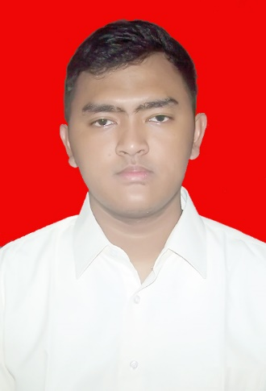

**DATA PRIBADI**

Nama Lengkap : Subhan Maulana

Nama Panggilan : Subhan

Tempat/Tgl Lahir : Bekasi, 10 Juni 1997

Jenis Kelamin : Laki – laki

Agama : Islam

Alamat Asal : Jl. Tirta Raya Blok A no.2 (Perumahan Premier Savanna)

HP : 081288222955

Email : Subhanmln@gmail.com

IPK : 3.44

**PENDIDIKAN FORMAL**

|  |  |  |
| --- | --- | --- |
| **No.** | **Tahun** | **Pendidikan** |
| 1. | 2002 – 2003 | TK Annisa |
| 2. | 2003 – 2009 | SDN Bantargebang 5 |
| 3. | 2009 – 2012 | MTS Al-Muhtadin |
| 4. | 2012 – 2015 | SMA Negeri 24 Bandung |
| 5. | 2015 – Sekarang | S1 Teknik Informatika Institut Teknologi Sepuluh Nopember Surabaya |

**PENGALAMAN PELATIHAN DAN SEMINAR**

|  |  |  |
| --- | --- | --- |
| **No.** | **Tahun** | **Pelatihan** |
| 1. | 2015 | National Seminar of Technology ITS |
| 2. | 2015 | Latihan Keterampilan Manajemen Mahasiswa (LKMM) Pra-Tingkat Dasar FTIf ITS Surabaya |
| 3. | 2015 | Pelatihan Karya Tulis Ilmiah Teknik Informatika ITS |
| 4. | 2015 | Letihan Keterampilan Manajemen Kewirausahaan (LKMW) Teknik Informatika ITS Surabaya |
| 5. | 2016 | Public Relation Training FTIf ITS Surabaya |
| 6. | 2017 | Sekolah Himpunan Teknik Informatika ITS Surabaya |
| 7. | 2017 | MoU Making Training ITS |

**PENGALAMAN ORGANISASI**

|  |  |  |  |
| --- | --- | --- | --- |
| **No.** | **Tahun** | **Organisasi** | **Jabatan** |
| 1. | 2016 - 2017 | Himpunan Mahasiswa Teknik  Computer-Informatika ITS Surabaya | Staff Departemen Hubungan Luar |
| 2 | 2017 - 2018 | Himpunan Mahasiswa Teknik  Computer-Informatika ITS Surabaya | Kepala Departemen Hubungan Luar |

**PENGALAMAN KEPANITIAAN**

|  |  |  |
| --- | --- | --- |
| **No.** | **Tahun** | **Kepanitiaan** |
| 1. | 2016 | SCHEMATICS 2016 – Staff 3D |
| 2. | 2017 | SCHEMATICS 2017 – Staff Ahli REEVA |
| 3. | 2016 | The 10th International Conference on Information & Communication Technology and System – Committee |
| 4. | 2017 | The 11th International Conference on Information & Communication Technology and System – Student Committee |

**PENGALAMAN PROYEK**

|  |  |  |
| --- | --- | --- |
| **No.** | **Tahun** | **Proyek** |
| 1. | 2016 | Pembuatan Game Air Force Dual Player |
| 2. | 2016 | Pembuatan Website tema Bioskop |
| 3. | 2016 | Pembuatan Software Linux |
| 4. | 2016 | Pembuatan Aplikasi Kondisi Parkir Pesawat Menggunakan Algoritma Coloring |
| 5. | 2015 | Rencana Bisnis Technopreneurship |
| 6. | 2015 | Pembuatan Website untuk Mencari Lawan Futsal dan Lokasi Futsal |
| 7. | 2015 | Pembuatan Website Sekolah |
| 8. | 2017 | Pembuatan Website Lembaga Kursus |

**KEMAMPUAN**

|  |  |  |
| --- | --- | --- |
| **No.** | **Jenis** | **Kemampuan yang Dikuasai** |
| 1. | Bahasa | Indonesia, Inggris |
| 2. | Pemrograman | C, C++, C#, Java, Phyton |
| 3. | Web | HTML, PHP, CSS, JavaScript |
| 4. | Tools | CISCO, Visual Studio, Power Designer, StarUML, CodeBlocks , Eclipse, Unity, Matlab, Blender |
| 5. | Manajemen Basis Data | Oracle, MySQL |
| 6. | Sistem Operasi | Microsoft Windows, Linux |
| 9 | Software Perkantoran | Microsoft Word,Microsoft Excel, Power Point |
| 10 | Konsep | Pemrograman Terstuktur, Pemrograman Berbasis Obyek, Pemrograman Berbasis Web, Basis Data, Grafika Komputer, Jaringan Komputer, Sistem Operasi, Manajemen Proyek Perangkat Lunak. |