ARD 2017 Devenv installation procedure

# Git:

Create an account on github:

<https://github.com/>

Forker or add member to ard project

<https://github.com/wixiw/ard2017>

Clone repository (choose to do it with git desktop)

# Install tools:

Install an FTP browser like filezilla

Download binaries from :

<ftp://peyregne-ard@ftp.cluster014.hosting.ovh.net/4_Info/EnvDev/windows>

# Install the following apps :

* as-installer-7.0.1188-web.exe (you may accept updates)
* jre-8u101-windows-x64.exe (or newer version from https://www.java.com/fr/download/)
* visualcppbuildtools_full.exe
* python-3.6.0-amd64.exe
* eclipse-cpp-neon-1a-win32-x86_64.zip
* nanopb-0.3.7-windows-x86.zip

# Atmel

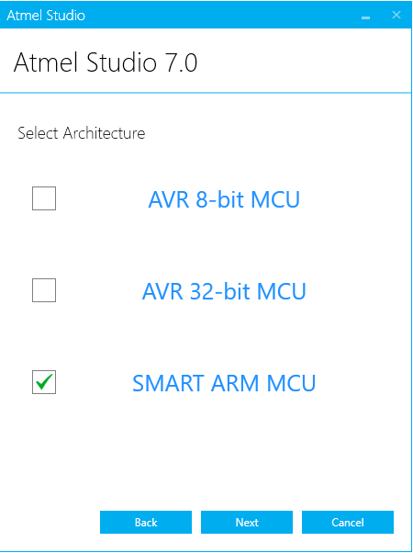

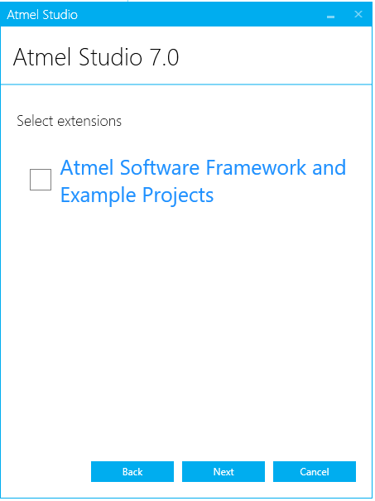

# Eclipse

Import…->Import existing : choisir le chemin vers le dossier github/ard2017

# Python

Install the following modules with pip from a windows terminal:

pip3 install protobuf

pip3 install pyqt5

# First compilation

Com/built.bat

generateCom.at

The Atmel solution is here :

ard2017\robot\ard2017.atsln

In the “Solution Explorer” tab : select 1_RobotA, right clic and “set as startup project” :

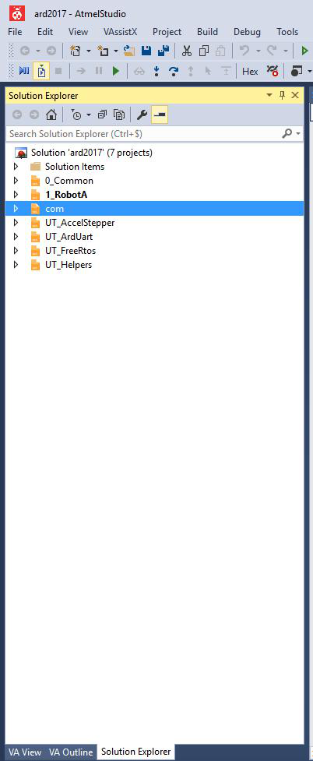

Then build the solution : F7 or 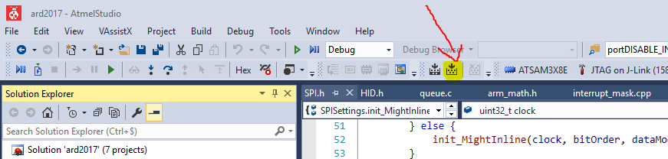

In the Output tab at the bottom of the screen you should be able to check that no errors happened:



Another mean to check that the compilation succeed is to check that the binary can be found in :

ard2017\robot\RobotA\Debug\RobotA.bin

# Vizu

The visualization tool can be found in:

ard2017\vizu\vizu.py

It’s better to launch it from command line so that errors can be read in case the installation failed.