Contract code: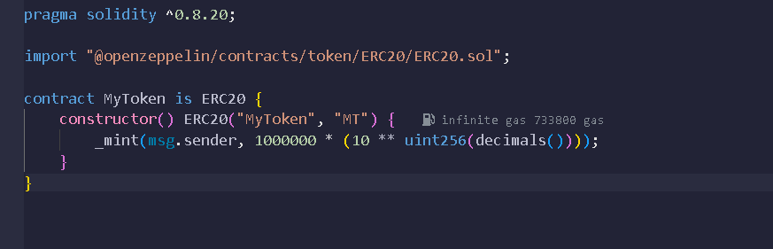  
  
ABI: [

{

"inputs": [],

"stateMutability": "nonpayable",

"type": "constructor"

},

{

"inputs": [

{

"internalType": "address",

"name": "spender",

"type": "address"

},

{

"internalType": "uint256",

"name": "allowance",

"type": "uint256"

},

{

"internalType": "uint256",

"name": "needed",

"type": "uint256"

}

],

"name": "ERC20InsufficientAllowance",

"type": "error"

},

{

"inputs": [

{

"internalType": "address",

"name": "sender",

"type": "address"

},

{

"internalType": "uint256",

"name": "balance",

"type": "uint256"

},

{

"internalType": "uint256",

"name": "needed",

"type": "uint256"

}

],

"name": "ERC20InsufficientBalance",

"type": "error"

},

{

"inputs": [

{

"internalType": "address",

"name": "approver",

"type": "address"

}

],

"name": "ERC20InvalidApprover",

"type": "error"

},

{

"inputs": [

{

"internalType": "address",

"name": "receiver",

"type": "address"

}

],

"name": "ERC20InvalidReceiver",

"type": "error"

},

{

"inputs": [

{

"internalType": "address",

"name": "sender",

"type": "address"

}

],

"name": "ERC20InvalidSender",

"type": "error"

},

{

"inputs": [

{

"internalType": "address",

"name": "spender",

"type": "address"

}

],

"name": "ERC20InvalidSpender",

"type": "error"

},

{

"anonymous": false,

"inputs": [

{

"indexed": true,

"internalType": "address",

"name": "owner",

"type": "address"

},

{

"indexed": true,

"internalType": "address",

"name": "spender",

"type": "address"

},

{

"indexed": false,

"internalType": "uint256",

"name": "value",

"type": "uint256"

}

],

"name": "Approval",

"type": "event"

},

{

"anonymous": false,

"inputs": [

{

"indexed": true,

"internalType": "address",

"name": "from",

"type": "address"

},

{

"indexed": true,

"internalType": "address",

"name": "to",

"type": "address"

},

{

"indexed": false,

"internalType": "uint256",

"name": "value",

"type": "uint256"

}

],

"name": "Transfer",

"type": "event"

},

{

"inputs": [

{

"internalType": "address",

"name": "owner",

"type": "address"

},

{

"internalType": "address",

"name": "spender",

"type": "address"

}

],

"name": "allowance",

"outputs": [

{

"internalType": "uint256",

"name": "",

"type": "uint256"

}

],

"stateMutability": "view",

"type": "function"

},

{

"inputs": [

{

"internalType": "address",

"name": "spender",

"type": "address"

},

{

"internalType": "uint256",

"name": "value",

"type": "uint256"

}

],

"name": "approve",

"outputs": [

{

"internalType": "bool",

"name": "",

"type": "bool"

}

],

"stateMutability": "nonpayable",

"type": "function"

},

{

"inputs": [

{

"internalType": "address",

"name": "account",

"type": "address"

}

],

"name": "balanceOf",

"outputs": [

{

"internalType": "uint256",

"name": "",

"type": "uint256"

}

],

"stateMutability": "view",

"type": "function"

},

{

"inputs": [],

"name": "decimals",

"outputs": [

{

"internalType": "uint8",

"name": "",

"type": "uint8"

}

],

"stateMutability": "view",

"type": "function"

},

{

"inputs": [],

"name": "name",

"outputs": [

{

"internalType": "string",

"name": "",

"type": "string"

}

],

"stateMutability": "view",

"type": "function"

},

{

"inputs": [],

"name": "symbol",

"outputs": [

{

"internalType": "string",

"name": "",

"type": "string"

}

],

"stateMutability": "view",

"type": "function"

},

{

"inputs": [],

"name": "totalSupply",

"outputs": [

{

"internalType": "uint256",

"name": "",

"type": "uint256"

}

],

"stateMutability": "view",

"type": "function"

},

{

"inputs": [

{

"internalType": "address",

"name": "to",

"type": "address"

},

{

"internalType": "uint256",

"name": "value",

"type": "uint256"

}

],

"name": "transfer",

"outputs": [

{

"internalType": "bool",

"name": "",

"type": "bool"

}

],

"stateMutability": "nonpayable",

"type": "function"

},

{

"inputs": [

{

"internalType": "address",

"name": "from",

"type": "address"

},

{

"internalType": "address",

"name": "to",

"type": "address"

},

{

"internalType": "uint256",

"name": "value",

"type": "uint256"

}

],

"name": "transferFrom",

"outputs": [

{

"internalType": "bool",

"name": "",

"type": "bool"

}

],

"stateMutability": "nonpayable",

"type": "function"

}

]  
  
  
  
Deploy:  
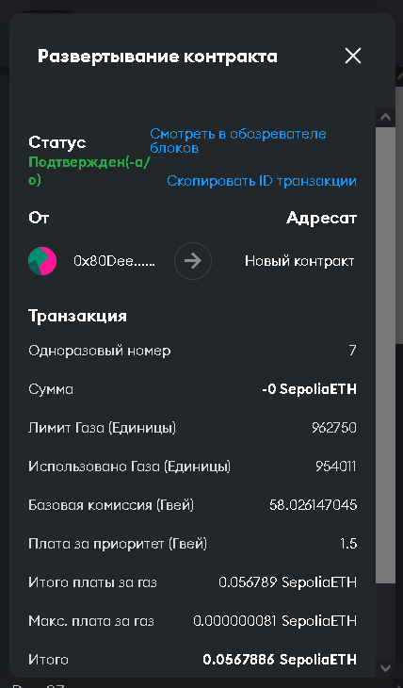  
  
С  
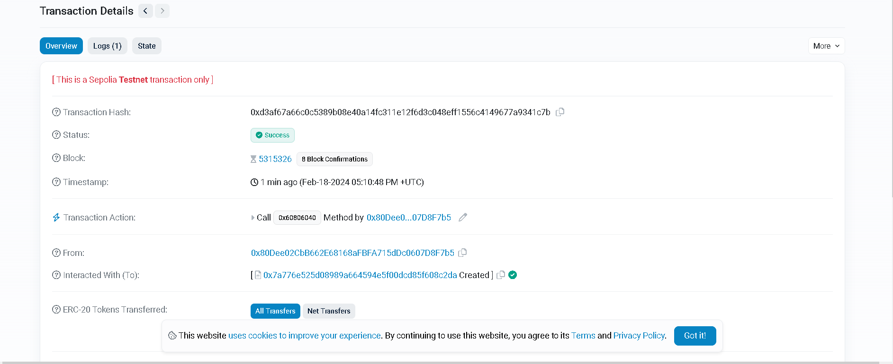  
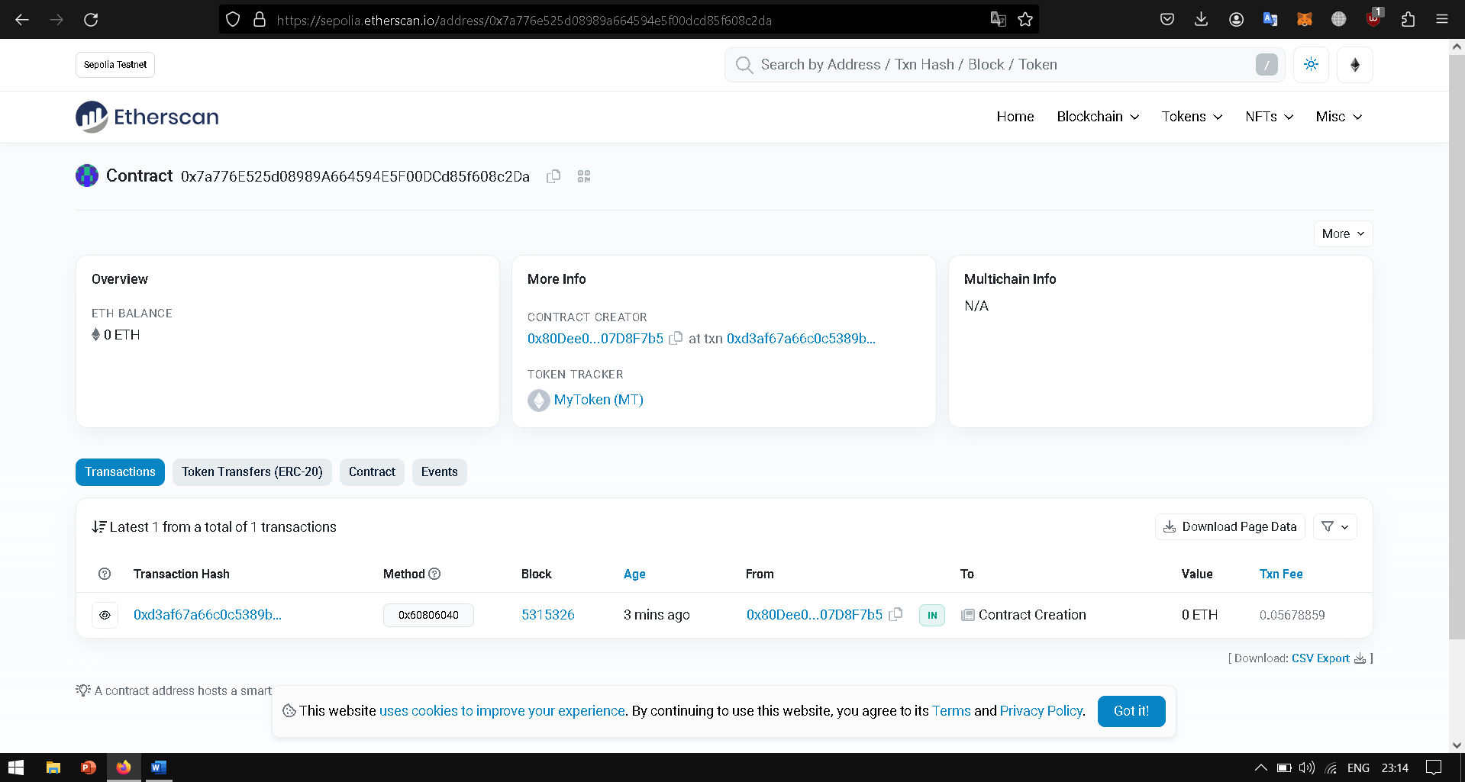  
  
  
  
My token :  
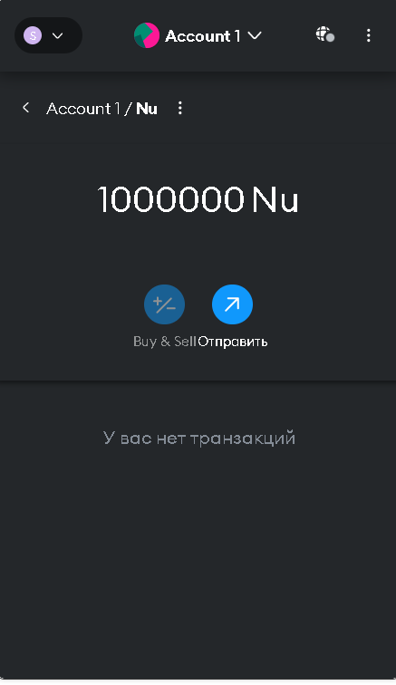  
  
Contract: 0x7a776E525d08989A664594E5F00DCd85f608c2Da