**Documentation**

1. When you launch EnerGO application the first thing you are going to see is Home page: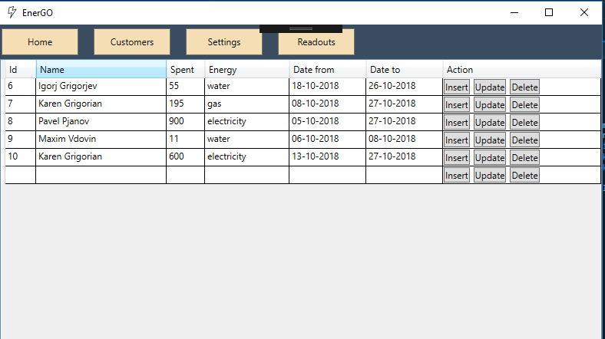

Here we can see all the information connected with users and their utilities.

Also, there is a navigation menu on the top of the application, which you can use to surf through other pages.

1. If you click on insert button the application will show you a dialog box where you can add a new record: 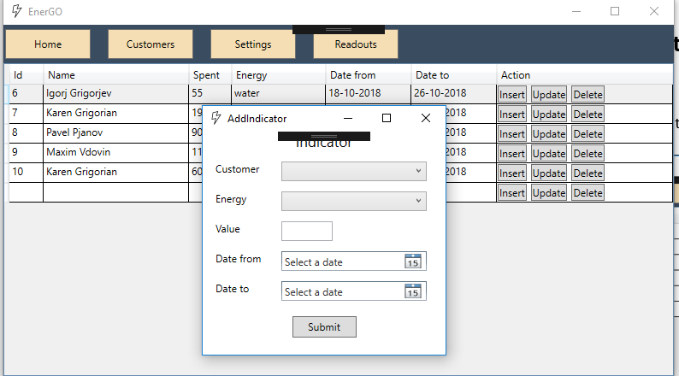

Same thing happens with Update button.

Delete button stands for deleting the row both from grid and database.

1. Next, if we click on customers tab in navigation menu, we are going to see a brand new page with all the customers we have in our database: 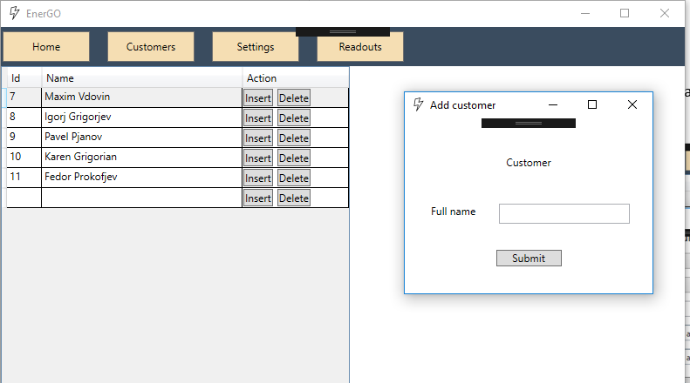

Insert and delete button work the same way as buttons on the Home page.

1. Next tab in our navigation menu is Settings, here you can add or delete energy meters: 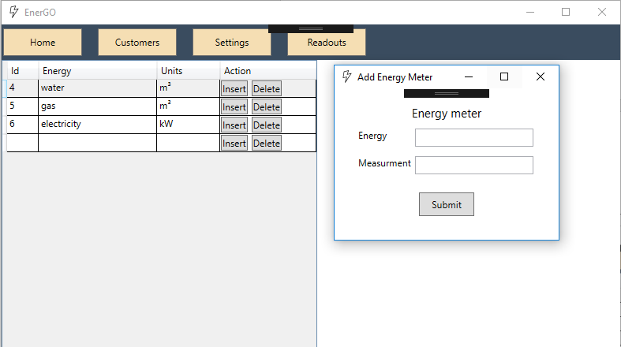
2. And the last but not least in our navigation is Readouts tab, here you will be able to evaluate a particular customer and leave comments if it is needed.

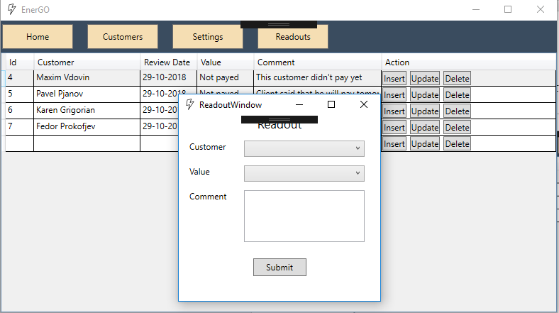

All the buttons you see here work the same way as the button on Home page