**Batch-6**

**A Web App to make buy/sell calls based on open range strategy for the picked stocks**

**Problem Statement:**

Create a Web App to make buy/sell calls based on Open Range strategy for the picked stocks. Pick any stocks and read live data feed through the APIs that are provided.

**Trading Strategy**

Any stock creates a range in the first 15 minutes of trading in a day. This is calling Opening Range. The highs and lows of this time frame is taken as entry and exit parameters.

Buy when the stock moves above the Opening Range high. 2. Sell when the stock moves below the Opening Range low.

**Rules for Buy**

* Buy when the stock price crosses above the opening range
* Initial Stop loss — Low of the Opening Range.

**Rules for Sell**

* Sell when the stock price crosses below the opening range.
* Initial Stop loss — High of the Opening Range.

The web app has the following file structure.

**1**. **views**-To create the webpage **hbs** template engine has been used.

* + 1. Stock Market Page( index.hbs) - The main page for the site.
    2. Market Close Page (holiday.hbs)-The page appears when market is closed

**2.** **Public folder**-This folder contain the static files and media -Styling of webpage done using

bootstrap, flexbox, css , fontawesome.

**3**.**Main.js** -The nodejs file to get the access token

**4**.**App.js** -The nodejs file to start the web app.

**5**.**Src** folder-This folder consists of datab.js which calls the api to get the data and store it in

stock.json file and logic for the orb strategy.

Steps to start the Web App:-

1.Install node_modules- **npm install**

2.Run the app- nodemon ./app.js

In your web browser go to- **http://localhost:8001/**

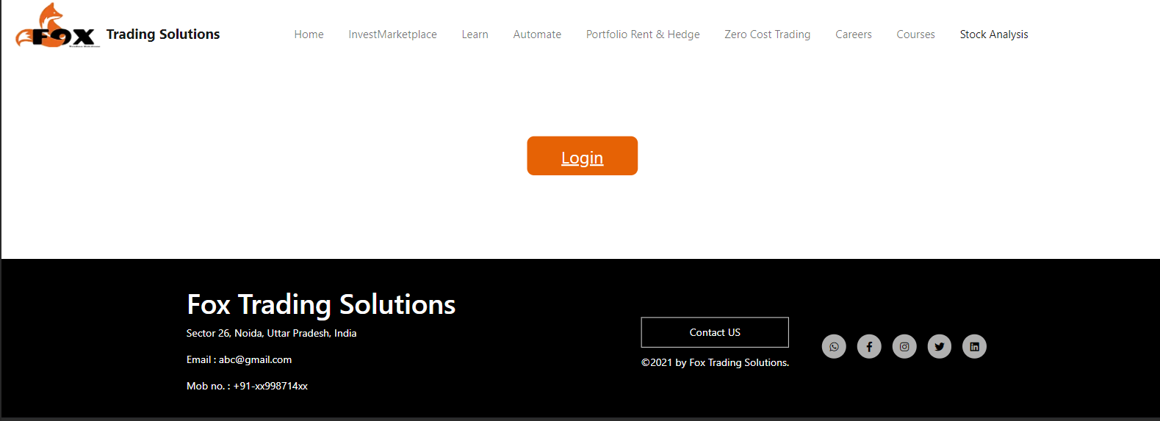

3.Press the login-It will redirect to kite login. Enter your credentials

And get the access_token

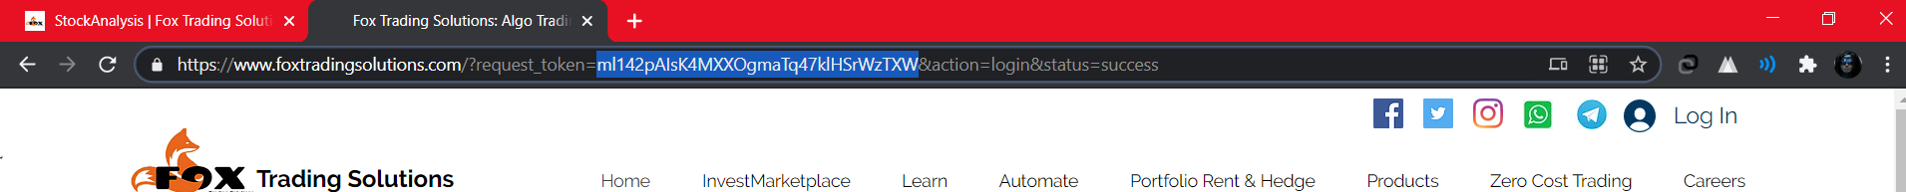

4.Paste the access_token in the input and press submit

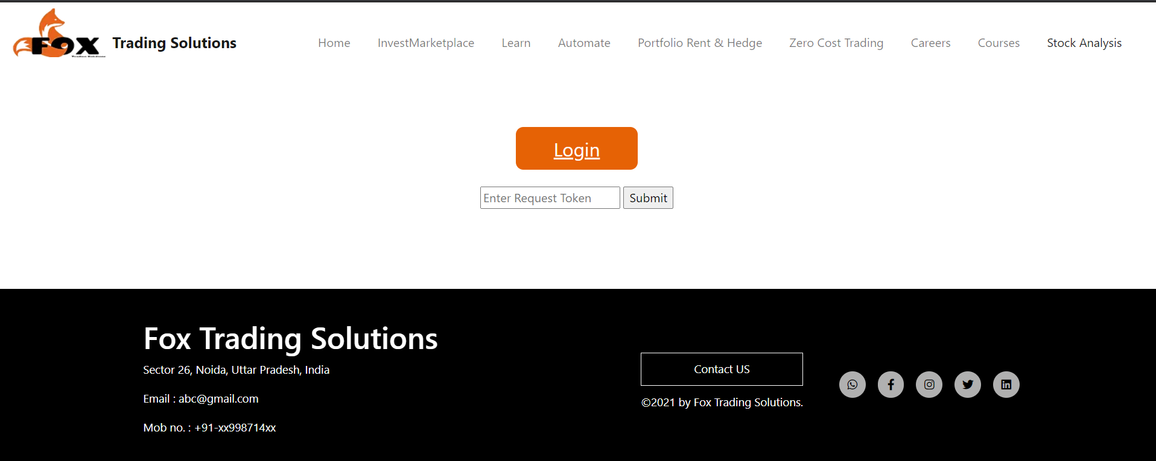

5.A Go will appear press the button to go to <http://localhost:8001/index>

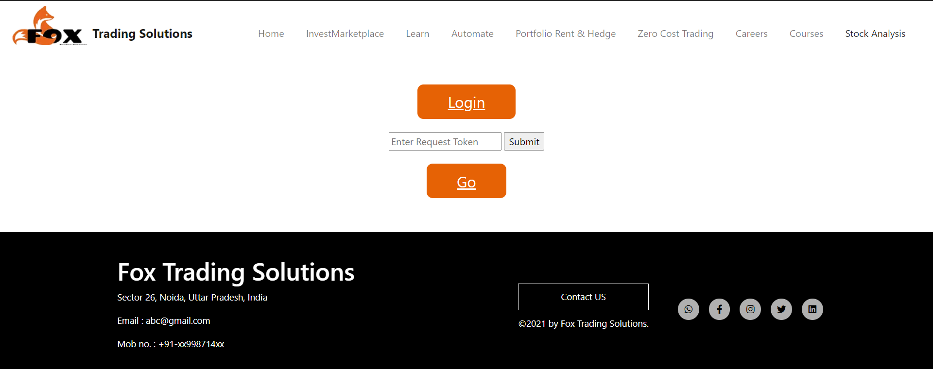

6.The main index page where stock data appears-<http://localhost:8001/index>

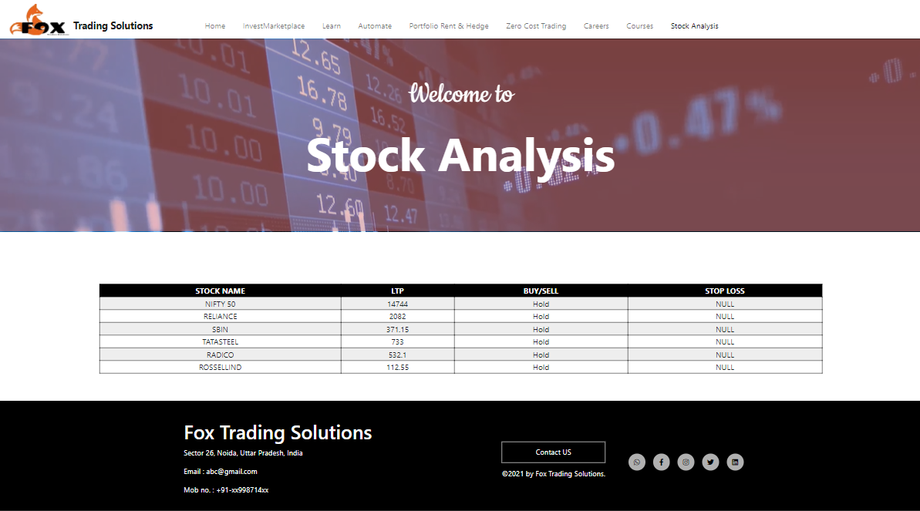

7.During market close

