WebTrends Implementation Reference

Prepared by

Wolfgang Jaegel
CTO
wjaegel@inetasia.com

Creation of a New Profile: Sample CPT

Content:

1) Create a Data Source Page 2
2) Go to ‘Web Analysis’ => ‘Reports & Profiles’ Page 6
3) Template Creation Page 13
4) Advanced Profile Settings Page 15

1) Create Data Source

go to ‘Administration’ => ‘Data Sources’

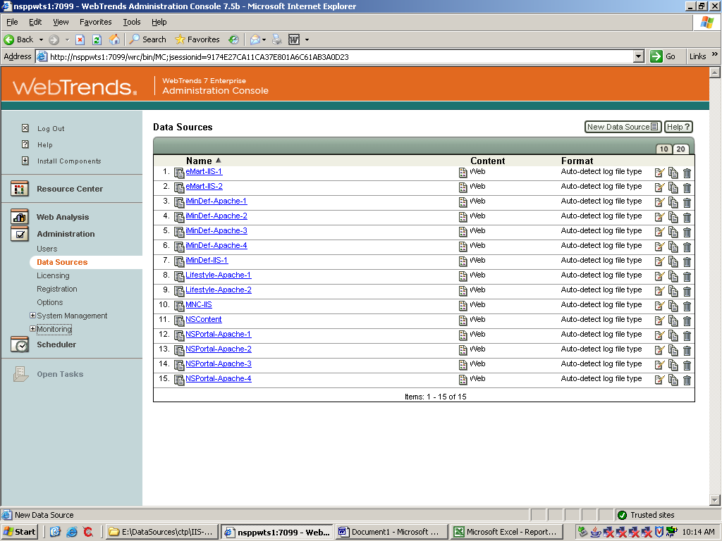

click ‘New Data Source’
Select the type of log file.

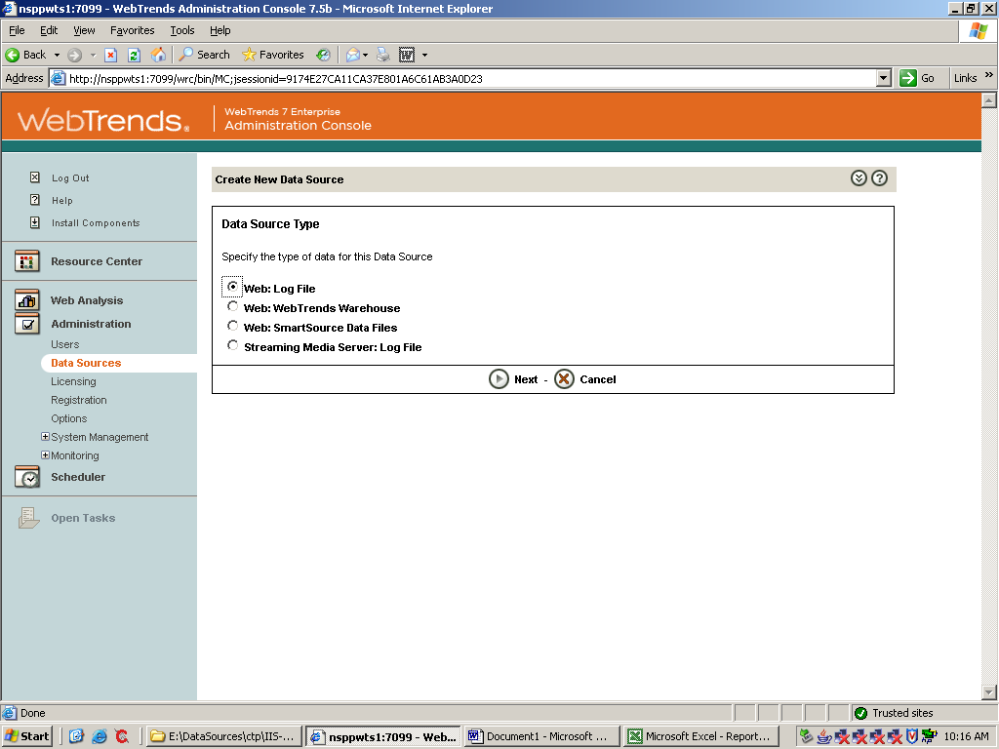’
click ‘Next’
Name the Data Source

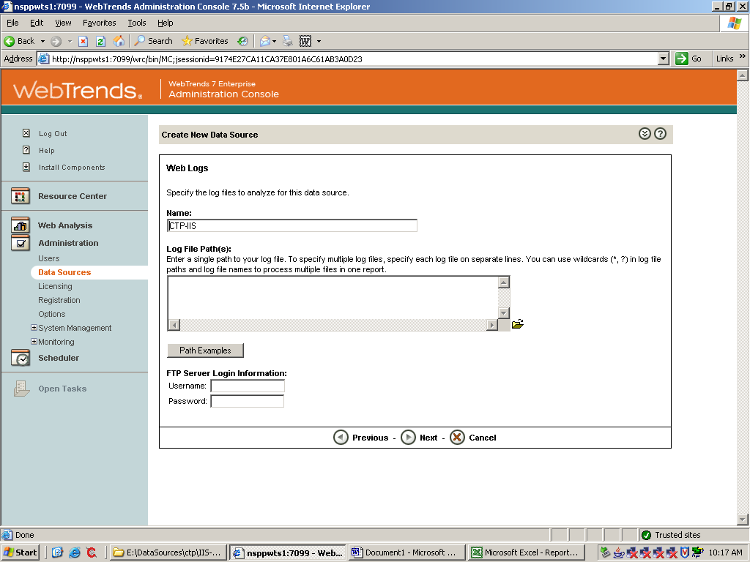

Click ‘Browse’ to select the location and files for the data source
Add the data source and change the specific date with the ‘wildcard’ character *
e.g. E:\DataSources\ctp\IIS-Log\ex*.log or \\serverlocation\folder\logfile*.log

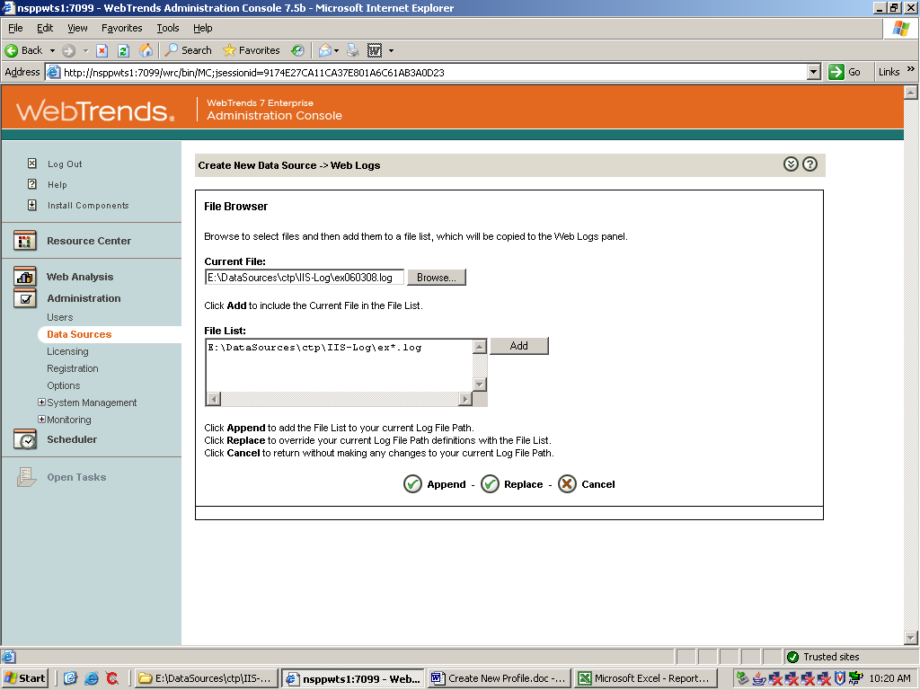
Click ‘Append’

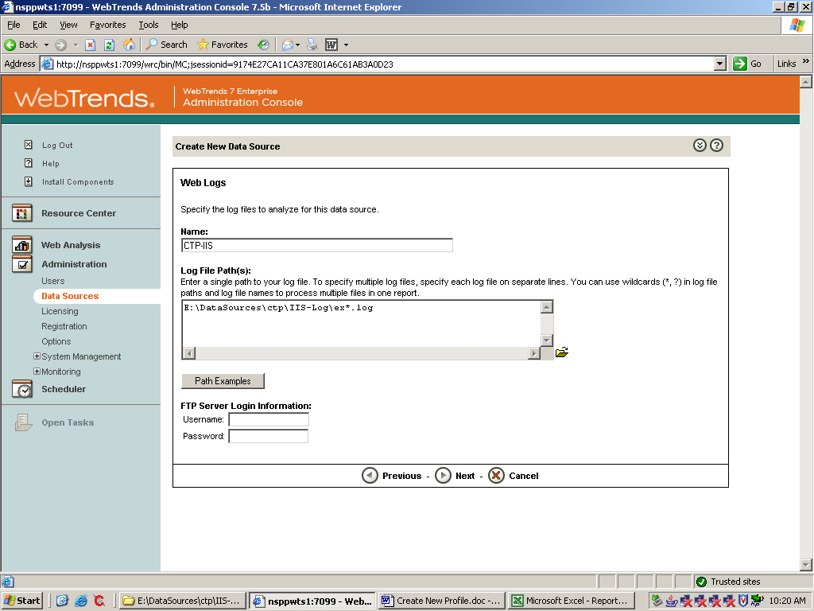

Click ‘Next’

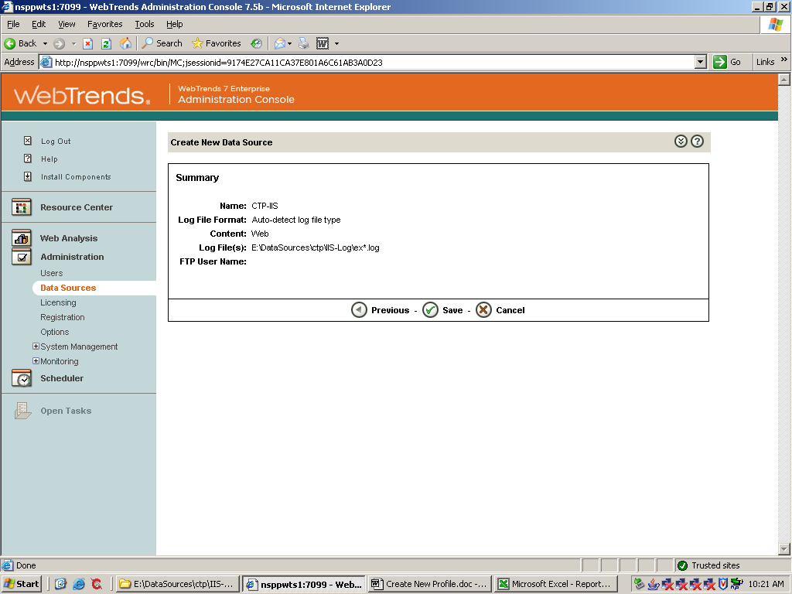

Click ‘Save’. The newly created Data Source is now available in the List of Data Sources

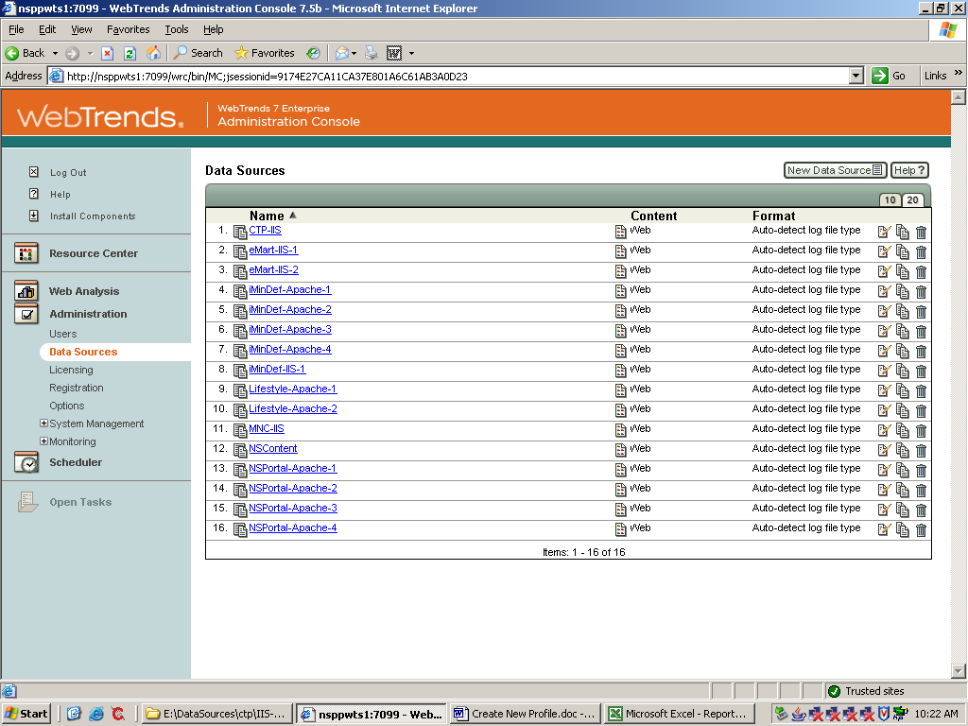

2) Go to ‘Web Analysis’ => ‘Reports & Profiles’

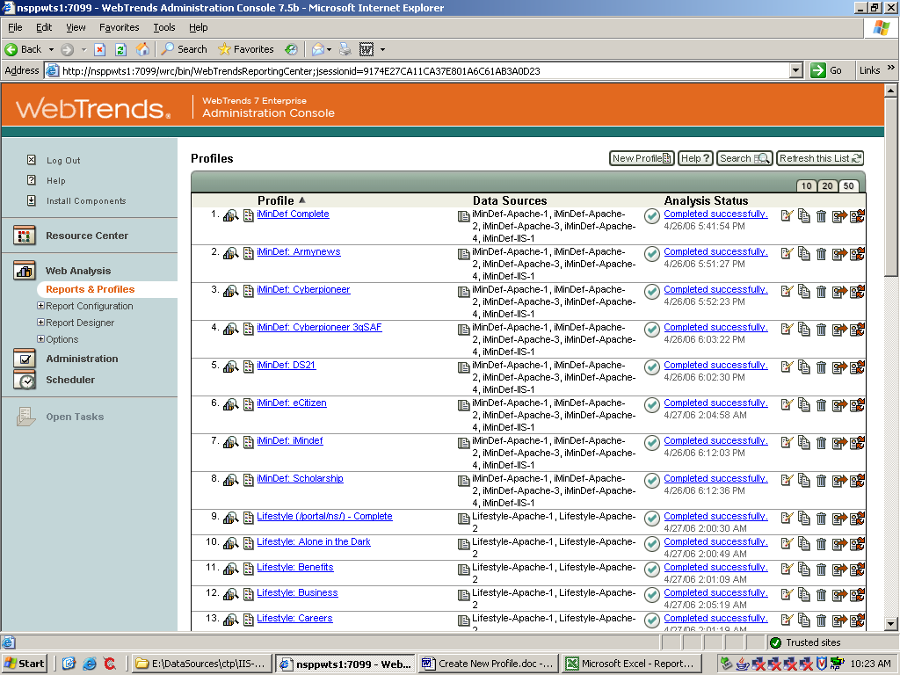

Click ‘New Profile’. Name the Profile. Add the Root URL of the Domain to track
Select ‘Advanced profile options’

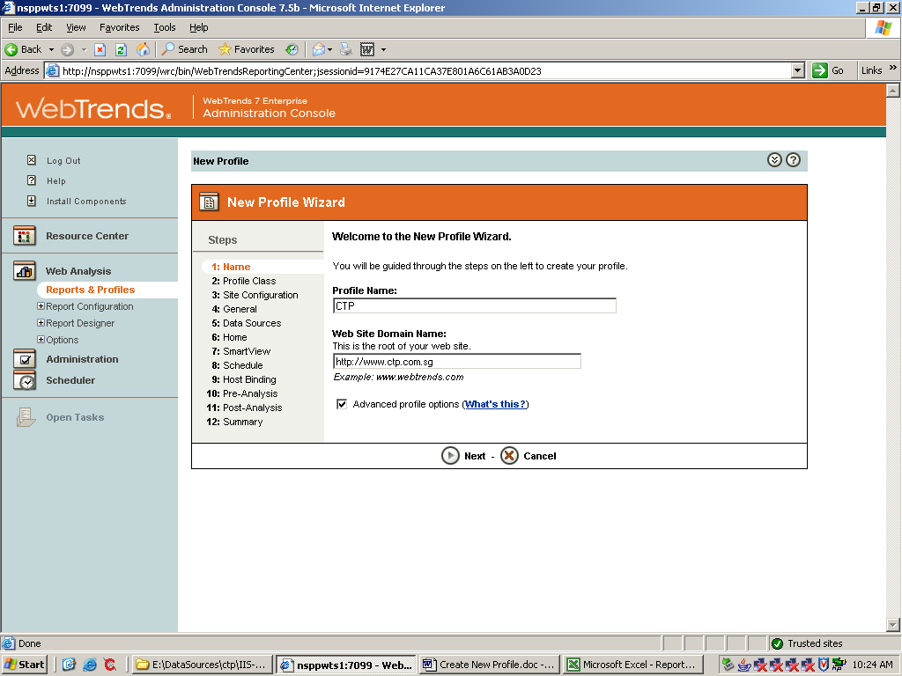
click next. If a single Profile, please select ‘Web Server’ (this is selected by default)

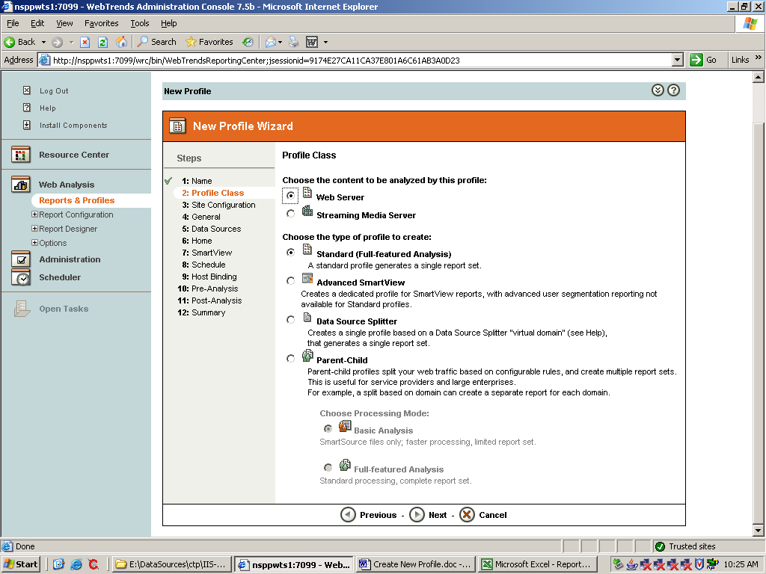

click next. Please select ‘Web site logs are stored in log files’
The next Question ‘Does your web site reside on a single server or on a cluster of servers?’ has to answered according to the WebServer setup (Single Webserver or load balanced Web servers)

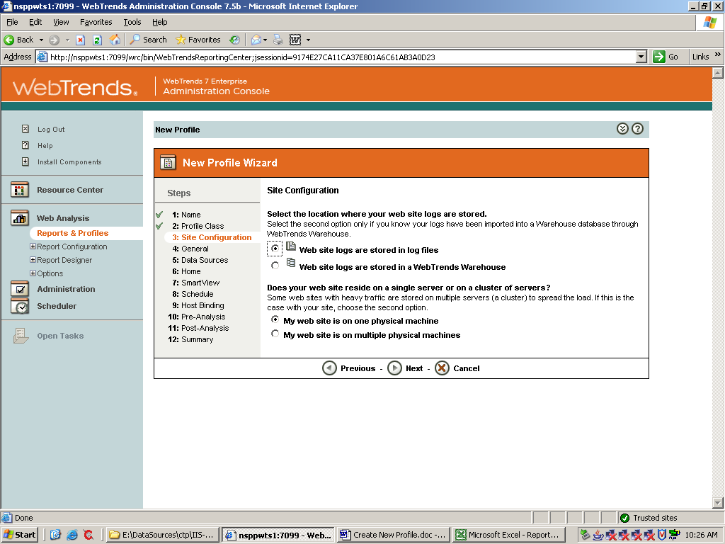
click next. This screen you can leave at the default settings

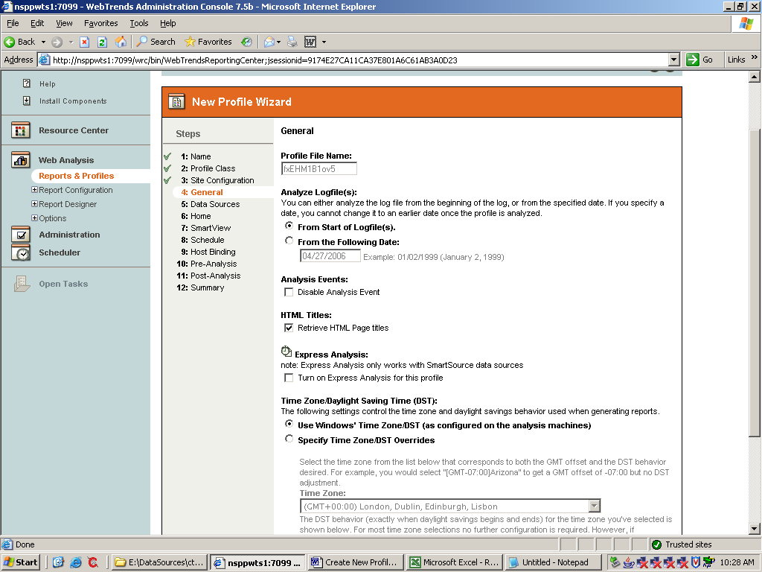

click next. Here you have to select the Data Source for this profile

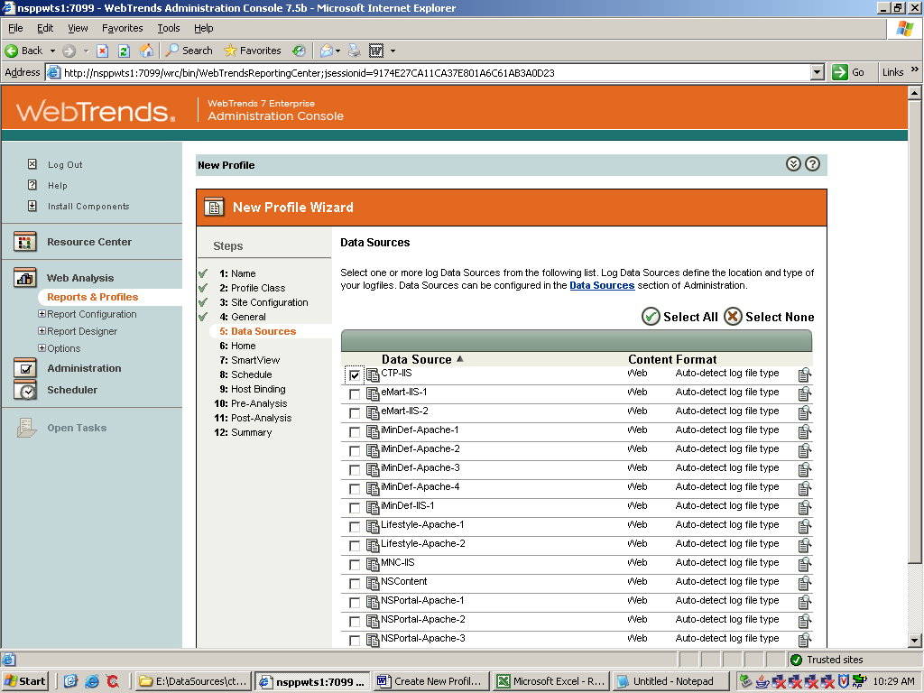
click next. In this screen define the possible index / default file extensions and also the Root URL of the Profile Domain

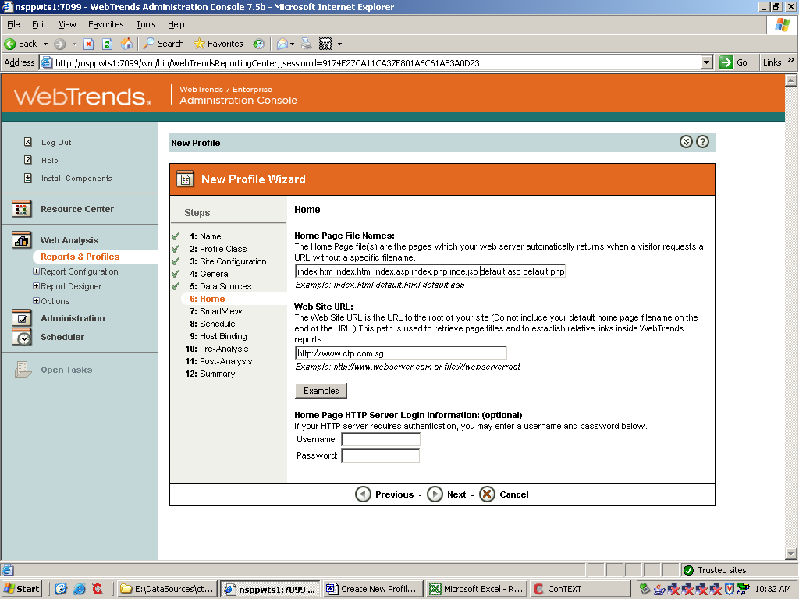

click next. Here you can set SmartView (pls refer to the Advanced Administrator Guide)

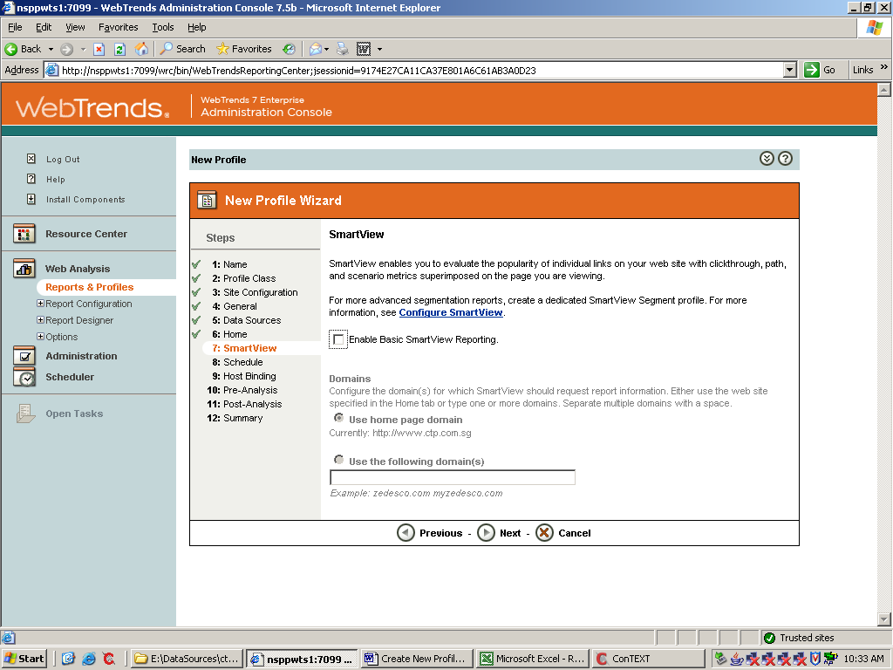

click next. This is the Scheduler page. The scheduled event can be edited any time after profile creation. Therefore during implementation of a new profile and for the initial test run it is recommended to set to ‘run once’ until it is verified that all settings are correct and reports are satisfactory. As soon the reports are confirmed you can change the scheduled event for analysis any time.

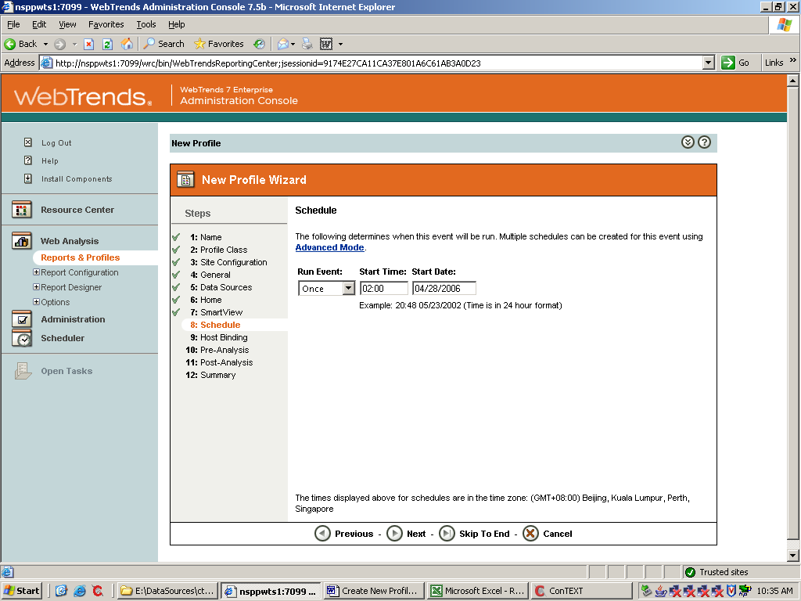

click next. Leave this screen at it’s default settings ‘any available host’

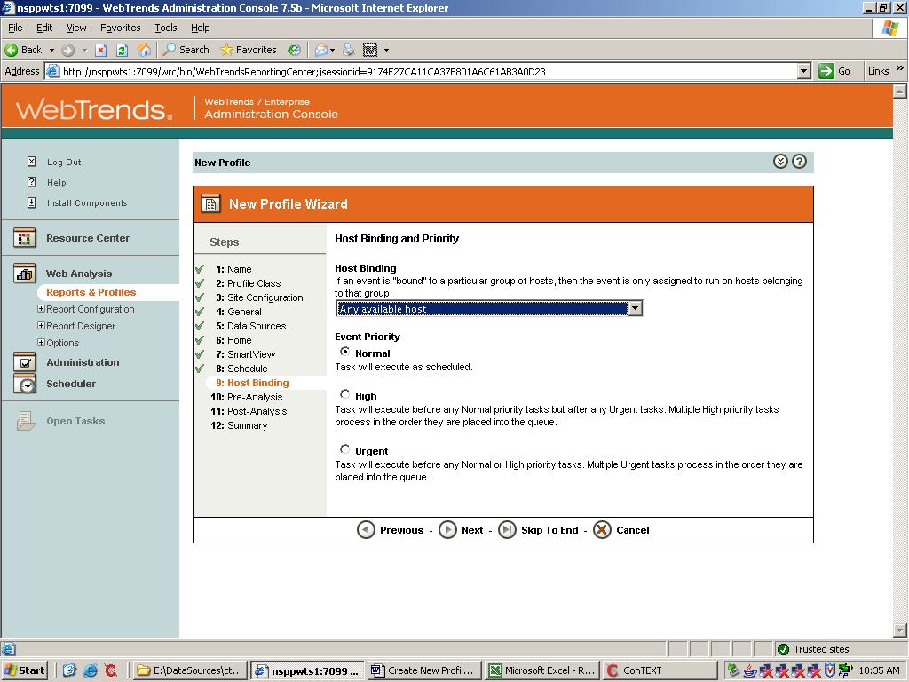

click next. At ‘Pre Analysis Processing’ you can enable events (3rd party scripts etc.) to be executed BEFORE the analysis starts. If there is none, just skip this step

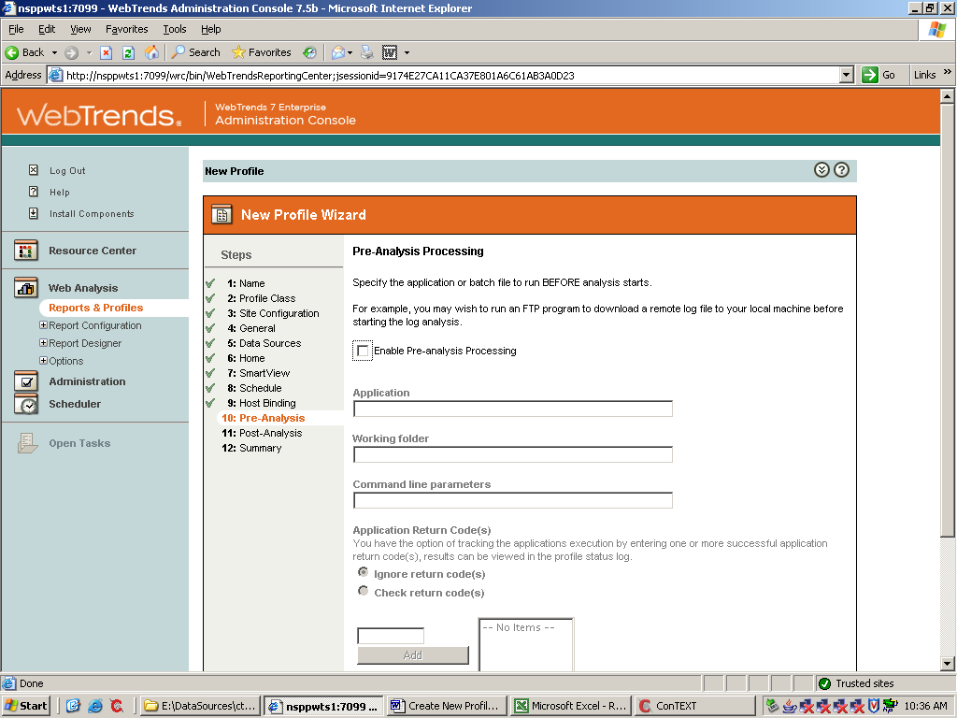

click next. Similar for the Post Analysis Processing. If there is none, skip this step

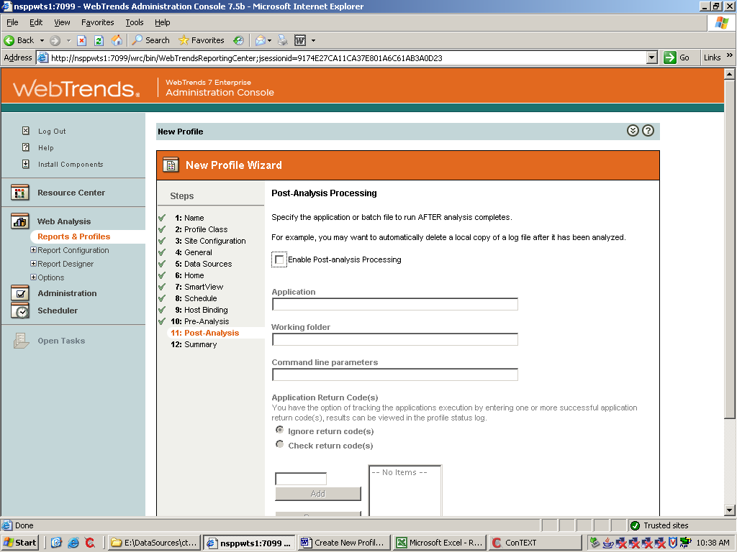

click next. At the next screen, please click ‘additional settings’

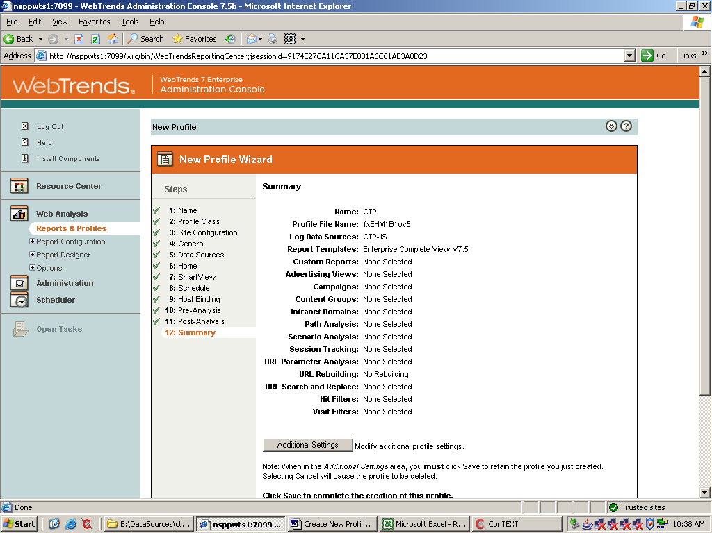

the menu and the tabs you will see here are the same as you see as soon you select ‘edit profile’ for an existing profile. (See Point 4)

3) Template Creation

go to ‘Web Analysis’ => ‘Report Designer’ => ‘Templates’
Either create a copy of an existing template and make according changes or select ‘Create New Template’ to start new.

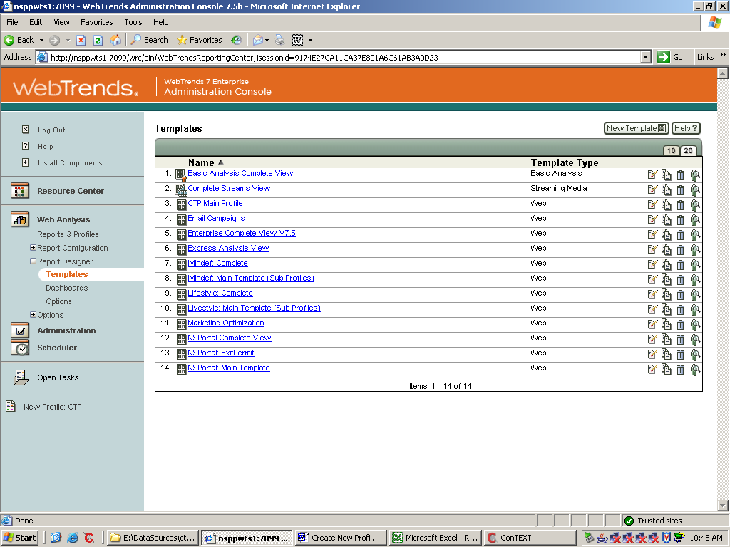

Start New Template. Name the Template and select the purpose of the Template. In most cases this will be ‘Web’

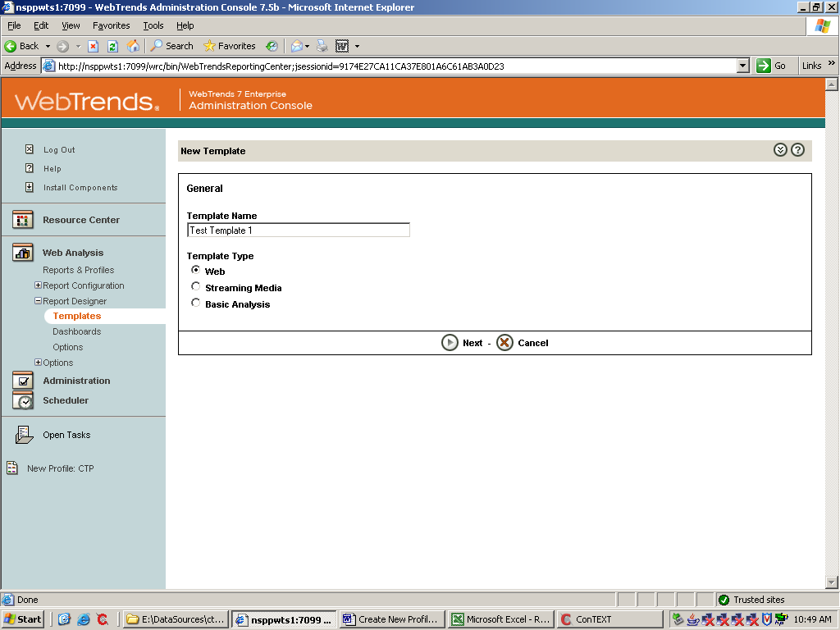
click next. You see the empty menu which has to be populated with reports

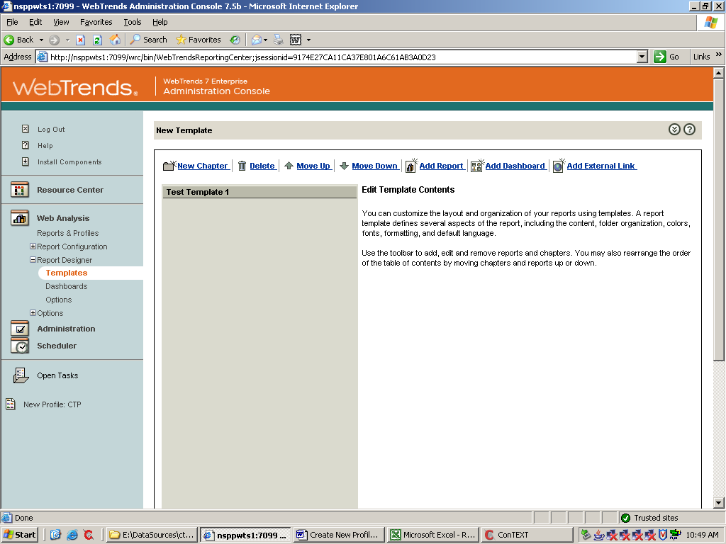

as soon you added the necessary reports, save the profile

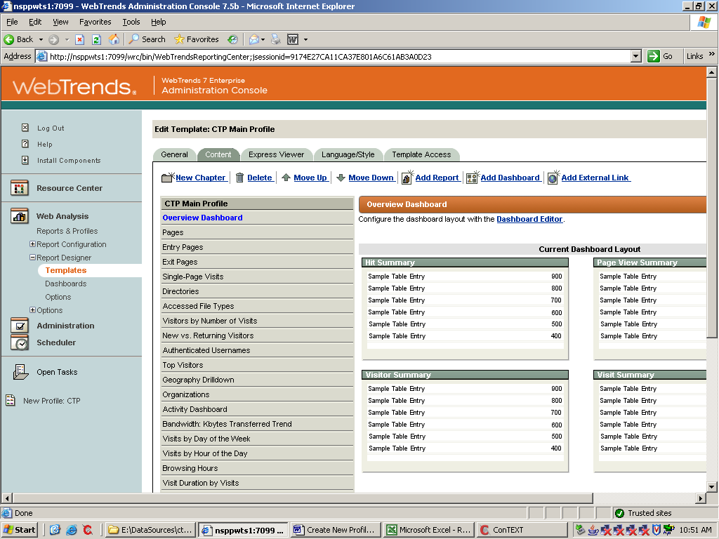

4) Advanced Profile Setting

at tab ‘Locale’ select the ‘Home Locale’ for the Website. This is NOT where the Website is hosted, but rather where the business owning the site is located.

Example: ABC is located in Singapore. Now let’s assume that the ABC Website is hosted in USA, the ‘Locale’ would be Singapore

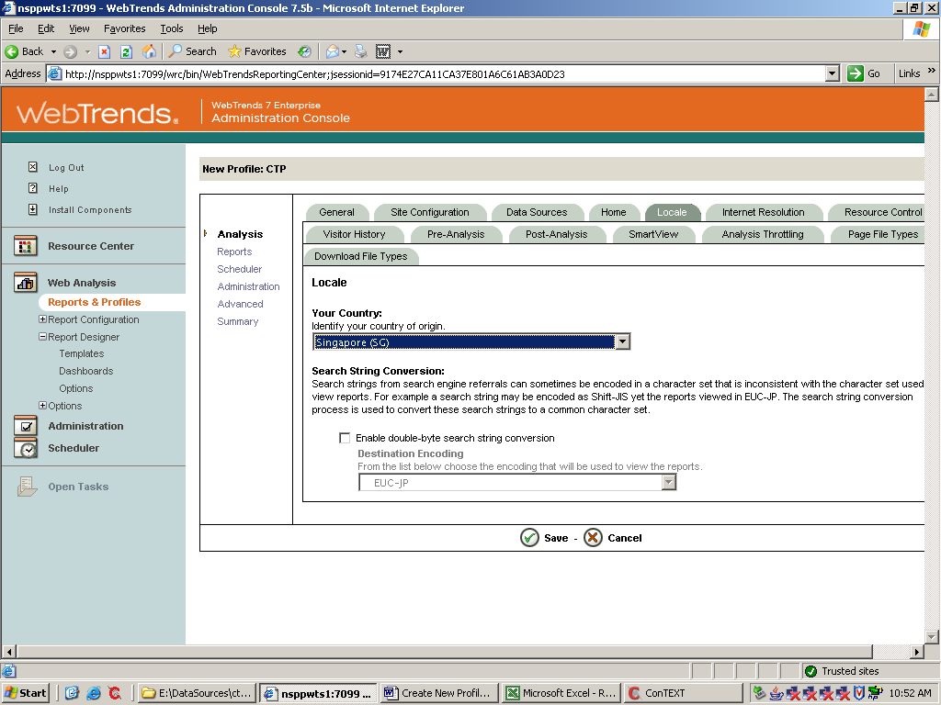

at Tab ‘Internet Resolution’ please select ‘Company Location Resolution’ (GeoTrends). NEVER select both options

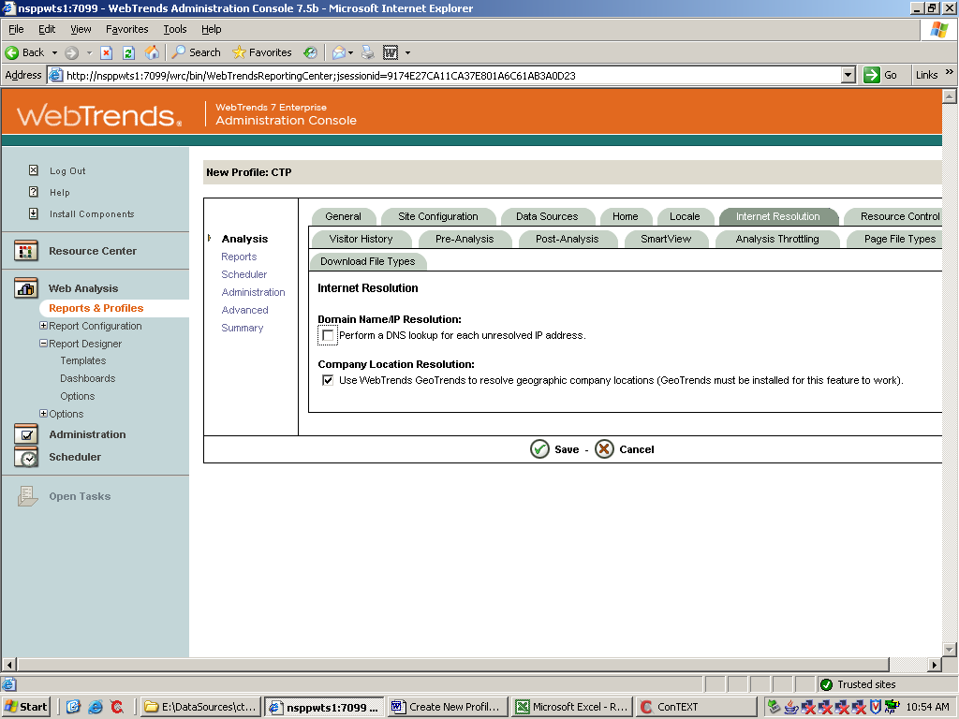
in Tab ‘Visitor History’ please enable Visitor History tracking. This is essential to be able to differentiate between Unique and Returning Visitors for example. It also can be utilized to attach a visitor to a specific campaign etc.

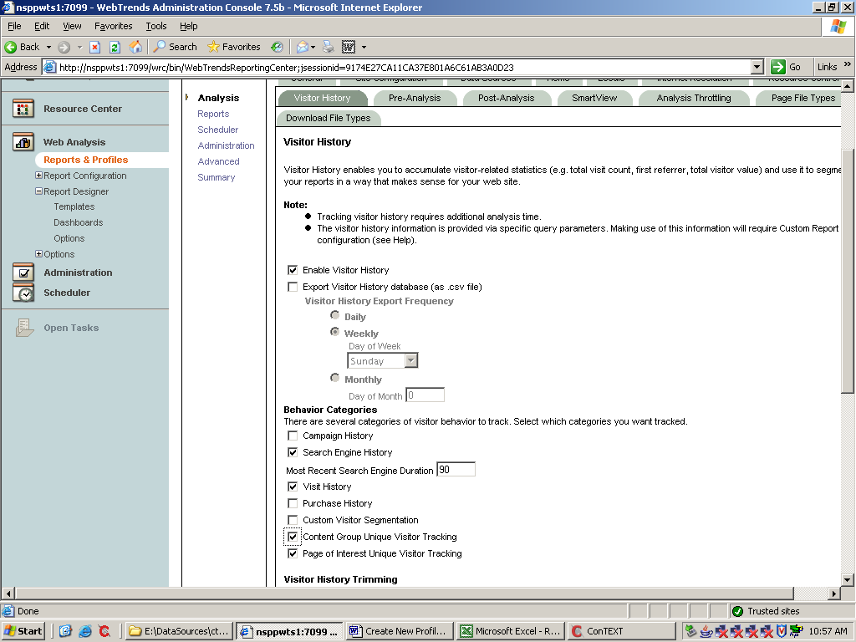

on the left hand menu select ‘Reports’. Name the report

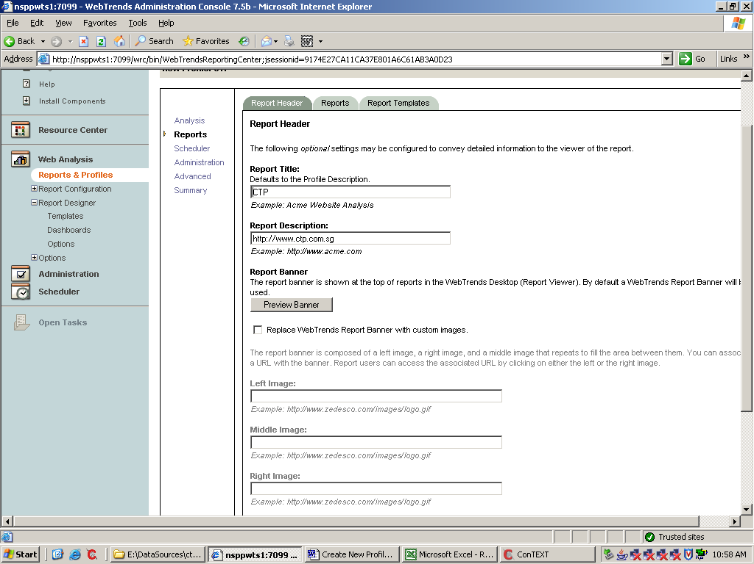

at tab ‘Report Templates’ select the newly created Template for this specific profile as default profile, You always can select additional templates generate additional views

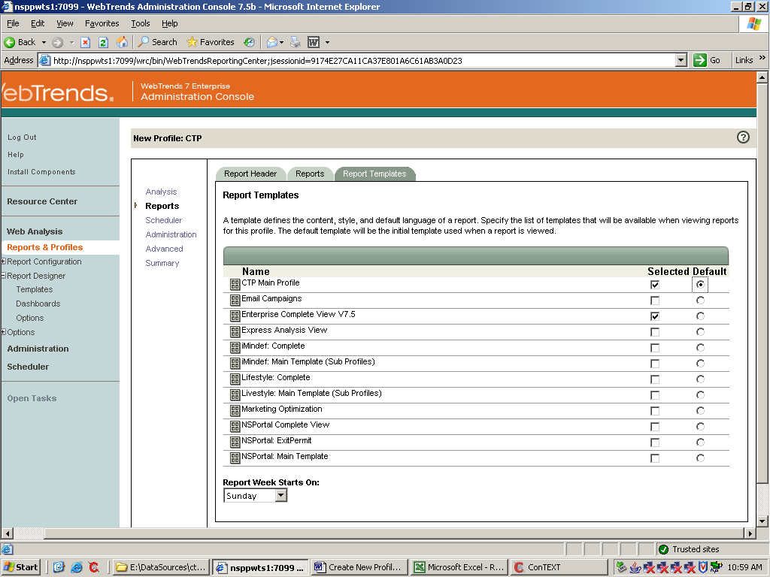

at the ‘Scheduler’ Tab you always can easily change the scheduled analysis time & frequency

