**Practical No 09**

**A] jQuery Animation effects, jQuery Chaining.**

**Animation effects:**

<!DOCTYPE html>

<html>

<head>

<script src="https://ajax.googleapis.com/ajax/libs/jquery/3.7.1/jquery.min.js"></script>

<style>

#box {

width: 100px;

height: 100px;

background: orange;

position: relative;

}

</style>

</head>

<body>

<button id="btn">Animate</button>

<div id="box"></div>

<script>

$(document).ready(function(){

$("#btn").click(function(){

$("#box").animate({left: '150px'}, 1000); // move right

$("#box").animate({opacity: 0.3}, 1000); // fade

});

});

</script>

</body>

</html>

**Output:**

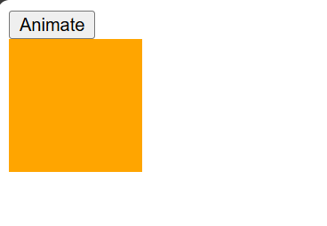

**After animation:**

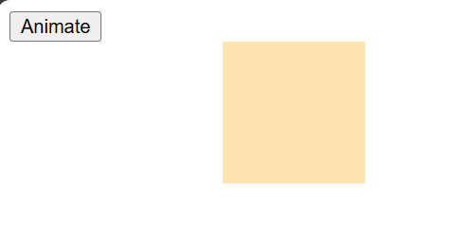

**Chaining:**

<!DOCTYPE html>

<html>

<head>

<script src="https://ajax.googleapis.com/ajax/libs/jquery/3.7.1/jquery.min.js"></script>

<style>

p {

background: lightblue;

padding: 10px;

width: 200px;

}

</style>

</head>

<body>

<p>Welcome! SRM College,Kudal.</p>

<button id="btn2">Start Chaining</button>

<script>

$(document).ready(function(){

$("#btn2").click(function(){

$("p").css("color", "red") // change text color

.slideUp(1000) // hide

.slideDown(1000); // show

});

});

</script>

</body>

</html>

**Output:**



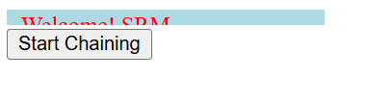

**B] jQuery Callback, jQuery Get and Set Contents.**

**Callback:**

<!DOCTYPE html>

<html>

<head>

<script src="https://ajax.googleapis.com/ajax/libs/jquery/3.7.1/jquery.min.js"></script>

<style>

#msg { background: lightgreen; padding: 10px; width: 250px; }

</style>

</head>

<body>

<p id="msg">This message will hide first.</p>

<button id="btn1">Hide with Callback</button>

<script>

$(document).ready(function(){

$("#btn1").click(function(){

$("#msg").slideUp("slow", function(){

alert("Paragraph is now hidden!"); // callback

});

});

});

</script>

</body>

</html>

**Output:**

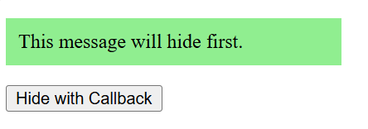

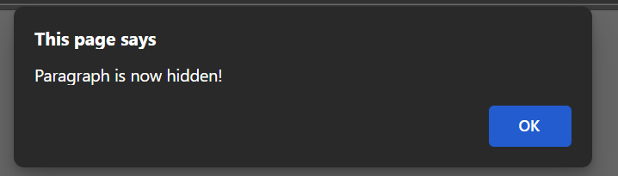

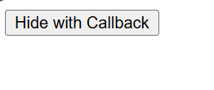

**jQuery get:**

<!DOCTYPE html>

<html>

<head>

<script src="https://ajax.googleapis.com/ajax/libs/jquery/3.7.1/jquery.min.js"></script>

</head>

<body>

<p id="para">Hello <b>World</b>!</p>

<input type="text" id="name" value="Soham">

<button id="btn2">Get Contents</button>

<script>

$(document).ready(function(){

$("#btn2").click(function(){

alert("Text: " + $("#para").text()); // Get only text

alert("HTML: " + $("#para").html()); // Get HTML with tags

alert("Value: " + $("#name").val()); // Get input value

});

});

</script>

</body>

</html>

**Output:**

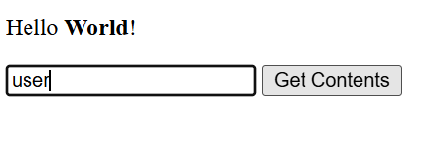

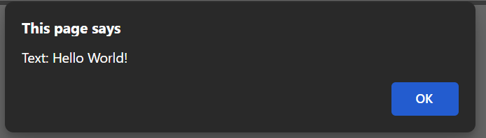

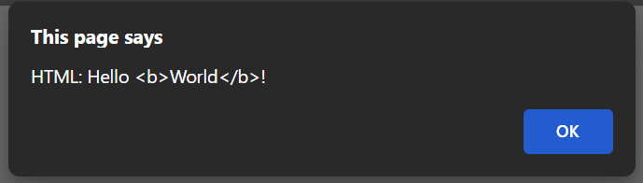

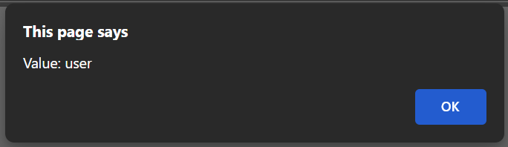

**jQuery set:**

<!DOCTYPE html>

<html>

<head>

<title>jQuery Set Example</title>

<script src="https://ajax.googleapis.com/ajax/libs/jquery/3.7.1/jquery.min.js"></script>

</head>

<body>

<p id="test1">First paragraph.</p>

<p id="test2">Second paragraph.</p>

<p>Input Box: <input type="text" id="test3" value="Text"></p>

<button id="btn1">Set Text</button>

<button id="btn2">Set HTML</button>

<button id="btn3">Set Value</button>

<script>

$(document).ready(function(){

// Set text

$("#btn1").click(function(){

$("#test1").text("Text Changed!");

});

// Set HTML

$("#btn2").click(function(){

$("#test2").html("<b>HTML Applied on the Text</b>");

});

// Set Input Value

$("#btn3").click(function(){

$("#test3").val("Input Value Changed");

});

});

</script>

</body>

</html>

**Output:**

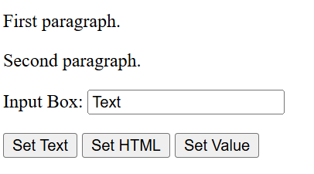

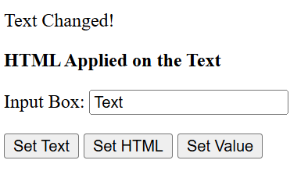

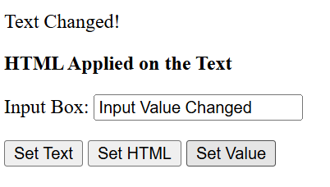

**C] jQuery Insert Content, jQuery Remove Elements and Attribute.**

**Insert Content:**

<!DOCTYPE html>

<html>

<head>

<title>jQuery Insert Example</title>

<script src="https://ajax.googleapis.com/ajax/libs/jquery/3.7.1/jquery.min.js"></script>

</head>

<body>

<p id="p1">SRM College,Kudal.</p>

<button id="btn1">Append</button>

<button id="btn2">Prepend</button>

<button id="btn3">Before</button>

<button id="btn4">After</button>

<script>

$(document).ready(function(){

$("#btn1").click(function(){

$("#p1").append(" <b>Appended text</b>.");

});

$("#btn2").click(function(){

$("#p1").prepend("<b>Prepended text</b> ");

});

$("#btn3").click(function(){

$("#p1").before("<p>Inserted BEFORE the paragraph.</p>");

});

$("#btn4").click(function(){

$("#p1").after("<p>Inserted AFTER the paragraph.</p>");

});

});

</script>

</body>

</html>

**Output:**

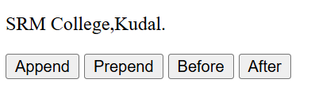

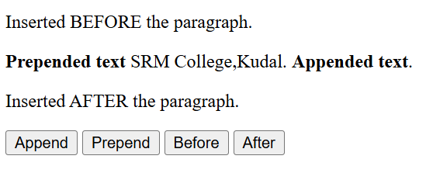

**jQuery Remove Elements and Attribute:**

<!DOCTYPE html>

<html>

<head>

<title>jQuery Remove & Attribute Example</title>

<script src="https://ajax.googleapis.com/ajax/libs/jquery/3.7.1/jquery.min.js"></script>

</head>

<body>

<h3 id="title" style="color:blue;">Hello World!</h3>

<img id="myImg" src="" alt="Image1">

<br><br>

<button id="btn1">Change Image</button>

<button id="btn2">Remove Alt Attribute</button>

<button id="btn3">Remove Title</button>

<script>

$(document).ready(function(){

// Change attribute

$("#btn1").click(function(){

$("#myImg").attr("src", "https://www.k12digest.com/wp-content/uploads/2024/03/1-3.jpg");

});

// Remove attribute

$("#btn2").click(function(){

$("#myImg").removeAttr("alt");

});

// Remove element

$("#btn3").click(function(){

$("#title").remove();

});

});

</script>

</body>

</html>

**Output:**

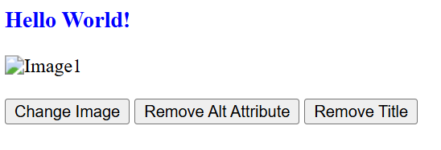

Remove attribute:

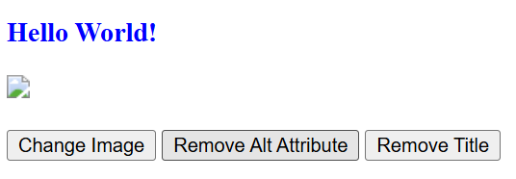

Remove title:

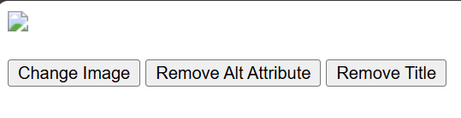

Change image:

