# Introduction

The main idea of the project is to investigate if it is possible to identify how the user carries the smartphone during everyday life, in particular in which location. When talking about location, we can distinguish several positions where a normal person carries the smartphone: trousers pocket, bag, jacket, hand etc. What we want to investigate if it is possible to use smartphone sensors to identify this different locations during everyday life. This knowledge could become very important both for smartphone usage studies, but even for other contexts, i.e. activity recognition, since data for the same activity change depending on where the user carries the phone. What we would like to do is to record the movement a user make to take the smartphone from the standard usage position (holding it in hand) to a final destination, during particular activities like walking, sitting, stairs up and down and standing. For this reason, we ask to record several movements made during everyday life from a standard usage location to a particular destination.

# *WhereIsMySmartphone* usage

The main interface of the application is provided in Figure 1.

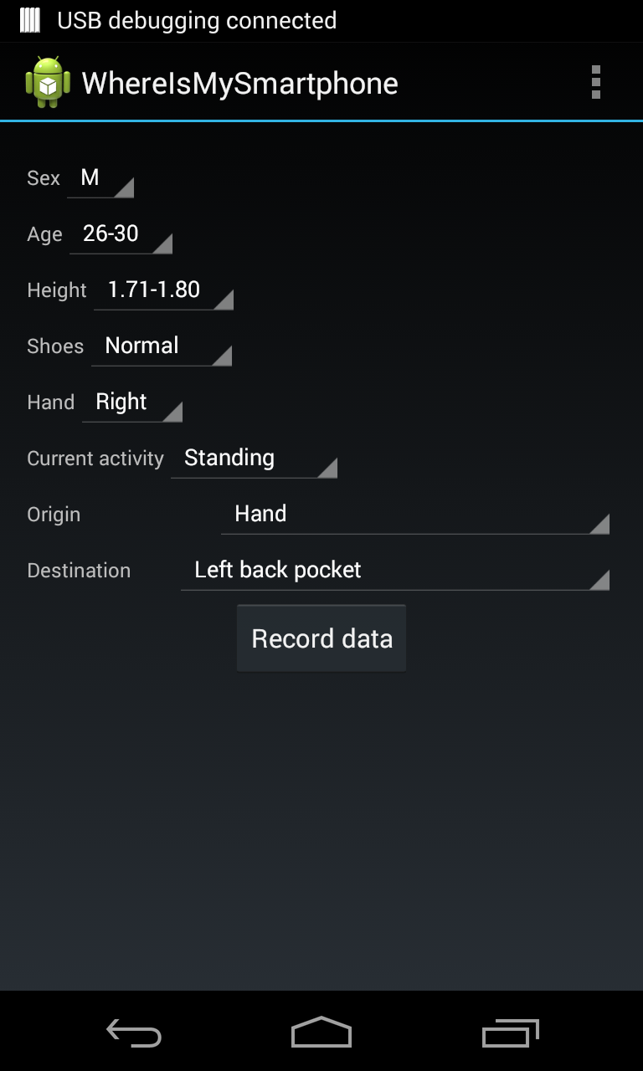

Figure 1: WhereIsMySmartphone application

Le general information required are:

* **Sex**: M (Male) o F (Female)
* **Age**
* **Height**
* **Shoes**: Normal or with heel
* **Hand**: the hand used to perform the exercise (Left or Right)

The last three options describe a particular exercise (movement):

* **Current action**: what you are currently doing while performing the exercise, i.e. “Sitting”, “Standing”, “Waling”, “Stairs Up”, “Stairs Down”
* **Origin**: the starting point of the movement, i.e. “Hand” or “Call”.
* **Destination**: this is the target destination of the movement, and could be
  + Right front pocket
  + Right back pocket
  + Left front pocket
  + Left back pocket
  + Bottom jacket
  + Top jacket
  + Bag
  + Fanny pack
  + Backpack

Once all the settings are defined, it is necessary to click on “Record data”. The data registration will last 8 seconds, and will collect data from all the available sensors on the smartphone (no personal data is collected). After four seconds a first vibration will be performed. This vibration means that you should now move the smartphone to the origin position to the destination. The movement should be as much natural as possible. After other 4 seconds, another vibration is performed to inform that the record is completed. You should repeat the same exercise two/three different times, and do as much as exercises as possible, combining the different options.

# Options and Database upload

Through the menu at the top right of the application it is possible to access to different options.

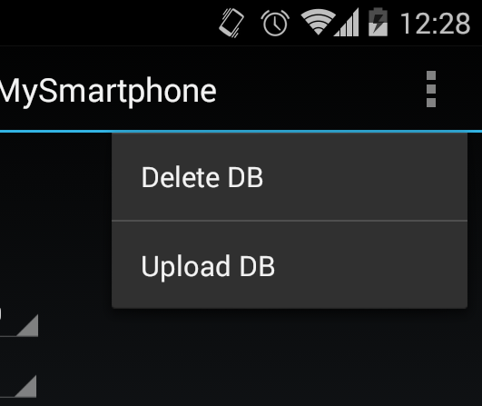

Figure 2: Options Menu

* **Delete DB**: Deletes all the recorded data (PLEASE pay attention since no confirmation dialog will be provided)
* **Send DB**: It uploads the data on the server. Since the amount of data is really high, we suggest to upload data frequently and to use only Wifi connection. Once all the files have been uploaded, a confirmation message will be shown and the database automatically deleted.

# Problems

For any problems or information about the project please feel free to contact as at [whereismysmartphone.math.unipd@gmail.com](mailto:whereismysmartphone.math.unipd@gmail.com)

The *WhereIsMySmartphone* team