WIZE RESTAURANT · RMS
Left Panel Testing & UI/UX Review
Every left-panel page tested, with the steps taken, screenshots, issues found, design improvements, the information each page should show, and a recommended menu order. A clickable HTML/CSS/JS prototype of the new design comes with this report.
Item | Detail
Prepared by | Kawshik
Prepared for | Manager, product & development team
Date | 23 October 2026
Environment | Staging: pallete.whizrmsstage.gobiens.com (logged in as Admin)
Scope | 28 pages under the left panel (Setting, User Management, Inventory, Vendor, Manage Steward, Housekeeping, POS Configurations) plus the Dashboard
Method | Each list was opened, the Add/Edit forms were opened and every field was checked, then the form was closed without saving. No records were created, changed or deleted on staging.
Deliverables | This document · wize-rms-prototype.html (new design for all pages, based on the Item Category design)

Contents
1. Executive summary
2. Issues common to all pages
3. Recommended left-panel order
4. Page-by-page testing
4.1 Location
4.2 Item Category (Category Master)
4.3 Department
4.4 Reason of Wastage
4.5 Vehicle Master
4.6 Driver Master
4.7 Roles
4.8 User List (Users)
4.9 Menu Section
4.10 Brand
4.11 Sub-Brand
4.12 Raw Material
4.13 Recipe
4.14 Vendor
4.15 Tax Setting
4.16 Order Channel View (POS Table Config)
4.17 Company Leave Category + Company Leave (→ Leave Policy)
4.18 Shift Master
4.19 Roster (Roster Pattern)
4.20 View Roster / My Roster (→ Team Roster, My Roster)
4.21 Attendance
4.22 Apply Leave
4.23 Approve Leave
4.24 Checklist Form
4.25 Checklist Assignment
4.26 My Checklist
4.27 Dashboard
5. Design guidelines for all pages
6. Prioritised backlog for the team
7. Using the prototype

1. Executive summary
All 28 pages in the left panel open and their forms load. The biggest problems are not visual. Data that other screens depend on is missing and nothing warns the user, so several modules look broken even though they work. Most pages also show only a name and a status, so users get very little context to act on.
Severity | Findings | Meaning
High | 13 | Blocks a workflow, gives wrong results, or risks data loss
Medium | 53 | Confusing, slow or inconsistent; causes errors or support calls
Low | 29 | Polish: wording, casing, typos

Top 8 problems to fix first
- Add Role cannot set permissions until the role is saved and reopened. Executive Chef currently has 0 of 212 permissions.
- Leave days are not allocated, so every balance in Apply Leave is 0. Company Leave Category and Company Leave duplicate each other.
- Both taxes are inactive, so bills are raised without tax, and nothing warns about it.
- Shift Master is empty, so Roster, My Roster and Attendance have nothing to work with. Attendance also lists future dates with a Delete button.
- Apply Leave shows a "Users" checklist in the employee's own form and does not calculate days or show the balance.
- Duplicate and format checks are missing: "Emami" brand exists twice, and vendor phone numbers have 9 digits.
- Item Category is being used for item names (Butter, Chicken, Basmati Rice…), so Raw Material is nearly empty.
- Tab titles show "Bazaar Next.js E-commerce Template" and "Admin Dashboard", and some pages take about 10 seconds to load behind a full-screen spinner.

What the new design changes
- One layout for every page, taken from your Item Category / Menu Section / Recipe / POS Table Config design: H1 + description, info strip, KPI cards, filters, a rich table, a dark-header dialog or a full-screen form with numbered sections and a "Still needed" footer.
- Every list shows the information a user needs to act on: counts, expiry dates, stock against reorder level, vendors, users per role, leave balance.
- Safer data handling: duplicate checks, format checks, blocked deletes with a reason, and "make it Inactive instead".
- A left panel ordered the way a restaurant is set up and run (section 3).

2. Issues common to all pages
These issues appear across many pages. Fixing each one once, in a shared component, fixes it on every page.
Severity | Issue | What we saw | Fix
High | Browser tab titles are wrong or left over from a template | Department and Dashboard show "Bazaar Next.js E-commerce Template"; Roles/Users/Menu Section show "Admin Dashboard"; Location shows "Warehouse - RMS"; Item Category shows "Stock Group RMS"; Raw Material shows "Stock Item - RMS Admin Dashboard". | Use one pattern everywhere: "<Page> | Wize Restaurant".
High | Slow page loads with a full white screen | Every menu click replaces the whole screen (sidebar included) with a spinner. Reason of Wastage, Vehicle Master and Driver Master took about 9–12 seconds to show data. | Keep the sidebar and header on screen; show a table skeleton only in the content area; cache master lists.
High | Setup data that other screens depend on is missing, with no warning | No shifts → roster and attendance cannot work; leave days are 0 → every balance in Apply Leave is 0; both taxes are inactive → bills go out without tax; Executive Chef role has 0 of 212 permissions. | Add a "Setup completeness" card on the Dashboard and warning strips on dependent pages.
Medium | Buttons look and behave differently on every page | Primary save is green on most dialogs, blue elsewhere; some Save buttons stay disabled until the form is valid while others stay enabled with no validation; Roster Cancel is a red filled button; Order Channel uses "ADD NEW" in capitals. | One primary button (blue), one secondary (outlined), danger only for delete. Save always enabled; on click show inline errors plus a "Still needed" list.
Medium | Names do not match between menu, breadcrumb and page heading | Sub-Brand vs Sub Brand; User List vs Users; Roster vs Roster Pattern; Checklist Form vs Checklist Forms; POS Configurations vs Pos Configuration; Reason of Wastage vs Reason of wastage; Distributor Name vs Vendor Name. | Keep one label per page and reuse it in menu, breadcrumb, H1 and tab title.
Medium | Some pages have no page heading or breadcrumb | Reason of Wastage, Roster and Vendor have no H1. Apply Leave has no breadcrumb. Vendor breadcrumb has no parent. | Every page: breadcrumb › H1 › one-line description.
Medium | Three different date formats | MM/DD/YYYY in Apply Leave and Checklist Assignment, DD-MM-YYYY in Roster, DD/MM/YY in Attendance. | Display "23 Oct 2026" everywhere and use DD/MM/YYYY for input (Indian users).
Medium | No duplicate or format checks | Brand "Emami" exists twice; vendor phone numbers have 9 digits (123456789); user phones are saved in different formats (+91 0010020030 vs 9830770140). | Block duplicate names and codes; validate mobile (10 digits), GSTIN, pincode (6 digits) and email on save.
Medium | Lists show only a name and give no context | Most masters show just Name + Status + Action. There is no total count, no "Showing 1–10 of 24", no filters, no export (only Checklist Assignment has PDF). | Add KPI cards, a record counter, status/type filters and Export on every list.
Medium | Two scroll bars on long lists | Item Category, Department, Wastage and Menu Section scroll inside the table and the page also paginates. | Let the page scroll and paginate at 10 rows with a counter.
Low | Mixed text case in tables | Checklist Form and Tax dialogs use UPPERCASE headers; Recipe tabs are UPPERCASE; other pages use Title Case. | Use Title Case for headers and tabs; UPPERCASE only for small section labels inside forms.
Low | Internal field names are visible in code | Fields named firstField / secondField (Sub-Brand, Leave Category), RegNo / BrandName, DriverName / LicNo. | Use meaningful names (brandId, subBrandName). This helps QA automation and analytics.
Low | Typos and test data on staging | "Avacado", "Hindustan Leaver", "india Mart", "preparatory cook" with description "test", test emails like uttiyogtest1@gmail.com. | Clean the seed data before demos.
Low | Logout sits in the main navigation | Logout is a sidebar item between modules, easy to click by mistake. | Move Logout to the avatar menu with My Profile and Change Password.

Every menu click blanks the whole screen, sidebar included, behind a spinner

3. Recommended left-panel order
The new order follows how a restaurant is set up and then run: organisation → people → items → suppliers → billing → staff operations → housekeeping. Each master comes before the pages that use it. Staff Management is grouped by who uses each page, so a cook sees "My space" without scrolling past manager pages.
# | Current | Recommended | Why
1 | Dashboard (top bar only) | Dashboard | Home screen for every role. Move it into the left panel and put it first.
2 | Setting: Location, Item Category, Department, Reason of Wastage, Vehicle Master, Driver Master | Setting: Location, Department, Reason of Wastage, Vehicle Master, Driver Master | Organisation set-up is done first. Item Category moves to Inventory because it is an inventory master.
3 | User Management: Roles, User List | User Management: Roles, Users | Roles must exist before users. Users need Location and Department, which come from Setting above.
4 | Inventory: Menu Section, Brand, Sub-Brand, Raw Material, Recipe | Inventory: Category Master, Brand, Sub-Brand, Raw Material, Menu Section, Recipe | Follows the order of dependency: category → brand → sub-brand → raw material. Menu Section sits next to Recipe, which uses it.
5 | Vendor | Vendor | Comes after Inventory because vendors are mapped to raw materials.
6 | Manage Steward (9 items) | POS Configurations: Tax Setting, POS Table Config | Billing set-up comes before staff operations. Order Channel View is renamed to POS Table Config, as in your design.
7 | Housekeeping | Staff Management, grouped as Setup: Shift Master, Leave Policy, Roster Pattern · Manager: Team Roster, Approve Leave · My space: Attendance, My Roster, Apply Leave | "Steward" is not clear to most users. Grouping by who uses each page cuts the list from 9 flat items to 3 short groups. Company Leave Category and Company Leave are merged into Leave Policy.
8 | POS Configurations | Housekeeping: Checklist Forms, Checklist Assignment, My Checklist | The current order is already correct: build → assign → fill.
9 | Logout | Avatar menu (top right) | Logout is not a module.

Proposed sidebar
- Dashboard
- Setting: Location · Department · Reason of Wastage · Vehicle Master · Driver Master
- User Management: Roles · Users
- Inventory: Category Master · Brand · Sub-Brand · Raw Material · Menu Section · Recipe
- Vendor
- POS Configurations: Tax Setting · POS Table Config
- Staff Management: Setup (Shift Master, Leave Policy, Roster Pattern) · Manager (Team Roster, Approve Leave) · My space (Attendance, My Roster, Apply Leave)
- Housekeeping: Checklist Forms · Checklist Assignment · My Checklist
- Top-right avatar menu: My Roster, My Attendance, Apply Leave, Change Password, Logout
Also: open only one group at a time (accordion), show red badges for pending approvals, and add a location switcher in the top bar so every page can be filtered to one outlet.

4. Page-by-page testing
Each page below has the screens as they are today, the steps tested, issues by severity, recommended improvements, the information the page should show, and the proposed design from the prototype.

4.1 Location
Menu: Setting · URL: /setting/location
Purpose: Outlets, warehouses and kitchens where stock, users and POS are tracked.

Current screens
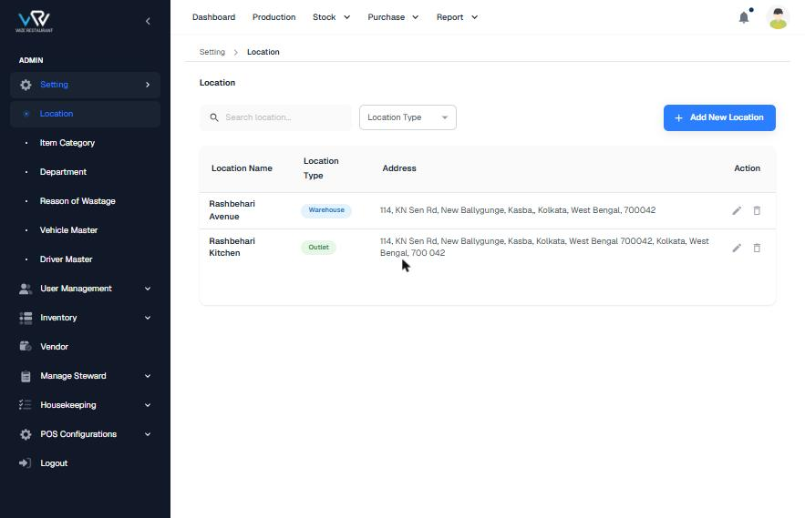
Current list
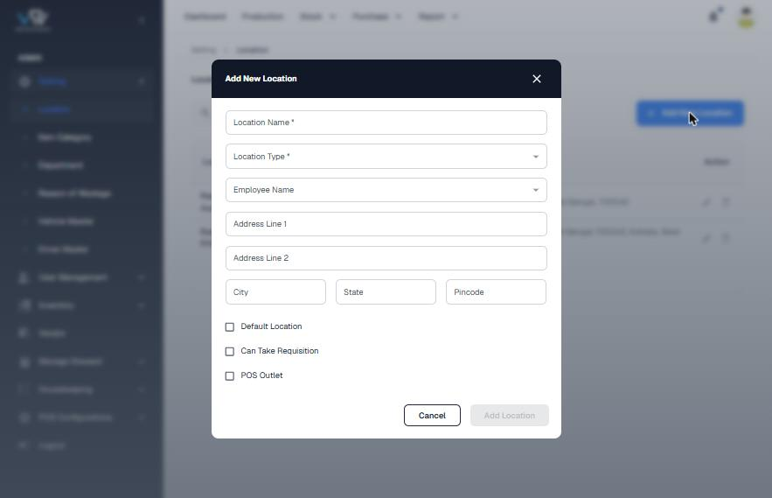
Current Add New Location dialog

Flow and steps tested
- Open Setting › Location.
- Search by name or filter by Location Type.
- Click "Add New Location". Fill Location Name*, Location Type*, Employee Name, Address Line 1/2, City, State, Pincode, and the Default Location / Can Take Requisition / POS Outlet check-boxes.
- "Add Location" stays disabled until the required fields are filled. Click it to save.
- Use the pencil icon to edit or the bin icon to delete.

Issues found
Severity | Finding
Medium | The address repeats city, state and pincode ("700042, Kolkata, West Bengal, 700 042"), and the pincode has a space in it.
Medium | City, State and Pincode are not required. The pincode is not checked for 6 digits and State is free text.
Medium | The check-boxes have no explanation. Nothing stops two locations being marked Default, or a warehouse being marked as a POS outlet.
Low | The tab title says "Warehouse - RMS".
Low | There is no short code, phone, GSTIN or manager column, and no location count.

Recommended improvements (UI/UX)
- Split the form into Basic, Address and Capabilities sections. Use a State dropdown, validate the pincode and add a Short Code.
- Replace the check-boxes with switches that explain what each one does. Allow only one default location.
- Block deleting a location that still has users or stock.

Information to show
- KPIs: total locations, POS outlets, warehouses, central kitchens
- Columns: Name + code, Type chip, formatted address, Manager, Capabilities (POS / Requisition) chips, Status

Proposed design
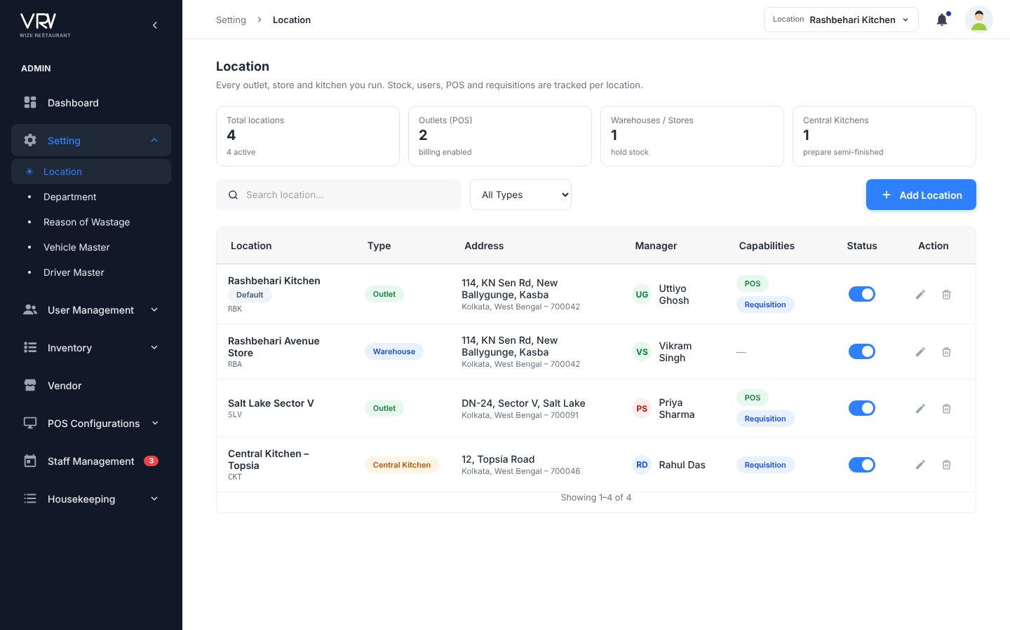
Proposed list
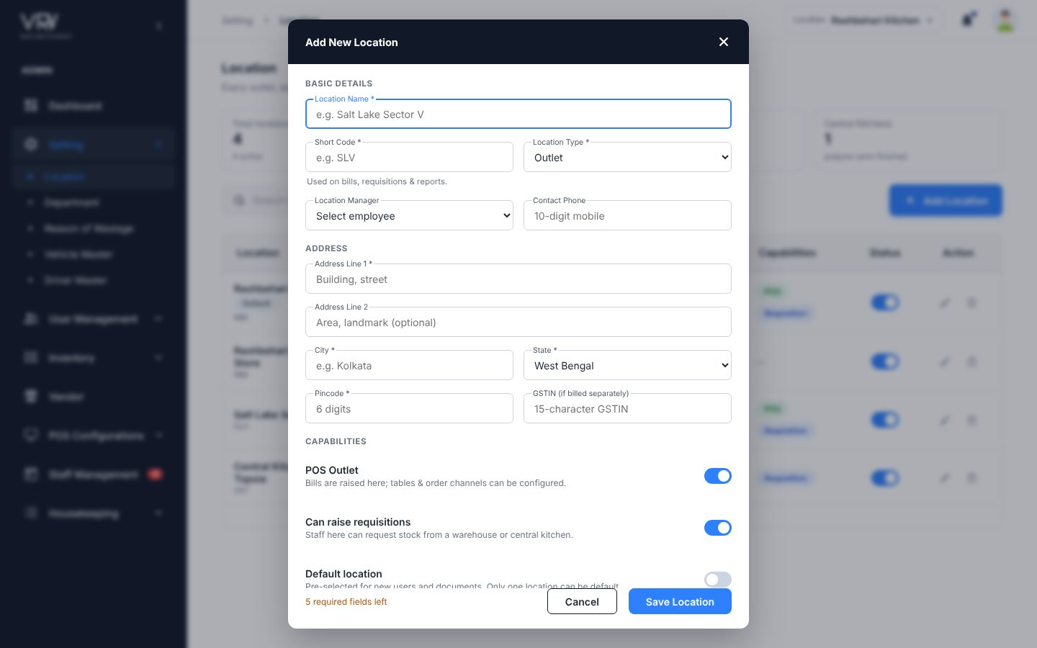
Proposed form

4.2 Item Category (Category Master)
Menu: Setting → Inventory · URL: /setting/item_category
Purpose: Groups for inventory items, by inventory type.

Current screens
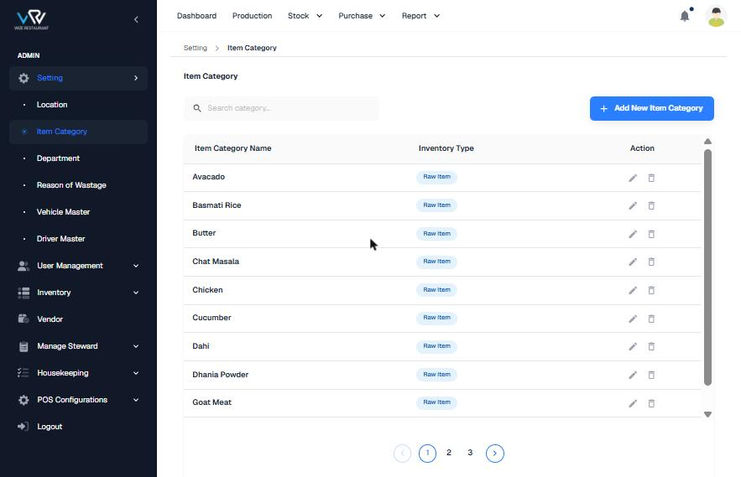
Current list
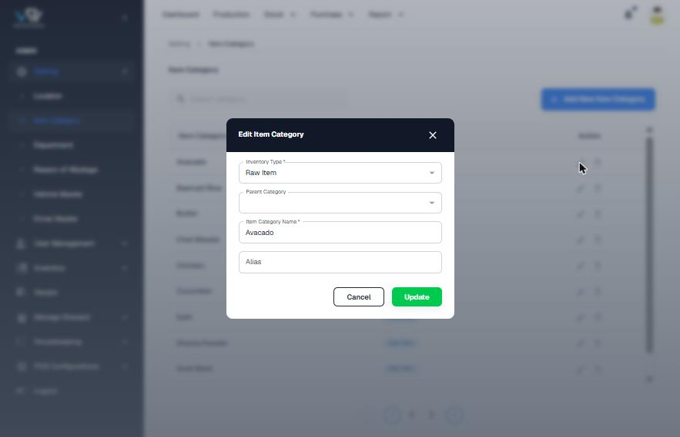
Current Edit dialog

Flow and steps tested
- Open Setting › Item Category.
- Click "Add New Item Category" and choose Inventory Type*, Parent Category, Item Category Name* and Alias.
- Click "Add Category" to save, or edit a row with the pencil icon and click "Update".

Issues found
Severity | Finding
High | Item names are being created as categories (Avacado, Basmati Rice, Butter, Chicken, Dahi…), so the Raw Material page ends up with one item "Oil" under a category called "Mustard Oil". Users do not understand the difference between a category and an item.
Medium | The parent category is never shown in the list, so the hierarchy is invisible.
Medium | There is no code, no status and no item count. The table scrolls inside the page and the list is only 10 rows over 3 pages.
Low | Typo "Avacado". The tab title says "Stock Group RMS".

Recommended improvements (UI/UX)
- Use your Category Master design: tabs for Raw Material / Semi-Finished / Finished Goods with counts, a tree view with sub-category counts, auto codes (RM-BAK-BKI) and a status column.
- Add a description and an info strip explaining that categories are groups and items are created in Raw Material.
- Move the page to Inventory.

Information to show
- Type tabs with counts
- Category code, parent, number of sub-categories, status

Proposed design
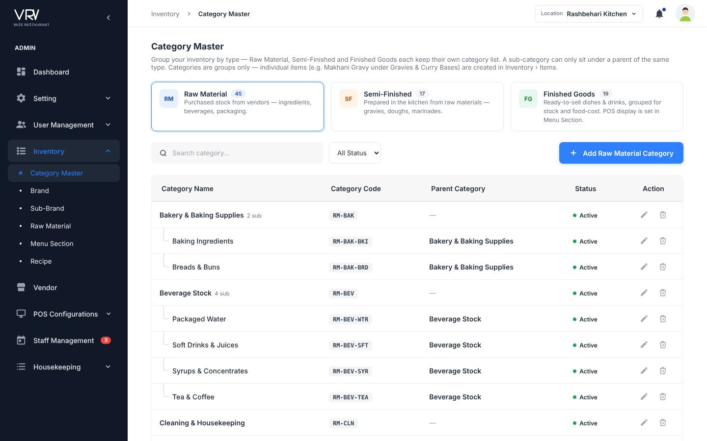
Your Category Master design (kept as-is in the prototype)

4.3 Department
Menu: Setting · URL: /setting/department
Purpose: Teams that staff belong to.

Current screens
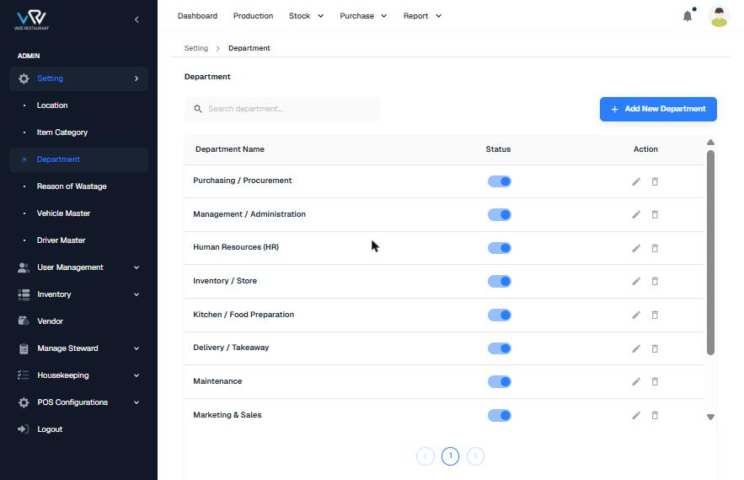
Current list
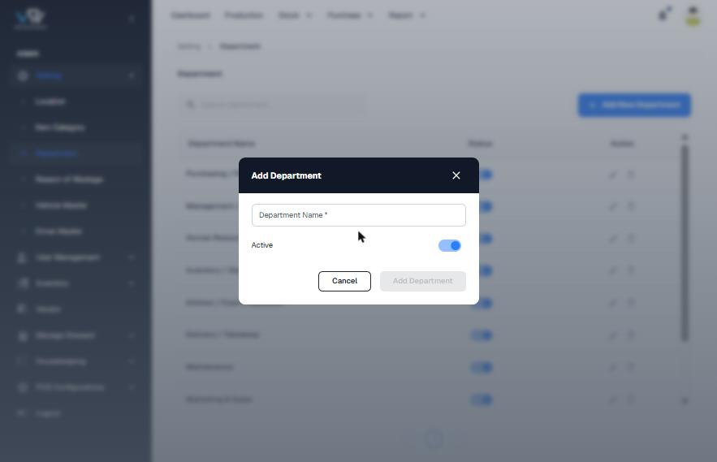
Current Add dialog

Flow and steps tested
- Open Setting › Department.
- Click "Add New Department", enter Department Name* and set Active.
- Click "Add Department". A department can be switched on or off from the list.

Issues found
Severity | Finding
Medium | The status toggle in the list changes data immediately, with no confirmation and no check for linked users.
Low | The tab title says "Bazaar Next.js E-commerce Template".
Low | There is no code, head of department or staff count.

Recommended improvements (UI/UX)
- Add Code, Department Head and a Staff count column.
- Block delete or deactivate while users are still linked, and say why.

Information to show
- Department head with avatar, staff count, status filter

Proposed design
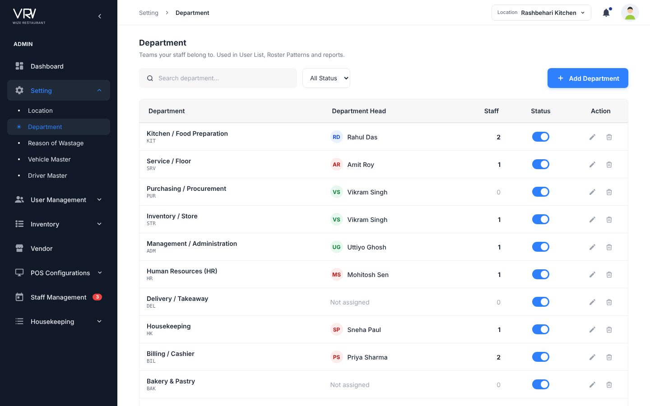
Proposed list

4.4 Reason of Wastage
Menu: Setting · URL: /setting/reason_of_wastage
Purpose: Reasons staff choose when they record wastage.

Current screens
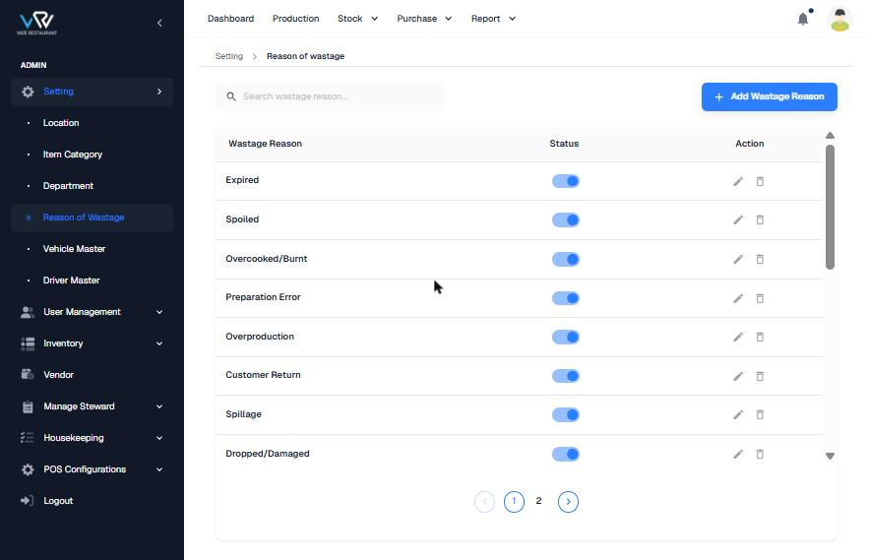
Current list
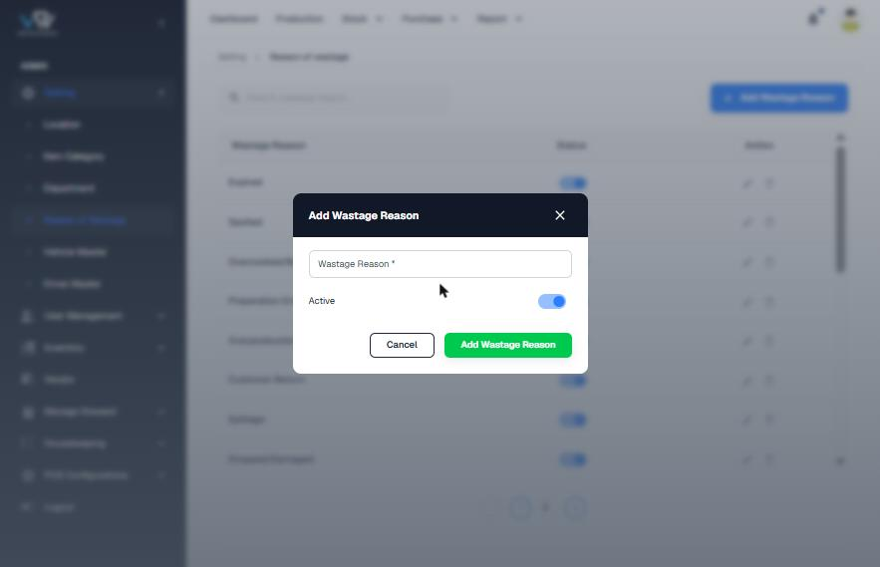
Current Add dialog

Flow and steps tested
- Open Setting › Reason of Wastage.
- Click "Add Wastage Reason", type the reason and set Active.
- Save. Edit, delete or toggle a reason from the list.

Issues found
Severity | Finding
Medium | The page has no H1 heading and the breadcrumb is in lower case.
Medium | All 20 reasons sit in one flat list. They are not grouped by Storage, Kitchen or Service, which wastage reports need.
Low | The Save button is enabled when the form is empty, while Department disables it.
Low | Data took about 12 seconds to load.

Recommended improvements (UI/UX)
- Add a category and tabs, an "Applies to" setting (Raw / Semi / Finished), and switches for "Photo required" and "Needs approval".

Information to show
- Category chip, applies-to chips, rule chips

Proposed design
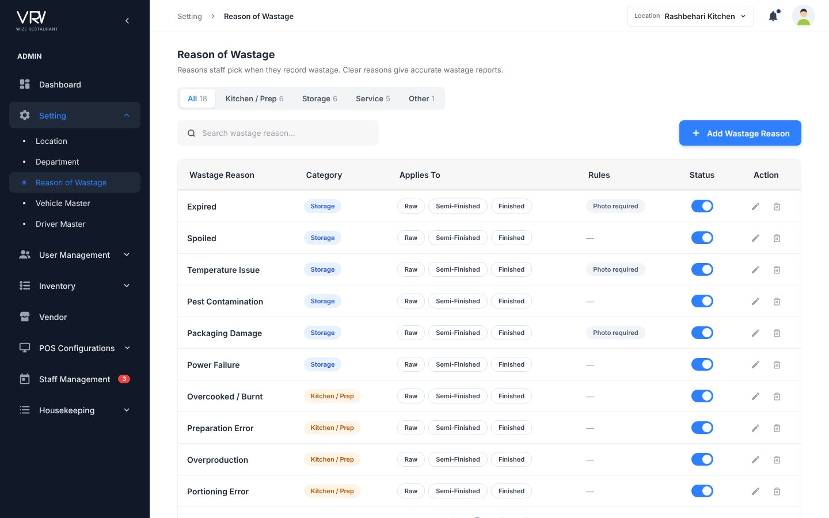
Proposed list with category tabs

4.5 Vehicle Master
Menu: Setting · URL: /setting/vehicle_master
Purpose: Delivery and transfer vehicles.

Current screens
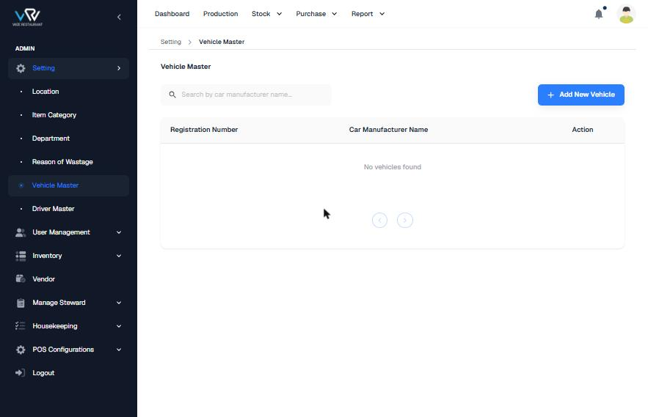
Current list (empty)
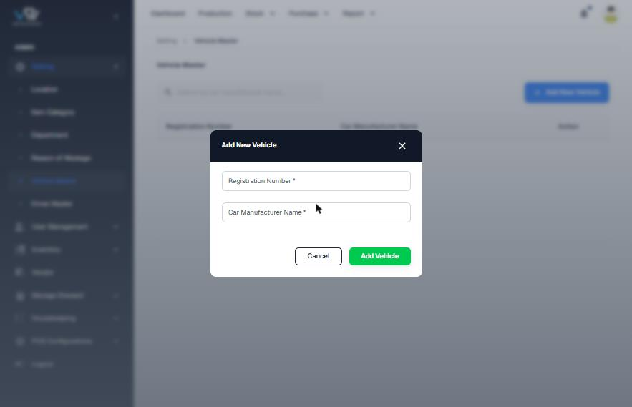
Current Add dialog

Flow and steps tested
- Open Setting › Vehicle Master.
- Click "Add New Vehicle" and enter Registration Number* and Car Manufacturer Name*.
- Save.

Issues found
Severity | Finding
Medium | The label says "Car Manufacturer Name", but restaurants mostly use bikes and vans.
Medium | There is no vehicle type, capacity, assigned driver or insurance/fitness expiry, so nobody can see which vehicle is legal to use.
Low | Pagination arrows show even when the list is empty, and the registration number format is not checked.

Recommended improvements (UI/UX)
- Add Type, Make & Model, Load capacity, Assigned driver and document expiry dates with a 30-day alert.

Information to show
- KPIs: vehicles, without driver, insurance due in 30 days
- Expiry shown in orange or red

Proposed design
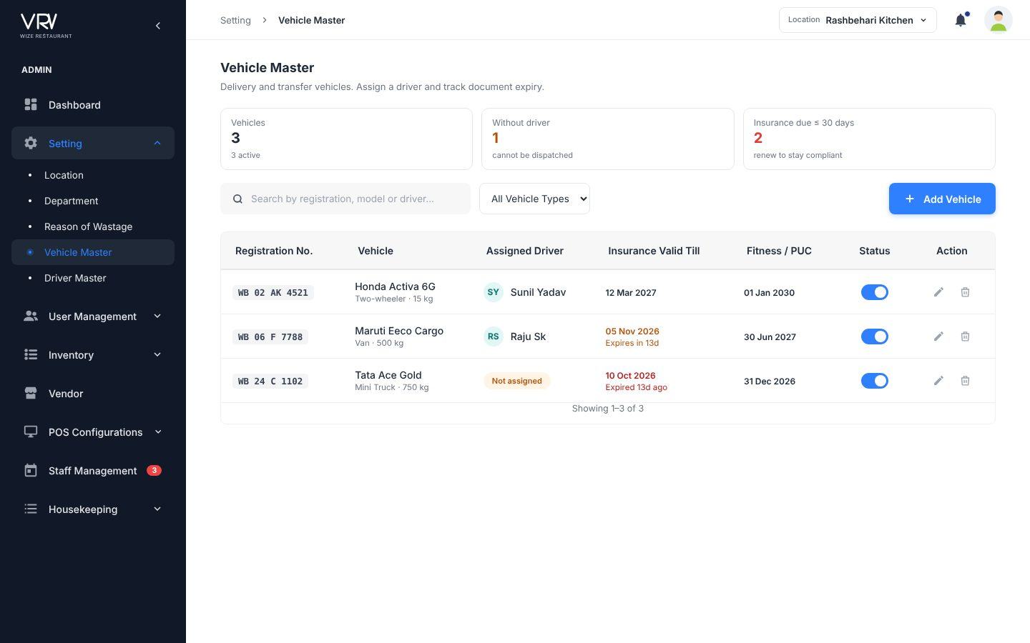
Proposed list
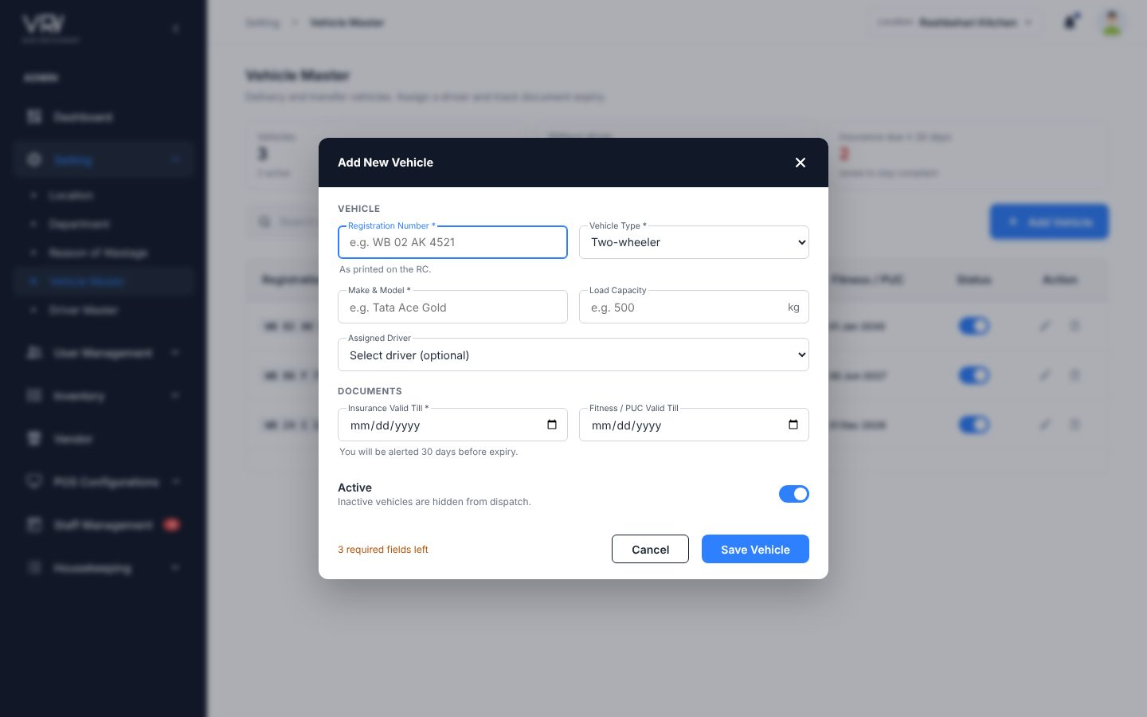
Proposed form

4.6 Driver Master
Menu: Setting · URL: /setting/driver_master
Purpose: Drivers for delivery and stock movement.

Current screens
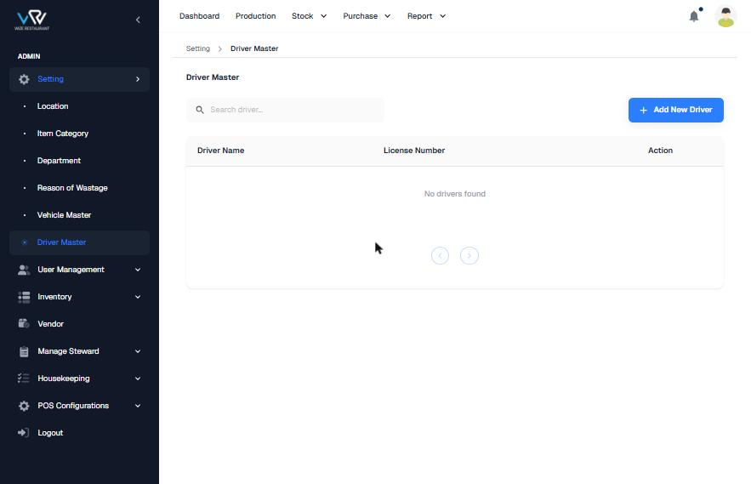
Current list (empty)
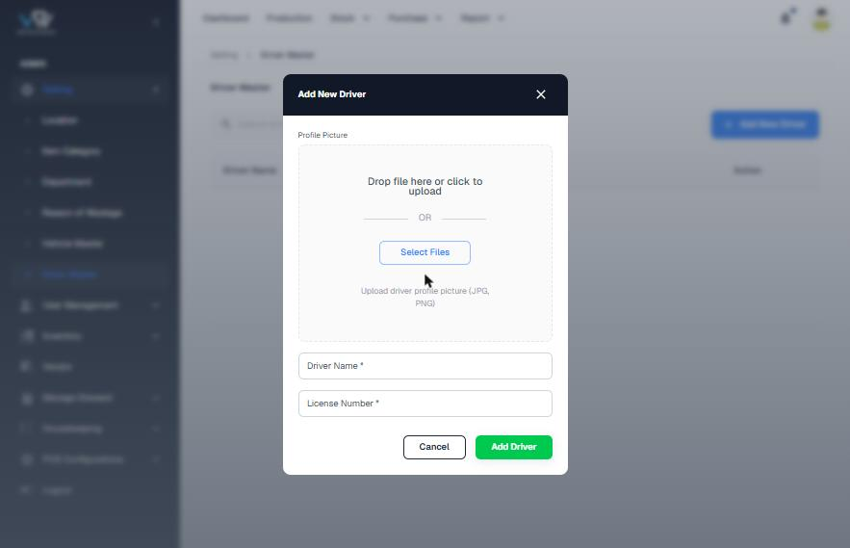
Current Add dialog

Flow and steps tested
- Open Setting › Driver Master.
- Click "Add New Driver", optionally upload a profile picture, and enter Driver Name* and License Number*.
- Save.

Issues found
Severity | Finding
Medium | There is no mobile number, which is the first thing dispatch needs.
Medium | There is no licence expiry and no link to a vehicle.
Low | The photo upload box takes 60% of the dialog for an optional field.

Recommended improvements (UI/UX)
- Add Mobile*, Licence expiry*, Assigned vehicle and Address. Make the photo a small avatar picker.
- Flag expiring or expired licences.

Information to show
- Avatar + phone, licence number, expiry status, vehicle

Proposed design
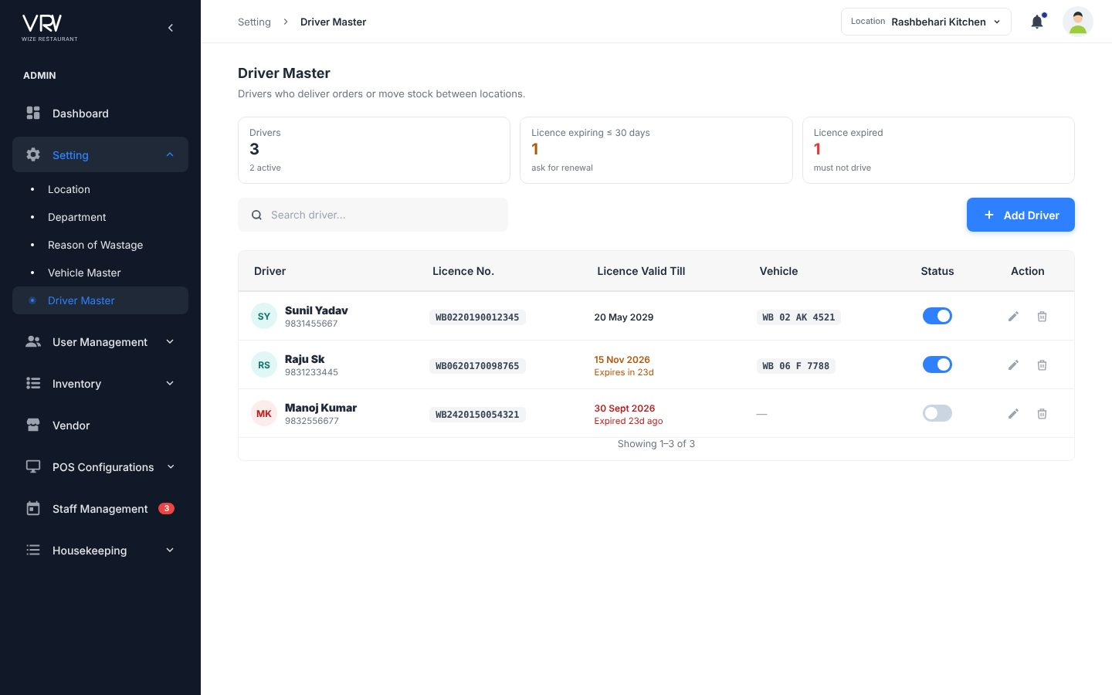
Proposed list

4.7 Roles
Menu: User Management · URL: /user_management/roles
Purpose: Permission sets assigned to users.

Current screens
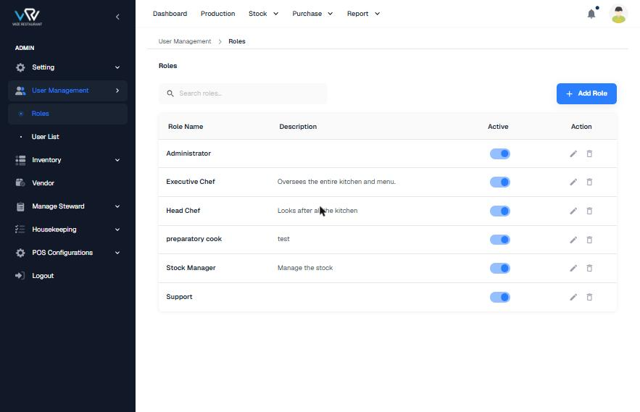
Current list
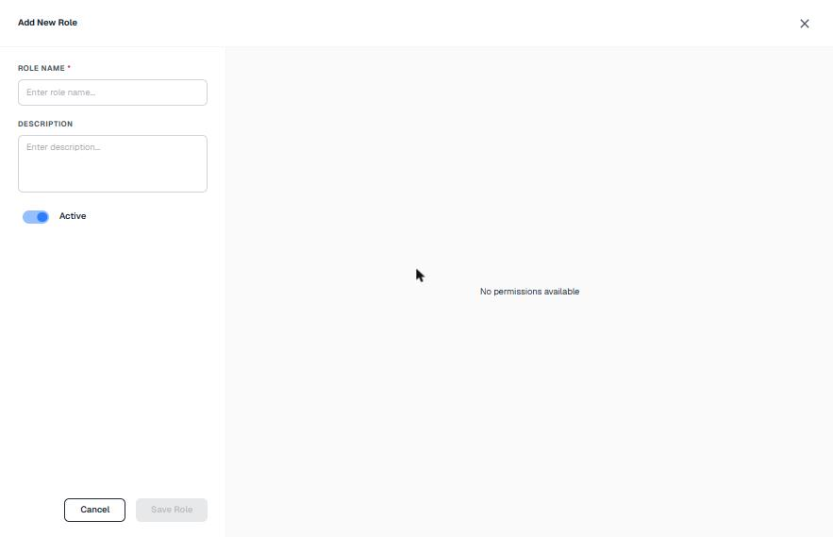
Current Add Role: "No permissions available"
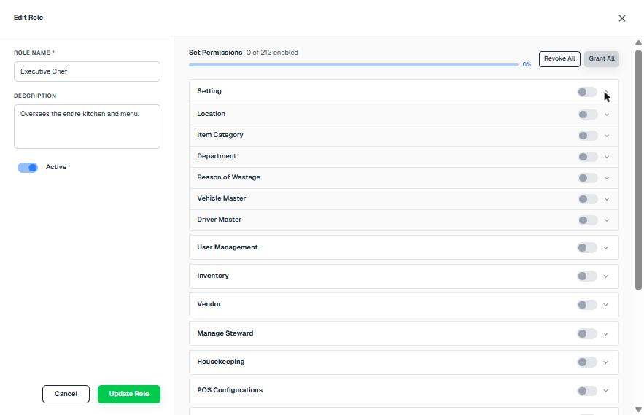
Current Edit Role permissions (toggles only)

Flow and steps tested
- Open User Management › Roles.
- Click "Add Role" (full-screen). Enter Role Name* and Description, and set Active. The permission panel says "No permissions available".
- Save the role, then open it again with Edit to set permissions.
- In Edit, expand each module accordion and switch pages on (0 of 212 enabled), or use Grant All / Revoke All.

Issues found
Severity | Finding
High | Permissions cannot be set while creating a role. It takes two passes: save, then edit.
High | Executive Chef has 0 of 212 permissions, so a user with this role sees nothing. The list does not warn about this.
Medium | The permissions are nested toggles, with no View / Create / Edit / Delete / Approve / Export split, so you cannot give someone read-only access.
Medium | There is no way to copy permissions from another role, and no count of users per role.

Recommended improvements (UI/UX)
- Put a permission matrix (module rows × action columns, with group check-boxes) on the Add screen.
- Add "Copy permissions from…", a search box, and a live summary card.
- Show the user count and an access bar for each role. Add a Duplicate role action. Block deleting the Administrator role.

Information to show
- Users per role, permissions x / total with a progress bar, "No access" warning

Proposed design
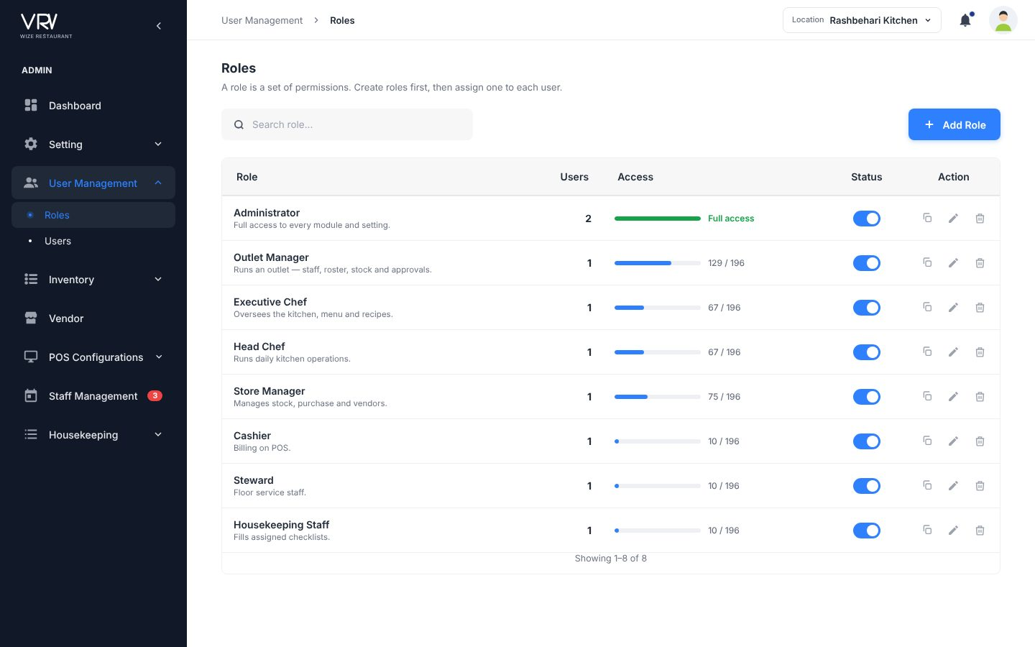
Proposed list
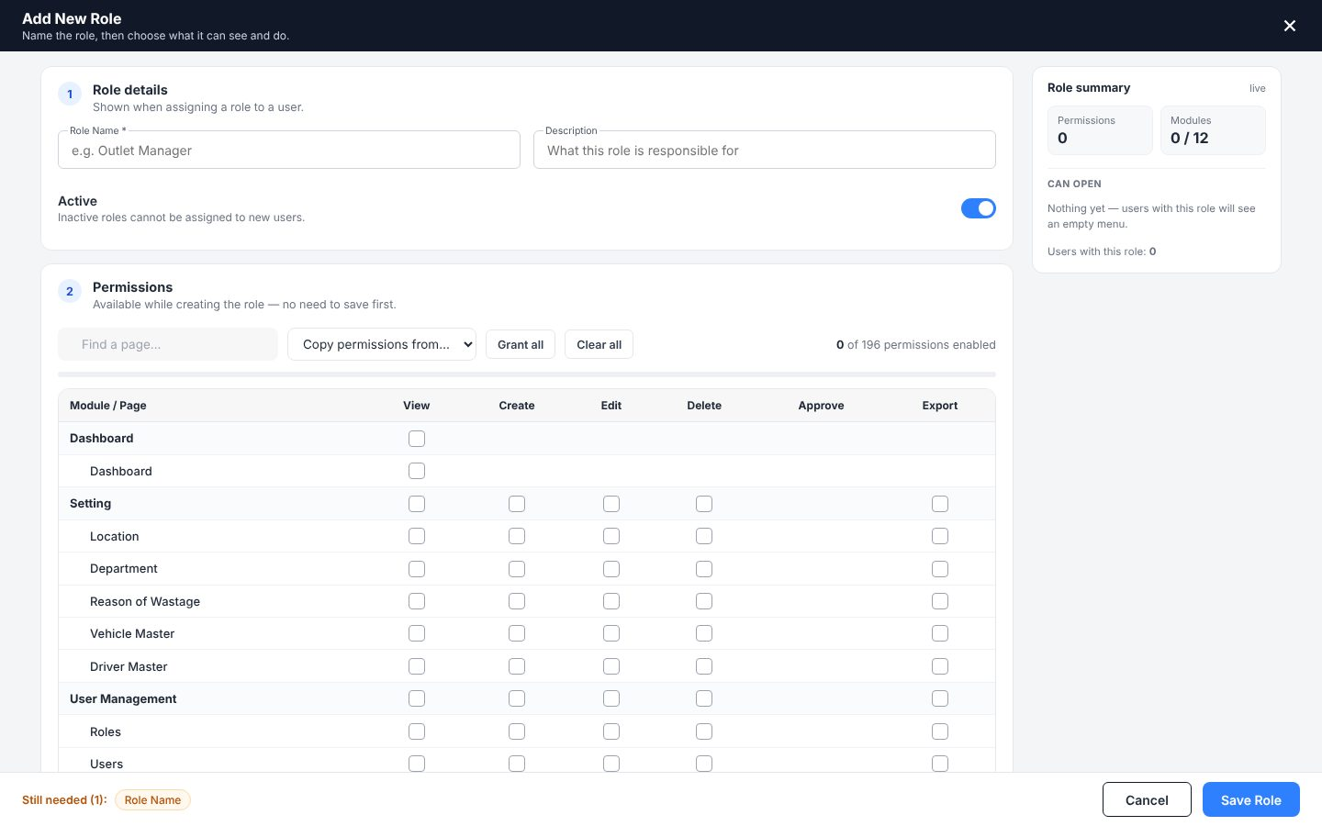
Proposed Add Role with permission matrix

4.8 User List (Users)
Menu: User Management · URL: /user_management/user_list
Purpose: Everyone who can sign in.

Current screens
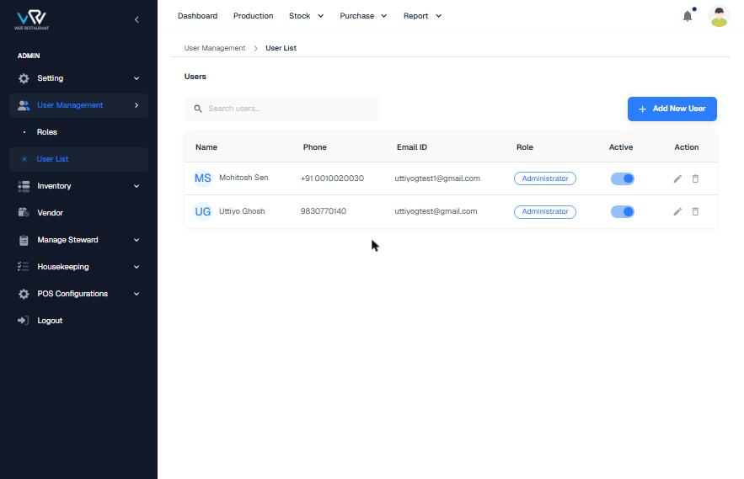
Current list
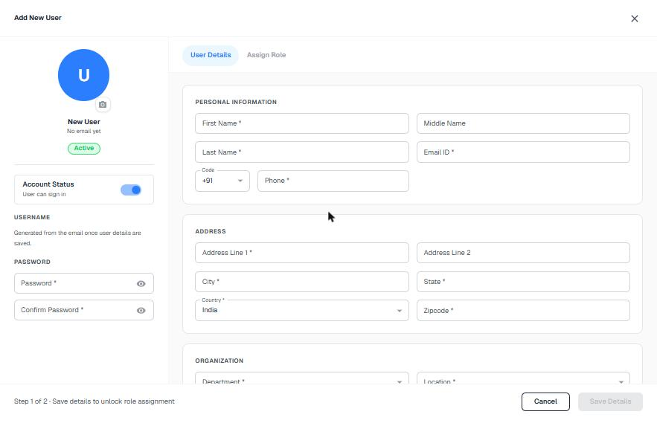
Current Add New User (step 1 of 2)

Flow and steps tested
- Open User Management › User List.
- Click "Add New User" (full-screen, 2 steps).
- Step 1, User Details: First*, Middle, Last*, Email*, Code + Phone*, Address 1*, Address 2, City*, State*, Country*, Zipcode*, Department*, Location*, Password* and Confirm*.
- Click "Save Details" to unlock step 2, Assign Role, then assign the role.

Issues found
Severity | Finding
High | The role is locked until details are saved, so a user can exist without a role.
Medium | The full home address is required just to create a staff login.
Medium | Phone formats are inconsistent, and the list has no location, department or last sign-in.
Medium | There are no role or location filters and no export. The heading "Users" does not match the menu label "User List".
Low | The admin types a password and shares it manually. There is no invite option.

Recommended improvements (UI/UX)
- Use one screen with numbered sections: Personal → Role & workplace → Sign-in → Address (optional).
- Add an "Send invite & let the user set a password" switch, an auto employee code and a live preview card.
- Add KPIs (signed in today, never signed in) and filters by role and location.

Information to show
- Avatar, employee code + email, formatted phone, role chip, location/department, last sign-in

Proposed design
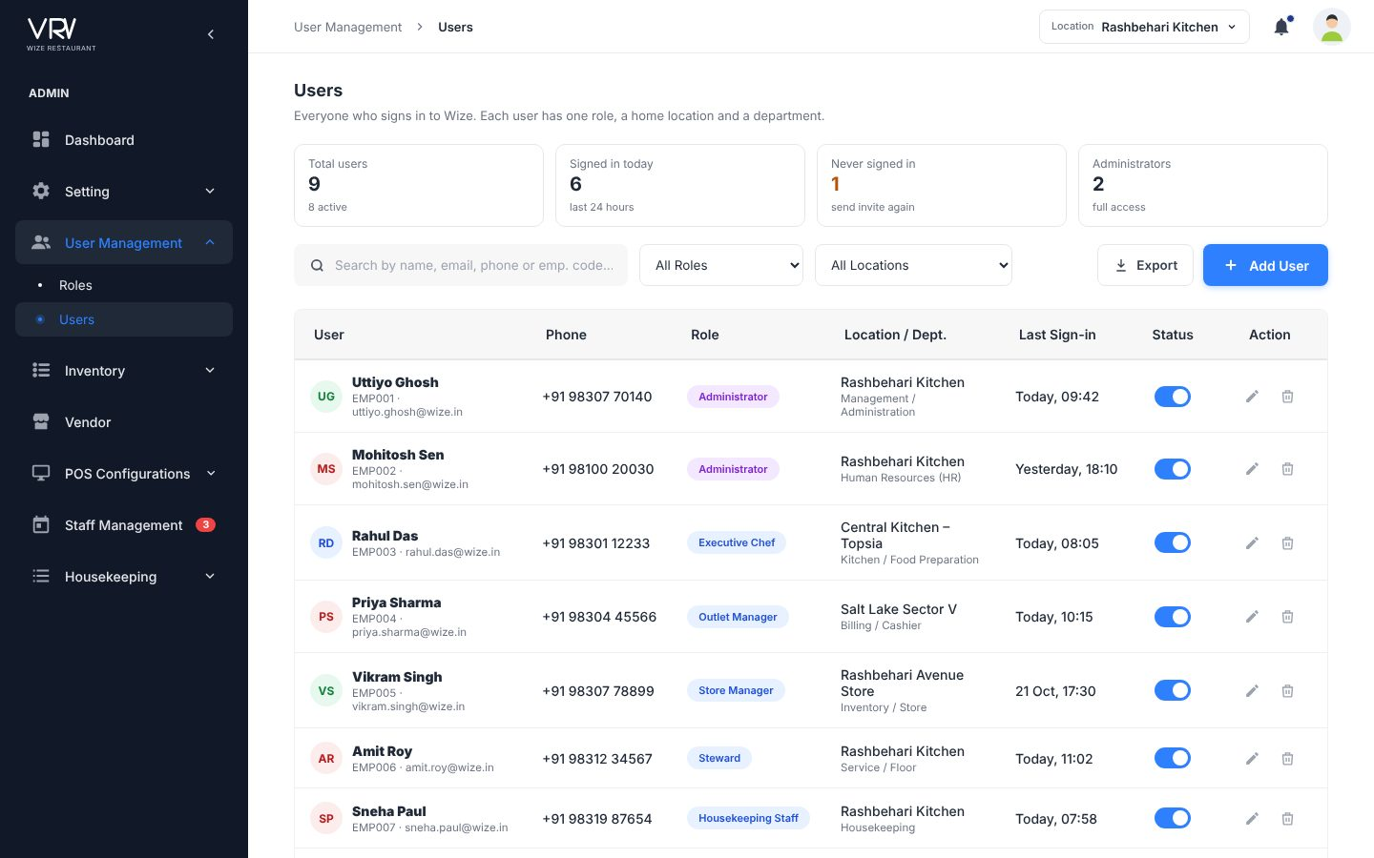
Proposed list
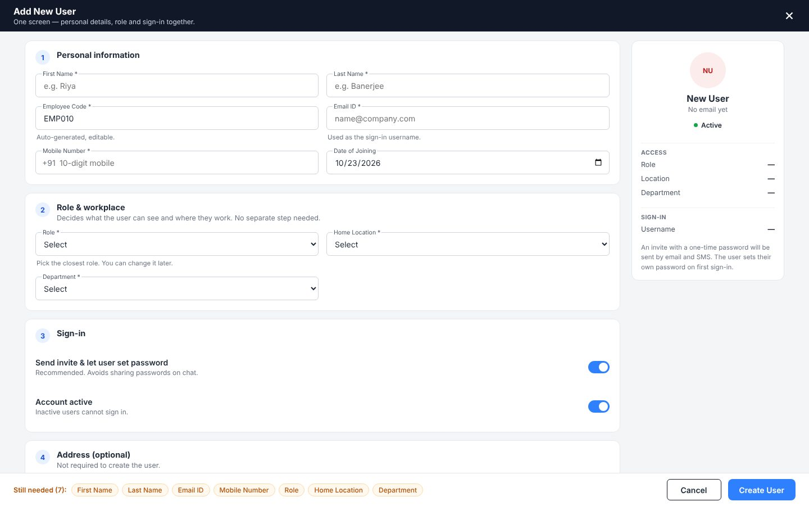
Proposed single-screen Add User

4.9 Menu Section
Menu: Inventory · URL: /inventory/menu_section
Purpose: Groups shown on the POS menu.

Current screens
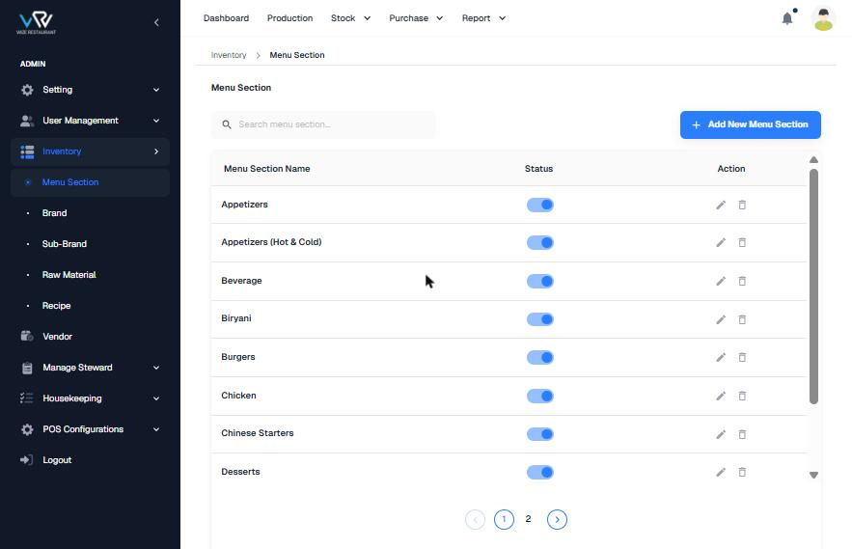
Current list
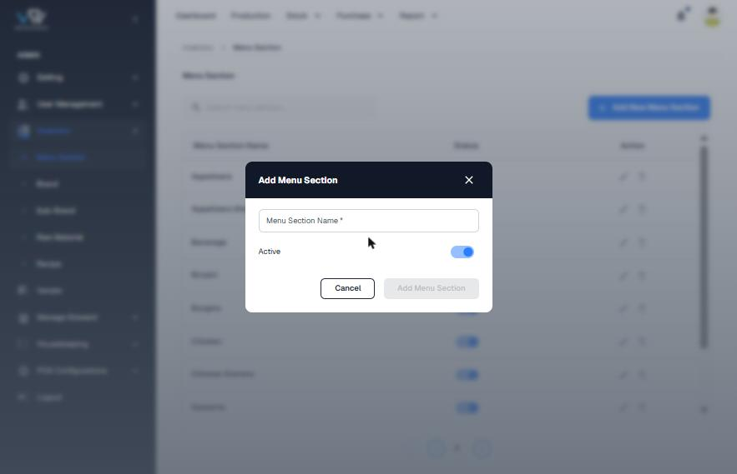
Current Add dialog

Flow and steps tested
- Open Inventory › Menu Section.
- Click "Add New Menu Section", enter the name and set Active.
- Save.

Issues found
Severity | Finding
Medium | There is no display order, so you cannot control the sequence on the POS.
Medium | The difference between a Menu Section and an Item Category is not explained.
Low | There is no item count, image or online visibility.

Recommended improvements (UI/UX)
- Use your Menu Section design with the info strip. Add drag-to-reorder and an item count.

Information to show
- Display order, items in section, POS / online visibility

Proposed design
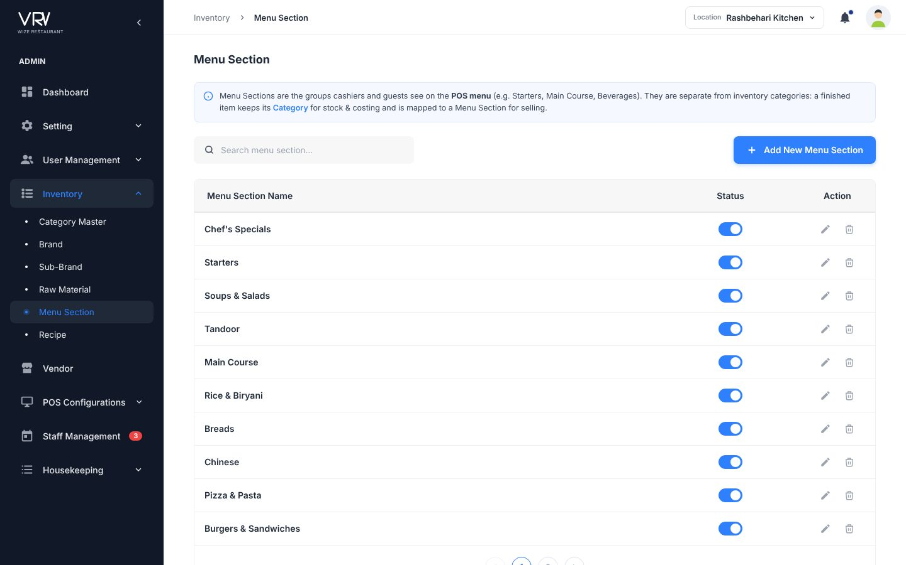
Your Menu Section design

4.10 Brand
Menu: Inventory · URL: /inventory/brand
Purpose: Manufacturer brands of items you buy.

Current screens
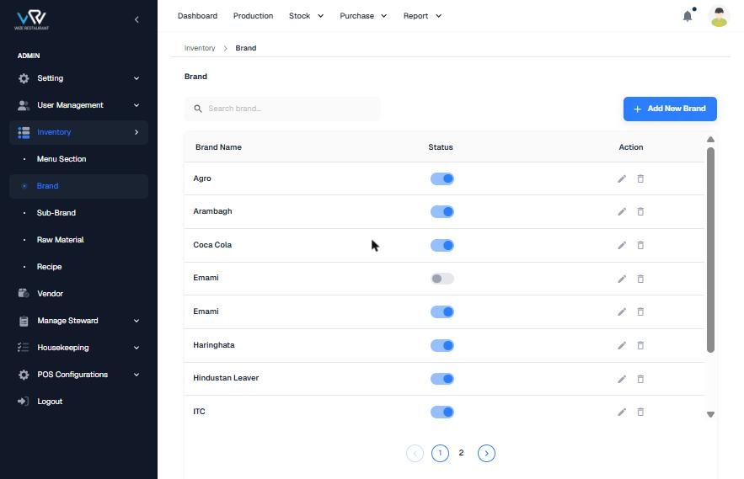
Current list
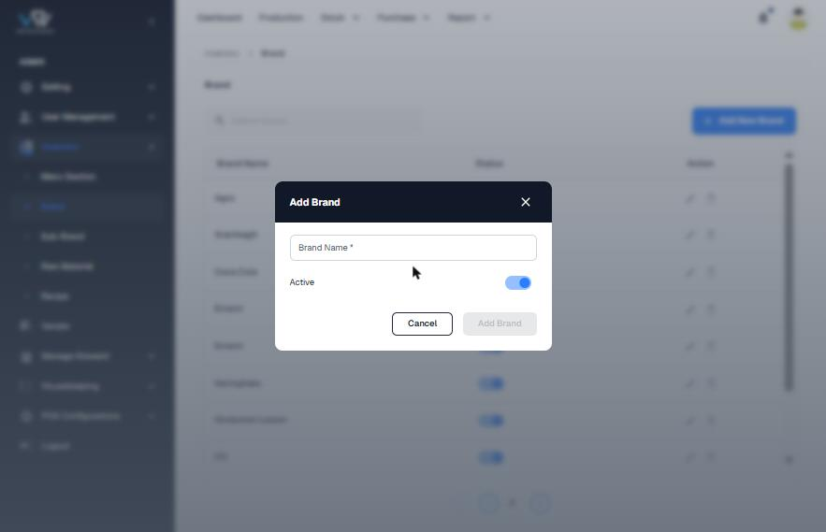
Current Add dialog

Flow and steps tested
- Open Inventory › Brand.
- Click "Add New Brand", enter Brand Name* and set Active.
- Save.

Issues found
Severity | Finding
Medium | "Emami" exists twice (once active, once inactive). Duplicates are not blocked.
Low | Typo "Hindustan Leaver".
Low | The list does not show sub-brands or how many items use each brand.

Recommended improvements (UI/UX)
- Check for duplicates without matching case. Show sub-brand chips and an item count. Block deleting a brand that is in use.

Information to show
- Sub-brands, items count

Proposed design
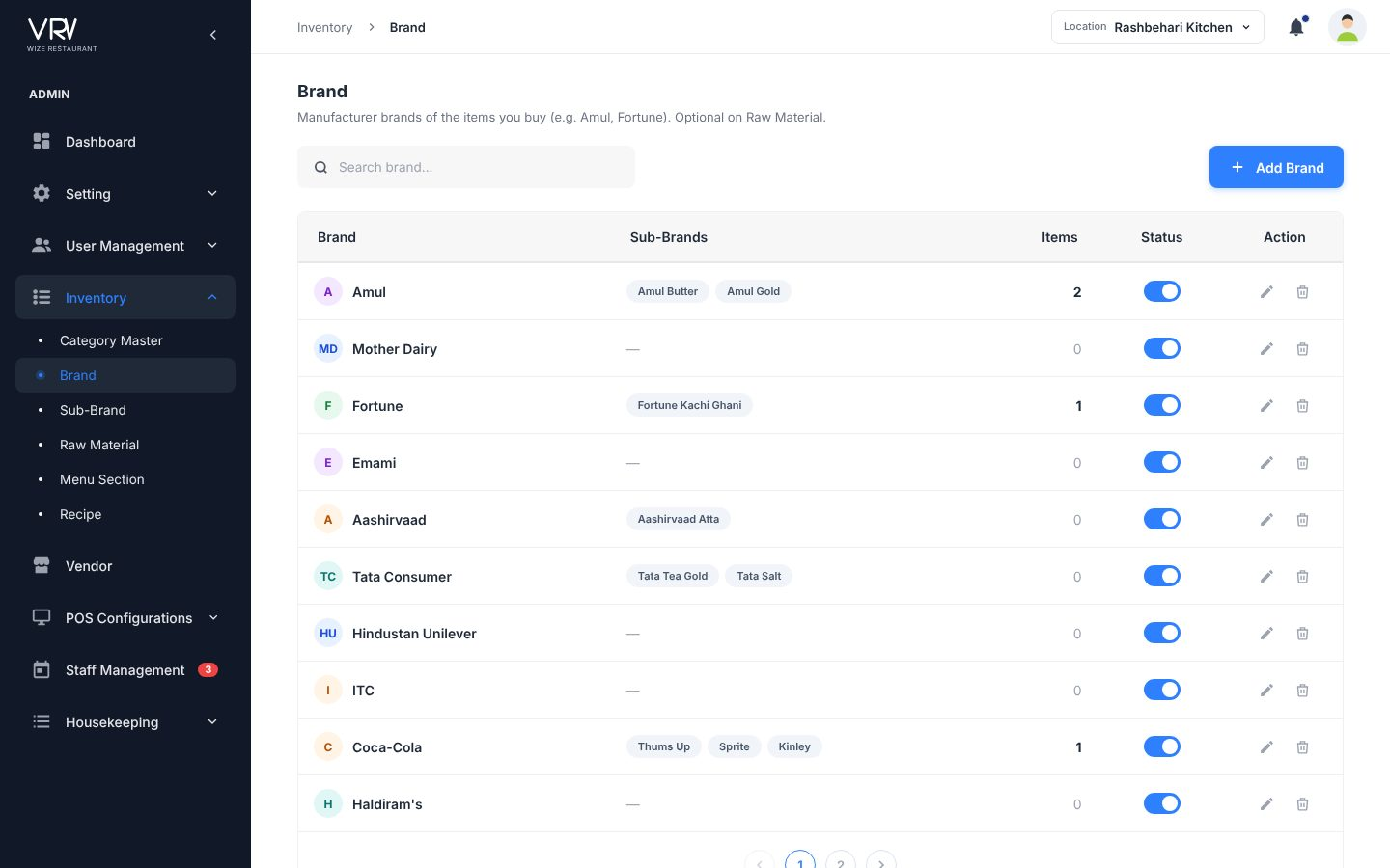
Proposed list

4.11 Sub-Brand
Menu: Inventory · URL: /inventory/sub_brand
Purpose: Product lines under a brand.

Current screens
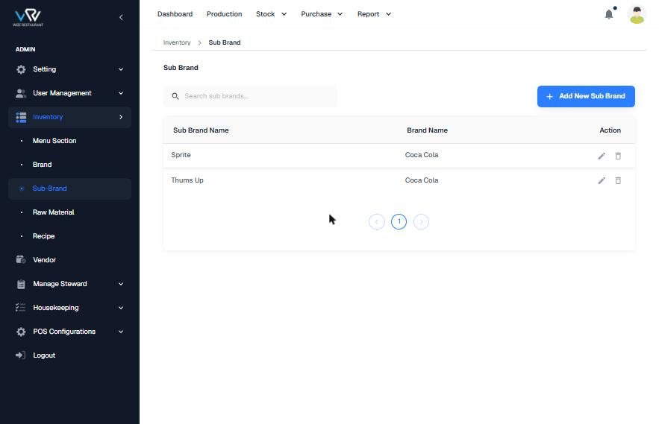
Current list
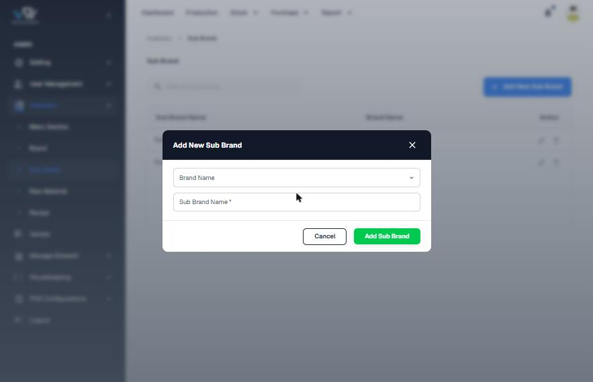
Current Add dialog

Flow and steps tested
- Open Inventory › Sub-Brand.
- Click "Add New Sub Brand" and choose Brand Name (optional) and Sub Brand Name*.
- Save.

Issues found
Severity | Finding
Medium | Brand is optional, so sub-brands can be created without a parent brand.
Low | There is no status column (Brand has one). The menu label is "Sub-Brand" and the page label is "Sub Brand". The fields are called firstField / secondField.

Recommended improvements (UI/UX)
- Make Brand required and put it first. Add a filter by brand and a status column.

Information to show
- Brand with avatar, items count, status

Proposed design
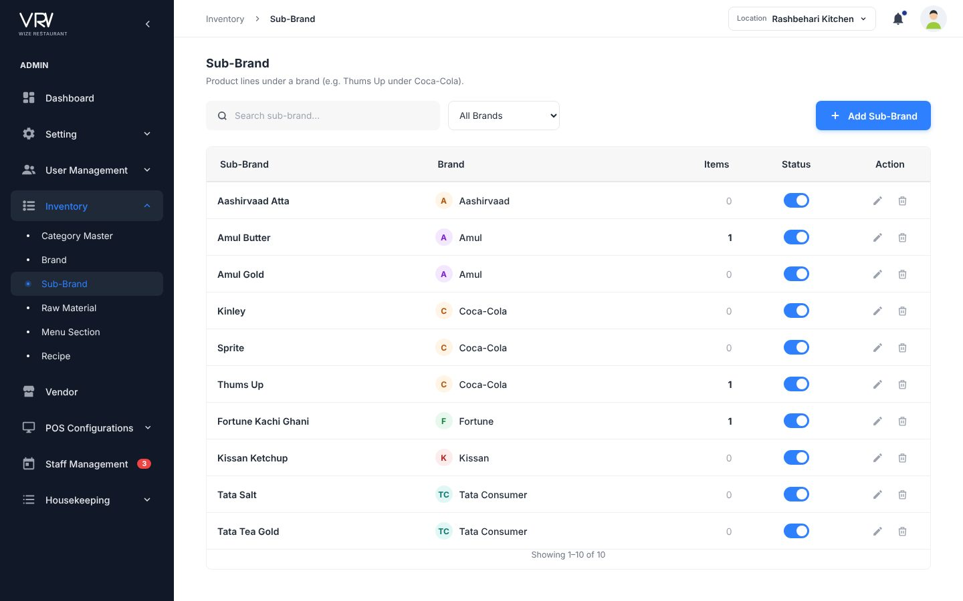
Proposed list

4.12 Raw Material
Menu: Inventory · URL: /inventory/raw_material
Purpose: Items you buy from vendors.

Current screens
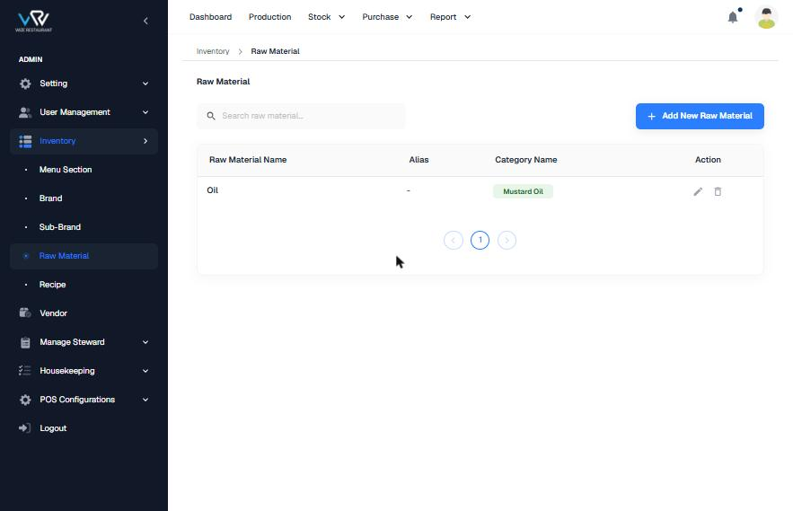
Current list (1 item)
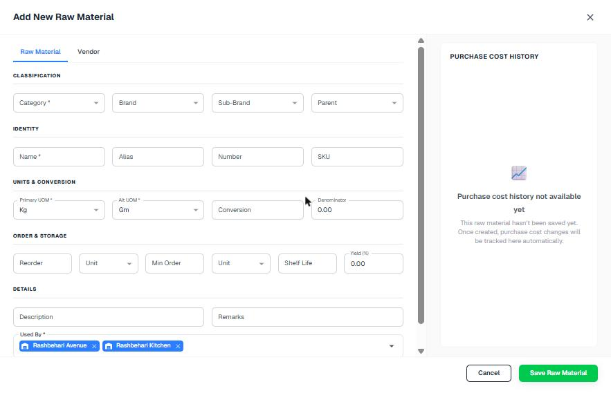
Current Add (full screen)
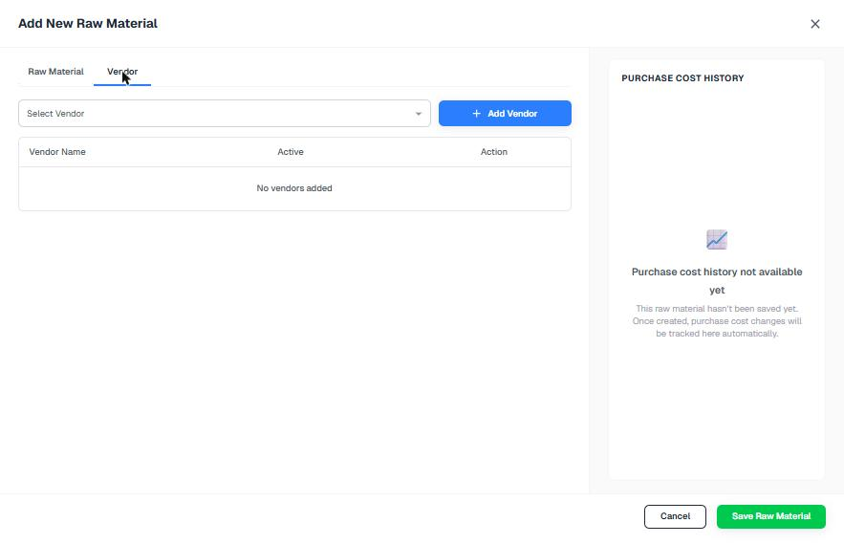
Current Vendor tab

Flow and steps tested
- Open Inventory › Raw Material.
- Click "Add New Raw Material" (full-screen with Raw Material and Vendor tabs).
- Fill Classification (Category*, Brand, Sub-Brand, Parent), Identity (Name*, Alias, Number, SKU), Units (Primary UOM*, Alt UOM*, Conversion, Denominator), Order & Storage (Reorder + unit, Min order + unit, Shelf life, Yield %), Details (Description, Remarks, Used By*).
- On the Vendor tab, choose a vendor and click "Add Vendor". Purchase cost history appears after the item is saved.
- Click "Save Raw Material".

Issues found
Severity | Finding
High | Only 1 item exists and it is filed under a category named after another item (see Item Category).
Medium | "Conversion" and "Denominator" are unclear, and there is no example such as "1 Kg = 1000 g".
Medium | Shelf Life has no unit, and Reorder / Min Order have separate unit pickers that can disagree with the item's UOM.
Medium | The list shows only Name, Alias and Category. There is no stock, reorder level, vendor, price or status.

Recommended improvements (UI/UX)
- Use numbered sections like your Recipe form, with live previews ("1 Kg = 1000 g — a recipe using 250 g consumes 0.250 Kg").
- Put the preferred vendor and last price inline. Add storage type (Dry / Chilled / Frozen) and GST.
- Add list KPIs: below reorder, no vendor mapped, stock value. Add storage tabs and export.

Information to show
- SKU, category › parent, units with conversion, in-stock vs reorder (red when low), preferred vendor + price, storage chip

Proposed design
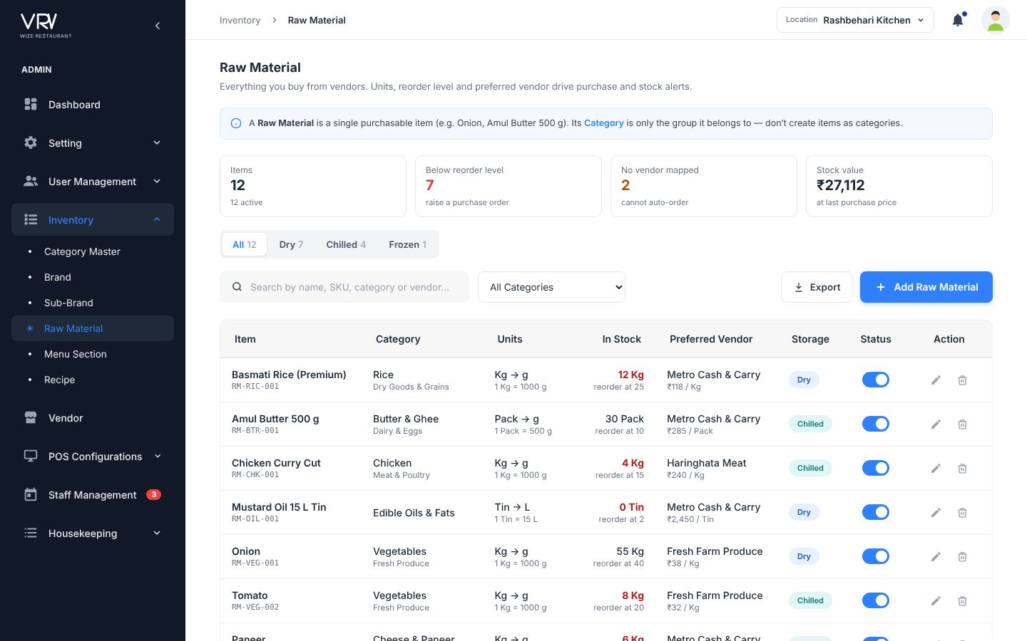
Proposed list
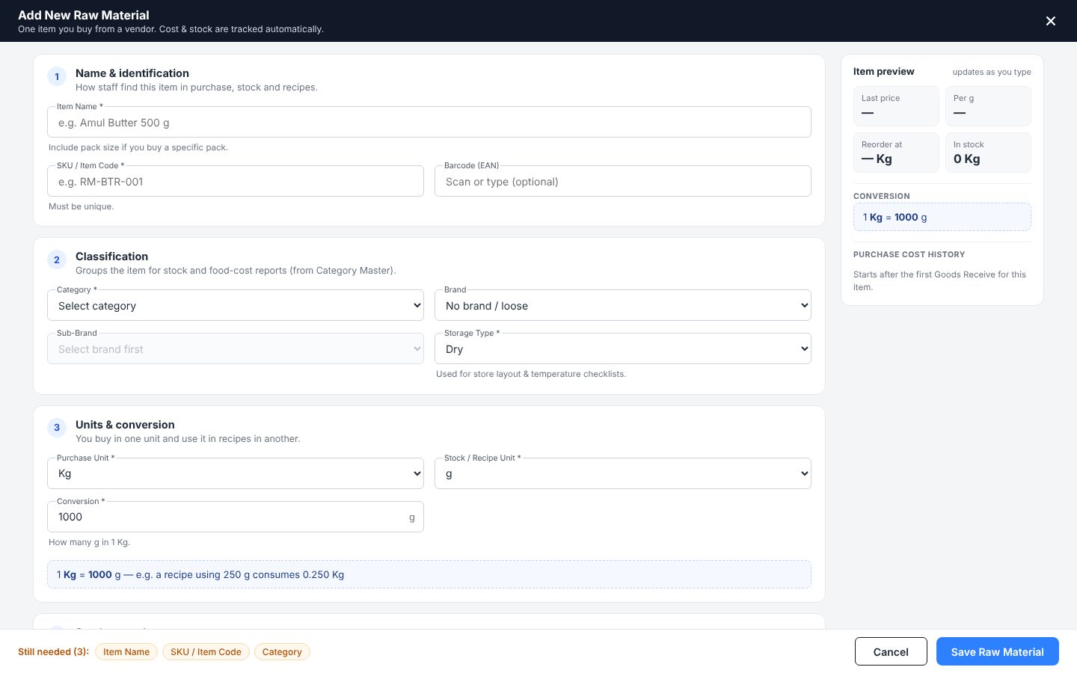
Proposed form with live preview

4.13 Recipe
Menu: Inventory · URL: /inventory/recipe
Purpose: Semi-finished and finished dishes with ingredients and cost.

Current screens
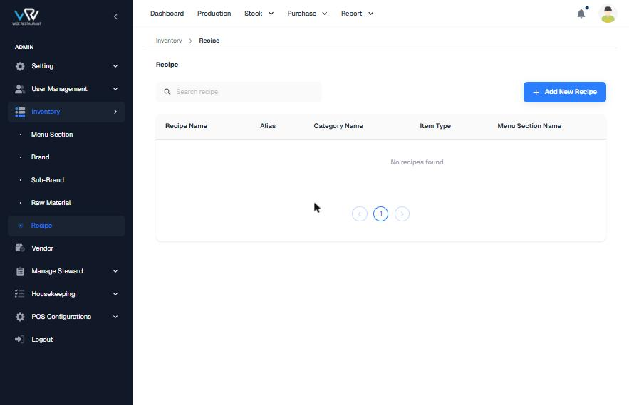
Current list (empty)
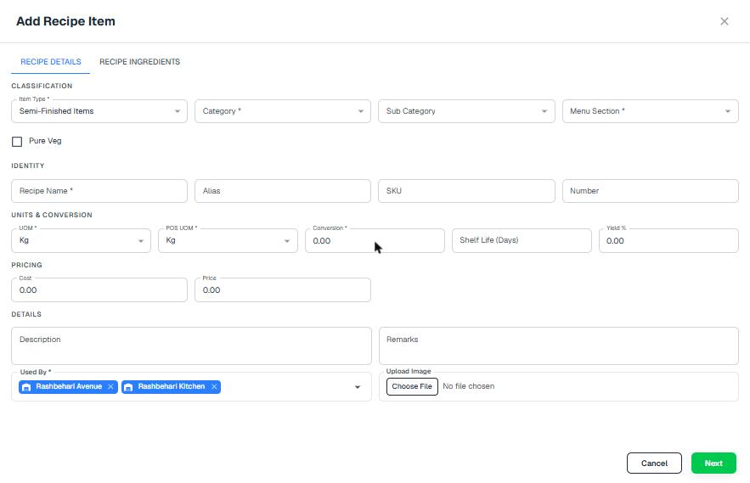
Current Recipe Details tab
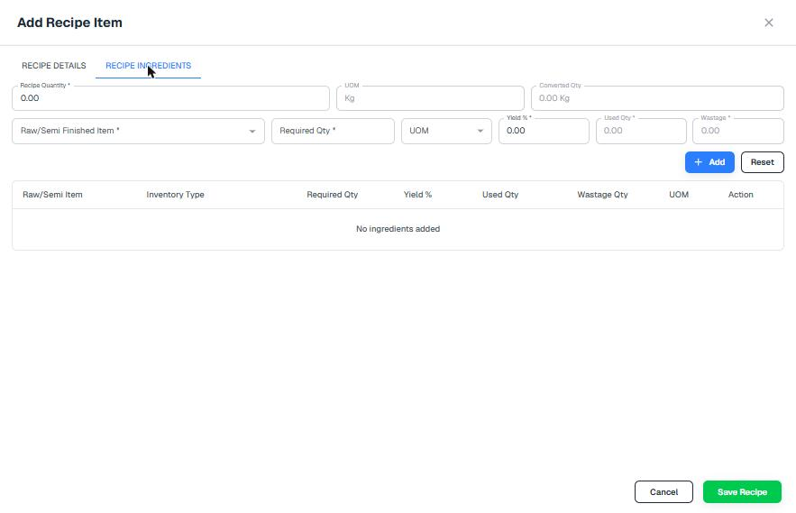
Current Recipe Ingredients tab

Flow and steps tested
- Open Inventory › Recipe and click "Add New Recipe".
- Recipe Details: Item Type*, Category*, Sub Category, Menu Section*, Pure Veg, Recipe Name*, Alias, SKU, Number, UOM*, POS UOM*, Conversion*, Shelf Life, Yield %, Cost, Price, Description, Remarks, Used By*, Upload Image. Click Next.
- Recipe Ingredients: enter Recipe Quantity*, then add Raw/Semi item*, Required Qty*, UOM and Yield* row by row with "+ Add".
- Click "Save Recipe".

Issues found
Severity | Finding
Medium | Cost is typed by hand instead of being calculated from the ingredients, and no food-cost % is shown.
Medium | Veg / Egg / Non-veg is a single check-box. Image upload is an unstyled native file input. Tabs are in UPPERCASE.
Low | The list has no cost, price or food-cost column.

Recommended improvements (UI/UX)
- Use your Recipe design: a type picker, numbered sections, live costing, a "Still needed" footer and food-cost colour bands.

Information to show
- Type, output, cost per unit, price, food cost %

Proposed design
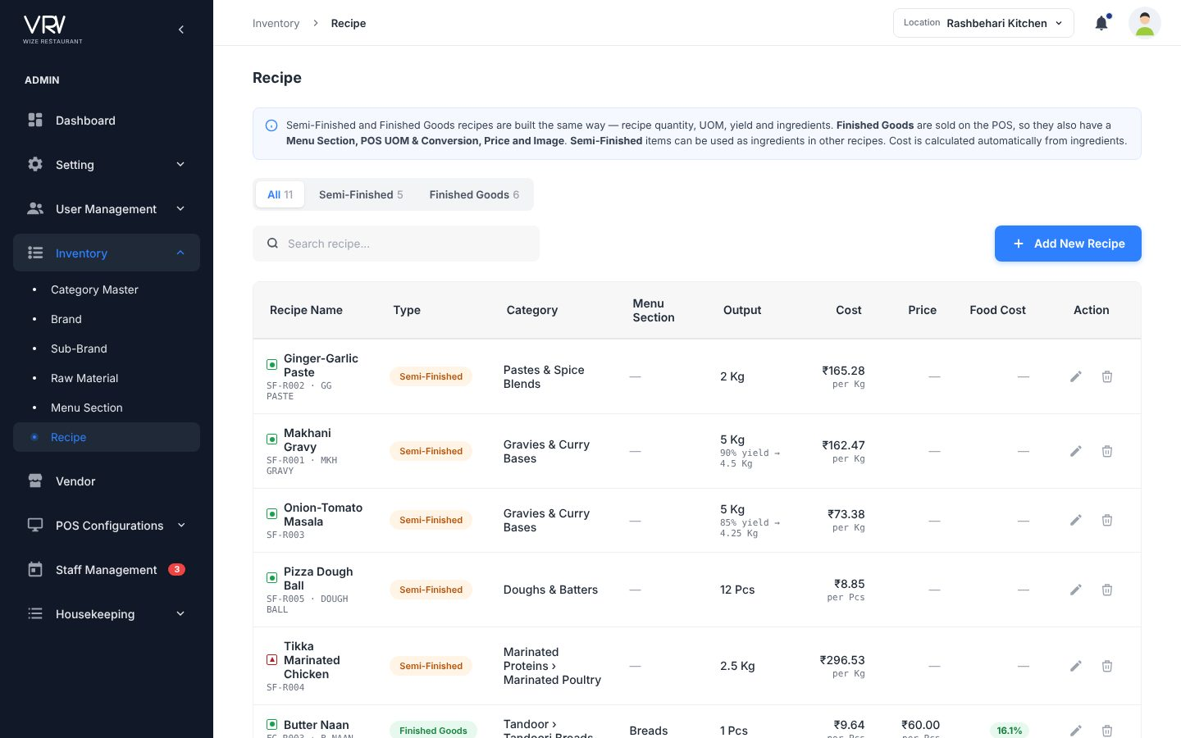
Your Recipe design (kept as-is)

4.14 Vendor
Menu: Vendor · URL: /vendor/vendor
Purpose: Suppliers.

Current screens
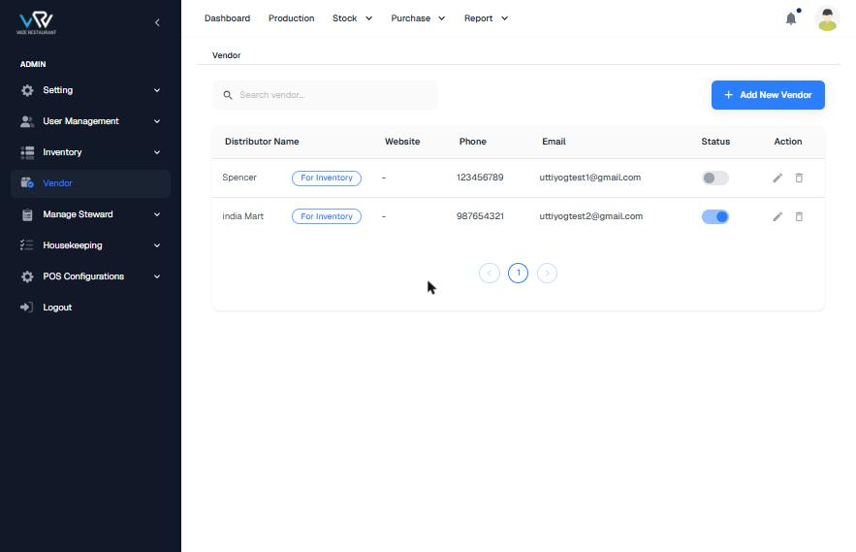
Current list
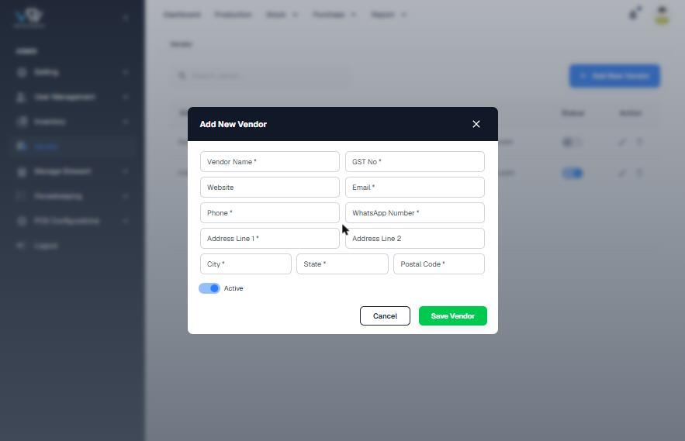
Current Add dialog

Flow and steps tested
- Open Vendor.
- Click "Add New Vendor" and enter Vendor Name*, GST No*, Website, Email*, Phone*, WhatsApp Number*, Address Line 1*, Line 2, City*, State*, Postal Code* and Active.
- Click "Save Vendor".

Issues found
Severity | Finding
Medium | Phone numbers have 9 digits (123456789, 987654321) and GSTIN is not checked.
Medium | WhatsApp is required even when it is the same number as the phone.
Medium | The list column says "Distributor Name" but the form says "Vendor Name". The "For Inventory" chip is not explained. There is no heading.
Low | There is no contact person, payment terms, lead time or supplied categories, and no GST in the list.

Recommended improvements (UI/UX)
- Group the form into Business, Contact, Address and Commercial sections. Add a "WhatsApp on the same number" switch, payment terms and lead time.
- Show the contact person, terms, supplied categories and number of mapped items. Add export.

Information to show
- GSTIN under the name, contact + phone, supplies chips, items, terms + lead time

Proposed design
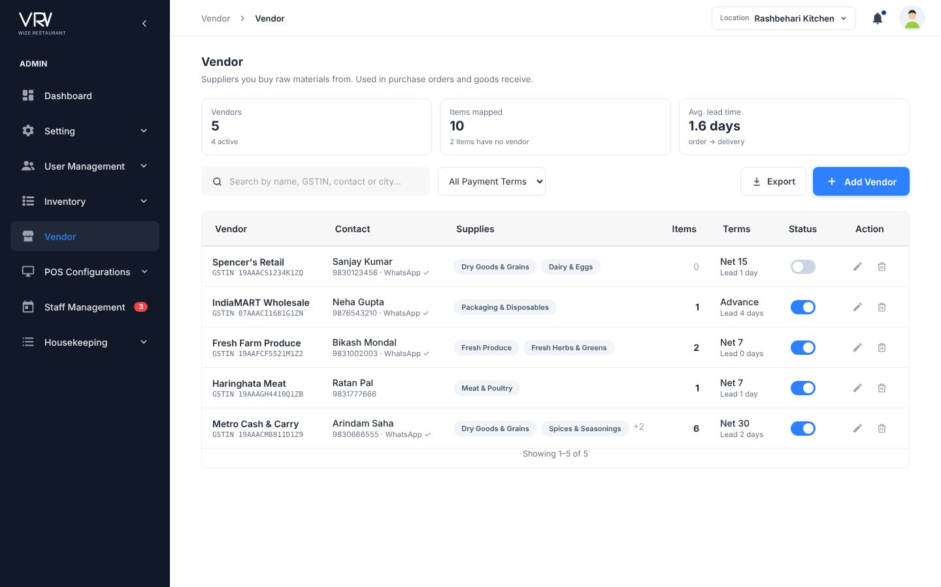
Proposed list
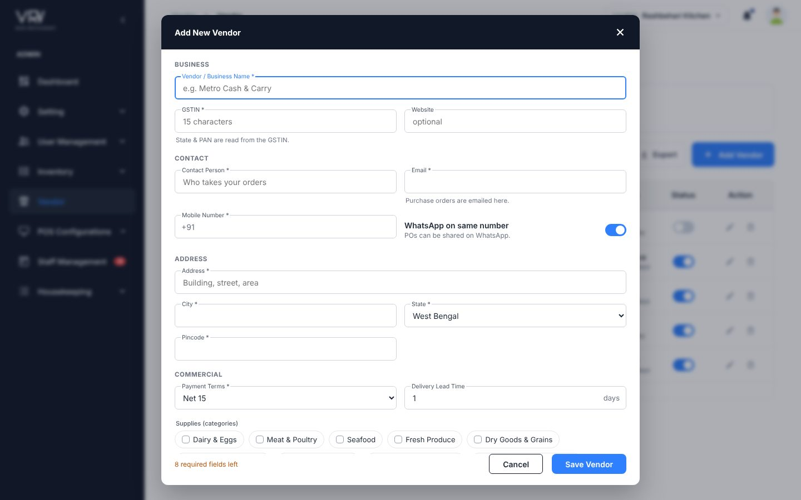
Proposed form

4.15 Tax Setting
Menu: POS Configurations · URL: /pos_configurations/tax_setting
Purpose: Tax applied on bills.

Current screens
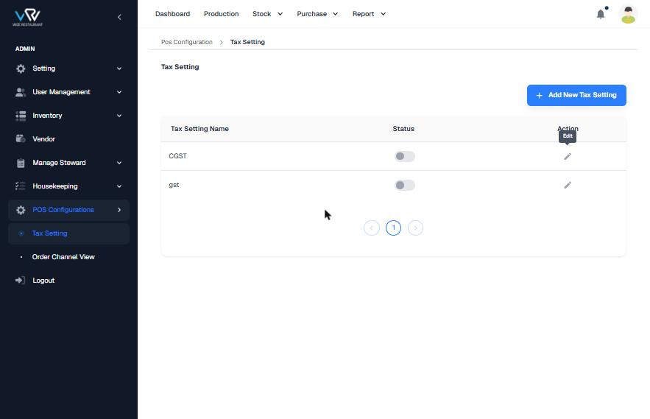
Current list
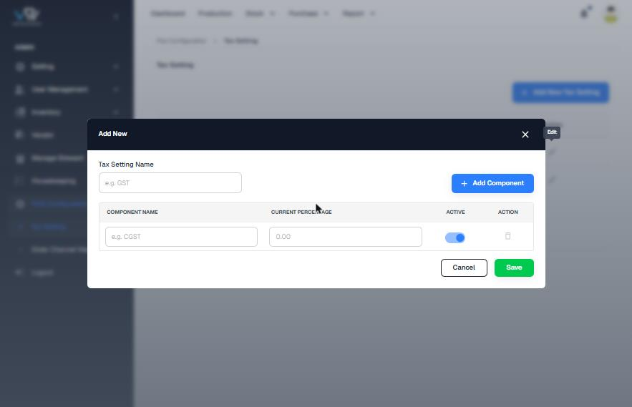
Current Add dialog

Flow and steps tested
- Open POS Configurations › Tax Setting.
- Click "Add New Tax Setting", enter Tax Setting Name, then add components (name + current %, active) with "Add Component".
- Click Save. There is an edit icon but no delete.

Issues found
Severity | Finding
High | Both tax settings (CGST, gst) are inactive, so bills carry no tax. Nothing on screen warns about this.
Medium | "CGST" is used as a group name when it is really a component of GST.
Medium | The list does not show components or total %, and there is no inclusive/exclusive option or order-type mapping.
Low | The dialog title is just "Add New". There is no search.

Recommended improvements (UI/UX)
- Show each tax group as components chips + total %. Add a live example ("on ₹200 the guest pays ₹210").
- Add inclusive/exclusive, applies-to (Dine-in / Takeaway / Delivery), a default flag, and a warning when nothing is active.

Information to show
- Components, total, calculation mode, applies to

Proposed design
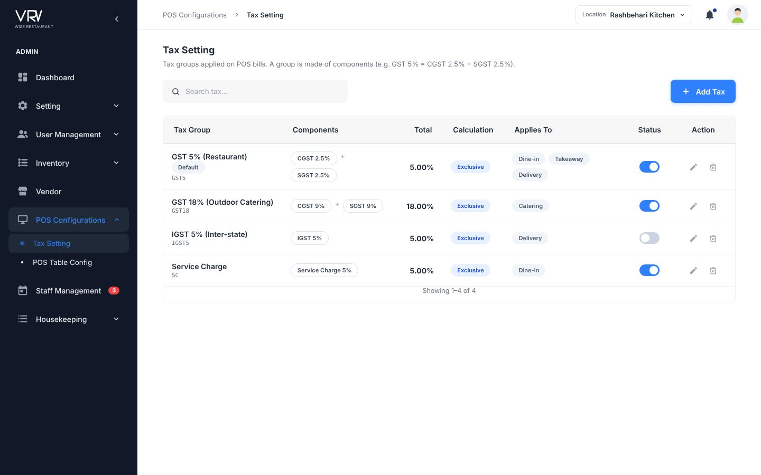
Proposed list
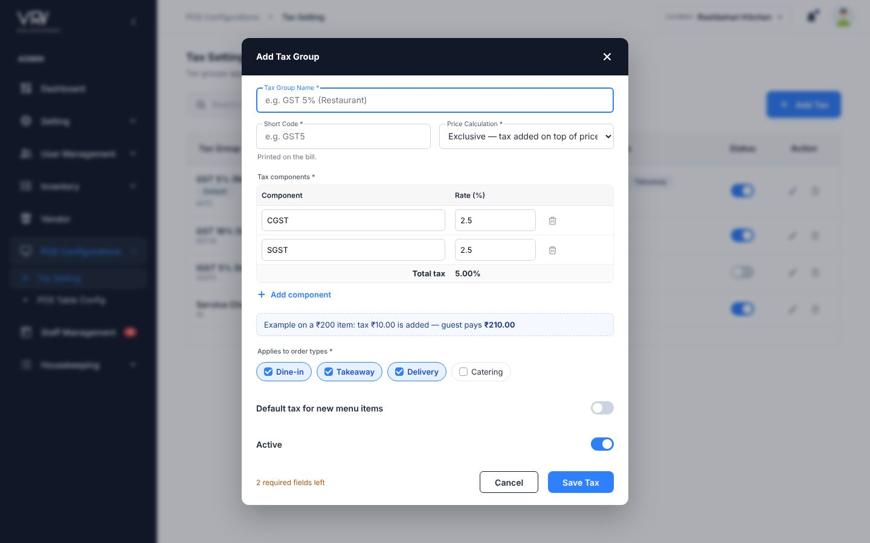
Proposed form with live example

4.16 Order Channel View (POS Table Config)
Menu: POS Configurations · URL: /pos_configurations/order_channel_view
Purpose: Tables and order channels used on the POS.

Current screens
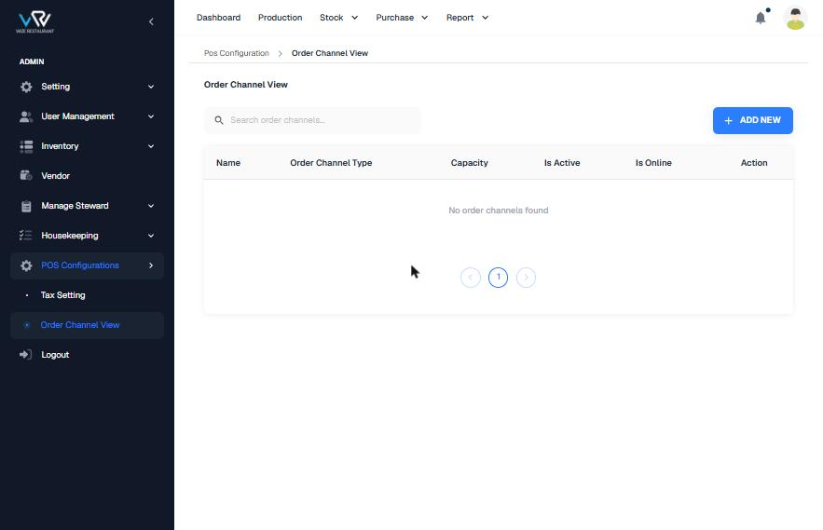
Current list (empty)
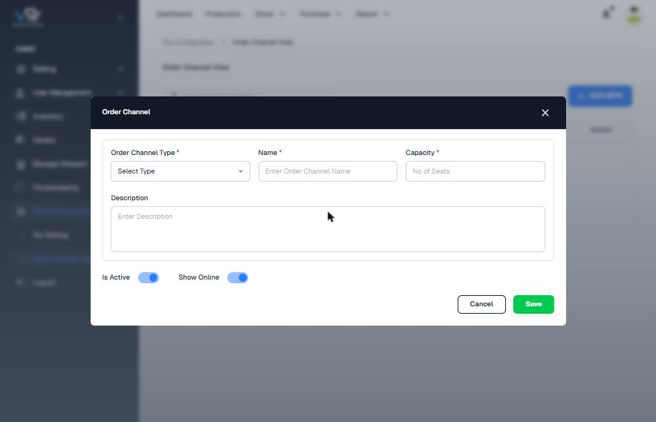
Current Add dialog

Flow and steps tested
- Open POS Configurations › Order Channel View.
- Click "ADD NEW" and enter Order Channel Type*, Name*, Capacity* (no. of seats) and Description, and set Is Active / Show Online.
- Save.

Issues found
Severity | Finding
Medium | Capacity (seats) is required even for Takeaway or Swiggy.
Low | There is no area/section, no bulk-add of tables (T1–T20) and no KPIs. The button text is in capitals.

Recommended improvements (UI/UX)
- Use your POS Table Config design: KPIs, channel-type tabs, area filter, seats shown only for tables, and bulk add.

Information to show
- Active tables, total seats, other channels, inactive

Proposed design
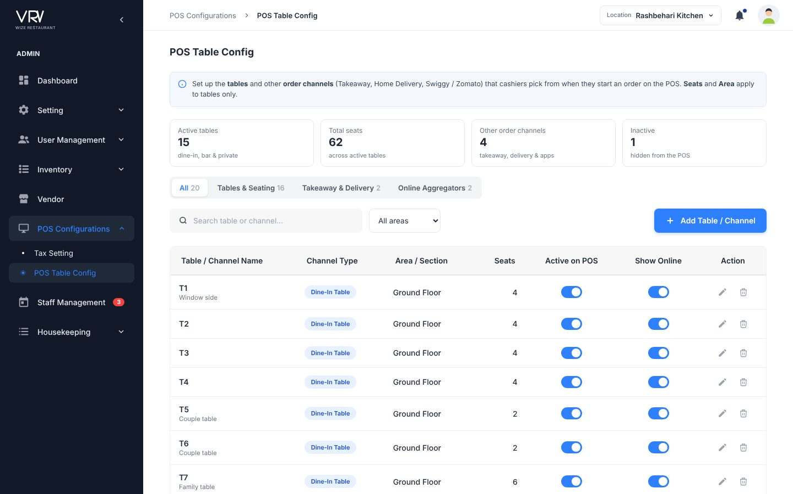
Your POS Table Config design (kept as-is)

4.17 Company Leave Category + Company Leave (→ Leave Policy)
Menu: Staff Management · URL: /manage_steward/company_leave_category, /company_leave
Purpose: Leave types and yearly allocation.

Current screens
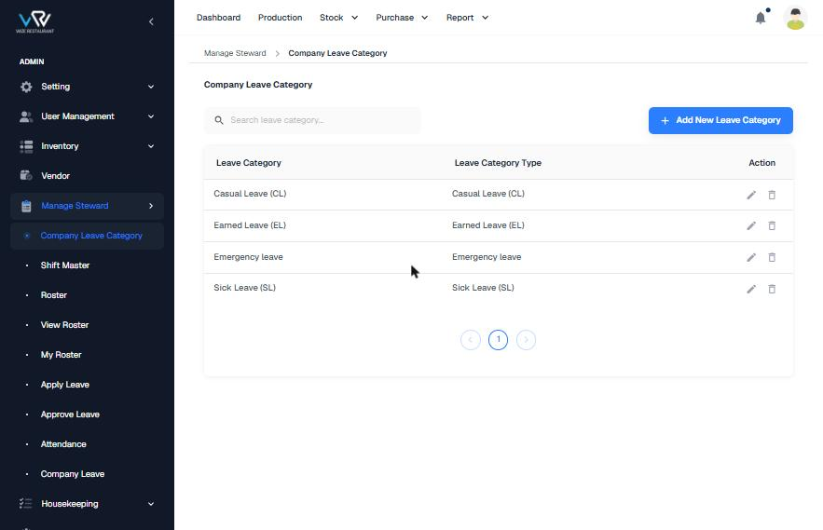
Current Company Leave Category
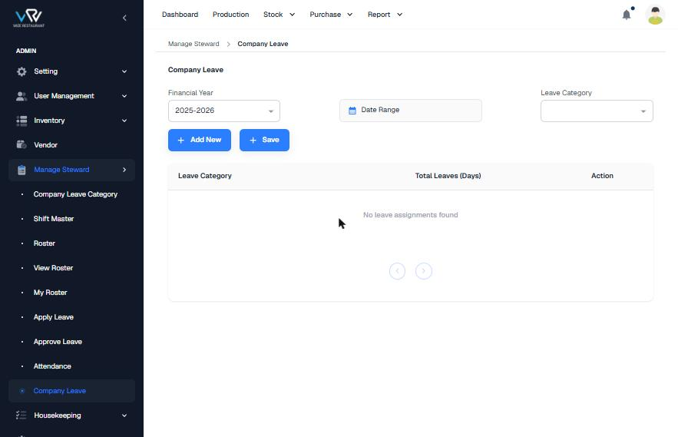
Current Company Leave (empty)
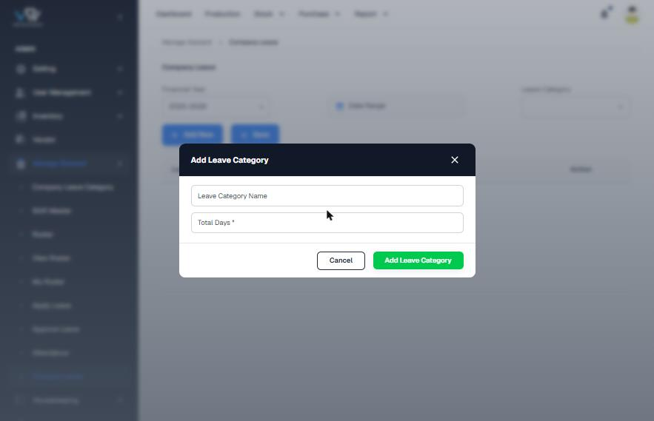
Current "Add Leave Category" inside Company Leave

Flow and steps tested
- Company Leave Category: click "Add New Leave Category", choose Leave Category Type and enter Leave Category Name*, then save.
- Company Leave: pick the Financial Year (defaults to 2025-2026), Date Range and Leave Category, then click "Add New" (opens "Add Leave Category" with Name + Total Days*) and click "Save".

Issues found
Severity | Finding
High | No days are allocated, so every balance in Apply Leave shows 0.
Medium | The same concept is split across two pages, and both dialogs are called "Add Leave Category".
Medium | The financial year defaults to 2025-26 even though today is October 2026 (FY 2026-27).
Low | Name and Type show identical values. The Save button has a "+" icon. There are no paid/unpaid, carry-forward or half-day rules.

Recommended improvements (UI/UX)
- Merge both into a single Leave Policy page: type, code, days per year, paid/unpaid, carry forward, max consecutive days, half-day and document rules, with a FY selector.

Information to show
- Days/year (red if 0 for paid leave), type chip, carry forward, rules chips

Proposed design
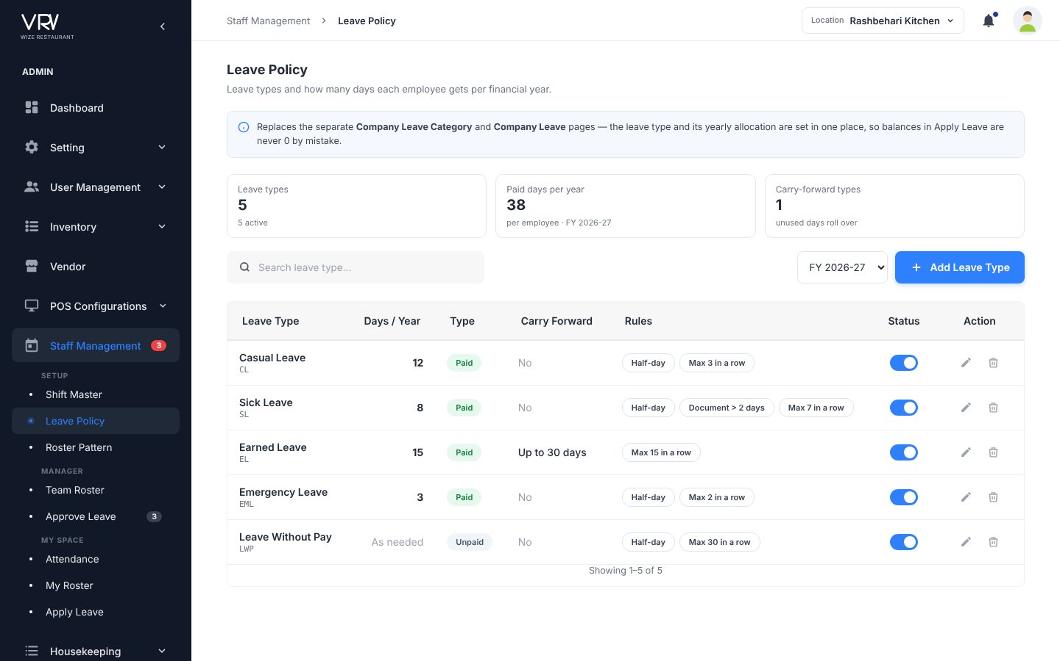
Proposed Leave Policy

4.18 Shift Master
Menu: Staff Management · URL: /manage_steward/shift_master
Purpose: Working hours used by rosters.

Current screens
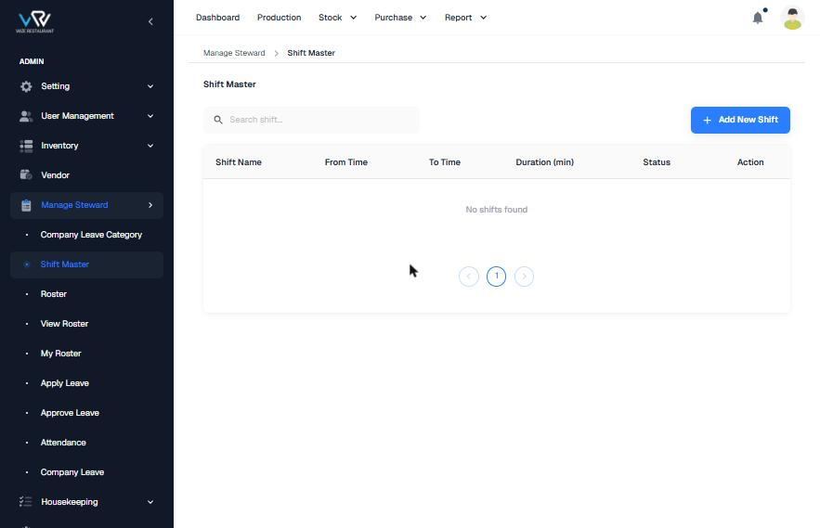
Current list (empty)
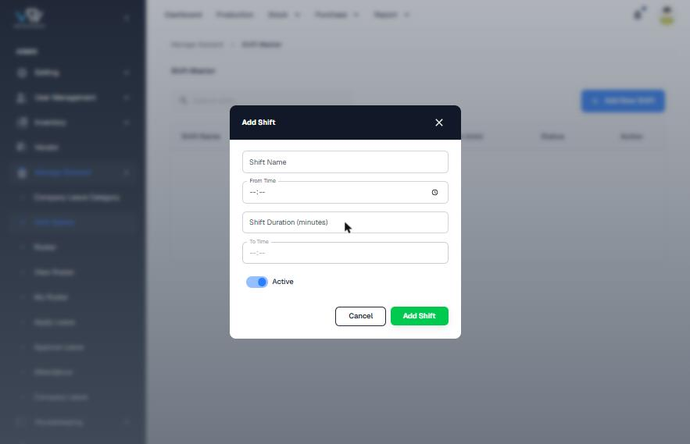
Current Add Shift

Flow and steps tested
- Click "Add New Shift" and enter Shift Name, From Time, Shift Duration (minutes), To Time and Active.
- Save.

Issues found
Severity | Finding
High | There are no shifts, so Roster, My Roster and Attendance cannot work.
Medium | No field is marked required. Duration has to be typed even though it follows from From and To, and the field order (From → Duration → To) is confusing.
Low | There is no break, late-mark grace, overnight flag or colour.

Recommended improvements (UI/UX)
- Calculate the duration automatically with a preview ("9h · 8h working · overnight"). Add break, grace minutes, a short code and a colour for the roster grid.

Information to show
- Code chip, 12-hour timing, duration + working time, break, grace

Proposed design
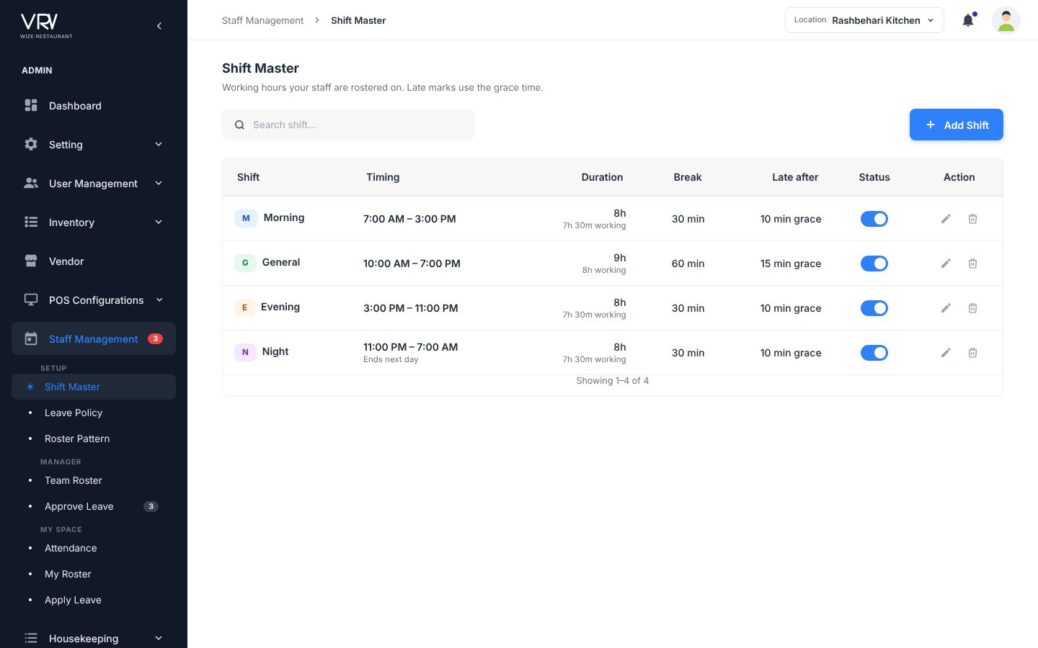
Proposed list
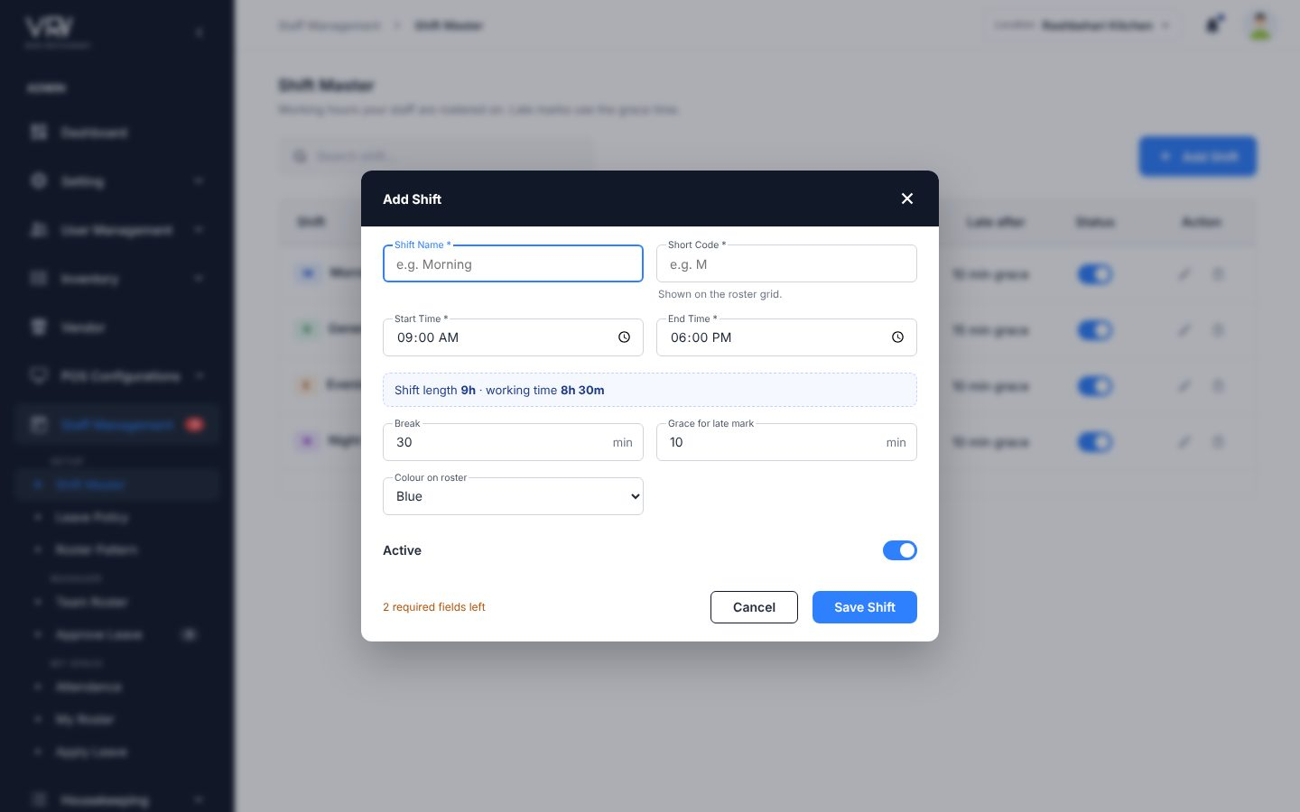
Proposed form

4.19 Roster (Roster Pattern)
Menu: Staff Management · URL: /manage_steward/roster
Purpose: Repeating shift patterns.

Current screens
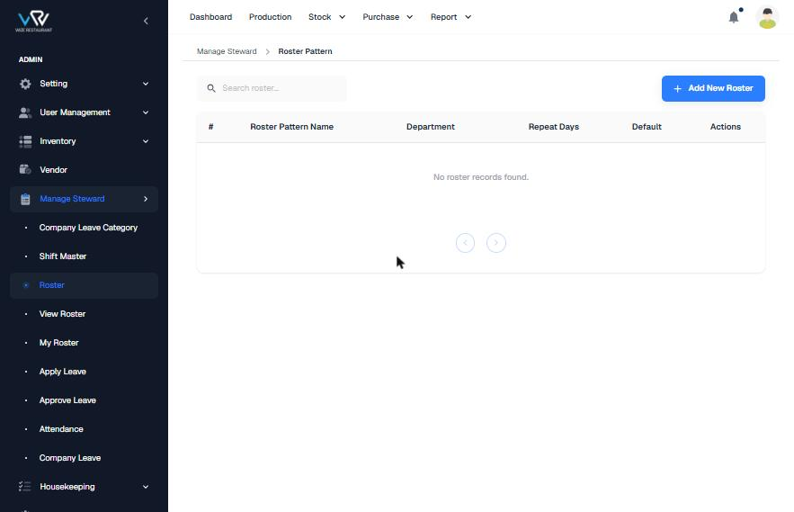
Current list
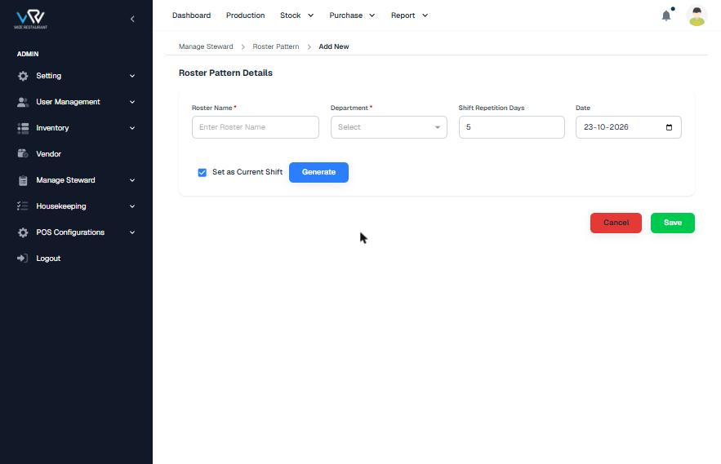
Current Add New (separate page)

Flow and steps tested
- Click "Add New Roster". This opens /admin/roster/add and the sidebar group collapses.
- Enter Roster Name*, Department*, Shift Repetition Days (5) and Date, tick "Set as Current Shift" and click "Generate".
- Save, or Cancel (a red button).

Issues found
Severity | Finding
Medium | The URL scheme changes (/admin/...) and the menu loses its place.
Medium | "Generate" and "Set as Current Shift" are not explained, and you cannot see which shift falls on which day.
Low | The menu says "Roster" and the breadcrumb says "Roster Pattern". There is no H1.

Recommended improvements (UI/UX)
- Use a dialog with a cycle length, a per-day shift picker with a preview of chips, and employee assignment.

Information to show
- Cycle chips (M M E E Off…), department, employees avatars

Proposed design
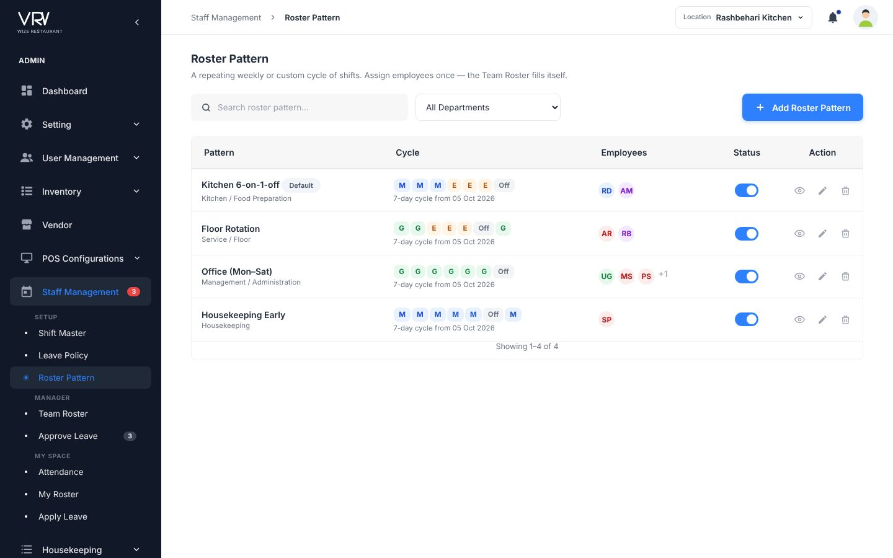
Proposed list
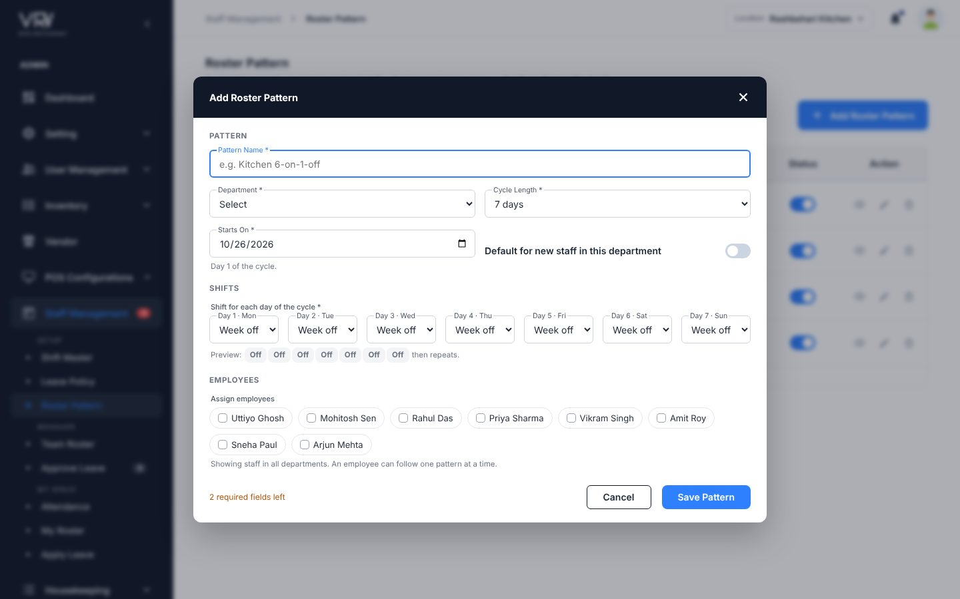
Proposed form

4.20 View Roster / My Roster (→ Team Roster, My Roster)
Menu: Staff Management · URL: /manage_steward/view_roster, /my_roster
Purpose: See who works when.

Current screens
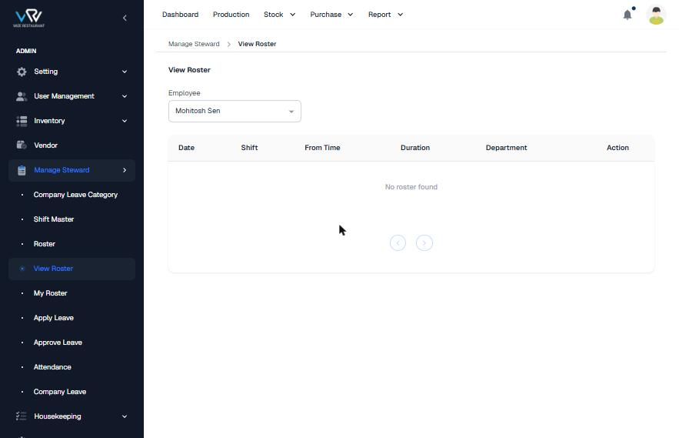
Current View Roster
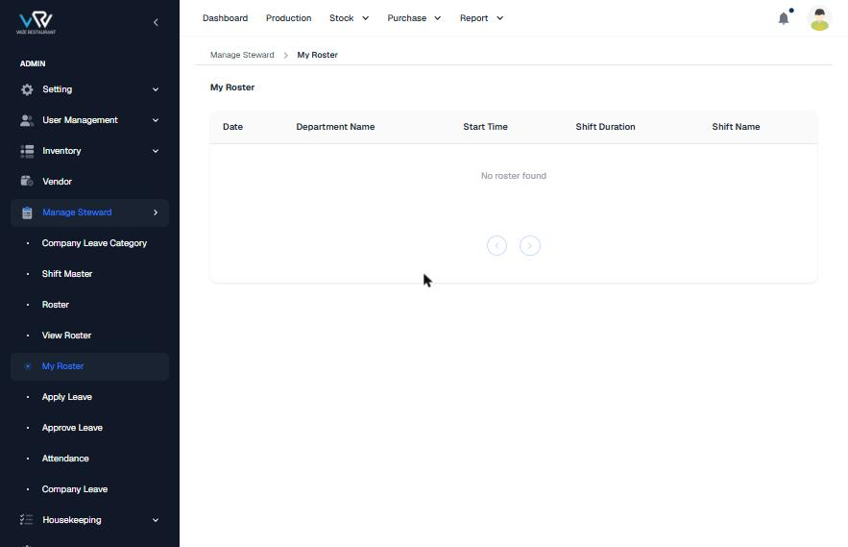
Current My Roster

Flow and steps tested
- View Roster: pick an Employee and read the date rows.
- My Roster: read your own rows.

Issues found
Severity | Finding
Medium | Rosters are shown as tables of dates rather than a week view, and a manager can only see one employee at a time.
Low | The two pages use different column names (From Time vs Start Time, Duration vs Shift Duration).

Recommended improvements (UI/UX)
- Team Roster: a weekly grid of employees × days with coloured shift chips, click-to-change, location/department filters, hours per person, and "Publish & notify".
- My Roster: 7 day cards plus weekly hours.

Information to show
- Unassigned cells count, people on leave, total hours

Proposed design
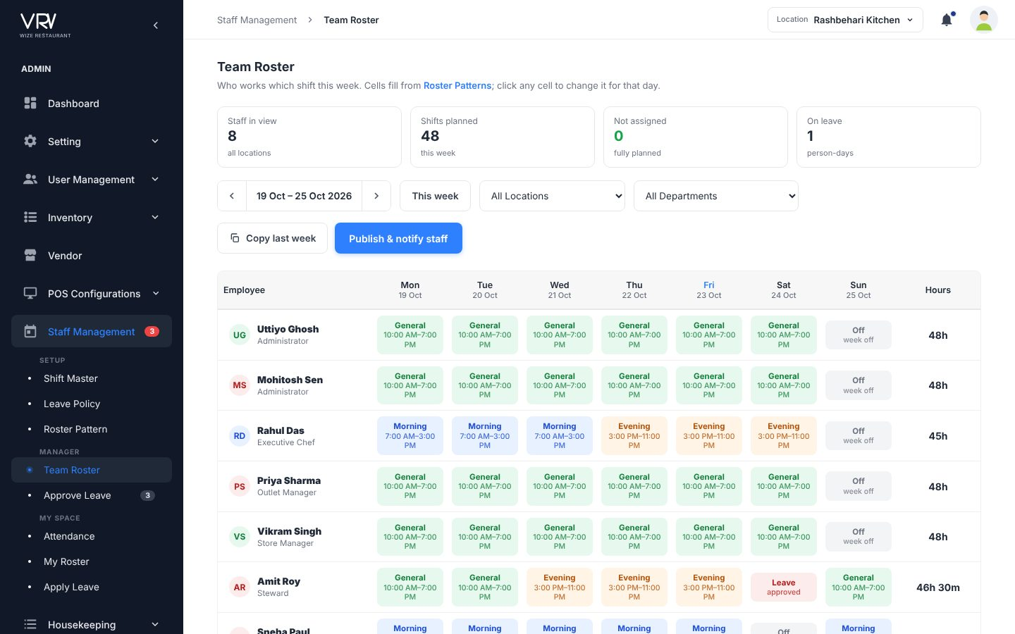
Proposed Team Roster
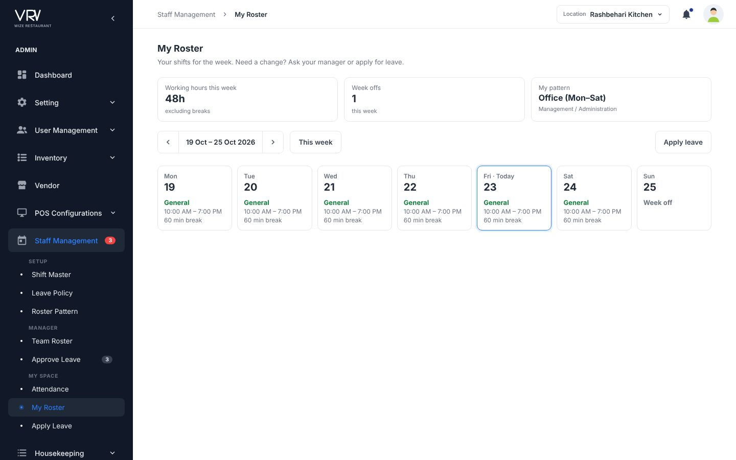
Proposed My Roster

4.21 Attendance
Menu: Staff Management · URL: /manage_steward/attendance
Purpose: Check-in/out and the monthly log.

Current screens
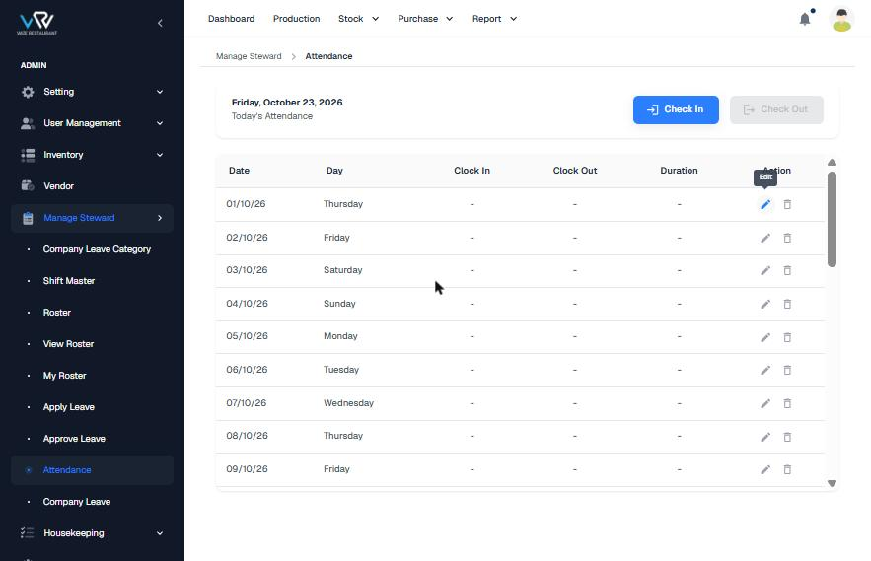
Current Attendance

Flow and steps tested
- Click "Check In" (and later "Check Out").
- Scroll the month table. Each row has Edit and Delete icons.

Issues found
Severity | Finding
High | Future dates (24–31 Oct) are listed with Edit/Delete, and attendance rows can be deleted.
Medium | There is no status (Present / Late / Absent / Leave / Week-off), no month picker and no totals.
Medium | A manager cannot see the team for today.

Recommended improvements (UI/UX)
- Add a today card with the shift, KPIs, and tabs for My Attendance and Team Today.
- Hide future rows and replace delete with "Regularise" (a request to the manager).

Information to show
- Present, late, absent, leave, week-off counts; worked hours per day

Proposed design
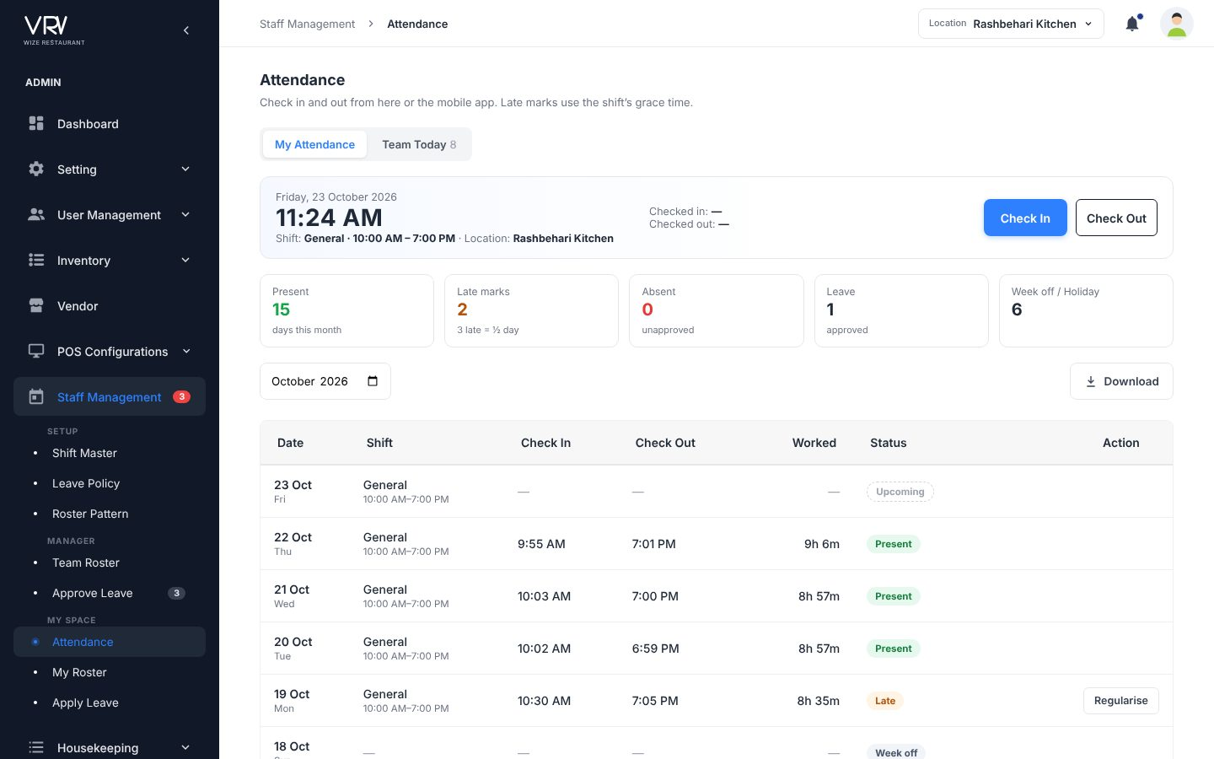
Proposed My Attendance
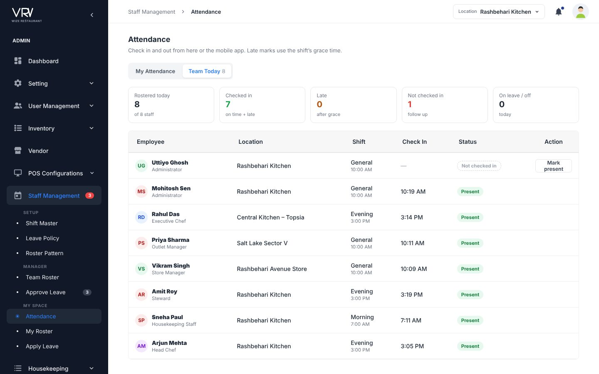
Proposed Team Today

4.22 Apply Leave
Menu: Staff Management · URL: /manage_steward/apply_leave
Purpose: Employee requests leave.

Current screens
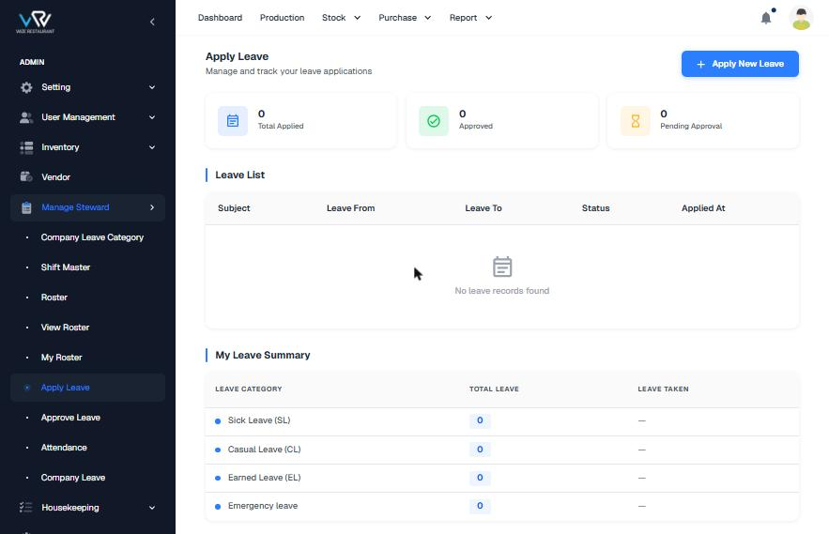
Current page
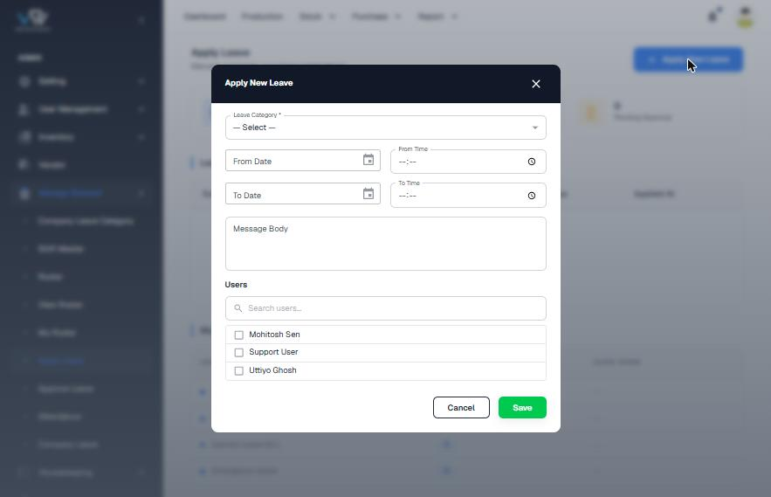
Current Apply New Leave

Flow and steps tested
- Click "Apply New Leave" and enter Leave Category*, From Date + Time, To Date + Time, Message Body, and tick Users.
- Click Save.

Issues found
Severity | Finding
High | A "Users" checklist appears in the employee's own form. It is unclear whose leave is being applied for.
Medium | The balance is not shown while applying, the number of days is not calculated, and there is no half-day or document upload.
Low | There is no breadcrumb. The date format is MM/DD/YYYY. "Message Body" should be "Reason".

Recommended improvements (UI/UX)
- Show balance cards per leave type. In the form: calculate days (Sundays excluded), show the balance after approval, offer half-day, require a document for sick leave over 2 days, check overlaps, and show "Goes to: manager".

Information to show
- Left / total, used, pending per type; request status with approver

Proposed design
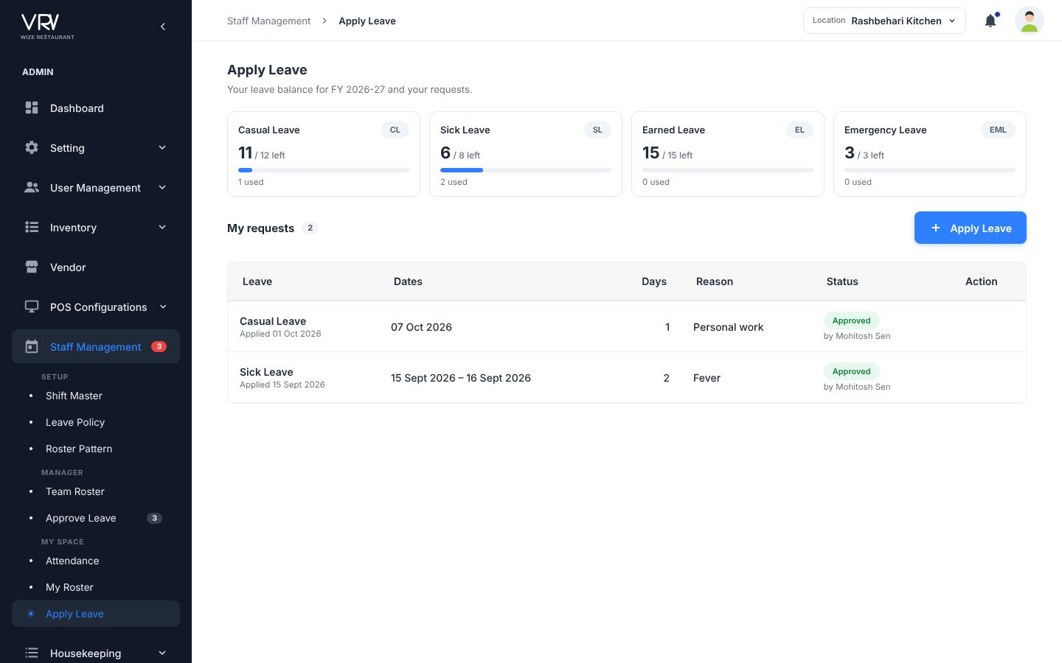
Proposed page
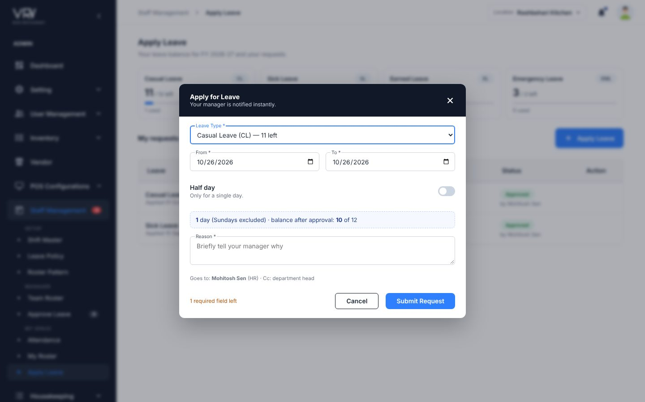
Proposed form

4.23 Approve Leave
Menu: Staff Management · URL: /manage_steward/approve_leave
Purpose: Manager decides on requests.

Current screens
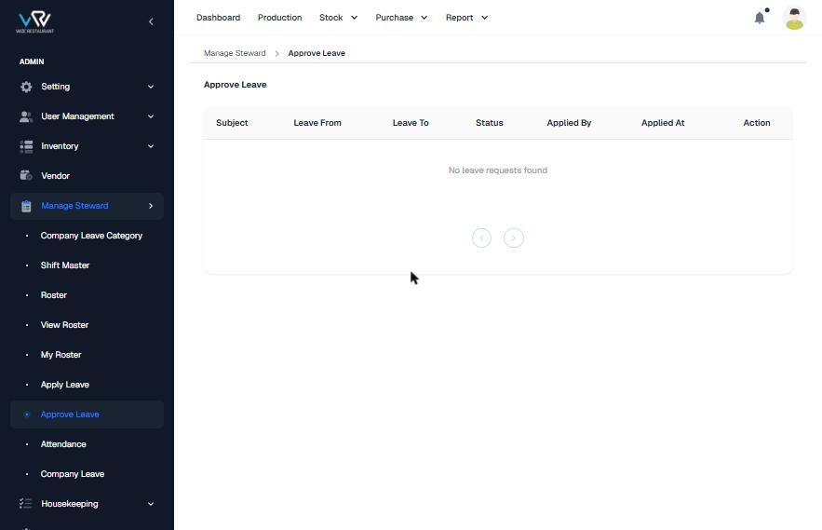
Current page (empty)

Flow and steps tested
- Open Approve Leave and act on each row.

Issues found
Severity | Finding
Medium | There are no filters or status tabs, the balance and team overlap are not shown, and there is no badge for pending requests.

Recommended improvements (UI/UX)
- Add Pending / Approved / Rejected tabs, a balance column, a "team overlap" check, one-click Approve, and Reject with a reason. Show a pending badge in the menu.

Information to show
- Waiting for you, approved this month, on leave today

Proposed design
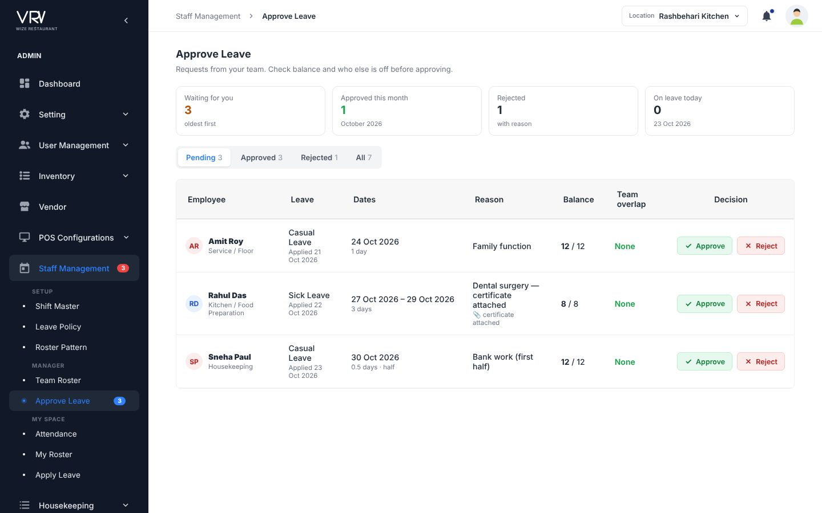
Proposed Approve Leave

4.24 Checklist Form
Menu: Housekeeping · URL: /housekeeping/checklist_form
Purpose: Build checklists.

Current screens
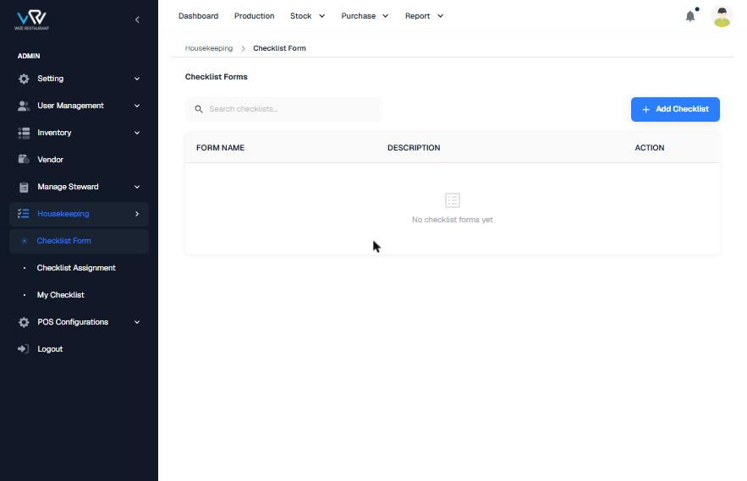
Current list
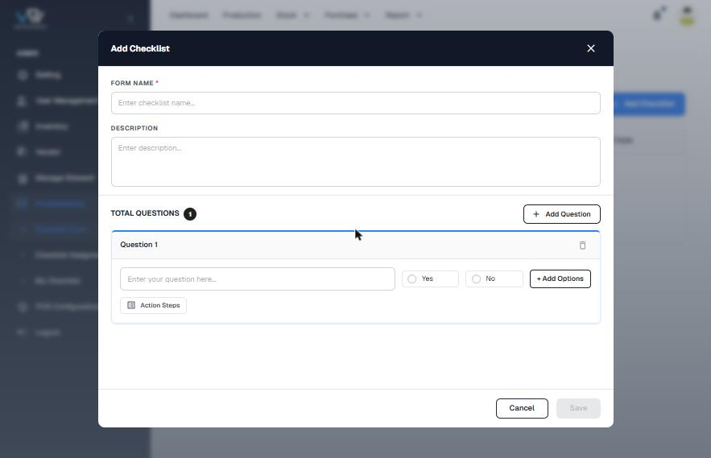
Current builder

Flow and steps tested
- Click "Add Checklist" and enter Form Name* and Description.
- Click "+ Add Question", type the question (Yes/No by default), and optionally add options or action steps.
- Save.

Issues found
Severity | Finding
Medium | There are no answer types (number, temperature, photo), no per-question "required" flag, and no area, frequency or due time.
Low | Table headers are in UPPERCASE.

Recommended improvements (UI/UX)
- Let each question pick a type and a Required flag. Add area, frequency and due time, plus a live preview of what staff will see.

Information to show
- Area chip, frequency + due, question count, assigned count

Proposed design
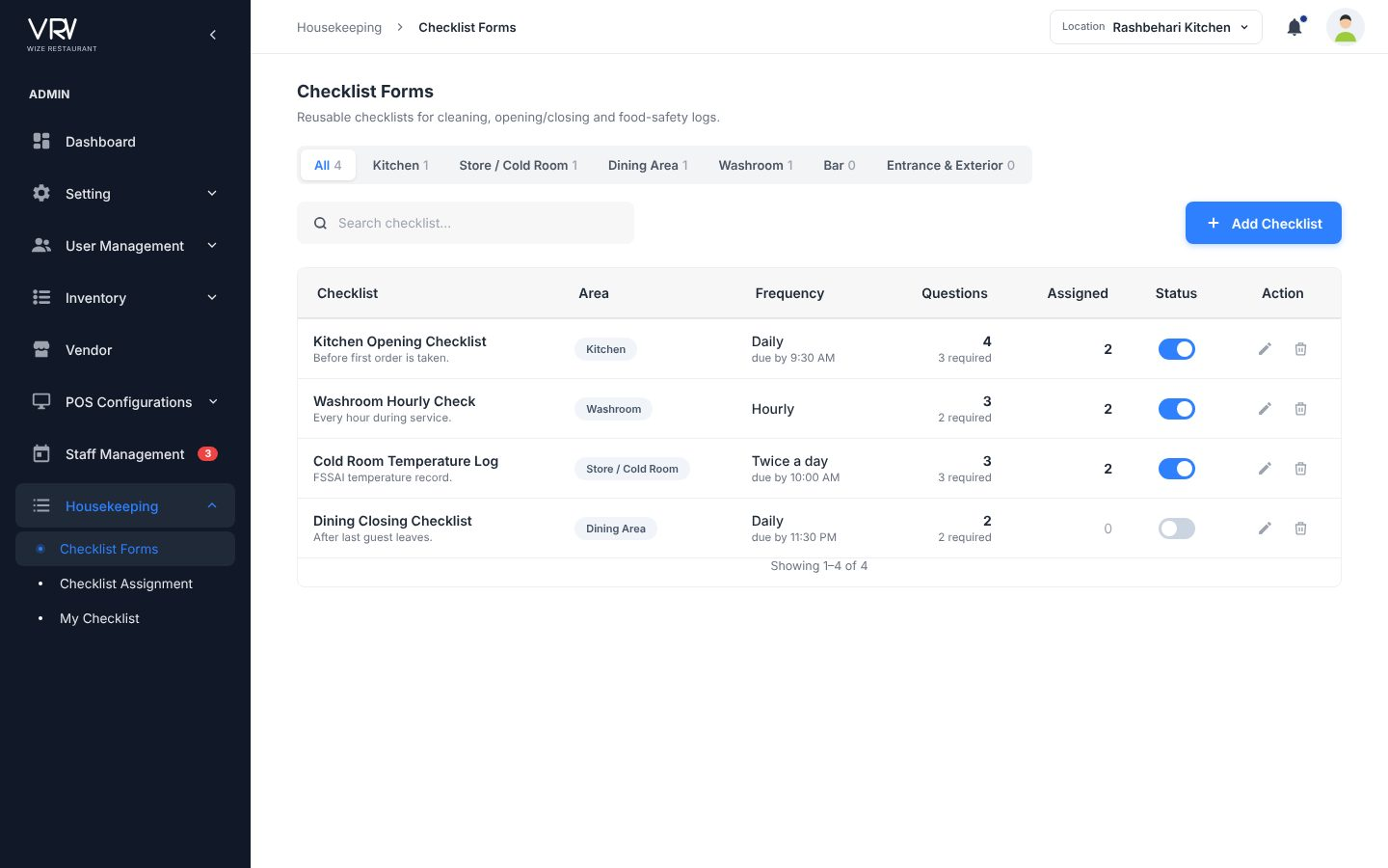
Proposed list
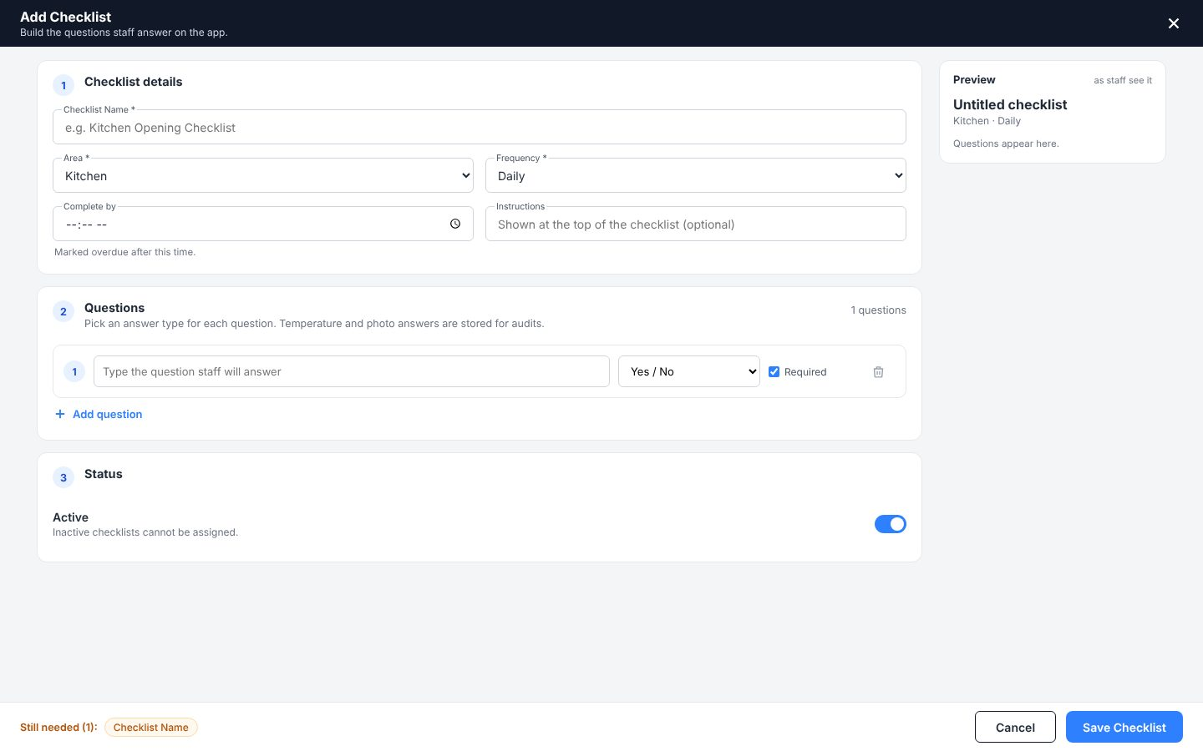
Proposed builder

4.25 Checklist Assignment
Menu: Housekeeping · URL: /housekeeping/checklist_assignment
Purpose: Assign checklists to staff.

Current screens
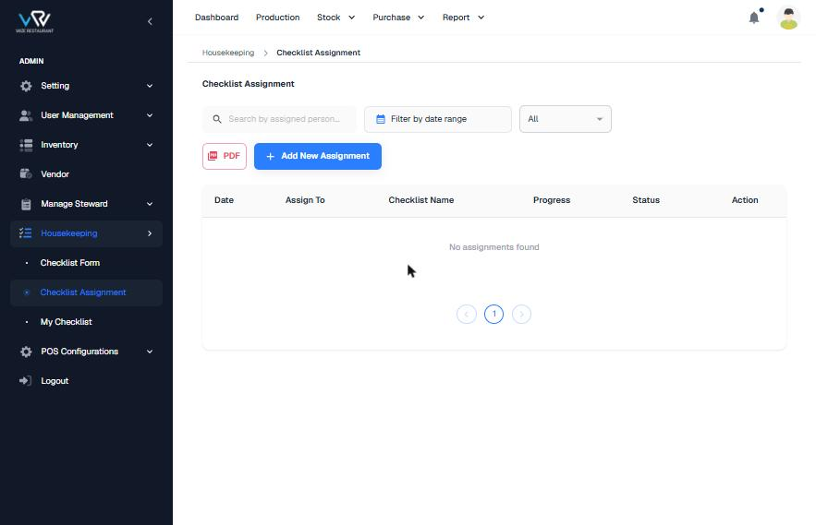
Current list
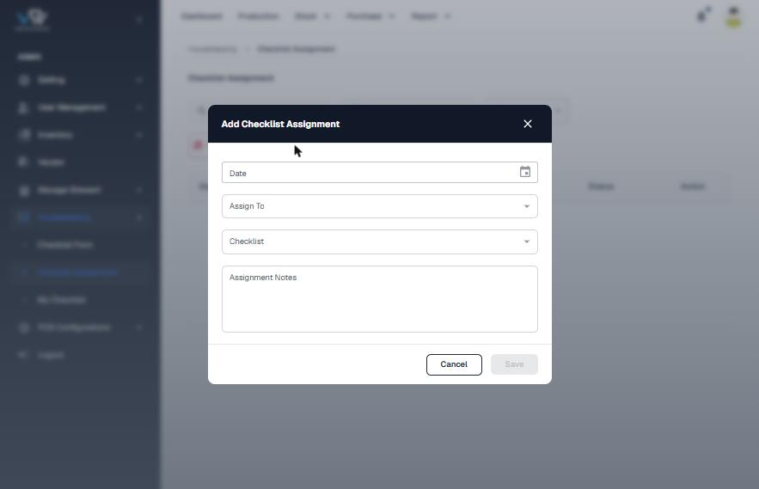
Current Add

Flow and steps tested
- Use search, date range, status and PDF export.
- Click "Add New Assignment" and enter Date, Assign To, Checklist and Notes, then Save.

Issues found
Severity | Finding
Medium | Assignments are one-time only, with no repeat. No field is marked required, and there is no location or due time.

Recommended improvements (UI/UX)
- Add repeat (hourly / daily / weekly), location and due time, KPIs (submitted / overdue), a progress bar per row and export.

Information to show
- Today progress x/y, status chip, schedule

Proposed design
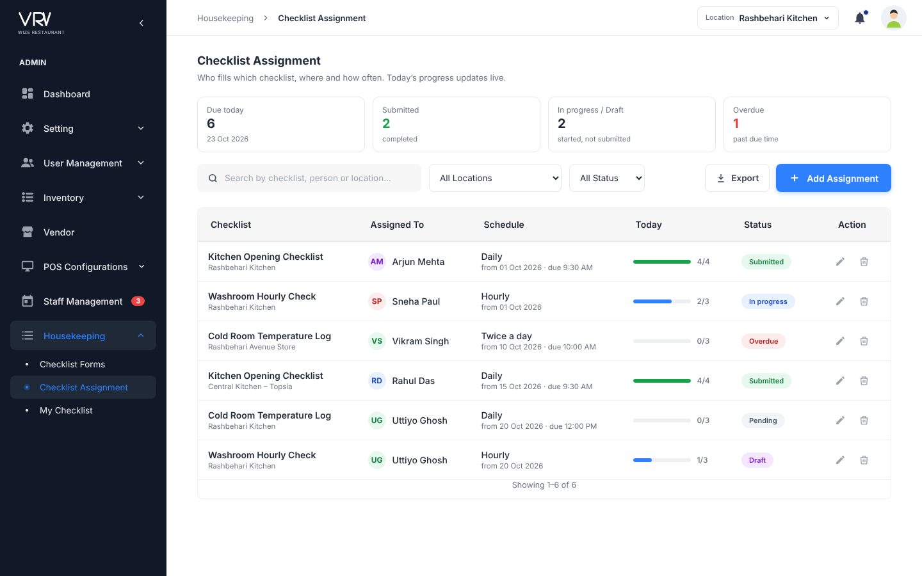
Proposed list

4.26 My Checklist
Menu: Housekeeping · URL: /housekeeping/my_checklist
Purpose: Staff fill their checklists.

Current screens
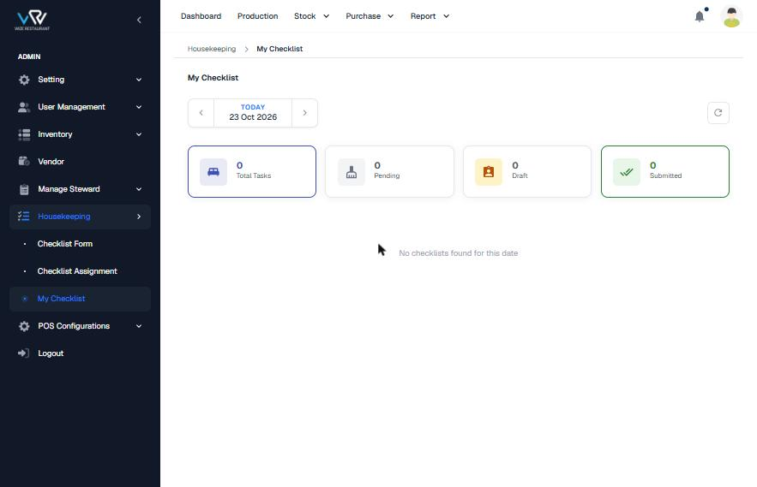
Current page

Flow and steps tested
- Step through dates and read the KPI cards (Total, Pending, Draft, Submitted).

Issues found
Severity | Finding
Low | The pattern is good. The empty state does not explain what to do.

Recommended improvements (UI/UX)
- Show assignment cards with progress, Start/Continue, Save Draft and Submit. Flag out-of-range temperatures.

Information to show
- Answered x/y, due time

Proposed design
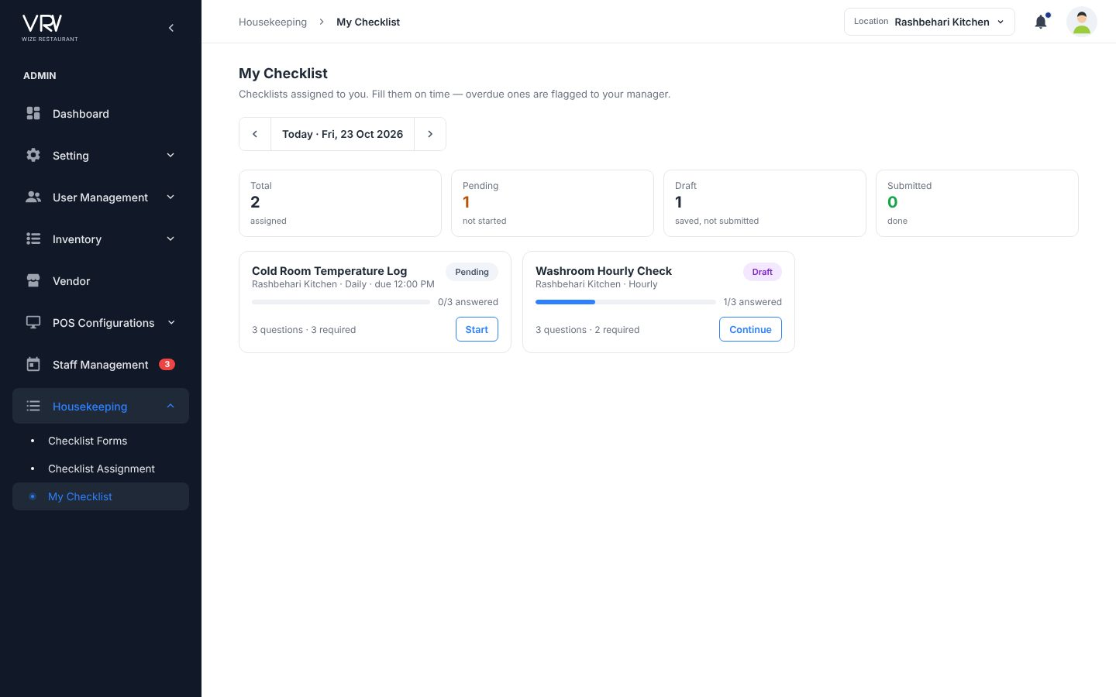
Proposed My Checklist
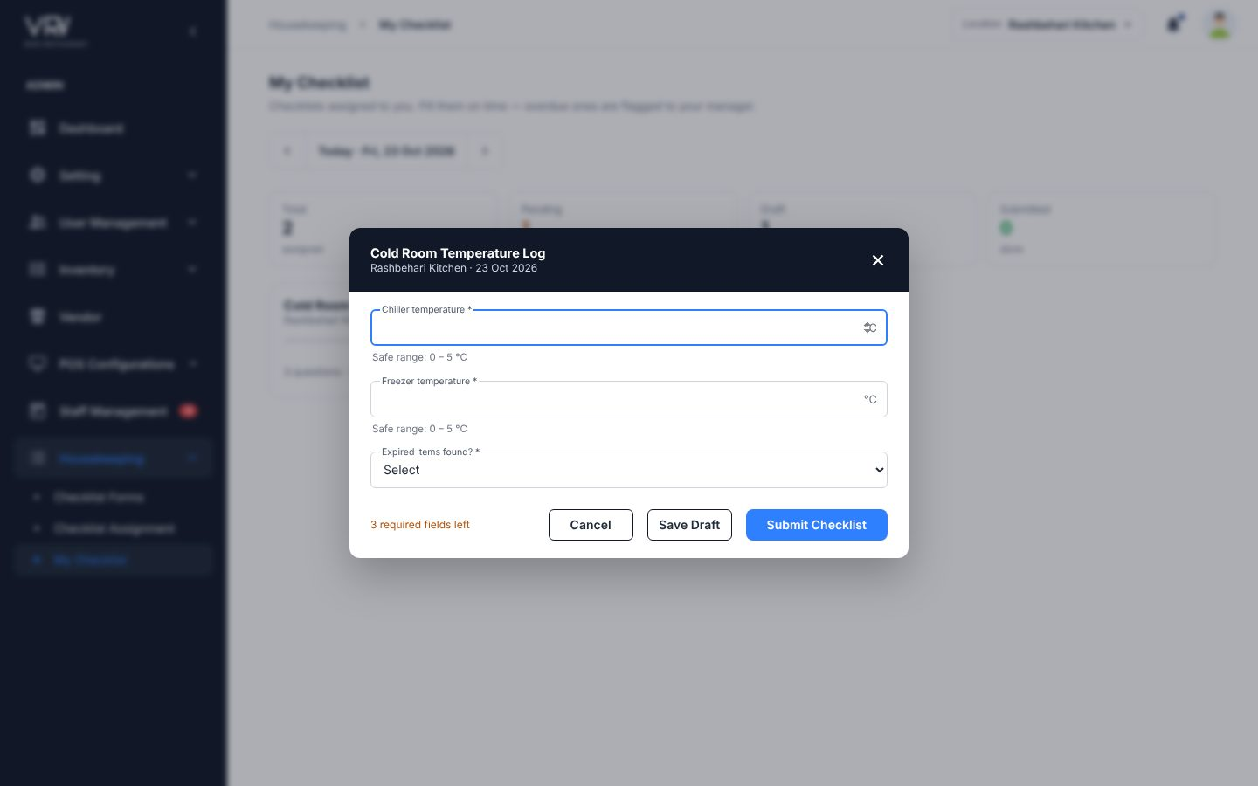
Proposed fill form

4.27 Dashboard
Menu: Top bar · URL: /dashboard/dashboard
Purpose: Home screen.

Current screens
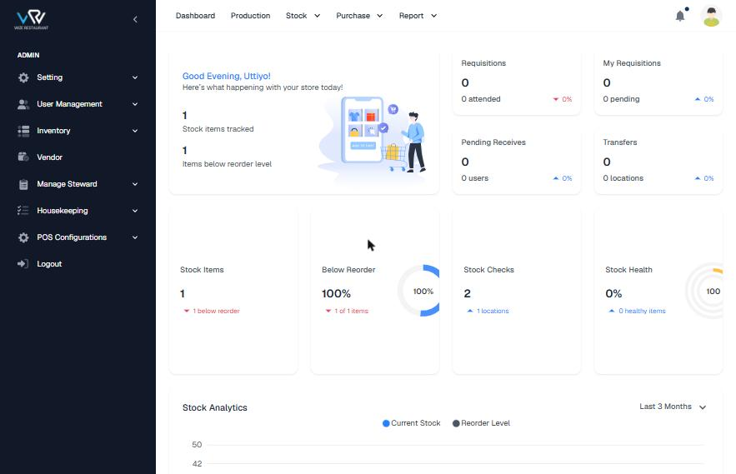
Current dashboard

Flow and steps tested
- Open Dashboard from the top bar.

Issues found
Severity | Finding
Medium | It uses an e-commerce shopping-cart illustration and the text "Here's what happening with your store" (grammar). The tab title is "Vendor Dashboard - Bazaar Next.js E-commerce Template".
Medium | It is not in the left panel, and it shows no staff, leave or checklist information. The Stock Health ring is clipped.

Recommended improvements (UI/UX)
- Make it an action dashboard: low stock, staff checked in, pending leave, checklists done, expiring documents, plus a setup-completeness checklist with "Fix →" links.

Information to show
- 5 KPI cards, stock vs reorder chart, low-stock table, setup completeness, today's checklists

Proposed design
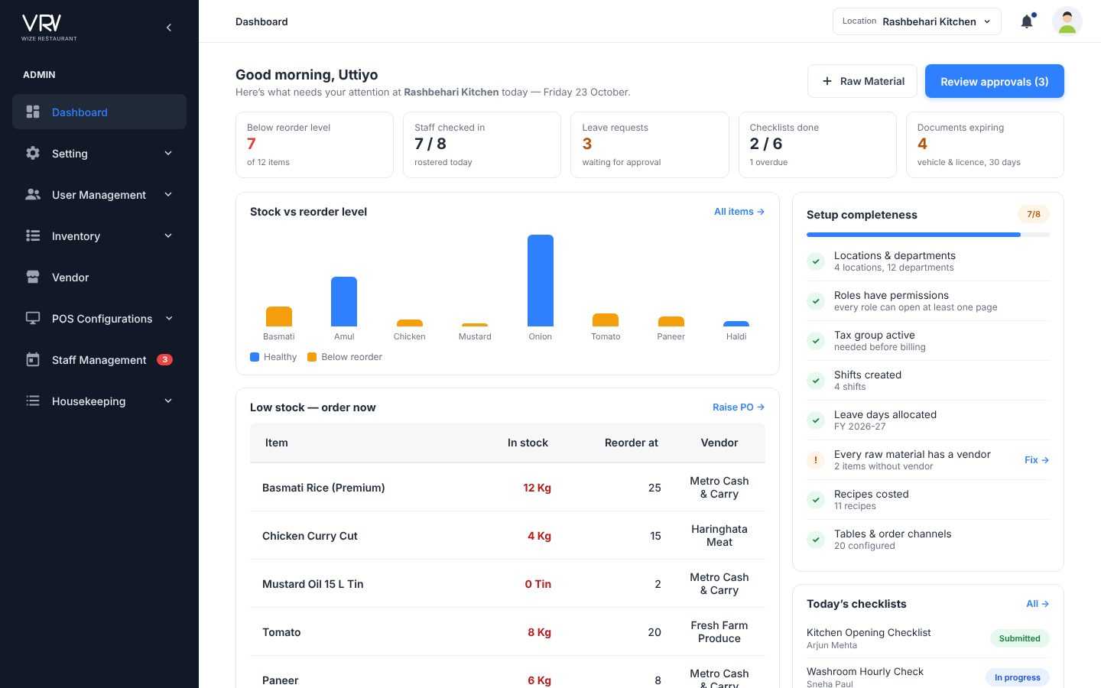
Proposed dashboard

5. Design guidelines for all pages
These rules come from the Item Category design and are applied to every page in the prototype. They can be built once as shared components.
Area | Rule
Layout | Dark sidebar (#111827) with accordion groups and a blue active state. Top bar holds the breadcrumb, location switcher, notifications and avatar menu. Content area: H1 18px bold, a one-line description in grey, an optional blue info strip, KPI cards, then the toolbar and table.
Colour | Primary #2F80FF (hover #1F6FE8), text #1F2937, muted #6B7280, border #E5E7EB, success #16A34A, danger #E53935, warning #B45309. Chips use soft backgrounds (blue, green, orange, purple, grey).
Typography | Inter. Table headers 14px semibold on #F7F7F8. Cell text 14px. Helper text 11.5px grey.
Buttons | Primary = blue filled with "+" icon, named "Add <Entity>". Secondary = outlined dark. Danger = red, only inside the delete confirmation. Save is never disabled: clicking it shows inline errors.
Lists | Search (350px) + filters on the left, Export + Add on the right. Status as a toggle or dot chip. Edit/Delete icons turn red on hover for delete. 10 rows per page with "Showing 1–10 of N". Clicking a KPI card filters the list.
Forms | Small masters use a 444–640px dialog with a dark header. Big masters (User, Role, Raw Material, Recipe, Checklist) use a full screen with numbered section cards, a live summary panel on the right, and a sticky footer listing the required fields still missing ("Still needed").
Fields | Fixed floating labels with an "e.g." placeholder and a hint line underneath. Required fields marked with *. Prefixes and suffixes for ₹, +91, %, days, kg, °C. Switches with a title and a one-line description instead of bare check-boxes.
Safety | Delete confirmations suggest "make it Inactive instead". Deleting a record that other records use is blocked with a reason (e.g. "2 users are assigned to this location"). Duplicate names and codes are blocked.
Feedback | A toast after every save, toggle or delete. Badges for pending approvals. Warning strips when setup data is missing.

6. Prioritised backlog for the team
P1 = fix before the next release · P2 = next sprint · P3 = polish. Effort: S ≤ 1 day, M 2–4 days, L 1–2 weeks (front-end estimate).
Priority | Task | Area | Effort
P1 | Fix tab titles (template leftovers) on all pages | All | S
P1 | Allow permissions while creating a role; add permission matrix | Roles | M
P1 | Merge Company Leave Category + Company Leave into Leave Policy; allocate days | Staff | M
P1 | Warn when no tax is active; show components & total | Tax Setting | S
P1 | Attendance: hide future dates, remove delete, add status + regularise | Attendance | M
P1 | Remove Users checklist from Apply Leave; add day count, balance and half-day | Apply Leave | S
P1 | Duplicate and format validation (name, code, phone, GSTIN, pincode, email) | All masters | M
P1 | Keep sidebar and header during page loads; improve load time | All | M
P2 | Reorder left panel and move Dashboard and Logout | Navigation | S
P2 | Apply common list template (KPIs, filters, counter, export) | All lists | L
P2 | Single-screen Add User with role and invite | Users | M
P2 | Raw Material sections with conversion preview, vendor & reorder | Raw Material | M
P2 | Shift auto-duration; roster pattern per-day editor; Team Roster week grid | Staff | L
P2 | Vehicle & Driver: type, phone, expiry dates, assignment | Setting | S
P2 | Checklist question types, repeat assignments | Housekeeping | M
P3 | Standardise date format, casing and naming across menu/breadcrumb/H1 | All | S
P3 | Action dashboard with setup completeness | Dashboard | M
P3 | Clean staging seed data (typos, test emails) | Data | S

7. Using the prototype
- Open wize-rms-prototype.html in Chrome. No install or server is needed.
- Every page in the recommended sidebar works: add, edit, delete, toggle, search, filters, KPI-card filters, pagination and export. Data is stored in the browser, so changes survive a refresh.
- Your four pages (Category Master, Menu Section, Recipe, POS Table Config) are kept exactly as designed. The other pages follow the same style.
- Things to try: add a Brand called "Amul" (duplicate blocked); create a Role and tick permissions on the same screen; apply for leave and approve it; change a cell in Team Roster; fill My Checklist; check in on Attendance.
- For developers: shared building blocks (crud list engine, form engine, store) are in one <script> block. Field rules (required, pattern, hint, suffix) map directly to form-validation schemas.

