**Borobudur, Indonesia**

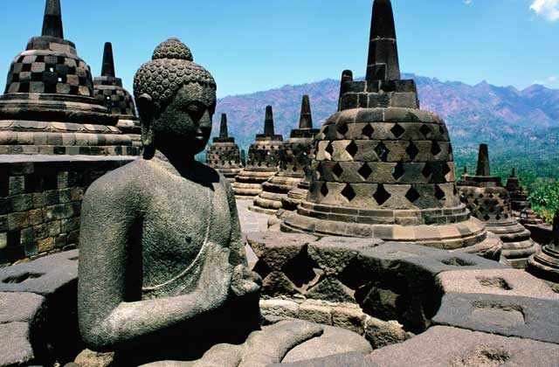

Borobudur is a Mahayana Buddhist monument in Indonesia.

The monument was built in 9th century with 504 Buddha statues, and is one of the most holy pilgrimage place in Buddhism. The total surface area of the monument is more than 2000 sq.m. Gunadharma is believed to be architect of the monument.

Borobudur was declared as UNESCO World Heritage Site in 1991.