**Colosseum, Italy**

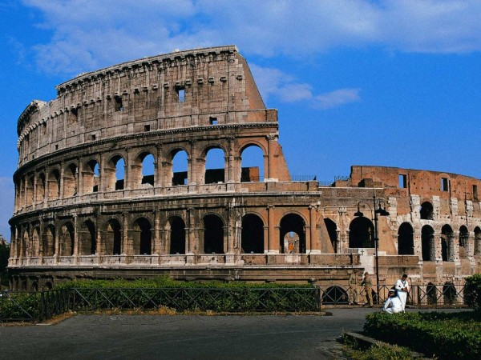

The Colosseum, one of the Seven Wonders of the World, is an Amphitheatre in the Roman city of Italy. It was built in the first century under Emperor Vespasian and Titus of Flavian dynasty.

The Colosseum of Rome is elliptical in structure, 189 meters long, 156 meters wide and 48 meters high. The Colosseum was used to host Gladiator contests and Public mock spectacles.Its capacity was more than 50,000 people.