**Moai, Chile**

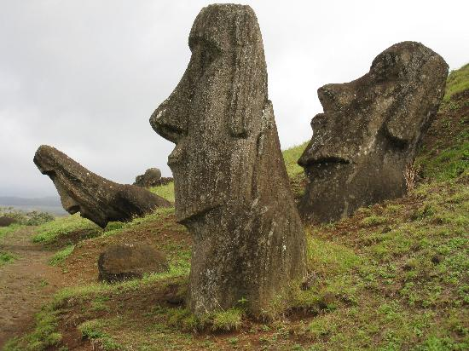

Moai are human faces carved on rock located in Easter Island. Amazingly, More than 800 Moai statues have been known till date. The tallest Moai erected weighed more than 80 tons.