**The Kaaba (Masjid al-Haram)**

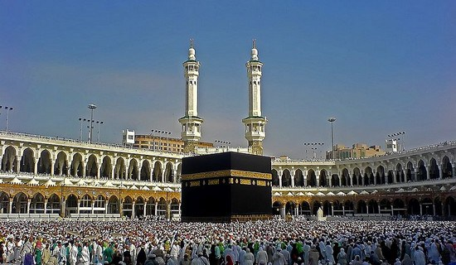

**The Kaaba (Masjid al-Haram)**is a cuboid-shaped building in Mecca, Saudi Arabia, and is the most sacred site in Islam, oldest and top the most Famous Cultural monuments in the world. The Quran states that the Kaaba was constructed by Abraham (Ibrahim in Arabic), and his son Ishmael (Ismaeel in Arabic), after the latter had settled in Arabia. The building has a mosque built around it, the Masjid al-Haram. All Muslims around the world face the Kaaba during prayers, no matter where they are. This is called facing the Qiblah.

One of the Five Pillars of Islam requires every Muslim to perform the Hajj pilgrimage at least once in his or her lifetime if able to do so. Multiple parts of the Hajj require pilgrims to walk seven times around the Kaaba in a counter-clockwise direction (as viewed from above). This circumambulation, the Tawaf, is also performed by pilgrims during the Umrah (lesser pilgrimage). However, the most dramatic times are during the Hajj, when about 6 million pilgrims gather to circle the building on the same day.