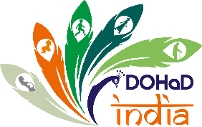

Guidance for the Management and Governance of DOHaD India Regional Society

1. The Constitution of the Society
The key document that describes in detail how the DOHaD India Regional Society is to be managed is the Constitution. This document is based on the constitution of the International DOHaD Society, but has been adapted to reflect as far as possible how the DOHaD India Regional Society is managed. The Constitution provides the framework for the governance of the DOHaD INDIA. The various activities it will undertake include formal decision-making in relation to strategic direction, the holding of conferences, the awarding of grants and contracts with third-party organizations, and the preparation of annual accounts.
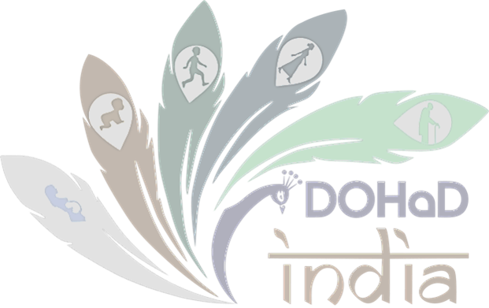

Advisory team, council members, and registered members
Membership of DOHaD India Regional Society is governed by and reflects the constitution of the International DOHaD Society’s arrangements, so that any academic or professional person over the age of 18 who is interested in furthering the objects of the DOHaD India Regional Society (the promotion of research and public health strategies supported by education and training in the developmental origins of disease and who pays the relevant membership subscription set by DOHaD India Regional Society from time to time. These registered members have a duty to exercise their membership powers to further the objects of the DOHaD India Regional Society . These powers are principally voting at meetings.
The Constitution sets out how members' meetings must be managed and how specific decisions must be taken, such as removing a poorly performing council member, amending the Constitution, or deciding to dissolve DOHAD INDIA. The Council members are obliged to call a Members meeting annually, at the Annual General Meeting (AGM). This is similar to the international DOHAD Society, and the DOHaD India Regional Society annual general meeting (AGM) will continue to be held. In years when there is also a Society Congress, the AGM will take place at the same time as the Congress. The quorum for holding an AGM is one-tenth of the total number of Members. Voting of all Members can be online or by email, in the same way as the original charity.
The Constitution sets out the first council members with the addition of two co-opted Council members to oversee legal and financial matters. Council members must be re-elected by rotation; one-third of the Council members are required to stand for re-election by the members every two years. As with the original charity, all day-to-day decisions for DOHaD India Regional Society will be delegated to the “Council members,” led by the President, the Secretary, and the Treasurer. The two co-opted Council members will have contracts with DOHaD India Regional Society to provide professional services regulated by the Constitution, but such services are distinct from their voluntary duties as Council members.

The Council (of around 40 experts in the field of life course epidemiology, epigenetics, developmental origins of health and disease, maternal, child, and adolescent health, NCDs, implementation science, health systems, health policy, and global health) will also continue to meet periodically (including on virtual platforms), and further details are given in the Appendix to the Constitution. Decisions by the Council members are to be taken after consideration has been given to the views of the Council in matters where the Council has been consulted. Within the Council, there are eight subcommittees composed of Council members: Advocacy, Communications, Education, Journal, Scientific Program Support, Sponsorship and Fundraising, Trainee, and Workshop committees. Each subcommittee is chaired by a Council member and each has its own Terms of Reference. The Secretariat appoints these subcommittees to assist in the conduct of the Society's affairs.

3. Communications and Publications
Communication internal to the DOHaD India Regional Society between Council members, advisory team, and registered members will be managed by the Secretary. The Secretary will handle the annual accounts and Annual Report (“AR”), supported by the council and two co-opted Council members. The registered office of the DOHAD INDIA is currently at the Public Health Foundation of India (PHFI), and the filing of the TAR and all other official documentation required by statute or the Constitution will be managed through the registered office.
Minutes of meetings of Council members, advisory team, and registered members will be communicated to and available to view on request by attendees of the relevant meeting. The website is the key vehicle for public communication of the DOHaD INDIA purpose and activities. Its content, management, and use as a key communication vehicle is managed by the Secretary with the support of the DOHAD INDIA’s registered office in the UK, the Secretariat, the Council Communications subcommittee, and third-party communications experts.

4. Timetable of DOHaD Activities
The principal activities of DOHaD India Regional Society , year on year, over which the Council provides oversight, are as follows:

Annual General Meeting (occurs generally in the last quarter of the calendar year)
The AGM is either held virtually or in person each year. At this meeting, members are presented with a President’s report, a Secretary’s report, and a Treasurer’s report. Any new business or items arising over the year, as well as changes to procedures or governance, can be made by the affirmative majority vote of the Membership entitled to vote and responding to a ballot, following discussion at the Annual General Meeting.

Workshops (occurring at random times throughout the calendar year)

DOHaD India Regional Society financially supports DOHaD-related workshops. These workshops are to advance the educational and/or research aims of the Society. Members may apply for workshop support through the Workshop Subcommittee Application and Review System.

