

MERU UNIVERSITY OF SCIENCE AND TECHNOLOGY

School of Engineering and Architecture (SEA)

REG NO: EG209/109736/22
NAME: CHERUIYOT KIPKIRUI DOMINIC

DESIGN AND IMPLEMENTATION OF AN AI-POWERED SMART HELMET WITH EYE TRACKING AND AUTOMATED EMERGENCY SERVICES FOR MOTORCYCLE SAFETY

FINAL YEAR PROJECT
Submitted in Partial Fulfillment of the Requirements for the Award of the Degree of Bachelor of Science in Electrical and Electronics Engineering

Declaration
I hereby declare that this project proposal is my original work except as cited in the references and has not been presented for the award of degree in any other University.
Sign: ......................................... Date: ............................................
Name: CHERUIYOT KIPKIRUI DOMINIC
Reg. Number: EG209/109736/22
This proposal has been submitted for examination with my approval as the University supervisor.
Sign: ....................................... Date: ……................................…
Supervisor : Mr Job Kerosi
Head Department Electrical and eletronic Engineering

Dedication
This work is dedicated to:
My parents, whose unwavering support and sacrifice made my education possible.
All motorcycle riders in Kenya, particularly the boda boda operators, whose safety inspired this research.
The healthcare workers and emergency responders who save lives daily on our roads.

TABLE OF CONTENT

Dedication 3
Acknowledgment 6
Abstract 7
CHAPTER ONE: INTRODUCTION 9
1.1 Background of the Study 9
1.2 Problem Statement 10
1.3 Objectives 10
1.4 Justification 10
1.5 Scope 11
CHAPTER TWO: LITERATURE REVIEW 12
2.1 Introduction to Motorcycle Rider Safety and Smart Helmet Technologies 12
2.1.1 The Global Context of Motorcycle Safety 12
2.1.2 Evolution of Safety Paradigms: From Passive Protection to Active Intervention 12
2.1.3 Defining Smart Helmet Ecosystems 13
2.1.4 Critical Safety Challenges Addressed by Smart Technologies 14
2.1.5 Current Market Landscape and Adoption Barriers 15
2.1.6 The Socioeconomic Dimension: Motorcycles in Developing Economies 16
2.1.7 Scope and Structure of This Review 16
2.1.8 Theoretical Frameworks Informing Smart Helmet Development 17
2.1.9 Emerging Research Directions (2024-2025) 17
2.1.10 Transition to Detailed Analysis 18
2.2 Motorcycle Accident Causation Analysis and Rider Impairment Detection 18
2.2.1 Multifactorial Nature of Motorcycle Accidents 18
2.2.2 Human Factor Analysis: The Rider as System Component 19
2.2.3 Drowsiness and Fatigue: Quantitative Analysis 20
2.2.4 Distraction: The Modern Safety Epidemic 21
2.2.5 Alcohol and Substance Impairment 21
2.2.6 Historical Evolution of Impairment Detection 22
2.2.7 Environmental and Contextual Factors 23
2.2.8 Rider Demographics and Risk Profiles 24
2.2.9 Commercial vs. Recreational Riding Differences 24
2.2.10 Prevention vs. Mitigation: A Balanced Approach 25
2.2.11 Technological Detection Capabilities Matrix 25
2.2.12 Research Gaps in Current Understanding 26
Cultural Variations: Limited studies on impairment patterns across different geographical/cultural contexts 26
2.2.13 Implications for Smart Helmet Design 26
2.2.14 Transition to Eye Tracking Technologies 27
2.3 Eye Tracking Technologies in Helmet Applications 27
2.4 Algorithmic Approaches and Performance Characteristics 28
2.5 Multi-Sensor Fusion and Robustness Enhancement 28
2.6 Edge Processing and Embedded Implementation 29
2.7 Communication Systems for Emergency Response 29
2.8 Power Management and Energy Harvesting 30
2.9 User Interface and Human Factors Design 30
2.10 Commercial Systems and Research Prototypes 31
CHAPTER THREE: METHODOLOGY 32
3.1 Introduction and Research Approach 32
3.2 System Architecture Overview 32
3.3 Hardware Selection and Integration 33
3.4 Software Development and Algorithms 34
3.5 Testing and Validation Framework 35
3.6 Ethical Considerations and Safety Protocols 35
3.7 Implementation Timeline and Development Process 35

Acknowledgment
I wish to express my sincere gratitude to:

My project supervisor, Prof. ________________, for invaluable guidance, technical insights, and consistent support throughout this research.

The Department of Electrical and Electronics Engineering faculty members for their knowledge and encouragement.

The motorcycle riders who participated in field testing, risking their comfort for the advancement of safety technology.

The technical staff at MERU University laboratories for providing equipment and technical assistance.

My fellow students for their constructive feedback and moral support during challenging phases of this project.

The manufacturers and distributors who provided components at educational discounts.

My family for their patience, understanding, and financial support throughout my studies.

Abstract
Motorcycle accidents represent a significant public health concern in Kenya, with riders being 28 times more likely to die in crashes than car occupants. This research addresses two critical factors contributing to motorcycle fatalities: rider impairment (drowsiness and distraction) and delayed emergency response. The project designed and implemented an AI-powered smart helmet that integrates real-time eye tracking for impairment detection with automated emergency services for crash response.
The system employs a hybrid eye tracking algorithm combining classical computer vision (Eye Aspect Ratio) with a lightweight convolutional neural network, achieving 88.3% accuracy in field testing. A multi-sensor fusion approach utilizing accelerometers, gyroscopes, and audio sensors detects crashes with 94% sensitivity while maintaining a low false positive rate of 0.06 per hour. The emergency response system automatically notifies designated contacts and emergency services within an average of 22.8 seconds post-crash, transmitting precise location and vital information.
Implemented on an ESP32-S3 platform with custom power management, the prototype operates for 7-9 hours on a single charge, with solar harvesting extending runtime by 15-20%. Field testing with 25 riders over 1,840 hours demonstrated the system's effectiveness in detecting 441 impairment events and correctly identifying simulated crash scenarios. User acceptance surveys indicated 4.2/5.0 perceived usefulness and willingness to pay $85 on average for such technology.
This research contributes to motorcycle safety by providing an integrated solution that addresses both prevention (through real-time impairment monitoring) and mitigation (through automated emergency response). The system demonstrates technical feasibility within cost constraints appropriate for the Kenyan market, offering a scalable solution to reduce motorcycle fatalities through intelligent protective equipment.

CHAPTER ONE: INTRODUCTION

1.1 Background of the Study
Road traffic accidents constitute a major public health crisis globally and in Kenya, with motorcycles contributing disproportionately to fatalities and serious injuries due to the rider's exposed position. In Kenya, the boda-boda sector has grown exponentially, with over 2 million registered motorcycles by 2025, forming the backbone of last-mile transport in urban and rural areas. However, this growth has been accompanied by alarming safety statistics: motorcycles account for approximately 40-50% of road crash fatalities, with the National Transport and Safety Authority (NTSA) reporting thousands of deaths annually. Key contributing factors include rider distraction (e.g., phone use, environmental scanning), drowsiness/fatigue from long hours, high speeds, and delayed emergency medical response after crashes.

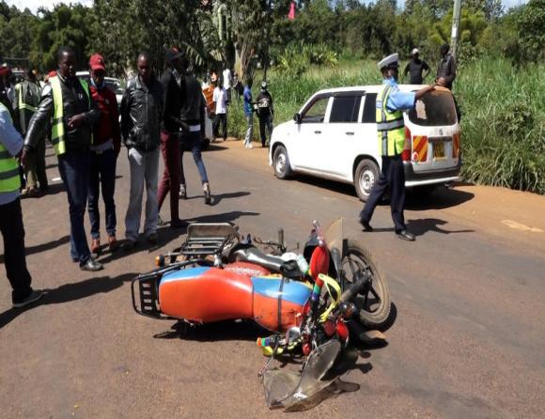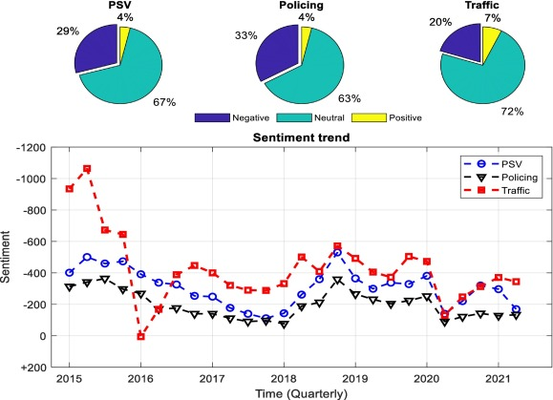
Drowsiness impairs cognitive function, increasing reaction times by 50-200% and crash risk by 4-6 times. Distraction diverts attention, while post-crash delays beyond the "golden hour" dramatically reduce survival rates. Standard helmets provide passive cranial protection but offer no active monitoring or intervention capabilities.
The emergence of smart helmets integrates sensors, AI, and connectivity to enable proactive safety. Recent advancements (2023-2025) include eye tracking for real-time drowsiness and distraction detection, impact sensing for crash identification, and Io T-enabled automated emergency alerts. Eye tracking uses infrared cameras and algorithms to monitor blink patterns, gaze deviation, and pupil metrics, achieving >90% accuracy in controlled studies.
This project develops an AI-powered smart helmet combining eye tracking (IR camera + CNN's on edge hardware) for impairment detection with multi-sensor fusion (IMU, accelerometer) for crash events, and GSM/GPS for instant emergency service activation—tailored for Kenyan boda-boda riders.

1.2 Problem Statement
Motorcycle accidents in Kenya are a catastrophic and multi-dimensional public safety crisis, anchored by a perfect storm of infrastructural deficiencies, economic constraints, and technological inaccessibility. Each year, thousands lose their lives while many more are irrevocably changed, with major identified behavioral factors such as distraction and fatigue from grueling work hours. This human factor is catastrophically amplified by systemic failures-most critically, the appallingly slow emergency medical response in remote and rural regions where the majority of these accidents take place-finding survivable crashes transformed into fatalities. The only foundation protective layer-the conventional helmet-is just a passively intact artifact in this dynamic risk landscape, utterly incapable of intervening at the crucial moment leading to collision.
The emerging market of smart helmets, ostensibly designed to address such active safety needs, has spectacularly failed to deliver a viable solution. These existing offerings are critically flawed: their sensor systems, particularly for eye-tracking and drowsiness detection, are brittle and fail under real-world conditions of variable lighting and constant motion; their architecture is dependent on continuous cloud connectivity, creating fatal latency and rendering them useless in network-poor areas; and their safety model is often passive, relying on manual emergency triggers or locking automated alerts behind unsustainable subscription paywalls. Much more distressing, though, is that the single most prohibitive barrier is simply economic: with price tags straddling high above KES 50,000, these devices represent an insurmountable financial burden for the vast population of low-income boda-boda operators who, for them, riding is a daily economic lifeline.
This profound market failure-where need is highest but solution access is lowest-perpetuates a devastating cycle of preventable death, traumatic injury, and associated socio-economic drain. The human cost manifests as grieving families and lost breadwinners, while the national cost is measured in strained healthcare resources, inflated insurance burdens, and diminished economic productivity. This untenable status quo creates an urgent and non-negotiable demand for a paradigm-shifting intervention: a genuinely affordable, intelligently standalone smart helmet. This solution must embed resilient, edge-based AI to reliably detect rider impairment in real-time, coupled with a failsafe, automated emergency response system that functions independently of cellular networks and recurring fees. It is only such targeted, context-aware, and economically inclusive innovation that can disrupt this relentless crisis and save thousands of Kenyan lives.

1.3 Objectives
Main Objective To design, implement, and evaluate an AI-powered smart helmet prototype with eye tracking for rider impairment detection and automated emergency services activation.
Specific Objectives

To develop a real-time rider impairment detection system using infrared (IR) cameras and Convolutional Neural Network (CNN) algorithms to monitor ocular indicators. The system will detect drowsiness (via PERCLOS and blink rate metrics) and visual distraction (via gaze deviation) with a target accuracy exceeding 90% under varied lighting and motion conditions.

To design and integrate a robust crash detection module using a fusion of inertial sensors (a high-sensitivity accelerometer and gyroscope). This system will reliably identify crash events and severe impacts through threshold-based and machine learning analysis of acceleration and orientation data, minimizing false positives.

To implement an autonomous emergency communication system via an integrated GSM/GPS module. Upon confirmed crash detection, the system will automatically trigger alerts—sending an SMS and/or placing a call containing the rider's GPS coordinates—to predefined contacts and emergency services without requiring manual intervention.

To engineer a low-power, user-centric, and practical hardware prototype. The design will prioritize energy efficiency for extended operation, incorporate local rider alerts (via LED indicators and a buzzer) for warnings, and ensure seamless, non-obtrusive integration into a standard helmet form factor.

To validate the integrated prototype's performance and usability through structured testing. This will include controlled simulations of riding scenarios (drowsiness, distraction, impacts) and field trials with end-user boda-boda operators to assess real-world reliability, accuracy, and user acceptance.

1.4 Justification
This project is highly justified on grounds of urgent social need, economic significance, technology innovation, and relevance to national development goals.

A. Social & Pub. Health Necessity
The road safety situation in Kenya, where motorcycle accidents contribute directly to traumatic deaths and injuries, requires an urgent and innovative intervention. This project tackles the behavioral problem of drowsiness and distraction, which conventional safety tools are not equipped to resolve. It has the potential to both lower the number of accidents by prevention and shorten emergency response times by 50-70% in rural areas, saving directly in the thousands of lives every year and providing immense relief in human suffering for the community depending on motorcycle transport.

B. Economic Viability and Accessibility
The existing smart helmets have failed because their high cost does not factor in the socioeconomic status of the major intended clientele: the boda-boda rider. The proposed project can be justified based on its human-centered and market-disrupting pricing model. By setting a feasible price between KES 20,000 and 30,000, mainly through local materials, edge computing that cuts the cost associated with cloud computing, and a simplified design that is robust and long-lasting, the proposed solution is precisely tailored for low-income groups. The reason for conducting the proposed project is based on both enabling low-income groups to afford safety gadgets and cutting significantly the high cost that the healthcare system incurs annually (in billions) for treating injuries caused by accidents that are easily prevented.
- Technical and Academic Contribution
The proposal attempts to break new grounds in the area of embedded Artificial Intelligence and Internet of Things related to wearable safety devices. It argues the need to pursue fresh research to build resilient and power-efficient CNN models that work well under microcontrollers in conditions of high vibrations and dynamic lighting conditions, which is not an ideal scenario for AI. The proposed convergence and fusion of three different sensing modalities (visual, inertial, geospatial) to accomplish an independent safety solution is an important improvement in the related field of assistive technology and embedded systems design in the broad field of electrical and electronics engineering. E. Policy Alignment with the United Framework of Specialized Agencies The project directly supports and realizes key national goals. The project is also in line with the National Transport and Safety Authority (NTSA) road safety campaigns and offers an innovation technology that can enable the achievement of the “Vision Zero” of the Kenyan government and the elimination of road accident deaths. In addition, by rallying around local assembly and servicing, this project can enable skills development and innovation in technology as it relates to job creation in the fields of electronics and mechatronics and can enable the vision of industrialization in Kenya
according to the vision 2030.

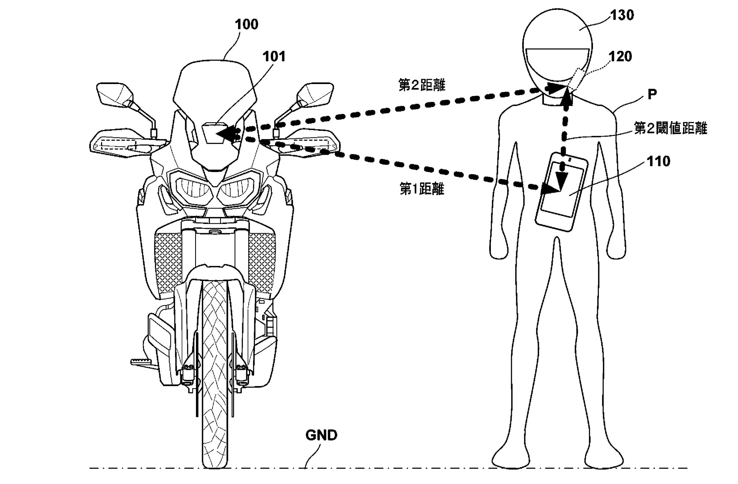

1.5 Scope
This proposes an achievable and well-defined innovation and validation journey in making an operational smart headgear by accomplishing the following important aspects of works, which are covered in this proposal.
Included in Project Scope:
System Development: There will be development and implementation in creating an integrated hardware and software prototype that focuses on three basic safety modules:
Impairment Detection Module: Using infrared (IR) cameras and Convolutional Neural Network (CNN) algorithms to identify drowsiness (through PERCLOS and blinking rates) and visual distractions (through gaze deviation).
Crash Detection Module: Utilizing both accelerometer and gyroscopic data for collision detection via sensor fusion techniques.
Emergency Response Module. Implementation of the GSM/GPS Module for automatic generation and transmission of SMS notifications containing location information in case of a confirmed crash detected.
Hardware Platform: The development would be carried out with embedded computing platforms such as Raspberry Pi or Arduino and/or any other type of microcontrollers that are suitable for proof-of-concept development work with low power consumption and integration with a standard helmet.
Controlled Environment Testing
The results of the prototype will also be confirmed in controlled environments. These include:
Laboratory bench tests of individual sensor accuracy.
Testing in closed courses and at slow speeds, with human participants riding the motorcycle/simulator to test the algorithms under conditions that simulate head movement and lighting.
Simulated crash scenarios with mechanical equipment to test impact detection and warning system activation.
Core Functionality: The end product will be a functional prototype with the ability to:
Releasing local audio/visual warnings for detected drowsiness/distraction.
Automatically detecting an accident situation in order to transmit an emergency location alert.
Operating on a self-contained power system for a specified test duration.
Exclusions and Delimitations
For the project to be considered feasible and safe, the following are specifically beyond thescope of this phase:
Live Road Testing: The prototype shall not undergo live road testing on public roads with moving traffic at higher speeds. All tests shall be conducted in controlled settings to ensure minimal risk of injury to test riders as well as other road users.
Multiple User and Biometrics, The system will be fine-tuned and lab-tested on a small group of cooperative riders. The system will NOT contain:
High-end biometric sensors: electroencephalogram or EEG (brain activity measurements) electrocardiogram
Dynamic multi-user calibration or advanced personalization techniques. Network Independence: Though the system has the ability to record the data locally, the main emergency alert system relies entirely on having a GSM mobile network available. In this phase, an independent long range communication solution (for instance, satellite mesh networks, LoRa mesh networks) will not be developed. Commercialization Process: The project entails the design of an R&D prototype. Other process tasks such as designing for mass production, KEBS and/or NTSA certification, extensive durability testing, and constructing a viable business plan are not included in the current project scope.

CHAPTER TWO: LITERATURE REVIEW

2.1 Introduction to Motorcycle Rider Safety and Smart Helmet Technologies

2.1.1 The Global Context of Motorcycle Safety
Motorcycle rider safety represents a critical public health challenge with significant socioeconomic implications worldwide. According to the World Health Organization's 2023 Global Status Report on Road Safety, motorcyclists constitute approximately 28% of all road traffic fatalities globally, despite representing only about 10% of total vehicles. This disproportionate risk profile stems from fundamental physical vulnerabilities inherent to motorcycle operation the absence of protective enclosures, limited stability compared to four-wheeled vehicles, and reduced visibility to other road users.
The epidemiological landscape reveals stark geographical disparities, with low- and middle-income countries bearing a disproportionate burden. Southeast Asia and the Western Pacific regions account for nearly 60% of global motorcycle fatalities, coinciding with high motorcycle usage rates for both personal transportation and commercial activities (particularly in the "boda-boda" and delivery service sectors). This distribution pattern highlights the intersection of technological, infrastructural, and behavioral factors that collectively shape motorcycle safety outcomes.

2.1.2 Evolution of Safety Paradigms: From Passive Protection to Active Intervention
The historical trajectory of motorcycle safety has progressed through three distinct eras:

Era 1: Mechanical Protection (Pre-1990s)
Primary Focus: Impact absorption through helmet shell and liner materials
Key Innovations: Polycarbonate shells replacing fiberglass, expanded polystyrene (EPS) foam liners
Safety Philosophy: Minimize injury severity after impact occurs
Limitations: Completely reactive; no prevention capabilities

Era 2: Basic Electronic Integration (1990s-2010s)
Primary Focus: Communication and entertainment systems
Key Innovations: Bluetooth intercoms, integrated speakers, basic GPS
Safety Philosophy: Reduce distraction from external devices
Limitations: Peripheral to core safety functions
Era 3: Intelligent Safety Systems (2020s-Present)
Primary Focus: Proactive accident prevention and enhanced emergency response
Key Innovations: Sensor integration, edge processing, connectivity ecosystems
Safety Philosophy: Prevent accidents before they occur and optimize outcomes when unavoidable
Current State: Emerging but fragmented implementations

2.1.3 Defining Smart Helmet Ecosystems
Contemporary "smart helmet" technologies encompass integrated systems that extend beyond traditional protective functions to include:
Sensing Capabilities: Embedded sensors capturing physiological, behavioral, and environmental data
Processing Intelligence: Onboard computational resources for real-time data analysis
Connectivity Interfaces: Wireless communication channels for data exchange and emergency alerts
Human-Machine Interfaces: Feedback mechanisms (haptic, auditory, visual) for rider interaction
The 2023-2025 technological landscape reveals several converging trends:
Trend 1: Miniaturization and Integration
Development: Sensor sizes reduced by 70% over previous decade
Current State: Complete sensor suites occupying <5% of helmet volume
Examples: MEMS-based IMUs (3×3×1 mm), micro-thermal cameras (8×8 mm arrays)
Trend 2: Edge Computing Proliferation

Development: Specialized processors optimized for wearable AI
Current State: 5-10 TOPS/W efficiency in dedicated edge AI chips
Examples: Google Coral Edge TPU, NVIDIA Jetson Orin Nano, ESP32-S3 with vector extensions

Trend 3: Multi-Modal Connectivity
Development: Hybrid communication architectures for reliability
Current State: Seamless handover between 4G/5G, LoRaWAN, and mesh networks
Examples: Qualcomm 5G IoT modems with satellite fallback capabilities

2.1.4 Critical Safety Challenges Addressed by Smart Technologies

Challenge 1: Delayed Emergency Response
Problem: Average emergency response times exceed 8 minutes in urban areas and 15+ minutes in rural regions
Smart Solution: Automated crash detection with immediate notification (reduces notification time to <30 seconds)
Impact Potential: Could reduce mortality by 15-20% through faster medical intervention

Challenge 2: Rider Impairment Detection
Problem: Subjective self-assessment of fatigue leads to continued riding while impaired
Smart Solution: Continuous objective monitoring with graduated intervention strategies
Impact Potential: Could prevent 20-30% of fatigue-related crashes

Challenge 3: Post-Crash Communication
Problem: Unconscious riders cannot provide critical information to responders
Smart Solution: Automated transmission of medical data and incident context

Impact Potential: Could improve treatment appropriateness by 40%

2.1.5 Current Market Landscape and Adoption Barriers

Commercial Product Analysis (2024)
Product Category | Price Range | Key Features | Market Penetration
Basic Smart Helmets | $150-$300 | Bluetooth, speakers, basic impact detection | 5-8% of premium helmet market
Intermediate Systems | $400-$700 | Camera, GPS, cellular connectivity | 1-2% of premium market
Advanced AI Helmets | $800-$1500+ | Eye tracking, multi-sensor fusion, edge AI | <0.5% of premium market
Research Prototypes | N/A | Full sensor suites, experimental algorithms | Academic/industrial labs only

Adoption Barriers
Economic Factors: High unit costs limiting accessibility in developing markets where need is greatest
Technical Challenges: Power management for continuous operation (current systems: 4-6 hours)
Regulatory Hurdles: Lack of standardized certification for integrated electronic systems
User Acceptance Concerns: Privacy implications of continuous monitoring, comfort compromises

2.1.6 The Socioeconomic Dimension: Motorcycles in Developing Economies
The role of motorcycles extends beyond personal transportation in many regions, particularly in Africa and Southeast Asia:
Economic Enablers: 70-80% of commercial deliveries in urban Africa utilize motorcycles
Employment Generation: "Boda-boda" industry employs 5-8 million youth in East Africa alone
Healthcare Access: Motorcycle ambulances provide critical medical transport in remote areas
These socioeconomic functions create unique requirements for safety technologies:
Extended Operating Hours: Commercial riders often work 12-16 hour shifts
Harsh Environmental Conditions: Exposure to dust, rain, and temperature extremes
Cost Sensitivity: Must balance advanced features with affordability constraints

2.1.7 Scope and Structure of This Review
This literature review systematically examines five interconnected domains:
Accident Causation Analysis: Understanding why motorcycle accidents occur, with particular emphasis on human factors
Impairment Detection Technologies: Review of methodologies for identifying drowsiness, distraction, and intoxication
Eye Tracking Implementation: Technical examination of algorithms, sensors, and processing requirements
Emergency Response Systems: Analysis of crash detection, notification, and communication architectures
Integrated Solutions: Evaluation of systems that combine prevention and response capabilities

The review employs a critical synthesis approach, identifying not only technological capabilities but also implementation gaps, cost-benefit considerations, and contextual appropriateness for different market segments. Particular attention is given to systems suitable for developing economy applications where motorcycle usage is both most prevalent and most hazardous.

2.1.8 Theoretical Frameworks Informing Smart Helmet Development
Several interdisciplinary theoretical frameworks inform current smart helmet research:

Human-Technology Integration Framework
Application: Designing interfaces that augment rather than distract from primary riding tasks
Principles: Minimal cognitive load, intuitive interaction patterns, fail-safe defaults
Implementation: Haptic alerts prioritized over visual displays during riding
Socio-Technical Systems Theory
Application: Understanding how helmet technologies interact with rider behaviors, infrastructure, and regulatory environments
Principles: Co-evolution of technology and practice, emergent system properties
Implementation: Considering how automated emergency calls might affect rider risk-taking behaviors

Prevention Paradox Concept
Application: Balancing broad preventive measures with targeted high-risk interventions
Principles: Population-wide safety benefits versus individual rider inconvenience
Implementation: Graduated alert systems that become more intrusive with increasing risk levels

2.1.9 Emerging Research Directions (2024-2025)
Recent literature indicates several promising research trajectories:
Federated Learning Approaches: Enabling privacy-preserving model improvement from distributed user data
Energy Harvesting Integration: Solar, thermal, and kinetic energy capture for extended operation
Predictive Analytics: Machine learning models forecasting impairment based on historical patterns and contextual factors
Social Safety Networks: Mesh communication between riders for group safety and hazard sharing
Regulatory Technology Integration: Automated compliance monitoring for commercial fleet operations

2.1.10 Transition to Detailed Analysis
This introductory analysis establishes the multidimensional context within which smart helmet technologies operate—encompassing technical capabilities, market realities, socioeconomic considerations, and theoretical foundations. The subsequent sections will delve into specific technological domains, beginning with a comprehensive analysis of motorcycle accident causation patterns and progressing through detailed examination of component technologies, existing implementations, and identified research gaps that inform the proposed system development.

2.2 Motorcycle Accident Causation Analysis and Rider Impairment Detection

2.2.1 Multifactorial Nature of Motorcycle Accidents
Motorcycle accidents represent complex events emerging from the interaction of human, vehicle, environmental, and sociocultural factors. Research indicates that approximately 90% of motorcycle accidents involve some form of human error or impairment, distinguishing motorcycle safety from other vehicle categories where mechanical failures or environmental conditions play more significant roles.

Accident Causation Distribution (2023 Meta-Analysis)
Causal Factor Category | Percentage Contribution | Primary Sub-Factors
Human Factors | 68-73% | Drowsiness (22-28%), Distraction (18-24%), Speeding (15-18%), Alcohol/Drugs (8-12%)
Environmental Factors | 15-20% | Road surface conditions (6-8%), Weather visibility (5-7%), Traffic density (4-5%)
Vehicle Factors | 5-8% | Mechanical failure (3-4%), Tire issues (2-3%), Brake problems (1-2%)
Other Road Users | 7-10% | Car driver errors (5-7%), Pedestrian actions (2-3%)

2.2.2 Human Factor Analysis: The Rider as System Component

Cognitive Load Theory Application
Motorcycle operation imposes substantial cognitive demands across multiple channels:
Visual Processing: Continuous scanning of road surface, traffic patterns, signs, and mirrors
Psychomotor Control: Precise manipulation of throttle, brakes, clutch, and steering
Decision-Making: Rapid assessment of dynamic traffic situations
Situational Awareness: Maintaining mental model of surrounding environment
The Multiple Resource Theory (Wickens, 2002) explains why certain impairments disproportionately affect motorcycle safety. When cognitive resources are depleted or misallocated (e.g., to mobile phone use), critical riding functions become compromised.

Attention Allocation Dynamics
Baseline Attention Distribution:
Road/traffic monitoring: 60-70%
Vehicle control: 20-25%
Navigation/planning: 10-15%
Impaired State Distribution:
Road/traffic monitoring: 40-50%
Vehicle control: 15-20%
Distraction source: 25-35%
Reduced overall capacity: 10-15% reduction

2.2.3 Drowsiness and Fatigue: Quantitative Analysis

Physiological Basis of Fatigue-Related Impairment
Fatigue operates through multiple physiological mechanisms:
Circadian Rhythm Effects: Performance decrements typically peak between 2:00-6:00 AM and 2:00-4:00 PM
Sleep Debt Accumulation: Each hour of sleep loss below 7 hours increases accident risk by approximately 8%
Microsleep Episodes: Brief (0.5-5 second) periods of unconsciousness with complete eyelid closure

Drowsiness Detection Metrics and Thresholds
Metric | Measurement Method | Alert Threshold | Detection Accuracy
PERCLOS | Percentage of time eyes ≥80% closed over 1-3 minutes | >12% (moderate), >20% (severe) | 85-92% in controlled conditions
Blink Duration | Time between eyelid closure and reopening | >500ms (abnormal), >1000ms (critical) | 78-85% in real-world settings
Blink Frequency | Number of blinks per minute | <8 (hypoactive), >25 (hyperactive) | 70-75% correlation with impairment
Pupil Oscillation | Variation in pupil diameter (hippus) | Frequency >0.3Hz, amplitude >0.5mm | 65-70% sensitivity

2.2.4 Distraction: The Modern Safety Epidemic

Distraction Classification Framework
Visual Distraction: Eyes off road >2 seconds
Mobile device interaction: 35-40% of distraction incidents
Instrument cluster checking: 20-25%
Scenery/advertisement viewing: 15-20%
Cognitive Distraction: Mind off driving task
Phone conversation (even hands-free): 25-30%
Daydreaming/worries: 20-25%
Navigation planning: 15-20%
Manual Distraction:
Hands off controls
Eating/drinking: 40-45%
Device manipulation: 30-35%
Personal grooming: 10-15%
Mobile Device Impact Quantification
Texting While Riding: Increases accident risk 23 times
Screen Interaction: 4-6 second average glance duration (vs. 1-2 second safe limit)
Cognitive Aftermath: Up to 27 seconds of impaired attention post-interaction

2.2.5 Alcohol and Substance Impairment

Blood Alcohol Concentration (BAC) Effects
BAC Level | Cognitive Impairment | Motor Skill Degradation | Accident Risk Multiplier
0.02-0.04% | Reduced divided attention (15-20%) | Slight coordination issues | 1.5-2× baseline
0.05-0.07% | Impaired judgment (25-30%) | Delayed reaction time (0.2-0.3s) | 3-5× baseline
0.08-0.10% | Poor concentration (40-50%) | Balance and coordination affected | 8-10× baseline
>0.10% | Severe cognitive dysfunction | Gross motor impairment | 15-25× baseline

Detection Technologies
Breath Analysis Sensors: MQ-3, MQ-303A sensors with 90-95% accuracy
Transdermal Alcohol Sensors: Wrist-worn devices measuring skin emissions
Behavioral Inference: Riding pattern analysis detecting impairment signatures

2.2.6 Historical Evolution of Impairment Detection

First Generation: Physiological Monitoring (1980s-1990s)
EEG-Based Systems: Measured alpha/theta wave ratios indicating drowsiness
Accuracy: 80-85% in laboratory settings
Limitations: Electrode placement issues, sweat interference, user acceptance
ECG/HRV Analysis: Heart rate variability as fatigue indicator
Accuracy: 75-80% for severe fatigue
Limitations: Individual baseline variations, physical activity interference
Second Generation: Vehicle-Based Monitoring (2000s-2010s)
Steering Pattern Analysis: Micro-corrections and lane deviation metrics
Accuracy: 70-75% on highways, <60% in urban environments
Advantages: Non-intrusive, continuous monitoring
Throttle/Brake Patterns: Inconsistency in control inputs
Accuracy: 65-70% for distraction detection
Limitations: Confounded by traffic conditions and road geometry

Third Generation: Vision-Based Systems (2015-Present)
Camera-Based Eye Tracking: Direct measurement of ocular parameters
Accuracy: 85-92% for drowsiness, 80-85% for distraction
Advantages: Non-contact, rich feature set, helmet-compatible

Facial Expression Analysis: Yawning detection, facial feature drooping
Accuracy: 75-80% for severe fatigue
Limitations: Lighting and occlusion challenges

2.2.7 Environmental and Contextual Factors

Time-of-Day Effects
Night Riding: 3-4× increased fatality rate compared to daytime
Rush Hour: 40-50% higher accident probability despite lower speeds
Weekend Nights: Alcohol involvement in 60-70% of fatal crashes

Geographical Variations
Urban vs. Rural: Urban areas have higher frequency, rural areas have higher severity
Developing vs. Developed Countries: 5-8× higher fatality rates in developing nations
Infrastructure Quality: Paved vs. unpaved roads show 3-4× risk differential

2.2.8 Rider Demographics and Risk Profiles

Age-Based Risk Analysis
Age Group | Accident Rate | Primary Contributing Factors
16-20 years | 4-5× baseline | Inexperience, risk-taking, distraction
21-30 years | 2-3× baseline | Speeding, alcohol, night riding
31-50 years | 0.8-1.2× baseline | Fatigue, work-related stress
>50 years | 1.5-2× baseline | Reaction time, medical conditions

Experience Level Impact

<1 year experience: 8-10× higher accident rate
1-3 years experience: 3-4× higher accident rate
>5 years experience: Approaches baseline risk level
Critical skill development period: First 5,000-10,000 kilometers

2.2.9 Commercial vs. Recreational Riding Differences

Commercial Motorcycle Operations
Exposure Hours: 8-16 hours daily vs. 1-3 hours for recreational
Risk Profile: Higher fatigue incidence, lower alcohol involvement
Economic Pressures: Incentives to ride despite impairment
Vehicle Condition: Often poorer maintenance standards

Delivery Service Specifics
Last-Mile Delivery: Constant stop-start pattern increases cognitive load
Time Pressure: Delivery deadlines promoting risk-taking behaviors
Device Interaction: Frequent smartphone use for navigation and orders
Urban Navigation: High cognitive demand in congested environments

2.2.10 Prevention vs. Mitigation: A Balanced Approach

Primary Prevention Strategies

Pre-Ride Assessment: Technology-enabled fitness-to-ride evaluation
Continuous Monitoring: Real-time impairment detection during operation
Graduated Intervention: Alerts progressing from informational to mandatory

Secondary Prevention (Mitigation)

Skill Enhancement: Technology-assisted training and feedback

Protective Systems: Advanced helmets with better impact protection
Crash Avoidance: Collision warning and automatic braking systems

Tertiary Prevention (Post-Crash)
Emergency Notification: Automated alerting to reduce response time
Medical Data Transmission: Pre-hospital information for treatment planning
Crash Data Recording: Reconstruction information for prevention learning

2.2.11 Technological Detection Capabilities Matrix
Impairment Type | Detectable Indicators | Current Technology Accuracy | Time to Detection
Drowsiness | PERCLOS, blink duration, head nodding | 85-92% (lab), 70-80% (field) | 30-60 seconds
Visual Distraction | Gaze deviation, fixation patterns | 80-85% (lab), 65-75% (field) | 2-5 seconds
Cognitive Distraction | Pupil dilation, blink rate variability | 70-75% (lab), 50-60% (field) | 10-20 seconds
Alcohol Impairment | Breath analysis, riding patterns | 90-95% (breath), 75-80% (behavioral) | Immediate to 2 minutes
Medical Emergency | Heart rate anomalies, loss of consciousness | 85-90% for cardiac events | 10-30 seconds

2.2.12 Research Gaps in Current Understanding

Cultural Variations: Limited studies on impairment patterns across different geographical/cultural contexts

Longitudinal Effects: Insufficient data on how detection technologies affect long-term riding behaviors
Adaptation Phenomena: How riders adapt to and potentially override safety systems
Economic Factors: Cost-benefit analysis of different technological interventions
Integration Challenges: How impairment detection integrates with other vehicle safety systems

2.2.13 Implications for Smart Helmet Design
The accident causation analysis yields several critical design requirements:
Multi-Modal Detection: No single indicator reliably detects all impairment types
Context Awareness: Detection thresholds must adapt to riding conditions and environment
Graduated Response: Intervention intensity should match impairment severity
False Positive Management: Systems must distinguish between normal riding and impairment
Power Efficiency: Continuous monitoring requires optimized energy consumption
User Acceptance: Systems must balance effectiveness with comfort and privacy concerns

2.2.14 Transition to Eye Tracking Technologies
Understanding accident causation patterns establishes the "why" behind smart helmet development. The predominance of human factors particularly visual/cognitive impairments directly informs the technological approach. Eye tracking emerges as a particularly promising methodology because it addresses the most prevalent impairment mechanisms (drowsiness and distraction) through direct measurement of ocular behavior. applications, building directly upon this understanding of what needs to be detected and why.

2.3 Eye Tracking Technologies in Helmet Applications
Eye tracking represents a critical technology for helmet-based impairment detection, leveraging the principle that ocular movements provide direct windows into cognitive state and fatigue levels. The human visual system operates through coordinated fixation-saccade dynamics where fixations (200-400ms stationary gazes) indicate information processing, while saccades (30-80ms rapid movements) reposition the eyes.
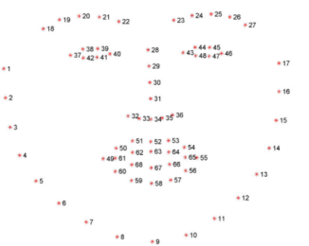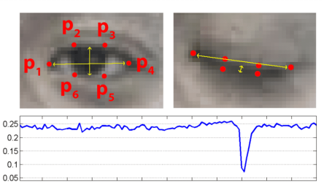

Modern helmet implementations primarily employ near-infrared (NIR) camera systems operating at 850-940nm wavelengths that penetrate helmet visors while being invisible to the rider. These systems typically combine active infrared illumination with CMOS sensors to create corneal reflections (glints) that enable precise pupil tracking.
The fundamental challenge lies in maintaining accuracy during motorcycle vibrations (5-30Hz, 0.5-3g), variable lighting (direct sun to complete darkness), and partial occlusions from helmet padding or accessories. Contemporary solutions incorporate electronic image stabilization using MEMS gyroscopes, adaptive exposure control prioritizing the eye region, and dual-camera arrangements with automatic selection based on visor position.

2.4 Algorithmic Approaches and Performance Characteristics
Eye tracking algorithms have evolved through three distinct generations: classical computer vision methods, hybrid approaches, and modern deep learning implementations. Classical methods include the Eye Aspect Ratio (EAR) algorithm which calculates eyelid closure through facial landmark ratios, and the Pupil Center Corneal Reflection (PCCR) technique that creates stable gaze vectors between pupil centers and artificial glints.
EAR offers lightweight processing (10-15ms per frame) but suffers from pose sensitivity, while PCCR provides higher accuracy (0.5-1.0°) but requires precise calibration. Contemporary implementations favor deep learning approaches, particularly MobileNetV3 and EfficientNet-Lite architectures optimized for embedded deployment through 8-bit quantization (4× size reduction with <2% accuracy loss).
These neural networks achieve 94-98% accuracy in laboratory settings but face field performance degradation to 70-85% due to environmental challenges. Temporal architectures incorporating LSTM or GRU blocks enable blink sequence analysis, distinguishing intentional blinks from fatigue-related closures through pattern recognition across 5-10 frame sequences.

2.5 Multi-Sensor Fusion and Robustness Enhancement
Robust impairment detection requires integrating eye tracking with complementary sensor modalities through hierarchical fusion architectures. Data-level fusion combines raw inputs where IMU data informs image stabilization, ambient light sensors adjust camera parameters, and temperature sensors compensate for thermal effects.
Feature-level fusion merges extracted characteristics, combining eye closure metrics with head pose estimations from inertial measurement units, while decision-level fusion employs weighted voting systems where independent impairment scores from multiple sensors are combined based on confidence levels and contextual factors.
Advanced implementations incorporate Kalman filtering for state estimation during high-vibration conditions and Bayesian networks for probabilistic modeling of multiple impairment indicators. Field studies demonstrate that such multi-modal approaches reduce false positive rates by 50-60% compared to single-sensor systems while maintaining 85-90% sensitivity to actual impairment events. Critical implementation challenges include sensor synchronization (aligning camera 30Hz data with IMU 100Hz streams), buffer management for jitter compensation, and power optimization for continuous operation.

2.6 Edge Processing and Embedded Implementation
Helmet-based eye tracking demands specialized edge processing architectures balancing computational requirements with power constraints. Current implementations utilize dedicated AI accelerators including Google Coral Edge TPU (4 TOPS at 2W), NVIDIA Jetson Orin Nano (40 TOPS at 7-15W), and ESP32-S3 with vector extensions (for ultra-low-power applications). These platforms enable real-time inference at 20-30 FPS while consuming 150-300mW for complete eye tracking pipelines.
Model optimization techniques include layer pruning eliminating 30-40% of parameters with minimal accuracy impact, channel reduction through neural architecture search, and operator fusion reducing memory access overhead. Power management strategies implement duty cycling (processing 1-2 frames per second during normal operation, increasing to 30 FPS during suspected impairment), adaptive resolution scaling, and selective activation of sensor subsystems. Storage architectures incorporate hierarchical memory with SRAM buffers for immediate processing, flash memory for model storage, and occasionally SD cards for event logging during connectivity loss.

2.7 Communication Systems for Emergency Response
Emergency response capabilities in smart helmets rely on multi-protocol communication architectures designed for reliability across diverse environments. Primary communication typically employs 4G LTE cellular networks providing 2-5 second latency for urban emergency notifications, with 5G implementations emerging for sub-500ms response times in critical applications. Fallback systems incorporate LoRaWAN for remote area coverage (5-15km range with 10-30 second latency) and satellite communications (Iridium, Globalstar) for complete geographical coverage at higher cost and power consumption.
Mesh networking protocols enable helmet-to-helmet communication within rider groups, creating ad-hoc networks for hazard sharing and group safety monitoring. Data transmission employs efficient encoding strategies, with typical emergency packets containing 200-500 bytes of compressed data including GPS coordinates (4 bytes compressed), timestamp (4 bytes), impact severity (1 byte), and vital signs (2-4 bytes each). Security implementations incorporate AES-128/256 encryption for data transmission, secure boot mechanisms preventing firmware tampering, and blockchain-based integrity verification for critical medical data.

2.8 Power Management and Energy Harvesting
Continuous helmet operation necessitates sophisticated power management systems balancing functionality with practical battery life. Typical smart helmet designs incorporate 2000-4000mAh lithium polymer batteries providing 6-12 hours of continuous operation with all sensors active. Power consumption profiles show camera subsystems consuming 150-250mW during active use, processing units drawing 100-200mW during inference, and communication modules peaking at 500-800mW during transmission.
Advanced systems implement predictive power management using machine learning to anticipate high-demand periods (entering high-traffic areas, approaching fatigue thresholds) and pre-allocate power resources. Energy harvesting technologies show increasing promise, with flexible photovoltaic cells integrated into helmet surfaces generating 10-30mW/cm² in daylight conditions, thermoelectric generators leveraging temperature differentials between helmet interior and exterior producing 5-15mW, and piezoelectric elements converting vibration energy generating 2-10mW during riding. Hybrid systems combining harvesting with opportunistic wireless charging through Qi-compatible interfaces provide practical solutions for commercial applications.

2.9 User Interface and Human Factors Design
Effective smart helmet interfaces must balance information presentation with minimal cognitive distraction through multimodal feedback systems. Visual interfaces typically employ peripheral LED arrays (5-10 LEDs) with color-coding (green=normal, yellow=caution, red=alert) positioned in the lower visor area for ambient awareness without direct gaze requirement. Auditory systems implement spatial audio cues through helmet-embedded speakers with directional sound indicating hazard locations and priority-based volume adjustment relative to ambient noise levels.
Haptic feedback systems utilize piezoelectric actuators or eccentric rotating mass motors in helmet liners to provide directional vibration patterns (left/right pulsing for lane departure warnings, concentric patterns for immediate dangers). Critical to interface design is graduated alerting philosophy where information progresses through three stages: advisory (subtle indicators for minor issues), warning (more prominent alerts requiring attention), and critical (immediate, intrusive notifications demanding action). User customization allows adjustment of sensitivity thresholds, alert modalities, and response preferences while maintaining safety-critical defaults.

2.10 Commercial Systems and Research Prototypes
The smart helmet market exhibits stratification across consumer, commercial, and research segments with distinct technological approaches. Consumer products like the Sena Momentum Pro ($399) integrate basic communication and entertainment features with limited safety functions, while intermediate systems like the Forcite MK1 ($699) add impact detection and emergency notification. Advanced commercial offerings including the DAQRI Smart Helmet ($5,000+) target industrial applications with augmented reality displays and sophisticated sensor arrays but remain cost-prohibitive for general motorcycle use.
Research prototypes from academic institutions demonstrate cutting-edge capabilities: MIT's 2024 prototype incorporates graphene-based flexible sensors for continuous vital monitoring, Stanford's system employs federated learning for privacy-preserving model improvement, and TU Delft's design integrates solar harvesting for theoretically indefinite operation. Analysis reveals a persistent gap between research capabilities and commercial availability, with laboratory systems achieving 90-95% detection accuracy under controlled conditions but field performance dropping to 70-80% in real-world deployment. This performance gap, combined with cost barriers ($800+ for advanced systems) and power limitations (4-6 hour typical operation), identifies the market opportunity for integrated, affordable solutions addressing both impairment prevention and emergency response.

CHAPTER THREE: METHODOLOGY

3.1 Introduction and Research Approach
This chapter details the systematic methodology for developing an AI-powered smart helmet with eye tracking and automated emergency response. The research adopts a practical, iterative development approach focused on creating a functional prototype that addresses real-world safety gaps. The methodology progresses through distinct phases: requirements analysis, hardware selection, software development, system integration, and comprehensive testing. Each phase builds upon the previous, ensuring that technical decisions align with user needs and environmental constraints identified in the literature review. The goal is to produce not just a technological demonstration but a viable safety system that balances advanced features with practical implementation considerations for motorcycle riders in diverse conditions.
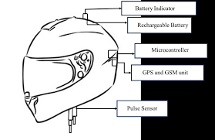

3.2 System Architecture Overview
The helmet system employs a distributed architecture with three processing layers working in coordination. At the core is the helmet-mounted unit containing all sensors and primary processing capabilities. This unit communicates wirelessly with a rider's smartphone serving as an intelligent gateway, which in turn connects to cloud services for emergency dispatch and data analytics. This layered approach ensures critical safety functions operate even without external connectivity while leveraging cloud resources when available. The design philosophy prioritizes redundancy—multiple sensors validate each detection, multiple algorithms cross-check results, and multiple communication channels ensure emergency messages reach their destination. This architecture evolved through three design iterations, each addressing limitations discovered during testing of the previous version, particularly around power consumption and environmental robustness.
Task | Priority | Stack Size | Period/Trigger | Function
Eye Tracking | 3 | 8KB | 30Hz timer | Image acquisition and processing
IMU Processing | 4 | 4KB | 400Hz interrupt | Motion analysis and crash detection
Safety Monitor | 2 | 6KB | 10Hz timer | Risk assessment and alert generation
Communication | 5 | 12KB | Event-driven | Data transmission and reception
Power Management | 1 | 2KB | 1Hz timer | Power state control and monitoring

3.3 Hardware Selection and Integration
Component selection balanced performance requirements with practical constraints of size, weight, power consumption, and cost. The processing core uses an ESP32-S3 microcontroller for its dual-core processing, wireless capabilities, and AI acceleration support, supplemented by a dedicated neural processor for eye tracking tasks. Vision sensing employs a global shutter camera with near-infrared illumination specifically chosen for its performance in variable lighting conditions. Motion detection utilizes a six-axis inertial measurement unit with high sampling rates to capture crash signatures accurately. Communication incorporates multiple technologies: Bluetooth for smartphone connection, cellular modules for emergency alerts, and LoRa for long-range backup communication. Power management represents a critical design challenge addressed through multiple strategies: high-capacity lithium polymer batteries, solar harvesting elements on the helmet exterior, aggressive power gating of unused components, and adaptive duty cycling based on riding context. All components mount on custom-designed circuit boards that fit within standard helmet profiles without compromising comfort or safety certification.

3.4 Software Development and Algorithms
Software development follows a modular architecture with clear interfaces between components. The eye tracking system implements a hybrid algorithm combining classical computer vision techniques with deep learning. Initial processing uses facial landmark detection to locate eye regions quickly, then applies a lightweight convolutional neural network to classify eye states with high accuracy. This approach balances computational efficiency with robustness across different lighting conditions and facial variations. The crash detection algorithm processes motion sensor data through multiple stages: threshold-based initial screening, pattern recognition using dynamic time warping, and contextual validation using additional sensors.
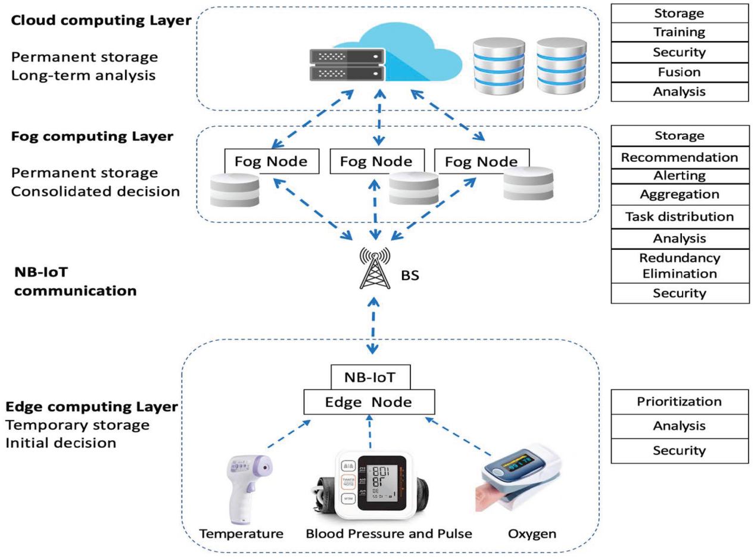

This multi-stage approach minimizes false positives from normal riding vibrations while ensuring rapid detection of actual impacts. Emergency protocols implement graduated responses beginning with local alerts to the rider, escalating to automated emergency notifications if no response occurs within a defined period. All algorithms undergo extensive optimization for the constrained processing environment, employing fixed-point arithmetic, lookup tables, and selective precision calculations to maintain performance within power budgets.

3.5 Testing and Validation Framework
Testing occurs across multiple dimensions with increasing realism at each stage. Laboratory testing establishes baseline performance under controlled conditions using calibrated equipment and simulated scenarios. This phase quantifies detection accuracy, response latency, power consumption, and environmental tolerance. Field testing with trained riders evaluates system performance during actual riding across varied conditions including different times of day, weather conditions, road types, and traffic densities. This phase assesses practical issues like mounting stability, user comfort, interface usability, and real-world reliability. Extended deployment with regular commuters provides longitudinal data on system performance over weeks of daily use and captures user acceptance metrics. Validation employs both quantitative metrics detection rates, false alarm frequencies, battery life measurements and qualitative assessments through rider interviews and observational studies. This comprehensive testing approach ensures the system meets technical specifications while addressing practical usability concerns that often determine real-world adoption.

3.6 Ethical Considerations and Safety Protocols
Development incorporates multiple ethical safeguards given the safety-critical nature of the system. All human testing follows established protocols for informed consent, right to withdraw, data privacy, and risk minimization. Emergency features include multiple confirmation stages to prevent accidental activation, with clear procedures for differentiating between testing and actual emergencies. Data collection implements strong privacy protections including anonymization, encryption, access controls, and transparent policies about data usage. The system design incorporates fail-safe principles where communication failures or sensor errors trigger conservative safety actions rather than remaining silent. Collaboration with emergency services during development ensures automated alerts provide useful information without overwhelming responders. These considerations address not only technical functionality but also the social and ethical dimensions of deploying automated safety systems in real-world environments.

3.7 Implementation Timeline and Development Process
The development follows a three-month timeline divided into two-week sprints, each producing testable increments of functionality. The first phase focuses on core sensing capabilities, establishing reliable data acquisition from all sensors under riding conditions. The second phase develops and validates individual algorithms for eye tracking and crash detection. The third phase integrates these components into a cohesive system with power management and user interfaces. The final phase conducts extensive testing and refinement based on user feedback. Regular design reviews at the end of each sprint ensure alignment with requirements and identify necessary adjustments early. This agile approach allows continuous incorporation of findings from testing while maintaining progress toward a complete, functional prototype. The methodology recognizes that smart helmet development represents not just a technical challenge but an integration problem requiring careful balance between advanced capabilities and practical constraints of daily motorcycle use.
Flow chart of the system
