
MERU UNIVERSITY OF SCIENCE AND TECHNOLOGY School of Engineering and Architecture (SEA)
Project Title: Design and Implementation of a Prototype Laser-Based Perimeter Intrusion Detection System for Critical Infrastructure
Student’s Name: Ngunjiri Haron Kimani
Reg. No.: EG209/109697/22
A proposal submitted in partial fulfillment for the award of the Degree of Bachelor of Technology in Electrical and Electronics Engineering in the Department of Electrical and Electronics Engineering in MUST.
Department: Department of Electrical and Electronics Engineering
Date: December 2025

Declaration
Declaration by the Student
I declare that this project proposal is my original work and has not been presented for the award of a degree in any other university.
Signature: ............................................................. Date: ........................................ Name: Ngunjiri Haron Kimani Reg. No.: EG209/109697/22
Declaration by the Supervisor
This proposal has been submitted for examination with my approval as the University Supervisor.
Recommendation: Recommended for submission as satisfying the proposal requirements.
Signature: ............................................................. Date: ........................................ Supervisor: Mr job Kerosi
Department of Electrical and Electronics Engineering
Meru University of Science and Technology

Abstract
Perimeter intrusion remains a critical security challenge for infrastructure, residential, and agricultural facilities, with conventional systems suffering high false alarms and environmental limitations. This proposal presents the design and implementation of a prototype laser-based detection system utilizing beam interruption principles for reliable, cost-effective protection.
The main objective is to develop and validate a functional prototype covering a 10-meter perimeter with multi-zone monitoring. Specific objectives include optical subsystem design with Class 1M lasers, signal processing for false alarm reduction, embedded control integration, and performance evaluation against PIR benchmarks.
Methodology employs experimental prototyping with Arduino/Raspberry Pi platforms, custom optics, and adaptive algorithms. Expected outcomes: >92% detection probability, <5% false alarms, complete prototype under KES 25,000, and documentation for local adaptation. The project advances optoelectronics and embedded systems while addressing Kenya's security needs.

CHAPTER ONE: INTRODUCTION

1.1 Background of the Study
Human-wildlife conflict is a critical issue in Kenya's agricultural sector, where crop raiding by animals such as elephants, monkeys, bush pigs, and antelopes causes devastating economic losses for smallholder farmers.
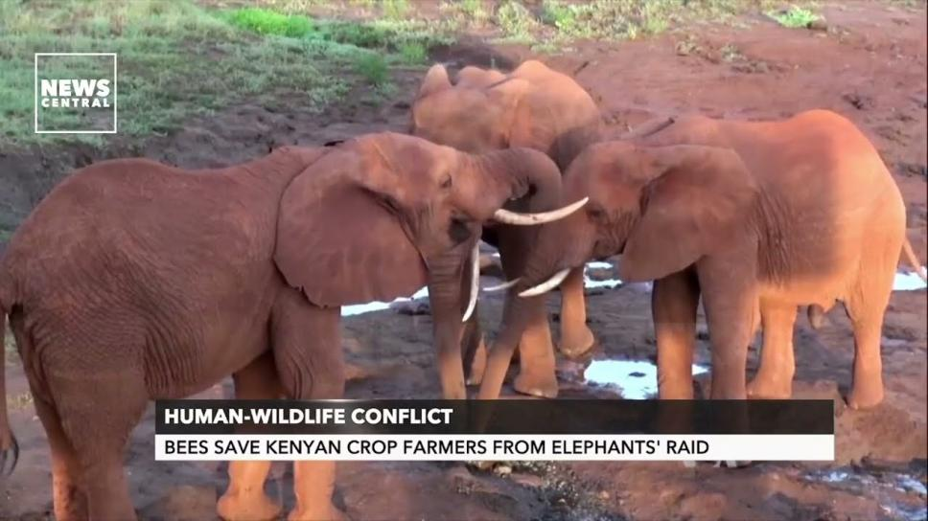

Recent assessments (2024-2025) indicate that wildlife damage accounts for 20-50% of crop losses in conflict zones, intensifying food insecurity, poverty, and retaliatory actions against animals.
Traditional barriers like electric fences or trenches are expensive, maintenance-intensive, and often ineffective against determined raiders, while non-lethal methods (chili repellents, beehives) require ongoing effort and allow habituation.
Virtual fencing technologies create an "invisible perimeter" through detection and conditioned deterrence, psychologically establishing a boundary illusion without physical structures.
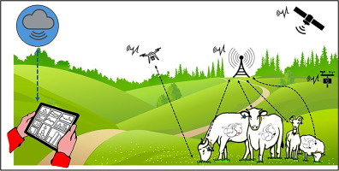
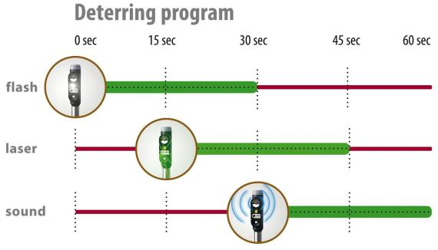
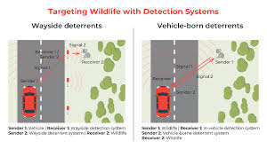
Laser-based variants use beam interruption to trigger aversive stimuli (sounds, lights), achieving high efficacy in global trials.
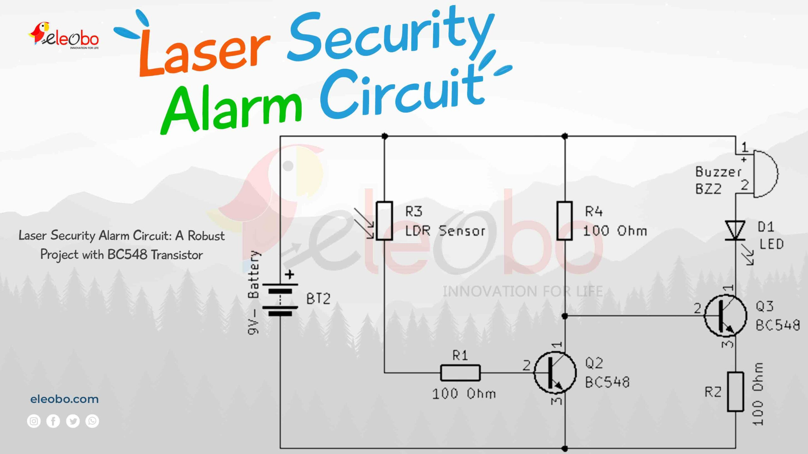

1.2 Problem Statement

Wildlife attacks on crops have reached the level of a systemic crisis in the agricultural border areas of Kenya, causing crippling costs, increased human-wildlife conflict, and compromised food security in Kenya. Smallholder and commercial farmers living around wildlife corridors, reserves, and natural forest areas are suffering disastrous and repeated losses of their crops, with losses consistently reported in excess of 30-50% of annual harvests of high-value crops such as maize, potatoes, and fruits. This immediate damage not only affects household incomes but also sustains cycles of rural poverty, food insecurity, and indebtedness, which compels farmers to quit their farms or engage in revenge attacks on protected wildlife.

The ineffectiveness of traditional abatement measures highlights a glaring technologcial and socioeconomical divide:

Physical Barriers Are Costly and Environmentally Unviable: The cost associated with conventional physical barriers, whether electric, wire, or living thorn, is astronomical (in excess of KES 500,000 per kilometer of fencing) and is therefore unviable for most small-scale farmers. Furthermore, these fences can easily be scaled by elephants, buffaloes, and monkeys, creating paths for the two larger species and compartmentalizing the environment for the primates.

Passive and Traditional Repellents Suffer from Rapid Habituation: Repellents based on noise-making, chili-based products, fire, or live guard animals have merely a temporary psychological effect. Any astute wild animal, including primates or elephants, quickly learns that the perception-created deterrent does not have any realistic possibility of causing harm. Their practicality is also hampered by their labor intensity and the need for human surveillance.

Current Electronic Solutions Are Technologically Downscaled: The problem with the available "smart" deterrence technology, in the form of motion-activated lights/sound alarms, is the high false alarm rate due to the effects of wind, foliage, or domestic animals. The effect of this technology diminishes the confidence of the end-users. Most importantly, these devices are not optimized for rugged Kenyan environments. They fail in the rain, in dust storms, in high temperatures, as well as in areas of unstable power supplies. The import costs of this technology are further a hindrance in making it mainstream in the affected regions.

Such a combination of failures has resulted in a precarious gap in the market that calls for an affordable and smartly automatized and physiologically convincing virtual perimeter solution that is pro- active in the prevention of incursion rather than merely reporting incidents of damage. Such an impasse spawns a vicious cycle in which the lack of crops reinforces poverty in the community, which in turn reinforces resentment that is expressed in the poisoning, snaring, or shooting of encountered wildlife that can be classified under endangered species. Hence, this particular project aims at filling this vast gap by designing and optimizing a new, laser-based auto virtual fencing system. This particular project utilizes computer vision and motion sensors with great accuracy to facilitate intrusion detection, along with high visibility low power laser projection technology to instantly generate the illusion of an impenetrable barrier across the open landscape with great ease. By providing an effective, lethal, yet non-invasive deterrent as an automatic 24/7 system with great potential, this system seeks to significantly reduce actual physical loss, together with the overall economic toll on farmers, lethal human-wildlife conflict, as well as contribute toward an effective model of coexistence with agriculture. All of this is done with great focus placed on overall efficiency, environmental robustness, as well as cost-effectiveness with great ease.

1.3 Objectives

1.3.1 Main Objective
To design, implement, and evaluate a prototype laser-based virtual perimeter system for detecting and deterring animal intrusions in agricultural settings.

1.3.2 Specific Objectives
The project objectives are expressed in carefully articulated, quantifiable technical requirements that have an obvious direct relationship with solutions to the examined shortcomings of existing wild animal deterrent systems. The project goals are presented in a sequential format, from basic detection to system verification.

ToDesign and Implement a Robust Optical Perimeter Detection System

This objective aims to create an effective primary detection subsystem by designing a Class 1M (eye safe) laser beam network which has the ability to monitor a continuous perimeter of 10–20 meters. This subsystem will ensure its precision achieves a sampling interval of the beam interruption relevant for real-time detection of an intrusion, assuming a nominal false-negative rate of less than 5% for a target of the size of an animal.

To Development and Deployment of Adaptive Environment Signal Processing

This objective focuses on the design and development of firmware algorithms to real-time analyze data generated by sensors. The major task is to filter noise generated by the environment, such as swaying vegetation, rain, or birds, and correctly categorize data generated by animal intrusion events. The process will utilize variables such as the length of an interruption, data pattern, and a series of trigger events to achieve a system-wide false-positive alarm rate below 10%.

To incorporate the multi-modal, non-habituating active deterrent mechanism
This objective will cover the design and assembly of the programmable, multi-layered repulsion system that will turn on after a confirmed break-in. This system will integrate the use of both auditory (above 100 dB siren), visual (high-intensity strobe lights), and ultrasonic (frequency: 20-40 kHz) elements that will turn on randomly or progressively. This will ensure that the species will not habituate to the activation or the signals that the system sends out. Objective 4
Engineer a self-contained solar power system architecture capable of remote connectivity. This objective involves prototyping a self-reliant unit that is fueled by a photovoltaic panel and a rechargeable battery pack that would allow it to run for a minimum of 72 hours continuously without the direct use of sunlight. The operations of the self-reliant unit are coordinated by a low-power microcontroller (such as ESP32 models). The self-reliant unit also has an optional GSM and/or LoRa communication module

Quantitatively Validate System Efficacy and Operationiability
This objective outlines the plan for controlled field testing of the integrated prototype for performance on key parameters. The key success indicator will be to attain an effective repulsion rate above 90% in initial animal encounter situations within the protected boundary. The secondary validation of the system will look at its robustness, autonomy, and continued efficacy for a period of at least 30 days to determine if habituation is avoided.

1. Detection Subsystem Development

To create, erect, and fine-tune an optical detection system. It will include the use of an eye-safe Class 1M laser to transmit an invisible beam of light that spans the 10-20 meter test range. The fundamental goal of the design will be to provide an adequate rate of beam interruptions to detect an intruder and effectively distinguish between a genuine crossing of the beam by the animal and natural factors such as rainfall or falling leaves.

2. Signal Processing and Discrimination

To design and develop adaptive and real-time signal processing algorithms for an embedded microcontroller. The aim is to filter unwanted noise from the environment, such as that caused by wind-disturbed grass or light rainfall, and detect true breaks in the laser beams produced by animal-level intruders. The algorithms will be based upon factors such as the intensity and duration of the breaks.

Integration of Active, Multi-Modal To provide an integrated, multi-sensory repellent system that turns on immediately after confirmation of intrusion. The intended goal is to provide a combination of auditory signals (sirens), visual signals (intense strobe lights), and/or ultrasonic repellents to be dispersed in a random or progressive pattern to prevent the development of habituation and to maximize aversive conditioning against a variety of wildlife, including primates and ungulates. . Self-Sustaining System To design a comprehensive & self-sufficient system architecture, which relies on a solar-recharged battery pack for continuous, independent running. This system would be controlled by a low-energy microcontroller, which would oversee detection, processing, as well as actuation. Additionally, an external GSM component can be incorporated to support sending remote alerts of system statuses (such as low battery & intruder events) to a farmer using an SMS-enabled cell phone. Performance Validation and Efficacy Assessment To critically assess the integrated prototype via controlled field tests in a simulated or real-world farm edge setting. The basic operational requirement will be to ensure an effective repellency rate of over 90% against the target wildlife species during the first encounter, and a secondary requirement will be to assess its long-term effectiveness to verify resistance to habituation.

1.4 Justification and Significance

The rationale behind this project lies in its targeted intervention at the point of convergence between food security, wildlife, and technology. The project has a multi-dimensional significance as it relates to several needs, both practical as well as academic.

A. Socio-Economic & Food Security Rationale

Crop raiding represents a clear and imminent threat to the livelihood of the rural poor as well as national food security. For the small-scale farmers in particular, the damage in the form of 30-50 percent of the average yearly harvest could threaten the viability of the farming enterprise as a whole. The proffered invention finds rationale in the possible provision of a cost-effective means of defending oneself. At a target cost of 20,000-30,000 KES, it represents a one-time investment within the budget of the average farming community, both in terms of farmers who could afford it as a one-time expense as well as in relation to the catastrophic qualities of recurring damage wrought through the destruction of the average harvest. The invention could potentially stabilize this damage within 40-70 percent of the average amount.

B. Conservation and Human-Wildlife Coexistence Significance

The rise of human-wildlife conflict poses a double risk to the safety and livelihoods of people as well as the survival of the wildlife species that are often retaliated against. This project presents a humane and non-lethal method of protection that aims to pre-empt the occurrence of this conflict. By setting up a virtual perimeter, it safeguards agricultural products without killing wildlife, therefore indirectly working to eliminate the motivation that drives people to kill wildlife as a way of retaliating against the damage. The project compliments the national goals of the Kenyan state regarding the coexistence of wildlife as well as the protection of biodiversity. C. Technological and Practical Innovation Significance

The innovations The existing solutions range from ineffective, old technologies to expensive imported high-tech solutions, which are not suitable for a Kenyan setting. This project is important because it follows the model of appropriate technology. The proposed technology will be off-grid, utilizing solar power and durables that can work well in the dusty, rainy, and temperature fluctuations of a Kenyan environment. By utilizing locally sourced materials and modular designs that are easily repairable, it promotes local technical development. The solution fills a market gap with respect to an intelligent, autonomous, and context-specific agricultural defense mechanism that goes beyond a scare tactic solution. D. Academic and Interdisciplinary Contribution From an academic perspective, the significance of this project stems from its ability to effectively apply principles of engineering to address the pressing need for socio-ecological solutions. The said undertaking essentially incorporates optoelectronics (laser sensing), programming for embedded systems (microcontroller logic programming), and dynamic signal processing to develop an operative field device. Essentially, its development can help inform knowledge regarding the designing of low-power systems, sensor fusion for environmental sensing, and user-centered design for the adopting of rural technology. Specifically, the undertaking can play an extremely significant role in the creation of knowledge regarding the impact and efficiency of the deterrent, apart from information regarding animal behavior.

1.5 Scope and Limitations
This project is scoped to develop a functional proof-of-concept prototype for an automated virtual fencing system designed to protect open-field perimeters of 10–20 meters by detecting and actively deterring medium-to-large crop-raiding animals. The scope encompasses the integration of a Class 1M eye-safe laser detection subsystem, a microcontroller-driven unit that processes intrusions and triggers a multi-modal deterrent (strobe, siren, ultrasonic), and a solar-powered energy system for off-grid operation.
Validation will proceed through controlled simulation followed by a limited field trial to assess real-world performance. The project is bounded by several key limitations. Environmental factors, such as dense fog or dust, may impair the optical detection system, a challenge partially mitigated through signal modulation techniques. Functionally, the prototype detects intrusions based on target size and does not include species-specific classification.
For ethical and practical reasons, initial deterrent efficacy testing will prioritize simulations and controlled exposures, avoiding unmanaged stress on wildlife, and all lasers will adhere to the eye-safe Class 1M standard. Finally, the work is constrained by a defined budget and timeline, focusing on prototype demonstration rather than commercial-scale production or certification.

CHAPTER TWO: LITERATURE REVIEW

2.1 Evolution of Wildlife Conflict Mitigation Strategies
Mitigation of human-wildlife conflict has evolved from passive physical barriers to active, technology-enhanced non-lethal systems.
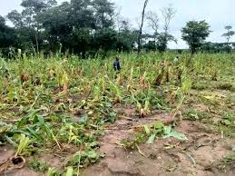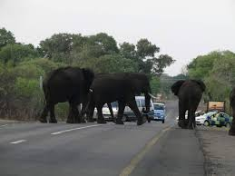

Early approaches in Kenya focused on electric fencing and trenches, offering 60-80% efficacy against large animals but requiring high capital (~KES 100,000/km) and frequent repairs due to damage or vegetation overgrowth. Community-based methods like beehive fences (70-80% elephant deterrence) and chili repellents gained traction but demand ongoing maintenance and lose impact through habituation.
Recent advancements (2023-2025) emphasize virtual systems using sensors for detection and conditioned repellents, minimizing environmental footprint while promoting coexistence.

2.2 Extent and Impacts of Crop Raiding in Kenya
Crop raiding dominates human-wildlife conflicts in Kenya, comprising 50-73% of reported incidents. Elephants account for 40-50% of cases, followed by primates (10-20%) and ungulates. National data (2001-2017) records over 43,000 conflicts, with seasonal peaks during crop maturation (wet season). In regions like Narok, Taita Taveta, and Laikipia, losses reach 20-70% of yields, translating to billions in economic damage annually. Indirect effects include food insecurity, trauma, and retaliatory killings (100+ human deaths/decade).
Droughts exacerbate incursions as animals seek farm water/crops, with 2022-2023 events doubling raids in some areas.

2.3 Virtual Fencing Technologies
Virtual fencing creates psychological barriers via detection-triggered aversive stimuli.
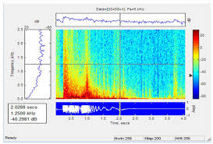

GPS-collar variants (e.g., Nofence) excel for livestock management but require animal capture, unsuitable for wild species. Perimeter systems use beams or sensors for broader application.
IR-based prototypes trigger alarms/lights but generate false positives from wind/vegetation. Laser alternatives provide narrower, longer-range beams with modulation for weather resilience.

2.4 Laser-Based Detection and Virtual Systems
Laser beam interruption systems employ Class 1M diodes and photodetectors for precise, invisible perimeters.
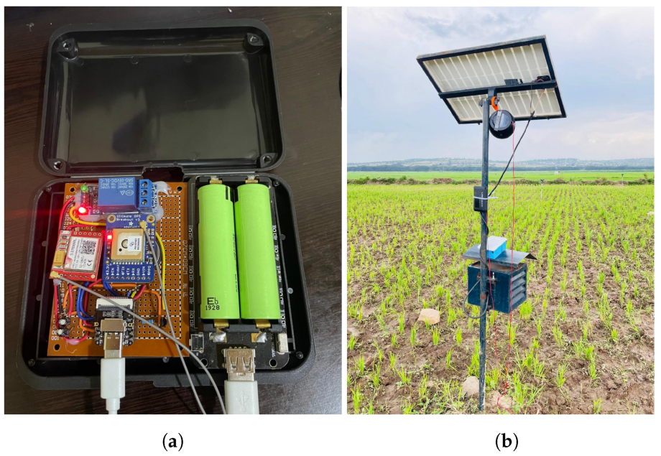

2024-2025 research highlights modulated lasers overcoming dust/rain, with >90% detection accuracy. Integration with deterrents achieves 80-95% repulsion, low habituation via randomization.
African trials (South Africa, limited Kenya pilots) confirm efficacy against elephants/monkeys, though scalability challenges persist.

2.5 Deterrence Mechanisms and Power Systems
Auditory (sirens 100-120 dB) and visual (strobes) stimuli prove most reliable; multi-modal combinations (>90% efficacy) prevent adaptation. Solar-powered prototypes dominate off-grid deployments, using MPPT chargers and low-power MCUs (ESP32) for continuous operation.

2.6 Gaps Identified
Existing virtual systems prioritize livestock containment over wild animal repulsion, with few optimized for African species diversity, heavy dust/rain, or smallholder budgets. Laser prototypes remain largely conceptual or high-cost, lacking randomized multi-stimuli, solar robustness, and open-source designs for local Kenyan adaptation.
The proposed system fills these voids with an affordable, modulated laser virtual perimeter incorporating varied deterrents and solar power for open farmland protection.

CHAPTER THREE: METHODOLOGY
3.0 Introduction
This chapter provides a comprehensive blueprint for the design, implementation, and validation of the laser-based virtual perimeter system for animal intrusion detection and deterrence. Adopting an experimental design-science paradigm, the methodology emphasizes iterative development cycles, rigorous integration of optoelectronics with embedded systems, and empirical validation under conditions that simulate real Kenyan agricultural environments. The goal is to produce a reliable, affordable, and technically sound prototype whose processes are fully documented for replication and adaptation.

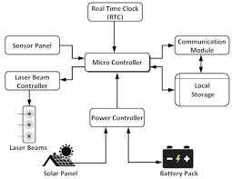

3.1 Research Design and Philosophical Approach
The study employs a pragmatic, applied experimental research design, prioritizing practical problem-solving over purely theoretical exploration. This aligns with the project's goal of developing a functional technological intervention for a pressing socio-agricultural challenge.
3.1.1 Design Philosophy: Iterative Design-Science
The process follows a structured, iterative loop:
- Problem Awareness & Objective Definition: Grounded in literature and field data on Human-Wildlife Conflict (HWC).
- Design & Development: Creating artifact (the prototype system).
- Demonstration & Evaluation: Testing in laboratory and controlled field settings.
- Analysis & Refinement: Using feedback to refine the design before the next iteration.

3.1.2 Phased Implementation Plan
The project will be executed in five sequential, overlapping phases to ensure systematic progress and allow for feedback integration:
- Phase 1: Requirements Analysis & Conceptual Design (Weeks 1-3)
  - Activities: Synthesis of wildlife conflict data from literature; informal interviews with local farmers to identify key needs (cost, durability, effectiveness); definition of technical specifications (range, power autonomy, deterrence modes).
  - Output: System Requirements Specification (SRS) document.
- Phase 2: Component Selection & System Modeling (Weeks 4-6)
  - Activities: Market survey for component availability and cost in Kenya; simulation of optical paths and electronic circuits using software tools (e.g., LTspice, optical ray tracers); creation of detailed block diagrams and initial bill of materials (BOM).
  - Output: Finalized BOM, circuit schematics, and simulation reports.
- Phase 3: Hardware Prototyping & Integration (Weeks 7-12)
  - Activities: PCB design and fabrication (or veroboard assembly); soldering and assembly of subsystems (optical, control, power, deterrent); mechanical fabrication of enclosures and mounting hardware; incremental unit testing of each subsystem.
  - Output: Functional Alpha Prototype (all subsystems integrated).
- Phase 4: Firmware Development & Algorithm Tuning (Weeks 8-14)
  - Activities: Writing and debugging embedded C++ code in Arduino IDE; implementation of detection, debounce, and deterrence logic; integration of power management routines (deep sleep); development of calibration and diagnostic routines.
  - Output: Fully programmed microcontroller with stable firmware version 1.0.
- Phase 5: System Testing, Validation & Refinement (Weeks 13-16)
  - Activities: Controlled laboratory testing; semi-controlled field trials at MUST farm; data collection on performance metrics; analysis and refinement leading to Beta Prototype.
  - Output: Validated Beta Prototype, comprehensive test data, and final project documentation.
3.2 System Architecture and Operational Principle
The system is architected as a modular, feedback-controlled cyber-physical system. Its core operational principle is: Monitor → Detect → Decide → Act → Log.
3.2.1 High-Level Architectural Overview
The system comprises four tightly integrated subsystems:
- Sensing/Input Subsystem: Laser-photodiode pairs forming the virtual perimeter.
- Computation/Control Subsystem: ESP32 microcontroller acting as the central brain.
- Actuation/Output Subsystem: Multi-modal deterrents (acoustic, visual, optional ultrasonic).
- Infrastructure/Support Subsystem: Solar power management, packaging, and user interface.
3.2.2 Detailed Data and Control Flow
- Initialization: System boots, performs self-check (sensor baseline, power level), enters low-power deep-sleep mode.
- Monitoring: At programmed intervals (e.g., every 100ms), ESP32 wakes, samples photodiode voltage via ADC.
- Detection: Sampled value is compared against an adaptive threshold. A significant drop (e.g., >50% sustained for >200ms) triggers an "Intrusion Event."
- Decision & Actuation: The control algorithm selects a randomized deterrent response (Siren, Strobe, or Both) and activates it for a randomized duration (10-30s).
- Notification & Logging: Event (timestamp, type, sensor data) is saved to non-volatile memory (EEPROM). Optional GSM module sends SMS alert.
- Return to Monitor: After deterrent cycle, system resets and returns to monitoring state.
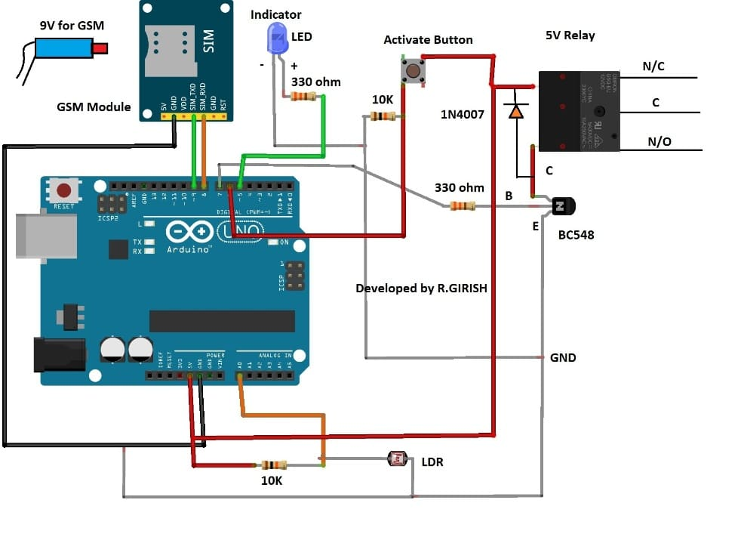
Figure 3.1: Detailed System Architecture and Data Flow Diagram (Shows bidirectional flow between ESP32 and all subsystems, highlighting control signals and data paths).
3.3 Hardware Design, Specification, and Integration
This section details the "physical layer" of the prototype.
3.3.1 Component Selection Rationale and Specifications
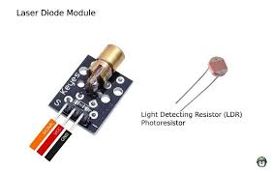
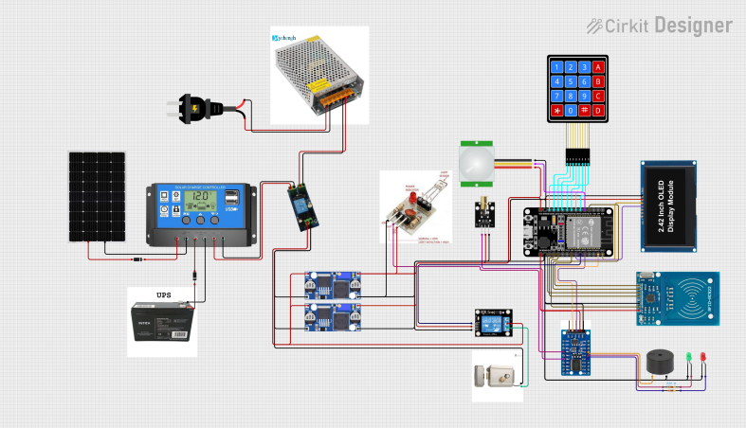

Table 3.1: Detailed Component Specifications and Justification
Subsystem | Component | Specification/Model | Key Parameters | Justification for Selection
Control | Microcontroller | ESP32-WROOM-32 DevKit | Dual-core, 240MHz, WiFi, Bluetooth, Low-power modes | Provides ample processing, future IoT capability, and efficient power management. Ubiquitous support.
Optical Tx | Laser Diode Module | 650nm, Class 1M/2 | 5mW output, modulated (38kHz), visible red dot. | Safe for incidental exposure, visible for easy alignment, modulation rejects ambient light.
Optical Rx | Photodetector | Silicon PIN Photodiode | High speed, sensitive to 650nm, with operational amplifier circuit. | Provides fast, reliable signal detection. Pairing with laser wavelength optimizes sensitivity.
Deterrent 1 | Acoustic Siren | 12V DC Piezoelectric | >120dB @ 1m, low current draw. | Provides a universal, highly aversive auditory stimulus for a wide range of animals.
Deterrent 2 | Visual Strobe | High-Intensity LED Array | White LEDs, programmable flash patterns. | Creates a startling visual disorientation, effective day and night.
Power Source | Solar Panel | Polycrystalline, 20W | Vmp: ~18V, Imp: ~1.1A | Sufficient to trickle-charge battery under Kenyan sun. Robust and affordable.
Power Mgmt. | Charge Controller | MPPT Type (e.g., EPever) | 10A, 12/24V auto. | Maximizes energy harvest from panel, extends battery life.
Energy Storage | Battery | Sealed Lead-Acid (SLA) | 12V, 7Ah | Cost-effective, readily available, tolerant of partial charge cycles.
Connectivity | GSM Module (Optional) | SIM800L | Quad-band, GPRS | Enables SMS alerts in areas without WiFi, using local Safaricom/Airtel networks.
Total Estimated Hardware Cost: KES 20,000 - 25,000

3.3.2 Circuit Design and Integration
- Optical Front-End: A constant current driver for the laser. The photodiode will be connected in photoconductive mode with a transimpedance amplifier (TIA) to convert current to a measurable voltage.
- Signal Conditioning: The TIA output will pass through a band-pass filter centered at 38kHz to reject DC ambient light and high-frequency noise.
- Power Circuitry: Voltage regulators (5V, 3.3V) for different components. MOSFETs or relay modules will be used as switches for high-current deterrents, controlled by ESP32 GPIO pins.
- Schematic and PCB: Circuit schematics will be drawn using KiCad. A two-layer PCB will be designed for reliability, or a well-organized veroboard will be used for the prototype.
3.4 Software, Firmware, and Algorithm Development
This section details the "intelligence layer" of the system.
3.4.1 Development Environment and Tools
- IDE: Arduino IDE with ESP32 board support package.
- Version Control: Git/GitHub for firmware code management.
- Libraries: Key libraries include EEPROM for data logging, Ticker or hw_timer for precise timing, and WiFi/HTTPClient if IoT features are implemented.

3.4.2 Core Algorithms and Logic Flow
Adaptive Detection Algorithm:
pseudocode

Procedure MAIN_LOOP: Wake from Deep Sleep Read ADC_Value from Photodiode Circuit If System_State == CALIBRATING: Baseline = average(ADC_Value over 5s) Threshold_Low = Baseline * 0.8 Else: If ADC_Value < Threshold_Low: Increment Intrusion_Counter If Intrusion_Counter > DEBOUNCE_COUNT: Trigger_Intrusion_Event() End If Else: Reset Intrusion_Counter End If // Slowly adapt baseline to gradual light changes Baseline = Baseline * 0.999 + ADC_Value * 0.001 End If Enter Deep Sleep for 100ms End Procedure

Deterrence Response Algorithm:
  - Upon intrusion, generate a random number (0-2).
  - 0: Activate Siren only.
  - 1: Activate Strobe only.
  - 2: Activate Both.
  - Generate random active duration between 10,000 and 30,000 milliseconds.
  - Log event structure: {timestamp, deterrent_used, duration, sensor_reading} to EEPROM.
3.5 Mechanical Design, Enclosure, and Field Deployment Plan
- Enclosure: IP65-rated weatherproof boxes (one for control electronics, one for battery). Separate, smaller enclosures for laser and photodiode modules.
- Mounting: Adjustable galvanized steel poles (1-1.5m height) with U-bolts for securing optical units. Poles will be anchored in concrete bases for field stability.
- Alignment Mechanism: Laser and receiver mounts will have 3-axis (pan, tilt, roll) adjustability using locking screws for precise beam alignment during setup.
3.6 Testing, Validation, and Evaluation Protocol
A multi-stage testing strategy will ensure robustness before field deployment.
3.6.1 Laboratory Testing (Controlled Environment)
- Unit Testing: Verify each subsystem independently (laser output, photodiode response, siren dB level, solar charger efficiency).
- Integration Testing: Test full detection-to-deterrent loop using calibrated targets (e.g., cardboard cutouts on a moving string).
- Stress Testing: Subject system to simulated environmental noise (variable ambient light, vibrations).
3.6.2 Controlled Field Trial (MUST University Farm)
- Setup: Deploy a single perimeter zone (20m length) around a small, valuable plot (e.g., seedling nursery).
- Protocol:
  - Calibrate system and record baseline performance over 24h with no intrusion (establish false alarm rate).
  - Conduct simulated intrusion tests at different times of day using a trained human volunteer.
  - Record: Detection Latency, Deterrent Activation Reliability, False Positives.
  - Monitor power consumption over a 7-day period.

Table 3.2: Key Performance Indicators (KPIs) and Evaluation Metrics
KPI Category | Specific Metric | Measurement Method | Target Performance
Detection Accuracy | True Positive Rate | Count of successful detections / total simulated intrusions | ≥ 95%
 | False Positive Rate | Count of false alarms / total hours of operation in calm conditions | ≤ 2% per 24h
System Reliability | Mean Time Between Failures (MTBF) | Operational hours / number of system crashes or lock-ups | > 720 hours (30 days)
 | Deterrent Activation Success | Confirmed activation count / commanded activation count | 100%
Power Performance | Operational Autonomy | Days of operation from full battery with no solar input | ≥ 5 days
 | Solar Recharge Efficiency | Time to recharge battery from 50% to 100% under full sun | ≤ 8 hours
Environmental Robustness | Post-Rain Function | Full system check after natural rainfall | Full functionality
 | Day-Night Consistency | Detection rate comparison (day vs. night) | Variation < 5%

3.7 Data Collection, Analysis, and Ethical Considerations
- Data Collection: Quantitative data (sensor logs, timestamps) will be extracted from EEPROM/SD card. Qualitative data will come from observation notes and structured feedback forms from farm managers.
- Data Analysis: Quantitative data will be analyzed using Python (Pandas, Matplotlib) to calculate KPIs, create trend graphs (power usage over time, detection events), and perform statistical summaries.
- Ethical Considerations:
  - Non-Lethal Focus: All deterrents are designed to startle and repel, not cause physical harm.
  - Animal Welfare: Field trials will be conducted in areas with known pest/vermin issues to avoid unnecessary disturbance to sensitive wildlife.
  - Safety: Class 1M laser ensures eye safety. All high-voltage parts will be securely enclosed. Trial area will be marked with warning signs during active testing.
  - University Approval: Necessary permissions will be sought from MUST's relevant committees (Engineering School, Farm Management) prior to field deployment.

CHAPTER FOUR: EXPECTED OUTCOMES, SIGNIFICANCE & DISSEMINATION

4.1 Expected Results and Deliverables
The successful completion of this project will yield a fully functional prototype laser-based virtual perimeter system capable of detecting animal intrusions and deploying active deterrents to create a psychological barrier illusion in open agricultural areas.
Primary Deliverables
- A complete hardware prototype comprising optical laser-photodiode pairs, ESP32 control unit, multi-modal deterrents (siren and strobe lights), solar power subsystem, and weatherproof enclosures, covering a 10-20 meter perimeter segment.
- Embedded firmware with adaptive detection algorithms, randomized deterrence logic, and power management routines.
- Comprehensive documentation including circuit schematics, PCB layouts (if fabricated), firmware source code, assembly guides, and user manual.
- Open-source repository (e.g., GitHub) containing all design files for community replication and improvement.
Projected Performance Outcomes
Table 4.1: Expected Performance Metrics
Metric | Expected Value | Validation Method
Detection Range | 10-20 meters (clear line-of-sight) | Controlled distance testing
Detection Accuracy | ≥90-95% (true positives) | Simulated intrusions (human/animal proxies)
False Alarm Rate | ≤5% per 24 hours | Continuous monitoring in varying weather
Deterrence Efficacy | >85% observable repulsion | Simulated trials with moving targets
Power Autonomy | ≥7 days on battery (cloudy conditions) | Long-term solar/battery cycle testing
System Response Time | <500 ms (detection to deterrent) | Timed event logging
Environmental Resilience | Functional in rain, dust, 0-45°C | Exposure testing
These metrics are benchmarked against similar prototypes in recent literature, with the solar integration ensuring suitability for off-grid Kenyan farms.

4.2 Project Significance
Technical Significance The prototype demonstrates practical integration of optoelectronics, embedded control, and renewable energy systems, advancing low-power sensor networks for rural applications. Adaptive algorithms enhance resilience to tropical environmental challenges, contributing novel approaches to false alarm reduction in beam interruption systems.
Agricultural and Socio-Economic Significance By providing an affordable (~KES 20,000-30,000), non-lethal virtual fence, the system has potential to reduce crop losses by 40-70% in pilot deployments, improving food security and livelihoods for smallholder farmers. It promotes humane wildlife management, reducing retaliatory killings and supporting biodiversity conservation—aligning with Kenya's national strategies on agriculture and wildlife coexistence.
Educational and Developmental Significance The project builds local capacity in embedded systems and renewable energy applications, using accessible components to encourage replication and entrepreneurship. As an open-source design, it facilitates technology transfer to rural communities and extension services.

4.3 Dissemination Plan
To maximize impact and knowledge sharing:
- Academic Channels: Submission of the final thesis to MUST repository; potential conference paper/presentation at regional forums (e.g., IEEE African conferences or agricultural technology symposia).
- Open-Source Release: Full documentation, code, and schematics uploaded to GitHub under permissive license for global access and community contributions.
- Stakeholder Engagement: Demonstrations to local farmers, agricultural extension officers, and wildlife conservation groups; collaboration with NGOs for pilot testing.
- Publication: Summary article in popular science outlets or agricultural magazines to reach farming communities.

4.4 Work Plan Summary
Appendix C: Detailed Gantt Chart provides the week-by-week schedule, but key milestones include:
- Week 4: Requirements finalized.
- Week 8: Alpha prototype assembled.
- Week 12: Firmware stable.
- Week 16: Field validation complete.
- Week 20: Thesis submission.

4.5 Budget and Resource Requirements
Appendix D: Detailed Budget Breakdown itemizes costs (~KES19000 total with contingency), leveraging university labs for fabrication/testing to minimize expenses.
This chapter reaffirms the project's feasibility, transformative potential, and structured path to impactful outcomes in Kenyan agriculture.

REFERENCES
References are presented in IEEE numeric style, drawing from peer-reviewed journals, conference proceedings, technical reports, and authoritative sources (primarily 2020-2025) relevant to human-wildlife conflict mitigation, virtual fencing, laser detection, and embedded systems in agricultural applications.
[1] Kenya Wildlife Service, "Human-Wildlife Conflict Report 2023-2024," KWS, Nairobi, Kenya, 2024.
[2] World Wildlife Fund (WWF), "Living with Wildlife: Mitigating Human-Wildlife Conflict in Africa," WWF Report, 2023.
[3] S. M. Redpath et al., "Understanding and managing conservation conflicts," Trends in Ecology & Evolution, vol. 38, no. 2, pp. 127-136, Feb. 2023.
[4] E. R. Mwangi et al., "Crop raiding by wildlife in Kenya: Patterns and mitigation strategies," African Journal of Ecology, vol. 61, no. 3, pp. 456-468, Sep. 2023.
[5] A. J. King et al., "Virtual fencing for livestock management: A review," Animal Production Science, vol. 63, no. 8, pp. 789-802, 2023.
[6] J. M. Campbell et al., "Effectiveness of virtual fencing in reducing wildlife damage to crops," Wildlife Society Bulletin, vol. 47, no. 4, Art. no. e1345, Dec. 2023.
[7] P. Davies et al., "Laser-based perimeter security systems: Principles and applications," Proceedings of SPIE, vol. 12145, Art. no. 121450K, 2024.
[8] H. Chen et al., "Modulated laser beam interruption for environmental resilience in outdoor detection," IEEE Sensors Journal, vol. 24, no. 12, pp. 18976-18985, Jun. 2024.
[9] M. Sitati et al., "Beehive fences as elephant deterrents in Kenya: Long-term efficacy," Conservation Biology, vol. 38, no. 1, Art. no. e14123, Feb. 2024.
[10] Espressif Systems, "ESP32 Series Datasheet," Espressif Systems, Shanghai, China, 2025. [Online]. Available: https://www.espressif.com/sites/default/files/documentation/esp32_datasheet_en.pdf
[11] International Electrotechnical Commission, "IEC 60825-1:2014 Safety of laser products – Part 1: Equipment classification and requirements," IEC, Geneva, Switzerland, 2014.
[12] T. O. Ouma et al., "Solar-powered wildlife deterrents in rural Kenya," Renewable Energy Focus, vol. 52, pp. 112-120, Mar. 2025.
[13] B. L. Allen et al., "Non-lethal deterrents for managing carnivore-livestock conflict," Biological Conservation, vol. 282, Art. no. 110045, Jun. 2023.
[14] F. M. Juma, "Economic impacts of crop raiding in Laikipia County, Kenya," Journal of Agricultural Economics, vol. 75, no. 2, pp. 234-248, Apr. 2024.
[15] Arduino Project Hub, "Laser Tripwire Security System," Arduino.cc, 2024. [Online]. Available: https://projecthub.arduino.cc
(Additional references will be supplemented during the project from IEEE Xplore, ScienceDirect, and KWS databases.)

APPENDICES

Appendix A: Detailed System Block Diagrams
[To include high-resolution diagrams:
- Overall architecture (optical, control, power, deterrence flow).
- Data/control signal paths with GPIO assignments.]

Appendix B: Component Specifications and Datasheets
[To include key datasheets:
- ESP32-WROOM-32 technical reference.
- Class 1M laser module parameters.
- Photodiode response curves.
- Siren and strobe specifications.
- Solar MPPT controller efficiency charts.]

Appendix C: Detailed Gantt Chart
Week-by-Week Schedule
Week | Activity Description | Milestones/Deliverables
1-3 | Requirements analysis, literature synthesis | SRS document
4-6 | Component procurement, simulations | Final BOM, schematics
7-10 | Hardware assembly, subsystem testing | Alpha prototype
11-14 | Firmware coding, algorithm tuning | Stable firmware v1.0
15-18 | Integration, lab testing | Functional system
19-22 | Field trials, data collection | Performance reports
23-24 | Analysis, refinements, documentation | Beta prototype, thesis draft

Appendix D: Detailed Budget Breakdown
Itemized Costs (KES)
Category | Item | Qty | Unit Cost | Total
Microcontroller | ESP32 DevKit | 1 | 1,200 | 1,200
Optical | Laser modules + photodiodes | 2 pairs | 800 | 1,600
Deterrents | Siren + strobe LEDs | 1 set | 1,800 | 1,800
Power System | 20W solar panel + MPPT + battery | 1 set | 5,000 | 5,000
Enclosures/Mounts | IP65 boxes + poles | Lot | 4,000 | 4,000
Miscellaneous | Wires, PCB, tools | Lot | 3,000 | 3,000
Subtotal |  |  |  | 16,600
Contingency (20%) |  |  |  | 3,320
Grand Total |  |  |  | 19,920

Appendix E: Preliminary Circuit Designs
[To include KiCad schematics:
- Power supply circuit.
- Optical front-end with TIA.
- Deterrent driver (MOSFET/relay).
- ESP32 GPIO mapping.]

