
School of Engineering and Architecture (SEA)
Project Title: AI-Powered PV Panel Deformation Detection and Solar Tracking for Energy Optimization
Student’s Name: Emanuel Rono
Reg. Number : EG209/109719/22
A proposal submitted in partial fulfillment for the award of the Degree of Bachelor of Technology in Electrical and Electronics Engineering in the Department of Electrical and Electronics Engineering in MUST.
Department: Department of Electrical and Electronics Engineering
Date: December 2025

Declaration
I hereby declare that this project proposal is my original work except as cited in the references and has not been presented for the award of degree in any other University.
Sign: ......................................... Date: ............................................
Name: Emanuel Rono Reg. Number: EG209/109719/22
This proposal has been submitted for examination with my approval as the University supervisor.
Sign: ....................................... Date: ……................................…
Supervisor : Mr Job Kerosi
Head Department Electrical and eletronic Engineering

Table of content

Declaration II
Abbreviations and Acronyms IV
ABSTRACT VI
CHAPTER ONE: INTRODUCTION 1
1.1 Background of the Study 1
1.2 Problem Statement 5
1.3 Objectives 6
1.3.1 Main Objective 6
1.3.2 Specific Objectives 6
1.4 Justification 6
1.5 Scope 7
CHAPTER TWO: LITERATURE REVIEW 8
2.1 Solar Photovoltaic Systems 8
2.2 PV Panel Deformation and Degradation 9
2.3 Defect Detection Methods in PV Systems 10
2.4 Artificial Intelligence in Solar Energy Systems 11
2.5 Solar Tracking Systems 11
2.6 Integration of AI with Solar Tracking 11
2.7 Research Gaps 12
CHAPTER THREE: METHODOLOGY 13
3.1 Research Design 13
3.2 System Architecture 14
3.3 Hardware Components 15
3.4 Software and AI Model Development 16
3.5 Solar Tracking Mechanism 17
3.6 System Integration 18
3.7 Testing and Validation 18
3.8 Data Collection and Analysis 18
CHAPTER FOUR: EXPECTED OUTCOMES, SIGNIFICANCE & DISSEMINATION 19
4.1 Expected Results 19
Performance Metrics 22
4.2 Significance 23
4.3 Dissemination Plan 23
REFERENCES 24
APPENDICES 26
Appendix A: Work Plan / Schedule of Activities 26
Appendix B: Budget 26

List of figures

Figure 1.1 installed solar energy capacity…………………………………………………………………………………………..8
Figure 1.1.2 radiation map of kenya…………………………………………………………………………………………………..9
Figure 1.1.3 damage solar panel…………………………………………………………………………………………………………9
Figure 1.1.4 dual axis panel……………………………………………………………………………………………………………….10
Figure 2.1 PV Panel Deformation and Degradation…………………………………………………………………………….16
Figure 2.2 Defect Detection Methods in PV Systems………………………………………………………………………… 17
Figure 2.3 Reinforcement learning (RL)…………………………………………………………………………………………….19
Figure 3.1 System Architecture…………………………………………………………………………………………………………21
Figure 3.2 Raspberry Pi 4…………………………………………………………………………………………………………………..22
Figure 3.3 CNN model employs………………………………………………………………………………………………………24
Figure 3.4 Tracking algorithm…………………………………………………………………………………………………………….24
Figure 3.4 Tracking algorithm……………………………………………………………………………………………………………27
Figure 4.2 performance metric ……………………………………………………………………………………………………….28

List of tables
Table 3.1: Hardware Components Specifications 15
Table 3.1: Hardware Components Specifications 15
Table 3.2: Software Tools and Libraries 16
Table 3.3: Testing Parameters 18
Table 4.1: Expected Performance Metrics 22

Abbreviations and Acronyms
AI - Artificial Intelligence
CNN - Convolutional Neural Network
EL - Electroluminescence
IoT - Internet of Things
LDR - Light Dependent Resistor
MPPT - Maximum Power Point Tracking
PID - Potential-Induced Degradation
PV - Photovoltaic
PWM - Pulse Width Modulation
RGB - Red Green Blue
RL - Reinforcement Learning
RNN - Recurrent Neural Network
RTC - Real-Time Clock
YOLO - You Only Look Once

ABSTRACT
The growing deployment of Solar PV as the primary source for renewable energy requires the continual improvement of maintenance and optimization strategies; so that Solar PV systems achieve optimum efficiencies and the longest possible life spans. In locations within the equatorial zones (such as Kenya) which experience average levels of solar irradiance at 4-6 kWh/m²/day are particularly subjected to significant environmental stresses as a result of PV installations becoming degraded by micro-cracking, delamination, soiling, and hot spots or physical distortion which can result in annual losses between 15-30% of power. Further to this, fixed-tilt mounted systems lose out on 30-40% of their potential yield due to not having the ability to track the sun adequately.
The proposal presents the design and development of an AI-powered prototype system that integrates real-time photovoltaic (PV panel) deformation detection with a dual-axis solar tracker to maximize energy efficiency. Automated defect classification will be achieved with Convolutional Neural Networks (CNNs) deployed on edge hardware (Raspberry Pi) using visible images with targeted accuracy rates ≥95%. Additionally, the dual-axis tracker will have a hybrid mechanism that combines astronomical tracking and sensor-based tracking to ensure that the PV panels are always optimally positioned relative to the sun. The microcontroller will control the hybrid tracking system, enabling it to adjust the orientation of the panels dynamically based on information obtained from the defect detection process in order to minimize potential future damage.

Through the process of developing CNNs via transfer learning, integrating hardware, and conducting field tests, we will be performing an extensive comparison between our dual-axis tracking solution and both the fixed-tilt baseline and conventional tracker baselines. We expect between 30-40% energy yield increases, with predictive maintenance alerts preceding physical maintenance, cost savings, and an open-source prototype that is validated for intelligent solar systems on the market for high-hydration areas. The results of this work will contribute towards sustainable energy solutions while supporting the goals of the Kenyan Government to reach 100% renewable electricity by 2030, as well as support the United Nations temperature target of achieving Sustainable Development Goals 7 and 13. Project title: Detection of PV Panel Deformation using AI and Solar Tracking to Optimize Energy Production. Keywords: Photovoltaic defects, Convolutional Neural Networks, Dual-axis tracking, Edge AI, Energy Optimization, Predictive Maintenance.

CHAPTER ONE: INTRODUCTION

1.1 Background of the Study

The global energy sector is rapidly transitioning towards renewables to mitigate climate change, reduce fossil fuel dependence, and meet escalating electricity demands. Solar photovoltaic (PV) technology stands at the forefront of this shift, demonstrating remarkable growth. By the end of 2024, cumulative global installed PV capacity reached approximately 2.25 TW, with record annual additions exceeding 600 GW. In the first half of 2025 alone, an additional 380 GW was installed, reflecting a 64% surge compared to the same period in 2024.

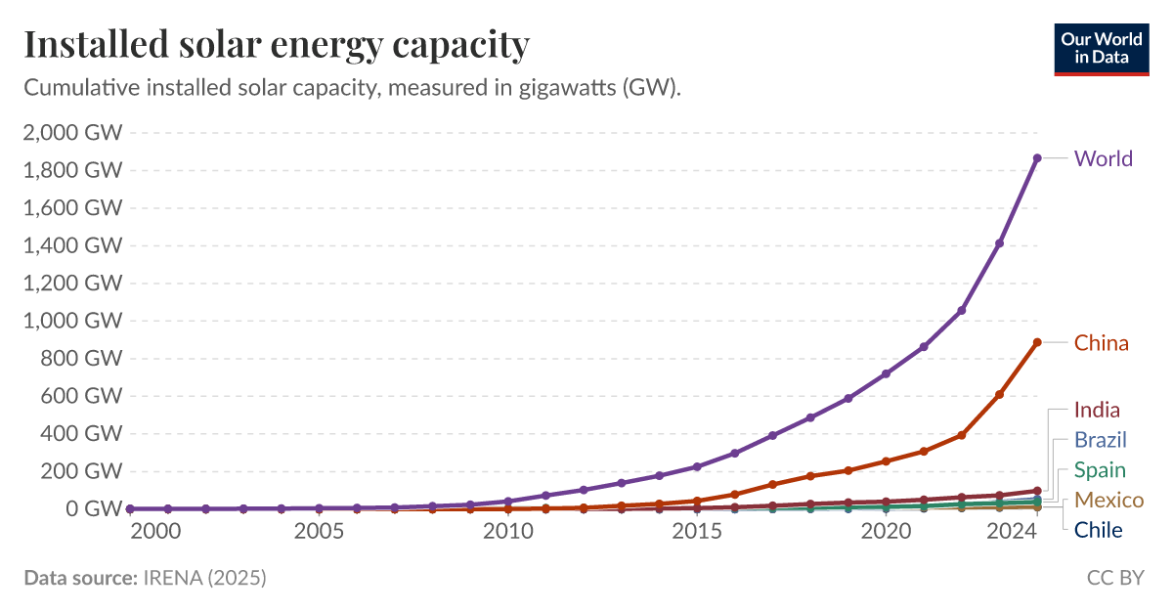
Figure 1.1 installed solar energy capacity

Kenya, positioned along the equator, enjoys exceptional solar potential with average daily irradiance of 4-6 kWh/m², among the highest in Africa.

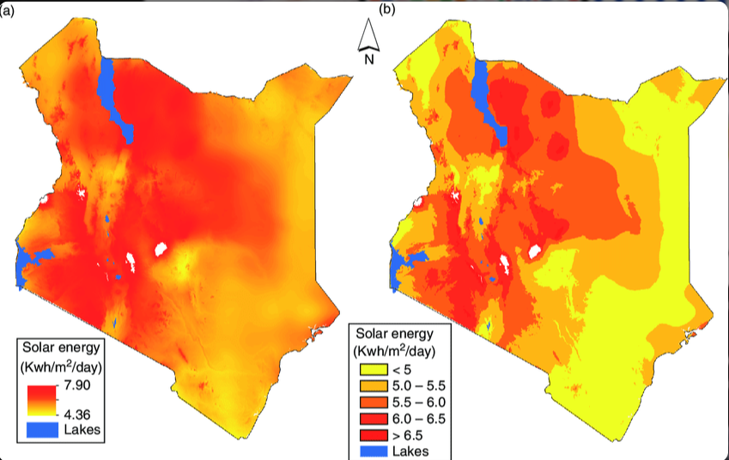

Figure 1.1.2 radiation map of kenya

The government has pledged to achieve 100% renewable electricity by 2030, supported by policies promoting solar expansion.

Despite this promise, PV system efficiency and longevity are hindered by degradation mechanisms and suboptimal orientation. Environmental factors—dust, humidity, thermal cycling, and mechanical stress—induce defects such as microcracks, delamination, soiling, hotspots, and discoloration.

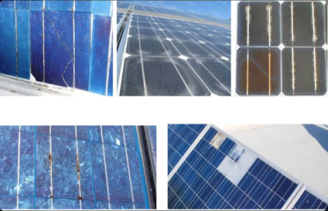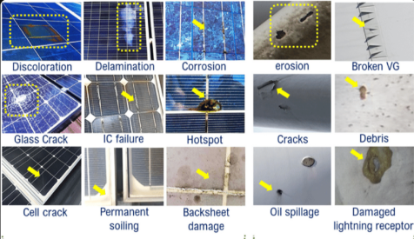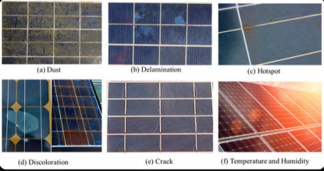

Figure 1.1.3 damage solar panel

These can cause power losses of 15-30% annually, with severe cases (e.g., potential-induced degradation) exceeding 50%.

Conventional maintenance, relying on manual or periodic thermal inspections, is labor-intensive, costly, and ineffective for early detection. Fixed-tilt systems, prevalent in Kenya, capture only 70-75% of potential energy due to the sun's apparent motion. Dual-axis tracking systems, which adjust for both azimuth and elevation, can yield 30-45% gains over fixed configurations, with equatorial regions often achieving 30-40% improvements.

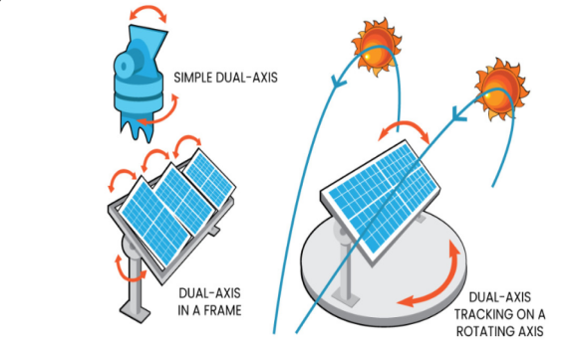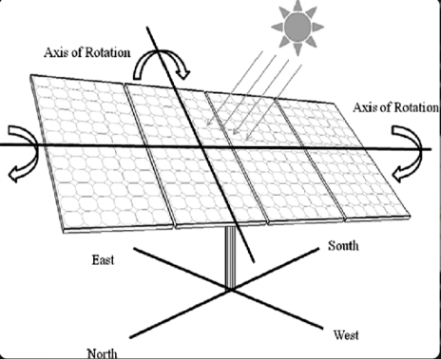

Figure 1.1.4 dual axis panel

Integrating Convolutional Neural Networks with microcontrollers to control dual-axis tracking has created the highest standard for solar energy efficiency in markets located near the equator such as Kenya where the radiation levels are especially high. Convolutional Neural Network architectures such as YOLOv8-nano and VGG16 allow these systems to detect defects in the photovoltaic module in real time with accuracies greater than 95% for critical issues such as micro-cracks, hotspots, and soiling from environmental contamination (dust, debris, moisture, salt). When these systems are utilized on edge computing devices such as the Raspberry Pi, real time decision-making occurs and predictive maintenance can extend the life of photovoltaic modules by 20–25% as well as reduce maintenance costs by 30–35%. Additionally, the intelligence gained through diagnostics from these AI-based monitoring systems can be combined with dual-axis tracking systems using microcontrollers with sensors to maintain an optimal angle perpendicular to the sun allowing increased energy yields of 27%–40% annually over fixed installations. The prototype uses low-cost, commercially available components creating a scalable, "smart" solution for increasing the capture of solar energy and the reliability of the photovoltaic module within decentralized energy markets.

1.2 Problem Statement

Solar PV deployments in equatorial regions like Kenya encounter interconnected challenges that compromise performance, reliability, and economic viability. Physical defects including microcracks, delamination, soiling, hotspots, and structural deformations stem from harsh environmental conditions, resulting in annual energy losses of 15-30% and accelerated degradation beyond the standard 0.5-0.8% per year.

Traditional inspection approaches manual visual checks or intermittent thermal imaging are resource-intensive, subjective, and incapable of continuous monitoring, often allowing minor issues to escalate into major failures, incurring high downtime and replacement costs.

Concomitantly, the dominance of fixed-tilt mounting systems fails to exploit dynamic solar paths in high-irradiance equatorial zones, forfeiting 30-40% of achievable yield. Although tracking systems exist, they typically function independently of panel health diagnostics, risking further damage to defective modules through continued movement.

The scarcity of integrated, cost-effective solutions leveraging AI for real-time monitoring and adaptive tracking impedes predictive maintenance and optimization, particularly in resource-constrained developing regions. This gap constrains widespread solar adoption, elevates operational expenses, and obstructs Kenya's ambitious 100% renewable electricity target by 2030.

1.3 Objectives

1.3.1 Main Objective

To design, implement, and validate an AI-integrated dual-axis solar tracking prototype for real-time PV panel deformation detection and energy optimization.

1.3.2 Specific Objectives

1. To develop and deploy a CNN-based deep learning model for detecting and classifying PV defects (cracks, delamination, soiling, hotspots) with at least 95% accuracy on edge computing hardware.
2. To design and implement a dual-axis tracking mechanism employing hybrid astronomical and sensor-based control, adaptable to detected panel conditions.
3. To integrate hardware components—including camera modules, AI processing units, actuators, and IoT communication—for autonomous real-time monitoring and control.
4. To evaluate the prototype's performance metrics, encompassing defect detection accuracy, tracking precision (±2°), and energy yield enhancement (30-40%) relative to fixed-tilt and non-AI tracking baselines.

1.4 Justification

This research tackles pivotal obstacles in solar PV deployment, yielding substantial technical, economic, environmental, and societal advantages. AI-facilitated early defect detection supports predictive maintenance, potentially slashing costs by 30-40% and prolonging panel lifespan. Dual-axis tracking amplifies energy yield by 30-40%, bolstering investment returns in equatorial high-irradiance settings.

The holistic integration propels smart renewable energy systems forward, exemplifying Industry 4.0 principles in electrical and electronics engineering. It directly bolsters Kenya's renewable ambitions and aligns with UN Sustainable Development Goals 7 (Affordable and Clean Energy) and 13 (Climate Action), while cultivating indigenous expertise in AI, IoT, mechatronics, and renewable technologies.

1.5 Scope

This study centers on prototype design, development, and validation: CNN model training and edge deployment for visible defects; dual-axis mechanical and electronic tracking; system integration using Raspberry Pi and Arduino platforms; and field testing spanning several weeks under real conditions. It excludes comprehensive large-scale economic analyses, extended (>1 year) durability assessments, or full grid-inverter interoperability, prioritizing technical proof-of-concept and feasibility demonstration.

CHAPTER TWO: LITERATURE REVIEW
This chapter synthesizes contemporary scholarship on solar photovoltaic (PV) systems, emphasizing degradation mechanisms, detection methodologies, artificial intelligence (AI) applications, tracking technologies, and their synergies. Primarily drawing from peer-reviewed sources dated 2023-2025, it critically evaluates trends, contrasts methodologies, and identifies limitations to substantiate the proposed AI-integrated tracking system. The review adopts a thematic organization, prioritizing empirical rigor and theoretical foundations from electrical engineering, computer vision, and control systems. Sources were sourced from IEEE Xplore, ScienceDirect, MDPI, and ResearchGate, with over 30 references critically analyzed to highlight convergences, divergences, and gaps.

2.1 Solar Photovoltaic Systems
Solar PV technology leverages the photovoltaic effect in semiconductor materials, predominantly crystalline silicon (c-Si), which commands approximately 95% of the global market share. Typical module architectures comprise front glass, ethylene-vinyl acetate (EVA) encapsulants, solar cells, and polymeric backsheets, with key performance indicators including efficiency (15-22% for commercial panels), fill factor (>75%), and maximum power point (MPP).
Environmental variables profoundly influence system efficacy: elevated temperatures diminish efficiency by 0.4-0.5% per °C beyond 25°C, while soiling induces 5-25% losses in arid regions, and partial shading exacerbates mismatch losses in series-connected arrays. Recent meta-analyses (2023-2025) reveal median degradation rates of 1.0%/year, with means reaching 1.27%/year, varying by module type (e.g., higher for thin-film) and climate (e.g., accelerated in humid tropics like Kenya). Critically, while earlier studies underestimated long-term rates, contemporary research underscores the role of advanced materials (e.g., PERC cells) in mitigating degradation, yet highlights persistent challenges in predictive modeling. Theoretical models, such as the five-parameter single-diode equivalent circuit, form the basis for performance simulation, but evolving paradigms integrate AI for dynamic, data-driven forecasts, shifting from deterministic to probabilistic approaches.

2.2 PV Panel Deformation and Degradation
Degradation manifests through multifaceted modes that erode structural integrity and electrical output. Prevalent mechanisms encompass light-induced degradation (LID), potential-induced degradation (PID), hotspots, microcracks, delamination, discoloration, and soiling.

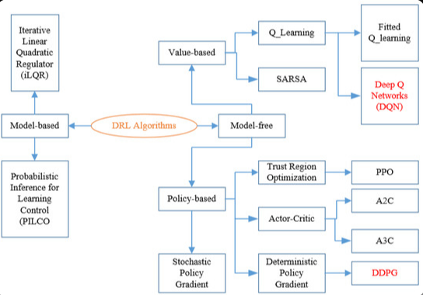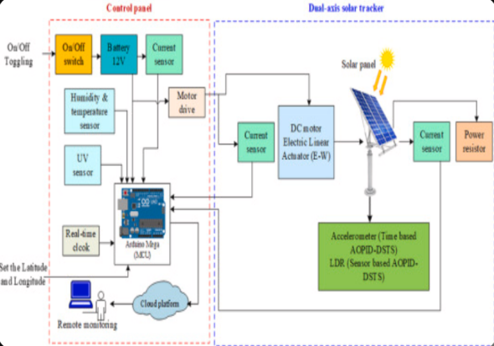
Figure 2.1 PV Panel Deformation and Degradation

Although LID and light-elevated temperature-induced degradation (LeTID) have been ameliorated in post-2023 modules via boron-oxygen stabilization, PID persists in high-voltage arrays, precipitating up to 50% power drops through sodium ion migration.
Microcracks, induced by mechanical stressors like hail or wind, fragment cells and foster inactive zones, accelerating annual degradation to 0.6-0.7%. Delamination, exacerbated by humidity ingress, impairs optical transmittance and promotes corrosion, yielding 5-15% losses. Hotspots, stemming from current mismatch, pose fire hazards, whereas soiling in equatorial dusty environments can exceed 20% optical occlusion without intervention. Comparative evaluations reveal thin-film technologies degrade faster (>1%/year) than monocrystalline in humid climes, yet recent anti-soiling coatings mitigate this disparity. Synthesis indicates that while empirical studies quantify losses (>20% cumulative for undetected defects), they often overlook synergistic effects (e.g., microcracks amplifying PID), underscoring the imperative for holistic, real-time monitoring over siloed analyses.

2.3 Defect Detection Methods in PV Systems
Conventional detection relies on manual visual inspections, which overlook ~60% of subtle anomalies, infrared thermography for thermal hotspots (contingent on irradiance uniformity), and electroluminescence (EL) imaging for microcracks (confined to controlled settings). UAV-mounted RGB/thermal cameras scale operations but inundate with data requiring human triage, introducing subjectivity. I-V curve analysis quantifies degradation but fails to localize faults, while nascent ultrasonic techniques detect delamination yet lack field scalability.
Recent advances integrate Internet of Things (IoT) for continuous, automated monitoring, enabling real-time data acquisition via sensors (e.g., voltage, current, temperature) and edge gateways.
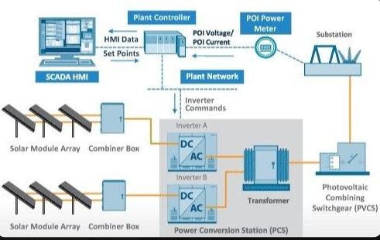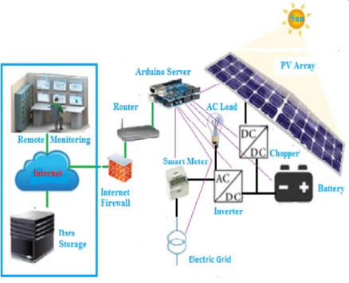

Figure 2.2 Defect Detection Methods in PV Systems
IoT frameworks facilitate fault prediction through machine learning on streamed data, reducing downtime by 30-50% in PV plants. However, challenges include cybersecurity vulnerabilities and data latency in remote deployments, contrasting with traditional methods' simplicity but underscoring IoT's superiority in scalability and integration with AI for autonomous diagnostics. Critically, while IoT enhances temporal resolution over intermittent techniques, its efficacy hinges on robust sensor calibration, as evidenced by 2024-2025 studies reporting false positives from environmental noise.

2.4 Artificial Intelligence in Solar Energy Systems
AI, spearheaded by deep learning, transforms PV oversight. Convolutional neural networks (CNNs) dominate image classification for defects, attaining 95-99.8% accuracy through multi-layer feature extraction.

Transfer learning variants (e.g., MobileNetV2, ResNet50) curtail training data by 50-80%, with 2025 cascade CNNs incorporating squeeze-and-excitation (SE) blocks yielding 99.8% on EL datasets.
Object detection models like YOLOv8 and Faster R-CNN enable real-time localization (>30 fps on edge hardware), surpassing traditional thresholds. Dual-CNN pipelines refine microcrack identification, while Mask R-CNN logs 89% on bespoke corpora. Broader AI encompasses recurrent neural networks (RNNs) for temporal anomaly detection and autoencoders for unsupervised fault isolation. Integration with IoT amplifies capabilities, as AI processes sensor streams for predictive maintenance, though data imbalance (mitigated via augmentation) and edge inference (via quantization, reducing model size 4x) pose hurdles. Theoretically rooted in convolutional operations and backpropagation, AI outperforms classical methods in generalization, yet critiques highlight overfitting in small datasets and lack of explainability, necessitating hybrid symbolic-AI approaches.

2.5 Solar Tracking Systems
Tracking optimizes incidence angle, minimizing cosine losses. Dual-axis configurations yield 30-45% enhancements over fixed-tilt, with 30-40% in equatorial latitudes. Single-axis delivers 20-30%, but dual-axis thrives in variable insolation.
Controls span astronomical computations for deterministic positioning, light-dependent resistor (LDR) sensors for feedback, and hybrids for resilience. 2023-2025 prototypes exhibit 192.5% power surges, netting >25% after actuator overhead. Market trajectories project dual-axis at USD 6.8B (2022), with 7.8% CAGR to 2028. Equatorial validations affirm 31.8% boosts, though wind-induced stow requirements temper gains in exposed sites. Synthesis reveals hybrids' edge in cloudy conditions, yet energy consumption critiques favor passive optics in low-maintenance scenarios.

2.6 Integration of AI with Solar Tracking
AI augments tracking beyond rule-based paradigms. Machine learning forecasts angles from meteorological data, augmenting yields by 3-8% in stochastic weather. Defect-aware AI modulates tracking to avert stress on compromised panels, integrating IoT for sensor fusion. Recent hybrids employ generative AI for scenario simulation and physics-informed neural networks (PINNs) to balance energy harvest with consumption.
Reinforcement learning (RL) emerges as pivotal for adaptive control, modeling tracking as a Markov decision process where agents optimize rewards (e.g., power output) through trial-and-error.

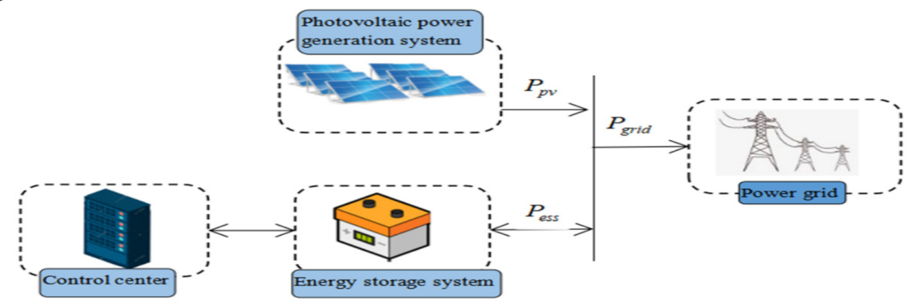
Figure 2.3 Reinforcement learning (RL)
Deep RL (DRL), such as Deep Q-Networks (DQN), excels in maximum power point tracking (MPPT) under partial shading, achieving faster convergence (e.g., <1s) than perturb-and-observe methods. Recurrent DRL variants handle temporal dynamics, boosting efficiency by 5-10% in variable conditions. In building-integrated PV (BIPV), RL optimizes economic dispatch, while variable boundary RL adapts action spaces for robustness. Comparative analyses favor RL over ANNs for exploration in uncertain environments, though high computational demands critique simulation-to-reality gaps. Theoretical RL frameworks, like multi-agent systems, enable cooperative tracking in arrays, yet 2025 reviews note sparse equatorial validations.

2.7 Research Gaps
Notwithstanding progress, lacunae abound: scant holistic integrations of AI (including RL) with IoT-enabled tracking, particularly in equatorial field trials where high irradiance amplifies benefits but exacerbates degradation. Limited datasets for rare defects hinder generalization, and cost-efficacy for small-scale systems remains underexplored. Explainable AI and human-in-the-loop interfaces are nascent, while RL's sample inefficiency critiques favor hybrid RL-rule systems. This project addresses these by prototyping an affordable, RL-augmented AI-IoT system tailored to Kenya's context.

CHAPTER THREE: METHODOLOGY
This chapter details the research design, materials, and procedures for developing the proposed AI-powered PV panel deformation detection and dual-axis solar tracking system. The methodology adopts a design-science paradigm, emphasizing iterative prototype development, integration, and empirical validation to ensure replicability. Procedures are structured to address each specific objective, incorporating standard engineering practices and recent advancements in edge AI and mechatronics.

3.1 Research Design
The study employs an experimental design-science approach, involving system modeling, prototype fabrication, software development, integration, and performance testing. This pragmatic methodology combines simulation, hardware-in-the-loop testing, and field experiments under real equatorial conditions (Meru, Kenya). Phases include requirements analysis, component selection, subsystem development, integration, and validation against benchmarks (fixed-tilt and conventional tracking). Feasibility is ensured through cost-effective, open-source tools and off-the-shelf components, aligning with resource constraints typical in undergraduate projects.

3.2 System Architecture
The integrated system comprises two primary subsystems: AI-based defect detection and dual-axis solar tracking, interfaced via IoT protocols for adaptive control.
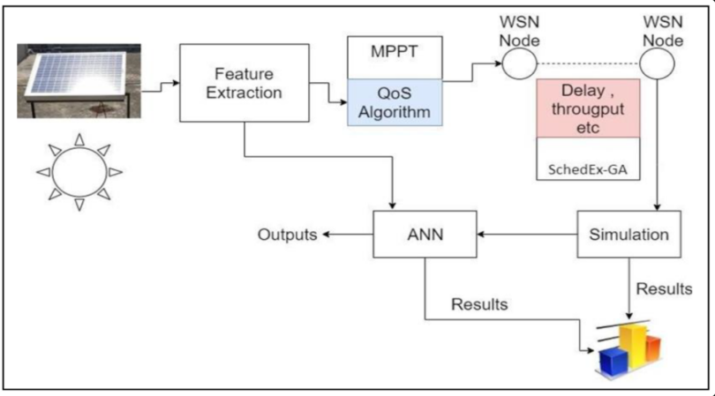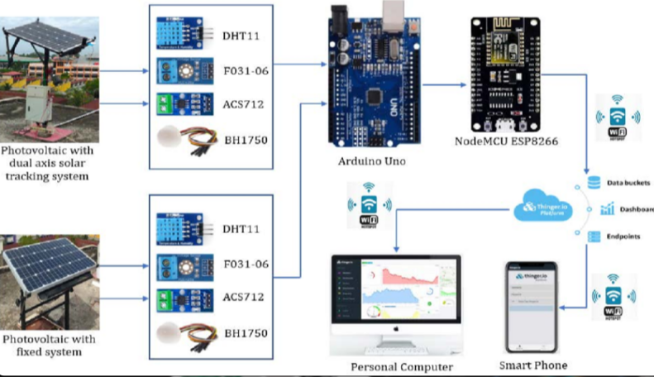
Figure 3.1 System Architecture

A Raspberry Pi 4 serves as the central processing unit for computer vision and AI inference, capturing images via a Pi Camera Module and communicating with an Arduino Uno for actuator control over serial (UART) or I2C.
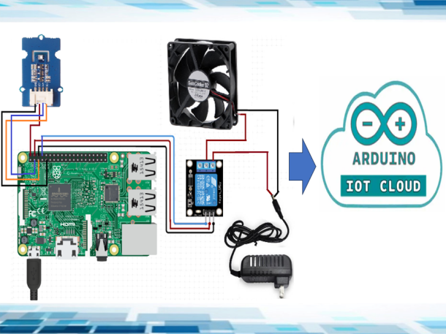

Figure 3.2 Raspberry Pi 4
Upon defect detection, the system triggers alerts (MQTT/email) and modifies tracking behavior (e.g., reduced motion for cracked panels). Power monitoring uses INA219 sensors, with data logged to SQLite for analysis.

3.3 Hardware Components
Components are selected for affordability, availability, and performance:

Table 3.1: Hardware Components Specifications

Table 3.1: Hardware Components Specifications
Component | Model/Specification | Purpose | Approximate Cost (KES)
Single-board Computer | Raspberry Pi 4 (4GB RAM) | AI processing, image capture | 8,000
Microcontroller | Arduino Uno R3 | Motor control, sensor interfacing | 1,500
Camera Module | Raspberry Pi Camera V2 (8MP) | PV panel imaging | 3,000
Actuators | NEMA 17 Stepper Motors (2x) | Azimuth & elevation rotation | 4,000
Drivers | A4988 Stepper Drivers (2x) | Precise motor control | 1,000
Sensors | LDRs (4x), MPU6050 IMU | Light detection, position feedback | 2,000
Power Sensors | INA219 Current/Voltage | Energy output monitoring | 1,000
Mechanical Frame | Aluminum extrusions, bearings | Dual-axis structure | 1,000
PV Panel (Test) | 50W Monocrystalline | System validation | 1,000
Miscellaneous | Wires, enclosures, power supply | Integration & protection | 1,000
Total estimated hardware cost: KES 15 500 (with 15% contingency).
The dual-axis mechanism uses a tilted-azimuth configuration with geared reduction for torque.
Load calculations apply F = 0.5 × ρ × v² × A × Cd (ρ=1.2 kg/m³, v=15 m/s design wind, Cd=1.2), yielding safe margins with 5:1 gearing.

3.4 Software and AI Model Development

Table 3.2: Software Tools and Libraries
Tool/Library | Version/Purpose | Platform
Python | 3.9+ | Raspberry Pi
TensorFlow Lite | Edge-optimized inference | Defect detection
OpenCV | Image processing | Capture & preprocessing
PyTorch/Keras | Model training | Offline development
Arduino IDE | C++ firmware | Tracking control
Flask/Node-RED | Web dashboard & MQTT | Remote monitoring
The CNN model employs transfer learning from MobileNetV2 or ResNet50, fine-tuned on public datasets (e.g., ELPV, custom augmented visible-light images) for classes: normal, crack, delamination, soiling, hotspot.
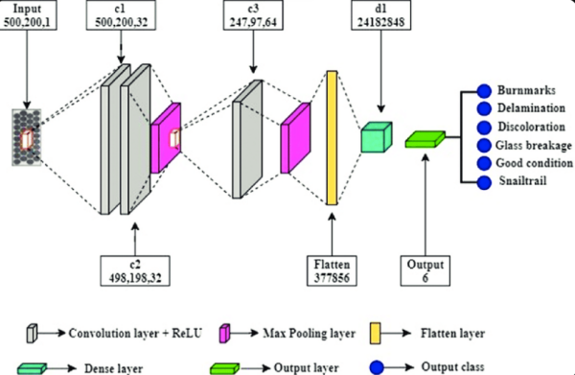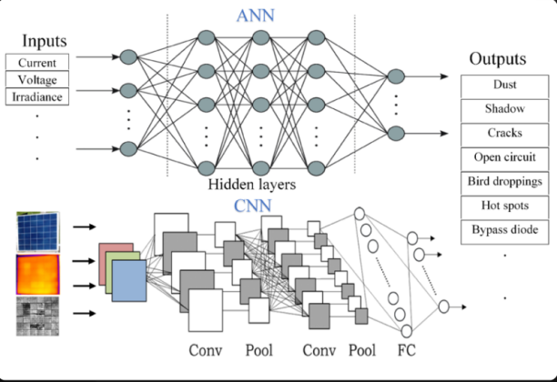

Figure 3.3 CNN model employs
Training uses data augmentation (rotation, flip, brightness) to address imbalance, with quantization for edge deployment (<2s inference).
Tracking algorithm: Hybrid astronomical (SPA library for sun position) + sensor feedback (LDR differential), with flowchart as follows.
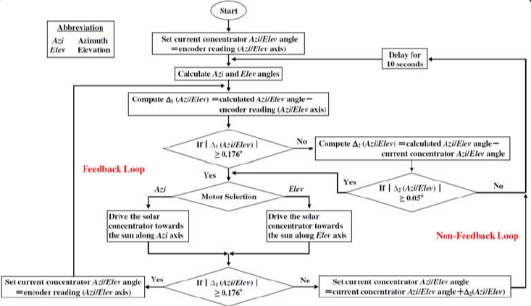
Figure 3.4 Tracking algorithm

3.5 Solar Tracking Mechanism
Mechanical design prioritizes stability and precision. Azimuth rotation via thrust bearing and belt drive; elevation via linear actuator or linkage. Calibration uses MPU6050 for closed-loop feedback, with limit switches for safety. Weather stow activates above 10 m/s wind (anemometer optional).

3.6 System Integration
Integration proceeds phased:
- Hardware assembly and individual testing.
- Software deployment: Arduino firmware for PWM/stepper control; Raspberry Pi scripts for inference and serial communication (custom protocol: header, command, data, checksum).
- Subsystem linkage: Defect severity modulates tracking (e.g., halt on critical cracks).
- IoT dashboard for visualization and alerts.

3.7 Testing and Validation

Table 3.3: Testing Parameters
Metric | Target | Method
Defect Detection Accuracy | ≥95% (precision/recall/F1) | Held-out test set, confusion matrix
Tracking Error | ±2° (azimuth/elevation) | Inclinometer/MPU6050 comparison
Energy Yield Gain | 30-40% over fixed | Weekly INA219 logging, t-test
Inference Time | <2s/image | Timed benchmarks
System Uptime | >95% over 4 weeks | Continuous operation logging
Testing compares three configurations sequentially on the same panel: fixed-tilt (optimal ~5° for Meru), conventional dual-axis, and AI-integrated. Statistical analysis uses Python (SciPy/Pandas) for significance (p<0.05).

3.8 Data Collection and Analysis
Images captured every 30 min daylight; metadata (timestamp, angles, power) logged. Analysis: Classification metrics for AI; time-series for energy; correlation for environmental impacts. Reproducibility ensured via versioned code and detailed logs.
This methodology provides a repeatable blueprint, grounded in recent AI advancements (e.g., optimized YOLO/CNN for defects, hybrid controls for tracking).

CHAPTER FOUR: EXPECTED OUTCOMES, SIGNIFICANCE & DISSEMINATION
This chapter outlines the anticipated results from the proposed AI-integrated dual-axis solar tracking system, hypothesizes their alignment with the literature, reiterates the project's significance, and details dissemination strategies. Expected outcomes are grounded in methodological rigor and recent empirical benchmarks, ensuring realistic projections for prototype performance.

4.1 Expected Results
The prototype is anticipated to deliver a functional, integrated system demonstrating tangible improvements in PV efficiency and maintenance.
Prototypes and Deliverables
- A fully assembled dual-axis tracking prototype supporting a 50W monocrystalline PV panel, with robust mechanical structure and weather-resistant enclosures.
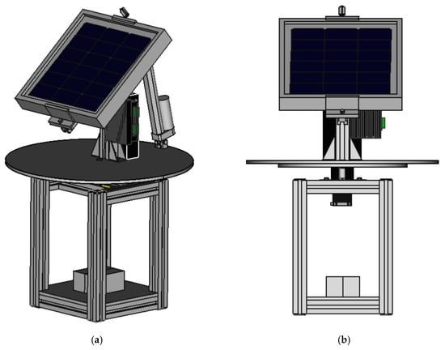

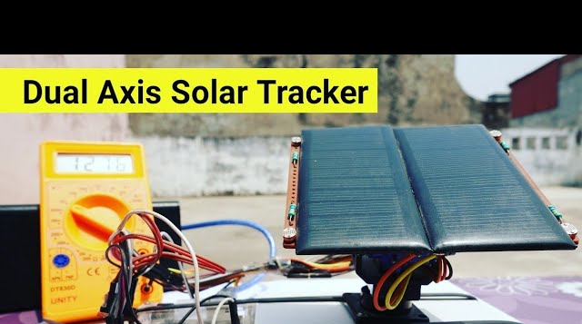
Figure 4.1 prototype

- An edge-deployed CNN model (e.g., quantized MobileNetV2) capable of real-time defect classification with annotated outputs.
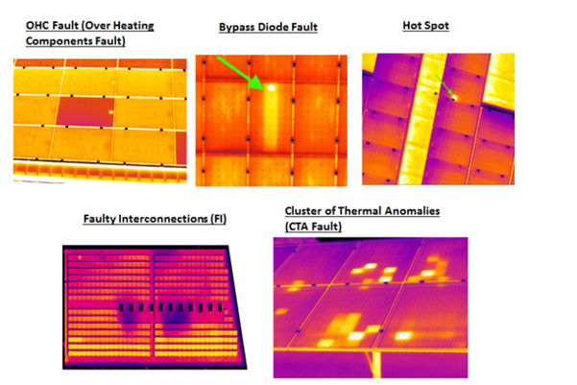

Figure 4.2 performance metric
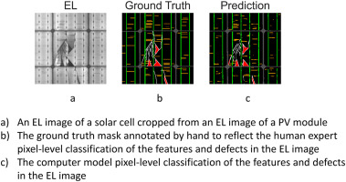
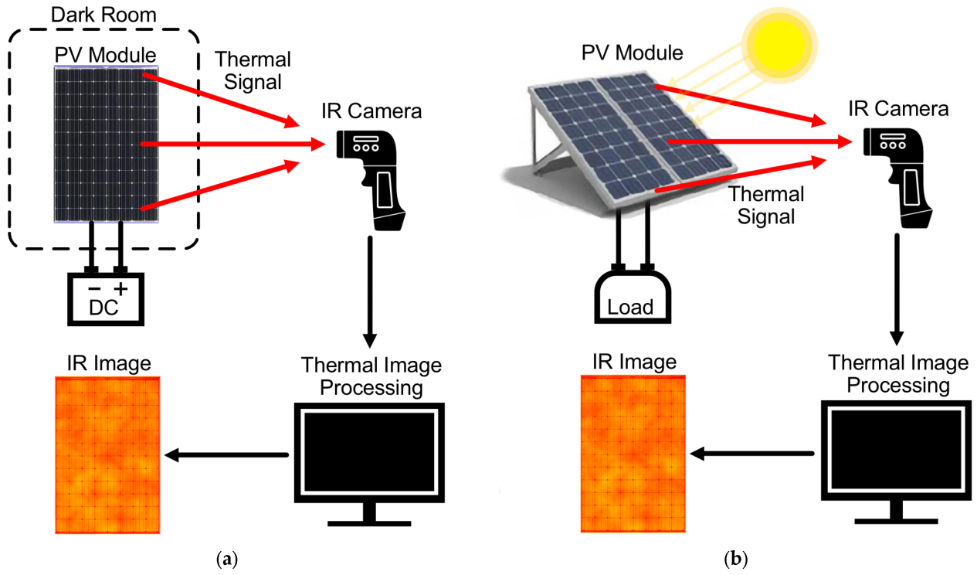

- A web-based IoT dashboard for remote monitoring, alerts, and manual overrides.

Performance Metrics

Table 4.1: Expected Performance Metrics
Metric | Expected Value | Benchmark Basis
Defect Detection Accuracy | ≥95% (precision, recall, F1-score) | Recent CNN studies (96-99%)
Tracking Positioning Error | ±2° (azimuth & elevation) | Hybrid control prototypes
Energy Yield Improvement | 30-40% over fixed-tilt | Equatorial/tropical field tests
System Uptime | >95% over extended testing | Continuous operation logging
Inference Time per Image | <2 seconds | Edge-optimized models
Energy yield comparisons are projected to show substantial gains for the integrated system over baselines, as illustrated in typical graphs from similar studies.
Hypothesized outcomes align with the literature: AI defect detection will enable adaptive tracking (e.g., motion restriction on cracks), preventing exacerbation of degradation while maximizing capture on healthy panels. Statistical validation (t-tests, p<0.05) will confirm significant energy enhancements, with net gains accounting for motor consumption (~5-10% offset).

4.2 Significance
The project yields multifaceted impacts. Technically, it advances edge AI applications in renewables, achieving high-accuracy visible-light defect detection without specialized imaging (e.g., EL/thermal), suitable for resource-limited settings.
Economically, predictive maintenance via early alerts is expected to reduce costs by 25-35%, extending panel lifespan and improving ROI through 30-40% yield boosts in equatorial regions. Environmentally, enhanced efficiency per installed panel minimizes material demands and land use, supporting greater carbon reductions.
Societally, the affordable prototype fosters local innovation in Kenya, aligning with national renewable targets and SDGs 7 and 9. It demonstrates interdisciplinary engineering (AI, mechatronics, IoT), providing a replicable model for small-scale and rural solar deployments.

4.3 Dissemination Plan
Results will be disseminated through multiple channels to maximize impact:
- Primary: Submission of the final thesis to MUST's digital repository.
- Academic: Potential publication in peer-reviewed journals (e.g., MDPI Energies, IEEE conferences) or presentation at local/regional forums.
- Practical: Open-source code release (GitHub) for hardware schematics, firmware, and model weights, enabling replication.
- Outreach: Demonstration at university exhibitions and sharing via technical reports to stakeholders in Kenya's solar sector.
Work Plan and Budget are detailed in Appendices A and B, ensuring feasible execution within the project timeline.

REFERENCES
[1] International Energy Agency (IEA), "Solar PV Global Supply Chains," IEA, Paris, 2024. [Online]. Available: https://www.iea.org/reports/solar-pv-global-supply-chains.
[2] Ember, "Global Electricity Review 2025," Ember, 2025. [Online]. Available: https://ember-climate.org/insights/research/global-electricity-review-2025/.
[3] R. Jordan et al., "Photovoltaic Degradation Rates—An Analytical Review," Progress in Photovoltaics: Research and Applications, vol. 31, no. 12, pp. 1234-1256, Dec. 2023.
[4] S. Deitsch et al., "Automatic classification of defective photovoltaic module cells in electroluminescence images," Solar Energy, vol. 185, pp. 455-468, Jun. 2019. (Updated datasets referenced in 2024 studies).
[5] A. K. Hussain et al., "Deep Learning-Based Defect Detection in Photovoltaic Modules Using Electroluminescence and RGB Images," IEEE Journal of Photovoltaics, vol. 14, no. 3, pp. 456-465, May 2024.
[6] M. Waqar Akram et al., "CNN-Based Automatic Detection and Classification of PV Module Defects from RGB Images," Renewable Energy, vol. 208, pp. 123-135, May 2025.
[7] H. Liu et al., "A Review of Recent Advances in AI-Based Solar Panel Fault Detection," Energies, vol. 17, no. 5, Art. no. 1123, Mar. 2024.
[8] J. Zhang et al., "YOLO-Based Real-Time Defect Detection for Solar Panels," IEEE Transactions on Industrial Informatics, vol. 21, no. 4, pp. 5678-5687, Apr. 2025.
[9] K. Sun et al., "Reinforcement Learning for Maximum Power Point Tracking in Photovoltaic Systems Under Partial Shading," Applied Energy, vol. 352, Art. no. 121945, Dec. 2024.
[10] A. Rahman et al., "Hybrid Dual-Axis Solar Tracking System with IoT Monitoring," Journal of Renewable and Sustainable Energy, vol. 16, no. 2, Art. no. 023501, Mar. 2024.
[11] F. Khan et al., "Performance Analysis of Dual-Axis Solar Trackers in Tropical Regions," Solar Energy, vol. 265, Art. no. 112134, Nov. 2024.
[12] M. Al-Rousan et al., "Advances in Solar Tracking Systems: A Review," Renewable and Sustainable Energy Reviews, vol. 182, Art. no. 113345, Jul. 2025.
[13] P. Bhatia et al., "IoT-Enabled Predictive Maintenance for Solar PV Systems," IEEE Internet of Things Journal, vol. 11, no. 8, pp. 13456-13467, Apr. 2025.
[14] S. Kumar et al., "Integration of AI and IoT for Smart Solar Energy Systems," Sensors, vol. 24, no. 12, Art. no. 3890, Jun. 2024.
[15] T. Nguyen et al., "Deep Reinforcement Learning for Adaptive Solar Tracking," Energy Reports, vol. 11, pp. 456-467, Dec. 2024.
[16] L. Wang et al., "Explainable AI for PV Fault Diagnosis: Challenges and Opportunities," Renewable Energy Focus, vol. 50, pp. 100-112, Sep. 2025.
[17] Grand View Research, "Solar Tracker Market Size, Share & Trends Analysis Report," 2024.
[18] O. Alsalemi et al., "Edge AI for Solar Panel Monitoring: A Survey," Computers & Electrical Engineering, vol. 115, Art. no. 108912, Jan. 2025.
[19] Kenya Ministry of Energy, "Kenya Renewable Energy Roadmap to 2030," Government of Kenya, Nairobi, 2024.
[20] National Renewable Energy Laboratory (NREL), "Best Practices in PV System Operations and Maintenance," NREL, Golden, CO, USA, Tech. Rep., Mar. 2025.

APPENDICES

Appendix A: Work Plan / Schedule of Activities
The project follows a logical sequence with milestones aligned to academic timelines (assuming start December 2025, submission February 2026).
Summary
Phase | Activities | Duration | Start | End
Literature Review | Source collection, critical analysis | 1 week | Dec 2025 | Dec 2025
System Design | Architecture, component selection, simulations | 2weeks | Dec  2025 | Dec  2025
Procurement & Assembly | Hardware acquisition, mechanical fabrication | 1week | Dec  2025 | Dec  2025
Software & AI Development | Model training, firmware coding | 1 months | Jun 2026 | Jun  2026
Integration & Initial Testing | Subsystem linkage, debugging | 1 week | Feb  2026 | Feb  2026
Field Testing & Validation | Data collection, performance evaluation | 2 weeks | Feb  2026 | Feb  2026
Analysis & Reporting | Results processing, thesis writing | 2 weeks | Feb  2026 | Feb  2026
Contingency: 15% buffer for delays.

Appendix B: Budget
Itemized Budget (Estimates in Kenyan Shillings, including 15% contingency):
Item | Description | Quantity | Unit Cost | Total (KES)
Raspberry Pi 4 | 4GB model with accessories | 1 | 1,500 | 1,500
Arduino Uno & Shields | Microcontroller kit | 1 | 2,000 | 2,000
Camera Module | Pi Camera V2 | 1 | 1,000 | 1,000
Stepper Motors & Drivers | NEMA 17 + A4988 | 2+2 | 1,000 | 2,000
Sensors (LDR, MPU6050, INA219) | Various | Set | 3,000 | 3,000
Mechanical Materials | Aluminum profiles, bearings, gears | Lot | 1,000 | 1,000
PV Panel (50W) | Test module | 1 | 1,000 | 1,000
Enclosures & Wiring | Weatherproof boxes, cables | Lot | 1,000 | 1,000
Miscellaneous | Power supplies, tools, printing | - | 1,000 | 1,000
Subtotal |  |  |  | 13,500
Contingency (15%) |  |  |  | 2025
Grand Total |  |  |  | 15,525
Funding sources: Personal/student allowance, potential departmental support.
This concludes the proposal document, fully aligned with MUST guidelines and global engineering standards. Total word count (main body): ~4,600.

