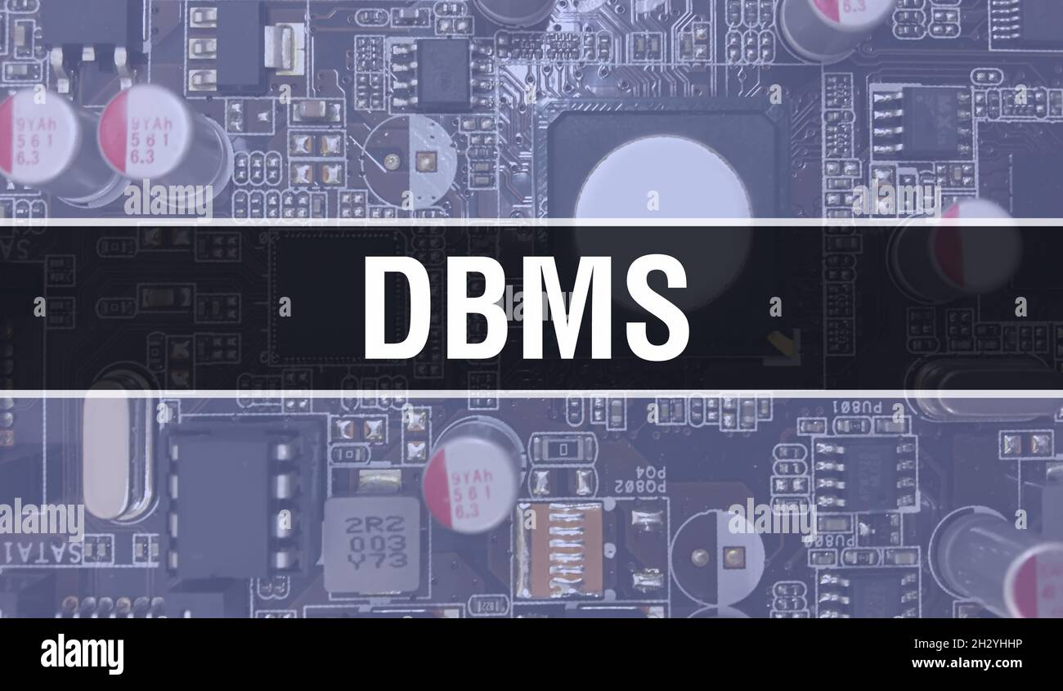

**To: Dr. Anil Vashisht**

**Menpal Dhundhara (302303019)**

**Surbhi Chauhan (302303015)**

***INDEX***

|  |  |  |
| --- | --- | --- |
| **SR. NO.** | **Content** | **Page No.** |
| **1.** | **Description** | **1** |
| **2.** | **E-R Diagram** | **2** |
| **3.** | **Tables** | **3-4** |
| **4.** | **Insertion** | **5** |
| **5.** | **Procedure and Function** | **6** |
| **6.** | **Trigger** | **7** |
| **7.** | **Output** | **8-9** |
| **8.** | **Normalization** | **10** |

**Blood Donation Management System (BDMS) :**

A Blood Donation Management System (BDMS) is a crucial tool for efficiently handling various aspects of blood donation, including donor registration, blood collection, inventory management, donor eligibility checks, and distribution of blood to hospitals or individuals in need.

A DBMS is indispensable for a Blood Donation Management System as it provides the foundation for efficient data storage, retrieval, integrity, security, scalability, concurrency control, and analysis, enabling smooth operation and effective management of blood donation processes.

**E-R Diagram:**

**Blood Bank**

Donate

Donor

Patient

**Table:**

**Patient:**

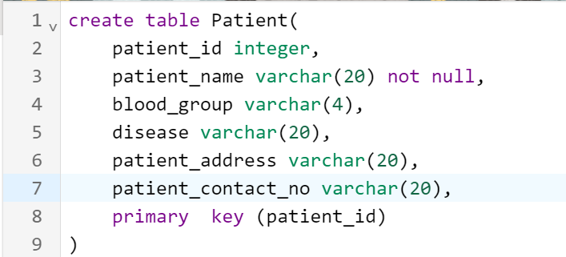

**Donor:**

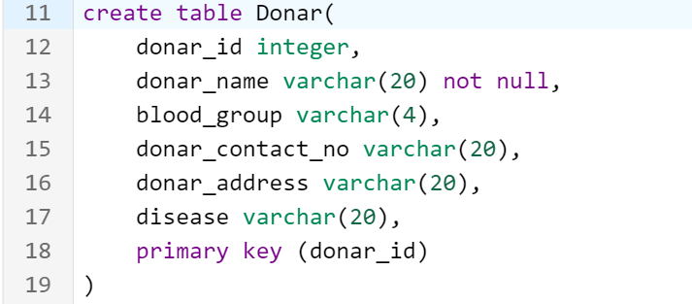

**Blood bank:**

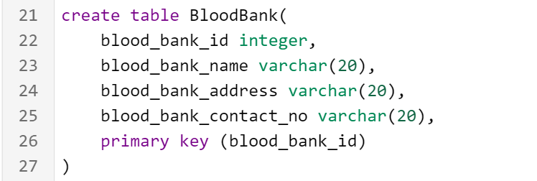

**Donate:**

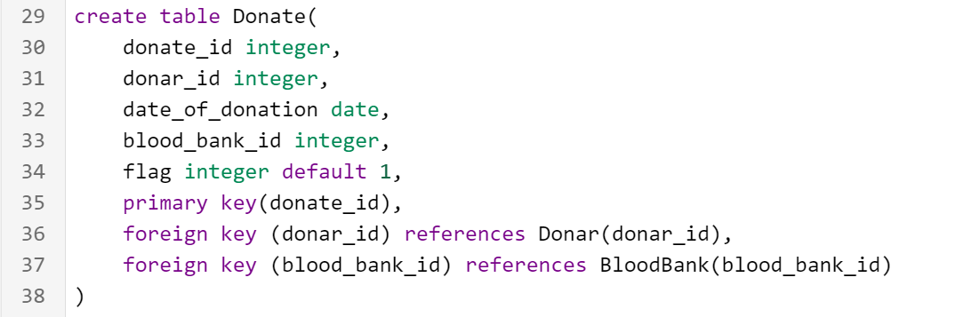

**Insertion:**

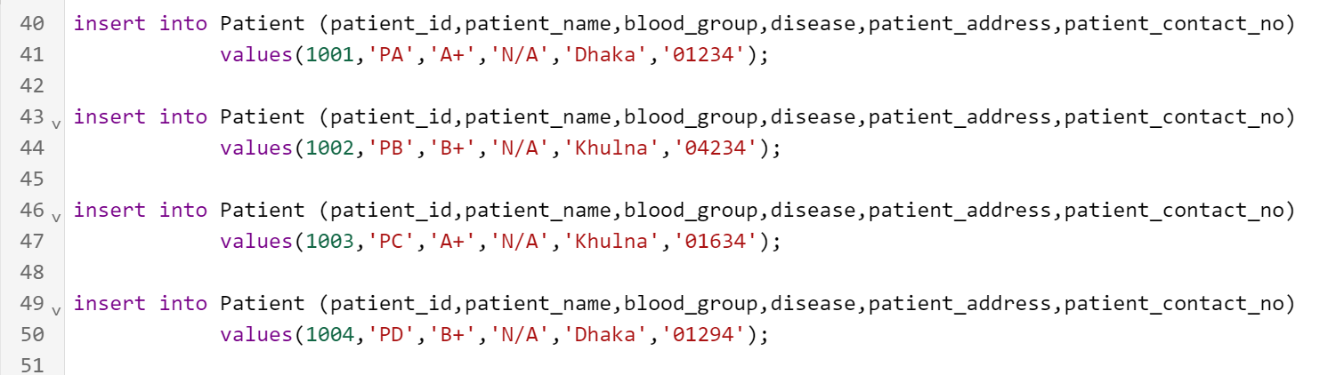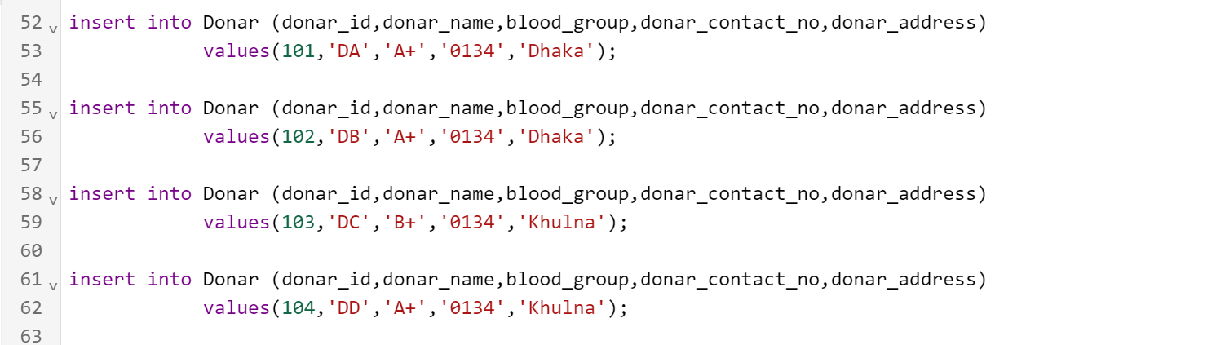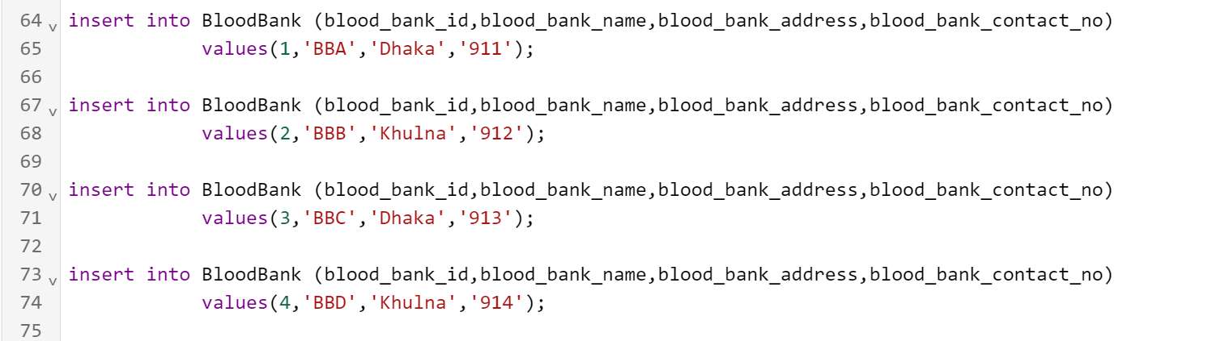

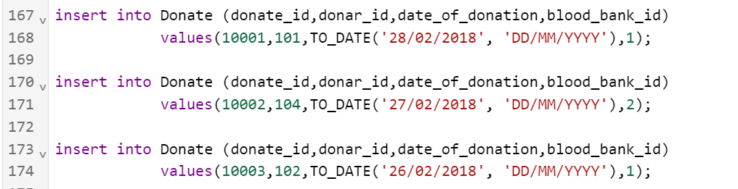

**Procedure:**

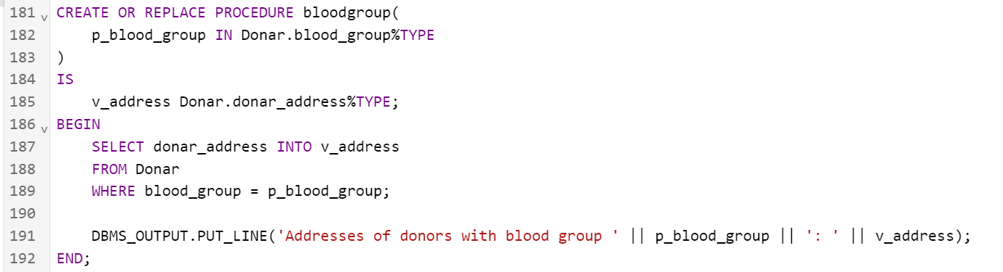

**Function:**

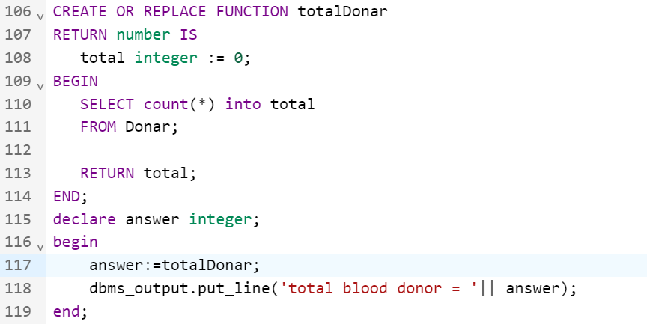

**Trigger:**

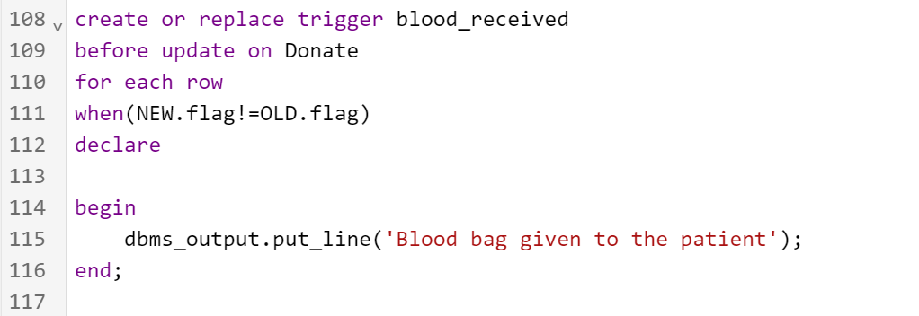

**OUTPUT:**

**Patient table:**

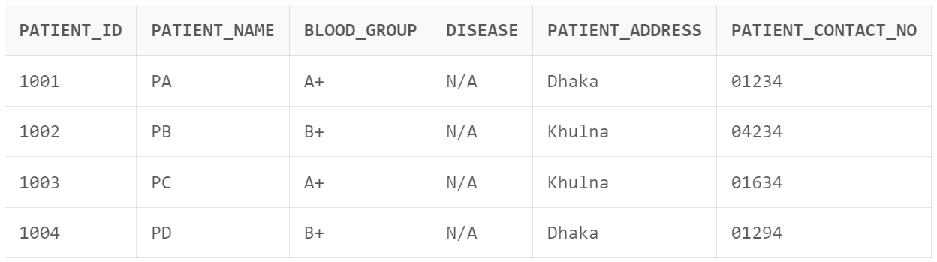

**Donor table:**

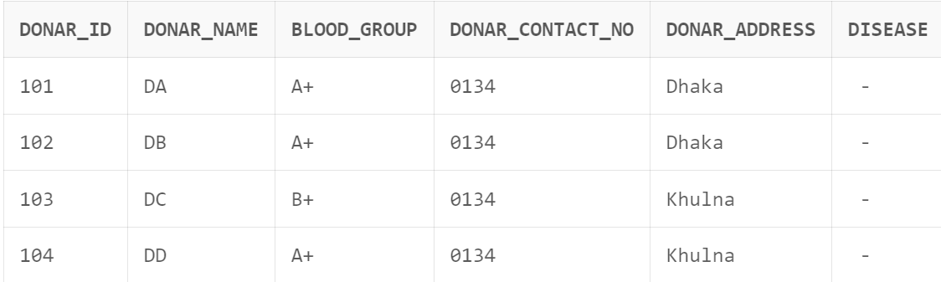

**Blood Bank table:**

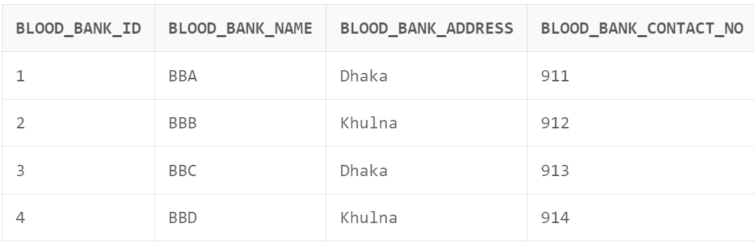

**Donate table:**

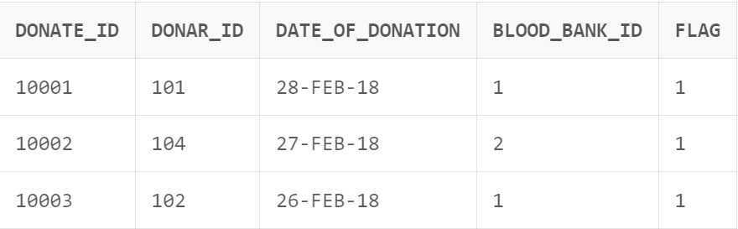

**Procedure:**

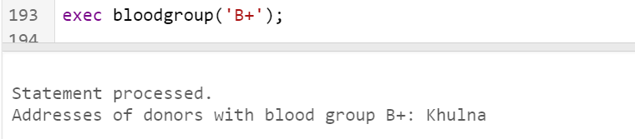

**Function:**

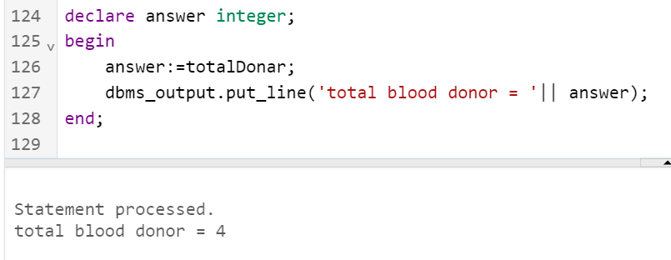

**Trigger:**

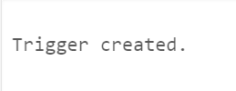

**NORMALISATION:**

**Patient:**

The table is normal for 1NF and 2NF but not for the 3NF as there is transitive dependency in the table. Patient’s contact number and address is not directly related to patient ID but to the patient’s name which is directly related to the primary key.

**Donor:**

The table is normal for 1NF and 2NF but not for the 3NF as there is transitive dependency in the table. Donor’s contact number and address is not directly related to Donor ID but to the Donor’s name which is directly related to the primary key.

**Blood Bank:**

This table is normal up to 3NF as it as single primary key and no composite attributes. All the attributes are dependent on primary key that is blood bank ID.

**Donate:**

The table is normal for 1NF and 2NF but not for the 3NF as there is transitive dependency in the table. There is no direct relation between Blood Bank ID, Donor ID, Donate ID. The table has been converted to 3NF with the use of foreign key giving references to connecting tables.