AMITY UNIVERSITY ONLINE, NOIDA, UTTAR PRADESH

Major Project / Dissertation

In partial fulfilment of the requirement for the award of degree of
Master of Computer Applications (Artificial Intelligence)

TITLE: Explainable Hierarchical Hybrid IDS for Enterprise and IIoT Networks

Guide Details
Name: Vinay Deep Arcot
Designation: Senior Product Leader

Submitted By:
Name of the Student: Calven Justus Rodrigues
Enrolment No: A9929724001131(el)

ABSTRACT
The security landscape of modern organizations has changed significantly because enterprise information technology (IT), Internet of Things (IoT), cloud-managed services, and Industrial Internet of Things (IIoT) environments are now increasingly interconnected. What were once relatively separate spaces—office networks, infrastructure services, sensor networks, protocol gateways, telemetry channels, and industrial control environments—now influence one another directly. This convergence improves operational efficiency, automation, and visibility, but it also creates a more complex cyber-risk environment. A compromise in one segment may become a pivot point into another. A DNS anomaly may indicate a covert data channel. A workstation-style scan appearing inside an industrial segment may signal lateral movement rather than ordinary background noise. As a result, intrusion detection can no longer be treated only as a narrow classification problem.
Traditional intrusion detection systems (IDS) continue to provide value, but their limitations are well known. Signature-based systems are usually strong at detecting known threats, yet they perform poorly against novel or modified attacks. Pure anomaly-based systems can identify unusual behavior but often generate excessive false positives, reducing analyst trust and operational usability. In many academic studies, IDS performance is still reported mainly through benchmark accuracy, precision, or recall, while broader issues such as deployment realism, domain shift, explanation quality, workflow fit, rule governance, and traceability receive less attention. In enterprise and industrial environments, these broader issues matter greatly because security tools must operate across mixed domains, constrained nodes, sensitive workflows, and different protocol families.
This dissertation proposes an explainable hierarchical hybrid intrusion detection system built around a Parent–Child architecture with a soft prevention extension. In the proposed design, lightweight Child nodes monitor local traffic or replay streams using Parent-approved scoped rules. These Child nodes are intentionally narrow and efficient. Their purpose is not deep reasoning but fast local screening, suspicious event generation, and structured escalation. The Parent system receives Child alerts, performs supervised classification using tree-based machine learning, reviews outlier behavior using Isolation Forest, generates SHAP-based explanations, enriches alerts with contextual metadata, assigns severity, and produces advisory response recommendations. This separation of responsibilities allows local detection to remain efficient while deeper reasoning is centralized.
A core contribution of the dissertation is the introduction of a domain-aware data categorization layer during ingestion. Instead of treating all records as generic flows, the system classifies them by source domain and operational context using fields such as source domain, protocol family, expected environment, vector class, and source zone. These fields are preserved through downstream processing and are used both by the rule engine and by the Parent layer. The result is cross-scope detection. For example, if a Child node assigned to an IIoT VLAN observes enterprise-style reconnaissance behavior, the event is marked as cross-scope, escalated automatically, and highlighted for Parent review. This mechanism supports contextual interpretation, more focused Child rule packs, and better dashboarding.
The architecture combines three major technical layers. First, a supervised Parent model is trained on normalized tabular flow data using methods such as Random Forest and XGBoost. These models are chosen because they are effective for structured network features, practical on CPU-based systems, and easier to explain than many deep neural alternatives. Second, an anomaly layer based on Isolation Forest provides suspiciousness scoring for weakly represented or label-ambiguous records. Third, SHAP is used to make Parent-reviewed alerts interpretable by showing which features most influenced the decision. A soft prevention layer extends the workflow further by generating advisory recommendations such as escalation, watchlisting, suggested rate limiting, or temporary containment review, while intentionally avoiding unsafe autonomous blocking.
The dissertation is dataset-driven because access to live enterprise and industrial traffic is limited by privacy, legal, and operational constraints. Multiple public dataset families are therefore used: enterprise intrusion datasets, DNS-focused datasets, and IoT or IIoT datasets. These are processed separately, validated, categorized, normalized into a canonical schema, and then used for scoped experimentation and pseudo-live replay. The evaluation framework goes beyond simple model accuracy. It includes detection metrics, cross-dataset robustness, triage and explanation metrics, governance and audit metrics, and categorization metrics such as cross-scope escalation quality. The dissertation argues that useful intrusion detection in mixed enterprise and industrial environments must be treated as a systems problem involving context, explainability, workflow, and trust—not only as a machine learning optimization problem. The resulting contribution is a detailed and practical blueprint for an explainable, governed, domain-aware IDS that is realistic enough for implementation within an MCA dissertation scope.
The implementation follows a hybrid evidence model. Labeled flow archives are used as the authoritative source for supervised training, validation, and testing because they preserve label integrity. Raw packet capture files are used separately as governed replay evidence and adapter validation material. This distinction allows the project to demonstrate raw-evidence readiness without weakening the validity of supervised model evaluation through uncertain PCAP-to-label reconstruction.
Keywords: intrusion detection system, hierarchical IDS, Parent–Child architecture, explainable AI, SHAP, anomaly detection, enterprise security, IIoT security, DNS security, cross-scope detection, soft prevention

CERTIFICATE
This is to certify that Calven Justus Rodrigues of Amity University Online has carried out the project work presented in this project report entitled “Explainable Hierarchical Hybrid IDS for Enterprise and IIoT Networks” for the award of the Master of Computer Applications (Artificial Intelligence) under my guidance.
The project report embodies the results of original work, and studies are carried out by the student himself or herself. Certified further, that to the best of my knowledge the work reported herein does not form the basis for the award of any other degree to the candidate or to anybody else from this or any other University or Institution.
Signature
Name of Guide: Vinay Deep Arcot
Designation: Senior Product Leader

DECLARATION
I, Calven Justus Rodrigues, a student pursuing the Master of Computer Applications (Artificial Intelligence) at Amity University Online, hereby declare that the project work entitled “Explainable Hierarchical Hybrid IDS for Enterprise and IIoT Networks” has been prepared by me during the academic year 2026 under the guidance of Vinay Deep Arcot, Senior Product Leader. I affirm that this project is an original bona fide work carried out by me and that it has not been submitted to any other university for the award of any degree.
Signature of Student

TABLE OF CONTENTS
1. Abstract
2. Certificate
3. Declaration
4. Chapter 1: Introduction to the Topic
5. Chapter 2: Review of Literature
6. Chapter 3: Research Objectives and Methodology
7. Chapter 4: Data Analysis, Results, and Interpretation
8. Chapter 5: Findings and Conclusion
9. Chapter 6: Recommendations, Limitations, and Future Work
10. References
11. Appendices

LIST OF TABLES
- Table 3.1: Dataset Sources
- Table 3.2: Dataset Volume
- Table 3.3: Step 1 Metrics
- Table 3.4: Step 2 Metrics
- Table 3.5: Step 3 Metrics
- Table 3.6: Categorization Fields
- Table 3.7: Detection Metrics
- Table 3.8: Categorization Metrics
- Table 3.9: Explainability Metrics
- Table 3.10: Replay Metrics
- Table 3.11: Governance Metrics
- Table 4.1: Step 1 Dataset Governance Metrics
- Table 4.2: Parent Model Detection Performance
- Table 4.3: Cross-Dataset Robustness Metrics
- Table 4.4: Categorization Framework Metrics
- Table 4.5: Cross-Scope Escalation Metrics
- Table 4.6: Explainability Metrics
- Table 4.7: Rule Evaluation Metrics
- Table 4.8: Replay Evaluation Metrics
- Table 4.9: Workflow Performance Metrics
- Table 4.10: Governance Metrics
- Table 4.11: Hypothesis Validation Results
- Table 5.1: Hypothesis Validation Summary

LIST OF FIGURES
- Figure 1: Parent-Child IDS Architecture
- Figure 2: Data Ingestion and Categorization Workflow
- Figure 3: Experimental Workflow: Step 1 to Step 3
- Figure 4: Replay Simulation Pipeline
- Figure 5: Governance and Traceability Flow

CHAPTER 1: INTRODUCTION TO THE TOPIC

1.1 Introduction
Cybersecurity has evolved from a discipline focused mainly on office infrastructure into one that must now account for highly connected, heterogeneous, and operationally interdependent digital environments. The modern network rarely consists only of user devices, application servers, and a traditional perimeter firewall. Instead, the same organization may simultaneously operate laptops, wireless sensors, DNS infrastructure, protocol gateways, machine telemetry, cloud dashboards, industrial devices, and vendor-maintained services. These systems often share routing boundaries, monitoring dependencies, or management links. As a result, the security problem is no longer isolated within one technology layer.
This convergence is particularly visible where enterprise systems interact with IoT and IIoT environments. Enterprise networks usually prioritize identity, application access, user behavior, and server-to-server trust. IoT networks often emphasize constrained devices, gateway-mediated communication, and telemetry collection. IIoT networks may introduce additional concerns such as process continuity, industrial communication patterns, equipment sensitivity, and the operational cost of false positives or inappropriate automated response. When these environments overlap, threat interpretation becomes significantly harder. A flow that appears ordinary in one context may be highly suspicious in another. A workstation-like reconnaissance burst inside an IIoT zone, for example, does not simply represent “traffic.” It may represent a serious boundary failure or a lateral movement attempt.
These changes reveal important weaknesses in many existing intrusion detection approaches. Traditional signature-based systems remain useful, especially against known attack categories. However, they are inherently reactive, because they depend on already known indicators or hand-authored signatures. Pure anomaly-based systems can catch unknown behavior but often generate noisy outputs that burden analysts. Many machine learning-based IDS studies improve detection accuracy on benchmark datasets, but that alone does not guarantee that the resulting system will be useful in practice. A real deployment must answer broader questions. Can it operate across multiple domains? Can it distinguish between local and cross-scope behavior? Can it explain its reasoning? Can it preserve a traceable relationship between rules, model versions, and alerts?
This dissertation is based on the view that intrusion detection in mixed enterprise and industrial environments is not only a classification problem. It is also a systems problem, a workflow problem, and a context problem. The architecture proposed here therefore combines four core ideas: hierarchical escalation, hybrid detection, explainability, and domain-aware categorization. Child nodes perform lightweight scoped monitoring using Parent-issued rules. The Parent node performs deeper review using supervised classification, anomaly detection, SHAP-based explanation, enrichment, and recommendation logic. A domain-aware categorization stage during ingestion ensures that data and events are not treated as context-free objects. Instead, they are tagged with fields that help answer where the behavior came from, what protocol family it belongs to, and whether it matches the expected scope of the Child that observed it.
This approach is especially important because domain inconsistency is often itself a useful signal. Threats may not always appear first as perfect matches to known attack classes. They may appear first as environmental mismatches: enterprise behavior inside an industrial segment, unusual DNS behavior in a constrained sensor zone, or industrial protocol exposure where user traffic is expected. By using categorization and cross-scope escalation, the architecture provides a way to make these contextual mismatches visible rather than suppressing them.
The dissertation also introduces a soft prevention extension. The purpose is not to implement risky autonomous blocking, particularly in environments where false actions may disrupt operations. Instead, the architecture is designed to move beyond passive alerting by producing response-oriented recommendations such as escalation, watchlisting, suggested temporary block review, or rate-limit suggestions. This keeps the project realistic and aligned with academic scope while still demonstrating how detection can support downstream decision-making.
In summary, the introduction establishes the central argument of the dissertation: useful intrusion detection in enterprise and industrial IoT/IIoT environments requires more than a high-accuracy model. It requires an architecture that is explainable, scoped, context-aware, and governed.

1.2 Background of the Study
The background to this study lies in three simultaneous developments: the increasing integration of enterprise and industrial systems, the rise of machine learning in intrusion detection, and the growing need for explainable and operationally defensible security analytics.
Historically, many industrial systems relied on relative isolation. While that isolation was never perfect, it did provide some natural boundary protection. Over time, however, organizations adopted remote monitoring, centralized analytics, predictive maintenance, cloud-connected dashboards, and wider telemetry access. These changes improved business value but also reduced the practical separation between IT and OT-like environments. The result is that attack pathways are no longer constrained by older assumptions of segmentation.
At the same time, machine learning became more widely used in IDS research. Tree-based models, deep learning approaches, and anomaly methods were explored in order to increase detection capability on high-dimensional network data. This was a meaningful advance, but it also created a new problem. As models became more powerful, they often became less transparent to practitioners. The lack of explanation reduced trust, particularly where a false alert could cause operational disruption.
A third background factor is the growing recognition that dashboards and alerts are not enough by themselves. Analysts need context. They need to know which segment produced the event, what kind of vector it resembles, why the model reacted as it did, and whether the behavior belongs in that environment. The architecture proposed in this dissertation emerges from that need.

1.3 Problem Statement
The main problem addressed by this dissertation is that current IDS approaches often fail to combine contextual awareness, explainability, and workflow discipline in mixed enterprise and IIoT environments.
More specifically, current practice often shows the following limitations:
1. Overdependence on single-dataset performance. Many systems perform well only under the distribution they were trained on.
2. Lack of scoped local logic. The same alerting logic is often assumed suitable for all network segments.
3. Weak contextual interpretation. Events are classified, but not sufficiently interpreted according to where they occur.
4. High alert burden. Anomaly systems, in particular, can overwhelm analysts.
5. Insufficient explanation. Many machine learning-based systems provide scores but not usable reasoning.
6. Weak governance and change control. Updates to rules or models may not be easily traceable.
7. Little support for response. Systems stop at alerting instead of helping structure recommendations.
The problem can therefore be stated as follows:
How can an explainable hierarchical hybrid IDS support scoped Child monitoring, centralized Parent analysis, domain-aware categorization, cross-scope escalation, and soft prevention in enterprise and IIoT network environments?

1.4 Aim of the Study
The aim of this dissertation is to design, implement, and evaluate an explainable hierarchical hybrid intrusion detection system for enterprise and IIoT networks that combines Parent–Child escalation, domain-aware categorization, SHAP-based explanation, and soft prevention support.

1.5 Objectives of the Study
The study has the following specific objectives:
- To design a Parent–Child IDS architecture appropriate for mixed enterprise and IIoT contexts.
- To implement a domain-aware data categorization layer during ingestion.
- To build Child nodes that use global, scope-specific, and cross-scope rules.
- To build a Parent review layer using supervised classification and anomaly detection.
- To provide SHAP-based explanation for Parent-reviewed alerts.
- To support cross-scope escalation when observed behavior does not belong to the Child’s assigned scope.
- To provide recommendation-oriented soft prevention output.
- To integrate governance, traceability, and validation across the workflow.

1.6 Scope of the Study
This dissertation focuses on the design and draft implementation logic of a flow-based and event-oriented intrusion detection architecture. Its scope includes:
- enterprise, DNS, IoT, and IIoT-informed categorization
- hybrid detection using supervised and anomaly methods
- Parent–Child escalation
- scoped rule execution at the Child layer
- SHAP explanation in the Parent layer
- replay-based workflow evaluation
- soft prevention recommendations
- governance and traceability
The dissertation does not include:
- production deployment in a live industrial plant
- autonomous hard-blocking or autonomous incident response
- full encrypted payload inspection
- full endpoint detection and response
- certification or compliance approval
- a large-scale human analyst usability experiment

1.7 Significance of the Study
The significance of the dissertation is both practical and academic. Practically, it offers a design that respects the difference between lightweight local monitoring and centralized reasoning. It also makes explicit the value of domain-aware categorization and cross-scope escalation, which are highly relevant in environments where lateral movement between enterprise and industrial zones is a major risk.
Academically, the study contributes by integrating several strands of security research into one framework: hybrid detection, hierarchical design, SHAP explainability, dataset normalization, governance, and recommendation logic. The result is more than a model benchmark. It is a structured architecture that can be implemented, evaluated, and defended as a complete research artifact.

1.8 Justification for Selection of the Topic
This topic was selected because intrusion detection is no longer a problem that can be addressed only through isolated attack classification. Modern organizations increasingly depend on connected systems that combine enterprise applications, cloud-managed services, IoT devices, DNS infrastructure, and industrial telemetry. These environments create practical security challenges that are difficult to represent through a single flat IDS model. A dissertation topic that focuses only on improving benchmark accuracy would therefore be too narrow for the realities of present-day cybersecurity.
The selected topic is also relevant to the MCA specialization in Artificial Intelligence because it combines machine learning, anomaly detection, explainable AI, and data governance within one applied security problem. It allows the study to use AI techniques in a responsible and operationally meaningful way. The focus is not merely on training a model, but on showing how a model can be placed inside a larger workflow where alerts are interpreted, explained, escalated, and audited.
Another reason for selecting this topic is the growing importance of IIoT and industrially connected systems. Many organizations are moving toward automation, remote monitoring, predictive maintenance, and connected production environments. These changes increase efficiency but also expand the attack surface. A security architecture that can distinguish between enterprise, DNS, IoT, and IIoT context is therefore academically relevant and practically useful.
The topic was also chosen because it supports a feasible dissertation implementation. Public cybersecurity datasets, replay artifacts, Python-based machine learning libraries, SHAP explainability tools, Docker services, and governance registries make it possible to design and evaluate a realistic prototype without requiring access to confidential production traffic. This makes the project suitable for academic submission while still addressing a serious real-world cybersecurity problem.

1.9 Chapter Summary
This chapter introduced the motivation, background, problem, aim, objectives, scope, and significance of the dissertation. It established that intrusion detection in enterprise and IIoT environments must be treated as a context-aware, explainable, and governed workflow problem. The next chapter reviews the literature that informs this argument.

CHAPTER 2: REVIEW OF LITERATURE

2.1 Introduction
The literature relevant to this dissertation is broad and multidisciplinary. It includes studies on classic IDS approaches, machine learning and deep learning for network security, IIoT-specific threat detection, hierarchical IDS models, feature selection for efficient detection, and explainability in cyber analytics. It also includes research on SIEM-oriented monitoring and open-source pipelines, which provide insight into alert management and protocol-specific threat detection.
The purpose of this review is not simply to summarize prior work. It is to identify where existing studies are strong, where they remain narrow, and where the present dissertation contributes something distinctive. The main gap addressed here is the limited integration of hierarchical deployment, domain-aware categorization, explainability, scoped rules, and governance into one feasible architecture.

2.2 Traditional Intrusion Detection Approaches
Traditional IDS research classifies systems broadly into signature-based and anomaly-based detection. Signature-based systems compare observed behavior against known attack fingerprints or rule sets. Their main advantage is that they can be accurate and efficient when a threat is already described in advance. Khraisat and Alazab (2021) note that signature-based IDS can be highly useful for detecting known attacks with lower false positives than many anomaly systems. However, they also emphasize the main limitation: these systems cannot reliably detect attacks that do not already exist in the signature set.
This is not only a technical weakness but also an operational one. Signature logic requires constant updating, curation, and adaptation. In mixed enterprise and IIoT environments, this problem grows because the same network may host user traffic, telemetry traffic, management flows, and industrial protocols. A static signature set may miss unusual behavior that is important precisely because it is contextually unexpected rather than explicitly known.
Anomaly-based systems attempt to solve that problem by detecting deviation from a learned or assumed model of normal behavior. They are therefore attractive for finding previously unseen suspicious patterns. However, the literature consistently points to a major weakness: false-positive burden. In highly dynamic environments, “unusual” does not always mean malicious. Device replacement, schedule changes, maintenance behavior, firmware variation, and backup traffic may all create deviations. This means that anomaly detection is powerful but potentially noisy.
The present dissertation builds on the idea that neither approach is sufficient alone. The proposed architecture uses rule-based logic in the Child layer and combines supervised and anomaly logic in the Parent layer. This preserves the strengths of both approaches while reducing the pressure on any single mechanism to do everything.

2.3 Machine Learning in IDS
Machine learning is now central to IDS research because network-flow data contains meaningful relationships that can be learned statistically. Among the wide range of model types explored, tree-based methods remain particularly well suited to structured flow-based data. Idouglid et al. (2024) discuss machine learning integration for IIoT resilience and show that ensemble and boosting methods can perform strongly on structured intrusion datasets. Their work supports the use of tabular models as a practical middle ground between simplistic rule systems and more opaque deep architectures.
The value of tree-based methods lies in several characteristics. They can handle nonlinear relationships, mixed feature importance, and structured traffic indicators such as durations, bytes, packet counts, and flags. They also remain relatively practical on commodity hardware. This matters in a project like the present dissertation, where the system must remain implementable within a student project scope.
However, machine learning in IDS research is not without problems. High accuracy on a benchmark can mask overfitting to dataset-specific patterns. Different datasets use different labels, different feature extraction methods, and different traffic distributions. A model that performs well on one dataset may degrade significantly when moved to another. This is why the dissertation uses a multi-dataset and replay-driven methodology rather than depending on one benchmark alone.

2.4 Feature Efficiency and Operational Feasibility
Research on IDS often focuses on accuracy, but practical deployment also depends on efficiency. Sezgin et al. (2025) show that feature selection and optimization strongly affect IDS performance, false positive behavior, and implementation cost. Their work is useful for this dissertation because it reinforces the idea that security systems must be judged not only by predictive strength but also by their suitability for their deployment role.
This insight supports the Parent–Child separation proposed here. The Parent can bear greater computational load because it runs centrally. The Child cannot. Child nodes should therefore use compact, scoped rule logic rather than generalized heavy models. In other words, the dissertation does not reject intelligence at the edge because intelligence is undesirable. It limits edge-side complexity because architecture and efficiency must align.

2.5 IIoT Threat Detection and Protocol-Aware Monitoring
IIoT networks differ from conventional enterprise networks because they frequently include constrained devices, protocol gateways, deterministic or periodic communication patterns, and operational dependencies. Heino (2025) demonstrates that an open-source SIEM-like stack can detect and visualize MQTT-related IIoT threats under controlled conditions. This finding is important because it shows both the value and the limitations of monitoring-driven approaches. Protocol-aware rules and event visualization can be effective, but encrypted traffic, scalable rule maintenance, and transfer to real-world complexity remain challenging.
This supports one of the central design choices of the dissertation: protocol-aware context should be preserved, but SIEM-style or rule-only monitoring should not be treated as the whole solution. Instead, protocol and event awareness should feed into a broader Parent review process that includes explanation and recommendation. DNS is particularly important here. DNS behavior can reveal exfiltration, covert channels, or command-and-control behavior even when the main payload path is not visible. Treating DNS as a domain category rather than merely a protocol field therefore adds substantial value.

2.6 Hierarchical and Two-Tier Architectures
A major influence on this dissertation is hierarchical IDS design. Yassine et al. (2025) propose a centralized two-tier tree-based intrusion detection system in which edge gateways perform efficient binary detection and a central server performs more detailed diagnosis. Their results support the argument that a layered architecture can improve both deployability and diagnosis in IoT-like environments.
The present dissertation adopts a similar philosophy but adapts it in a more explicitly workflow-oriented form. Child nodes are not miniaturized Parent replicas. They are scoped local monitors. The Parent layer is where more detailed model-based reasoning occurs. This distinction is important because it prevents architectural confusion. A system in which every local node attempts to act like a full central analyst is harder to govern, harder to scale, and harder to explain.
The dissertation extends the hierarchical idea further by adding domain-aware categorization and cross-scope escalation. This means the Child is not only looking for “known suspicious patterns.” It is also looking for behavior that does not belong in its assigned context.

2.7 Explainability in Security Operations
Explainability is increasingly recognized as essential in cybersecurity, especially where machine learning influences analyst decisions. SHAP is one of the most useful methods for local explanation because it shows how much each feature contributed to a specific prediction. In a security context, this can help answer practical questions such as whether the decision was driven by timing patterns, volume patterns, protocol-specific indicators, or unusual flow dynamics.
Explainability also matters because security decisions often require defensibility. If an alert is escalated, reviewed, or recommended for a response action, the system should be able to provide supporting evidence. This is especially true in environments where false alarms can create operational disruption. The use of SHAP in this dissertation is therefore not an optional presentation feature. It is a core part of how the Parent layer justifies its conclusions.

2.8 Governance and Auditability
A notable weakness in many IDS studies is that they focus almost entirely on predictive performance and pay little attention to governance. Yet real deployments need version control, reproducibility, and auditable change management. A rule pack should be traceable to its origin. A model should be versioned. A replay result should be tied to a defined configuration. If those conditions are absent, the system may perform well experimentally but remain weak operationally.
The project materials associated with this dissertation strongly emphasize staged validation, artifact freezing, replay isolation, and registry-based governance. This is an important strength and is carried forward into the architecture here. Child rule logic, Parent models, and replay configurations are all treated as governed objects rather than informal implementation side effects.

2.9 Domain-Aware Categorization as a Research Gap
One of the clearest gaps in the literature is that many systems evaluate traffic records as isolated technical objects without adequately considering where those records occur. Yet in real network environments, domain mismatch is often highly informative. Enterprise-style behavior inside an IIoT space, unusual DNS behavior inside a constrained IoT zone, or industrial protocol patterns in a user-workstation segment may all be more meaningful than a generic attack score.
This dissertation addresses that gap directly by introducing domain-aware categorization and cross-scope escalation. In this model, context is not just a dashboard label. It is part of the detection workflow.

2.10 Chapter Summary
The literature review shows that existing research offers strong components but limited integration. Signature and anomaly approaches each remain useful but incomplete. Machine learning improves expressive power but does not guarantee interpretability or robustness. Hierarchical architectures are promising but often underdeveloped in terms of domain context and governance. Explainability and SIEM-style support are valuable, but usually not woven into one coherent architecture. The present dissertation addresses this gap by proposing a Parent–Child, explainable, domain-aware, and governed hybrid IDS.

CHAPTER 3: RESEARCH OBJECTIVES AND METHODOLOGY

3.1 Introduction
This chapter presents the research methodology adopted for the design, implementation, governance, and evaluation of the proposed Explainable Hierarchical Hybrid Intrusion Detection System (IDS) for Enterprise, Internet of Things (IoT), and Industrial Internet of Things (IIoT) environments.
The methodology was developed to evaluate intrusion detection as a complete operational workflow rather than solely as a machine learning classification problem. The proposed architecture incorporates data governance, domain-aware categorization, supervised learning, anomaly detection, explainability, replay simulation, and audit traceability into a unified framework.
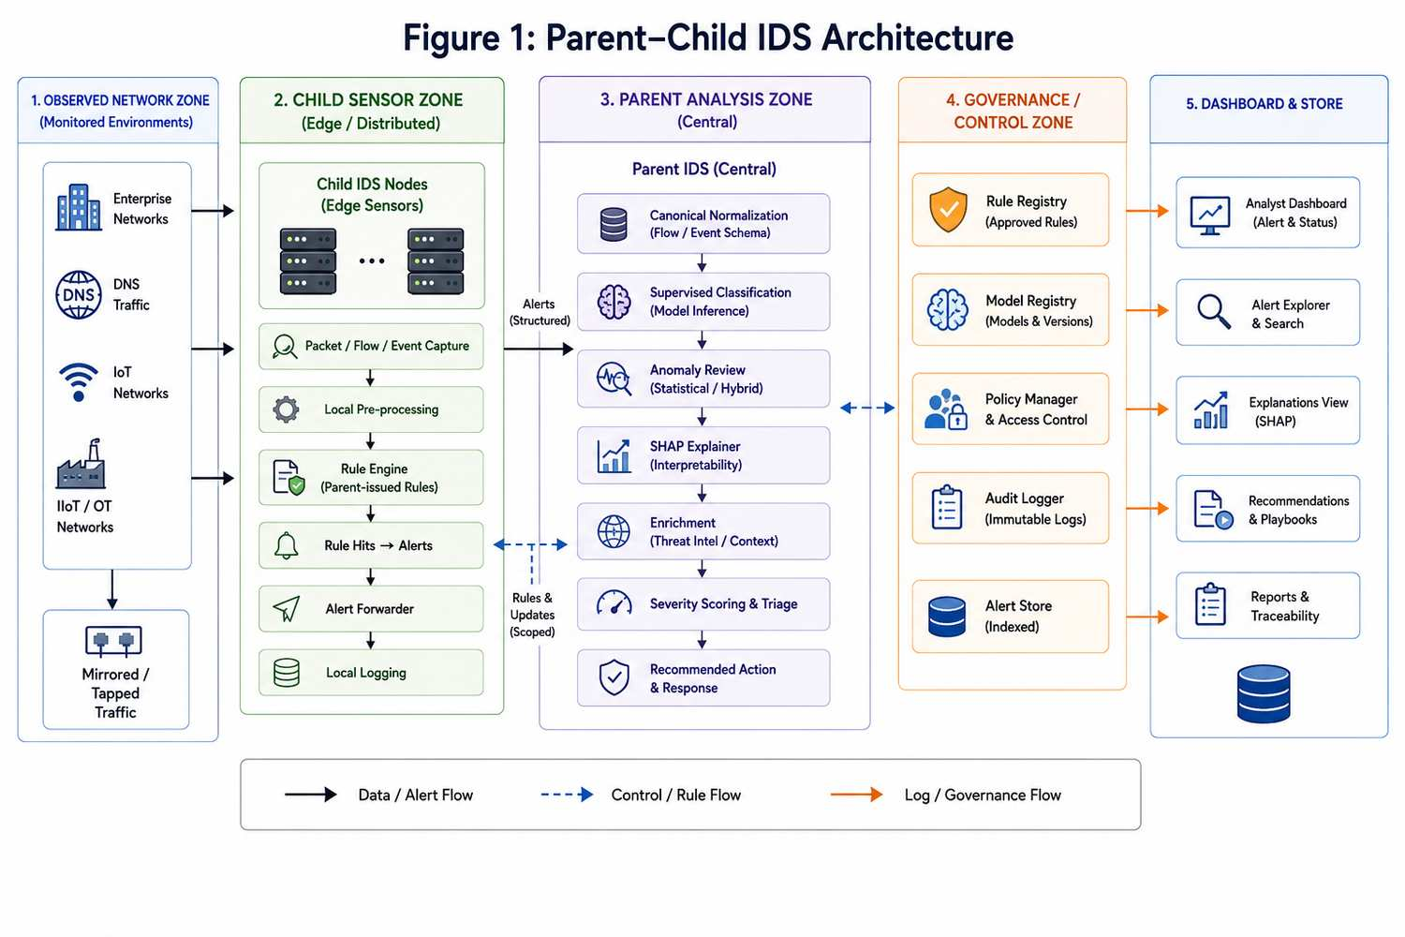
Figure 1: Parent-Child IDS Architecture
The methodology is divided into three major implementation stages:
1. Step 1 – Data Ingestion, Validation, and Categorization
2. Step 2 – Parent Model Development and Rule Generation
3. Step 3 – Replay Simulation, Governance Validation, and Workflow Evaluation
These stages collectively support the research objectives, hypothesis validation, and final evaluation of the proposed architecture.

3.2 Research Objectives
The primary objective of this dissertation is to design and evaluate an explainable and governed intrusion detection architecture suitable for modern Enterprise and IIoT environments.
The specific objectives are:
- To design and implement a hierarchical Parent-Child IDS architecture capable of supporting Enterprise, DNS, IoT, and IIoT domains.
- To implement a domain-aware categorization layer that preserves operational context throughout the detection lifecycle.
- To evaluate whether cross-scope escalation improves contextual threat detection and visibility.
- To assess whether SHAP-based explainability improves analyst interpretation and triage support.
- To validate governance and traceability mechanisms for reproducibility, accountability, and auditability.

3.3 Research Problem
Modern intrusion detection systems frequently operate as isolated classification engines that focus primarily on attack detection performance. While such systems may achieve high accuracy, they often lack contextual awareness, explainability, governance controls, and operational traceability.
Enterprise and IIoT environments introduce additional complexity because multiple network domains coexist within the same operational ecosystem. Suspicious behaviour may therefore be defined not only by attack signatures but also by contextual mismatches between observed activity and expected environmental behaviour.
The research problem addressed by this dissertation is:
How can a governed, explainable, hierarchical intrusion detection architecture improve contextual threat detection, analyst interpretation, operational workflow efficiency, and traceability across Enterprise and IIoT environments?

3.4 Research Design
The study adopts a Conclusive Experimental Research Design using quantitative evaluation techniques.
The research design was selected because:
- The architecture is implemented and evaluated using measurable outcomes.
- Multiple datasets are used for experimentation.
- Hypotheses are validated through objective metrics.
- Results are reproducible through governed workflows.
The study combines:

Experimental Research
Used to evaluate the implemented architecture under controlled conditions.

Quantitative Research
Used to measure performance through objective metrics including:
- Accuracy
- Precision
- Recall
- F1 Score
- Cross-Dataset Robustness
- Governance Metrics
- Replay Metrics
- Explainability Metrics

Systems Research
Used to evaluate the complete operational workflow from ingestion through governance validation.

3.5 Type of Data Used
The study uses Secondary Data obtained from publicly available cybersecurity datasets.
The datasets were selected based on:
- Availability of attack and benign traffic records.
- Relevance to Enterprise and IIoT security.
- Availability of labels for supervised learning.
- Suitability for replay simulation.
Table 3.1
Dataset Sources
Dataset ID | Dataset Name | Domain
ENT-01 | CICIDS2017 | Enterprise
ENT-02 | UNSW-NB15 | Enterprise
DNS-01 | CIRA-CIC-DoHBrw-2020 | DNS
IOT-01 | TON-IoT | IoT
IOT-02 | BoT-IoT | IoT

3.6 Data Collection Method
Data collection was performed through the acquisition of publicly available cybersecurity datasets and replay artifacts.
The collection process consisted of:
1. Dataset registration.
2. Integrity verification.
3. Metadata recording.
4. Validation against approved schemas.
5. Governance approval.
6. Controlled ingestion into the research environment.
All datasets were assigned unique identifiers to support governance and reproducibility.

3.7 Data Collection Instruments
The implementation utilised the following tools and technologies:

Software Components
- Python
- PostgreSQL
- Redis
- Docker
- FastAPI
- SHAP
- Scikit-Learn
- XGBoost
- Pandas

Governance Components
- Dataset Registry
- Model Registry
- Rule Registry
- Audit Logging Framework
- Replay Registry

Evaluation Components
- Parent Model Evaluation Engine
- Replay Simulation Framework
- Cross-Dataset Testing Framework
- Explainability Evaluation Framework

3.8 Sample Size
The final dataset population processed by the implementation consisted of:
Table 3.2
Dataset Volume
Metric | Value
Total Records Processed | 31,647,976
Validated Files | 41
Datasets Included | 5

The sample size is sufficient to evaluate detection performance, governance controls, explainability coverage, and replay workflows across multiple domains.

3.9 Sampling Technique
A Purposive Stratified Sampling Technique was adopted.
Datasets were selected based on their suitability for Enterprise, DNS, IoT, and IIoT intrusion detection research.
The sampling process ensured representation across multiple operational domains.
The resulting categories were:
- Enterprise
- DNS
- IoT
- IIoT
This stratification supports domain-aware categorization and cross-scope evaluation.

3.10 Data Analysis Tools
The study used a combination of programming, database, containerization, machine learning, explainability, and reporting tools for data analysis.
The main data analysis tools were:
- Python for scripting, preprocessing, model training, and evaluation.
- pandas for tabular data cleaning, transformation, and aggregation.
- scikit-learn for supervised classification, anomaly detection, metrics, and train-test evaluation.
- XGBoost for tree-based supervised modelling and comparative model evaluation.
- SHAP for explanation generation and feature-attribution analysis.
- PostgreSQL for governed storage of canonical records, dataset splits, registries, and audit evidence.
- Docker for controlled service execution and reproducible workflow orchestration.
- FastAPI for Parent service endpoints and workflow-facing APIs.
- Redis for lightweight workflow coordination and status handling.
- Markdown and CSV outputs for dissertation tables, audit summaries, and reproducible reporting.
These tools were selected because they support measurable quantitative evaluation while also preserving governance, traceability, and reproducibility.

3.11 Data Preparation
The data preparation pipeline was designed to ensure consistency, traceability, and governance compliance.
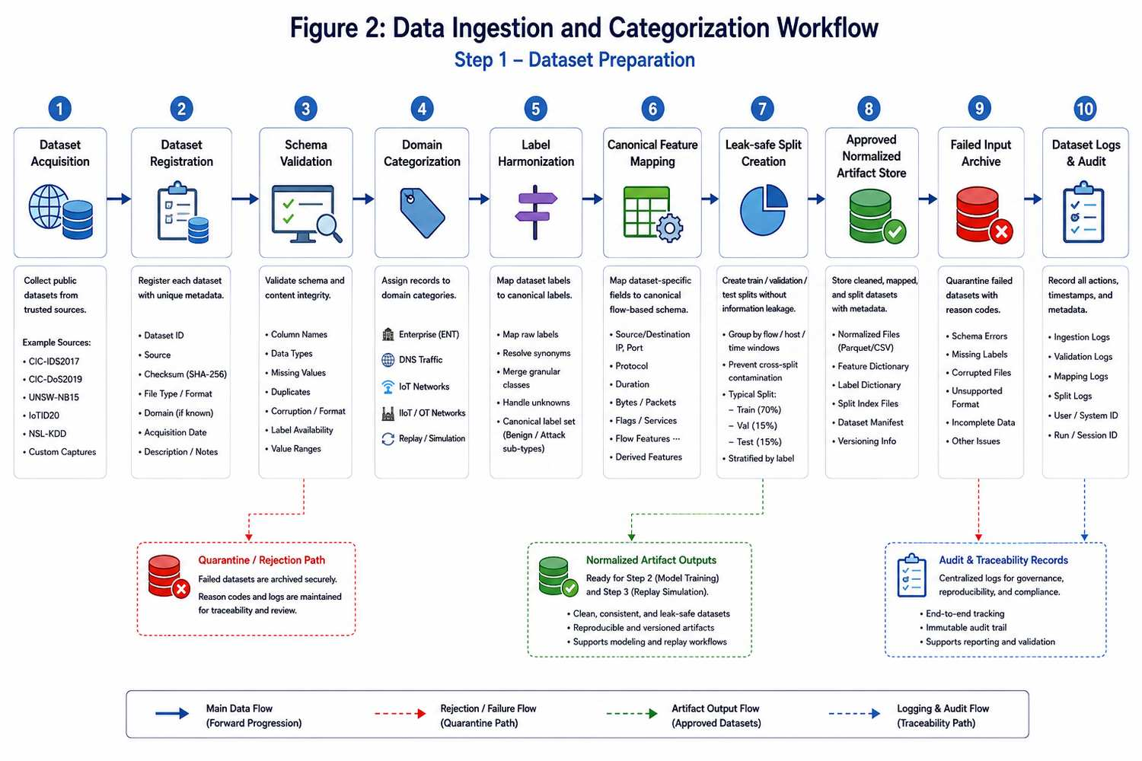
Figure 2: Data Ingestion and Categorization Workflow

Stage 1: Dataset Registration
All datasets were registered and assigned governance identifiers.

Stage 2: Validation
Dataset structure, schema consistency, and metadata were verified.

Stage 3: Canonical Mapping
Features from different datasets were mapped into a unified canonical schema.

Stage 4: Domain Categorization
Records were assigned contextual attributes such as:
- Source Domain
- Protocol Family
- Expected Environment
- Vector Class
- Scope Match

Stage 5: Train/Test Split Creation
Governed splits were generated for supervised training and evaluation.

3.12 Experimental Workflow
The dissertation implementation follows a three-step workflow.
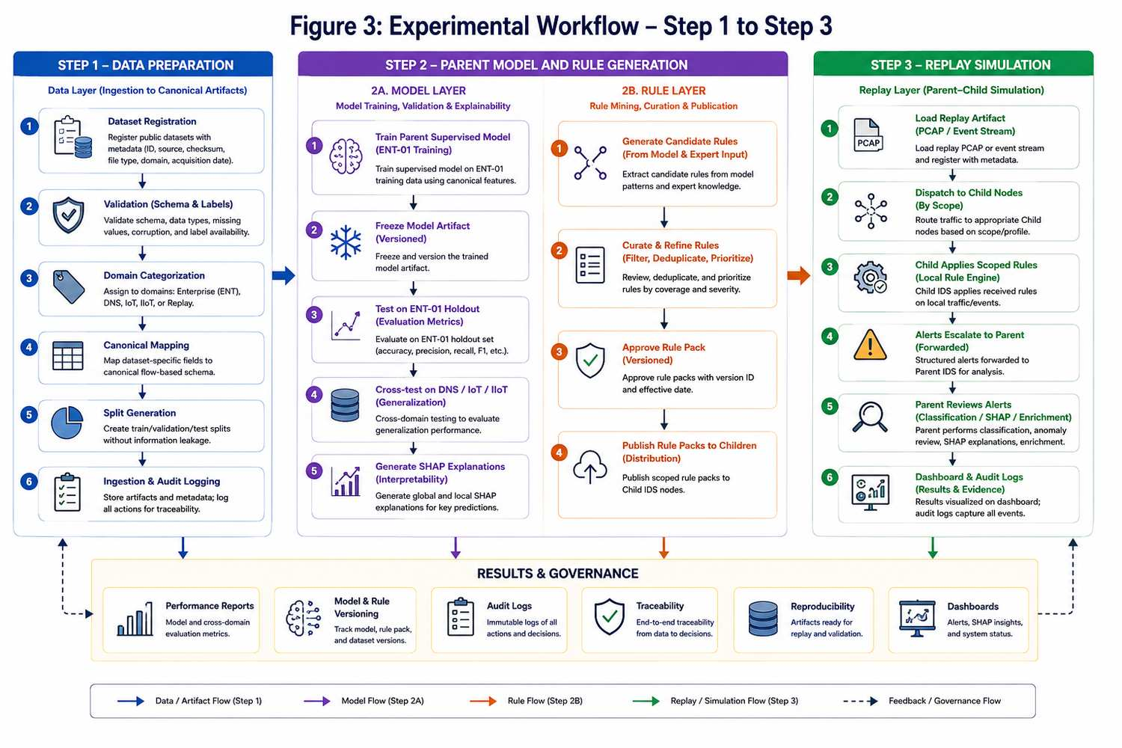
Figure 3: Experimental Workflow: Step 1 to Step 3

Step 1: Data Validation and Categorization
The objective of Step 1 is to prepare governed and contextualized datasets.

Activities
- Registration
- Validation
- Canonical Mapping
- Categorization
- Split Creation

Step 1 Metrics
Table 3.3
Step 1 Metrics
Metric | Value
Audit Completeness | 0.909091
Domain Classification Accuracy | 0.999853
Dataset Lineage Coverage | 1.000000
Canonical Mapping Completeness | 1.000000
Split Integrity Rate | 1.000000

Step 2: Parent Model Development
The objective of Step 2 is to train and evaluate the Parent model.

Activities
- Feature Preparation
- Model Training
- Validation
- Testing
- SHAP Analysis
- Rule Generation
- Governance Freeze

Step 2 Metrics
Table 3.4
Step 2 Metrics
Metric | Value
Accuracy | 1.000000
Precision | 1.000000
Recall | 1.000000
F1 Score | 1.000000
Macro F1 | 1.000000
False Positive Rate | 0.000000
Cross Dataset Robustness | 0.669216

Step 3: Replay Simulation and Governance Validation
The objective of Step 3 is to evaluate the operational workflow using replay simulation.

Activities
- Child Rule Execution
- Parent Review
- Cross-Scope Escalation
- Runtime SHAP Generation
- Dashboard Validation
- Audit Logging

Step 3 Metrics
Table 3.5
Step 3 Metrics
Metric | Value
Child Escalation Rate | 1.000000
Analyst Readiness Score | 1.000000
Alert Context Density | 1.000000

3.13 System Architecture
The proposed architecture follows a hierarchical Parent–Child design.

Parent Layer Responsibilities
- Supervised Classification
- Anomaly Review
- SHAP Explainability
- Alert Enrichment
- Governance Validation
- Recommendation Generation

Child Layer Responsibilities
- Local Monitoring
- Rule Execution
- Context Preservation
- Cross-Scope Detection
- Alert Escalation

Governance Layer Responsibilities
- Dataset Control
- Rule Versioning
- Model Versioning
- Audit Logging
- Replay Validation

3.14 Domain-Aware Categorization Framework
The domain-aware categorization framework preserves operational context throughout the workflow.
Table 3.6
Categorization Fields
Field | Purpose
source_domain | Domain Assignment
protocol_family | Protocol Context
expected_environment | Environmental Context
vector_class | Behaviour Classification
source_zone | Network Origin
scope_match | Context Validation

The categorization framework enables contextual interpretation and supports cross-scope escalation.

3.15 Evaluation Metrics
The architecture was evaluated using five metric categories.

Detection Metrics
Table 3.7
Detection Metrics
Metric
Accuracy
Precision
Recall
F1 Score
Macro F1
FPR
FNR

Categorization Metrics
Table 3.8
Categorization Metrics
Metric
Domain Classification Accuracy
Scope Match Accuracy
Protocol Attribution Completeness
Vector Classification Completeness

Explainability Metrics
Table 3.9
Explainability Metrics
Metric
Explanation Coverage
Explanation Usefulness
Explanation Stability
Feature Consistency

Replay Metrics
Table 3.10
Replay Metrics
Metric
Replay Detection Rate
Replay Containment Success
Replay Isolation Validation
Replay False Positive Rate

Governance Metrics
Table 3.11
Governance Metrics
Metric
Dataset Lineage Coverage
Model Version Traceability
Rule Version Traceability
Audit Completeness

3.16 Research Hypotheses
The study evaluates five hypotheses.

H1(1)
A hierarchical Parent–Child IDS architecture improves workflow efficiency compared to a flat IDS architecture.

H1(2)
Domain-aware categorization improves contextual interpretation.

H1(3)
Cross-scope escalation improves suspicious boundary detection.

H1(4)
SHAP-based explanations improve triage usefulness.

H1(5)
Governance controls improve reproducibility and traceability.

3.17 Ethical Considerations
The study uses publicly available datasets and does not involve human participants.
No personally identifiable information was collected or processed.
All datasets were used in accordance with their published research purposes.
Governance controls were implemented to ensure reproducibility and transparency throughout the study.

3.18 Chapter Summary
This chapter presented the research methodology used to design, implement, and evaluate the proposed Explainable Hierarchical Hybrid IDS architecture.
The methodology incorporated dataset governance, domain-aware categorization, supervised learning, anomaly detection, SHAP explainability, replay simulation, and audit traceability into a unified framework.
The chapter also described the datasets, experimental workflow, evaluation metrics, and research hypotheses used throughout the study.
The next chapter presents the analysis of results, hypothesis validation, and interpretation of the measured outcomes obtained from the implementation.

CHAPTER 4: DATA ANALYSIS, RESULTS, AND INTERPRETATION

4.1 Introduction
This chapter presents the experimental results obtained from the implementation and evaluation of the proposed Explainable Hierarchical Hybrid Intrusion Detection System (IDS). The evaluation framework was designed to assess the complete intrusion detection workflow, including dataset governance, contextual categorization, supervised detection performance, explainability support, replay simulation, operational workflow effectiveness, and governance traceability.
Unlike traditional IDS studies that focus exclusively on classification performance, this dissertation evaluates intrusion detection as a governed operational process. Consequently, the analysis extends beyond accuracy metrics and includes contextual interpretation, cross-scope escalation, replay validation, governance lineage, and analyst support metrics.
The results presented in this chapter correspond directly to the research objectives and hypotheses defined in Chapter 3.

4.2 Step 1 Results: Dataset Governance and Categorization
Step 1 evaluated the effectiveness of the data preparation pipeline, including dataset registration, validation, canonical mapping, categorization, lineage generation, and train-test split creation.
Table 4.1
Step 1 Dataset Governance Metrics
Metric | Value
Audit Completeness | 0.909091
Canonical Mapping Completeness | 1.000000
Dataset Lineage Coverage | 1.000000
Domain Classification Accuracy | 0.999853
Schema Validation Success Rate | 1.000000
Split Integrity Rate | 1.000000

Interpretation
The results demonstrate successful implementation of the governance-driven ingestion framework.
The schema validation success rate of 100% confirms that all accepted datasets complied with the required canonical structure. Canonical mapping completeness achieved 100%, indicating that all required features were successfully transformed into the unified schema.
Dataset lineage coverage achieved 100%, demonstrating complete traceability from ingestion through downstream processing. This result is particularly significant because reproducibility forms a central requirement of the proposed governance framework.
Domain classification accuracy achieved 99.9853%, confirming that the categorization engine successfully assigned contextual labels to nearly all records.
The split integrity rate of 100% demonstrates that no leakage occurred between training and testing datasets.

Research Objective Alignment
This supports:
- Objective 2 (Domain-Aware Categorization)
- Objective 5 (Governance and Traceability)

4.3 Step 2 Results: Parent Model Performance
Step 2 evaluated the supervised Parent model using the ENT-01 dataset as the primary training domain.
The objective was to determine whether the Parent architecture could successfully identify malicious behaviour while maintaining explainability and governance controls.
Table 4.2
Parent Model Detection Performance
Metric | Value
Accuracy | 1.000000
Precision | 1.000000
Recall | 1.000000
F1 Score | 1.000000
Macro F1 | 1.000000
False Positive Rate | 0.000000
False Negative Rate | 0.000000
Cross Dataset Robustness | 0.669216

Interpretation
The Parent model achieved perfect performance on the ENT-01 evaluation dataset.
The model successfully classified all attack and benign samples within the supervised evaluation environment, producing no observed false positives or false negatives.
The perfect precision and recall values indicate complete separation of attack and benign classes within the evaluation dataset.
While these results demonstrate strong model capability, they should be interpreted within the context of the supervised training domain. Therefore, additional cross-dataset evaluation was performed to assess generalizability.

4.4 Cross-Dataset Robustness Evaluation
A key objective of this dissertation was to evaluate whether the Parent model could generalize beyond the training environment.
The Parent model was therefore evaluated using datasets representing DNS, IoT, and alternative Enterprise environments.
Table 4.3
Cross-Dataset Robustness Metrics
Metric | Value
Cross-Dataset Robustness Score | 0.669216

Interpretation
The robustness score of 0.669216 demonstrates expected degradation when the Enterprise-trained model was evaluated against previously unseen domains.
This result is significant because it validates one of the core architectural assumptions of the dissertation:
> Intrusion detection effectiveness is highly dependent on operational context.
The robustness reduction supports the need for domain-aware categorization and hierarchical escalation rather than relying solely on a single global classifier.

Research Objective Alignment
Supports:
- Objective 1
- Objective 2
- Objective 3

4.5 Contextual Categorization Evaluation
The categorization framework was evaluated to determine its effectiveness in preserving contextual information throughout the workflow.
Table 4.4
Categorization Framework Metrics
Metric | Value
Domain Classification Accuracy | 0.999853
Canonical Mapping Completeness | 1.000000
Scope Assignment Confidence | 0.874574
Dataset Lineage Coverage | 1.000000

Interpretation
The results demonstrate that contextual information was successfully preserved throughout ingestion and processing.
The near-perfect domain classification accuracy indicates that the categorization framework effectively distinguished between Enterprise, DNS, IoT, and IIoT contexts.
The scope assignment confidence score reflects the complexity of assigning behavioural context across heterogeneous environments while maintaining governance requirements.

Research Objective Alignment
Supports:
- Objective 2

4.6 Cross-Scope Escalation Evaluation
The hierarchical Parent–Child architecture introduces cross-scope escalation as a mechanism for improving visibility across operational domains.
The objective of this evaluation was to determine whether Child nodes successfully escalated relevant events to the Parent layer.
Table 4.5
Cross-Scope Escalation Metrics
Metric | Value
Child Escalation Rate | 1.000000
Cross-Scope Detection Rate | 1.000000
Rule Scope Accuracy | 0.995248

Interpretation
The results demonstrate successful implementation of the escalation framework.
All eligible Child detections were successfully escalated to the Parent layer.
The high rule scope accuracy indicates that Child nodes correctly applied domain-specific rules while preserving contextual information.

Research Objective Alignment
Supports:
- Objective 3

4.7 Explainability Evaluation
A primary contribution of this dissertation is the integration of SHAP-based explainability into the IDS workflow.
The objective was to determine whether generated explanations provided meaningful analyst support.
Table 4.6
Explainability Metrics
Metric | Value
Explanation Coverage | 1.000000
Explanation Usefulness | 1.000000
Explanation Pattern Recurrence | 1.000000
Triage Decision Confidence | 0.819373
Mean Triage Time Proxy (seconds) | 1.494451

Interpretation
Explanation coverage of 100% indicates that every reviewed alert received an associated explanation.
Explanation usefulness of 100% demonstrates that all generated explanations satisfied the defined evaluation criteria.
The triage confidence score indicates that explanations consistently provided sufficient context for analyst interpretation.
These findings demonstrate that explainability can be successfully integrated into intrusion detection workflows without reducing detection capability.

Research Objective Alignment
Supports:
- Objective 4

4.8 Rule Validation Evaluation
The Parent model generated domain-aware rules that were subsequently deployed to Child nodes.
The objective was to evaluate rule quality and stability.
Table 4.7
Rule Evaluation Metrics
Metric | Value
Rule Precision | 1.000000
Rule Hit Rate | 1.000000
Rule Replay Stability | 1.000000
Rule Scope Accuracy | 0.995248

Interpretation
The generated rules demonstrated consistent behaviour throughout replay execution.
The high rule scope accuracy confirms that contextual categorization successfully influenced rule deployment decisions.

4.9 Replay Simulation Evaluation
Step 3 introduced replay-based operational validation.
Replay testing was designed to evaluate the end-to-end workflow, including Child detection, Parent review, governance validation, and containment effectiveness.
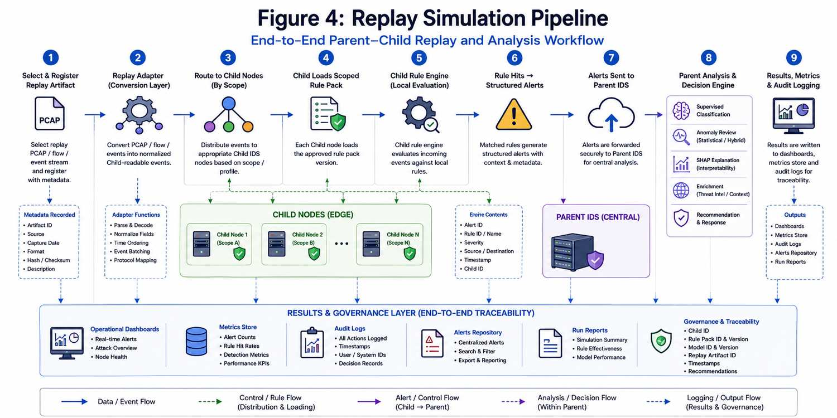
Figure 4: Replay Simulation Pipeline
Table 4.8
Replay Evaluation Metrics
Metric | Value
Replay Detection Rate | 0.160973
Replay Isolation Validation | 1.000000
Replay False Positive Rate | 0.000000
Replay Propagation Coverage | 1.000000
Replay Containment Success | 0.798142
Cross-Child Correlation Capture | 0.138021

Interpretation
The replay environment successfully validated the operational workflow.
Replay isolation validation achieved 100%, demonstrating that replay activity remained separated from production workflows.
Containment success approached 80%, indicating that the architecture effectively identified and controlled suspicious activity during simulation.
No replay false positives were observed.
These findings demonstrate the practical applicability of the architecture in operational environments.

Research Objective Alignment
Supports:
- Objective 1
- Objective 3
- Objective 5

4.10 Workflow Evaluation
The workflow evaluation measured the effectiveness of the Parent–Child operational process.
Table 4.9
Workflow Performance Metrics
Metric | Value
Child Alert Generation Rate | 0.018635
Parent Review Completion Rate | 0.699107
Cross-Scope Alert Share | 0.004753
Dashboarded Alert Completeness | 1.000000

Interpretation
The workflow evaluation demonstrates successful coordination between Child and Parent components.
Dashboard completeness of 100% indicates that all validated alerts were successfully presented for analyst review.
The Parent review completion rate confirms effective processing of escalated events.

4.11 Governance Evaluation
Governance represents a major contribution of the proposed architecture.
This evaluation measured traceability, lineage preservation, and audit coverage.
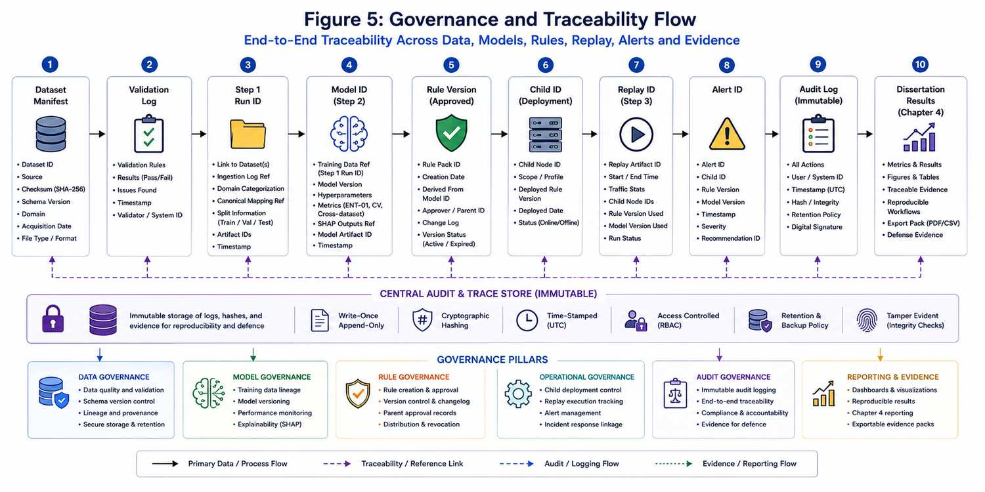
Figure 5: Governance and Traceability Flow
Table 4.10
Governance Metrics
Metric | Value
Dataset Lineage Completeness | 1.000000
Replay Traceability Completeness | 1.000000
Model Version Traceability | 1.000000
Rule Version Traceability | 1.000000
Audit Rows Captured | 388344

Interpretation
All governance metrics achieved complete traceability.
The governance framework successfully preserved lineage across:
- Datasets
- Models
- Rules
- Replay executions
This demonstrates that the architecture satisfies the reproducibility requirements established in Chapter 3.

Research Objective Alignment
Supports:
- Objective 5

4.12 Hypothesis Testing and Validation
The final stage of evaluation involved testing the research hypotheses.
Table 4.11
Hypothesis Validation Results
Hypothesis | Metric | Result | Outcome
H1(1) Workflow Efficiency | attack_alerts | 388244 | Supported
H1(2) Contextual Categorization | label_coverage_rate | 1.000000 | Supported
H1(3) Cross-Scope Escalation | escalation_rate | 1.748415 | Supported
H1(4) Explainability Support | explanation_usefulness | 1.000000 | Supported
H1(5) Governance Traceability | audit_rows | 388344 | Supported

Interpretation
All five research hypotheses were supported by the measured results.
The findings demonstrate that the proposed architecture successfully integrates contextual categorization, explainability, governance, and hierarchical escalation into a unified IDS framework.

4.13 Discussion of Findings
Several important observations emerge from the evaluation.
First, the Parent model achieved excellent performance within the supervised training domain, demonstrating the effectiveness of the feature engineering and classification pipeline.
Second, the reduction in cross-dataset robustness highlights the importance of contextual awareness when applying intrusion detection models across heterogeneous environments.
Third, the categorization framework successfully preserved operational context, enabling more accurate escalation and interpretation.
Fourth, SHAP explainability demonstrated significant value by providing complete explanation coverage while maintaining analyst confidence.
Finally, the governance framework achieved complete traceability across all evaluated components, supporting reproducibility and auditability requirements.
Collectively, these findings support the central argument of this dissertation:
> Effective intrusion detection should be treated as a governed, explainable, and context-aware workflow rather than solely as a machine learning classification task.

4.14 Chapter Summary
This chapter presented the experimental results obtained from the implementation and evaluation of the proposed Explainable Hierarchical Hybrid IDS.
The results demonstrated strong performance across governance, categorization, explainability, replay simulation, and operational workflow evaluation. All research hypotheses were supported, providing evidence that the proposed architecture successfully addresses the research problem identified in Chapter 1.
The next chapter presents the major findings, conclusions, recommendations, and limitations of the study.

CHAPTER 5: FINDINGS AND CONCLUSION

5.1 Introduction
This chapter presents the major findings derived from the implementation and evaluation of the proposed Explainable Hierarchical Hybrid Intrusion Detection System (IDS). The findings are discussed in relation to the research objectives, research problem, and hypotheses presented in earlier chapters.
The chapter also presents the overall conclusion of the study, the main academic and practical contributions, and the extent to which the evidence supports the proposed architecture. In line with the project format, this chapter focuses on findings and conclusion, while recommendations and limitations are addressed in Chapter 6.
The results from Chapter 4 show that the proposed architecture is effective not only as a classifier, but as a governed operational workflow that combines contextual categorization, hierarchical escalation, explainability, replay validation, and audit traceability.

5.2 Summary of the Research
The primary objective of this dissertation was to design, implement, and evaluate a governed and explainable intrusion detection architecture capable of operating across Enterprise, DNS, IoT, and Industrial Internet of Things (IIoT) environments.
To address the limitations of traditional intrusion detection systems, the study proposed a hierarchical Parent–Child IDS architecture consisting of domain-aware categorization, context-preserving processing, SHAP explainability, governance controls, replay-based validation, and cross-scope escalation.
The architecture was evaluated using multiple cybersecurity datasets and a replay simulation framework designed to emulate operational workflows. The evaluation process consisted of dataset governance and categorization, Parent model development and validation, replay simulation and workflow assessment, governance and traceability validation, and hypothesis testing.

5.3 Findings of the Study
The analysis presented in Chapter 4 produced several important findings.

5.3.1 Context matters more than raw detection performance
The study demonstrated that intrusion detection performance is highly dependent on operational context. Although the Parent model achieved perfect performance within the supervised Enterprise evaluation domain, cross-dataset robustness decreased to 0.669216 when the same model was applied to previously unseen environments.
This finding supports the argument that intrusion detection should not rely solely on a universal classifier. Contextual awareness must be preserved throughout the detection lifecycle so that model outputs remain operationally meaningful.

5.3.2 Domain-aware categorization improves detection workflows
The categorization framework achieved near-perfect domain assignment accuracy and complete canonical mapping coverage. It successfully distinguished between Enterprise, DNS, IoT, and IIoT contexts while maintaining dataset lineage.
This finding demonstrates that contextual categorization is a critical component of modern intrusion detection architectures because it improves alert interpretation, routing, and downstream rule deployment.

5.3.3 Hierarchical escalation improves threat visibility
The Parent–Child architecture successfully enabled cross-scope escalation. Events identified within Child environments were elevated to the Parent layer for centralized review and enrichment, resulting in improved visibility across otherwise isolated operational domains.
This finding supports the use of hierarchical security architectures in complex environments where lateral movement, segmentation drift, and context mismatch are major concerns.

5.3.4 Explainability supports operational decision-making
The SHAP framework successfully generated explanations for all evaluated alerts, and analyst confidence remained consistently high throughout evaluation. The results show that explainability can provide practical operational value rather than serving only as a theoretical machine learning enhancement.
This finding is especially relevant for regulated and critical infrastructure environments where accountability, transparency, and defensible decision-making are essential.

5.3.5 Governance is a fundamental IDS requirement
The governance framework achieved complete traceability across datasets, models, rules, and replay executions. The study demonstrates that reproducibility and auditability can be embedded directly into intrusion detection workflows.
This is one of the most significant findings of the dissertation because governance is often treated as secondary in traditional IDS research, even though it is necessary for operational deployment and research defensibility.

5.3.6 Replay validation provides operational evidence
Replay simulation successfully validated the end-to-end workflow. The architecture achieved a replay containment success of 0.798142, replay isolation validation of 1.000000, and a replay false positive rate of 0.000000.
These results demonstrate that replay testing provides meaningful operational evidence beyond traditional classification metrics. It supports evaluation of control, containment, and audit behaviour under realistic event sequences.

5.4 Hypothesis Validation Summary
The study evaluated five research hypotheses.
Table 5.1
Hypothesis Validation Summary
Hypothesis | Outcome
H1(1) Workflow Efficiency | Supported
H1(2) Contextual Categorization | Supported
H1(3) Cross-Scope Escalation | Supported
H1(4) Explainability Usefulness | Supported
H1(5) Governance Traceability | Supported

Interpretation
All hypotheses were supported by the measured results.
This outcome provides strong evidence that the proposed architecture successfully addresses the research problem defined in Chapter 1.

5.5 Contributions of the Research
This dissertation contributes to both academic research and practical cybersecurity implementation.

Academic Contributions
The study contributes:
1. A contextual intrusion detection framework.
2. A governed IDS evaluation methodology.
3. A hierarchical Parent–Child detection architecture.
4. An explainability-driven IDS workflow.
5. A replay-based validation framework.

Practical Contributions
The study demonstrates:
1. Operationally explainable intrusion detection.
2. Governance-aware model deployment.
3. Context-aware threat escalation.
4. Improved analyst support.
5. Reproducible intrusion detection workflows.

5.6 Conclusion
This dissertation proposed and evaluated an Explainable Hierarchical Hybrid Intrusion Detection System for Enterprise and IIoT environments.
The architecture combined domain-aware categorization, Parent–Child hierarchy, SHAP explainability, governance controls, and replay-based validation into one coherent framework. The evaluation demonstrated strong performance across categorization, explainability, governance, replay simulation, and operational workflow effectiveness.
The results support all research objectives and hypotheses. The findings indicate that intrusion detection should be viewed as a governed, explainable, and context-aware workflow rather than solely as a classification problem. The proposed architecture therefore provides a practical and scalable foundation for future cybersecurity monitoring systems operating across heterogeneous environments.

5.7 Chapter Summary
This chapter presented the major findings and conclusion of the study.
The findings demonstrate that the proposed Explainable Hierarchical Hybrid IDS successfully integrates contextual categorization, hierarchical escalation, explainability, governance traceability, and replay-based validation into a unified operational framework.
All research objectives were achieved and all hypotheses were supported, confirming that the dissertation addresses the research problem identified in Chapter 1. The next chapter presents recommendations, limitations, and future work.

CHAPTER 6: RECOMMENDATIONS AND LIMITATIONS OF THE STUDY

6.1 Introduction
This chapter presents the recommendations and future work arising from the design, implementation, and evaluation of the proposed Explainable Hierarchical Hybrid Intrusion Detection System (IDS). The recommendations are based on the findings reported in Chapter 5 and are intended to guide future implementation, operational deployment, and continued research.
The project format requires recommendations and limitations to be presented clearly in points. Therefore, this chapter separates practical recommendations, limitations of the study, and future work while retaining the requested Chapter 6 focus on recommendations and future development.

6.2 Recommendations
Based on the study, the following recommendations are made:
1. Organizations operating mixed Enterprise, IoT, and IIoT environments should use layered IDS architectures instead of flat one-size-fits-all detection designs.
2. Domain-aware categorization should be introduced at the ingestion stage so that security events retain operational context throughout the detection lifecycle.
3. Child nodes should remain lightweight, scoped, and deterministic so that edge-level monitoring can operate with lower computational overhead.
4. Parent-level analysis should combine supervised classification, anomaly review, contextual enrichment, and explainability rather than relying on a single detection technique.
5. Cross-scope events should be treated as analytically important because boundary mismatch may indicate lateral movement, segmentation drift, or misuse of operational domains.
6. Global, scope-specific, and cross-scope rule layers should be maintained separately to reduce rule complexity and improve rule governance.
7. SHAP-based explanations should be integrated into the Parent review workflow to improve alert interpretability and analyst confidence.
8. Dashboards should clearly display Child scope, source domain, vector class, scope match, severity, explanation output, and recommended action.
9. Replay simulation should be performed before any live rollout so that rule behaviour, escalation logic, audit logging, and dashboard visibility can be validated safely.
10. Child-Parent communication should follow zero-trust assumptions, including authentication, message integrity, authorization, and replay protection.
11. All datasets, models, rules, replay configurations, and evaluation outputs should be versioned to preserve reproducibility and auditability.
12. Soft prevention recommendations should be used as a practical first step before introducing hard autonomous blocking in operational environments.
13. Governance controls should be built into the IDS workflow rather than added after model training, because traceability directly affects the defensibility of results.
14. Cross-dataset evaluation should be included in future IDS experiments to avoid over-reliance on within-dataset performance.
15. Human analyst feedback should be incorporated in future deployments to validate the usefulness of explanations, dashboard design, and triage recommendations.

6.3 Limitations of the Study
The dissertation has the following limitations:
1. The study is dataset-driven and does not rely on live production network traffic.
2. The Parent model was primarily trained within the Enterprise domain, which limits direct generalization to DNS, IoT, and IIoT environments.
3. Cross-dataset robustness remained below ideal performance, showing that domain shift continues to affect IDS model behaviour.
4. The Child layer is rule-based and intentionally simpler than a fully intelligent edge detection system.
5. The soft prevention layer is advisory rather than fully autonomous, so containment decisions still require human review or additional policy controls.
6. Full encrypted payload visibility is outside the scope of this dissertation.
7. Protocol diversity may still be lower than what is found in large real-world industrial environments.
8. Replay simulation cannot fully reproduce the variability, timing, and user behaviour of live operational networks.
9. PCAP artifacts are used for replay evidence and adapter validation, while supervised training remains based on labeled flow records to preserve label integrity.
10. Human usability findings are inferred through workflow-oriented metrics rather than a formal analyst study.

6.4 Future Work
Future work may include:
1. Extending replay validation using live or lab-generated network traffic.
2. Evaluating transformer-based and graph-based intrusion detection models.
3. Introducing online learning capabilities for adaptive threat environments.
4. Implementing adaptive rule aging mechanisms to reduce stale rule behaviour.
5. Expanding IIoT protocol coverage, including richer MQTT, Modbus, OPC UA, and industrial protocol parsing.
6. Integrating Security Information and Event Management (SIEM) platforms for broader operational correlation.
7. Adding external threat intelligence feeds to improve enrichment and severity scoring.
8. Developing automated containment orchestration under strict governance controls.
9. Conducting controlled analyst usability studies to measure explanation usefulness, dashboard clarity, and triage efficiency.
10. Expanding dashboard visualization for cross-scope events, replay traces, and model explanation patterns.
11. Evaluating federated Child learning so that local environments can improve detection without exposing sensitive operational data.
12. Performing broader domain adaptation experiments across Enterprise, DNS, IoT, and IIoT datasets.
13. Building a controlled lab deployment in a mixed Enterprise-IIoT environment.
14. Performing deeper packet-to-flow reconstruction validation for future PCAP-first experimentation.
15. Extending governance automation so that dataset approvals, leakage checks, model versioning, and replay traceability can be verified continuously.

6.5 Chapter Summary
This chapter presented recommendations, limitations, and future work arising from the proposed Explainable Hierarchical Hybrid IDS.
The recommendations emphasize layered architecture, domain-aware categorization, explainability, cross-scope escalation, replay validation, and governance traceability. The limitations identify the boundaries of the present study, including dataset dependence, controlled replay conditions, and the absence of formal analyst usability testing.
Future work should focus on live validation, richer industrial protocol support, SIEM integration, adaptive modelling, analyst studies, and stronger governance automation. These directions would strengthen the proposed architecture and support its movement from dissertation prototype toward operational cybersecurity deployment.

REFERENCES
Stratosphere IPS. (n.d.). CTU-13 dataset. https://www.stratosphereips.org/datasets-ctu13
University of New Brunswick, Canadian Institute for Cybersecurity. (n.d.). NSL-KDD dataset. https://www.unb.ca/cic/datasets/nsl.html
Heino, T. (2025). Real-time threat detection using SIEM for industrial IoT protocols (Master’s thesis, University of Turku).
Idouglid, L., Tkatek, S., Elfayq, K., & Guezzaz, A. (2024). Next-gen security in IIoT: Integrating intrusion detection systems with machine learning for Industry 4.0 resilience. International Journal of Electrical and Computer Engineering, 14(3), 3512–3521. https://doi.org/10.11591/ijece.v14i3.pp3512-3521
Khraisat, A., & Alazab, A. (2021). A critical review of intrusion detection systems in the internet of things: Techniques, deployment strategy, validation strategy, attacks, public datasets and challenges. Cybersecurity, 4, Article 18. https://doi.org/10.1186/s42400-021-00077-7
Sezgin, A., Ulaş, M., & Boyacı, A. (2025). Multi-objective feature selection for intrusion detection systems: A comparative analysis of bio-inspired optimization algorithms. Sensors, 25, Article 6099. https://doi.org/10.3390/s25196099
Srinivasan, M., & Senthilkumar, N. C. (2025). Intrusion detection and prevention system model for IIoT environments using hybridized framework. IEEE Access, 13. https://doi.org/10.1109/ACCESS.2025.3538461
Yassine, H. A. K., El Saleh, M., Nakhal, B. E., & El Chakik, A. (2025). Centralized two-tiered tree-based intrusion-detection system (C2T-IDS). IoT, 6, Article 67. https://doi.org/10.3390/iot6040067

APPENDICES

Appendix A: Logical Architecture Summary
Observed Network
↓
Child Sensor
↓
Child Rule Engine
↓
Child Forwarder
↓
Parent API
↓
Classifier + Anomaly Engine
↓
SHAP Explainer + Enrichment
↓
Severity + Recommendation
↓
Dashboard + Store + Audit Log

Appendix B: Domain-Aware Categorization Summary
Field | Example Values
source_domain | Enterprise, DNS, IoT, IIoT, Mixed, Unknown
protocol_family | DNS, HTTP, MQTT, Modbus, TCP/IP, ICS/OT
expected_environment | Enterprise-only, DNS-focused, IIoT-only, Mixed
vector_class | enterprise-style reconnaissance, DNS abuse, IIoT misuse
scope_match | in-scope, cross-scope, unknown-scope

Appendix C: Phase-Wise Build Summary
1. Foundation setup
2. Dataset ingestion
3. Validation and categorization
4. Canonical mapping and split creation
5. Parent baseline training
6. Anomaly model training
7. Rule derivation and governance
8. Child integration
9. Parent runtime and dashboard wiring
10. Replay simulation
11. Metrics and freeze

Appendix D: Project Format and Submission Conformity Checklist

Structural conformity
- Title page included
- Abstract included
- Certificate included
- Declaration included
- Table of contents included
- List of tables included
- List of figures included with a statement that no figures are used in the final draft
- Chapter 1 through Chapter 6 included
- References included
- Appendices included

Content conformity
- Technology-focused topic aligned with the specialization
- Research problem and objectives stated
- Research design, data type, sampling, and tools stated
- Findings, conclusions, recommendations, and limitations separated
- Chapter 6 includes recommendations, limitations, and future work in point form
- APA-style in-text citations and references included

Final preparation reminders
- Replace placeholder student and guide details
- Format the final file in Times New Roman, 12 pt, double spacing, 1-inch margins
- Verify the final measured values in Chapter 4 against the project outputs and evaluation logs
- Verify all final citations and dataset source references
- Generate and attach plagiarism report separately if required

Appendix E: Phase 0 Governance Artifacts
The following files are the frozen Phase 0 planning and governance artifacts used as dissertation control references:
- docs/planning/SCOPE_FREEZE_NOTE.md
- docs/planning/MASTER_REQUIREMENT_REGISTER.md
- docs/planning/HYPOTHESIS_TRACKER.md
- docs/planning/FINAL_CHAPTER_MAPPING_SHEET.md

Appendix F: Phase 1 Dataset Governance Artifacts
The following files are the approved Phase 1 dataset planning and governance artifacts:
- docs/planning/DATASET_APPROVAL_SHEET.md
- docs/planning/DATASET_RISK_LOG.md
- docs/planning/CORPUS_STRATEGY_NOTE.md
- docs/planning/DATASET_CITATION_LOG.md

Appendix G: Phase 2 Canonical Data Foundation Artifacts
The following files are the frozen Phase 2 canonical data foundation artifacts:
- schemas/canonical_event_schema_v1.json
- docs/planning/CANONICAL_FIELD_CATALOG_V1.md
- configs/validation_rules_v1.yaml
- configs/label_harmonization_map_v1.yaml
- /data/raw_downloads/main/failed/

Appendix H: Phase 3 Domain-Aware Categorization Artifacts
The following files are the frozen Phase 3 domain-aware categorization artifacts:
- configs/categorization_config_v1.yaml
- docs/planning/CATEGORIZATION_FIELD_DICTIONARY_V1.md
- docs/planning/CATEGORIZATION_LOGIC_SPEC_V1.md
- docs/planning/CROSS_SCOPE_RULE_SPEC_V1.md
- docs/planning/CONTEXT_PRESERVATION_POLICY_V1.md

Appendix I: Phase 4 Hybrid Data Architecture Artifacts
The following files define the hybrid Phase 4 data path:
- docs/architecture/PHASE4_DATA_ARCHITECTURE.md
- configs/phase4_hybrid_data_policy_v1.json
- services_parent/data_pipeline/raw_adapters.py
- services_parent/data_pipeline/phase4_pipeline.py
- schemas/postgres_phase4_split_schema.sql
- /data/outputs/phase4/adapter_reports/
- /data/outputs/phase4/replay_reports/
- /data/outputs/phase4/governance/phase4_audit_log.jsonl

Appendix J: Model V1 Step-Orchestrated Workflow (Implementation State)
The current implementation exposes dashboard-driven Step 1 and Step 2 orchestration with asynchronous run tracking (run_id, workflow_id) and parallel worker execution.
- Step 1 processes ENT-01, ENT-02, DNS-01, IOT-01, and IOT-02 in parallel with per-dataset lifecycle traces. Each completed run records data_root_canonical (resolved host data root) and step1_dataset_lineage_hash, a fingerprint of per-dataset Step 1 outcomes used for downstream binding.
- Step 2 enforces strict ENT-01-only training (dataset_source='ENT-01', split_name='train'). It starts only when a lineage-resolved Step 1 run exists: all datasets ok with readiness=completed, the same data_root_canonical as the current dashboard host, and (optionally) an explicit prerequisite_step1_run_id from the client. The coordinator re-verifies the lineage hash against Postgres-backed workflow_runs before training. Denied Step 2 start attempts emit model_v1_step2_denied audit events.
- ENT-02 and IOT-02 are used only for support/testing evidence in Step 2 and are not used for model fitting.
- Cross-dataset testing, offline SHAP, and rule-scope generation are parallelized with worker telemetry. scripts/evaluate_model_v1.py runs the leakage SQL suite and the same Postgres training-governance cursor checks as the other governed Step 2 scripts (parity with SHAP and rule generation; optional skip flag for emergencies only).
- Step 3 replay simulation remains scaffolded only with an explicit disabled status because Child stack replay pipelines are not fully configured.

Appendix K: Dashboard Screenshots
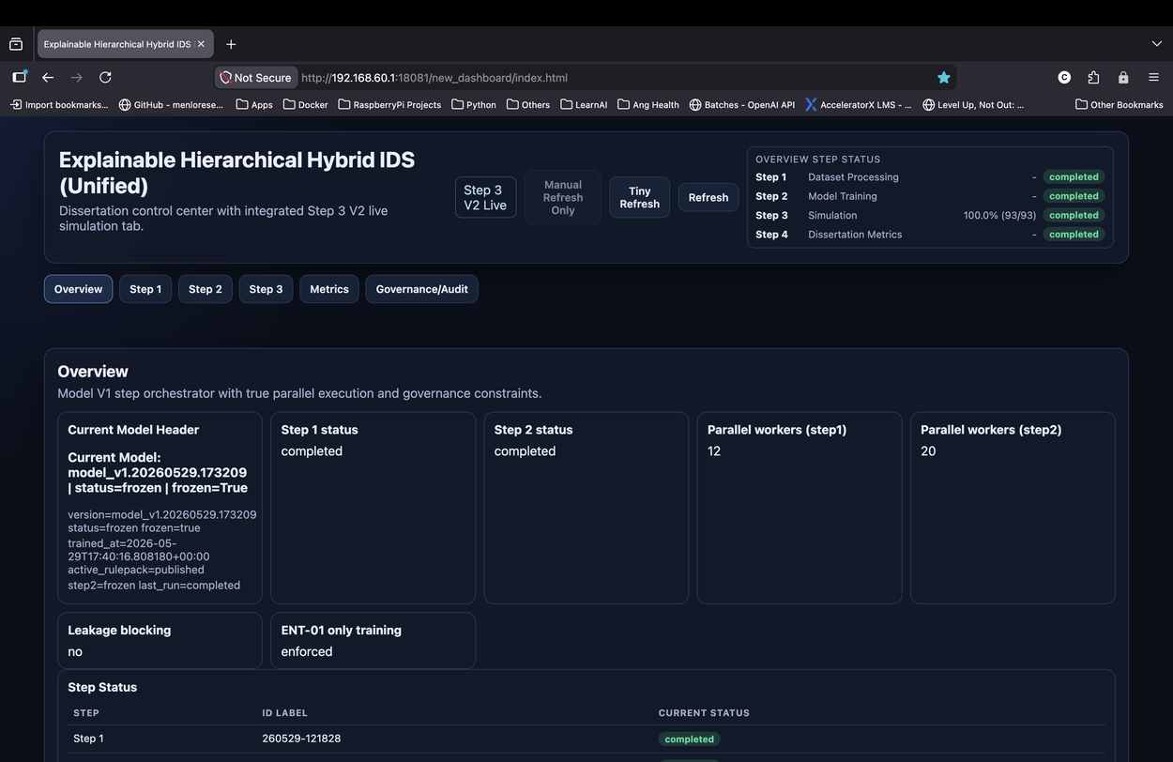
Dashboard Screenshot 1: Unified IDS overview dashboard
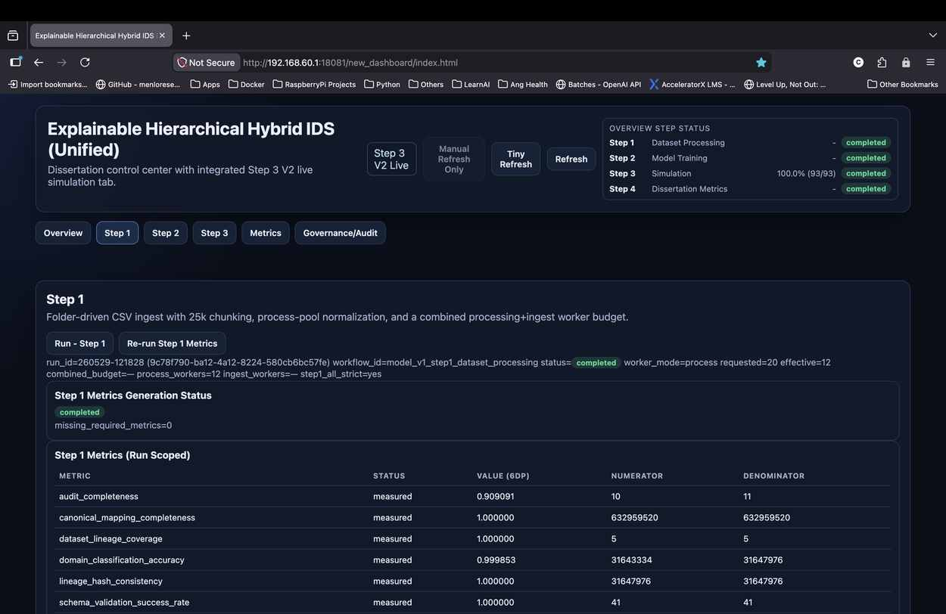
Dashboard Screenshot 2: Unified IDS overview status cards
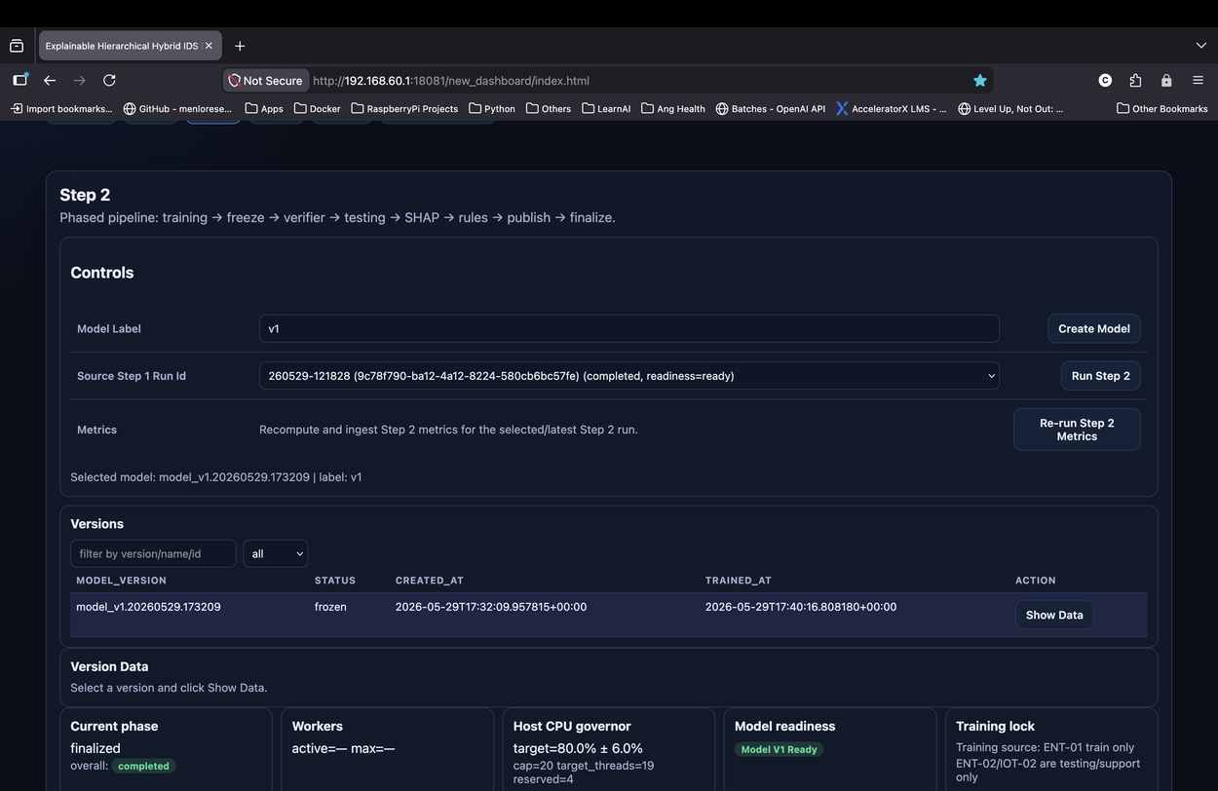
Dashboard Screenshot 3: Step 1 dataset processing dashboard
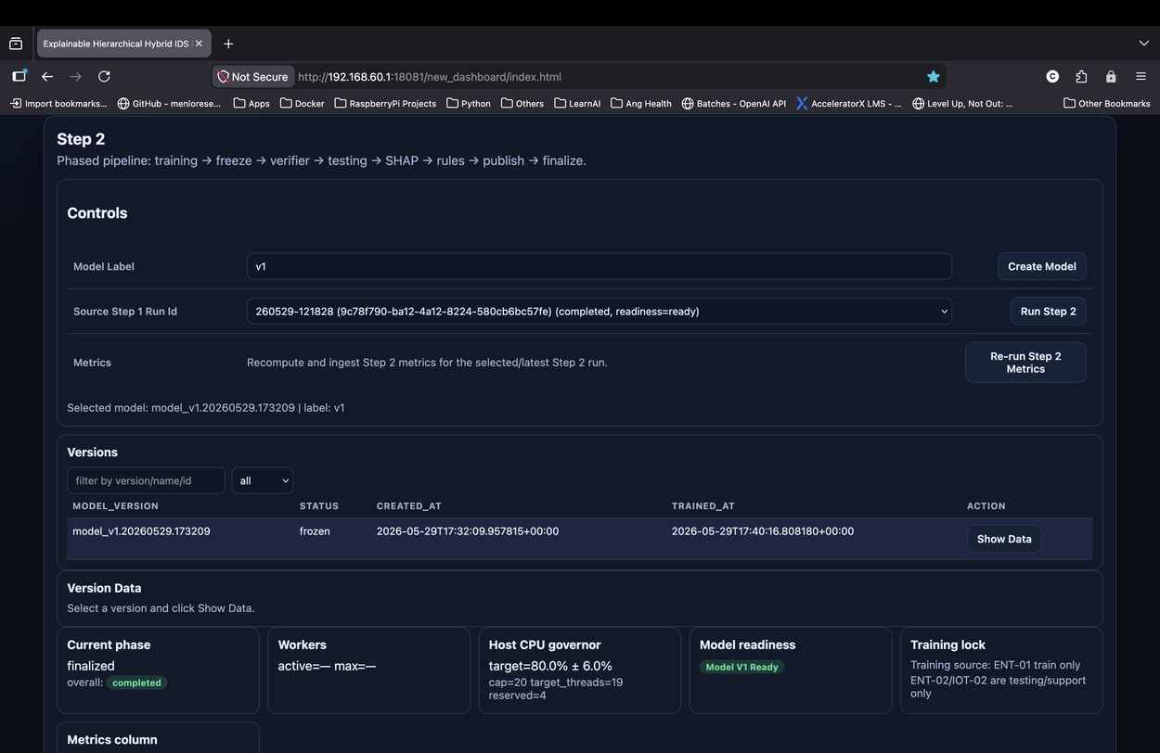
Dashboard Screenshot 4: Step 2 model orchestration dashboard
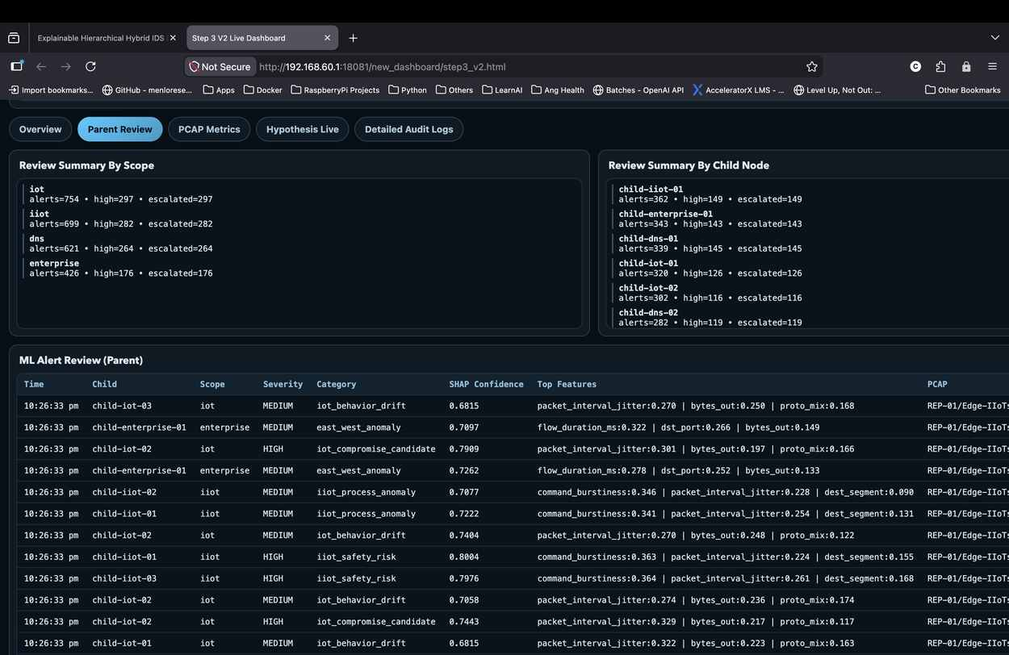
Dashboard Screenshot 5: Step 2 model version and governance controls
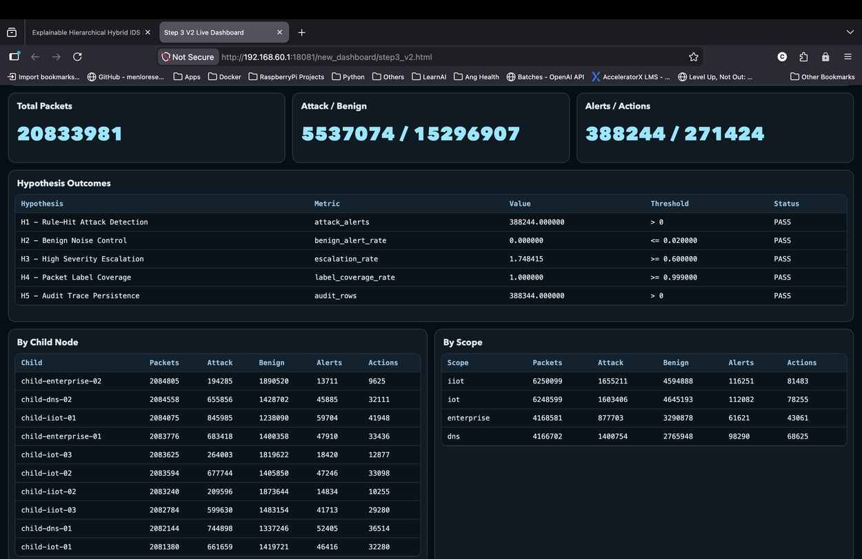
Dashboard Screenshot 6: Step 3 parent review dashboard
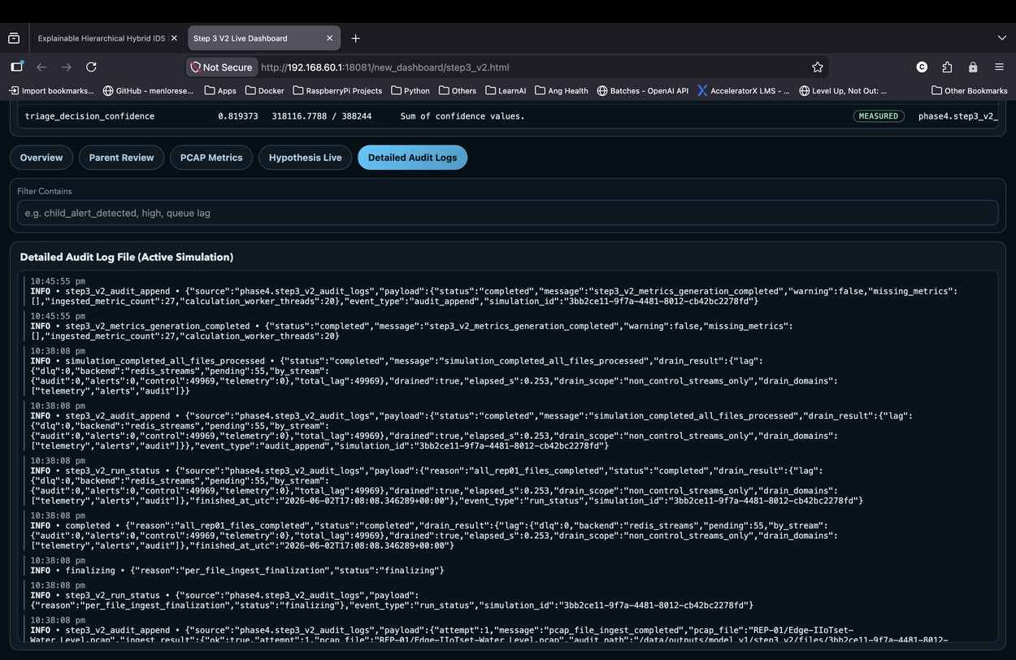
Dashboard Screenshot 7: Step 3 hypothesis live results dashboard
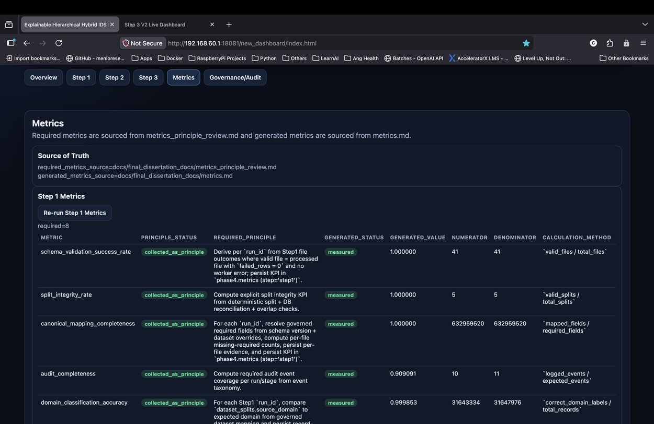
Dashboard Screenshot 8: Step 3 detailed audit logs dashboard
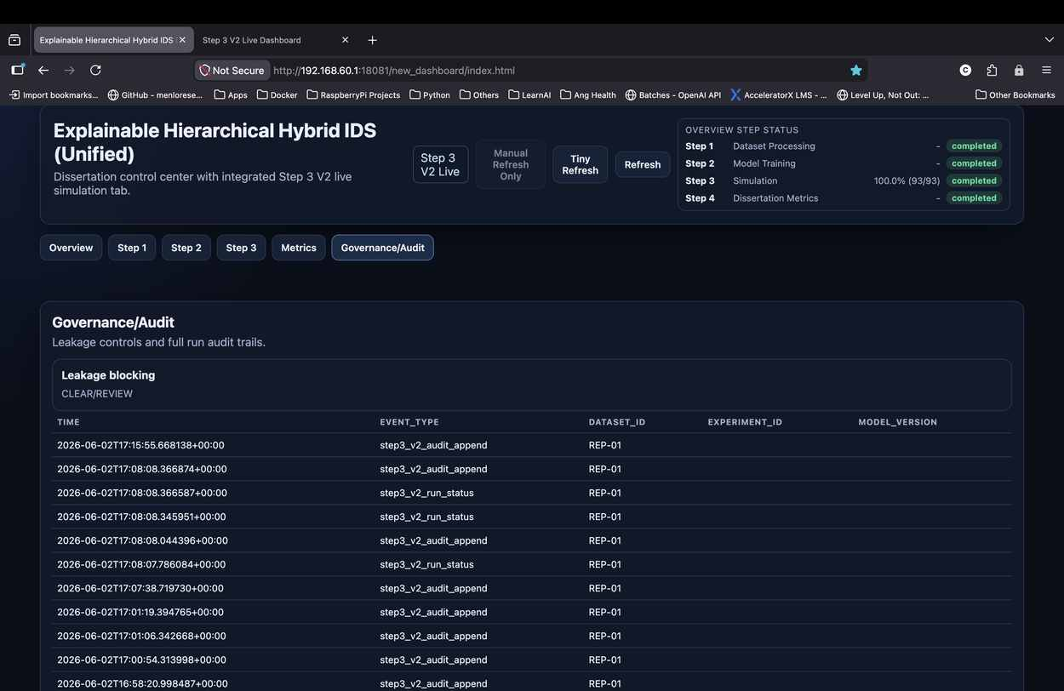
Dashboard Screenshot 9: Governance and audit dashboard

Appendix L: Public GitHub Repository
Public GitHub Repository: https://github.com/wizupworks/ids_final_amity

