WizzardChat · Training Documentation

Flow Redirect Outcome — End-to-End Demonstration
Demonstrates the full flow-redirect path: a visitor starts a chat, an agent takes the session and selects 'Redirect to Test Flow', and the visitor receives the configured flow message.
Generated: 2026-03-06 13:49 · 17 recorded steps · Applies to: WizzardChat (current)

Overview
Demonstrates the full flow-redirect path: a visitor starts a chat, an agent takes the session and selects 'Redirect to Test Flow', and the visitor receives the configured flow message.

Before you begin
- WizzardChat is running and accessible at http://localhost:8092.
- You have admin credentials (username and password).
- Your browser can reach the WizzardChat server.

Steps

The Agent Panel is where agents manage live sessions
The Agent Panel is where agents manage live sessions.
Sign in as an administrator to act as the handling agent.

1. [Navigate to] Open WizzardChat Agent Panel (Tab 1)
URL: http://localhost:8092/
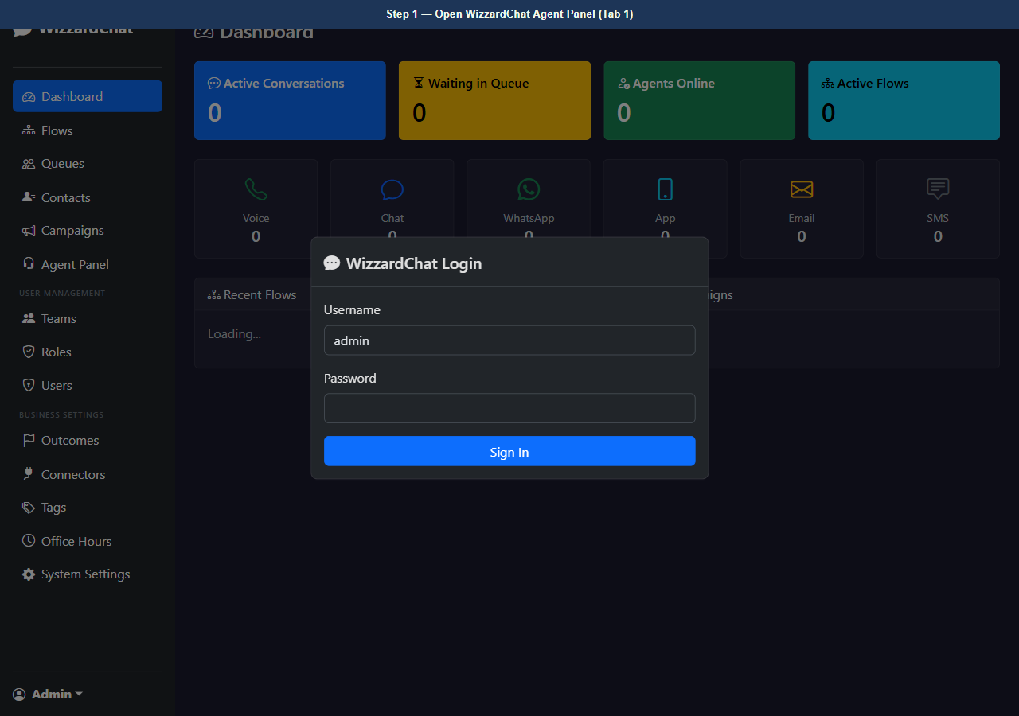
Figure 1 — Open WizzardChat Agent Panel (Tab 1)
2. [Type] Enter admin username
Element: #loginUser Value: admin
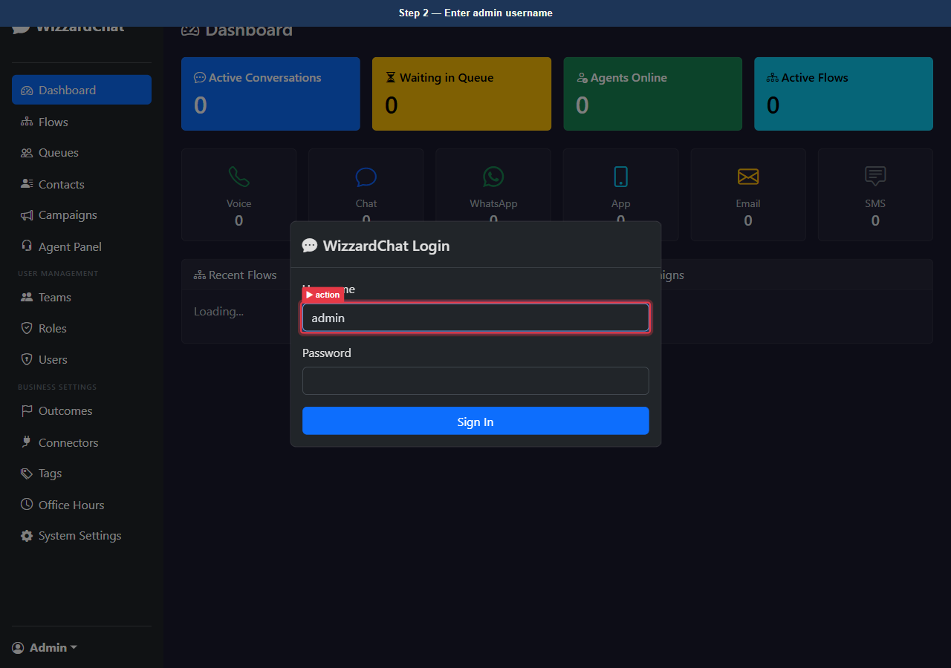
Figure 2 — Enter admin username
3. [Type] Enter admin password
Element: #loginPass Value: ••••••••
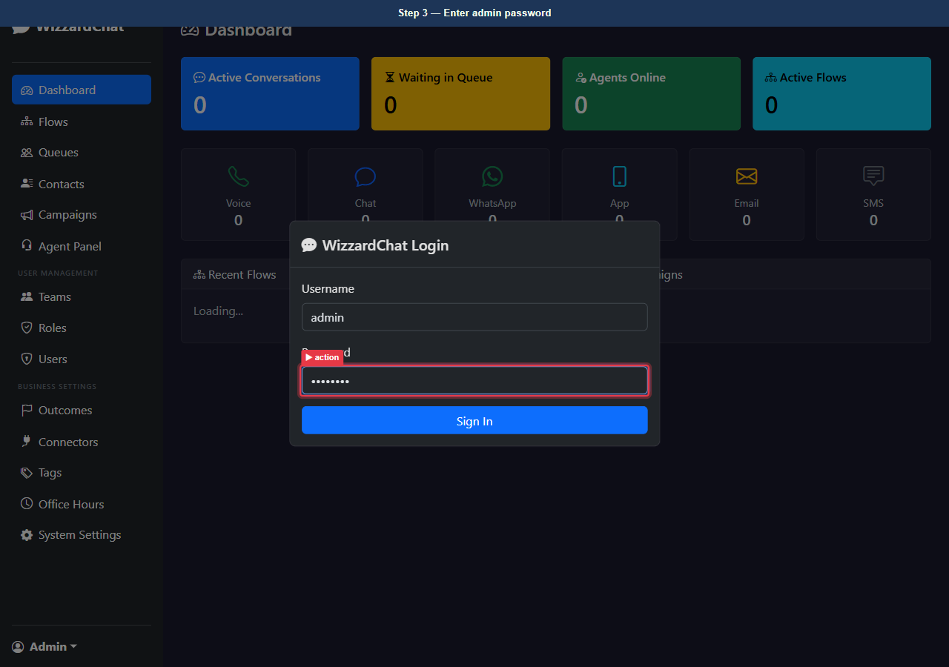
Figure 3 — Enter admin password
4. [Click] Sign in
Element: button[type=submit]
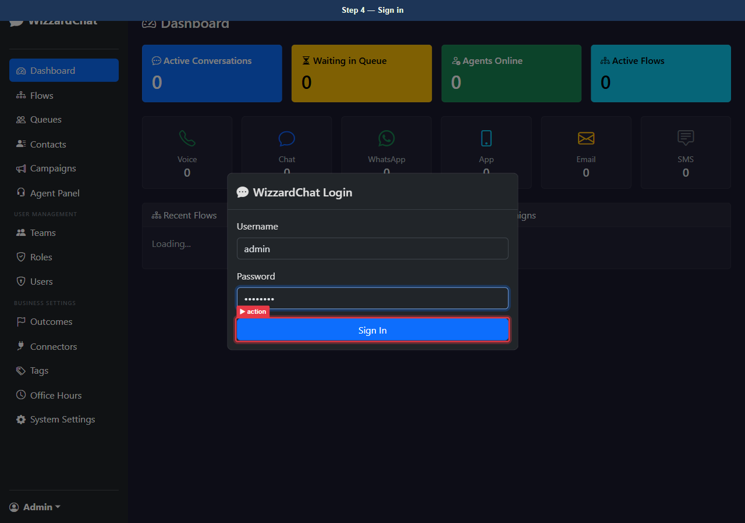
Figure 4 — Sign in
5. [Observe] Dashboard — logged in as administrator
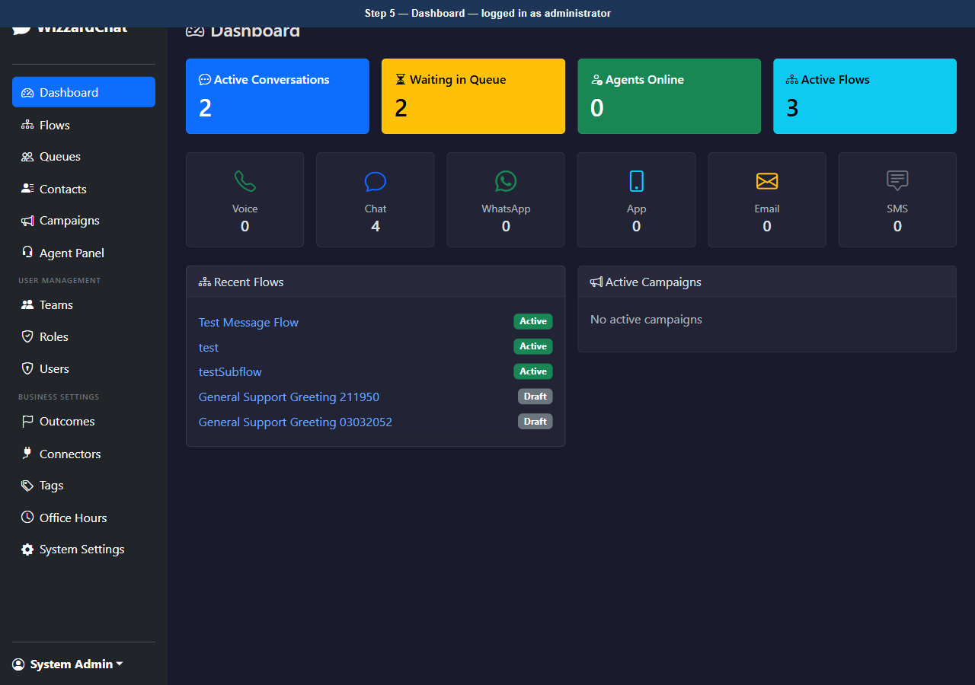
Figure 5 — Dashboard — logged in as administrator
6. [Navigate to] Open Agent Panel
URL: http://localhost:8092/agent
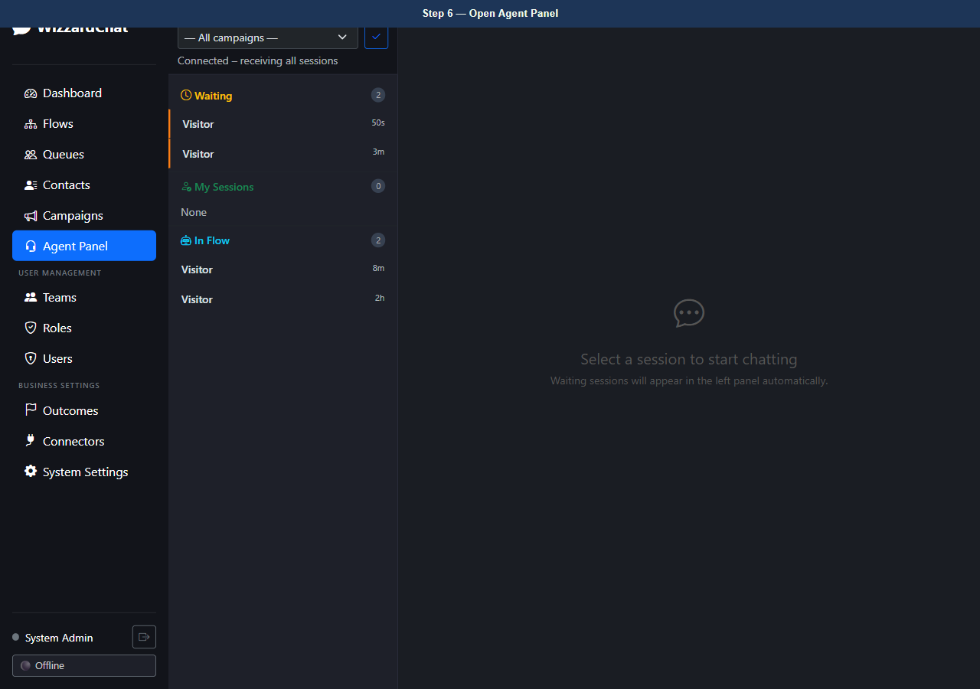
Figure 6 — Open Agent Panel
7. [Observe] Agent Panel — no active sessions
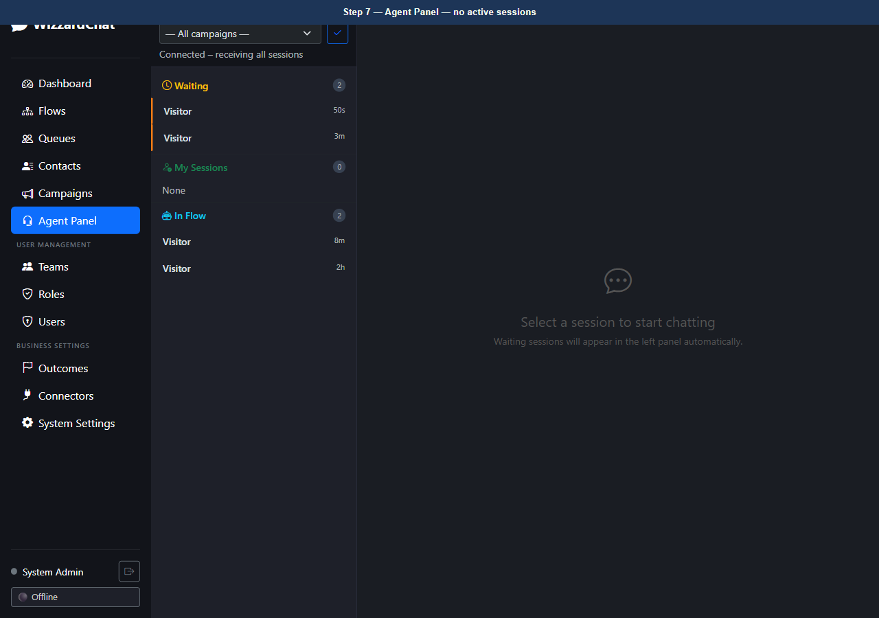
Figure 7 — Agent Panel — no active sessions

A visitor opens the chat widget.
Session ID: demo-651c5c55e3e6
The widget initialises the session via POST /chat/{api_key}/{session_id}/init and subscribes to the SSE stream to receive real-time messages from the bot and agent.

The visitor chat widget connects and the initial flow message appears.
The session is now in the queue, waiting for an agent.

The Agent Panel updates automatically via WebSocket
The Agent Panel updates automatically via WebSocket.
The new session from the visitor appears in the Waiting list on the left.
The agent clicks the session to preview it.

8. [Observe] Agent Panel — visitor session visible in queue
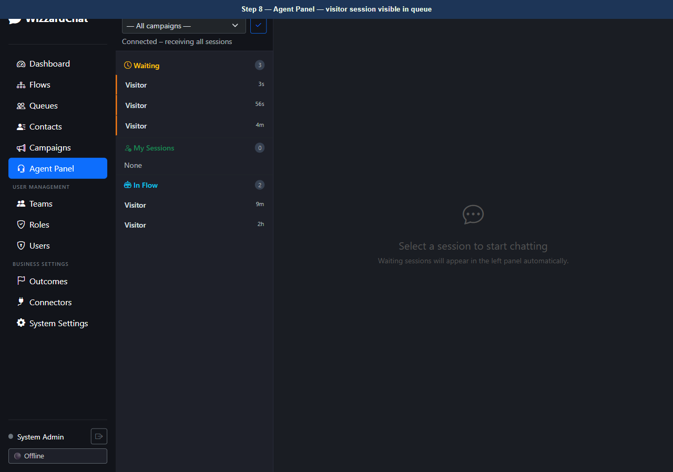
Figure 8 — Agent Panel — visitor session visible in queue

The agent clicks Take to claim the session
The agent clicks Take to claim the session.
The session moves from Waiting to Mine. The Outcome button appears in the chat header, replacing the plain Close button.

9. [Observe] Agent Panel — session owned, Outcome button visible in header
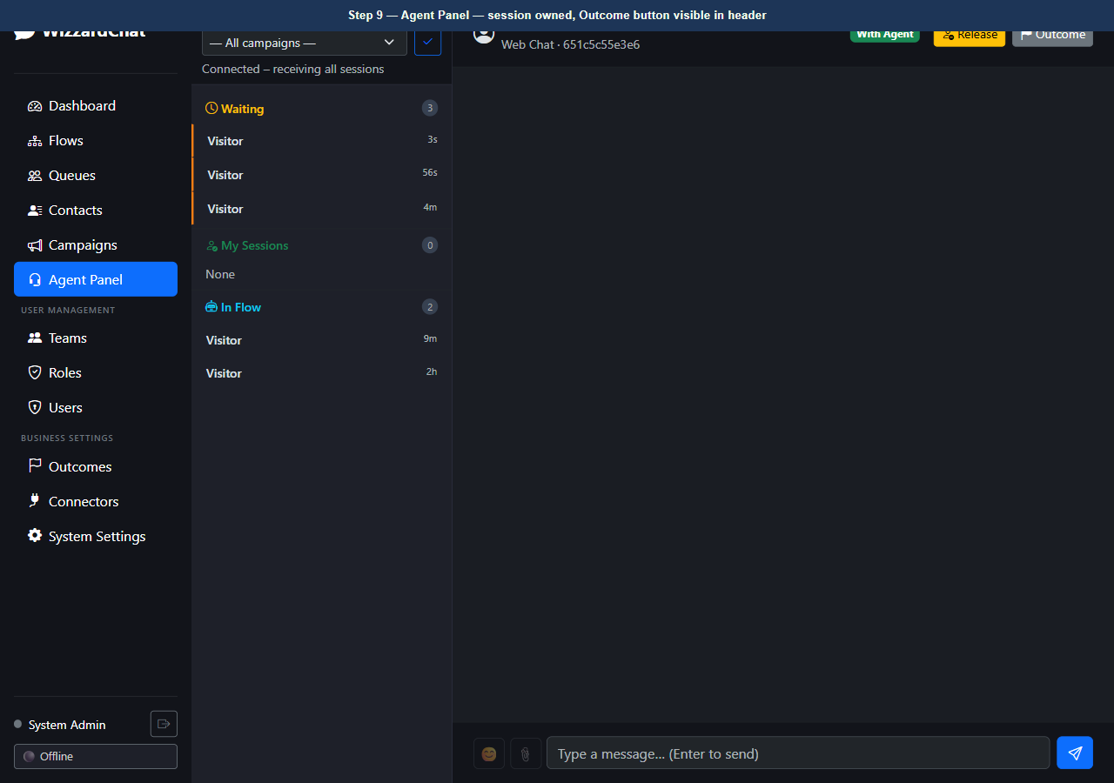
Figure 9 — Agent Panel — session owned, Outcome button visible in header

The agent clicks the Outcome button
The agent clicks the Outcome button.
The modal loads all four active outcomes from the API, grouped into four columns by sentiment type: Negative, Escalation, Neutral, Positive.

10. [Observe] Outcome modal — 4-column layout, loaded 6 outcomes
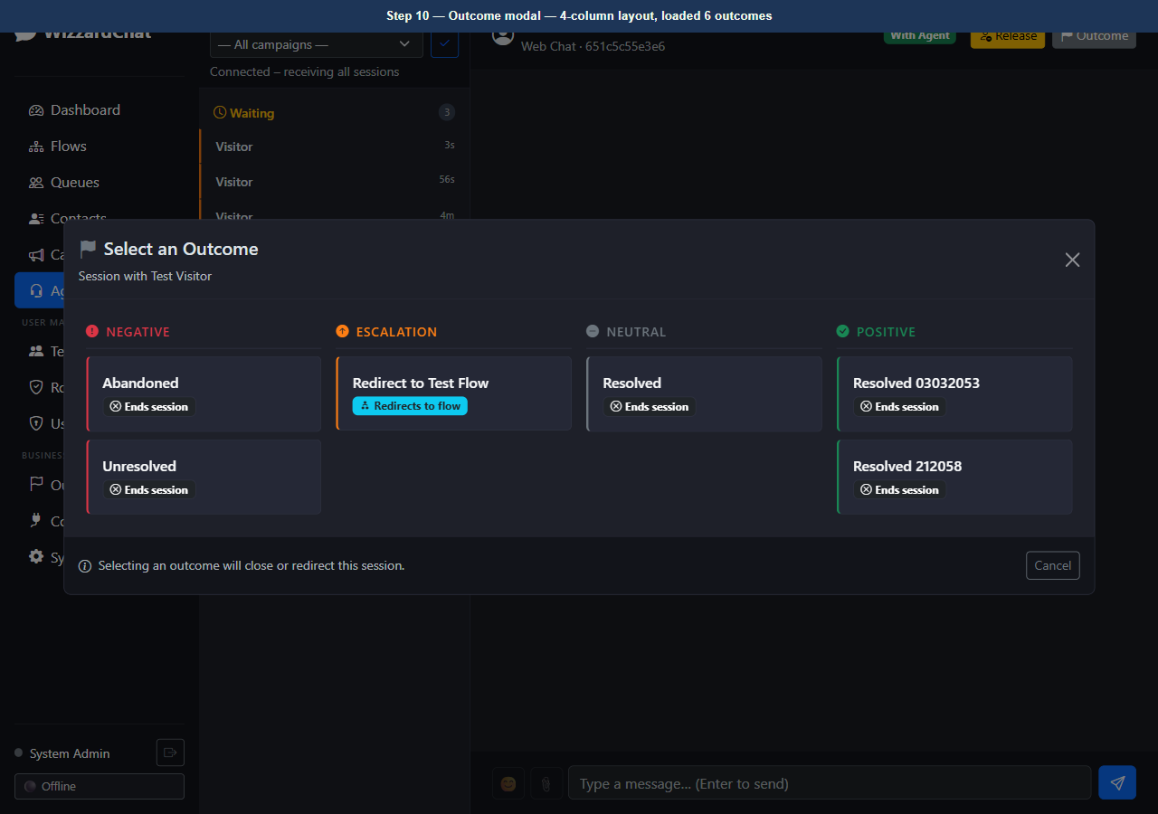
Figure 10 — Outcome modal — 4-column layout, loaded 6 outcomes

The Escalation column contains 'Redirect to Test Flow'
The Escalation column contains 'Redirect to Test Flow'.
This outcome has action_type = flow_redirect, which means selecting it will activate the Test Message Flow rather than immediately closing the session.

11. [Observe] Outcome modal — 'Redirect to Test Flow' (Escalation) highlighted
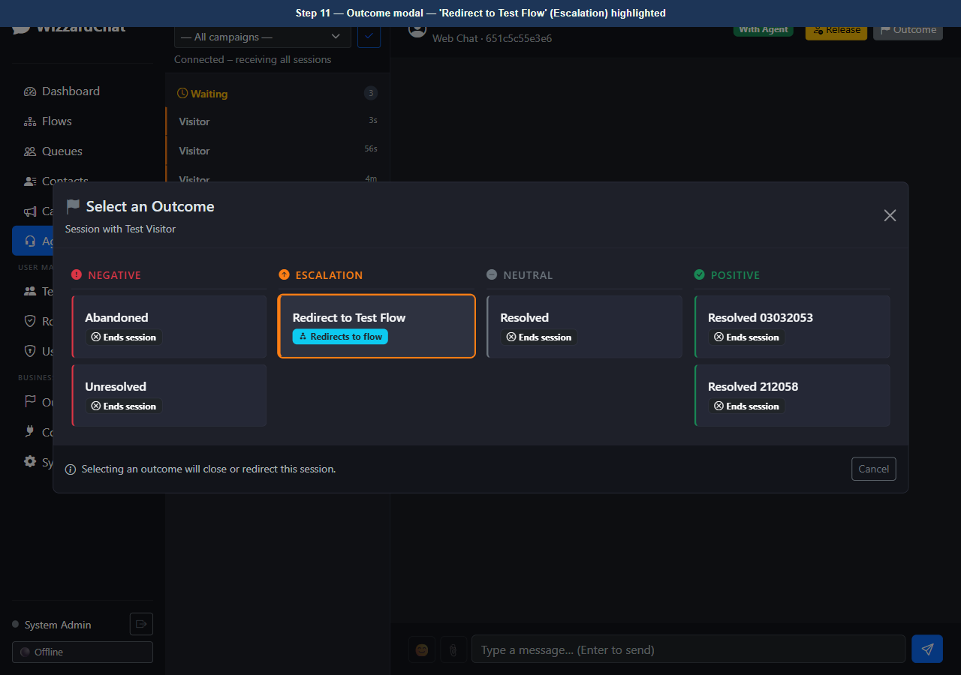
Figure 11 — Outcome modal — 'Redirect to Test Flow' (Escalation) highlighted

The agent selects 'Redirect to Test Flow'
The agent selects 'Redirect to Test Flow'.
WizzardChat sends a close_with_outcome WebSocket message to the server. The server calls apply_outcome_to_session(), sets _current_flow_id in the session's flow context, and then runs run_flow().
run_flow() loads the Test Message Flow and executes its nodes:
Start → Send Message → End
The Send Message node pushes the configured message to the visitor's SSE stream.

12. [Observe] API confirms flow-redirect outcome — {"id":"0ba975e8-d276-4fe9-a4d4-5d5f044c5726","code":"test_flow_redirect","label":"Redirect to Test Flow"}
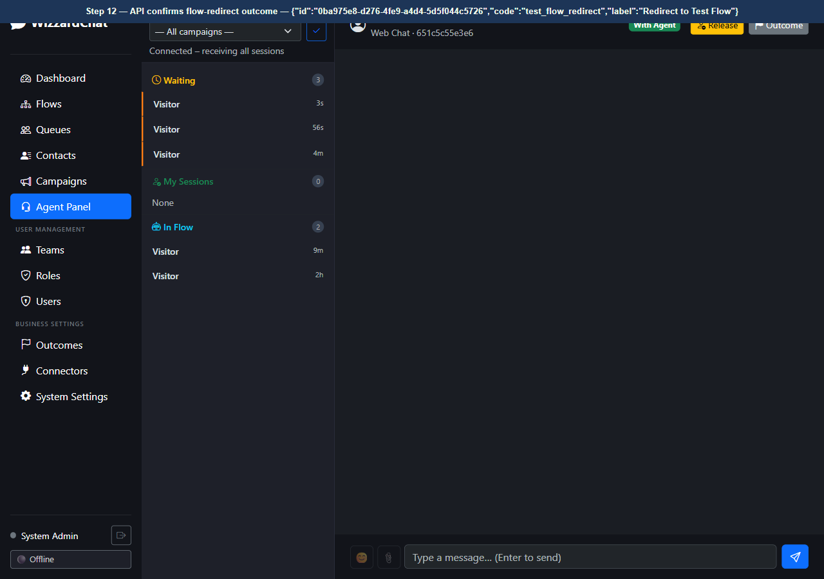
Figure 12 — API confirms flow-redirect outcome — {"id":"0ba975e8-d276-4fe9-a4d4-5d5f044c5726","code":"test_flow_redirect","label":"Redirect to Test Flow"}

The server-side log confirms run_flow was invoked with the correct flow ID. The visitor's SSE stream receives the flow message immediately.

Switching to the visitor's chat window shows what the visitor experiences
Switching to the visitor's chat window shows what the visitor experiences.
After the agent selects the outcome, the Test Message Flow executes and delivers its message: 'You have been redirected by your agent. We appreciate your patience — a specialist will be with you shortly.'

13. [Observe] Visitor chat tab — flow message delivery (visitor perspective)
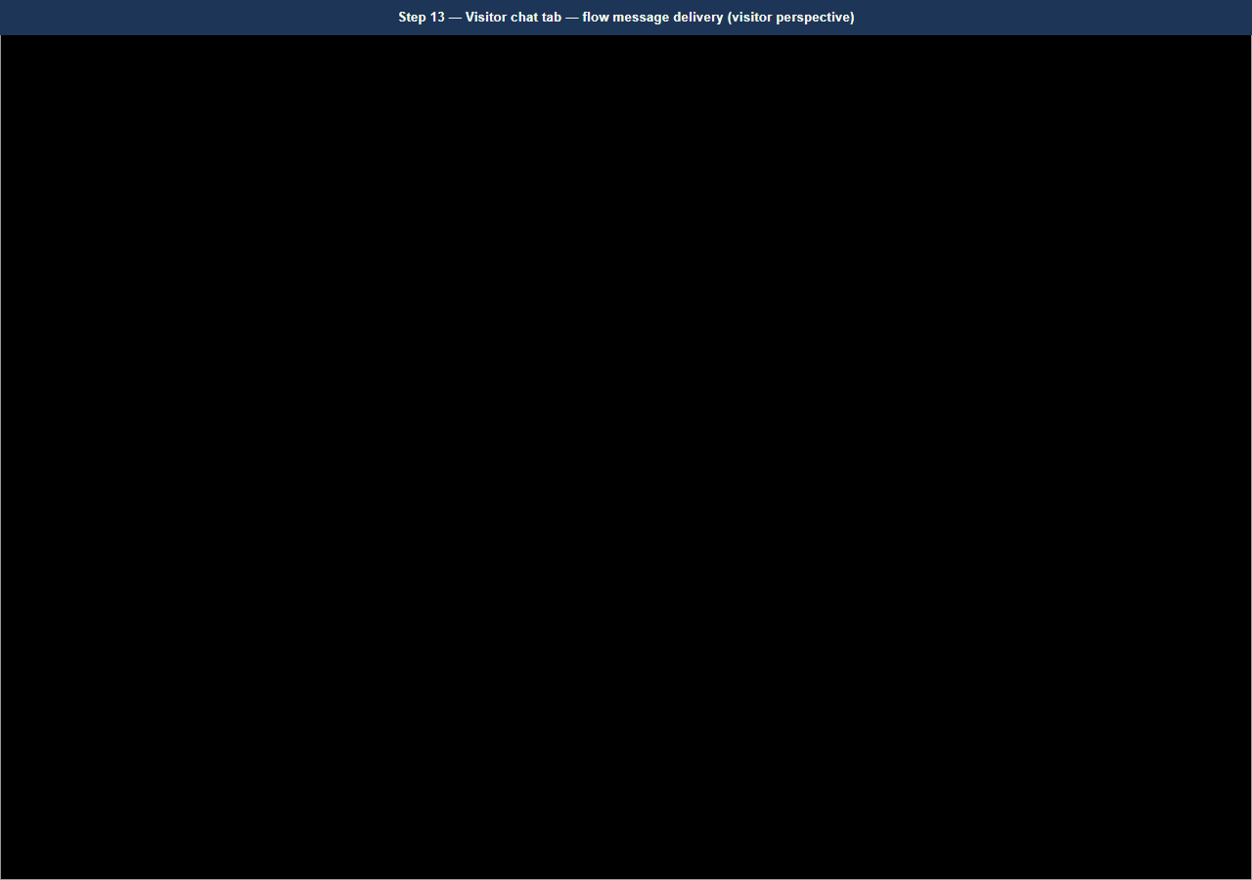
Figure 13 — Visitor chat tab — flow message delivery (visitor perspective)
14. [Navigate to] Return to Agent Panel
URL: http://localhost:8092/agent
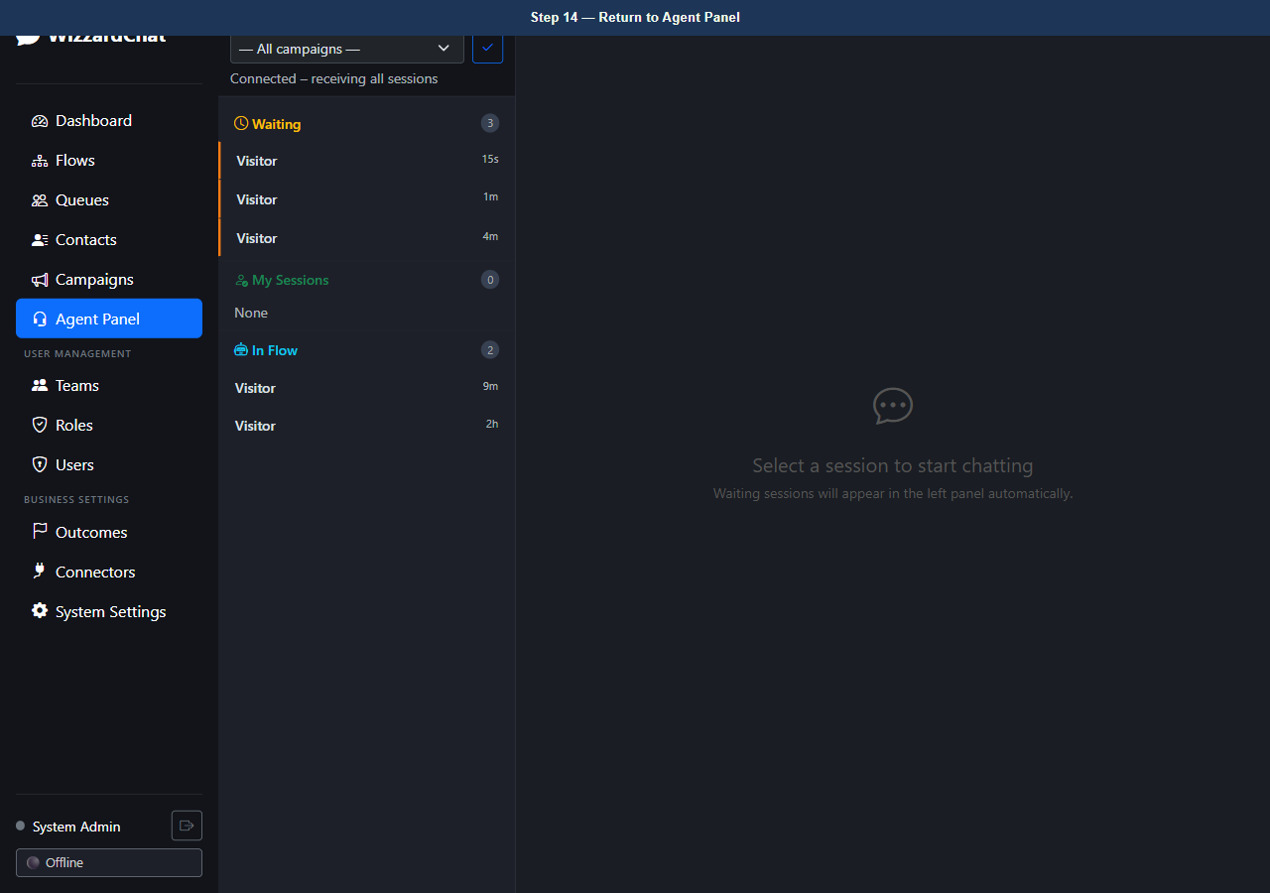
Figure 14 — Return to Agent Panel
15. [Observe] Agent Panel — session cleared after redirect, agent load decremented
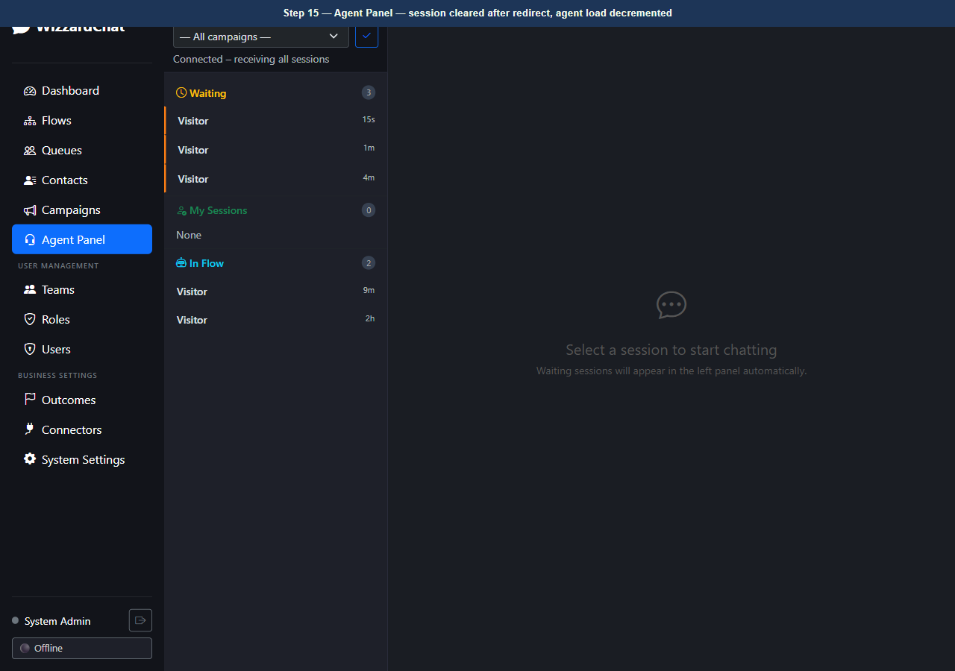
Figure 15 — Agent Panel — session cleared after redirect, agent load decremented
16. [Navigate to] Outcomes configuration page
URL: http://localhost:8092/outcomes
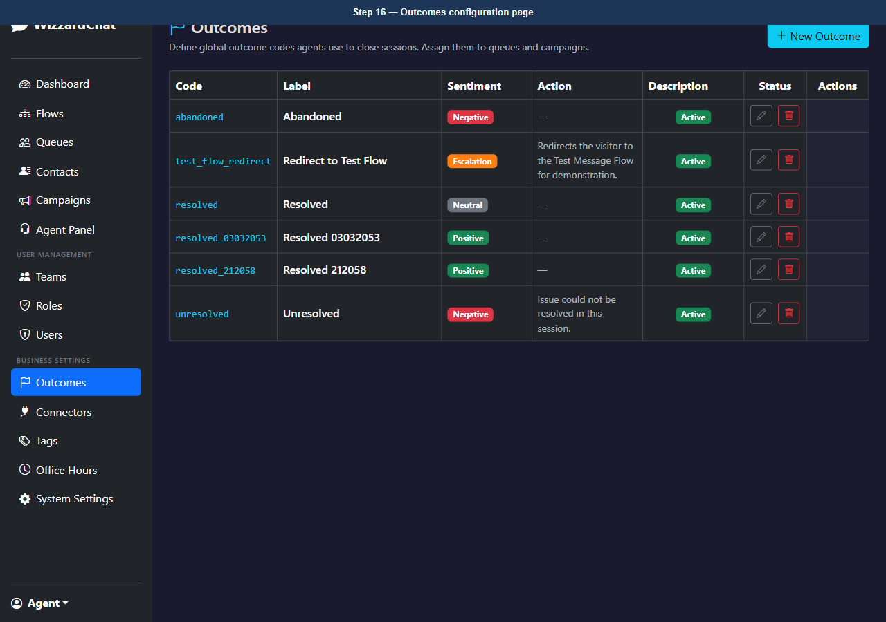
Figure 16 — Outcomes configuration page
17. [Observe] Outcomes page — all configured outcomes including flow redirect
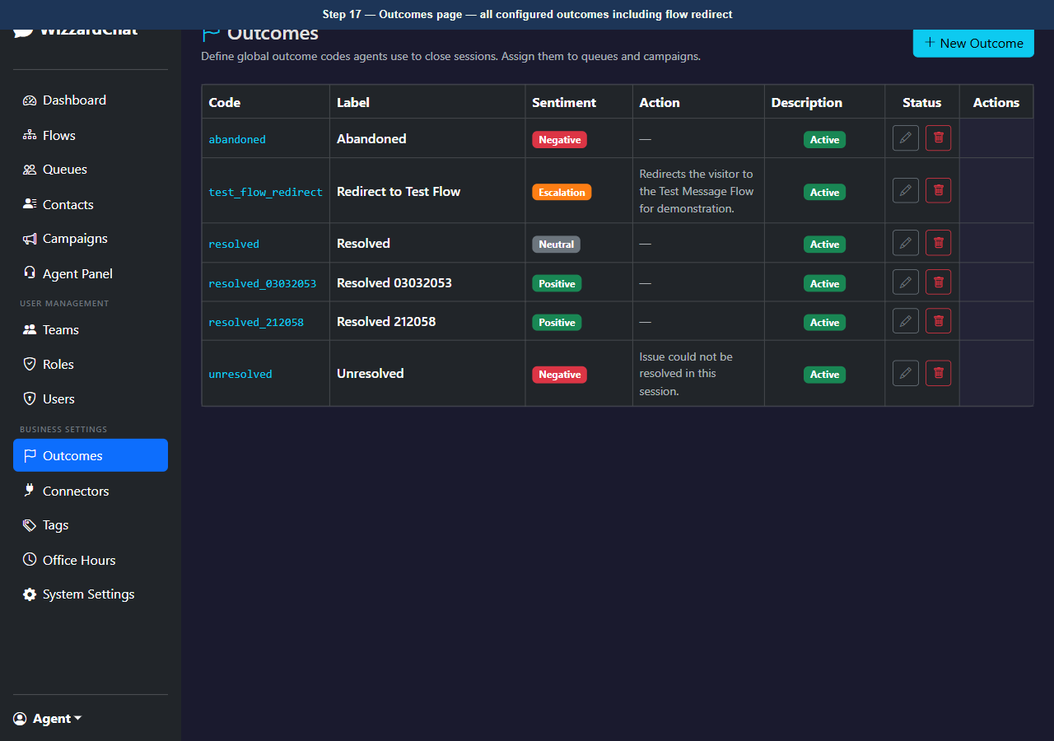
Figure 17 — Outcomes page — all configured outcomes including flow redirect

Troubleshooting
Use this table to resolve common problems.
Symptom | Likely cause | Resolution
The page redirects to the login screen. | Your session has expired. | Sign in again with your admin credentials.
A modal dialog does not close after you click Save. | A required field is empty or contains an invalid value. | Check all required fields (marked with *) and correct the value, then click Save again.
A button is visible but unclickable. | Your account does not have the required role. | Ask your administrator to assign the Admin or Supervisor role to your account.

Next steps
- Review the index for related training guides.
- Contact your administrator if configuration steps differ from those shown here.

