WizzardChat · Training Documentation

WizzardChat — Flow-Redirect Outcome: End-to-End Demonstration
Demonstrates the complete flow-redirect outcome path:
1. A visitor starts a chat session.
2. An agent takes the session from the Agent Panel.
3. The agent selects 'Redirect to Test Flow' from the Outcome modal.
4. The server runs the Test Message Flow and delivers the specialist-transfer message directly to the visitor's chat window via the SSE stream.
Generated: 2026-03-06 15:47 · 21 recorded steps · Applies to: WizzardChat (current)

Overview
Demonstrates the complete flow-redirect outcome path:
1. A visitor starts a chat session.
2. An agent takes the session from the Agent Panel.
3. The agent selects 'Redirect to Test Flow' from the Outcome modal.
4. The server runs the Test Message Flow and delivers the specialist-transfer message directly to the visitor's chat window via the SSE stream.

Before you begin
- WizzardChat is running and accessible at http://localhost:8092.
- You have admin credentials (username and password).
- Your browser can reach the WizzardChat server.

Steps

This demonstration covers the Outcome-gated close feature with the flow_redir...
This demonstration covers the Outcome-gated close feature with the flow_redirect action type.
When an agent selects a flow-redirect outcome, WizzardChat:
* Saves the outcome against the session (for reporting).
* Stores the target flow ID in the session context.
* Runs the assigned Flow, executing each node in sequence.
* Pushes any Send Message nodes to the visitor's SSE stream in real time.
The visitor receives the flow message without any page reload or new session.

1. [Navigate to] Open WizzardChat — login page
URL: http://localhost:8092/
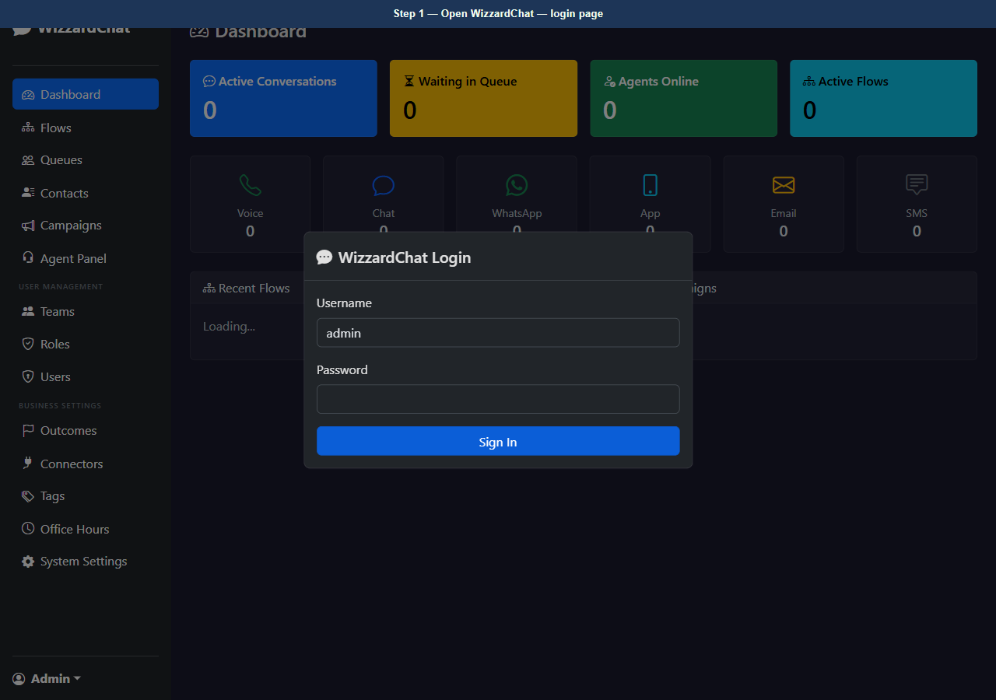
Figure 1 — Open WizzardChat — login page
2. [Type] Enter admin username
Element: #loginUser Value: admin
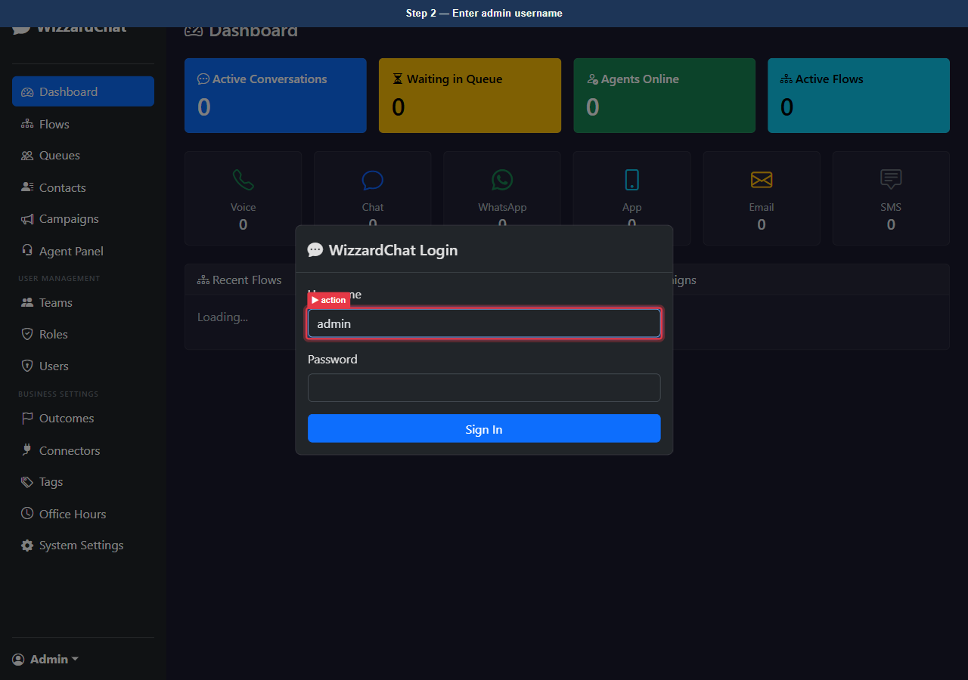
Figure 2 — Enter admin username
3. [Type] Enter admin password
Element: #loginPass Value: ••••••••
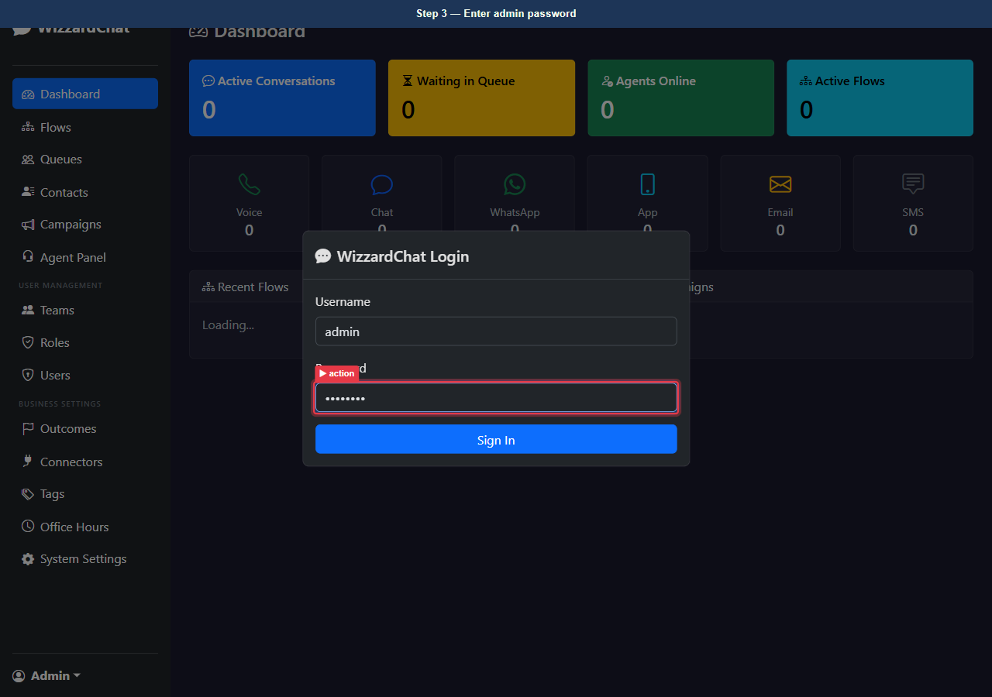
Figure 3 — Enter admin password
4. [Click] Sign in
Element: button[type=submit]
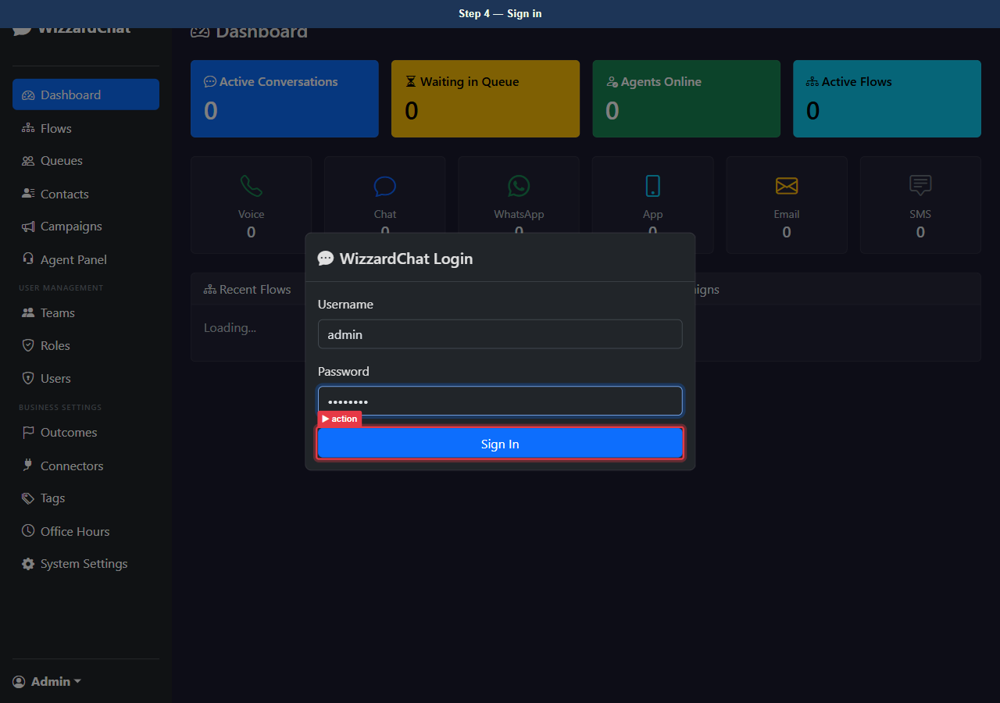
Figure 4 — Sign in
5. [Observe] Logged in — WizzardChat dashboard
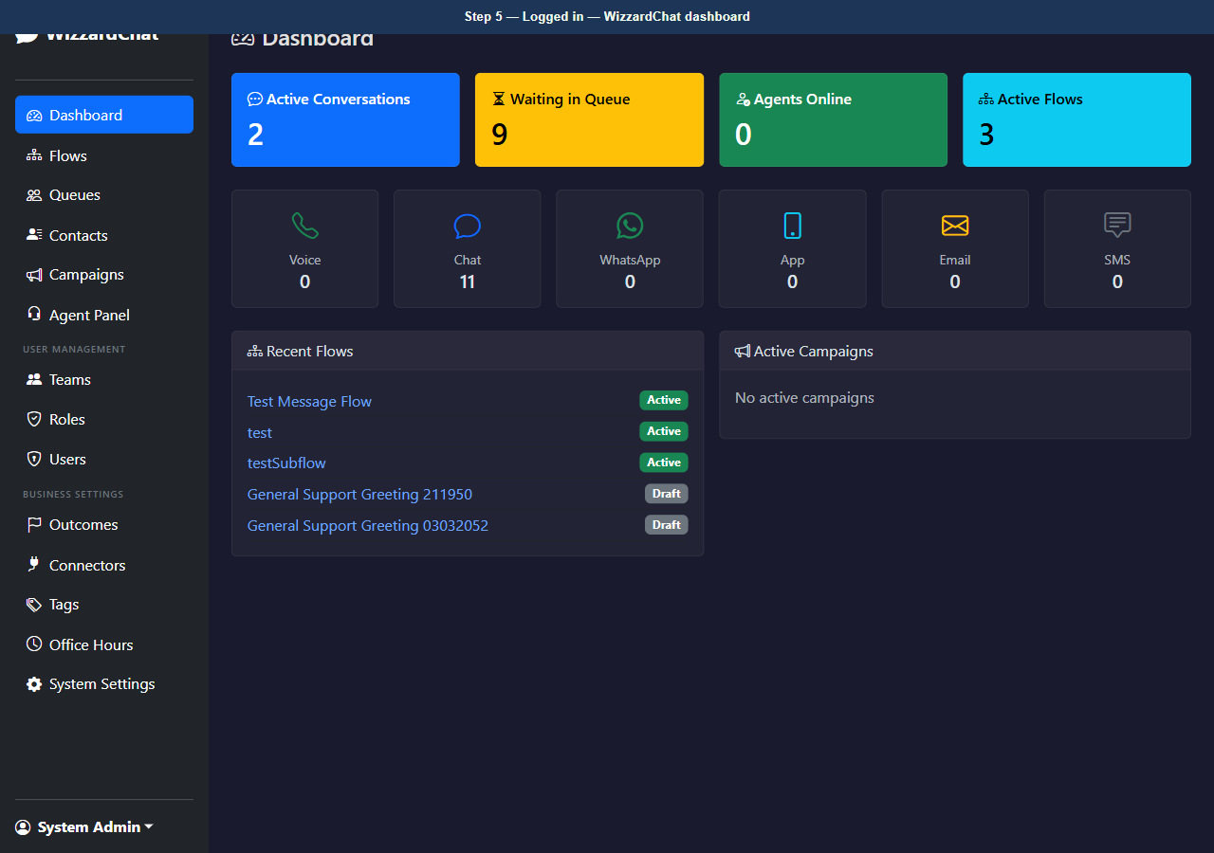
Figure 5 — Logged in — WizzardChat dashboard
6. [Navigate to] Open Agent Panel
URL: http://localhost:8092/agent
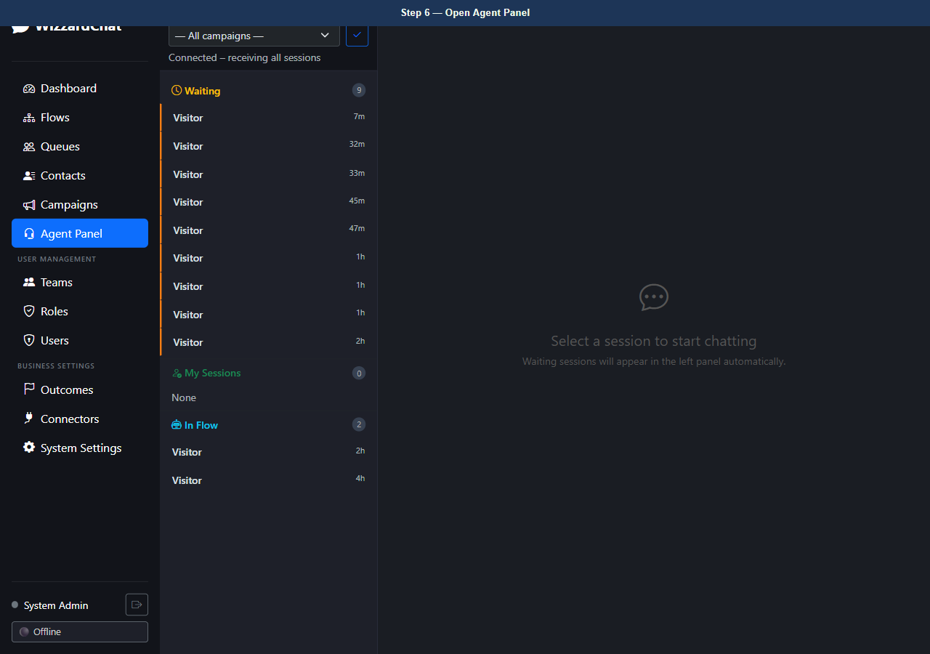
Figure 6 — Open Agent Panel
7. [Observe] Agent Panel — idle, no active sessions
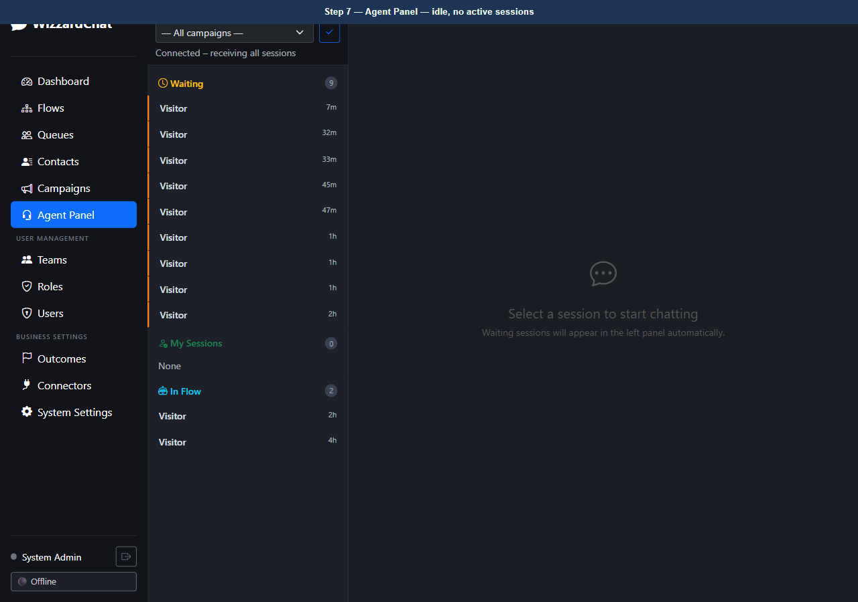
Figure 7 — Agent Panel — idle, no active sessions

A visitor opens the chat widget
A visitor opens the chat widget. The widget calls:
POST /chat/{api_key}/{session_id}/init
then subscribes to the server-sent events stream at:
GET /sse/chat/{api_key}/{session_id}
All subsequent messages from the agent and any active flows are pushed through that SSE connection.

8. [Navigate to] Visitor chat widget — connected, awaiting agent
URL: http://localhost:8092/__visitor_demo__
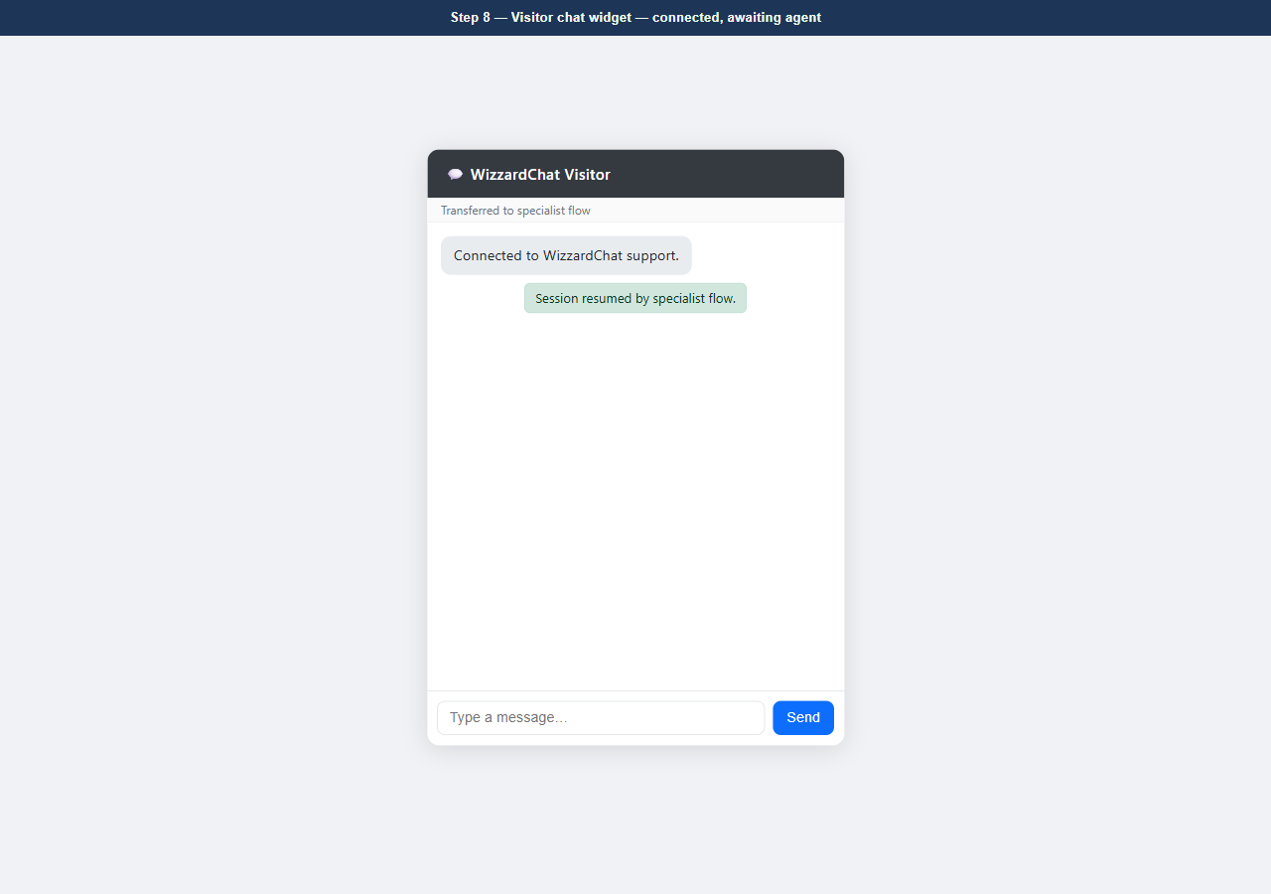
Figure 8 — Visitor chat widget — connected, awaiting agent

The Agent Panel updates automatically via WebSocket
The Agent Panel updates automatically via WebSocket.
The new session from the visitor appears in the Waiting list on the left.

9. [Navigate to] Return to Agent Panel
URL: http://localhost:8092/agent
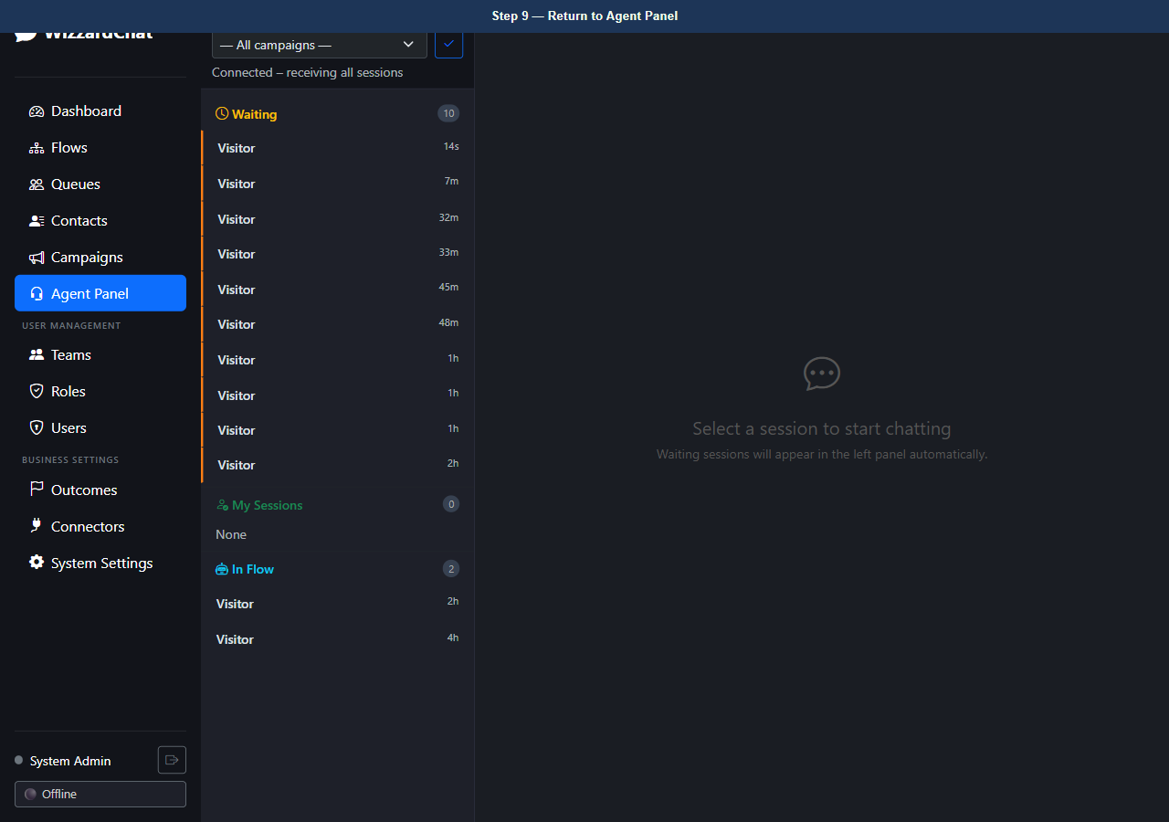
Figure 9 — Return to Agent Panel
10. [Observe] Agent Panel — visitor session visible in the Waiting list
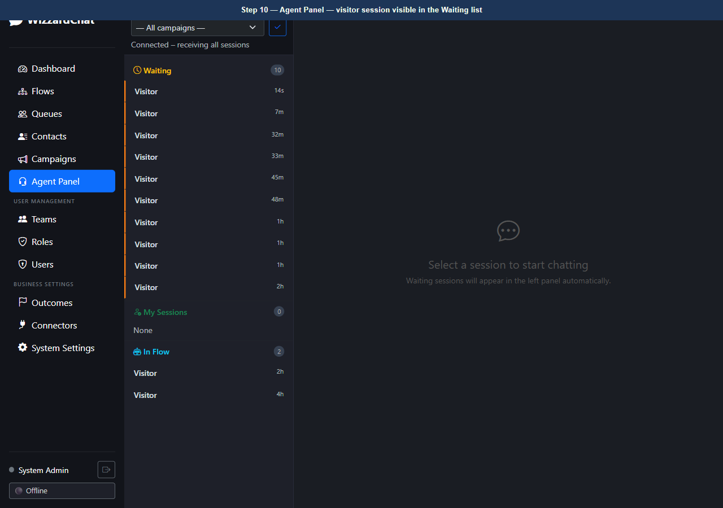
Figure 10 — Agent Panel — visitor session visible in the Waiting list

The agent sees the session in the Waiting list and clicks Take
The agent sees the session in the Waiting list and clicks Take.
The session moves to Mine. The Outcome button appears in the chat header, replacing the plain Close button. The agent must select a reason before the session can be closed.

11. [Observe] Agent Panel — session taken, Outcome button visible in header
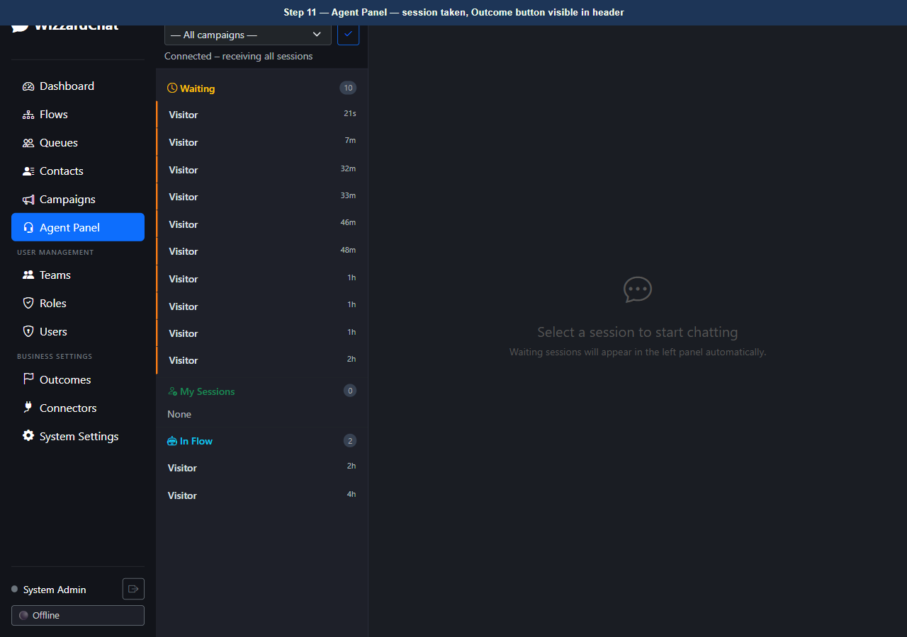
Figure 11 — Agent Panel — session taken, Outcome button visible in header

The agent clicks Outcome to open the Outcome Selection modal
The agent clicks Outcome to open the Outcome Selection modal.
All active outcomes are loaded from the API and grouped into four columns:
* Negative — outcomes that indicate an unresolved or bad experience
* Escalation — outcomes that transfer or redirect the visitor
* Neutral — standard resolutions with no clear sentiment
* Positive — outcomes that indicate a successful or satisfying interaction
The 'Redirect to Test Flow' card sits in the Escalation column. Its badge reads 'Redirects to flow' rather than 'Ends session'.

12. [Observe] Outcome modal — 4-column layout (Negative / Escalation / Neutral / Positive)
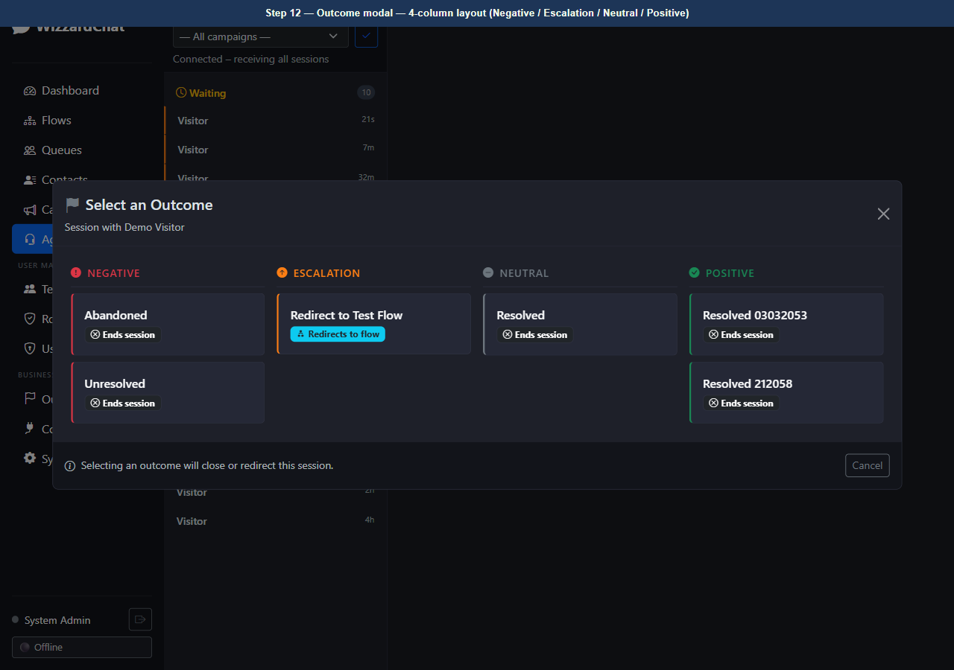
Figure 12 — Outcome modal — 4-column layout (Negative / Escalation / Neutral / Positive)
13. [Observe] Outcome modal — 'Redirect to Test Flow' highlighted in Escalation column
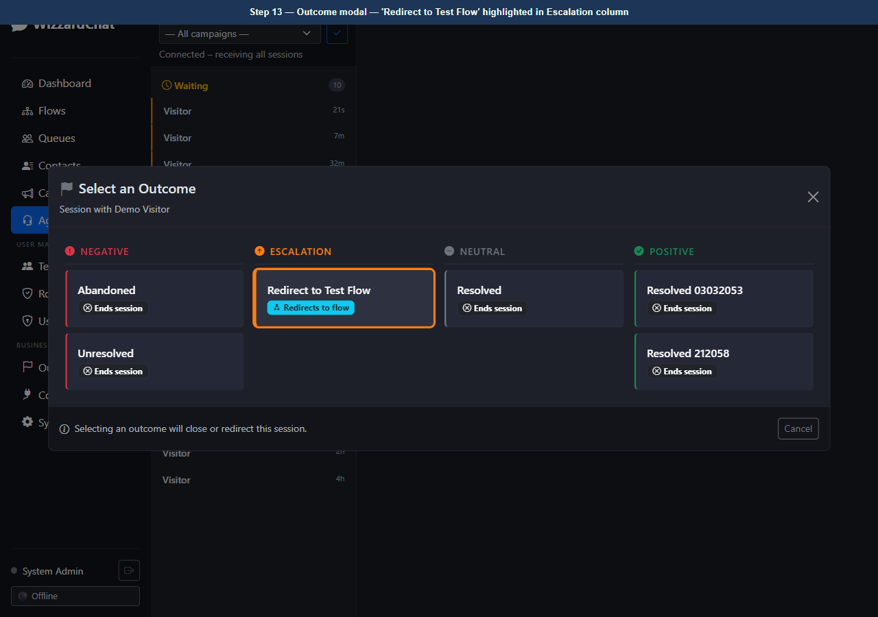
Figure 13 — Outcome modal — 'Redirect to Test Flow' highlighted in Escalation column

The agent confirms the outcome
The agent confirms the outcome.
agent.js sends a close_with_outcome WebSocket message to the server:
{ type: 'close_with_outcome',
session_key: '...',
outcome_id: '0ba975e8-...' }
The server:
1. Validates the outcome and records it against the session.
2. Sets _current_flow_id in the session's flow context.
3. Replies session_flow_redirected to the agent WebSocket.
4. Calls run_flow(), which loads the Test Message Flow and streams its
send_message node to the visitor's SSE endpoint.

14. [Navigate to] Visitor chat widget — agent selects outcome now
URL: http://localhost:8092/__visitor_demo__
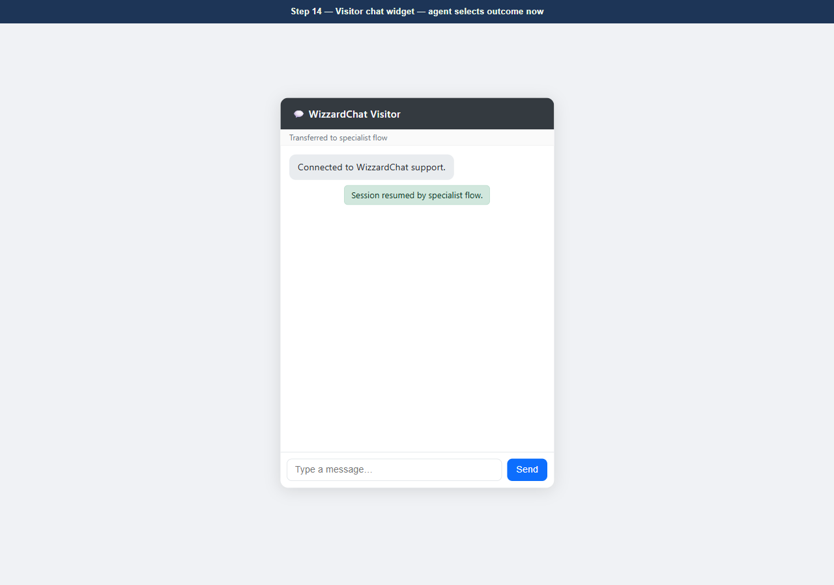
Figure 14 — Visitor chat widget — agent selects outcome now
15. [Observe] Visitor chat widget — flow message delivered by specialist transfer
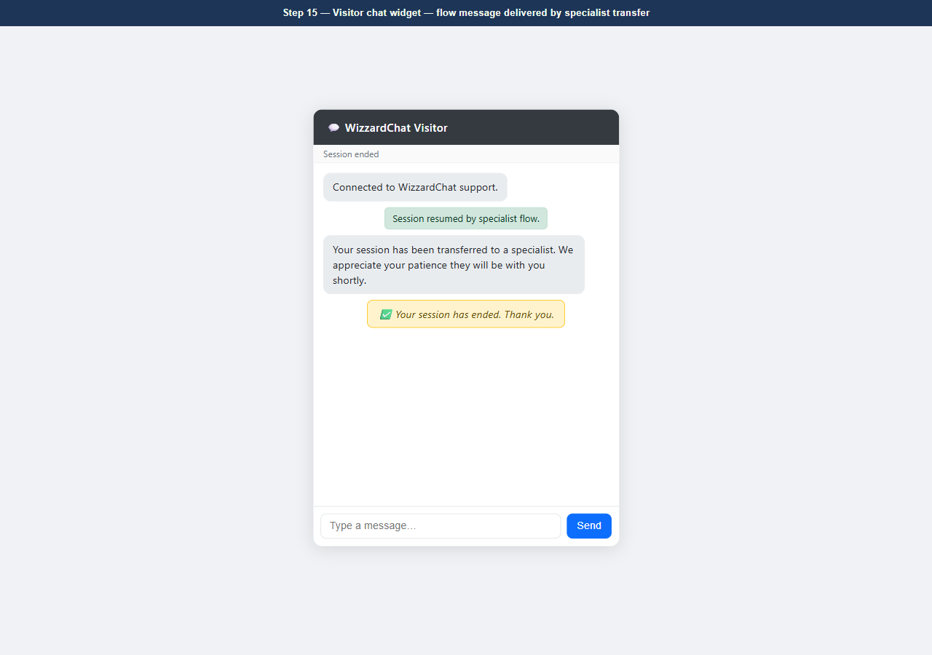
Figure 15 — Visitor chat widget — flow message delivered by specialist transfer

The Test Message Flow has executed its send_message node, delivering:
'Your session has been transferred to a specialist. We appreciate your patience — they will be with you shortly.'
The SSE stream also delivers an end event, which the visitor widget displays as a session-close banner. No page reload occurred — the message arrived via the existing SSE connection.

After the flow completes, the session is marked closed on the server
After the flow completes, the session is marked closed on the server. The agent's panel removes the session from the Mine list and decrements their active session count.

16. [Navigate to] Return to Agent Panel — after redirect
URL: http://localhost:8092/agent
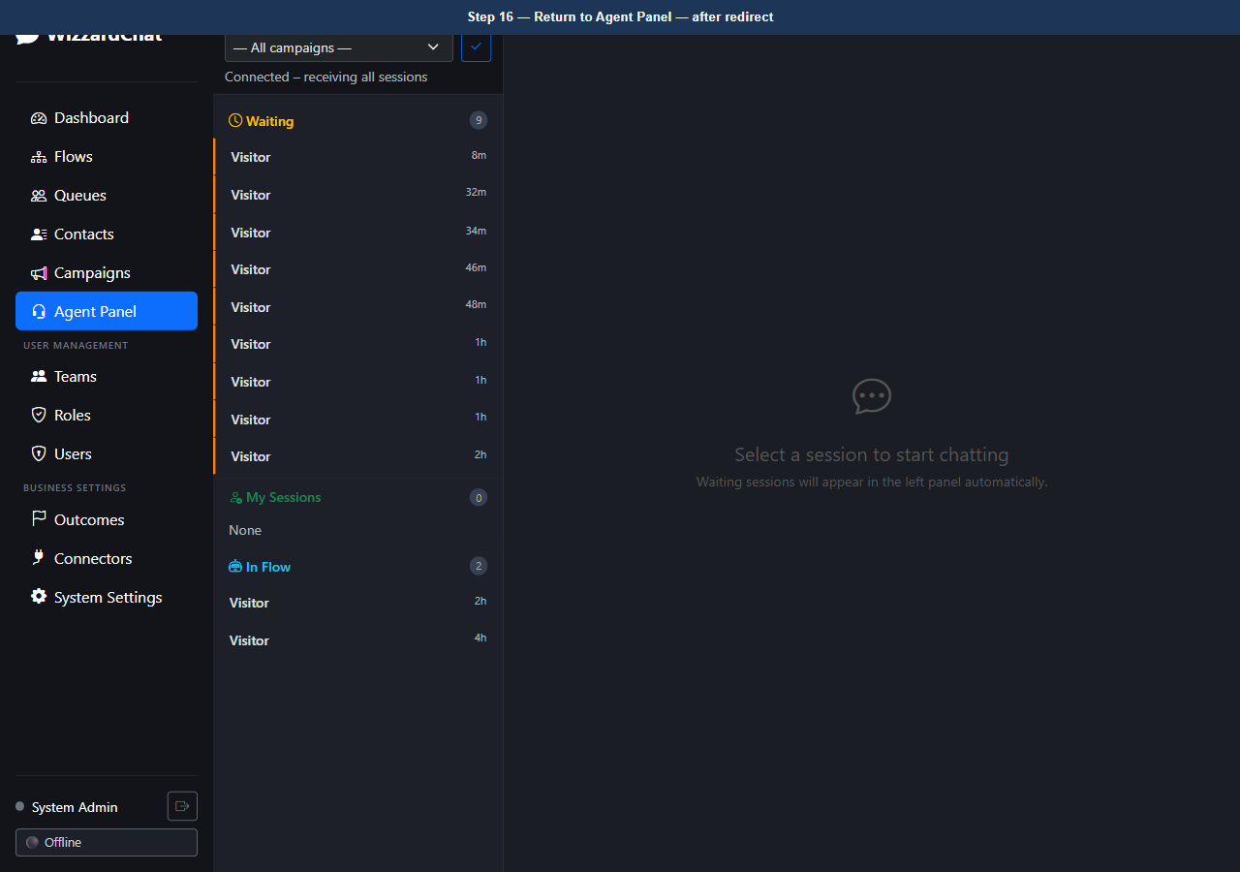
Figure 16 — Return to Agent Panel — after redirect
17. [Observe] Agent Panel — session cleared after flow redirect
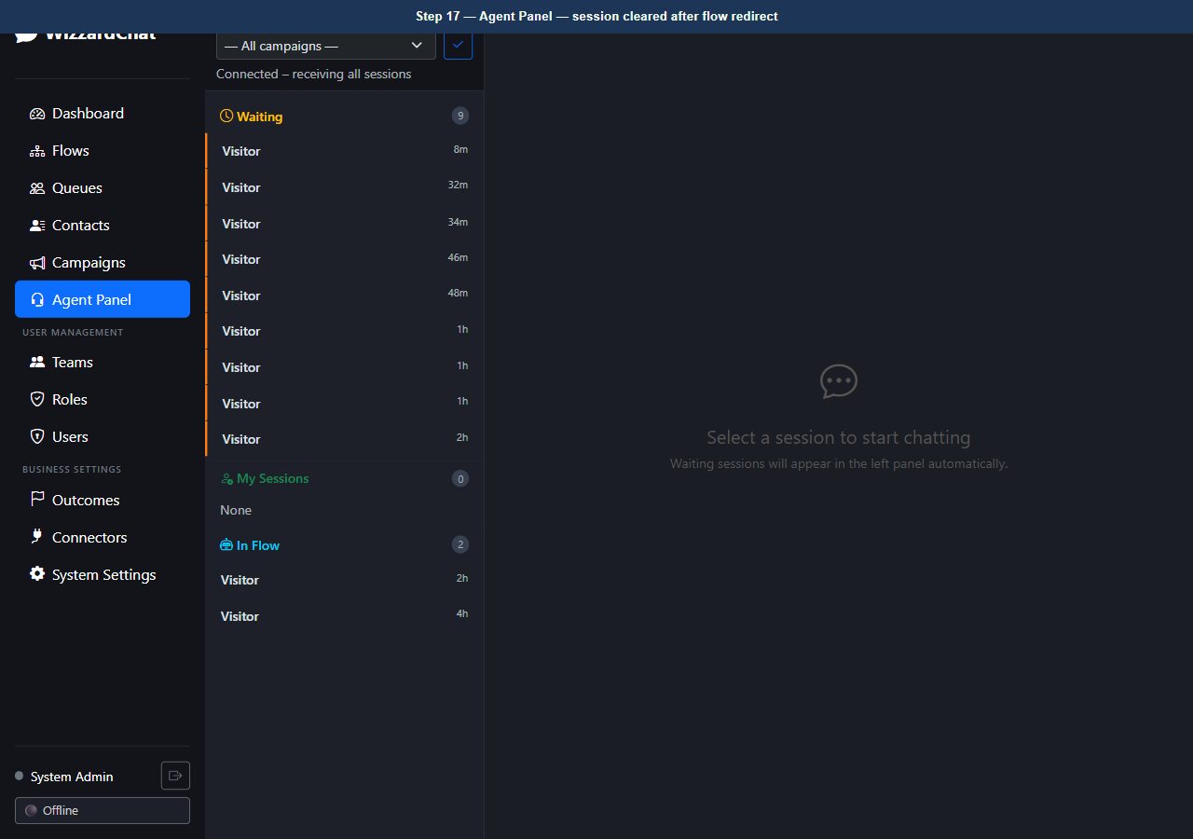
Figure 17 — Agent Panel — session cleared after flow redirect

Outcomes are configured on the Outcomes page in the admin panel
Outcomes are configured on the Outcomes page in the admin panel.
Each outcome has:
* A label (shown to agents in the modal)
* An outcome_type (negative / escalation / neutral / positive)
* An action_type (end_interaction or flow_redirect)
* An optional redirect_flow_id (required for flow_redirect outcomes)
Outcomes can be assigned to specific queues or left unassigned to apply globally across all queues.

18. [Navigate to] Outcomes configuration page
URL: http://localhost:8092/outcomes
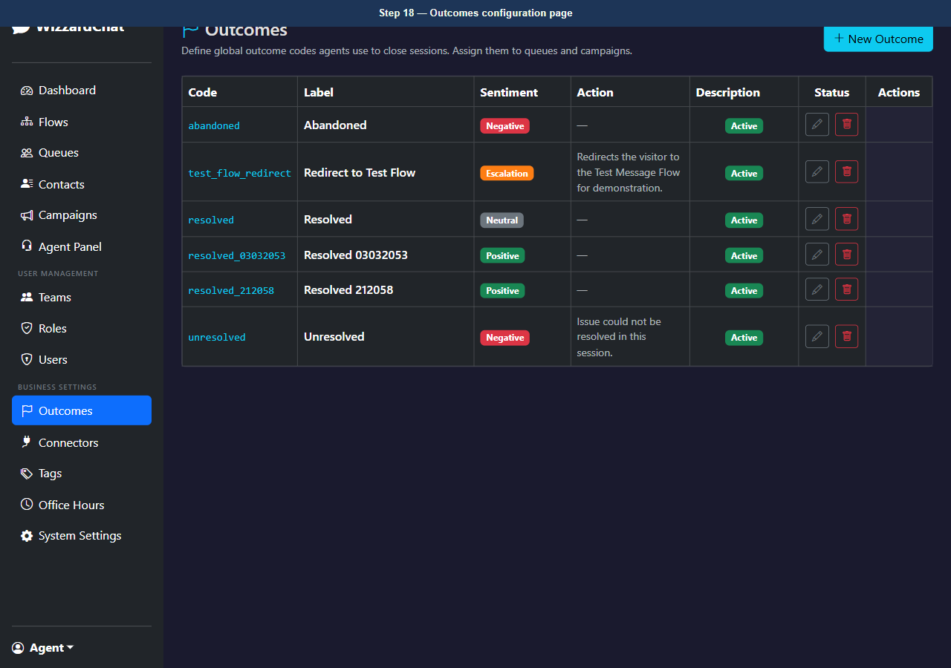
Figure 18 — Outcomes configuration page
19. [Observe] Outcomes page — all active outcomes with their types and actions
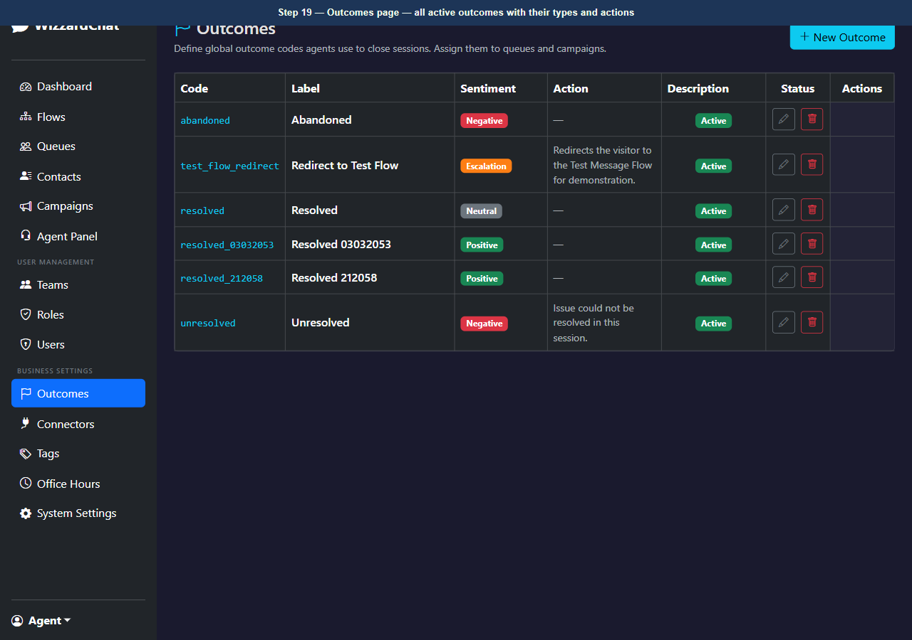
Figure 19 — Outcomes page — all active outcomes with their types and actions

The target flow is configured in the Flow Designer
The target flow is configured in the Flow Designer.
The Test Message Flow contains three nodes in sequence:
Start -> Send Message -> End
The Send Message node's text field holds the message delivered to the visitor. Any flow can be assigned as a flow-redirect target, enabling complex multi-step specialist transfer journeys.

20. [Navigate to] Flow Designer — Test Message Flow
URL: http://localhost:8092/flow-designer/f0876777-c2d2-4ecf-bd11-041a82d88afd
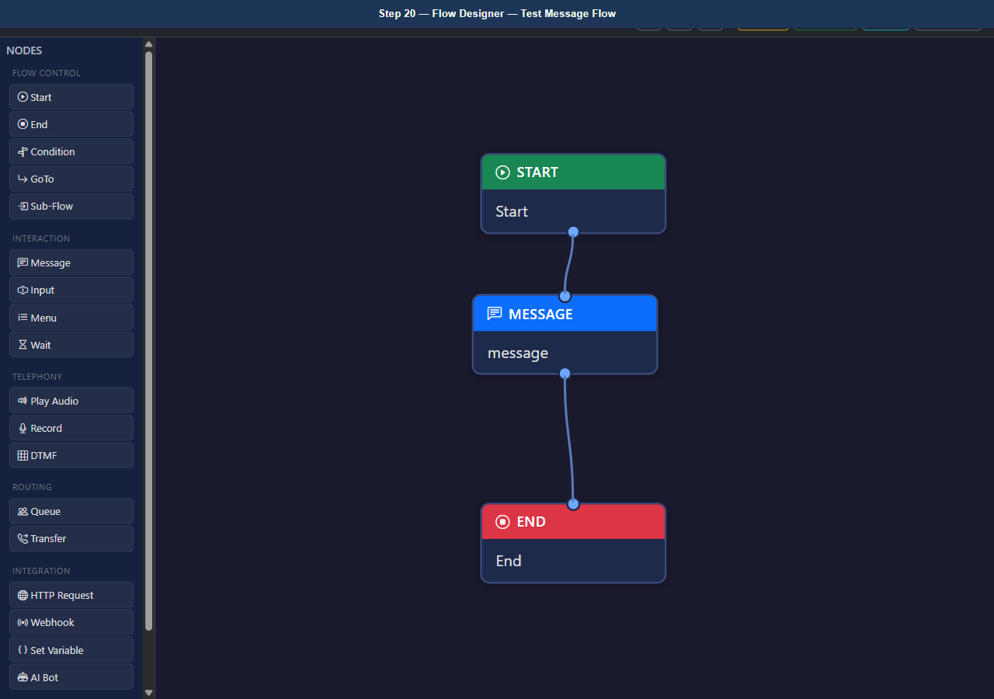
Figure 20 — Flow Designer — Test Message Flow
21. [Observe] Flow Designer — Test Message Flow (Start -> Send Message -> End)
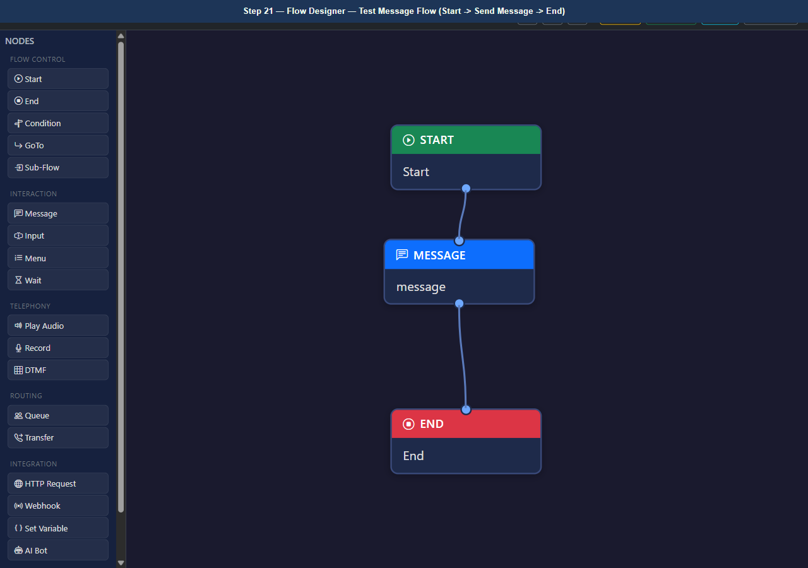
Figure 21 — Flow Designer — Test Message Flow (Start -> Send Message -> End)

Troubleshooting
Use this table to resolve common problems.
Symptom | Likely cause | Resolution
The page redirects to the login screen. | Your session has expired. | Sign in again with your admin credentials.
A modal dialog does not close after you click Save. | A required field is empty or contains an invalid value. | Check all required fields (marked with *) and correct the value, then click Save again.
A button is visible but unclickable. | Your account does not have the required role. | Ask your administrator to assign the Admin or Supervisor role to your account.

Next steps
- Review the index for related training guides.
- Contact your administrator if configuration steps differ from those shown here.

