WizzardChat · Training Documentation

Outcome Modal — Live Demo with Flow Redirect
Demonstrates the WizzardChat Outcome modal after database seeding. Four outcomes are shown grouped by sentiment: Resolved (positive), Unresolved and Abandoned (negative), and Redirect to Test Flow (escalation). The flow-redirect outcome is also demonstrated end-to-end.
Generated: 2026-03-06 10:48 · 21 recorded steps · Applies to: WizzardChat (current)

Overview
Demonstrates the WizzardChat Outcome modal after database seeding. Four outcomes are shown grouped by sentiment: Resolved (positive), Unresolved and Abandoned (negative), and Redirect to Test Flow (escalation). The flow-redirect outcome is also demonstrated end-to-end.

Before you begin
- WizzardChat is running and accessible at http://localhost:8092.
- You have admin credentials (username and password).
- Your browser can reach the WizzardChat server.

Steps

Sign in to WizzardChat as an administrator before reviewing the Outcomes conf...
Sign in to WizzardChat as an administrator before reviewing the Outcomes configuration.

1. [Navigate to] Open WizzardChat
URL: http://localhost:8092/
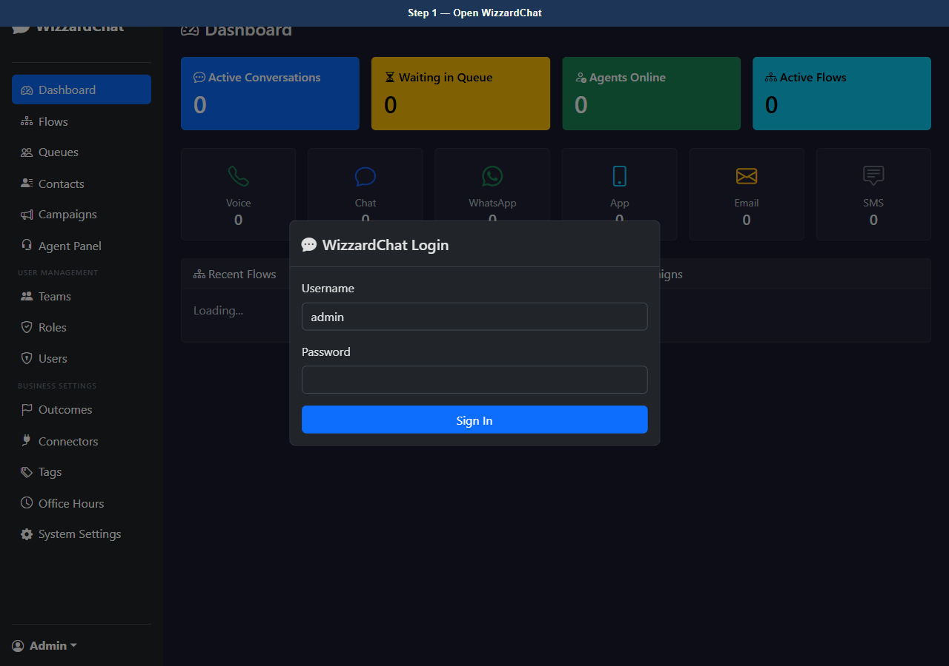
Figure 1 — Open WizzardChat
2. [Type] Enter admin username
Element: #loginUser Value: admin
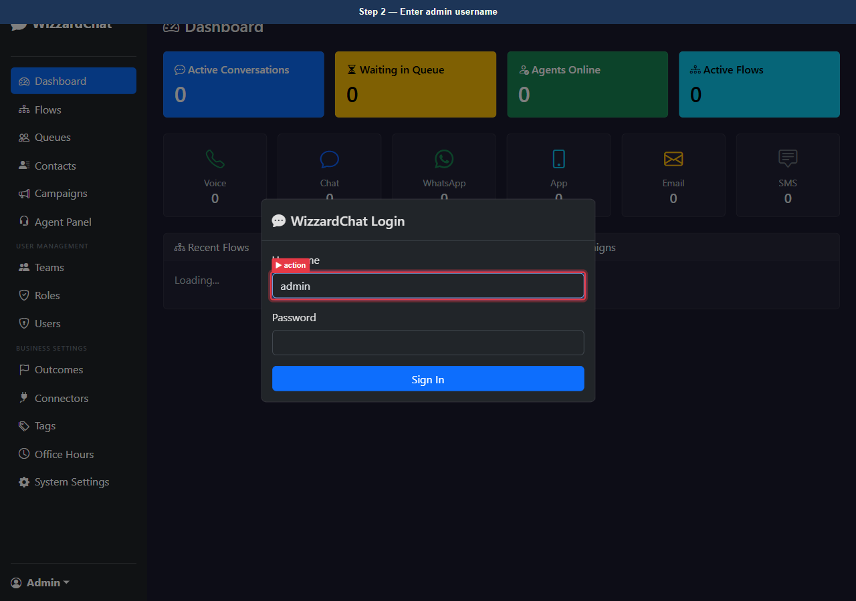
Figure 2 — Enter admin username
3. [Type] Enter admin password
Element: #loginPass Value: ••••••••
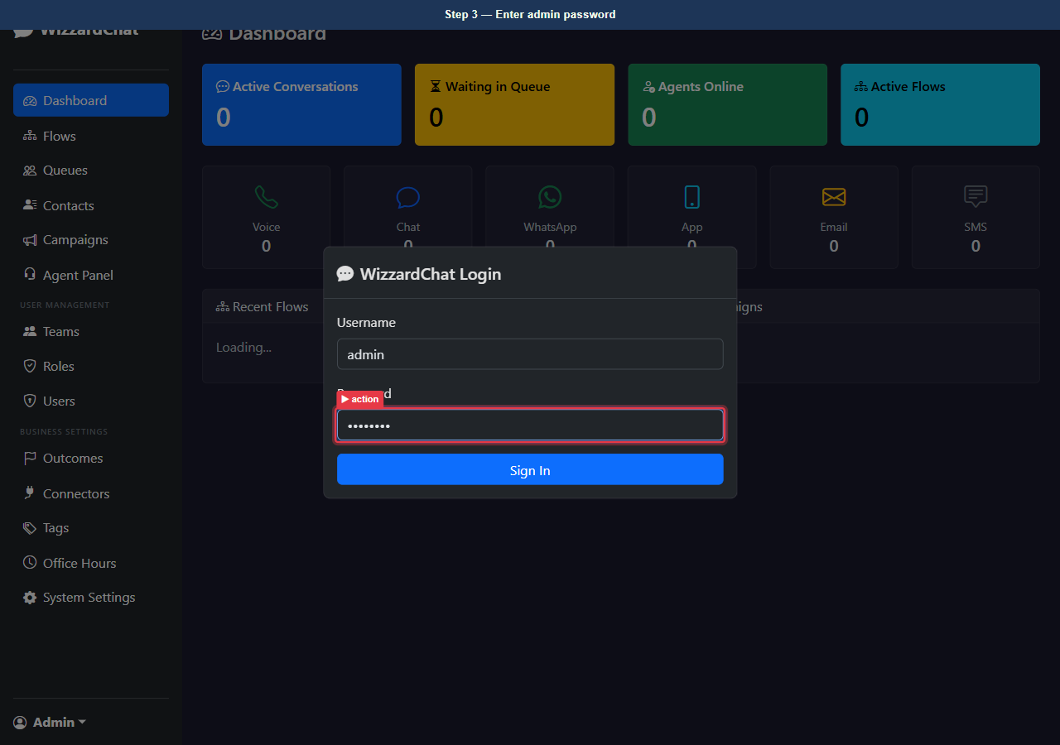
Figure 3 — Enter admin password
4. [Click] Sign in
Element: button[type=submit]
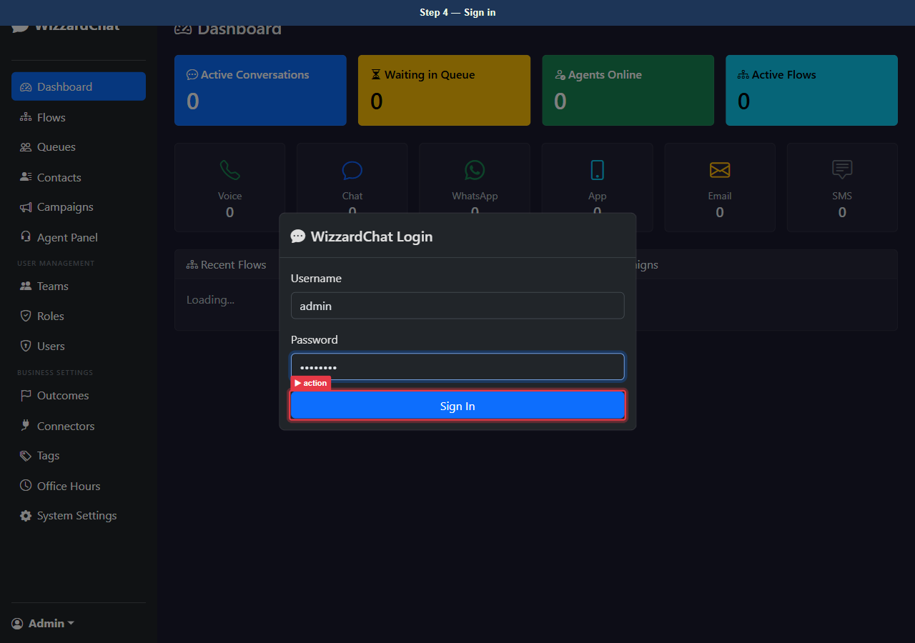
Figure 4 — Sign in
5. [Observe] Dashboard — logged in
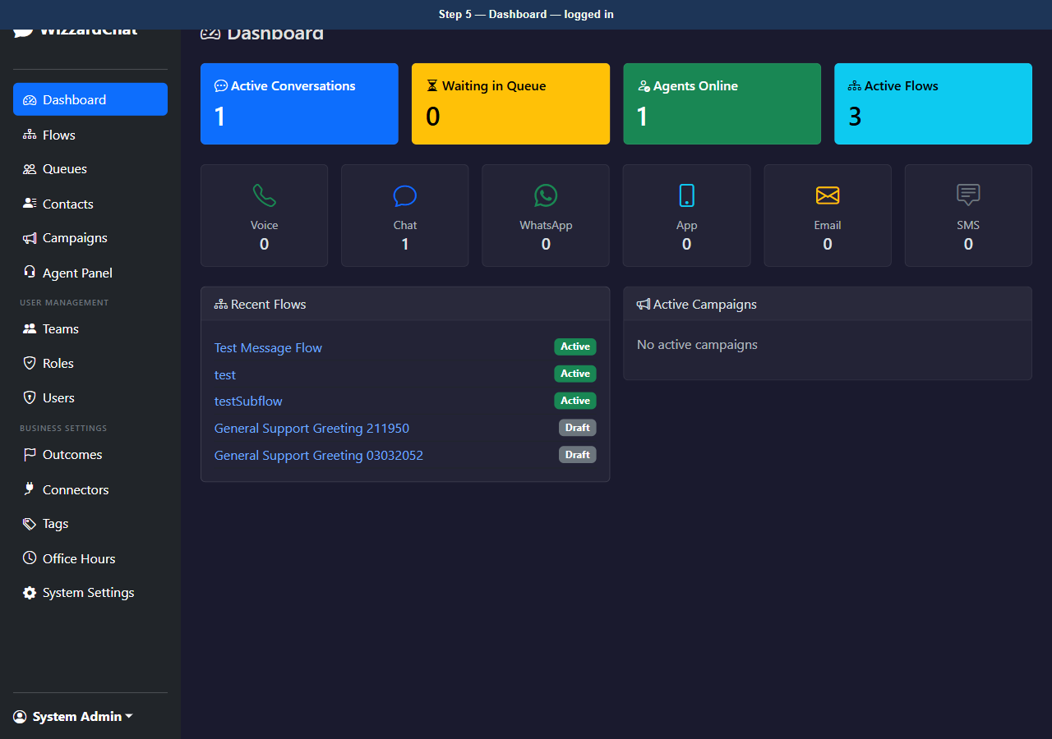
Figure 5 — Dashboard — logged in

The Outcomes page lists every configured resolution outcome
The Outcomes page lists every configured resolution outcome.
Four outcomes are now seeded:
- Resolved (positive) — ends the session, records a successful interaction.
- Unresolved (negative) — ends the session, flags the interaction for follow-up.
- Abandoned (negative) — ends the session, marks the customer as having left before resolution.
- Redirect to Test Flow (escalation) — hands the visitor to the Test Message Flow instead of closing the session immediately.

6. [Navigate to] Open Outcomes configuration page
URL: http://localhost:8092/outcomes
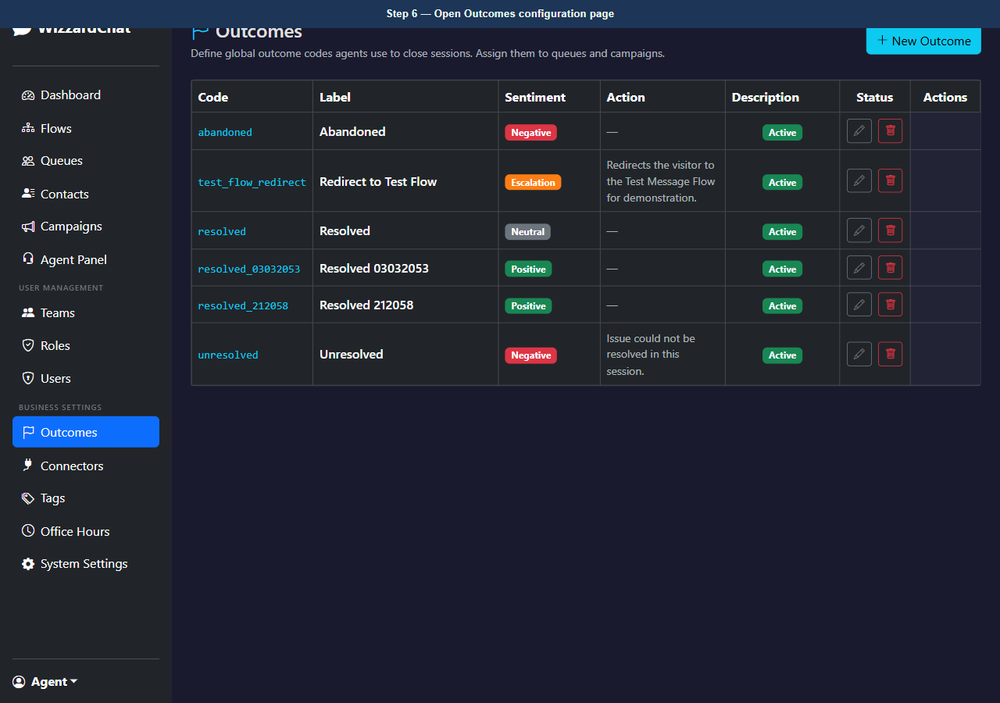
Figure 6 — Open Outcomes configuration page
7. [Observe] Outcomes page — four active outcomes
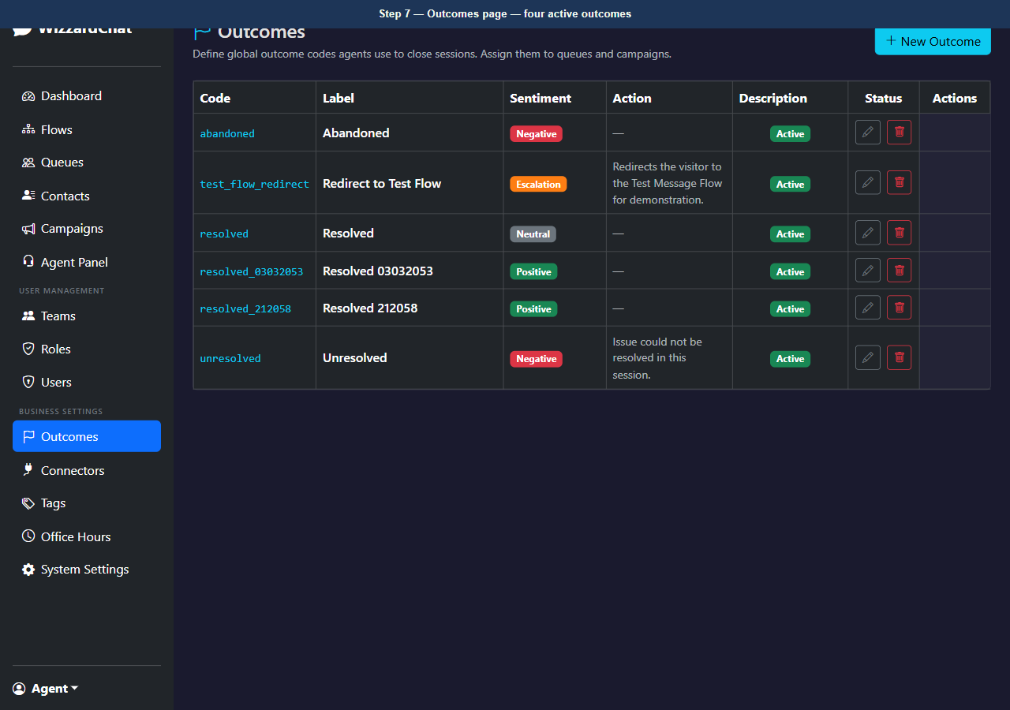
Figure 7 — Outcomes page — four active outcomes

The Test Message Flow is a minimal flow created to demonstrate the flow_redir...
The Test Message Flow is a minimal flow created to demonstrate the flow_redirect path.
It contains three nodes: Start → Send Message → End.
When the agent selects 'Redirect to Test Flow', WizzardChat activates this flow for the visitor and hands control to the flow engine, sending the configured message.

8. [Navigate to] Open Flows page
URL: http://localhost:8092/flows
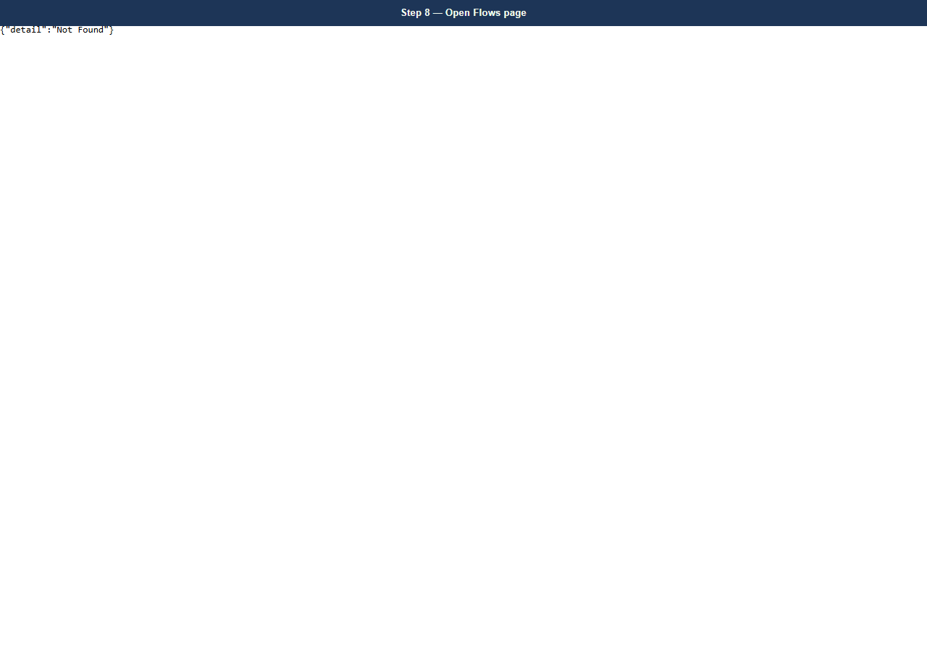
Figure 8 — Open Flows page
9. [Observe] Flows page — Test Message Flow listed
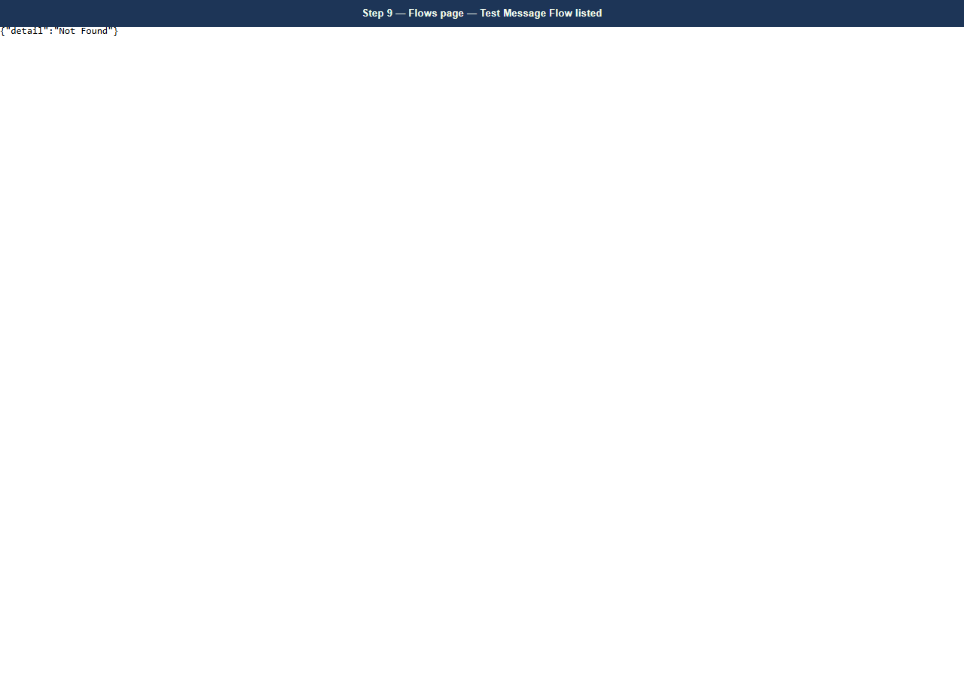
Figure 9 — Flows page — Test Message Flow listed

Opening the flow in the designer shows the three nodes and their connections
Opening the flow in the designer shows the three nodes and their connections.
The Send Message node is configured with the redirect message that the visitor receives.

10. [Observe] Flow designer — Test Message Flow (Start → Send Message → End)
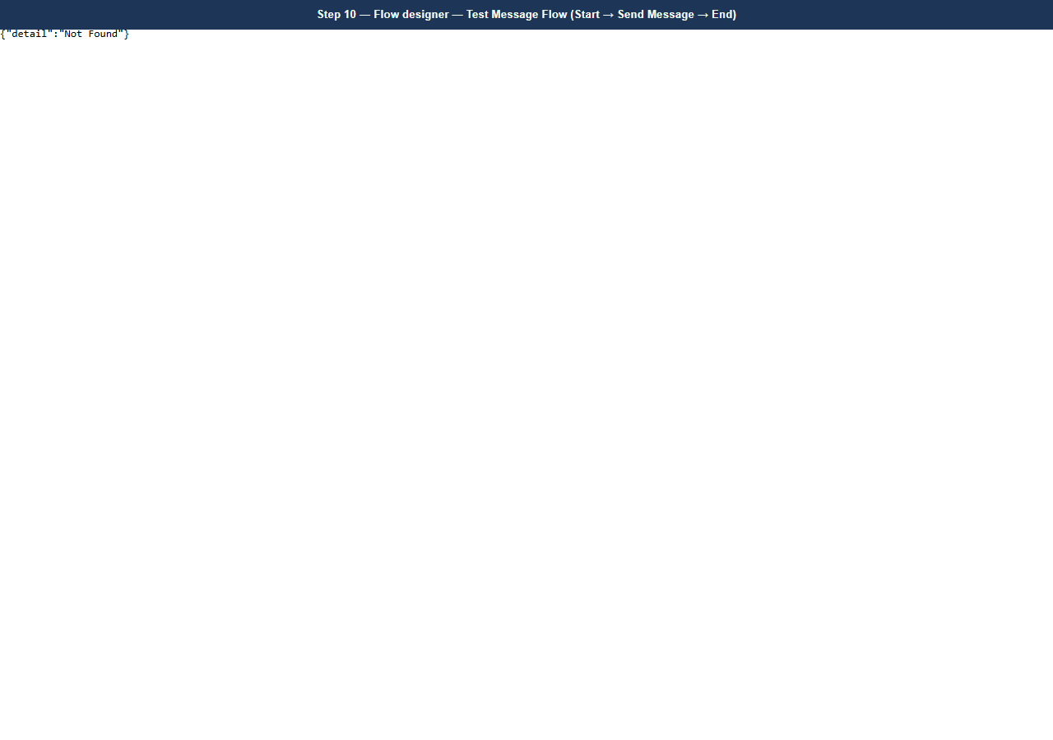
Figure 10 — Flow designer — Test Message Flow (Start → Send Message → End)

Outcomes are attached to queues
Outcomes are attached to queues. When an agent owns a session routed through a queue, the Outcome modal fetches that queue's outcome list.
All queues in the system have been updated to include the four seeded outcomes.

11. [Navigate to] Open Queues configuration page
URL: http://localhost:8092/queues
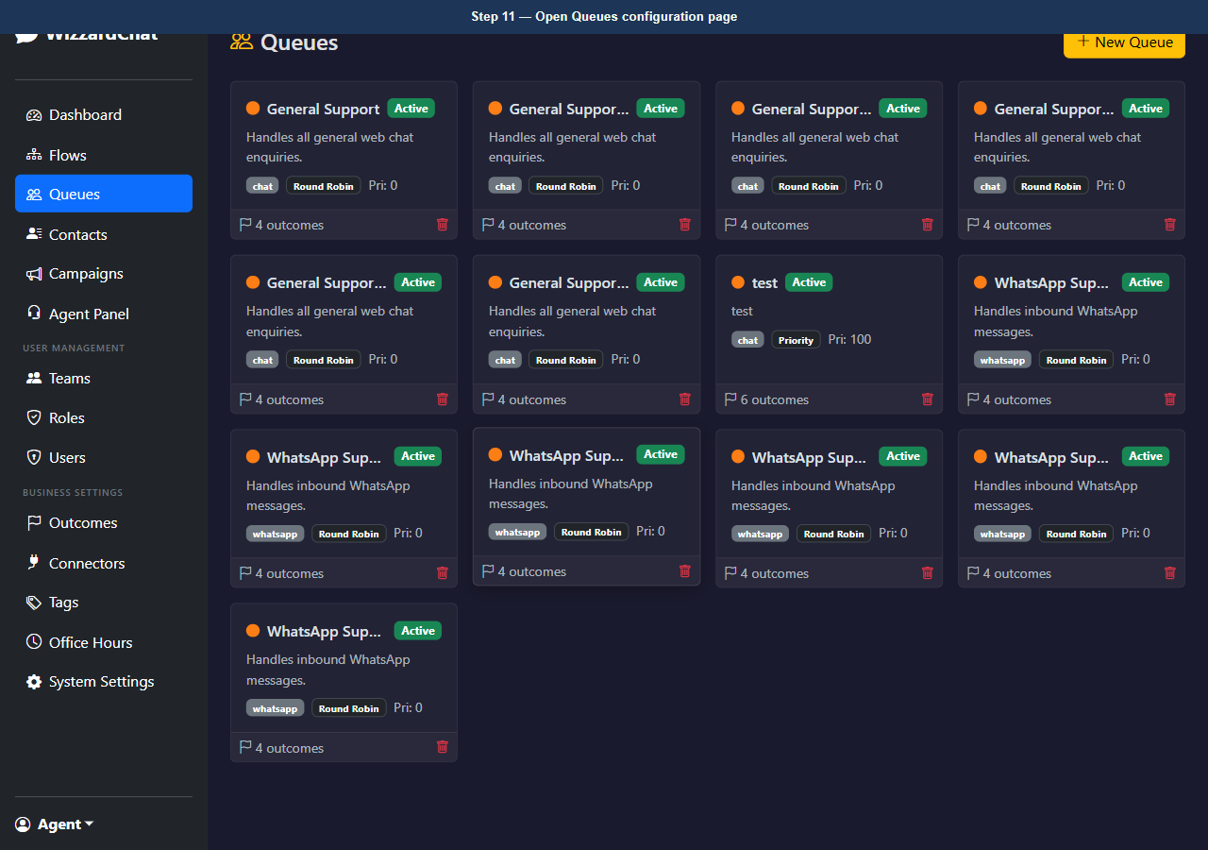
Figure 11 — Open Queues configuration page
12. [Observe] Queues page — queues with outcomes assigned
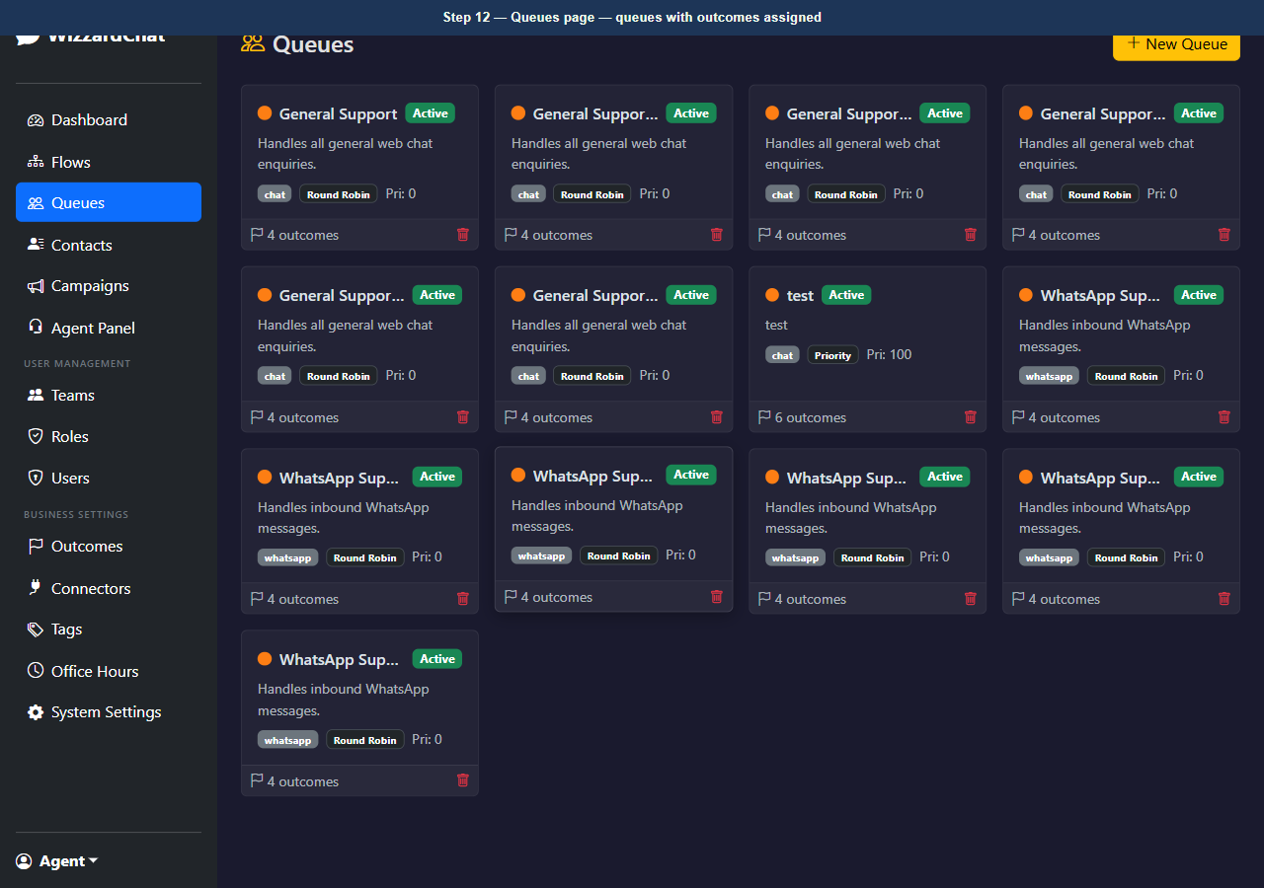
Figure 12 — Queues page — queues with outcomes assigned

The Agent Panel shows a placeholder when no session is selected
The Agent Panel shows a placeholder when no session is selected. The Outcome button is hidden until the agent owns a session.

13. [Navigate to] Open Agent Panel
URL: http://localhost:8092/agent
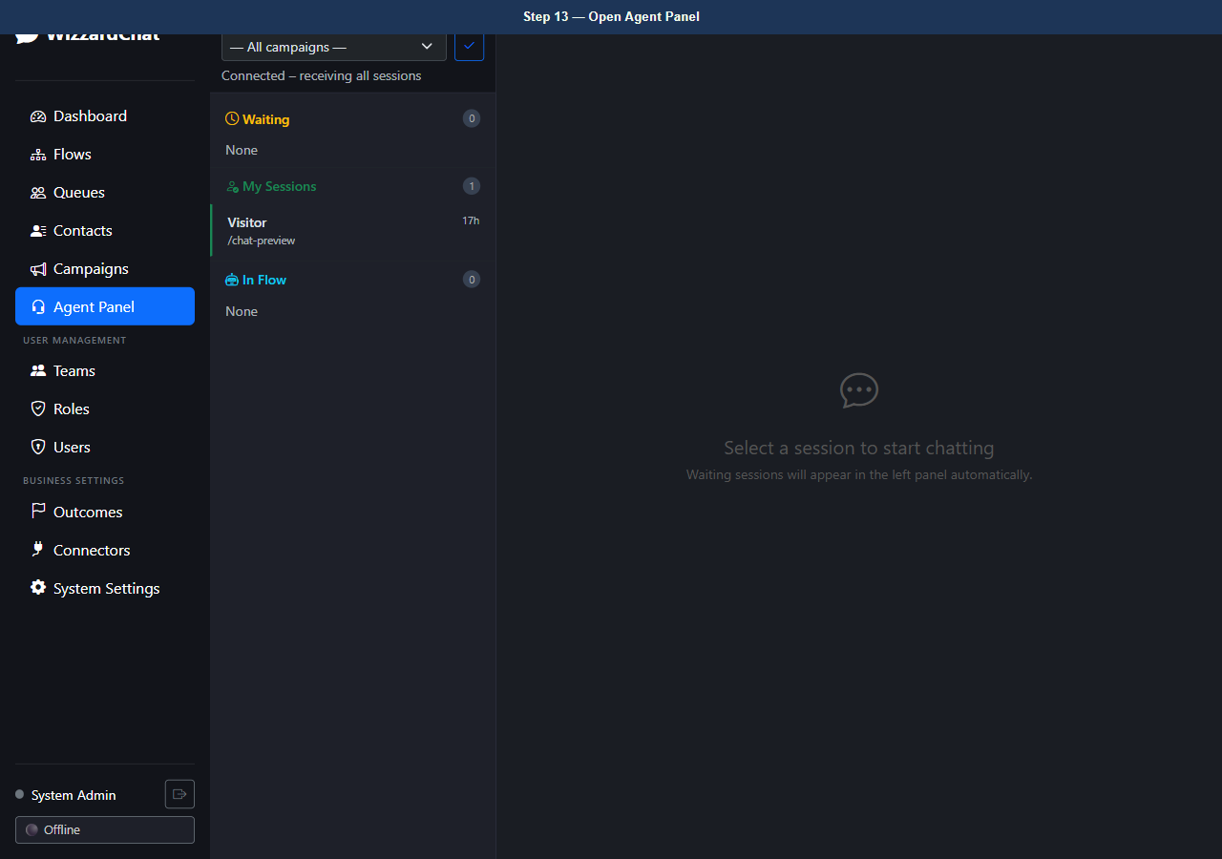
Figure 13 — Open Agent Panel
14. [Observe] Agent Panel — initial state, no session active
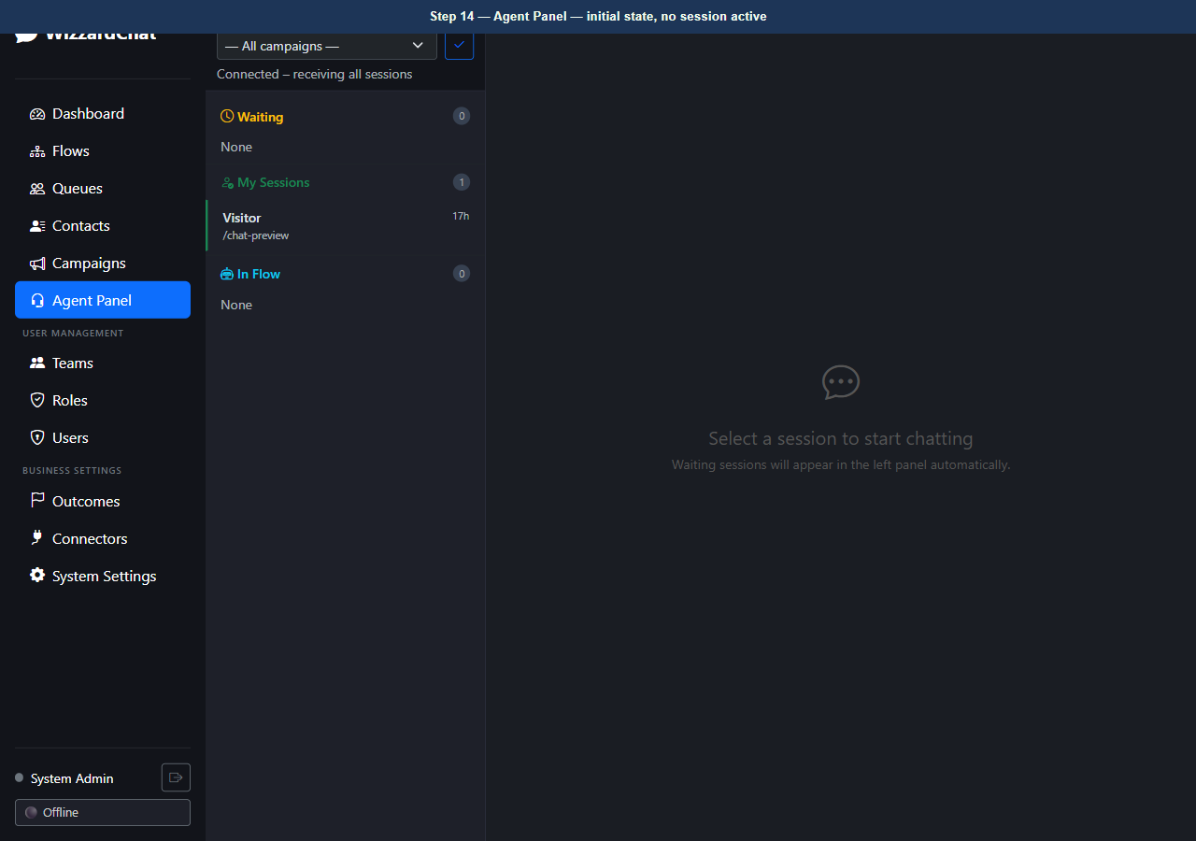
Figure 14 — Agent Panel — initial state, no session active

Once an agent takes ownership of a session, the chat header updates
Once an agent takes ownership of a session, the chat header updates.
The Outcome button replaces the plain Close button, requiring the agent to select a resolution outcome before the session can be closed.

15. [Observe] Agent Panel — session owned, Outcome button visible in header
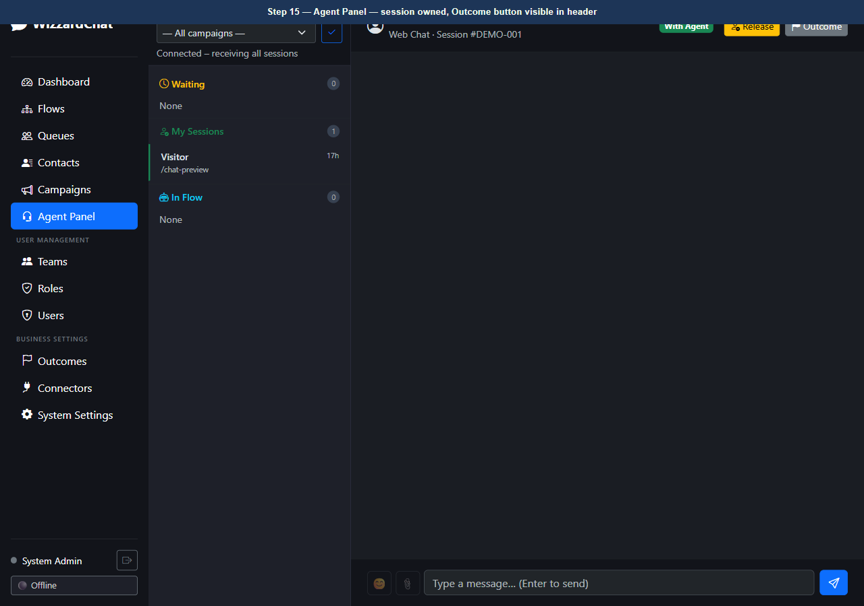
Figure 15 — Agent Panel — session owned, Outcome button visible in header

Clicking Outcome opens a wide modal that groups all available outcomes by the...
Clicking Outcome opens a wide modal that groups all available outcomes by their sentiment type.
Negative outcomes appear first: Unresolved and Abandoned.
The Escalation outcome (Redirect to Test Flow) follows, displayed with an orange top border and a 'Redirects to flow' badge to distinguish it from outcomes that simply end the session.
Positive outcomes (Resolved) appear last.

16. [Observe] Outcome modal open — outcomes grouped by sentiment (modal shown with 6 outcome(s))
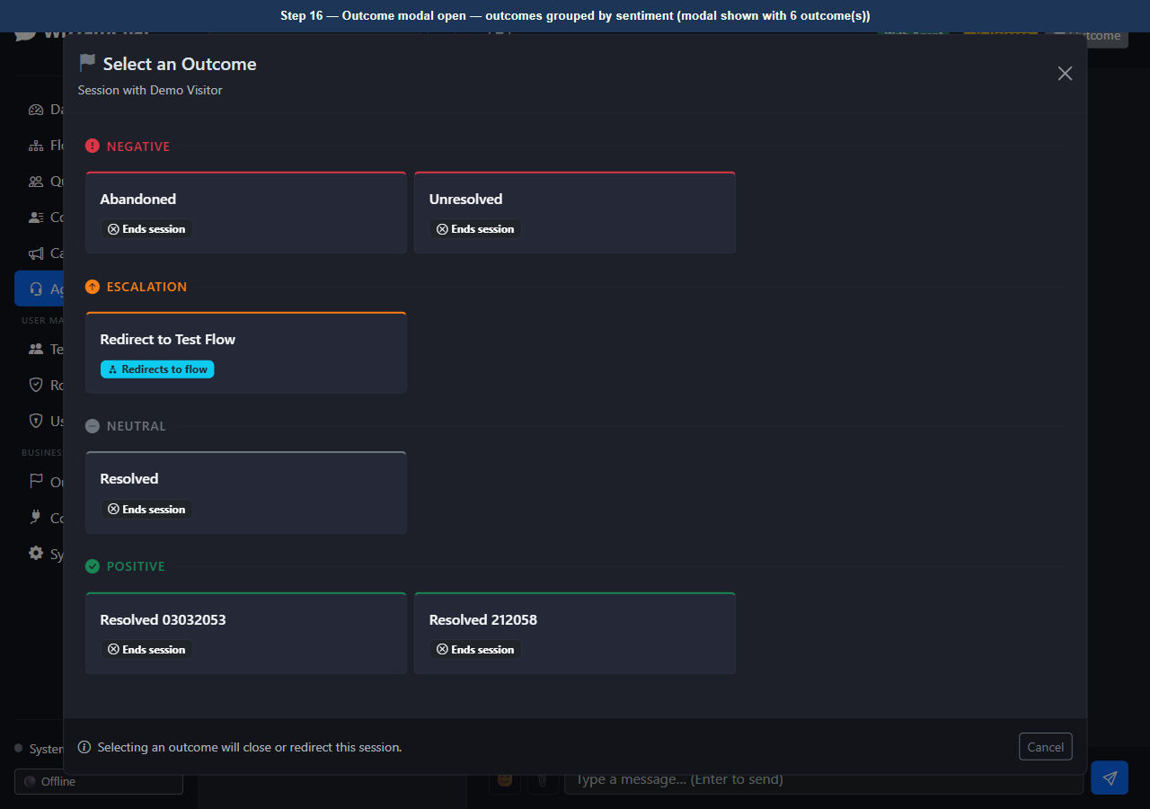
Figure 16 — Outcome modal open — outcomes grouped by sentiment (modal shown with 6 outcome(s))

The Redirect to Test Flow card is in the Escalation group
The Redirect to Test Flow card is in the Escalation group.
Its 'Redirects to flow' badge signals that selecting it will not immediately close the session — instead, WizzardChat activates the linked flow and sends the configured message to the visitor.

17. [Observe] Outcome modal — 'Redirect to Test Flow' card highlighted in Escalation group
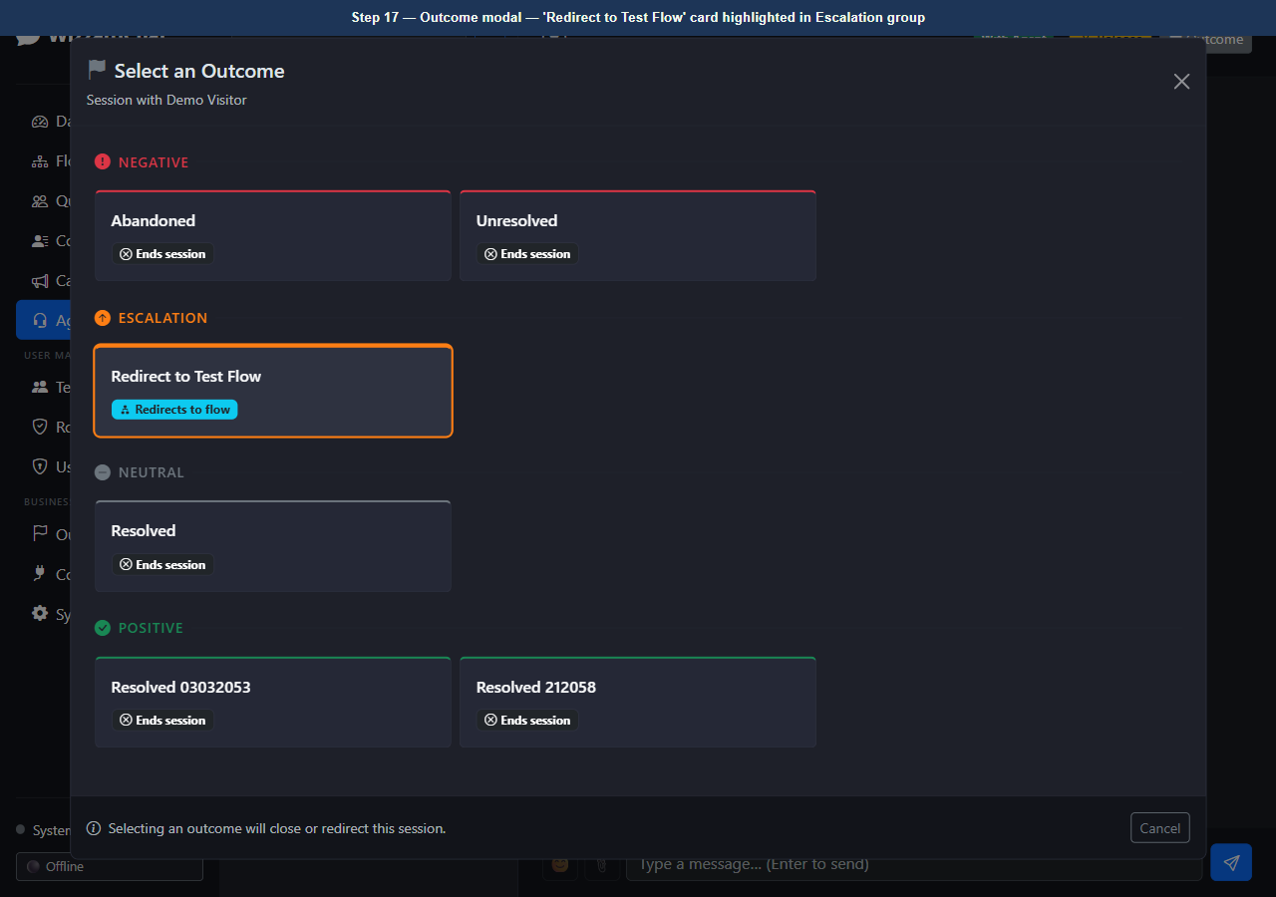
Figure 17 — Outcome modal — 'Redirect to Test Flow' card highlighted in Escalation group

Selecting Resolved marks the session as successfully closed
Selecting Resolved marks the session as successfully closed. The agent load counter decrements and the session moves to the closed state in the session list.

18. [Observe] Outcome modal — 'Resolved' card highlighted in Positive group
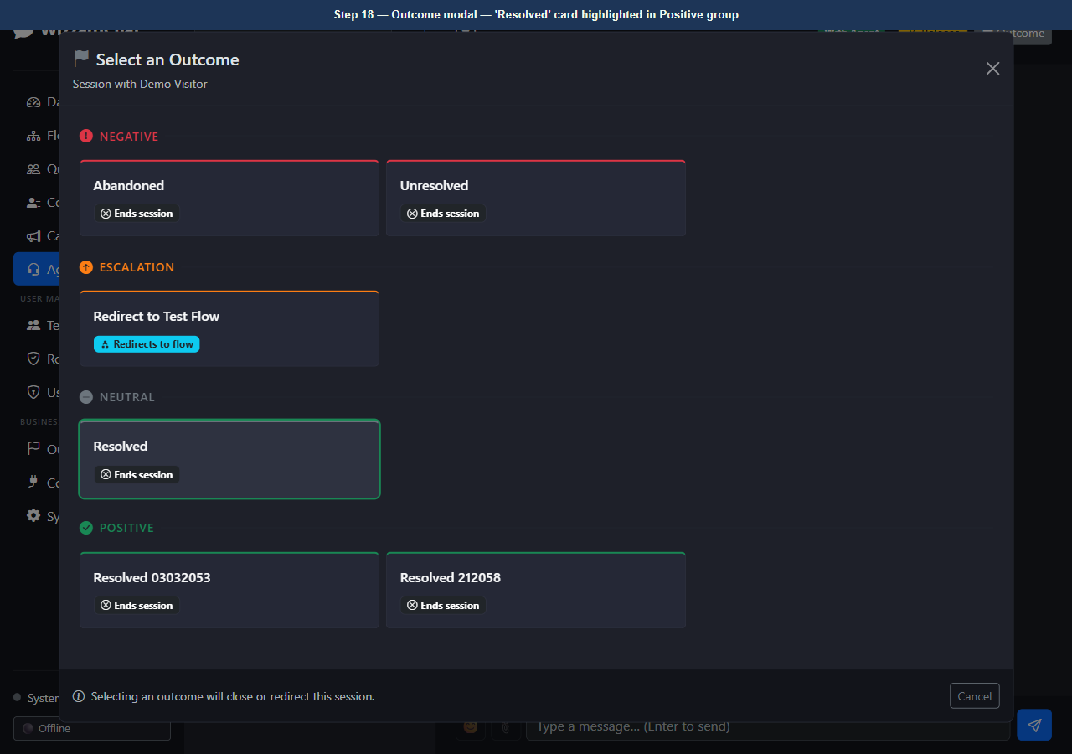
Figure 18 — Outcome modal — 'Resolved' card highlighted in Positive group

After outcome selection the modal closes and the chat panel updates immediately
After outcome selection the modal closes and the chat panel updates immediately.
The session is removed from the agent's active list and the load counter reflects the change. All outcomes are logged against the interaction record for reporting.

19. [Observe] Agent Panel — post-selection state
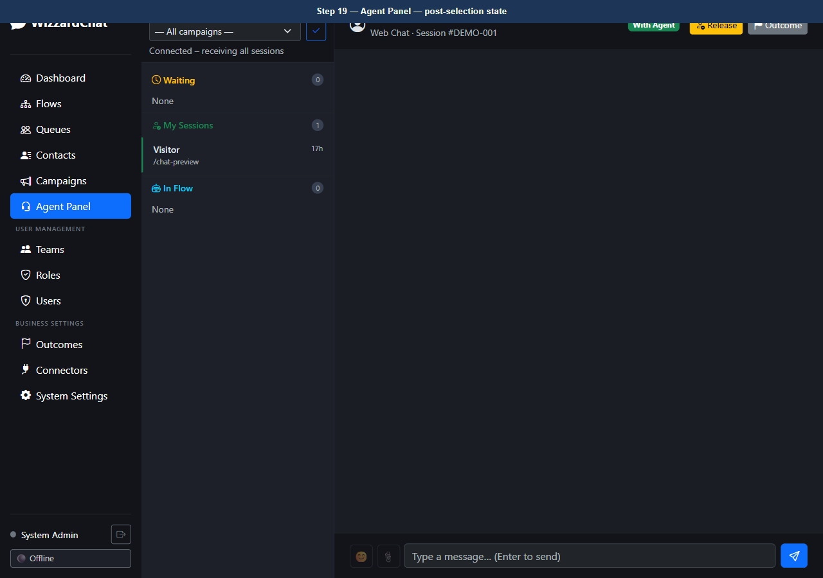
Figure 19 — Agent Panel — post-selection state
20. [Navigate to] Return to dashboard
URL: http://localhost:8092/
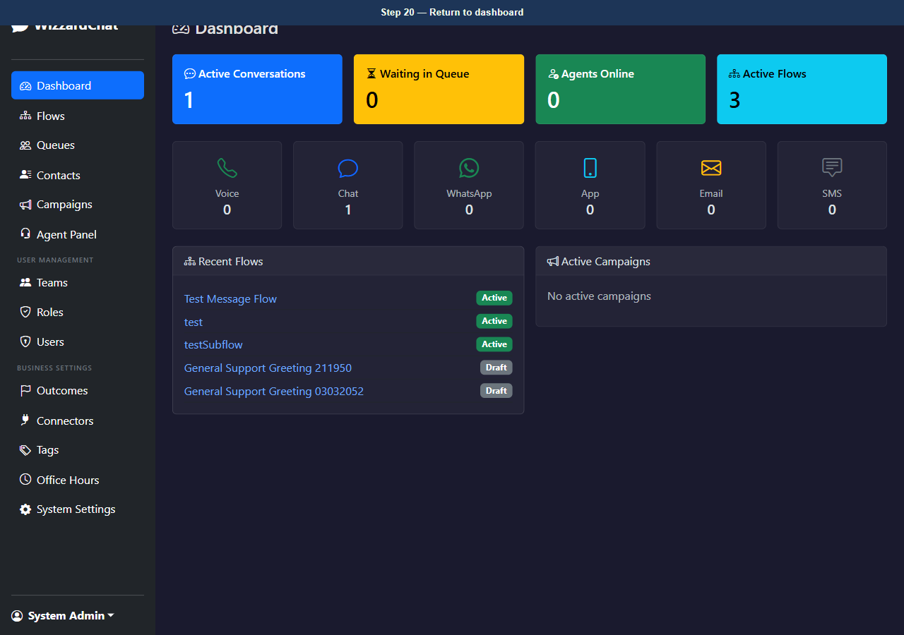
Figure 20 — Return to dashboard

The outcome selection logic is covered by six unit tests in tests/test_unit
The outcome selection logic is covered by six unit tests in tests/test_unit.py.
Tests verify:
- end_interaction sets status to closed and records the outcome code.
- The built-in Resolve fallback behaviour when no outcome is passed.
- Load counter protection (never drops below zero).
- flow_redirect sets status to active, assigns the flow context, and clears the agent.
- Pre-existing context keys survive a flow redirect.
- A misconfigured flow_redirect (no redirect_flow_id) gracefully falls back to end_interaction.
All six tests pass with the current codebase (pytest tests/test_unit.py -v).

21. [Observe] Dashboard — end of demonstration
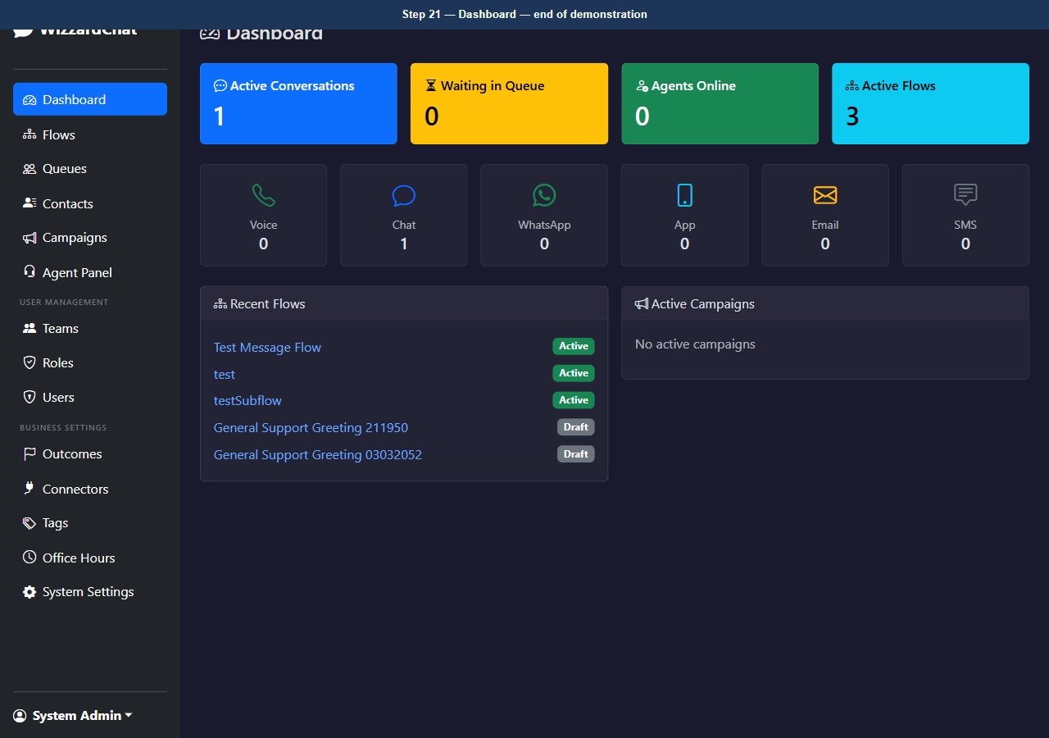
Figure 21 — Dashboard — end of demonstration

Troubleshooting
Use this table to resolve common problems.
Symptom | Likely cause | Resolution
The page redirects to the login screen. | Your session has expired. | Sign in again with your admin credentials.
A modal dialog does not close after you click Save. | A required field is empty or contains an invalid value. | Check all required fields (marked with *) and correct the value, then click Save again.
A button is visible but unclickable. | Your account does not have the required role. | Ask your administrator to assign the Admin or Supervisor role to your account.

Next steps
- Review the index for related training guides.
- Contact your administrator if configuration steps differ from those shown here.

