WizzardChat · Training Documentation

Outcome-Gated Interaction Close
This guide demonstrates how WizzardChat requires agents to select a resolution outcome before closing a chat session. Depending on the outcome type the system either ends the interaction or redirects the visitor to a configured flow.
Generated: 2026-03-06 09:23 · 15 recorded steps · Applies to: WizzardChat (current)

Overview
This guide demonstrates how WizzardChat requires agents to select a resolution outcome before closing a chat session. Depending on the outcome type the system either ends the interaction or redirects the visitor to a configured flow.

Before you begin
- WizzardChat is running and accessible at http://localhost:8092.
- You have admin credentials (username and password).
- Your browser can reach the WizzardChat server.

Steps

Sign in to WizzardChat as an administrator
Sign in to WizzardChat as an administrator.
The login modal appears automatically when no session token is found in the browser.

1. [Navigate to] Open WizzardChat in the browser
URL: http://localhost:8092/
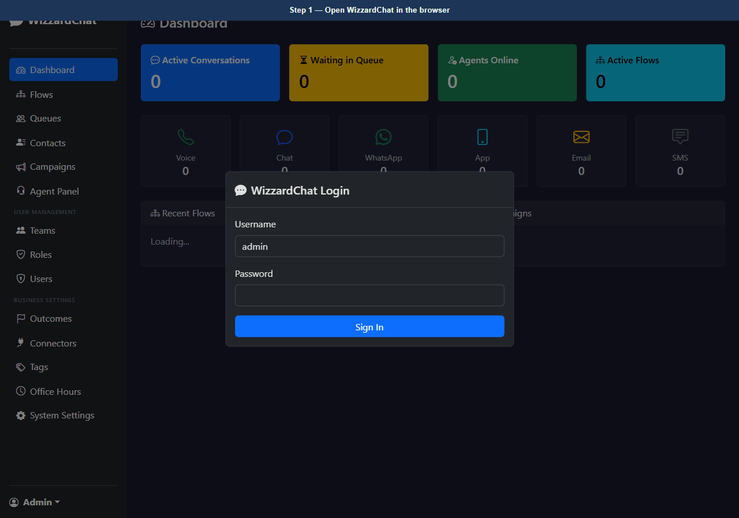
Figure 1 — Open WizzardChat in the browser
2. [Type] Enter the admin username
Element: #loginUser Value: admin
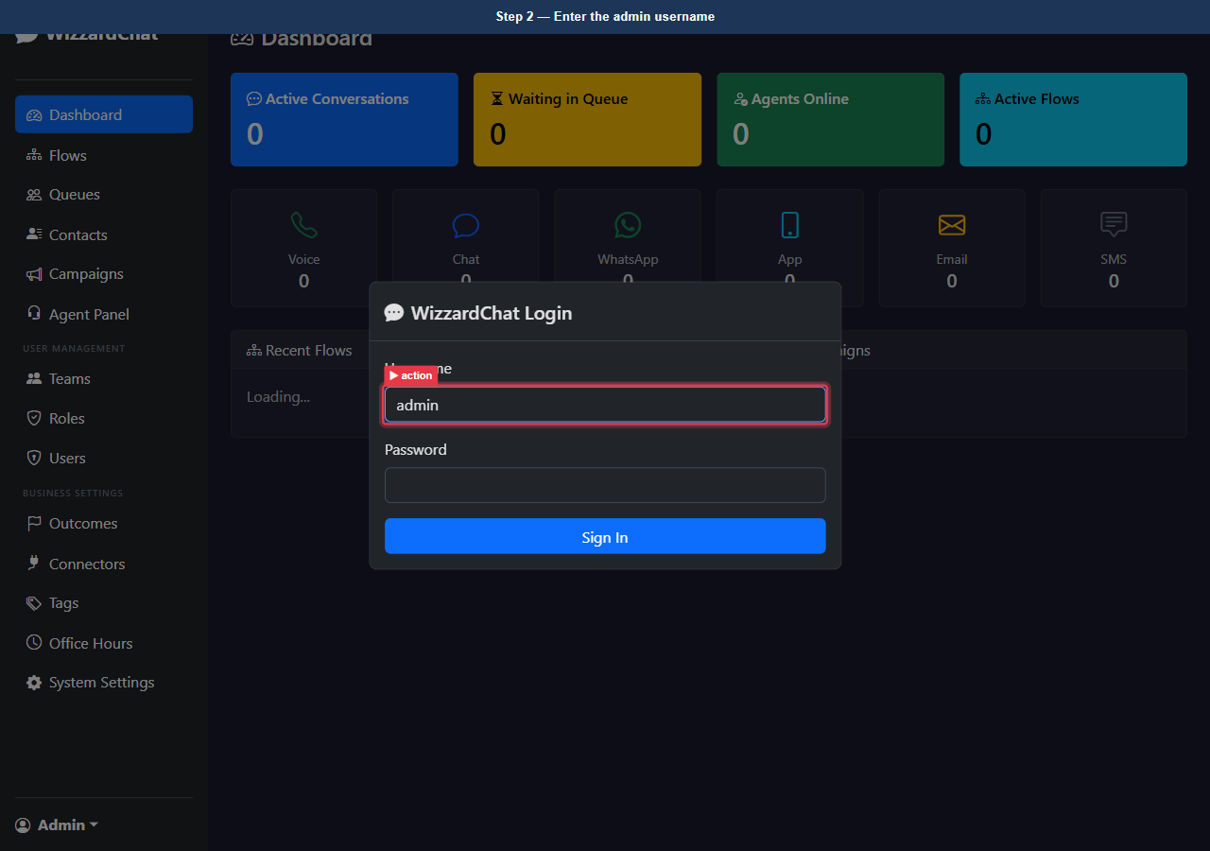
Figure 2 — Enter the admin username
3. [Type] Enter the admin password
Element: #loginPass Value: ••••••••
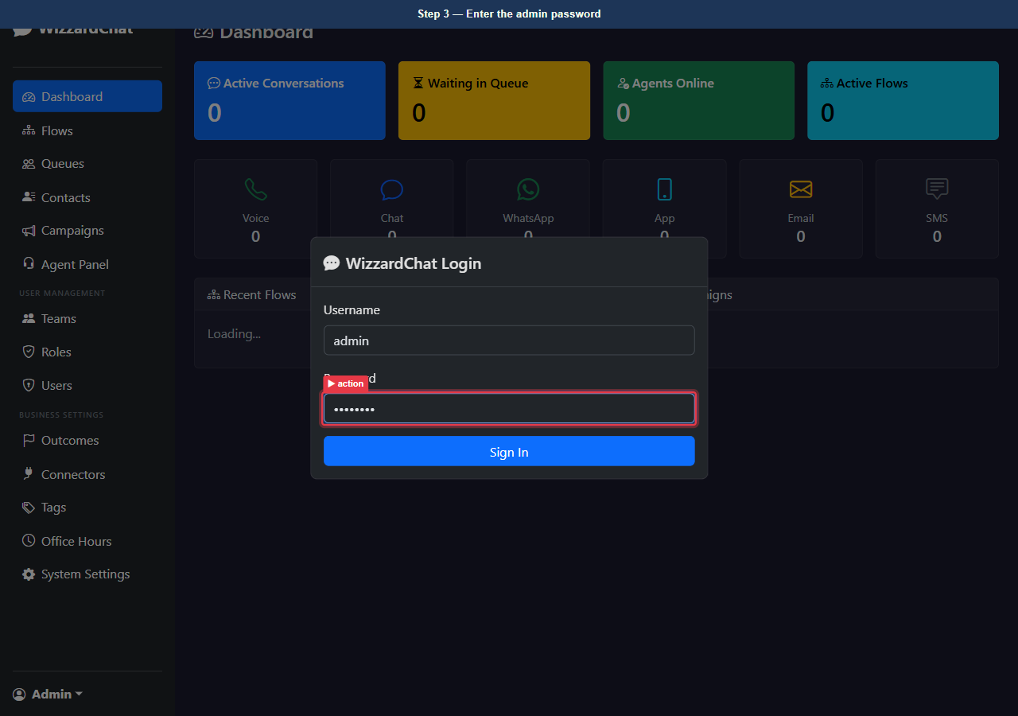
Figure 3 — Enter the admin password
4. [Click] Click Sign In to authenticate
Element: button[type=submit]
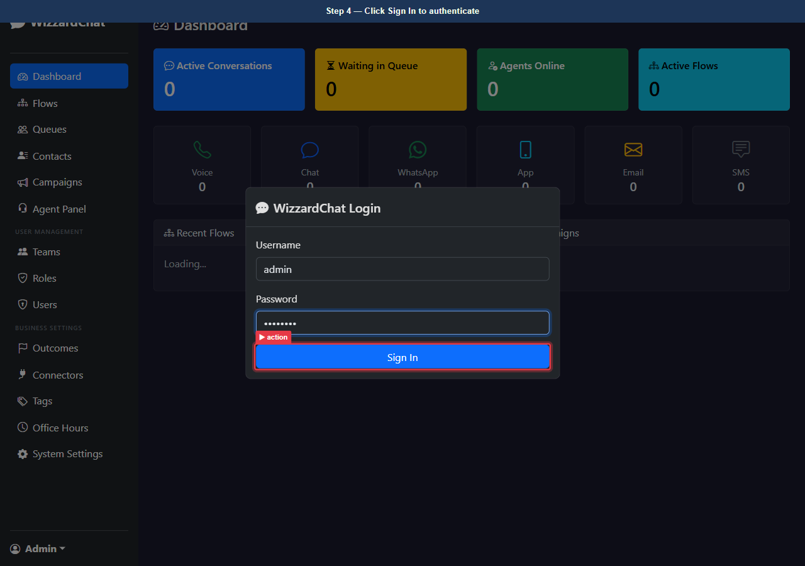
Figure 4 — Click Sign In to authenticate
5. [Observe] Dashboard — logged in as administrator
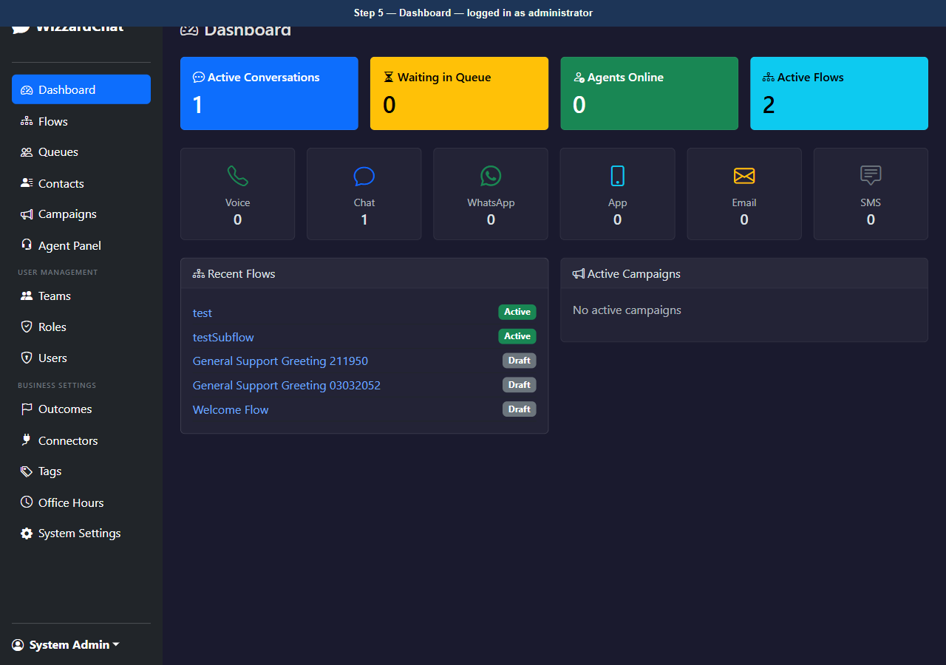
Figure 5 — Dashboard — logged in as administrator

Administrators define outcomes on the Outcomes page
Administrators define outcomes on the Outcomes page.
Each outcome has two fields that control its behaviour:
- Action type — end_interaction closes the session immediately; flow_redirect hands the visitor to a configured flow.
- Flow (optional) — the flow to activate when action type is flow_redirect.

6. [Navigate to] Open the Outcomes configuration page
URL: http://localhost:8092/outcomes
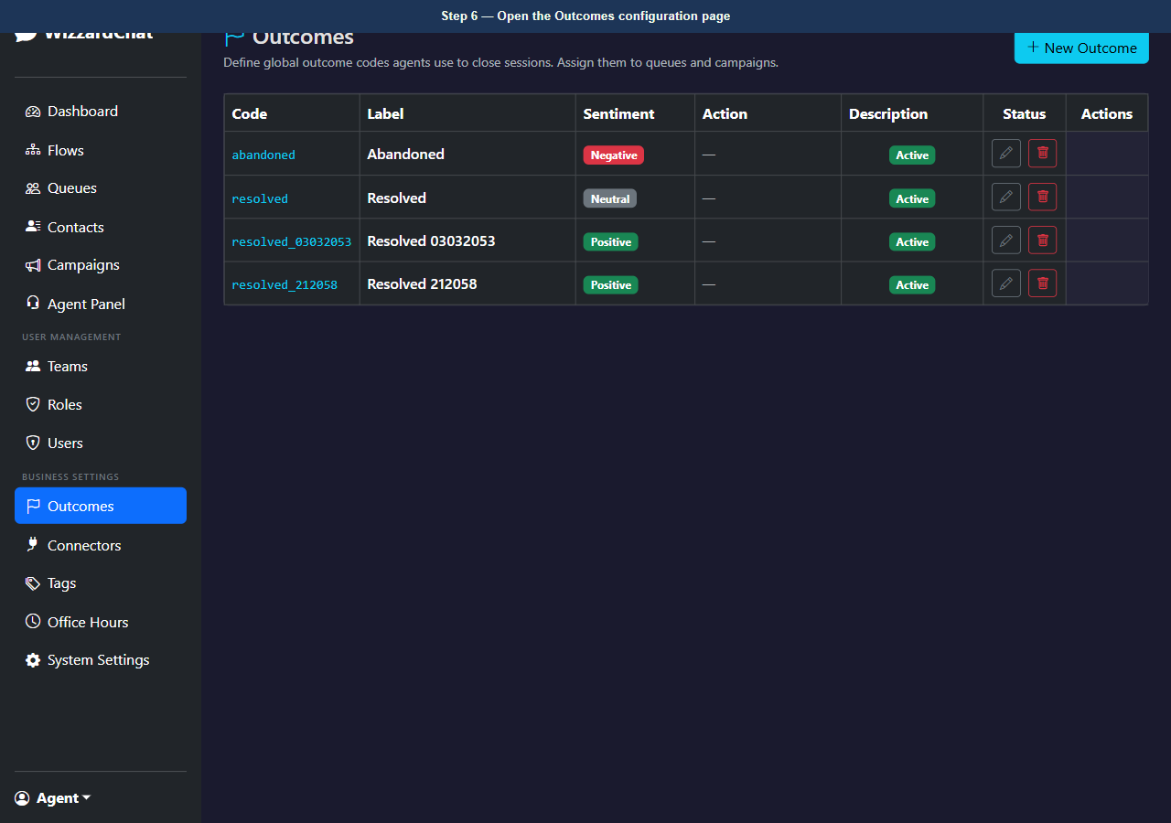
Figure 6 — Open the Outcomes configuration page
7. [Observe] Outcomes page — configured outcome records
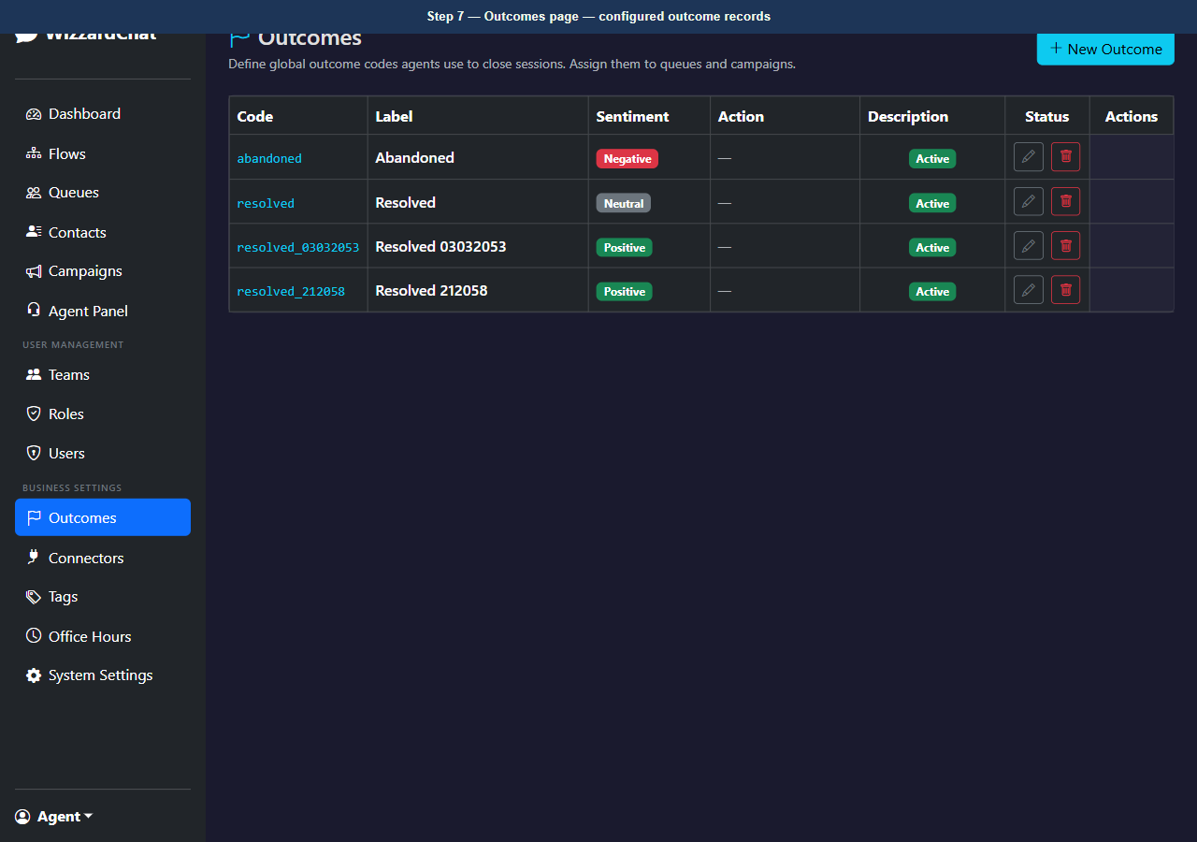
Figure 7 — Outcomes page — configured outcome records

Outcomes are attached to queues
Outcomes are attached to queues.
When an agent owns a session from a queue, the End Chat dropdown fetches that queue's outcome list. If the queue has no outcomes configured, the system always shows the built-in Resolve fallback so agents can never close a session without making a selection.

8. [Navigate to] Open the Queues configuration page
URL: http://localhost:8092/queues
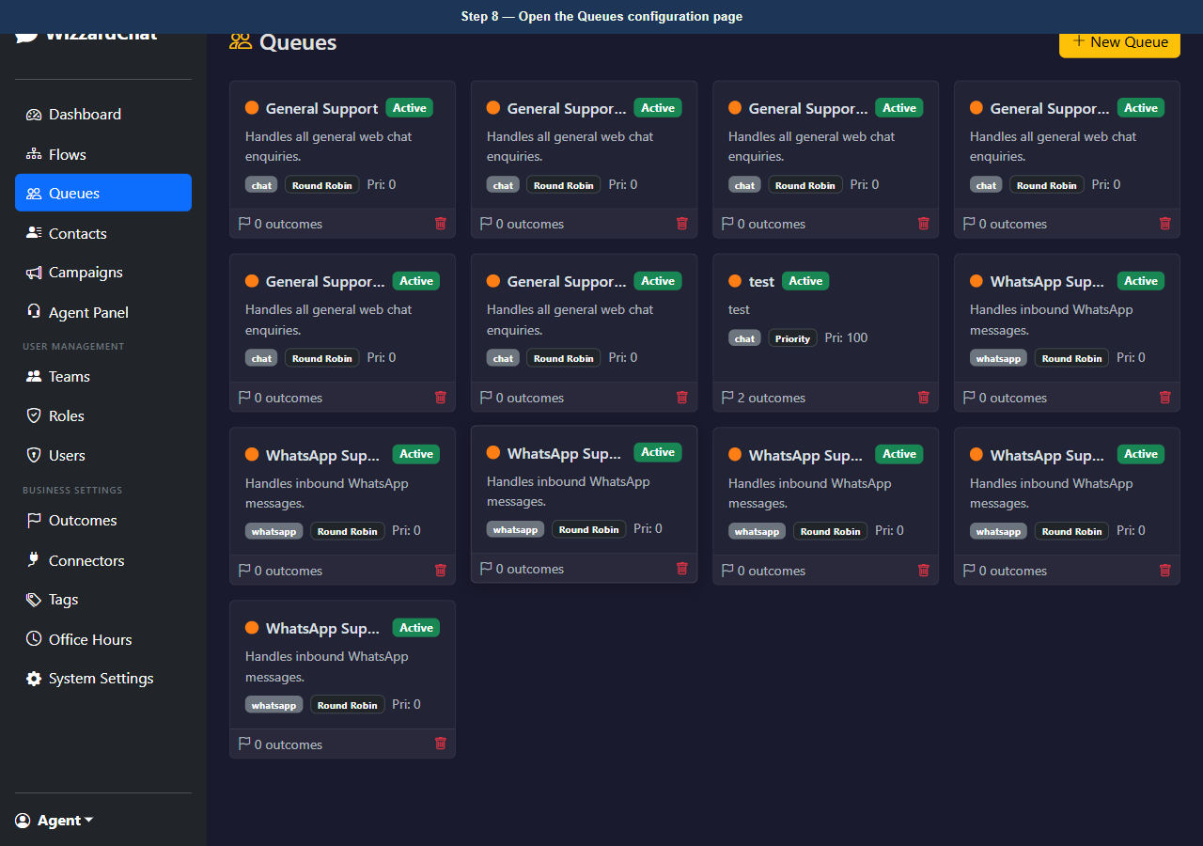
Figure 8 — Open the Queues configuration page
9. [Observe] Queues page — queues with outcome assignments
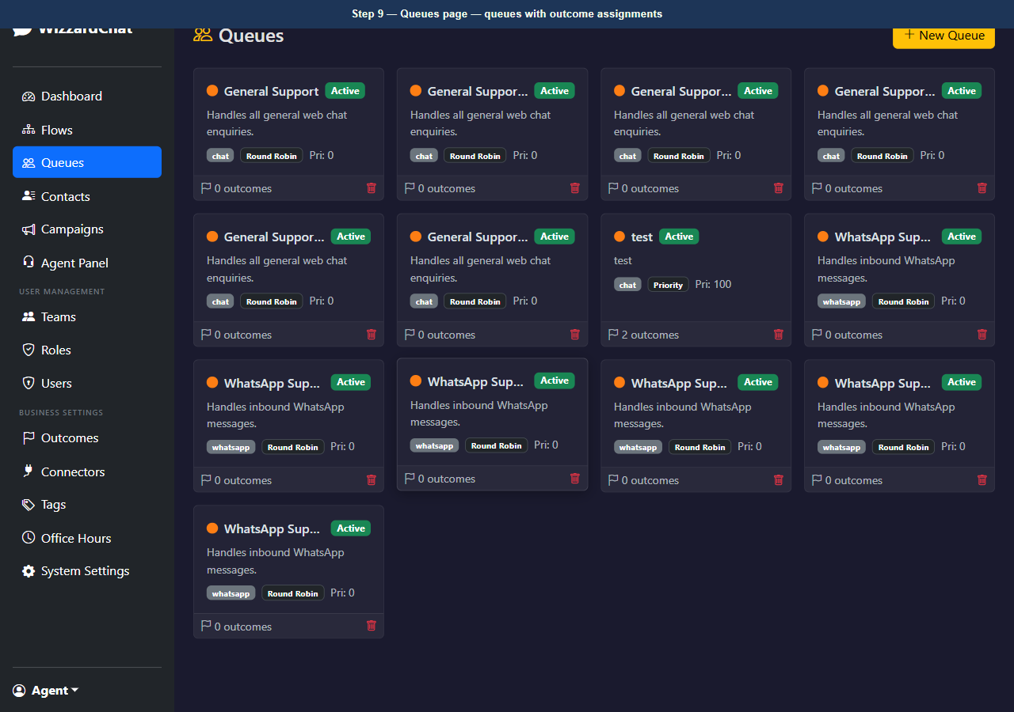
Figure 9 — Queues page — queues with outcome assignments

The Agent Panel is where agents handle live sessions
The Agent Panel is where agents handle live sessions.
Before a session is selected, the chat area shows a placeholder prompt. Sessions waiting for an agent appear in the left panel sorted by status.

10. [Navigate to] Open the Agent Panel
URL: http://localhost:8092/agent
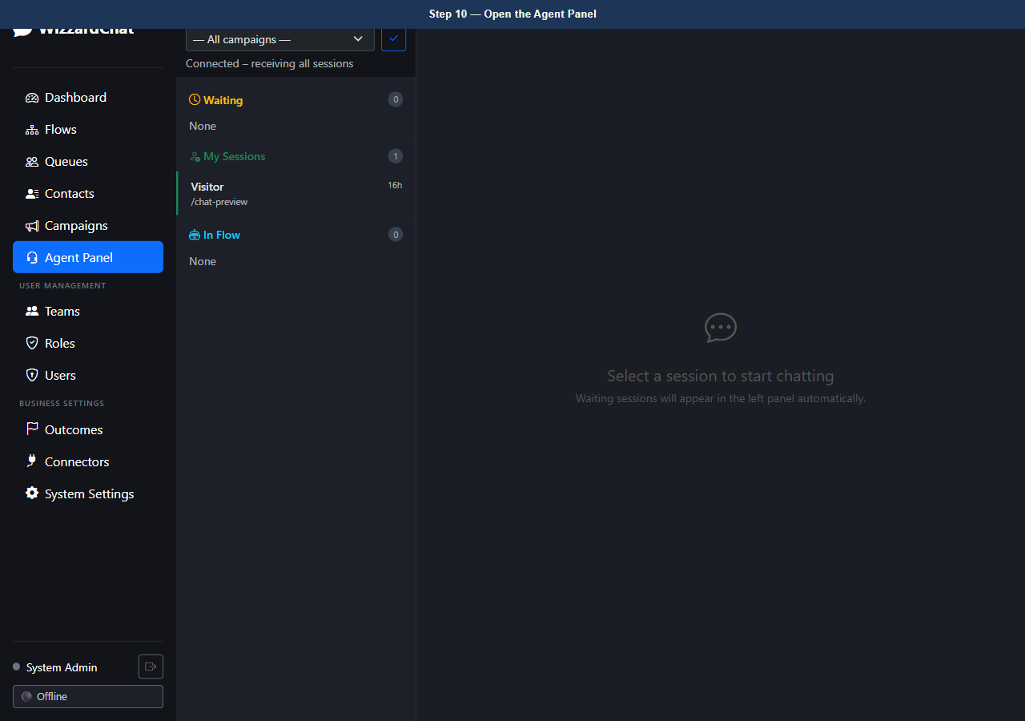
Figure 10 — Open the Agent Panel
11. [Observe] Agent Panel — initial state, no session selected
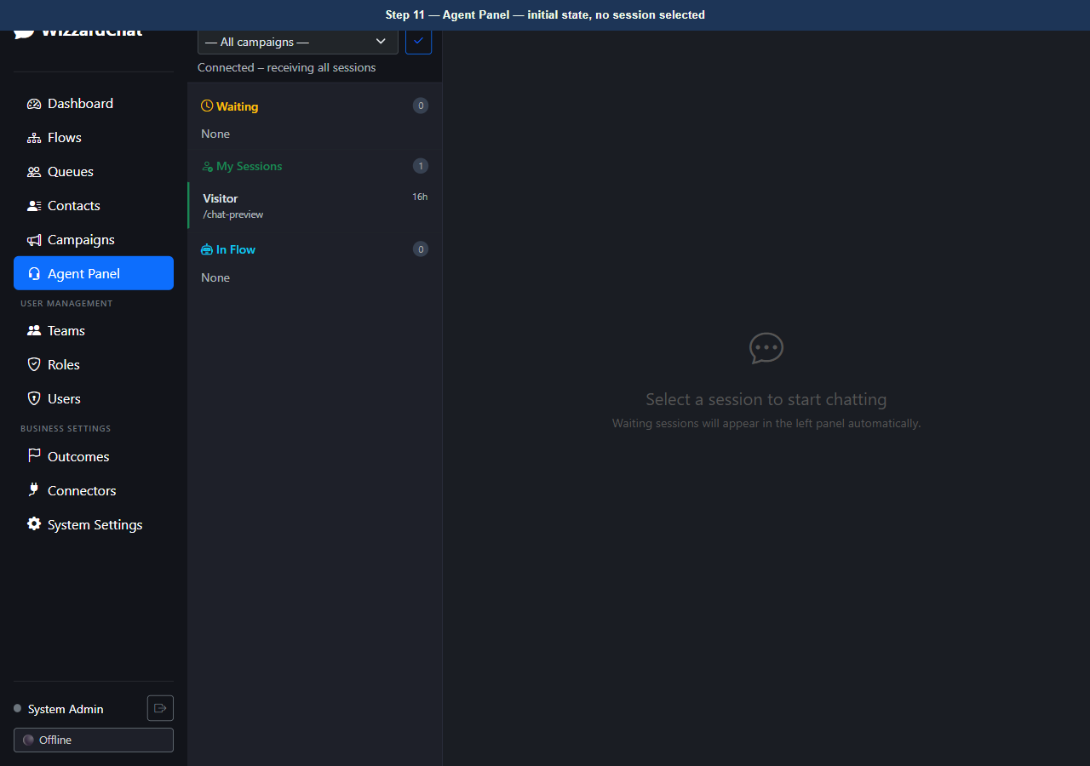
Figure 11 — Agent Panel — initial state, no session selected

Once an agent takes ownership of a session, the chat header changes
Once an agent takes ownership of a session, the chat header changes.
The single Close button is replaced by the End Chat dropdown. This prevents agents from closing sessions without selecting a resolution outcome.

12. [Observe] Agent Panel — session owned by agent, End Chat dropdown button visible
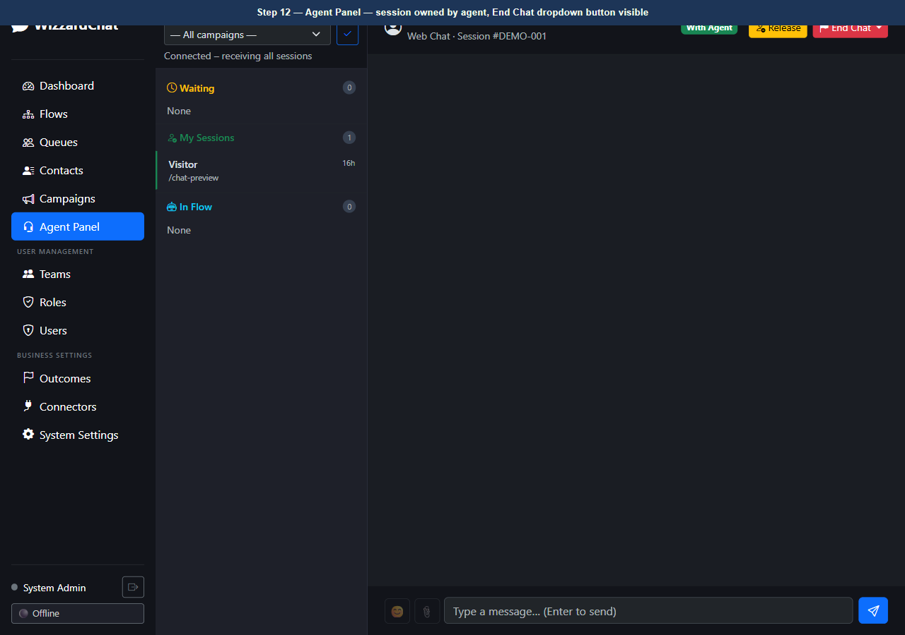
Figure 12 — Agent Panel — session owned by agent, End Chat dropdown button visible

Clicking End Chat opens the outcome dropdown
Clicking End Chat opens the outcome dropdown.
Each item shows the outcome label and a badge that indicates whether it will end the interaction or redirect the visitor to a flow.

13. [Observe] End Chat dropdown open — end_interaction and flow_redirect outcomes listed
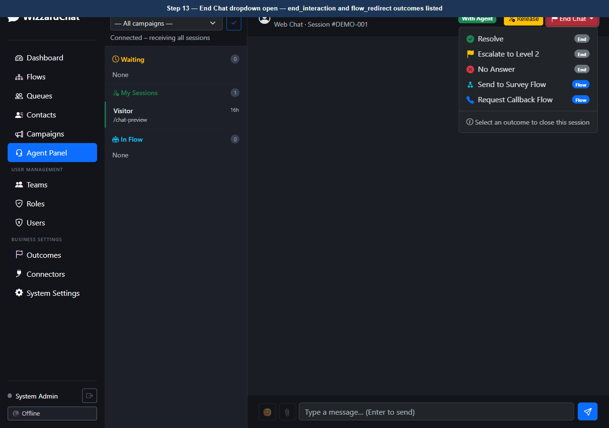
Figure 13 — End Chat dropdown open — end_interaction and flow_redirect outcomes listed

When a queue has no custom outcomes, the dropdown shows only Resolve
When a queue has no custom outcomes, the dropdown shows only Resolve.
This guarantees every session has a recorded outcome regardless of queue configuration.

14. [Observe] Fallback behaviour — queue without custom outcomes shows Resolve only
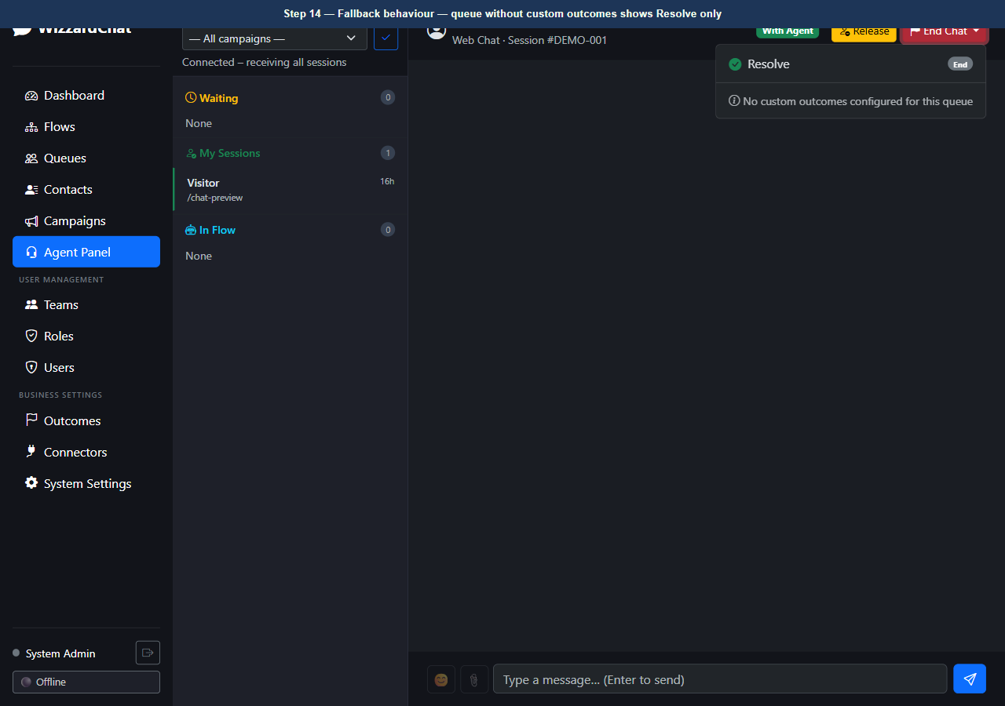
Figure 14 — Fallback behaviour — queue without custom outcomes shows Resolve only

The core decision logic lives in apply_outcome_to_session() — a pure function...
The core decision logic lives in apply_outcome_to_session() — a pure function with no database or WebSocket dependencies.
Six unit tests cover both paths:
- end_interaction sets session status to closed and records the outcome code.
- flow_redirect sets session status to active, stores the flow context, and activates the target flow.
- Both paths protect the agent load counter from dropping below zero.
All tests pass with the existing test suite (pytest tests/ -v).

15. [Observe] Agent Panel — final state after outcome selection demonstration
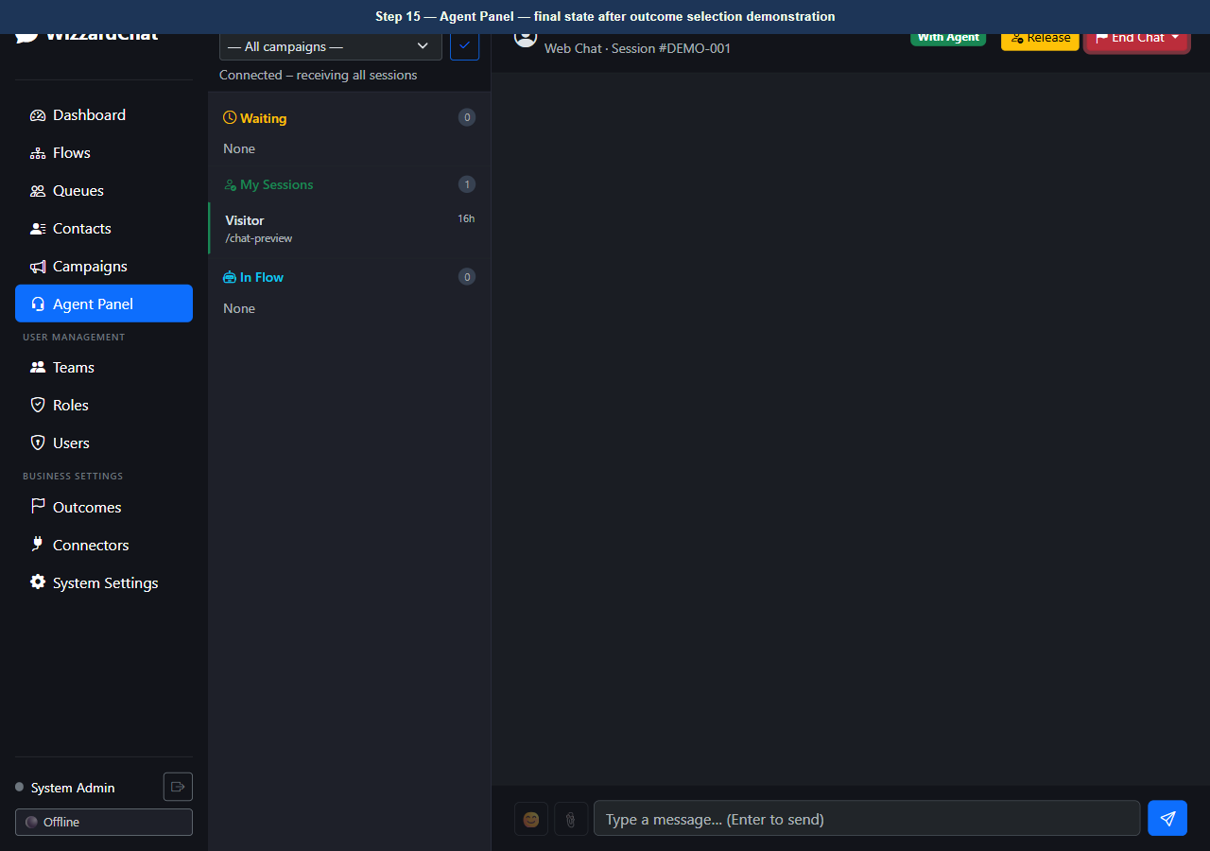
Figure 15 — Agent Panel — final state after outcome selection demonstration

Troubleshooting
Use this table to resolve common problems.
Symptom | Likely cause | Resolution
The page redirects to the login screen. | Your session has expired. | Sign in again with your admin credentials.
A modal dialog does not close after you click Save. | A required field is empty or contains an invalid value. | Check all required fields (marked with *) and correct the value, then click Save again.
A button is visible but unclickable. | Your account does not have the required role. | Ask your administrator to assign the Admin or Supervisor role to your account.

Next steps
- Review the index for related training guides.
- Contact your administrator if configuration steps differ from those shown here.

