WizzardChat — Live Flow Recording
Zyxel Router Installation — AI Bot Demo
Generated: 2026-03-07 20:34
Connector API Key: AWOuAYW1kieis50p…
AI Model: wizzardai://ollama/qwen3:8b
WizzardChat: http://localhost:8092

1. Live Chat Widget Screenshots
Each image below is a real Playwright browser screenshot taken from the live WizzardChat widget at http://localhost:8092. No mock rendering was used.

Stage 1: Widget launcher visible on preview page
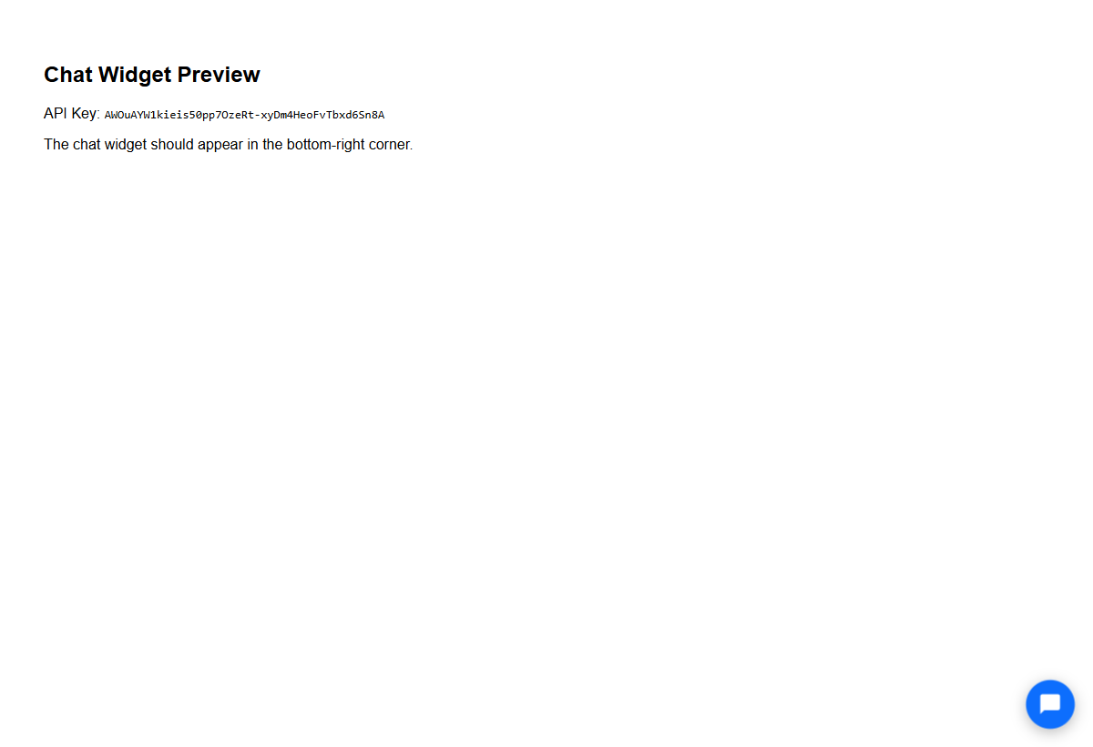

Stage 2: Bot greets visitor (flow starts, greeting node fires)
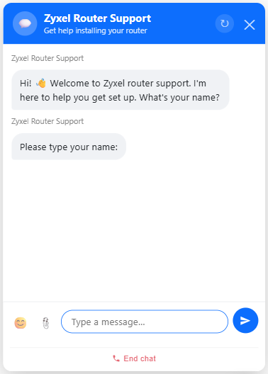

Stage 3: Visitor enters name: 'Alex'
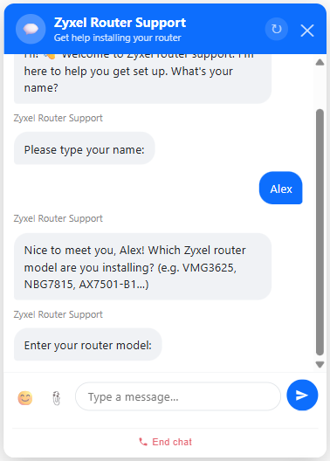

Stage 4: Bot asks 'What is your router model?' (message node)


Stage 5: Visitor enters router model: 'Zyxel VMG3625-T20A'
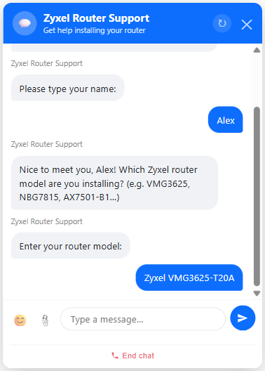

Stage 6: AI bot (qwen3:8b) responds with Zyxel setup guidance
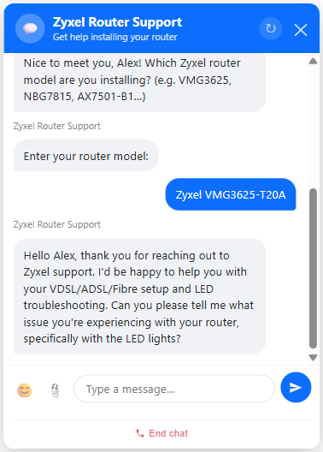

Stage 7: Visitor: 'I need to connect it via VDSL on a Telkom line. Where do I start?'
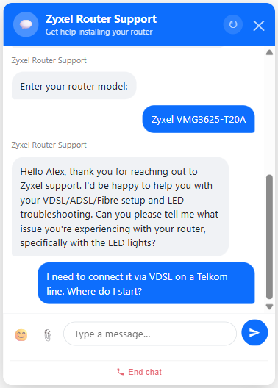

Stage 8: AI bot reply (turn 1)
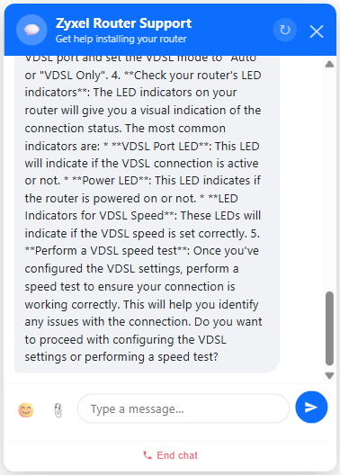

Stage 9: Visitor: 'I've plugged in the phone cable but the WAN LED is red. What does that mean?'
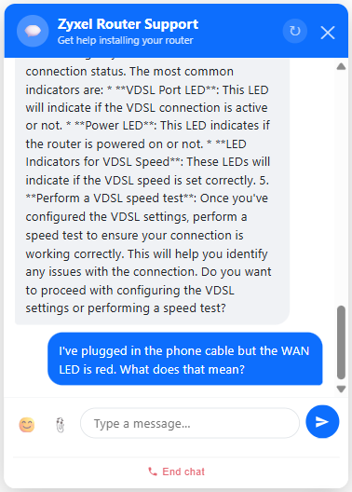

Stage 10: AI bot reply (turn 2)
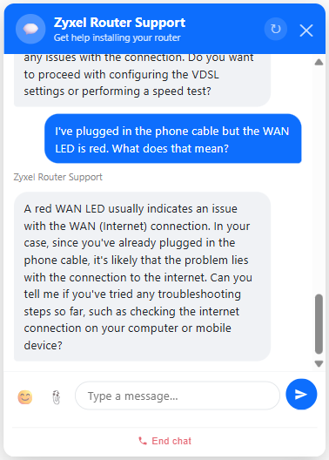

Stage 11: Visitor: 'I reseated the DSL splitter and now WAN is amber — then green! Internet light is green too.'
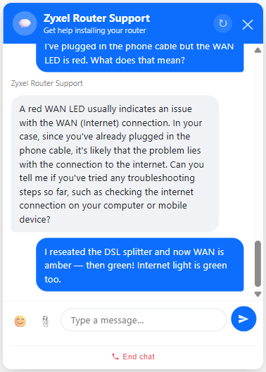

Stage 12: AI bot reply (turn 3)
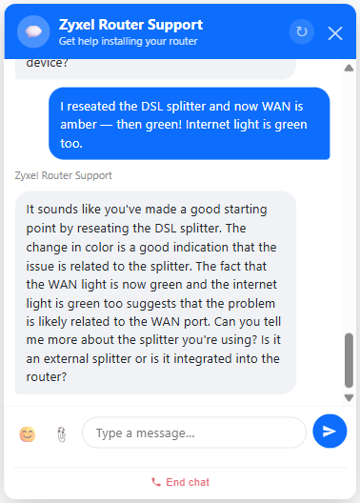

Stage 13: Visitor: 'done'
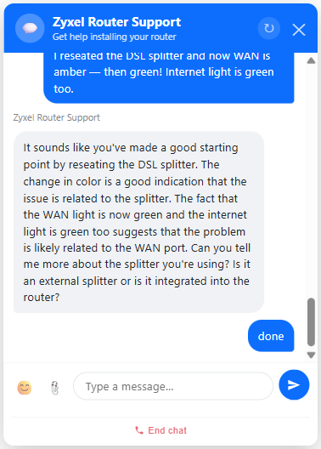

Stage 14: Exit keyword fires 'exit' edge → closing message node → end


Stage 15: Final state — flow reached End node


2. Full Conversation Transcript
Captured directly from the browser DOM after the flow completed.
# | Role | Message
1 | BOT | Hi! 👋 Welcome to Zyxel router support. I'm here to help you get set up. What's your name?
2 | BOT | Please type your name:
3 | VISITOR | Alex
4 | BOT | Nice to meet you, Alex! Which Zyxel router model are you installing? (e.g. VMG3625, NBG7815, AX7501-B1…)
5 | BOT | Enter your router model:
6 | VISITOR | Zyxel VMG3625-T20A
7 | BOT | Hello Alex, thank you for reaching out to Zyxel support. I'd be happy to assist you with your VDSL/ADSL/Fibre setup and LED troubleshooting. Can you please confirm that you have the latest firmware version installed on your router, and that you have followed the recommended settings for VDSL/ADSL/Fibre deployment on your Zyxel VMG3625-T20A?
8 | VISITOR | I need to connect it via VDSL on a Telkom line. Where do I start?
9 | BOT | To connect your Zyxel VMG3625-T20A router via VDSL on a Telkom line, you'll need to follow these steps: 1. **Check your Telkom line plan**: Ensure you have a VDSL line plan that is compatible with your router's speed. The VMG3625-T20A supports speeds up to 100 Mbps. 2. **Check your router's VDSL settings**: Log in to your router's web interface and look for the VDSL settings. You should see options like "VDSL Port", "VDSL Speed", and "VDSL Mode". 3. **Configure VDSL settings**: Set the VDSL speed to the maximum speed you have on your line (e.g., 100 Mbps). You may also need to enable the VDSL port and set the VDSL mode to "Auto" or "VDSL Only". 4. **Check your router's LED indicators**: The LED indicators on your router will give you a visual indication of the connection status. The most common indicators are: * **VDSL Port LED**: This LED will indicate if the VDSL connection is active or not. * **Power LED**: This LED indicates if the router is powered on or not. * **LED Indicators for VDSL Speed**: These LEDs will indicate if the VDSL speed is set correctly. 5. **Perform a VDSL speed test**: Once you've configured the VDSL settings, perform a speed test to ensure your connection is working correctly. This will help you identify any issues with the connection. Do you want to proceed with configuring the VDSL settings or performing a speed test?
10 | VISITOR | I've plugged in the phone cable but the WAN LED is red. What does that mean?
11 | BOT | A red WAN LED usually indicates an issue with the WAN (Internet) connection. In your case, since you've already plugged in the phone cable, it's likely that the problem lies with the connection to the internet. Can you tell me if you've tried any troubleshooting steps so far, such as checking the internet connection on your computer or mobile device?
12 | VISITOR | I reseated the DSL splitter and now WAN is amber — then green! Internet light is green too.
13 | BOT | It sounds like you've made a good starting point by reseating the DSL splitter. The change in color is a good indication that the issue is related to the splitter. The fact that the WAN light is now green and the internet light is green too suggests that the problem is likely related to the WAN port. Can you tell me more about the splitter you're using? Is it an external splitter or is it integrated into the router?
14 | VISITOR | done

3. Flow Topology
Node type | Label | Description | UUID (8)
start | Start | Entry point of the flow | ee8703fe
message | Greeting | Bot welcomes visitor | 961c9561
input | Capture name | Visitor enters their name | 30f9d938
message | Ask router model | Bot asks for the router model number | de0996a0
input | Capture router model | Visitor types their router model | 8ca9f35b
ai_bot | Zyxel AI Support | Multi-turn qwen3:8b support chat (max 8 turns) | 1471e4ee
message | Closing | Bot confirms success and says goodbye | b2f2f7fa
end | End | Flow completes | c484c0de

All screenshots in this document were captured from a real Playwright-driven Chromium session against a live WizzardChat instance. The AI responses are generated by qwen3:8b running locally via Ollama.

