WizzardChat — Integration Tabs Feature: Test Review
Generated: 2026-03-15 | Branch: wizzardchat/main | Server: http://localhost:8092

Summary
This document captures the Playwright end-to-end test run that verifies the Integration Tabs feature added to WizzardChat. The feature allows up to 5 configurable web-page URLs to be saved against a queue or campaign. Those URLs render as iFrame tabs in the agent panel whenever a session from that queue is active.

Changes verified
- app/models.py — integration_urls JSONB column on Queue and Campaign
- app/schemas.py — integration_urls field on QueueCreate, QueueOut, CampaignCreate, CampaignOut
- templates/queues.html — Integrations tab (5 name/URL slots + Override Campaign checkbox)
- static/js/queues.js — _fillIntegrationSlots, _readIntegrationSlots helpers; saveQueue payload
- templates/campaigns.html — Integrations tab (5 name/URL slots)
- static/js/campaigns.js — same helpers; saveCampaign payload
- templates/agent.html — #integrationTabBar, #chatSlot, #iSlot_1..5 structure + CSS
- static/js/agent.js — _loadIntegrationTabs() called in openSession()
- DB migration — integration_urls JSONB added to chat.chat_queues and chat.chat_campaigns

Test result
All assertions passed. Queue integration URLs (YouTube, CNN News) and campaign URL (News24) were saved and verified via API round-trip. Agent panel DOM elements confirmed present.

Screenshots

Step 0 — Login
Playwright logs in as admin and lands on the dashboard.
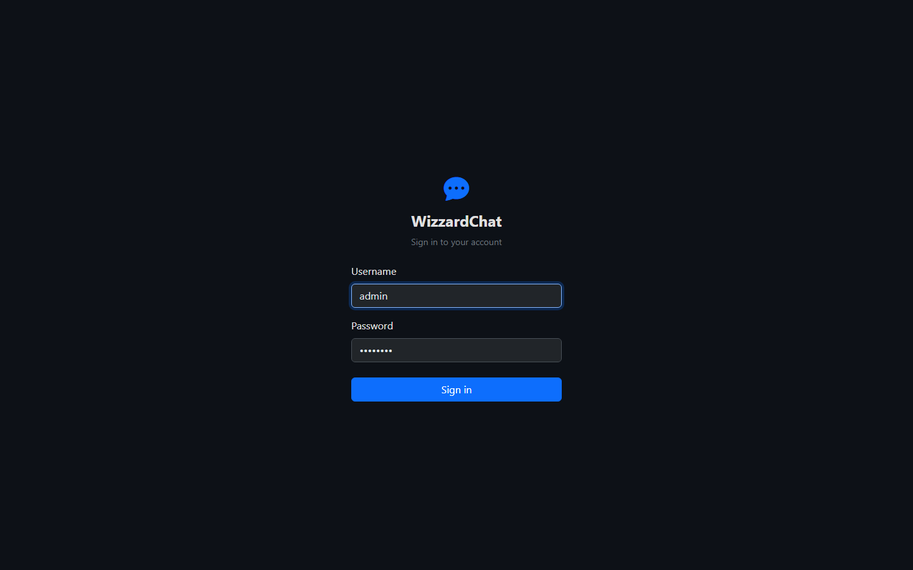

Step 1 — Queues list
The Queues page loads with existing queue cards rendered.
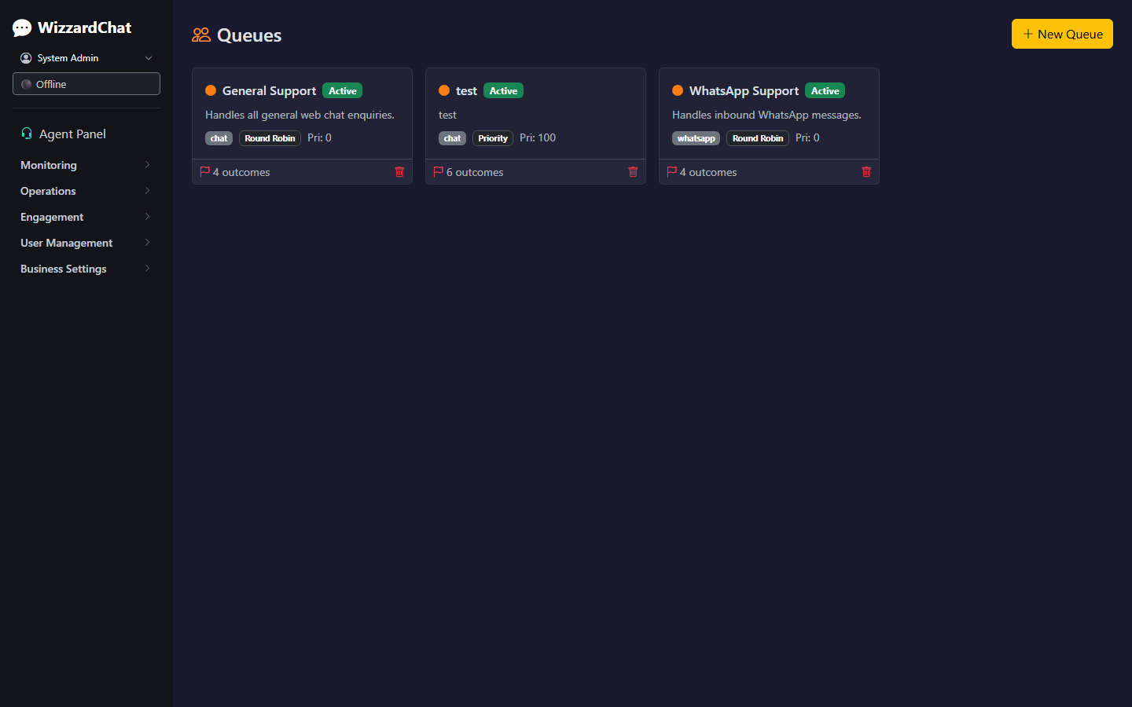

Step 1b — Queues debug
Debug screenshot confirming card count before modal interaction.


Step 2 — Queue modal: Integrations tab
The queue edit modal opens and the Integrations tab is activated.
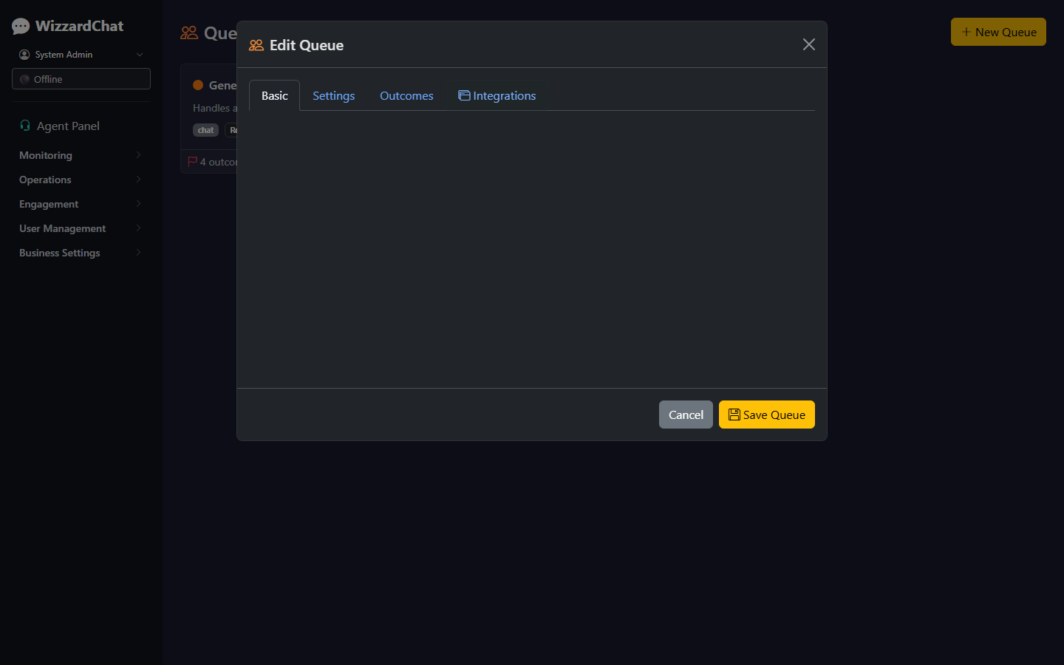

Step 3 — Slots filled
Slot 1 set to YouTube, slot 2 set to CNN News, Override Campaign checked.
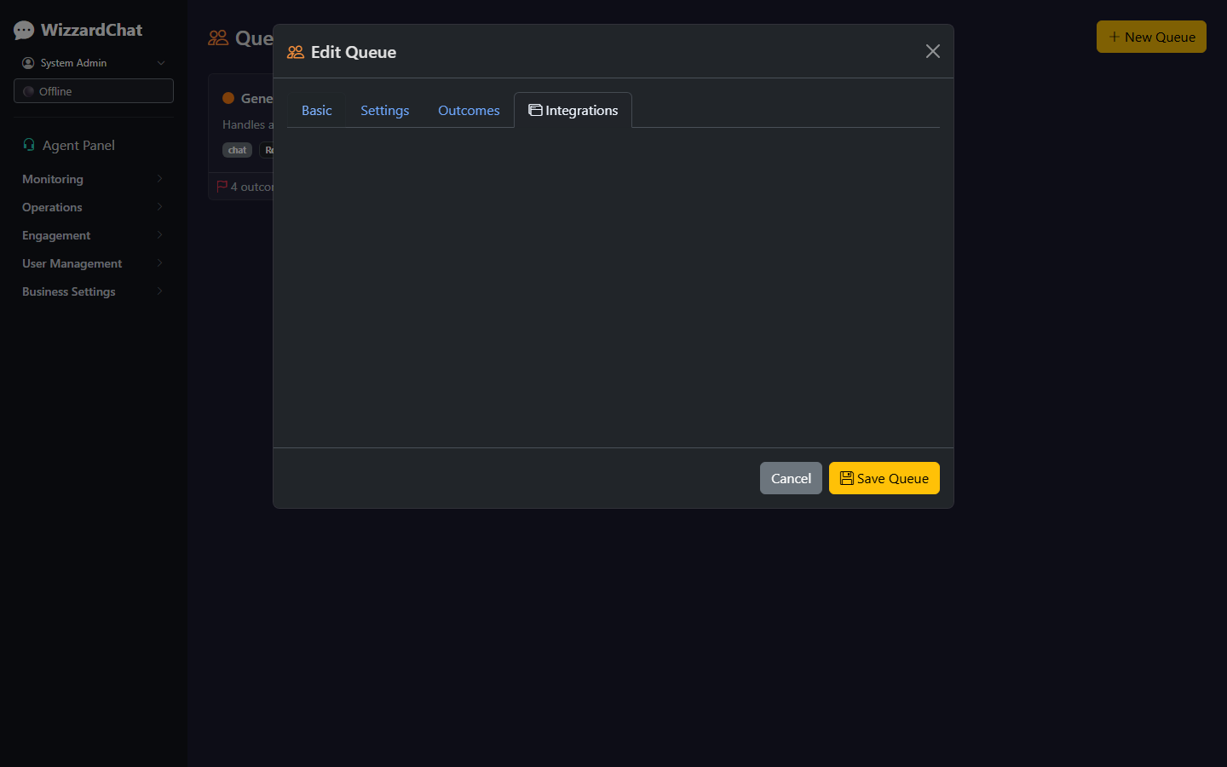

Step 4 — Queue saved
Save button clicked; modal closes and the queue list reloads.
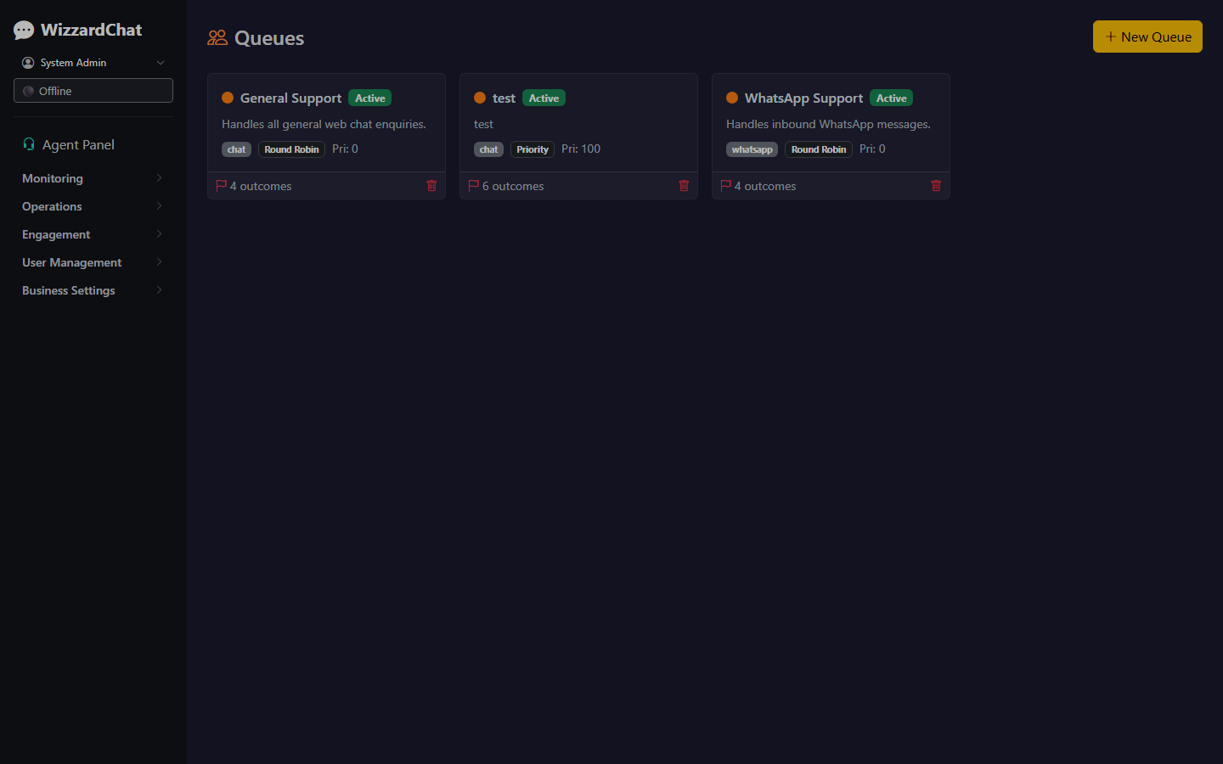

Step 5 — Campaigns list
The Campaigns page loads with campaign cards.
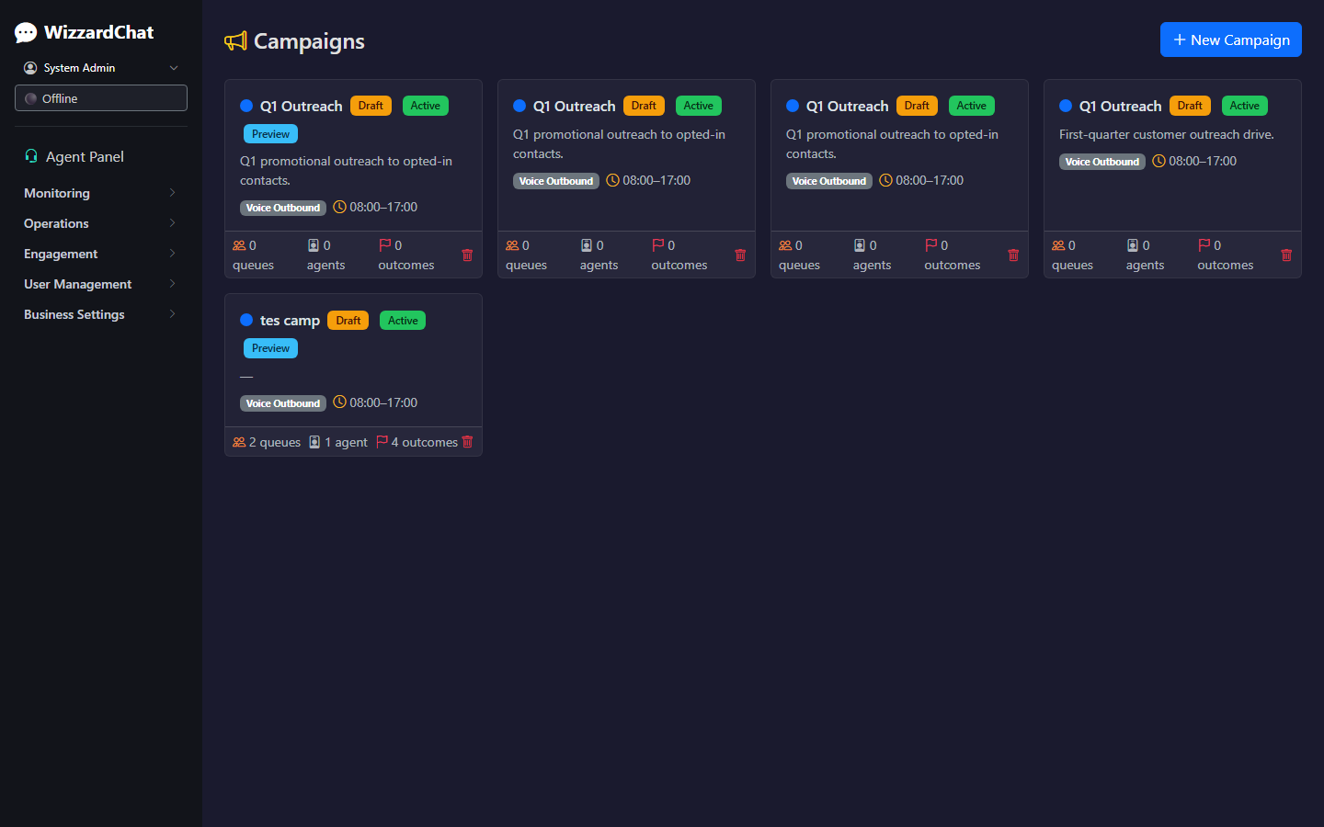

Step 6 — Campaign slot filled
Campaign modal: slot 1 set to News24 and saved.
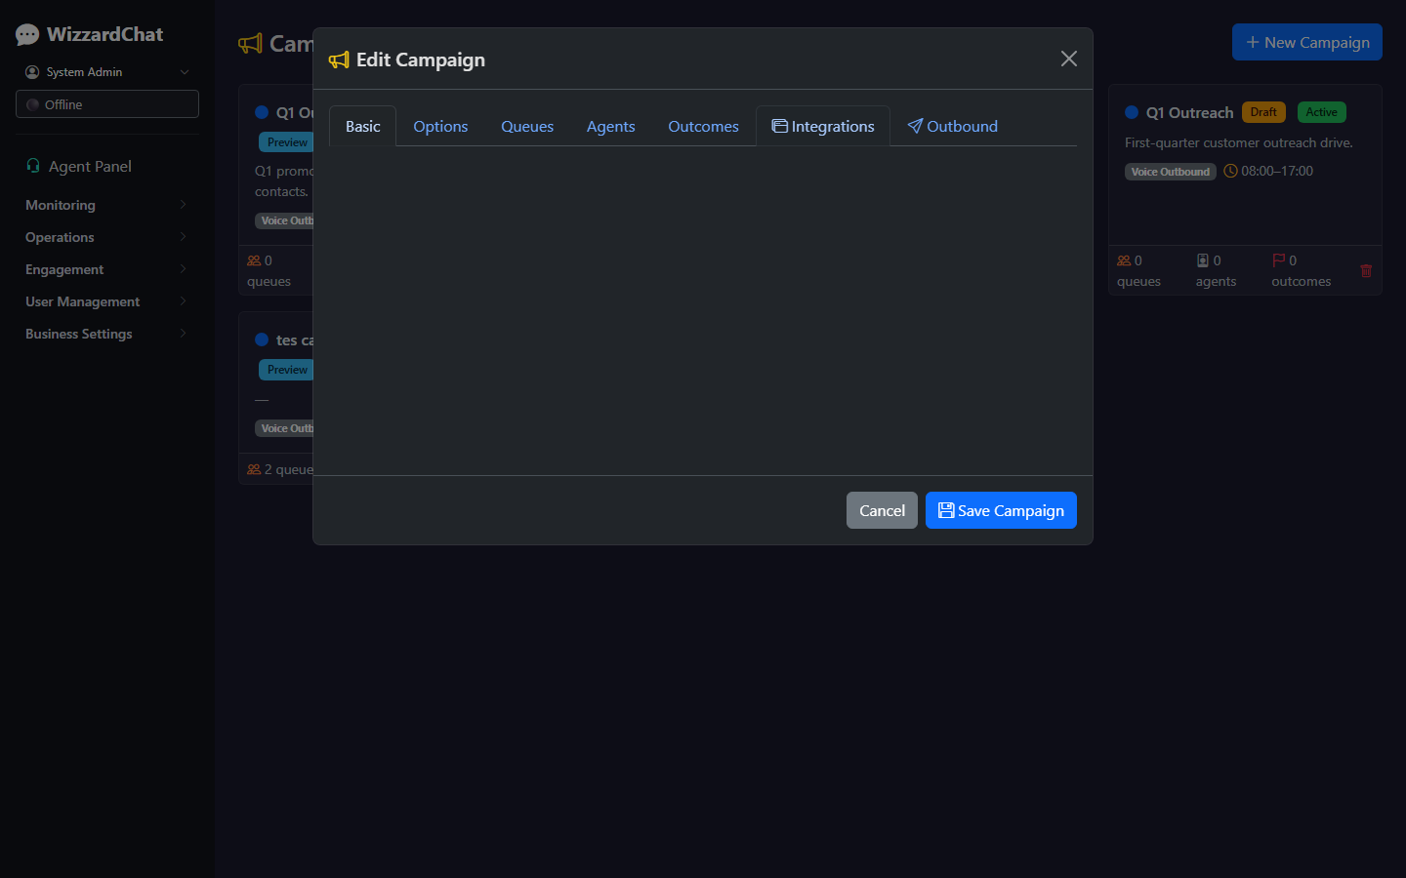

Step 7 — Agent panel (idle)
Agent panel loaded while no session is active — integration tab bar area visible.
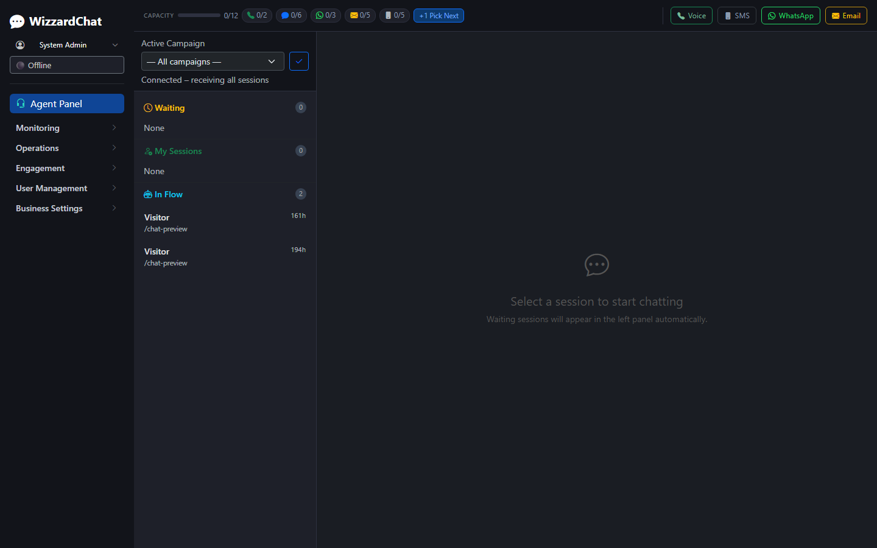

Step 8 — Agent DOM verified
#integrationTabBar, #chatSlot, and #iSlot_1 through #iSlot_5 present in DOM.


