WizzardChat — Webform Tabs Live Test
Generated: 2026-03-15 14:26:34

Test Scenario
Campaign "Webform Demo Campaign" defines three webform slots: News24, YouTube, and Disney+.
Queue A (no override) inherits these slots from the campaign.
Queue B (override_campaign=true) defines its own two slots: CNN and YouTube, replacing the campaign slots entirely.

Test Results
Check | Status
Campaign, Queue A, Queue B created/verified via API | PASS
Sessions injected with status=with_agent | PASS
Queue A: webform tab bar is visible | PASS
Queue A: tab 'News24' present | PASS
Queue A: tab 'YouTube' present | PASS
Queue A: tab 'Disney' present | PASS
Queue B: webform tab bar is visible | PASS
Queue B: tab 'CNN' present (override) | PASS
Queue B: tab 'YouTube' present (override) | PASS
Queue B: News24 and Disney absent (overridden by queue) | PASS

Login page
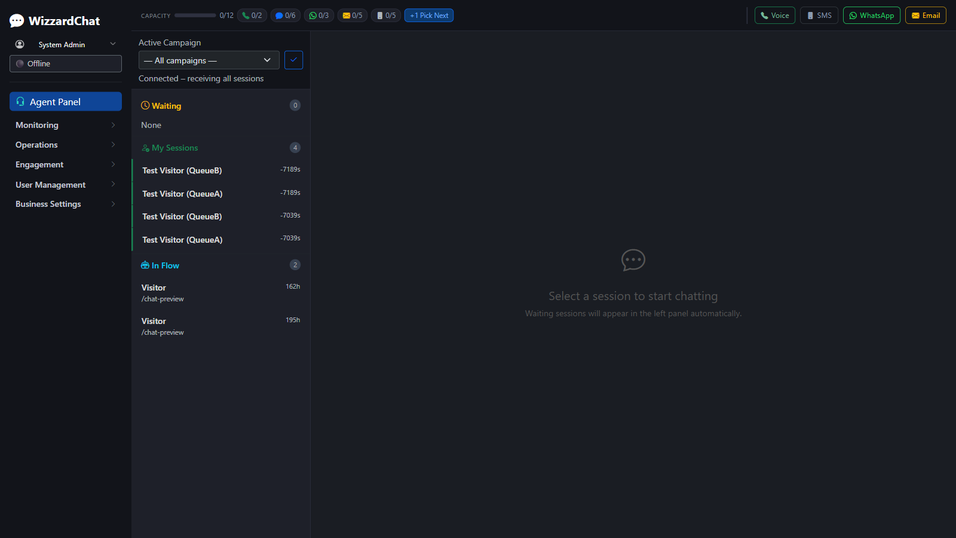

Queue A — session opened
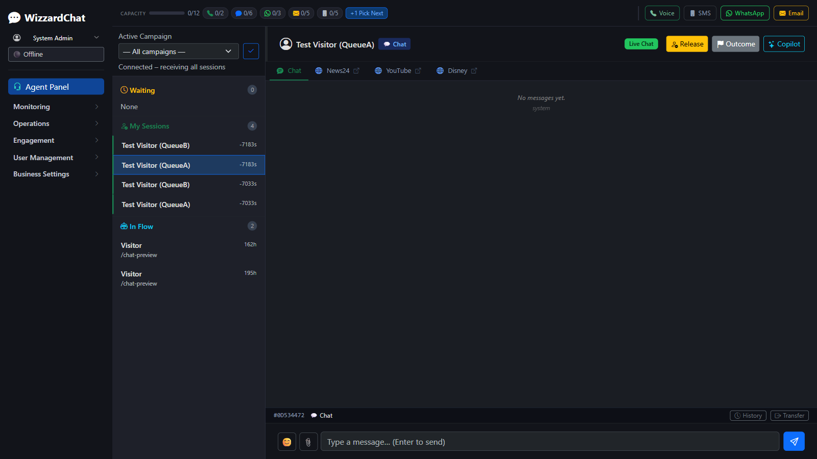

Queue A — webform tabs


Queue B — session opened
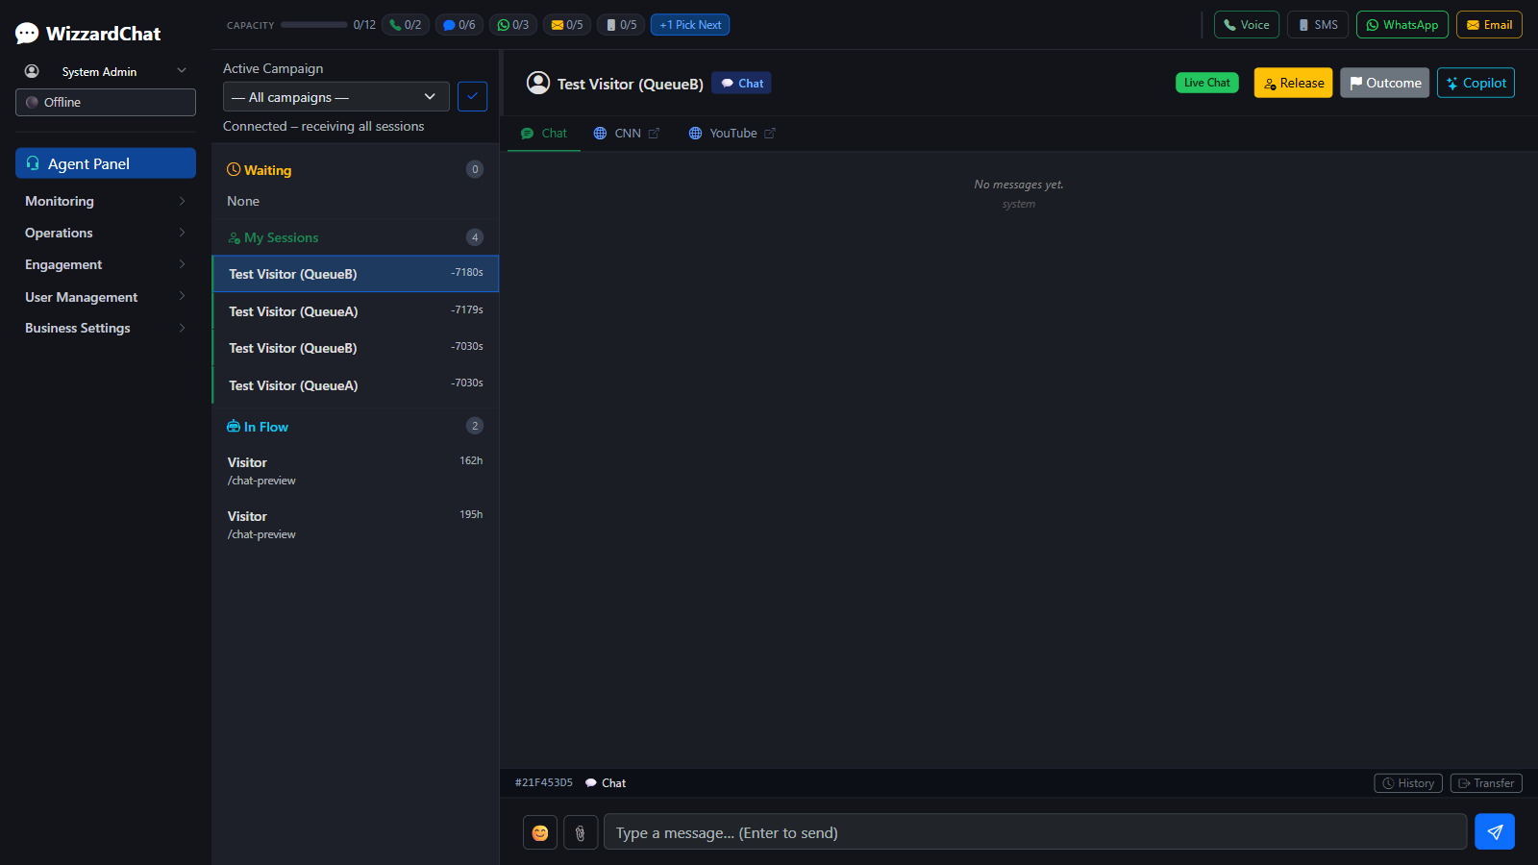

Queue B — webform tabs


Queue B — first webform tab active
