University Of Salford
Department Of Computer and Mathematical Sciences

Java Applet implementation of AI techniques
(Genetic Algorithms)

Initial Proposal

Supervisor: Dr. S Vadera

By: Stephen Jones

Date: 10th December 1998

Introduction
The theory of evolution is well known and was conceived before Darwin, however it was he who first offered mechanisms by which it could occur, through Natural Selection and Survival of the Fittest, and from these have come an understanding of the existence and workings of genes and DNA. The quantum nature of DNA makes it easy to model mathematically and so to implement evolutionary concepts on the computer.
Such modeling allows us a greater understanding of ourselves, our interactions and evolution
and those of our planet.

Background
Genetic Algorithms attempt to simulate the evolution of individuals via the process of selection for survival through chance, tests of fitness of the individual, random mutation of individuals to introduce new characteristics into the population, and reproduction which allows combination of successful genes.
The fitness of an individual is tested by its performance at surviving and reproducing in its environment. Only the fittest will reproduce.

Populations are created within a computer by representing individuals by chromosomes, a set of character strings that are analogous to the base-4 (the 4 amino acids that make up DNA) chromosomes that we see in our own DNA. The individuals in the population then go through a process of simulated evolution.
(adapted from AI -FAQ\ Genetics, see references)

Motivation
I have long been interested in the concepts of Natural Selection and Evolution, especially the multidisciplinary approaches of James Lovelocks modeling of Daisyworld and so its environmental extension to Gaia theory, Richard Dawkins modeling of evolution as a purely digital phenomenon and so his extension of the concept far beyond organisms and into the realm of ideas and information(Memes), and Henry Fords economic application of evolutionary concepts(efficiency of design and manufacture) and the philosophy of Fordism.
But for my project I have decided to base my model on Darwins Finches.
Darwin discovered the finches on his visit to the Galapagos Islands whilst on the HMS Beagle and the Finches were one of the most influential observations he made contributing towards his later theories detailed in Origin of the Species.
On different islands the same finch had evolved to specialise towards a particular food source.
Six are known as Tree finches and feed on insects and fruit and have longer, thinner beaks.
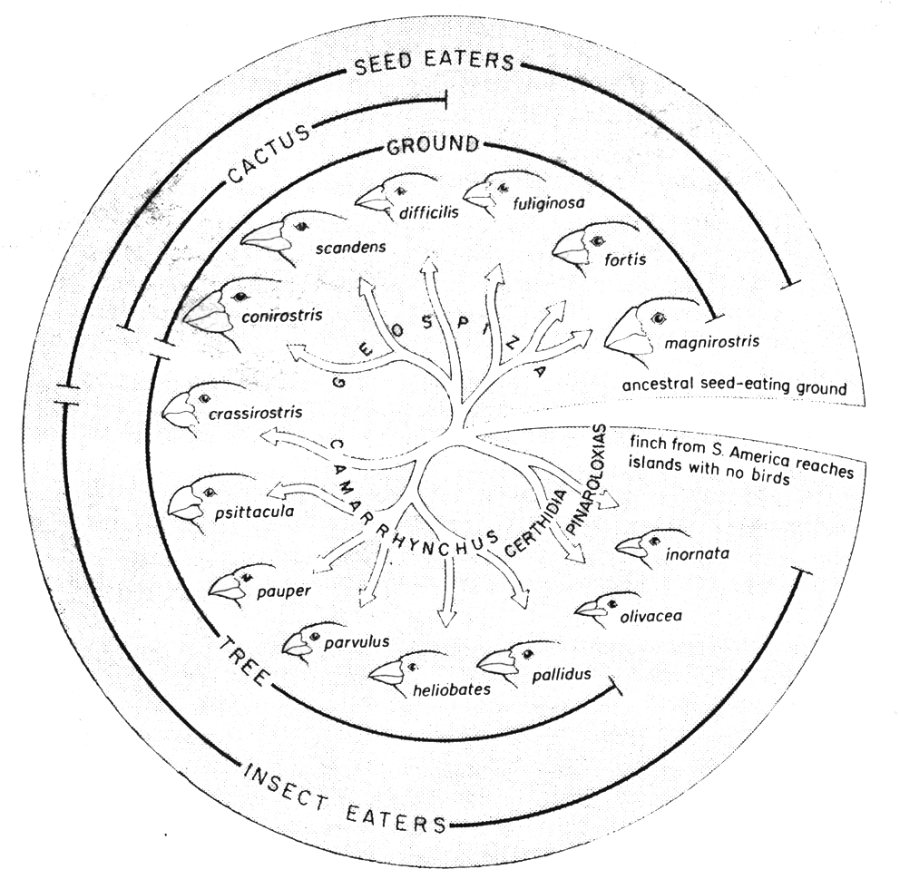
Six are known as Ground finches and feed mainly on seeds. They have shorter, fatter beaks
Diagram from Genesis of Diversity. It shows the
adaptive radiation Darwins Finches.
Darwin wrote in his ornithological notebooks:

Seeing this gradation and diversity in one small, intimately related group of birds, one might fancy that from an original paucity of birds on this archipelago, one species had been modified for different ends (from Genesis of Diversity, see references)

I intend to create an environment, populated with random individuals, and containing a food source. The efficiency of an individuals feeding on a food source will provide the fitness function to determine survival, and so reproduction. Hopefully the population will converge towards a mature form dictated by the environmental conditions.
The creation of several environments (with differing food sources) will allow the evolution of different forms in different environments.
(It may be possible for random individuals to be windswept from one island to another.)

Project Objectives

The objective is to create a Java Applet that will demonstrate the Artificial Intelligence Technique of Genetic Algorithms for a Website.
The Applet must:
- Be visually appealing
- Demonstrate a concept clearly and intuitively
- Easy enough for Internet Users to use
- Show successful evolution

I wish to produce a visual demonstration of AI, accessible and understandable to the casual viewer.

Approach
Because of the immense complexity of evolutionary interactions the system must necessarily be simplified and bounded.
Evolution of an individual and its environment are intimately linked, as the environment that produces an individual will be altered by the individual and so altering the conditions governing fitness for survival and therefore infinitely iterating. It would be much easier to consider the case of a constant environment, allowing a species to evolve to a "mature" form where its evolution can be seen to have reached a conclusion.

The project must be structured so that it can be broken down into clear stages with milestones.

- Familiarisation with Java - not only the language but also the development environment

- Familiarisation with AI genetic algorithm techniques and examples

- Design of Genetic Algorithm code
To evolve individuals to a mature state in a constant environment.

- Design of User Interface
To interpret the genes of the creatures in a visual way to shot to the user.

- Design of Visual Interpreter for genes
A mechanism must be designed to interpret the genes into a visual representation

- Implementation of Genetic Algorithm code

- Implementation of User Interface

- Evaluation of the model

Many parameters affect the rate of evolution of Genetic Algorithms and so these need to be set to optimise something, such as the efficiency (least number of generations) to evolve into a mature form.
Such parameters include:
- Crossover
- Mutation
- Population size
- Selection

The final stage of the project will involve an analysis of the relationships between these parameters and their affect on the evolution of the population.

Resource Requirements

Software

- Java compiler - Symantec Visual Café
- A Java enabled Web Browser - Microsoft internet Explorer
- Graphics package - Paint Shop Pro

Hardware

- Reasonably standard (Pentium) PC with Windows

References

WEBSITES

Genetic Algorithms in Java
http://www.msu.edu/~cps449/spr97/b/index.html

Huasong Yin's Java & AI page
http://ai.uga.edu/~hyin

Genetic Algorithms Frequently Asked Questions, from Artificial Intelligence Newsgroup:
Comp.ai.genetic,comp.answers,news.answers

BOOKS
Charles Darwin(1859), "Origin of the Sepcies"
(Penguin Classics, London 1985;New American Library, Mentor Paperback)

Patrick Henry Winston(1992),"Artificial Intelligence"(3rd Ed.)
Addison Wesley, Wokingham, UK.

Mark Watson(1997),"Intelligent Java Applications: For the Internet and Intranets"
ISBN 1-55860-420-0

Peter Coffee(1996),"How to program Java"
QUE, Macmillan Computer Publishing, CA

Bryan Shorrocks (1978)," The Genesis of Diversity "
UNIBOOKS, Hodder and Shoughton

INITIAL PROJECT PLAN

