**BACKGROUND AND GOALS FOR FELLOWSHIP TRAINING**

1. ***Doctoral Dissertation and Research Experience***

**Post-Baccalaureate Research (Johns Hopkins University).** In my senior year of undergraduate studies, I acquired a 30hr/wk internship at the Johns Hopkins Behavioral Pharmacology Research Unit (BPRU), which I became a full-time position following graduation. During my four-year tenure, I assisted or coordinated 11 studies, the most notable being a series of NIMH/NIDA Center Grant studies investigating the effect that cigarettes with strategically manipulated nicotine content had on smoking reduction/regulatory behavior in an average- to heavy-smoking sample with the goal of improving public health on a national scale. Tangential projects focused on nicotine reduction in vulnerable populations, including opioid-maintained populations and women of child-bearing potential. Coordinating these projects meant training and managing a small team of researchers to recruit hundreds of participants over a two-year period. Participants would return to lab on a weekly or biweekly basis for six months to receive a battery of cognitive tests, clinical tests, provide biospecimens, answer questionnaires, and exchange experimental product, all while also completing daily experiential sampling surveys. Our site specifically excelled in recruitment and participant retention under my coordination relative to other participating sites. This experience is where I first became interested in self-regulatory phenomena and concerns surrounding ecological validity in research. In overseeing these large-scale, heavily regimented and highly critiqued projects, I saw firsthand how crucial piloting and protocols were for study success. I also discovered that I excelled in the organization and attention to detail that this planning required.

**Post-Baccalaureate Research (Drug & Alcohol Dependence).** Due to my meticulousness and writing proficiencies, I was also offered the position of Editorial Office Manager for the Elsevier journal Drug and Alcohol Dependence. Over two years, I managed routine operations for the journal, coordinating across a team of editors and reviewers to evaluate the quality of manuscripts for publication. This meant greater exposure to self-regulatory models and neural research than I otherwise would have encountered and was where I first developed my interest in neuroimaging methods. To sustain our journal’s publishing rate of over 500 articles per year, I developed skills to quickly understand and review manuscripts that contained novel techniques and analyses in an efficient manner. I held this position simultaneously with my other roles at the BPRU.

**Post-Baccalaureate Research (Children’s Hospital of Philadelphia).** In 2017, I accepted a position as a Clinical Research Coordinator in the Gastroenterology, Hepatology, and Nutrition Department at the Children’s Hospital of Philadelphia to acquire clinical experience and explore my interest in early developmental populations. I acclimated quickly to the new environment and began overseeing two projects, one of which was a survey of the gut microbiota composition in patients who had gastrointestinal tract portions resected, resulting in short bowel syndrome (SBS), which typically results in greater variance in microbiome composition, making traditional antibiotic treatments ineffective and negatively impacting developmental cognition and health trajectories. The latter project resulted in a *Gut Microbe*s manuscript, on which I was an author, summarizing our microbiome survey and recommended treatment courses for patients suffering from these conditions. The second demanded collection, processing, and storage of live human tissue and other biospecimens during endoscopy procedures and organ resections. These samples yielded a biobank of 150 enteroids, or replicable patient cells from diseased or non-diseased GI tract tissue, which can be used to test experimental treatments without harming vulnerable patients. This was a major advancement for treatment development. I developed an appreciation for research stewardship, as helping to build research infrastructure for others with this repository directly motivated my interest in open-source programming and data-sharing practices. In working with these unique vulnerable populations, I also developed a greater appreciation for how pivotal the intersection of development is to my interests in affect, self-regulation, and neuroscience.

**Predoctoral Research (Temple University).** As a doctoral student under the mentorship of Dr. Chelsea Helion, I am interested in understanding representations of affective information across early development and how self-regulatory behaviors might moderate these experiences. Because social, affective, and self-regulatory phenomenon are highly context dependent, my research uses naturalistic stimuli and paradigms pursuing high ecological validity to yield the most accurate models that we can generate of common experiences. For example, while the emotion regulation field has demonstrated associations between low-intensity affective experiences and subsequent self-regulatory choices, high-intensity affective experiences have been elusive, especially outside of the lab. Yet, self-regulation in high-intensity situations is precisely when successful regulation may be of the utmost importance, especially for anxiety and traumatic stress disorders. As such, we leveraged a quasi-naturalistic, controlled environment (i.e., a Haunted Haunted) across two studies (N1 = 56, N2 = 118) to explore associations between high intensity affective experiences and self-regulation, memory, and physiology. We found that affective intensity strongly predicted effort to regulate but did not predict which strategies untrained and undirected participants chose in the field. However, participants who had not experienced the haunted house directly but were presented with information about those same events from the haunted house in the context of a lab did demonstrate an association between affective intensity and strategy choice. These results extend well-established relationships to new contexts and highlight how real-world situations can complicate what otherwise might appear to be clear effects. Results from the project were presented at the 2021 and 2022 Society for Personality and Social Psychology Conferences, the latter of which resulted in winning an SPSP travel award. The manuscript is also currently available as a preprint and under review at *Psychonomic Bulletin & Review.*

Much of my research has specifically focused on extending similar ecological validity to fMRI studies. In my second year I published my first first-author publication in *Social Cognitive & Affective Neuroscience* which used video stimuli and representational similarity analysis (RSA) to highlight differences in neural representations of affective information between adults (ages 20 - 44) and children (ages 4 - 10). We hypothesized, based on extant literature, that neural development between prefrontal and subcortical affective structures during adolescence should influence representations of affective information in those regions. We found evidence that representations of affective information in the ventromedial prefrontal cortex (vmPFC) grow more dissimilar with age relative to subcortical structures (i.e., amygdala and nucleus accumbens), as well as evidence for greater representational pattern similarity for negative relative to neutral and positive stimuli, which collectively may reflect a maturation towards more evaluative affective processes. Data from the project won poster awards at the 2021 Society for Personality and Social Psychology Emotion Pre-Conference as well as 2021 Social Affective Neuroscience Society Conference,and was presented at a symposium I organized for the 2022 American Psychological Association conference on the importance of context in affective research.

My interests in ecologically valid neuroimaging, development, social affective phenomena have culminated in a project Dr. Helion and I launched in my third year and which aims to document behavioral and neural representations of how social uncertainty judgments form using study designs that mirror important features of a social world. While many well-established trial-by-trial paradigms capture economic and perceptual uncertainty, the uncertainty a person might feel when determining trust or honesty is based upon information: a.) revealed across a continuous time course rather than in neatly defined trials, b.) that may be mixed with and need to be sorted from irrelevant information, and c.) that features both unknown possible outcomes and probabilities. While the literature highlights how aversive uncertainty can be, people seek uncertainty in media. By providing participants with a basic context, presenting a video stimulus with varying uncertainty (e.g., competitions, crime mysteries), and continuously recording how uncertain participants are of a given outcome, we can explore neural responses to social uncertainty, domain-specificity from economic and perceptual uncertainty, which stimulus features might be relevant, and how the uncertainty aversion can be mitigated. While data collection and analysis among adults is nearly complete, my dissertation aims to expand this paradigm to early developmental populations. Though existing studies of social uncertainty in development are limited, an increase interest in social feedback during adolescence suggests social ambiguity, unlike economic ambiguity, may still be especially aversive early in life. Understanding how certainty judgments form during this period would be highly relevant to treatment of anxiety disorders, depression, and related psychopathologies.

By merit of the statistical and programming skills I have developed pursuing these projects, I was also invited to contribute to and co-direct in my second and third years of graduate school, respectively, a new student-run organization, the Coding Outreach Group (COG). We host semi-annual coding bootcamps for beginners in R, Python and Bash; hands-on skill workshops for intermediate to advanced coders, on topics such as using fMRIPrep, Github, and Linux machines, or conduction data visualizations and RSA; and regular office hours for people of all skill levels, from undergraduates through faculty, to find solutions to coding problems. We plan to introduce new programming in Spring 2023, wherein contributors work together to produce a novel functional programming tool or library to be used in data collection, analysis, or visualization. Our educational materials are self-generated, free, open-source, and hosted on our webpage as tutorials so learners can progress at their own pace. COG has extended beyond the Temple community through outreach events with *Girls Who Code* but is currently resource limited. In October 2023, we are seeking NIH funding via a METER (NOT-NS-23-011) grant to increase our ability to serve local communities. As a first-generation college attendee from a low SES, single-parent background, I would not have the education or skills that I do if not for exceptional mentorship. As such, I dedicate much of my effort towards mentorship. I received a Mentor of the Year award from the Temple Psychology Department for my work with Honors students because of these efforts and I plan to continue in that vein for the rest of my time as a graduate student, post-doctoral fellow, and PI.

**Doctoral Dissertation (Temple University):** The project proposed under Specific Aim 1 in this application is intended to be my doctoral dissertation.

1. ***Training Goals and Objectives***

***Receiving this training grant will help me reach my long-term training goal of becoming an independent social affective developmental neuroscientist.*** Specifically, I will generate predictive models of social affective developmental phenomena using multimodal data. Though computational modeling is relatively new for social affective neuroscience, it is positively essential for disentangling the influence that complex socioaffective contextual features have upon human behavior and cognition. In building models of social uncertainty with behavioral, for example, we can identify the unique contributions of discrete neural structures towards a global certainty response and begin to identify how variations in the function of these structures might vary psychological (i.e., aversive feelings, curiosity) and behavioral responses (i.e., exploration, self-regulation) to uncertainty. As such, computational approaches are beneficial not only to researchers, but also clinicians seeking mechanistic understandings to develop and support treatment. I also aim to ***mentor and support diverse researchers***. I know firsthand how difficult navigating academic research spaces can be for underrepresented individuals as well as how valuable those unique perspectives are for the field. As such, I will create lab environments which foster and support diversity as a principal investigator.

To plan how to accomplish my long-term goals, I created an Individual Development Plan (IDP) using a tool from the American Association for the Advancement of Science which identified my strengths, including:

* **Technical skills:** managing data and resources, statistical analyses, developing programming skills; applying expertise to novel projects.
* **Project Planning:** recruiting participants and collecting data in a timely manner, planning and executing analyses that are hypothesis driven.
* **Responsible Conduct of Research:** ensuring participant safety, collecting informed consent and assent, adopting open-science practices in data and code sharing, managing conflicts of interest.

The IDP also identified areas needing improvement to be a successful principal investigator. These include:

1. **Mentorship:** providing constructive feedback, instruction & guidance, dealing with conflict, serving as a role model
2. **Lab Management:** experimental design, grant writing, delegating responsibilities, goal & vision development, negotiation
3. **Contributing to Field / Professional Development:** critical evaluation of scientific literature, navigating the peer review process, interpretation of data.

Therefore, my training goals are to learn computational methodologies, build my mentorship skillset, develop lab management skills, and improve my contributions to the field.

**Figure 1.** *Proposed timeline for activities planned under this award for the F99 and K00 phases*. Flux = Flux Conference; CCN = Computational Cognitive Neuroscience conference, SANS = Society for Affective Neuroscience conference, MIND = Methods in Neuroscience at Dartmouth computational summer school, Kavli = Kavli Summer Institute in Cognitive Neuroscience (BrainCamp), CN = Computational Neuroscience, COG = Coding Outreach Group at Temple University, CHOP = Children’s Hospital of Philadelphia.

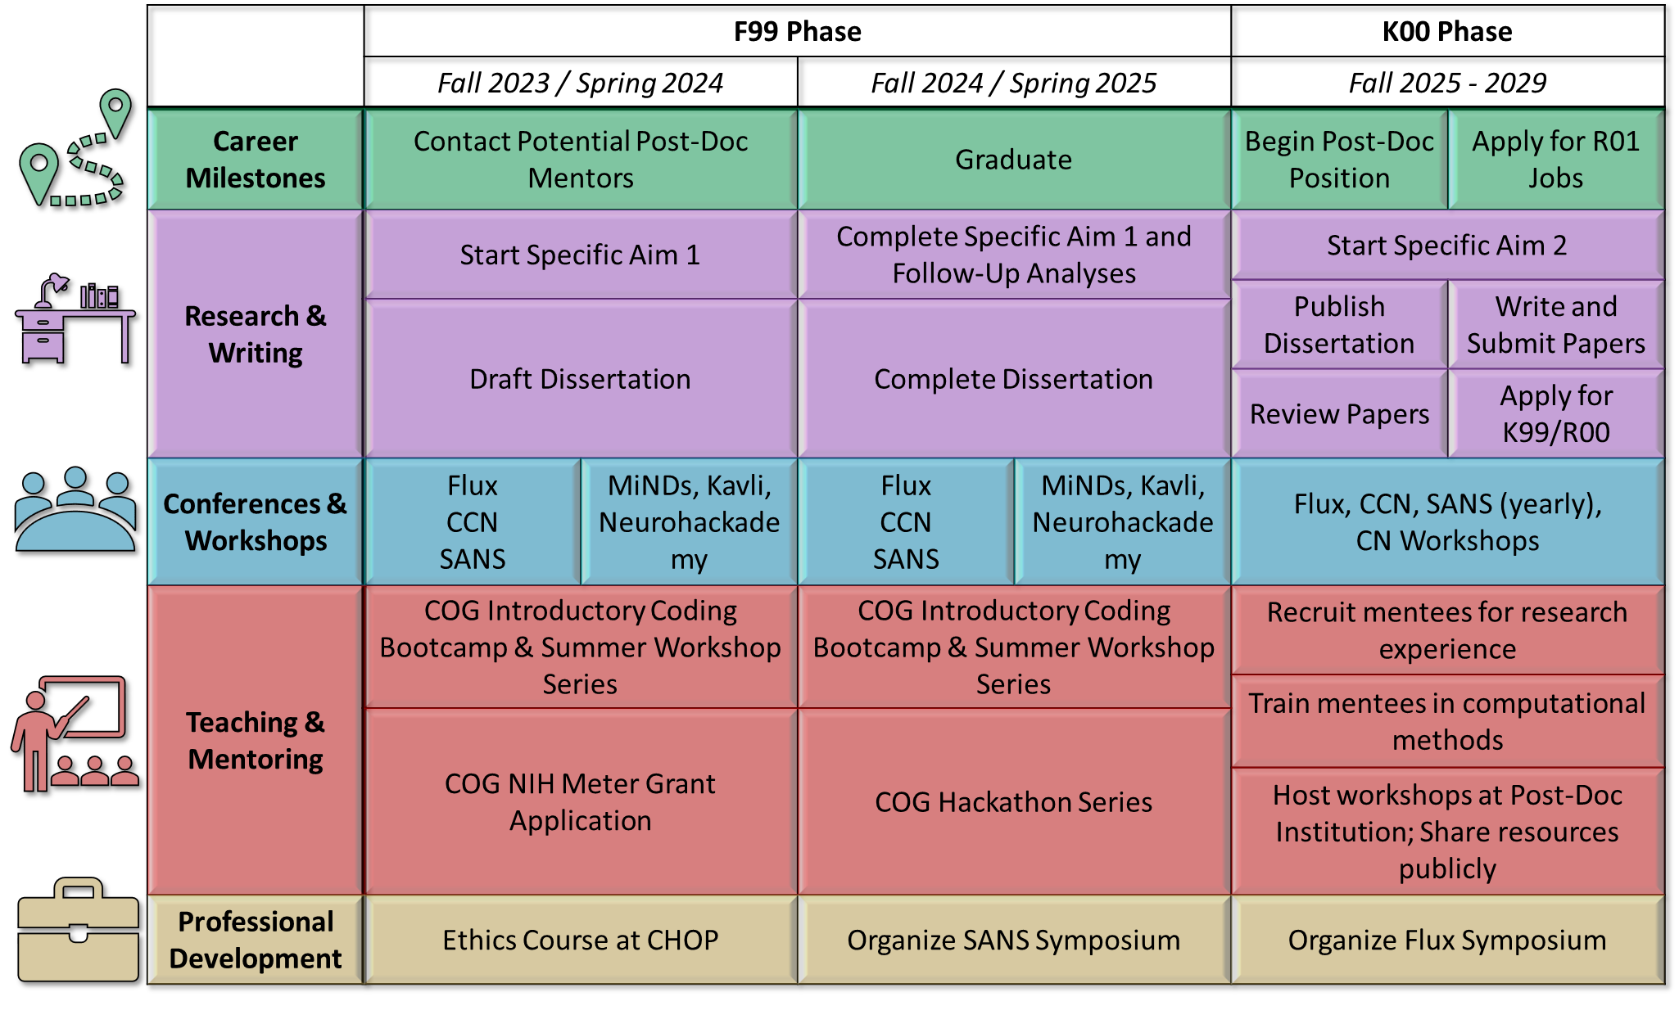

1. ***Activities Planned Under This Award***

The activities I have planned under this award (see **Figure 1)** will facilitate my short-term training goals and build a foundation for my long-term goals of becoming an independent social affective developmental neuroscientist and mentoring a diverse lab. I have visualized my effort pursuing these goals in **Figure 2**. By the end of the K00 Phase, I will have acquired the skills and experience I require to launch my own independent line of developmental research due to the support of this award.

**C.1. Learning computational methodologies**

***F99 Phase.*** Although I have acquired a strong technical and computational skills to conduct advanced statistical analyses, I have not yet developed sufficient expertise in advanced computational methodologies using neural data. Computational methodologies allow researchers to determine the approximate influence of different parameters which may demonstrate some predictive utility towards behavioral or neural functions. Such approaches are critical towards an in-depth understanding of social affective phenomena which are often informed by rich, multimodal information and subject to contextual influences. During my dissertation, I aim to learn more about how independent stimulus features, age-related neural developments, social and non-social directives, and attention influence neural representations of uncertainty. Dr. Helion’s strong command of advanced computational methodologies will be crucial to my developing advanced computation modeling techniques and we will meet weekly to discuss my progress in employing these techniques to complete my dissertation. Dr. Helion’s office is directly across the hall from our lab space and she is easily accessible should any urgent issues appear outside of our regularly scheduled meeting times. Dr. Chein’s expertise on affective neurodevelopment will also be crucial to understanding how to fit these features into my computational models, as well as noting important social and affective features to consider when developing these models. Dr. Chein and I will meet at least biweekly to discuss modeling techniques, concerns, and project progress, though additional meetings may be scheduled as needed. Dr. Chein’s has an office directly in the Temple University Brain Research Imaging Center (TUBRIC) where this data for this project will be collected and thus will also be readily available should issues arise. In additional to attending weekly meetings in Dr. Helion’s SAN Lab, I will also attend Dr. Chein’s weekly lab meetings to keep up to date with progress within the lab and receive greater exposure to affective developmental neuroscience research. In addition to lab meetings, I will also be attending the bi-weekly Social Psychology Journal Club hosted by department faculty and graduate students, in which recent social developmental and social neuroscience work in the field is reviewed and discussed. I am a scheduled presenter in this series and will continue to present during this journal club to receive critical feedback on my proposed project. The neuroscience faculty at Temple University also invite outside speakers to present during a monthly neuroscience seminar. These meetings will help me to stay up to date with the current literature, while also sharpening my critical thinking and critique of the literature by providing an opportunity for me to discuss with experts in the field. Lastly, to receive hands on training regarding cutting-edge computational methods, I aim to attend at least one summer program teaching neuroscience techniques each year, such as Dartmouth’s MiNDs program, the Kavli Summer Institute, the University of Michigan’s fMRI Training Course, or Neuromatch. I was invited to attend Neurohackademy during summer 2022 and plan to expand my skillset through additional focused computational courses.

***K00 Phase.*** During my post-doc, I hope to extend my computational modeling skills beyond affective valuation and into self-regulation in response to affective states. Models of affective self-regulation have been developed and refined within the field for decades, but as self-regulation moves beyond the lab and into naturalistic environments, accounting for context will be an ongoing challenge for researchers to navigate. This is further complicated by self-regulations position in-between decision-making phenomenon and reflexive response. Ideally, my post-doc mentor or others at their institution will be knowledgeable in computational modeling and train me on the techniques and literature. I plan on attending additional workshops to learn how computational models can be developed and applied to decision-making constructs. I plan on adopting these models to explore how contextual details determine the selection and efficacy of self-regulation strategies throughout early development and will continue using naturalistic fMRI paradigms and stimuli to do so. Incorporating naturalistic designs into the strict confines of MRI machines requires creative experimental design and I hope to identify a post-doctoral mentor who can help guide my development in this regard. Towards the end of my post-doc, I will apply for a K99/R00 grant focusing on my topic of interest for my independent work. Currently, this would aim to explore changes in neural correlates through early development in response to regulating uncertainty.

**C.2. Increase my contributions to the field**

***F99 Phase.*** During my F99 phase, I will contribute to my field of affective developmental neuroscience by publishing my research and presenting at conferences. I am in the process of preparing my predissertation research for journal submission in February 2023. I will be completing and submitting a review on affective self-regulation by May 2023. While preparing these manuscripts, I will also continue collecting data among adult participants for use within my dissertation (see **Specific Aim 1**). We expect this data collection to be complete by May 2023. Under the supervision of my mentor, Dr. Chelsea Helion, I will begin drafting my dissertation in the Fall of 2024, with my dissertation defense planned for May of 2025. I am passionate about creating tools for researchers and I have been working to generate libraries and functions to facilitate ecologically valid research (available at https://github.com/wj-mitchell/). As such, I will contribute to the field by building these analytic tools. I have three primary ongoing projects: 1) a collection of functions to generate study designs using naturalistic video stimuli in Python (NaStiPy); 2) a collection of tools to process fMRI data that uses naturalistic video in R (neuRotools); and 3) a collection of tools to automate representational similarity analysis decisions and formatting in R (ezRSA). My ultimate goal is to formalize them as libraries within R’s CRAN and Python’s PyPi by the end of the F99 Phase. In the fall, I will be attending conferences thematically centered upon computational and development neuroscience (Computational Cognitive Neuroscience, Flux Society) where I hope to meet with potential post-doctoral mentors and explore common research interests. In the spring, I will attend the Society for Affective Neuroscience (SANS) conference. I have been a member of SANS since my first year of graduate school and hope to continue to be a part of and network within the organization. My ideal post-doctoral mentor would likely be someone from one of these communities. My mentor, Dr. Helion, has also been a member of these societies for a long time and will help me network at when we attend to find a post-doc mentor.

***K00 Phase.*** During my post-doc, I will publish my dissertation and manuscripts related to my second specific aim. I also wish to develop a stronger research acumen by more closely engaging with and critically evaluating the extant scientific literature through reviewing papers, specifically in attention, memory and related sub-disciplines which inform decision-making and development, but which I could not complete during my doctoral studies. I will continue to attend the CCN, Flux, and SANS conferences annually and continue to build my social network of likeminded researchers. While I am attempting to develop computational models of self-regulation, CCN will be crucially important as a resource to examine how others build models to explain complex, multimodal affective phenomena. I also expect my attendance at Flux to ensure that I stay up-to-date on cutting edge developmental neuroscience research. As I transition deeper into my post-doctoral position and prepare to become my own independent principal investigator, I will become more involved in the planning and administration of these conferences by hosting programs, workshops, events, or assisting the organizing board. This will ensure that I receive sufficient practice in these sorts of management skills while contributing to resources which I have greatly benefited from.

**C.3. Gain more mentoring experience**

***F99 Phase.*** During the F99 phase, my efforts to develop my mentoring skills will primarily be directed towards my current position as co-director of Temple’s student-led Coding Outreach Group (COG). I have been closely involved with the operations of COG since its inception. It is a student-led organization which hosts semi-annual coding bootcamps for beginners, hands-on skill workshops for intermediate to advanced coders, and regular office hours for people of all skill levels to find solutions to their coding problems. I have been helping to develop the programming and free, open-source resources for COG since the summer of my first year. These events are well-attended with our most recent introductory bootcamp receiving a little over 40 attendees across three days. During the Fall 2023/Spring 2024 school year, I plan to expand COG’s pre-existing programming by applying for an NIH METER grant which will provide resources and funding to expand COG’s reach and ability to generate educational material for aspiring neuroscience researchers. This would also mean that COG could afford to conduct more outreach workshops in collaboration with organizations and schools in the greater Philadelphia area. Independent of the success of the METER grant, COG will hold weekly office hours, wherein I will meet with individuals to help them solve their coding issues, a summer workshop series, in which advanced coders organize hands-on tutorials to teach specific skills to interested attendees, and our introductory bootcamp. We are working with our department to make COG’s introductory bootcamp a mandatory class for all incoming first year graduate students, so as to standardize the programming experience that individuals enter the program with. During the Fall 2024/Spring 2025 school year, I also aim to expand COG’s regular programming by organizing a hackathon series in which coders of all skill-levels come together for an abbreviated portion of time to collaboratively work together to produce valuable analytic tools which could be of use to the broader scientific community. Such a program would allow me to exercise skills in delegation, coordination, and communicating with differently skilled individuals to accomplish a specific goal. As is our mission, all of our teaching resources will be available to people at all skill levels and financial situations through publicly available online repository. To serve as a role model, I will train others to take over my COG duties after I graduate so that they can also gain experience teaching and to continue providing these resources to the community.

***K00 Phase.*** During my post-doc I plan to continue mentoring in a similar vein as I had during my doctoral studies, but on a larger scale. In developing my computational and technical skills during my dissertation, I will have additional methods for which to host workshops and training seminars. I plan to regularly host such seminars at my post-doctoral institution. If my post-doctoral institution has a COG similar group, I intend to become an active member. However, if it lacks a group dedicated to teaching advanced technical skills relevant to research, I intend to create one. I will also manage a team of research mentees and advise them on their personal research projects and immediate career endeavors. This is especially important for me as a first-generation higher-education student from a low socioeconomic background, as I hope to reduce the confusion and complication inherent in trying to navigate the world of academia by yourself. Though I entered college with a very clear career goal, I did not understand how to accomplish it. It was only through the efforts of dedicated mentors that I found the opportunities that I did and, as such, I would like to serve in the same capacity for others. I will create an accessible, inclusive environment for my diverse research team. This will ensure researchers are getting the adequate care and attention they need while fostering independence ance creativity. Though I have had ample opportunities to gather research experience during my post-doctoral studies, building upon those skills is of the utmost importance to me. As such, I will also aim to pursue teaching opportunities with my post-doctoral advisor when possible.

**C.4. Develop lab management skills**

***F99 Phase.*** Lab management skills are “soft skills” that cut across many of the categories depicted in Figure 1. Although this is not often taught to graduate students, I believe it to critical for professional success. To be better aware of ethics in research, I will take the “Ethics in Developmental Research” course offered at the Children’s Hospital of Philadelphia. In addition to this formal course, I will discuss ethics in research and in being a principal investigator with my current mentor, Dr. Chelsea Helion, monthly during our regular meetings. This will especially be important in completing the final analyses of my dissertation and submitting the manuscript for publication. If attending this course is no longer an option, I will attend similar courses at Temple University or developmental neuroscience related conferences. To further develop my organizational and management skills, I plan to organize at least one developmental neuroscience symposium at SANS.

***K00 Phase.*** I plan on developing most of my skills in lab management during my post-doc, where I will have more of an opportunity to work with graduate students and research assistants. During the winter when potential doctoral students are applying to labs, I will assist my mentor in interviewing new students to gain experience in the hiring process. I will meet with my mentor annually to discuss how they manage their budget, discussing things such as how the decision-making process of include lab members and collaborators on grants, purchasing and managing lab resources, and on how I should approach managing resources when starting my own lab. I also aim to organize symposia at Flux during this period as well.

**C.5. Details on timeline and effort**

Details about the effort I will dedicate to research, writing, conferences and workshops, teaching and mentoring, and professional development are detailed in **Figure 2**.

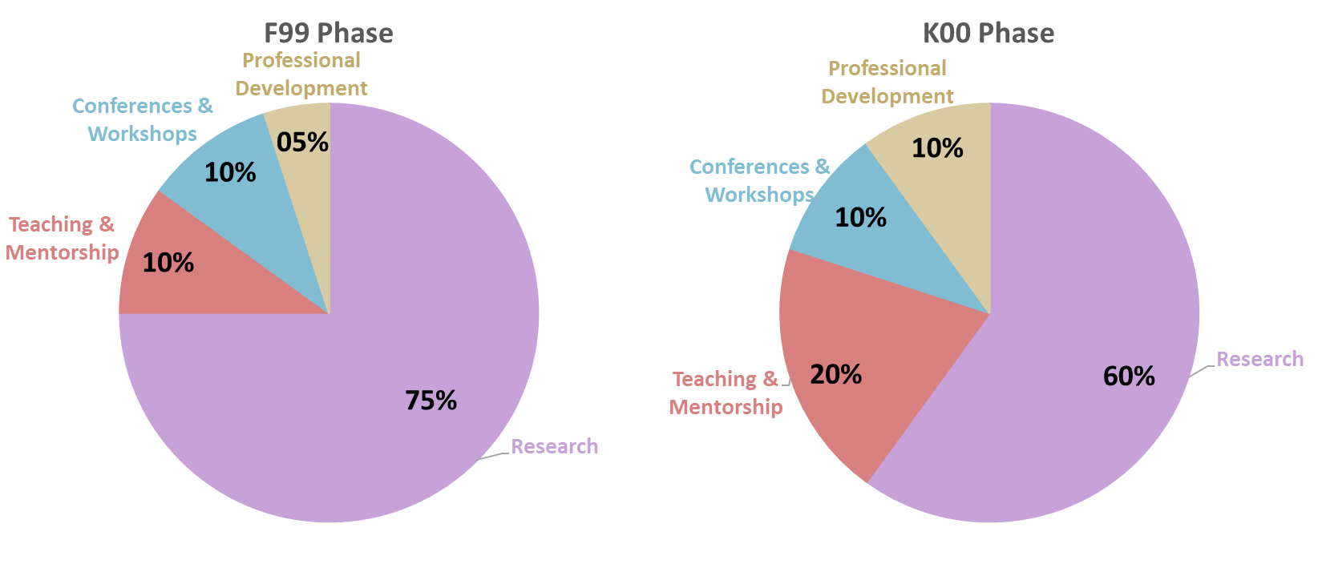

**Figure 2.** Summary of effort for the F99 and K00

In my F99 phase of this award, I will focus my efforts mostly on research, so that I may complete my doctoral work on time and graduate, thus putting me in a strong position to begin my post-doc. During my post-doc, I will divert some of my research time to mentoring. This is because with mentoring, I will be training others to help me complete my research with me. In addition, I will increase my professional development effort, to prepare myself for being the best mentor possible and thus launch my career as a principal investigator.

I also have a specific timeline on my meetings with my mentors, consultants, and dissertation committee. I will continue to meet with my PhD advisor weekly, as I have been throughout most of my graduate program. During my post-doc, I plan on meeting with my mentor weekly also, as I have found that frequent time to update and receive feedback with my mentor helps me progress my work more quickly. This will also be a consideration in selecting my post-doc mentor, as I would like someone with that type of availability. I will be meeting with my co-advisor monthly to learn specific topics and skills from them as I discussed above. Dr. Chein is on my dissertation committee, and so during my monthly meetings with him I will also receive feedback regarding progress on my dissertation.