https://blog.csdn[.net](https://search.bilibili.com/all?from_source=webcommentline_search&keyword=.net)/weixin_43424325/article/details/121684101

路由面试题：



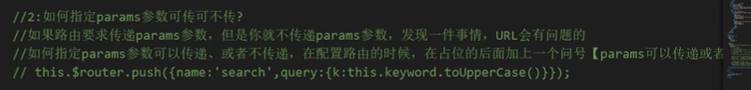





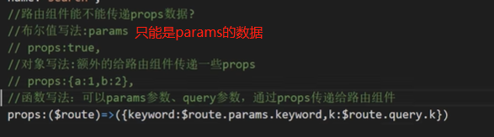

解决this.$route.push/replace 连点报错的问题

