产品规格书
SPECIFICATION
DEC.

产品名称 石英晶体谐振器
Description Crystal Unit
型号 · 标称频率
Type · Nominal Frequency 3225 25.000MHZ
规格书号
Specification . X3225 25.000M 2001
物料号
. 90013014

批准
APPROBED BY
审核
CHECKED BY
制作
DESIGNED BY

- 外观 · 印字
Outline and Marking
型号  Type | SMD Crystal3225/4PAD
外形尺寸图  Outline and Dimensions | 附图 1  Drawing 1
印字示意图  Marking | 附图 2  Drawing 2
回流焊温度曲线图  Reflow Temp. Profile | 附图 3  Drawing 3
- 电气性能
Electrical Performance
标称频率  Nominal Frequency | 25.000MHz
振荡模式  Mode of Oscillation | Fund
负载电容  Load Capacitance | 20pF
存储温度范围  Storage Temperature | -40℃ ～ +85℃
工作温度范围  Operating Temperature | -20℃ ～ +70℃
频率公差  Frequency Tolerance | ±10ppm (at +25℃±2℃)
温度特性  Frequency-Temperature Characteristics | ±20ppm (-20℃ ～ +70℃)  Based on the measured value at +25℃
等效串联电阻  Equivalent Series Resistance | 附表1
并联电容  Shunt Capacitance | 5pf MAX
激励功率  Level of Drive | 100uW
年老化率  Aging | ±1ppm/year
附表1
Resonance resistance
Frequency (MHz) | Mode | Ohm Max
8≤Fr≤10 | Fundamental | 70
10＜Fr≤12 | Fundamental | 60
12＜Fr≤16 | Fundamental | 50
16＜Fr≤40 | Fundamental | 40

3.机械性能
Mechanical Performance

冲击(自由落体)  Shock (Random Drop) | 下落高度 Height: 75mm  下落次数 Dropped Time: 3  自由落体到硬质木板(30mm)  Rigid Hardwood Surface | 频率变化量  Frequency change permitted ：  ±3 ppm  等效串联阻抗所允许的变化量  Equivalent series resistance change permitted:  ±5Ω or ±10%  两者选最大  whichever is the large
回流焊耐热性  Thermal Stability of Solder | 参考图 3
气密性  Leakage | 细漏Fine leak: Helium leak test  *JIS C 6701 10.6 | 漏率  Leak rate  5*10⁻⁸Pa.m³/sMAX

- 测试设备
Test Set
Π网络分析仪 Network Analyzer: S&A 250B

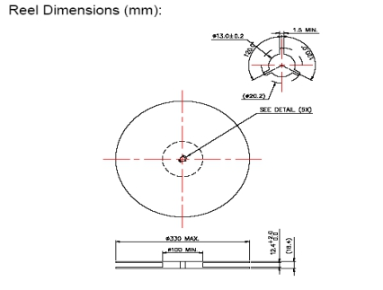附图 1
Drawing 1

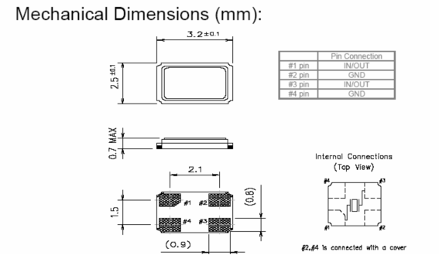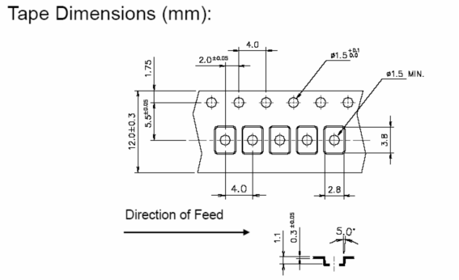

1)晶体编带方向有一致性。Pin1必须要在taping圆洞的那一边。
The orientation of typing should be coherent. Pin1 must be at the side of hole.

2)印字的左下角是在pin1的上方。
Under left corner is the pin 1.

见下图
As follows:
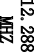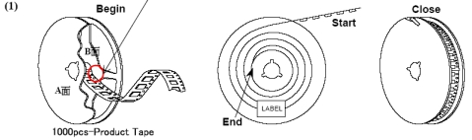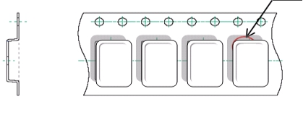

在装入晶体前必须至少留300mm（40个空格）的空的载带，并用胶膜封上。
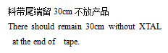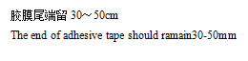There should remain at least 300mm (Forty blanks) before typing and be sealed.
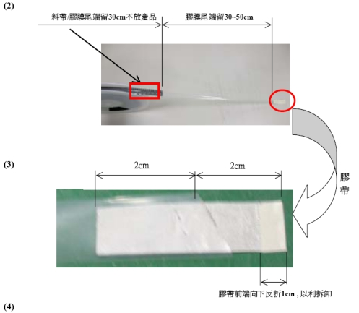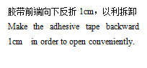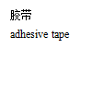

料带拉力值：30-60g。
Material belt pulling strength: 30-60g
a．料带拉力测试角度：165°～180°。
Material belt pulling force test angle: 165°～180°
b．料带拉力测试速度：300mm/min。
Material belt pulling force test speed: 300mm/min。
c．料带拉力测试长度：300mm。
Material belt pulling force test length
5.在胶盘正面粘贴标签，将胶盘放入气泡袋中，将气泡袋塑封密闭。
Affix the label on the obverse side of reel, then put the reel into air bubble bag and seal it.
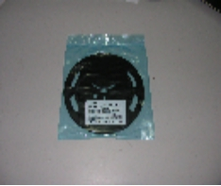
- 将装好胶盘的防静电袋装入小纸箱中，在纸箱表面标贴标签与无铅标识。
Put the anti-electrostatic bag into case and affix label and lead free mark.
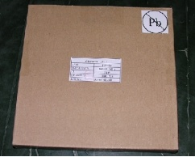
7.10只小纸箱放入大纸箱中，四周使用气泡袋填充。内附出货检验报告。
Put 10 small boxes into a big one and fill them with bubble bags. Enclose the goods inspection report.

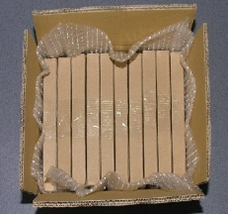

附图 2
Drawing 2
Marking
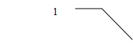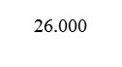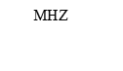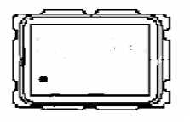
1.标识:
Nominal Frequency: XX.XXX
(e.g.) 12.000000Mhz ------ 12.00
16.934400Mhz ------ 16.93

附：产品电气参数验收依据：GB2828-87 一般检验水平Ⅱ AQL=0.4
Enclose: The product electricity parameter approval rests on GB2828-87 commonly test level Ⅱ AQL=0.4

