**MRTG**

MRTG可以分析网络流量，但是它必须依赖SNMP协议。将收集到的数据生成HTML文件，以图片的形式展示出来

1、安装一些依赖软件

|  |
| --- |
| [root@localhost bandwidthd-2.0.1]# **yum freetype** |

2、下载安装phpmyvisites，将软件解压后复制到apache网页根目录“/var/www/html/”

|  |
| --- |
| [root@localhost wj]# **tar –xvf phpmyvisites_2.4.tar**  [root@localhost wj]# **cp -r phpmyvisites_2.4/ /var/www/html/phpmyvisites/** |

3、启动snmp服务

|  |
| --- |
| [root@localhost bandwidthd]# **service snmpd start**  正在启动 snmpd： [确定]  [root@localhost bandwidthd]# |

4、下载bandwidthd软件（<https://oss.oetiker.ch/mrtg/pub/?M=D>），或者以yum方式在线安装

|  |
| --- |
| [root@localhost bandwidthd]# **yum install -y mrtg** |

5、修改配置文件”/etc/httpd/conf.d/mrtg.conf”

|  |
| --- |
| [root@localhost bandwidthd]# **gedit /etc/httpd/conf.d/mrtg.conf**  <Location /mrtg>  Order deny,allow  **# Deny from all //这句要注释掉**  **Allow from all //这里为all，允许检测所有ip**  Allow from ::1  # Allow from .example.com  </Location> |

6、生成mrtg文件，并做一些修改。

|  |
| --- |
| [root@localhost bandwidthd]# **cfgmaker public@192.168.0.113>/etc/mrtg/mrtg.cfg //生成文件，注意ip地址需要用户自己设置**  [root@localhost bandwidthd]# **gedit /etc/mrtg/mrtg.cfg //修改文件**  # for UNIX  **WorkDir: /var/www/mrtg //当前处于centos系统，因此这句去掉注释.这个路径是apache下的网页路径**  # or for NT  # WorkDir: c:\mrtgdata  ### Global Defaults  # to get bits instead of bytes and graphs growing to the right  **Options[_]: growright, bits //去掉注释** |

7、生成html文件，执行三次指令

|  |
| --- |
| [root@localhost bandwidthd]# **env LANG=C mrtg /etc/mrtg/mrtg.cfg //第一次**  2018-08-22 14:50:00, Rateup WARNING: /usr/bin/rateup could not read the primary log file for 192.168.0.113_2  2018-08-22 14:50:00, Rateup WARNING: /usr/bin/rateup The backup log file for 192.168.0.113_2 was invalid as well  2018-08-22 14:50:00, Rateup WARNING: /usr/bin/rateup Can't remove 192.168.0.113_2.old updating log file  2018-08-22 14:50:00, Rateup WARNING: /usr/bin/rateup Can't rename 192.168.0.113_2.log to 192.168.0.113_2.old updating log file  [root@localhost bandwidthd]# **env LANG=C mrtg /etc/mrtg/mrtg.cfg //第二次**  [root@localhost bandwidthd]# **env LANG=C mrtg /etc/mrtg/mrtg.cfg //第三次** |

8、在浏览器输入“127.0.0.1/mrtg/192.168.0.113_2.html”,这样就可以访问了

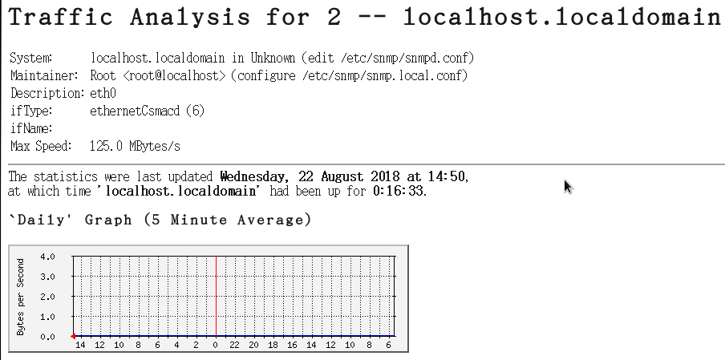

Copyright@david zhytwj2018@163.com