**安装spam**

spam（SpamAssassin）利用perl来进行文字分析，他会检测邮件的标题、内容、送信人，这样就可以过滤出垃圾邮件

1、安装spam。由于spam的依赖太多，用户一定要使用yum源来安装，这样减少不必要的麻烦

|  |
| --- |
| [root@localhost ~]# **rpm -qa | grep spamassassin**  [root@localhost openwebmail]# **yum install -y spamassassin**  Complete! |

2、配置postfix使用spam功能，修改配置文件“/etc/postfix/master.cf”

|  |
| --- |
| [root@localhost ~]# **gedit /etc/postfix/master.cf**  **smtp inet n - n - - smtpd -o content_filter=spamassassin**  **spamassassin unix - n n - - pipe user=nobody argv=/usr/bin/spamc -f /usr/sbin/sendmail -oi -f $(sender) -- $(recipient) //追加到最后一行** |

3、重启postfix

|  |
| --- |
| [root@localhost openwebmail]# **service postfix restart**  关闭 postfix： [确定]  启动 postfix： [确定]  [root@localhost openwebmail]# |

4、启动spam服务

|  |
| --- |
| [root@localhost ~]# **service spamassassin start**  启动 spamassassin： [确定]  [root@localhost ~]# |

5、测试垃圾邮件。

1）spamassassin为我们提供了一个垃圾邮件的模板“sample-spam.txt”，我们可以使用此模板的内容来发送

|  |
| --- |
| [root@localhost openwebmail]# **cat /usr/share/doc/spamassassin-3.3.1/sample-spam.txt**  Subject: Test spam mail (GTUBE)  Message-ID: <GTUBE1.1010101@example.net>  Date: Wed, 23 Jul 2003 23:30:00 +0200  From: Sender <sender@example.net>  To: Recipient <recipient@example.net>  Precedence: junk  MIME-Version: 1.0  Content-Type: text/plain; charset=us-ascii  Content-Transfer-Encoding: 7bit  This is the GTUBE, the  Generic  Test for  Unsolicited  Bulk  Email  If your spam filter supports it, the GTUBE provides a test by which you  can verify that the filter is installed correctly and is detecting incoming  spam. You can send yourself a test mail containing the following string of  characters (in upper case and with no white spaces and line breaks):  **XJS*C4JDBQADN1.NSBN3*2IDNEN*GTUBE-STANDARD-ANTI-UBE-TEST-EMAIL*C.34X //这就是垃圾邮件的内容**  You should send this test mail from an account outside of your network. |

2）使用openwebmail发信

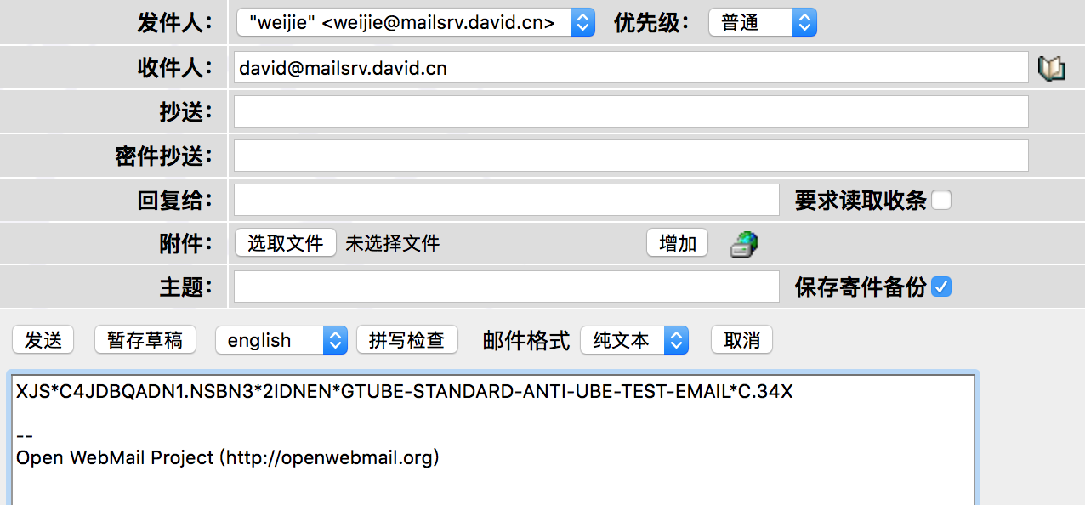

3）查看邮箱的日志文件。Spam采用积分制，默认超过5分就是垃圾邮件，而我们看到下面识别出的邮件是999分，很明显是垃圾邮件

|  |
| --- |
| [root@localhost openwebmail]# **cat /var/log/maillog**  Aug 21 08:44:14 localhost spamd[6401]: spamd: failed to create readable default_prefs: //.spamassassin/user_prefs  Aug 21 08:44:14 localhost spamd[6401]: spamd: processing message <20180821004332.M42441@mailsrv.david.cn> for nobody:99  Aug 21 08:44:26 localhost spamd[6401]: spamd: **identified spam (999.0/5.0)** for nobody:99 in 12.5 seconds, 603 bytes.  Aug 21 08:44:26 localhost spamd[6401]: spamd: result: Y 999 - ALL_TRUSTED,GTUBE,TVD_SPACE_RATIO scantime=12.5,size=603,user=nobody,uid=99,required_score=5.0,rhost=localhost,raddr=127.0.0.1,rport=33149,mid=<20180821004332.M42441@mailsrv.david.cn>,autolearn=no  Aug 21 08:44:26 localhost postfix/pipe[6443]: 3F2FD14141A: to=<david@mailsrv.david.cn>, relay=spamassassin, delay=13, delays=0.06/0.03/0/12, dsn=2.0.0, status=sent (delivered via spamassassin service)  Aug 21 08:44:26 localhost postfix/qmgr[6368]: 3F2FD14141A: removed  Aug 21 08:44:26 localhost spamd[6399]: prefork: child states: II |

Copyright@david zhytwj2018@163.com